Case Report

Coffin-Siris Syndrome Confirmed by an ARID1B Mutation: A Case Report

Abstract
Introduction: Coffin-Siris syndrome (CSS) is a rare disorder of the SWI/SNF-related intellectual disability group.
It typically presents with global developmental delay, variable intellectual disability, facial dysmorphism, and hypoplasia or absence of the distal phalanges, especially of the fifth digit.
Among the implicated genes, ARID1B is the most frequently mutated, explaining most confirmed cases.
Case presentation: We report a 14-year-old boy with developmental delay, moderate intellectual disability, characteristic dysmorphic features, bilateral hypoplasia of the fifth digits, dorsolumbar scoliosis, and a history of bilateral cryptorchidism.
Additional findings included café-au-lait macules, which are rarely described in CSS. Complementary investigations were unremarkable, including a normal karyotype.
Exome sequencing identified a novel heterozygous deletion in ARID1B (NM_001374828.1:c.2964del; NP_001361757.1:p.Ser989ValfsTer20), leading to a frameshift and predicted protein truncation.
This variant was absent from population databases and previously unreported, and was classified as likely pathogenic, confirming CSS type 1 (OMIM:135900).
Conclusion: This case highlights a typical ARID1B-related Coffin-Siris phenotype and contributes a novel variant to the molecular spectrum.
It also emphasizes the role of next-generation sequencing in confirming rare syndromes, supporting multidisciplinary management and genetic counseling.

Keywords
Coffin-Siris syndrome; ARID1B; exome sequencing; intellectual disability; dysmorphic features; next-generation sequencing.

Introduction
Coffin-Siris syndrome (CSS) is an uncommon and complex genetic disorder classified within SWI/SNF-related intellectual disability syndromes.
It is characterized by developmental delay, intellectual disability of variable severity, distinctive dysmorphic features, and hypoplasia or absence of the distal phalanges, especially of the fifth digit.
Since its original description in 1970, the clinical and molecular spectrum has expanded considerably, mainly due to advances in next-generation sequencing (NGS) [1–3].
Among the genes implicated, ARID1B is the most frequently mutated, representing the majority of confirmed cases [4–9].
The ARID1B phenotype typically includes moderate intellectual disability, speech delay, progressive facial features, and preserved survival, but shows variability, making diagnosis sometimes challenging.
Comprehensive overviews, such as the GeneReviews® entry on Coffin-Siris syndrome [10], further highlight its broad clinical spectrum and management considerations.
We present a case of CSS with a pathogenic ARID1B mutation, underlining the contribution of molecular analysis to the evaluation of rare malformation syndromes.

Case Presentattion
Ilyass, a 14-year-old boy, is the second of five siblings, born to unrelated parents.
Pregnancy and delivery (cesarean section) were uneventful, with good neonatal adaptation and a birth weight of 3000 g.
Family history was unremarkable.
Psychomotor development was delayed: independent walking occurred at 2.5 years, and first intelligible words around 3 years.
School performance remained poor, requiring specialized support; moderate intellectual disability was diagnosed by child psychiatry.
On examination, the child had triangular face, low anterior hairline, prominent ears, thick lips, long eyelashes, and microcrania.
Other findings included café-au-lait macules, broad intermammary distance, and flat feet.
Musculoskeletal exam showed dorsolumbar scoliosis.
Both fifth fingers displayed distal phalanx hypoplasia.
Past history included bilateral cryptorchidism, surgically corrected at 3 years.
Complementary investigations were unremarkable: karyotype was normal; ENT and ophthalmologic exams showed no anomalies; cardiac and abdominal ultrasounds were normal.
Skeletal X-rays confirmed dorsolumbar scoliosis.
Exome sequencing revealed a heterozygous deletion in ARID1B (NM_001374828.1:c.2964del; NP_001361757.1:p.Ser989ValfsTer20).
This variant is predicted to cause truncation or nonsense-mediated decay.
It was absent from gnomAD v4.1.0, not previously reported, and classified as likely pathogenic, confirming CSS type 1 (OMIM:135900) (Figure 1).

Discussion
CSS was first described in 1970 by Coffin and Siris in three female patients with intellectual disability, digital anomalies, and characteristic dysmorphic features [11].
It is now recognized as part of SWI/SNF-related intellectual disability syndromes, caused by variants in genes encoding subunits of the SWI/SNF chromatin-remodeling complex [1,12].
Epidemiology
CSS is considered ultra-rare. Only a few hundred cases have been published worldwide.
Its prevalence is estimated at <1 in 100,000 live births, but diagnoses have increased with the widespread use of NGS [13].
Clinical Spectrum
The classical phenotype includes:
• developmental delay and intellectual disability in >90% of cases [4–9],
• dysmorphic facial features such as wide mouth, thick lips, long eyelashes, low hairline, prominent ears, and flat/upturned nose [11,14],
• hypoplasia/aplasia of distal phalanges of the fifth fingers or toes [15].
Additional anomalies may involve the skeleton (scoliosis, joint laxity, flat feet), urogenital system (cryptorchidism, renal anomalies), neurological features (hypotonia, seizures, white matter anomalies), and skin manifestations (hirsutism, pigmentary lesions) [16–18].
Our patient showed the major features: developmental delay, intellectual disability, triangular face, fifth finger hypoplasia, scoliosis, and cryptorchidism.
The presence of café-au-lait macules, rarely reported in CSS, may represent an expansion of the cutaneous phenotype.
Genotype-Phenotype
Variants in several SWI/SNF genes (ARID1A, ARID1B, SMARCA4, SMARCB1, SMARCE1, DPF2) are known to cause CSS.
ARID1B is the most frequent, responsible for nearly two-thirds of confirmed cases [4–9,13].
Patients with ARID1B variants usually have moderate phenotypes with speech delay, intellectual disability, evolving facial features, and distal phalanx anomalies, without life-threatening visceral malformations [4–9,13].
By contrast, ARID1A and SMARCA4 mutations are often associated with severe or lethal forms [12].
The variant reported here (c.2964del; p.Ser989ValfsTer20) is novel, absent from databases, and never previously described, thereby expanding the molecular spectrum of ARID1B.
Role of NGS
Karyotype and array CGH are often normal in CSS [14].
NGS, especially exome sequencing, is essential for diagnosis and for distinguishing CSS from syndromes with overlapping phenotypes such as Nicolaides-Baraitser, Cornelia de Lange, or Rubinstein-Taybi [3,19].
Management and Prognosis
There is no curative treatment. Management relies on multidisciplinary care: developmental therapies (speech, psychomotor, special education), orthopedic surveillance, urological surgery for cryptorchidism or renal anomalies, and psychiatric follow-up [17,20].
As highlighted in GeneReviews® [10], prognosis is variable but survival is generally preserved in ARID1B-related cases.
Intellectual disability is the major limiting factor, ranging from moderate to severe, and determines autonomy.
Facial features become more apparent with age, facilitating recognition in older patients.
In our patient, intellectual disability remained stable, without major visceral complications, in line with expected ARID1B outcomes.

Conclusion
Coffin-Siris syndrome is rare but recognizable when developmental delay, dysmorphic features, and digital anomalies are associated.
ARID1B is the most frequently implicated gene, and exome sequencing is crucial when karyotype is normal.
This case illustrates the importance of molecular diagnosis for rare syndromes and adds a novel ARID1B variant to the CSS spectrum.
Beyond the molecular result, it emphasizes the clinical value of accurate genetic confirmation to guide multidisciplinary management and genetic counseling.
Consent
As per international standards, parental written consent has been collected and preserved by the author(s).
Disclaimer (Artificial intelligence)
Option 2:
Author(s) hereby declare that generativ AI technologies such as Large Language Models, etc. have been used during the writing or editing of manuscripts. This explanation will include the name, version, model, and source of the generative AI technology and as well as all input prompts provided to the generative AI technology
Details of the AI usage are given below:
- ChatGPT (OpenAI, GPT-5, 2025 version)
- used for language editing and grammar refinement.
- All outputs were critically reviewed, revised, and validated by the authors before submission.

References
1. Tsurusaki Y, Okamoto N, Ohashi H, Mizuno S, Matsumoto N, Makita Y, et al. Mutations affecting components of the SWI/SNF complex cause Coffin-Siris syndrome. Nat Genet. 2012;44(4):376–380. doi:10.1038/ng.2219
2. Kosho T, Miyake N. Coffin-Siris syndrome and related disorders involving components of the SWI/SNF complex. Congenit Anom (Kyoto). 2014;54(3):114–125. doi:10.1111/cga.12064
3. Hoyer J, Ekici AB, Endele S, Popp B, Zweier C, Wiesener A, et al. Haploinsufficiency of ARID1B is a frequent cause of intellectual disability. Am J Hum Genet. 2012;90(3):565–572. doi:10.1016/j.ajhg.2012.02.007
4. van der Sluijs PJ, Jansen S, Vergano SA, Takano K, Okamoto N, Kiyomizu K, et al. The ARID1B spectrum in 143 patients: from non-syndromic ID to Coffin-Siris. Genet Med. 2019;21:1295–1307. doi:10.1038/s41436-018-0330-z
5. Vasko A, Vergano SA, van der Sluijs PJ, Peron A, Smeets E, Webb BD, et al. Genotype-Phenotype Correlations in 208 Individuals with Coffin-Siris Syndrome. Genes. 2021;12:937. doi:10.3390/genes12060937
6. Bramswig NC, Lüdecke HJ, Pettersson M, Albrecht B, Bernier RA, Cremer K, et al. Exome sequencing in patients with suspected CSS reveals ARID1B and related genes. Hum Mutat. 2017;38:1374–1385. doi:10.1002/humu.23288
7. Coffin GS, Siris E. Mental retardation with absent fifth fingernail and terminal phalanx. Am J Dis Child. 1970;119(5):433–439. doi:10.1001/archpedi.1970.02100030435005
8. Mari, F., Marozza, A., Mencarelli, M. A., Rizzo, C. L., Fallerini, C., Dosa, L., ... & Renieri, A. (2015). Coffin–Siris and Nicolaides–Baraitser syndromes are a common well recognizable cause of intellectual disability. Brain and Development, 37(5), 527-536.
9. Vergano, S. A., van der Sluijs, P. J., & Santen, G. (2019). ARID1B-related disorder. Book from University of Washington, Seattle, Seattle (WA). PMID: 31132234 https://europepmc.org/article/NBK/nbk541502
10. Vergano SS, Santen G, Wieczorek D, Wollnik B, Matsumoto N, Deardorff MA. Coffin-Siris syndrome. GeneReviews® [Internet]. 2021 Aug 12. Available from: https://www.ncbi.nlm.nih.gov/books/NBK131811/
11. Mannino EA, Miyake N, Kuechler A, Gillessen-Kaesbach G, Suzuki T, Smith ACM, et al. Natural history study of Coffin-Siris syndrome: registry-based data. Am J Med Genet A. 2018;176(11):2250–2258. doi:10.1002/ajmg.a.40509
12. Mishra, S., & Phadke, S. R. (2016). Coffin Siris Syndrome: A Disorder of SWI/SNF Pathway. Genetic Clinics, 9(3), 7-12.
13. Vergano, S. S., Santen, G., Wieczorek, D., Wollnik, B., Matsumoto, N., & Deardorff, M. A. (2021). Coffin-siris syndrome. GeneReviews®[Internet]. https://www.ncbi.nlm.nih.gov/sites/books/NBK131811
14. Vasko, A., Drivas, T. G., & Schrier Vergano, S. A. (2021). Genotype-phenotype correlations in 208 individuals with Coffin-Siris syndrome. Genes, 12(6), 937.
15. Kosho, T., Okamoto, N., & Coffin‐Siris Syndrome International Collaborators. (2014, September). Genotype‐phenotype correlation of Coffin‐Siris syndrome caused by mutations in SMARCB1, SMARCA4, SMARCE1, and ARID1A. In American Journal of Medical Genetics Part C: Seminars in Medical Genetics (Vol. 166, No. 3, pp. 262-275).
16. Kline AD, Moss JF, Selicorni A, Bisgaard AM, Deardorff MA, Gillett PM, et al. Diagnosis and management of Cornelia de Lange syndrome: 2018 consensus guidelines. Am J Med Genet A. 2018;176(4):865–877. doi:10.1002/ajmg.a.38664
17. Vergano SA, Santen GW. ARID1B-related disorder. In: Adam MP, Mirzaa GM, Pagon RA, Wallace SE, Bean LJ, Gripp KW, Amemiya A, editors. GeneReviews® [Internet]. Seattle (WA): University of Washington; 1993–2025. Available from: https://www.ncbi.nlm.nih.gov/books/NBK541138/
18. Bogershausen N, Wollnik B. Mutational landscapes and phenotypic spectrum of SWI/SNF-related intellectual disability disorders. Front Mol Neurosci. 2018;11:252. doi:10.3389/fnmol.2018.00252
19. Retterer K, Juusola J, Cho MT, Vitazka P, Millan F, Gibellini F, et al. Clinical application of whole-exome sequencing across clinical indications. Genet Med. 2016;18(7):623–630. doi:10.1038/gim.2015.148
20. Sun Y, Lin Y, Wang X, Chen Z, Li Y, Hu Q, et al. De novo ARID1B variants and Coffin-Siris syndrome: expanding the clinical spectrum. BMC Med Genomics. 2024;17:56. doi:10.1186/s12920-024-01511-7
21. Li X, Wu J, Zhang Y, Huang L, Zhao Y, Chen H, et al. Anorectal malformation as part of ARID1B-related Coffin-Siris syndrome: case report and review. Eur J Med Genet. 2024;67(4):104923. doi:10.1016/j.ejmg.2024.104923
22. Yasui N, et al. Non-truncating ARID1B variants cause atypical presentations of Coffin-Siris syndrome. NPJ Genom Med. 2025;10:34. doi:10.1038/s41525-025-00456-1
23. Rauschendorf MA, et al. SMARCA4-related Coffin-Siris syndrome in a newborn: case report and literature review. Front Pediatr. 2025;13:1556291. doi:10.3389/fped.2025.1556291

FIGURES :
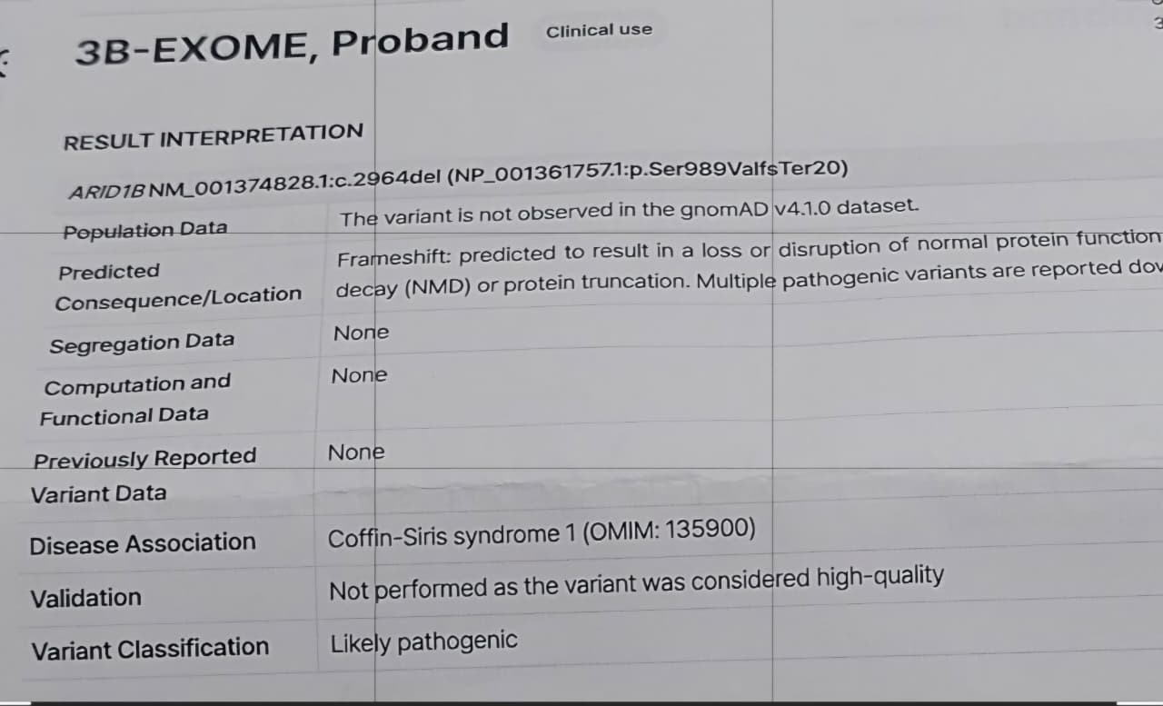
Figure 1. Molecular analysis by exome sequencing identified a heterozygous deletion in the ARID1B gene

