Case report
Langerhans cell histiocytosis associated with EVANS syndrome: A case report
Introduction: Langerhans cell histiocytosis (LCH) is a rare clonal disorder of dendritic cells with heterogeneous clinical manifestations, ranging from isolated bone lesions to severe multisystemic disease. Its association with Evans syndrome, defined by autoimmune haemolytic anaemia and immune thrombocytopenia, is extremely uncommon in paediatric patients.
Observation: We report the case of a 16-month-old girl admitted for bicytopenia. Clinical findings included pallor, an erythematous, squamous rash, splenomegaly, and bone involvement with vertebral collapse. Laboratory evaluation revealed autoimmune haemolytic anaemia with thrombocytopenia, confirmed by a positive Coombs test,elevated LDH levels and indirect hyperbilirubinaemia. Imaging demonstrated thymic hypertrophy, lytic skull lesions, and paravertebral tissue infiltration. A skin biopsy confirmed LCH with CD1a and PS100 positivity, and molecular analysis identified an activating MAPK/ERK pathway mutation. The patient was treated according to a high-risk LCH protocol with vinblastine and systemic corticosteroids, resulting in a favourable outcome both clinically and biologically.
Conclusion: This case illustrates the rarity of the LCH–Evans association and highlights the importance of considering autoimmune mechanisms in cytopenias occurring during LCH. The identification of a MAPK/ERK pathway mutation further suggests a potential link between histiocytic proliferation and immune dysregulation.
Keywords: Langerhans cell histiocytosis; Evans syndrome; autoimmune cytopenias; infant

Introduction
Langerhans cell histiocytosis (LCH) is a rare disease characterised by the pathological accumulation of dendritic cells expressing CD1a and CD207. Its incidence is estimated at 5 cases per million children [1]. Clinical expression is polymorphic, ranging from isolated bone involvement to severe multisystemic forms.
Evans syndrome is defined by the association of autoimmune haemolytic anaemia and immune thrombocytopenia, sometimes accompanied by neutropenia [2]. Its occurrence in children is unusual.
The association between these two entities is extremely rare, with only a few cases reported in the literature [3–5]. We present the case of a 16-month-old girl with multisystemic LCH associated with Evans syndrome.

Case Presentation
This is a 16-month-old girl, an only child, born to non-consanguineous parents, from a monitored pregnancy carried to term and delivered by caesarean section. Psychomotor development was normal, and there was no relevant medical history.
She was admitted for investigation of bicytopenia. Clinical examination revealed pallor of the skin and mucous membranes, and a rash consisting of pink erythematous macules and papules measuring 1–3 mm, arranged in a sleeveless-shirt pattern( Figure 1). This was associated with papular-squamous and crusty erythema of the scalp, as well as cervical intertrigo(Figure 2 ,3 ). Splenomegaly was observed on abdominal palpation( Figure 4 ). The rest of the examination was unremarkable.
Laboratory tests showed normochromic, normocytic, regenerative anaemia with a positive direct Coombs test,low haptoglobin, elevated LDH and total bilirubin, and thrombocytopenia. The search for irregular agglutinins and the autoimmune workup were negative. Viral serologies (HBV, HCV, HIV, EBV, CMV, Parvovirus B19) were negative.
Thoraco-abdominal CT revealed thymic hypertrophy with calcifications (Figure 5) and large homogeneous splenomegaly (Figure 6). Spinal CT demonstrated S1 vertebral collapse with vertebra plana appearance, associated with peri-vertebral, epidural, and intra-canal tissue infiltration suggestive of histiocytosis (Figure 7). Skull radiography showed fronto-parietal lytic lesions (Figure 8), while spinal radiography confirmed a flat vertebra.
A skin biopsy confirmed the diagnosis, demonstrating infiltration by CD1a+ and PS100+ cells.( Figure 9 ) Molecular testing revealed an activating mutation in the MAPK/ERK pathway
The patient was placed on a high-risk LCH chemotherapy protocol combining vinblastine and systemic corticosteroid therapy. The clinical and biological outcome was favourable.

Discussion
Langerhans cell histiocytosis (LCH) is a rare condition with an estimated incidence of 5 cases per million in children under 15 years of age and 2.7 cases per million in adults [1]. The age distribution is asymmetrical, with a slight male predominance. Etiological hypotheses, particularly viral ones (EBV [3], HHV6 [4], CMV [5]), have been suggested, but no causal relationship has been confirmed by case-control studies. To date, the only established risk factor remains active smoking, which is responsible for lung damage in adults [6].
The clinical presentation is extremely heterogeneous and can range from benign localised forms to severe multisystemic forms [7,8]. Bone involvement, present in 50 to 80% of cases, results in lytic bone defects, mainly affecting the skull, jaw, vertebrae and pelvis. Skin forms, found in approximately 30% of children, take on polymorphic appearances (papulosquamous, crusty, erythematous lesions), predominantly on the scalp and in skin folds. Multisystemic forms in children, affecting several organs, are associated with a more guarded prognosis, particularly when the liver, spleen or haematopoietic marrow are involved (Letterer-Siwe syndrome). Endocrine involvement, particularly of the pituitary stalk, is responsible for diabetes insipidus in 25% of cases, while neurological involvement, which is rarer, can take a tumoral or neurodegenerative form.
The diagnosis is based on a biopsy showing an infiltrate of CD1a+ and CD207+ cells, often also PS100+. In recent years, the discovery of activating mutations in the MAPK/ERK pathway, particularly BRAFV600E, has profoundly changed our understanding of the disease, confirming its clonal nature and paving the way for targeted therapies [9]. Recent advances have further highlighted the pathogenic role of MAPK/ERK pathway alterations in LCH, which may also explain its association with autoimmune manifestations such as Evans syndrome [15–17]. Moreover, general advances in the understanding of LCH pathophysiology and treatment have been comprehensively reviewed by Kobayashi & Tojo [18], providing an important background that supports the significance of our case.
Management is variable and multidisciplinary. Unifocal forms can sometimes regress spontaneously or be treated locally (curettage, intralesional corticosteroids). Multisystemic forms require first-line chemotherapy based on vinblastine and corticosteroids, evaluated after 6 weeks [7,10]. In cases of resistance, cladribine, cytarabine, and BRAF and MEK inhibitors have been shown to be effective [11].
In the literature, the association between LCH and Evans syndrome has been reported in very rare cases [12–14]. These observations suggest a link between clonal histiocytic proliferation and immune tolerance dysregulation.
In our observation, LCH manifested itself through skin, bone and spleen involvement, but the bicytopenia was of autoimmune origin, as confirmed by a positive Coombs test and biological markers of haemolysis. The major contribution of this case lies in the identification of an activating mutation in the MAPK/ERK pathway. This discovery suggests that the constitutive activation of this pathway is not limited to histiocytic proliferation, but could also play a role in the breakdown of tolerance and the development of secondary autoimmunity.
Several pathophysiological mechanisms are therefore plausible: the secretion of pro-inflammatory cytokines by histiocytic cells (TNF-α, IL-1β, IL-17) promoting polyclonal lymphocyte activation, and the aberrant activation of the MAPK/ERK pathway promoting both clonal survival and immune dysregulation.
From a therapeutic standpoint, it is essential to distinguish between cytopenia due to bone marrow infiltration and autoimmune cytopenia, as this determines the treatment strategy. In our case, the combination of vinblastine and corticosteroid therapy led to simultaneous improvement in LCH and Evans syndrome, which is consistent with the experience of Tsuji et al. [13]. However, given the recurrent nature of Evans syndrome, prolonged monitoring is required, and the use of immunomodulatory or targeted therapies may be considered in the event of relapse.

Conclusion
The association between Langerhans cell histiocytosis and Evans syndrome is rare and highlights the importance of comprehensive immunological testing in all patients with LCH presenting with cytopenias. The identification of a mutation in the MAPK/ERK pathway in our case supports the hypothesis of a common immune dysregulation. Management is based on conventional chemotherapy, but prolonged follow-up is essential due to the risk of relapse

Ethical Approval:

As per international standards or university standards written ethical approval has been collected and preserved by the author(s).

Consent
As per international standards, parental written consent has been collected and preserved by the author(s).

COMPETING INTERESTS DISCLAIMER:
Authors have declared that they have no known competing financial interests OR non-financial interests OR personal relationships that could have appeared to influence the work reported in this paper.
Disclaimer (Artificial intelligence)
Author(s) hereby declare that generative AI technologies have been used during the writing/editing of this manuscript. Specifically, ChatGPT (OpenAI, GPT-5, 2025 version) was used to improve the English language, grammar, and style of the text. No AI tools were used for data collection, analysis, or interpretation of results. The scientific content, clinical interpretation, and conclusions were entirely developed and verified by the authors.
Details of the AI usage are given below:
- ChatGPT (OpenAI, GPT-5, 2025 version) – used for language editing and grammar refinement.
- Prompts included requests for improving clarity of English sentences and formatting references.
- All outputs were critically reviewed, revised, and validated by the authors before submission.

References
- Guyot-Goubin A, Donadieu J, Barkaoui M, et al. Descriptive epidemiology of childhood Langerhans cell histiocytosis in France, 2000–2004. Pediatr Blood Cancer. 2008;51:71–5.
- Evans RS, Takahashi K, Duane RT, et al. Primary thrombocytopenic purpura and acquired hemolytic anemia; evidence for a common etiology. Blood. 1951;6(11):1196–1213.
- Shimakage M, Sasagawa T, Kimura M, et al. Expression of Epstein-Barr virus in Langerhans’ cell histiocytosis. Hum Pathol. 2004;35:862–8.
- Leahy MA, Krejci SM, Friednash M, et al. Human herpesvirus 6 is present in lesions of Langerhans cell histiocytosis. J Invest Dermatol. 1993;101:642–5.
- Kawakubo Y, Kishimoto H, Sato Y, et al. Human cytomegalovirus infection in foci of Langerhans cell histiocytosis. Virchows Arch. 1999;434:109–15.
- Hance AJ, Basset F, Saumon G, et al. Smoking and interstitial lung disease. Ann N Y Acad Sci. 1986;465:643–56.
- Haupt R, Minkov M, Astigarraga I, et al. Langerhans cell histiocytosis (LCH): guidelines for diagnosis, clinical work-up, and treatment for patients till the age of 18 years. Pediatr Blood Cancer. 2013;60(2):175–184.
- Lorillon G, Meignin V, Tazi A. Pulmonary Langerhans cell histiocytosis in adults. Presse Med. 2016.
- Badalian-Very G, Vergilio JA, Degar BA, et al. Recurrent BRAF mutations in Langerhans cell histiocytosis. Blood. 2010;116(11):1919–1923.
- Gadner H, Grois N, Arico M, et al. A randomized trial of treatment for multisystem Langerhans’ cell histiocytosis. J Pediatr. 2001;138:728–734.
- Heritier S, Jehanne M, Leverger G, et al. Vemurafenib use in an infant for high-risk Langerhans cell histiocytosis. JAMA Oncol. 2015;1(6):836–838.
- Henry, R. J., & Sweeney, E. A. (1996). Langerhans' cell histiocytosis: case reports and literature review. Pediatric Dentistry, 18, 11-16.
- Tsuji, Y., Kogawa, K., Imai, K., Kanegane, H., Fujimoto, J., & Nonoyama, S. (2008). Evans syndrome in a patient with Langerhans cell histiocytosis: possible pathogenesis of autoimmunity in LCH. International journal of hematology, 87(1), 75-77.
- Chen RL, et al. Evans syndrome after cord blood transplantation for disseminated Langerhans cell histiocytosis. J Pediatr Hematol Oncol. 2007;29:489–492.
- Berres, M. L., Merad, M., & Allen, C. E. (2015). Progress in understanding the pathogenesis of Langerhans cell histiocytosis: back to Histiocytosis X?. British journal of haematology, 169(1), 3-13.
- Krooks, J., Minkov, M., & Weatherall, A. G. (2018). Langerhans cell histiocytosis in children: history, classification, pathobiology, clinical manifestations, and prognosis. Journal of the American Academy of Dermatology, 78(6), 1035-1044.
- Rodriguez-Galindo C, et al. Current management and future directions in Langerhans cell histiocytosis. Pediatr Blood Cancer. 2024;71(1):e30845. doi:10.1002/pbc.30845.
- Kobayashi M, Tojo A. Langerhans cell histiocytosis in adults: Advances in pathophysiology and treatment. Cancer Sci. 2018;109(11):3707–3713. doi:10.1111/cas.13823.
FIGURES :

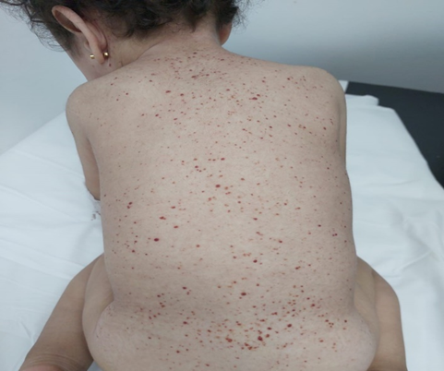
Figure 1: Cutaneous rash with erythematous papules on the back.
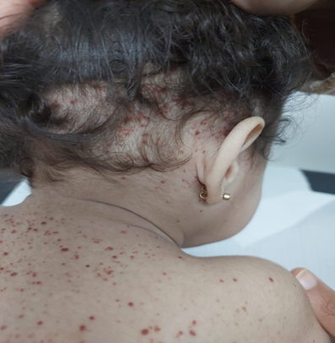
Figure 2: Papular-squamous lesions of the scalp and cervical region

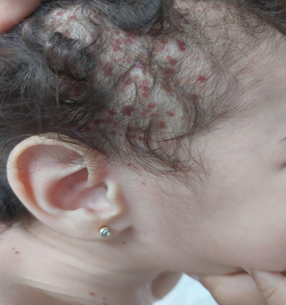
Figure 3: Erythematous and crusty lesions of the scalp.

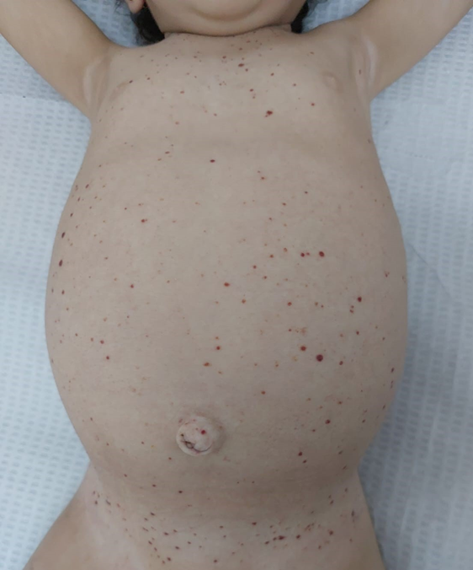

Figure 4: Diffuse cutaneous rash with splenomegaly

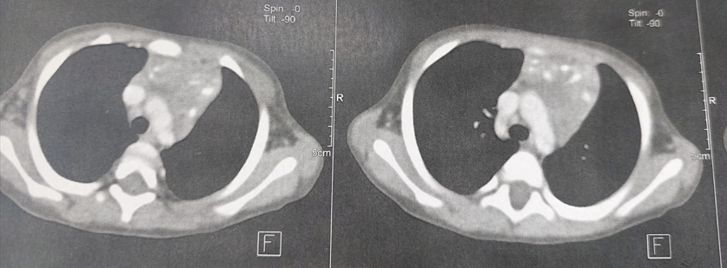
Figure 5: Thoracic CT showing thymic hypertrophy.

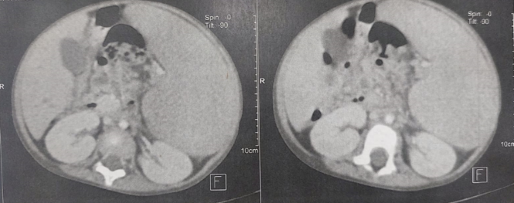
Figure 6: Abdominal CT showing homogeneous splenomegaly.
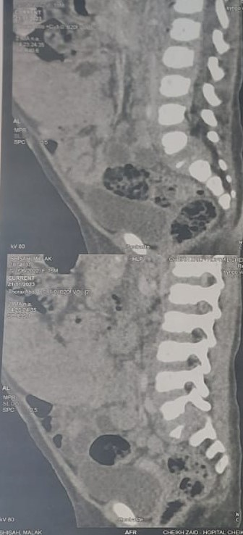
Figure 7: Spinal CT showing S1 vertebra plana with paravertebral and epidural soft tissue infiltration

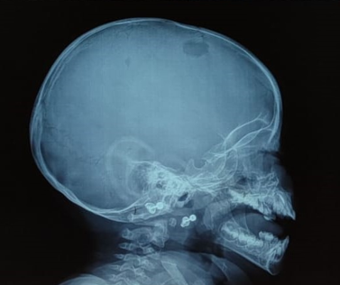
Figure 8: Skull radiograph showing fronto-parietal lytic lesions.

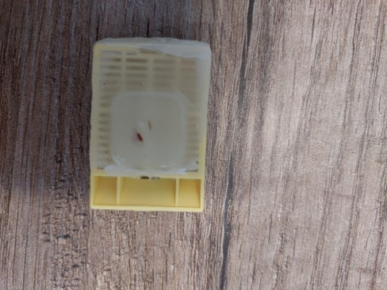
Figure 9 : Paraffin-embedded skin biopsy specimen used for histopathological and immunohistochemical confirmation of Langerhans cell histiocytosis

