Case report
Tuberculosis of the Submandibular Gland: A Diagnostic Pitfall

Abstract:
Background: Tuberculosis remains a major public health problem worldwide, with persistent endemicity in Morocco. While cervical lymph node involvement is the most frequent ENT localization, extranodal presentations such as salivary gland tuberculosis are rare and often misleading, raising diagnostic challenges with neoplastic pathologies.
Case presentation: We report the case of an 11-year-old girl presenting with a painless, firm left submandibular swelling evolving over 21 days, unresponsive to antibiotic therapy. Initial laboratory tests revealed an elevated erythrocyte sedimentation rate, with no other abnormalities. Ultrasound suggested a suppurative submandibulitis of bacterial origin, while cervical CT scan showed heterogeneous submandibular involvement with necrotic lymph nodes, suggestive of tuberculosis. Diagnosis was confirmed by GeneXpert detection of Mycobacterium tuberculosis from pus, and histopathological findings of epithelioid giant-cell granulomas with caseous necrosis. The patient tested HIV-negative and had no other tuberculous localizations. She received a six-month anti-tuberculous treatment with favorable clinical outcome.
Discussion: Submandibular gland tuberculosis is exceptionally rare, with fewer than 40 cases reported in the literature. Its clinical presentation mimics benign or malignant tumors, often leading to misdiagnosis. Imaging can provide suggestive features, but histopathology and microbiological confirmation remain the diagnostic gold standards.
Conclusion: Extra-ganglionic tuberculosis of the submandibular gland is a diagnostic pitfall due to its rarity and misleading clinical presentation. Histopathological confirmation is essential, and medical management with anti-tuberculous therapy ensures favorable prognosis.
Keywords: Tuberculosis, Submandibular gland, Pediatric case, Differential diagnosis, Salivary gland tuberculosis

Introduction:
Tuberculosis is one of the most widespread infectious diseases worldwide. In Morocco, it still remains endemic. ENT localizations are mainly dominated by lymph node involvement; however, extra-nodal forms are not uncommon. Clinical symptoms and paraclinical findings are often misleading, raising the problem of differential diagnosis with tumoral diseases [1]. We report a case of tuberculosis of the submandibular gland in a young girl hospitalized at the Department of Pediatrics 4, Children’s Hospital of Rabat.
Case Presentation:
The patient was an 11-year-old girl, with no significant past medical history, who presented with a left maxillary swelling evolving for 21 days. She had been treated with amoxicillin–clavulanate without improvement. The condition evolved without fever and with preserved general health status.
On admission, examination revealed a firm, painless left maxillary swelling with no overlying inflammatory signs. Laboratory investigations showed an elevated erythrocyte sedimentation rate of 45 mm in the first hour, negative C-reactive protein, a normal blood count, and sterile pus culture. Cervical ultrasound showed a suppurative bacterial-looking left submaxillitis. The patient was started on intravenous Ceftriaxone combined with Metronidazole.
Due to the lack of improvement, a cervical CT scan was performed, revealing a heterogeneous left submaxillitis communicating with necrotic lymphadenopathies, suggesting a tuberculous origin (Figure 1).

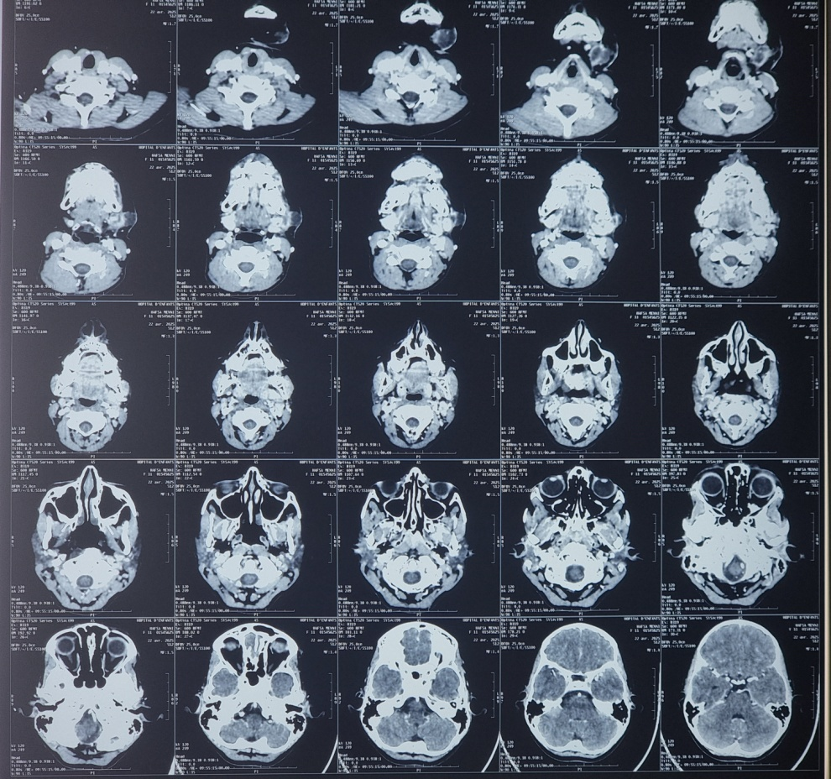
Figure 1: Facial CT scan showing submaxillitis with necrotic lymphadenopathies and superficial cellulitis

The diagnosis was based on the detection of Mycobacterium tuberculosis by GeneXpert on pus, supported by histological confirmation showing epithelioid giant-cell granulomas with caseous necrosis.
A thoraco-abdomino-pelvic CT scan and GeneXpert testing on sputum were also performed, revealing no other tuberculosis localizations. HIV serology was negative.
She was treated with anti-tuberculosis therapy for six months. The treatment regimen consisted of combination of four drugs- isoniazid (5 mg/kg/day), rifampicin (10 mg/kg/day), pyrazinamide (30 mg/kg/day), and ethambutol (20 mg/kg/day) for 2 months, subsequently isoniazid and rifampicin for 4 months. We noticed a good clinical outcome and no suspicion of local or regional recurrence.

Discussion
Epidemiology:
Current data show a global resurgence of tuberculosis. Approximately 8.7 million new cases are reported annually, 13% of which are co-infected with HIV, with nearly 1.4 million related deaths [2]. This increase is mainly due to growing immunocompromised populations, unfavorable socioeconomic conditions, and the emergence of multidrug-resistant strains of M. tuberculosis [1]. ENT localizations, apart from lymph node involvement, account for about 1.8% of all TB cases.
Historically, Mycobacterium bovis was often implicated, particularly in cervical lymph node TB, due to consumption of contaminated milk or dairy products. However, with widespread pasteurization and veterinary controls, this route of transmission has become rare. Today, Mycobacterium tuberculosis is the predominant species, followed by M. bovis, M. africanum, and some atypical mycobacteria.
Tuberculosis of the salivary glands remains exceptional: fewer than one hundred cases have been reported in the literature, with fewer than 40 affecting the submandibular gland. The first case was described by De Paoli in 1893 [3], while the most recent was reported by Rawle in 2004 [4]. The most documented series, published by Redon in 1955, included 24 cases—75% involving the parotid gland and 25% the submandibular gland [5]. TB may affect the glandular parenchyma directly or, more rarely, the adjacent lymph nodes.
Two mechanisms of contamination are proposed: retrograde spread via salivary ducts from the oral cavity, or hematogenous/lymphatic dissemination. In these reinfection forms, pulmonary TB is usually healed, with radiological sequelae preceding glandular swelling [3].
Diagnosis and Treatment:
The clinical presentation of submandibular TB is often misleading, especially since active pulmonary TB is rarely associated. It typically begins with a slowly progressive cervical swelling, sometimes with inflammatory signs. General symptoms (fever, fatigue, weight loss, anorexia) are seen in fewer than 20% of patients. Clinically, it is initially suggestive of a benign glandular tumor (e.g., pleomorphic adenoma) or metastatic lymphadenopathy, but later progression—with caseous necrosis and fistula formation—resembles inflammatory adenopathies (sarcoidosis, cat-scratch disease, etc.).
Pulmonary abnormalities suggestive of TB (primary infection, active or sequelae) are found in only 24–46% of cases. Tuberculin skin test is positive in 90% of cases, except in HIV-positive patients [6]. Locally, ultrasound is the most frequently performed test, showing an enlarged, heterogeneous gland with possible satellite lymphadenopathies. Panoramic or cervical radiography may show old calcifications, though interpretation is limited. Cervical CT scan is more sensitive, revealing a rounded mass with a thick wall and clear center, suggestive of TB [7]. However, caseous necrosis may also occur in some lymphomas, complicating the differential diagnosis.
Fine-needle aspiration cytology (FNAC) is helpful, often revealing epithelioid granulomatous cells, sometimes with multinucleated giant cells and caseous necrosis [3,4,6,8]. Its sensitivity is estimated at 88% and specificity at 96% [9], leading some authors to advocate medical treatment alone in selected cases.
The saliva, aspirate and tissue can be used for acid-fast bacilli staining ( AFB), culture and polymerase chain reaction assay (PCR). The sensitivity of AFB staining and culture is 28.6%; low for diagnosis of Extrapulmonary TB . Combining FNAC and culture increase the diagnostic yield to 85.7% [10]. The sensitivity and specificity can reach to 90% if FNAC is combined with PCR [11]. However, definitive confirmation most often relies on surgical excision, which allows reliable histopathological and/or bacteriological analysis in 100% of cases [5,6,9].
Due to its rarity, there are no established guidelines for the management of submandibular gland tuberculosis. However, once accurately diagnosed, the condition responds well to conventional short-course antituberculous therapy (ATT) [10]. Consequently, it is important to prioritize medical treatment and avoid unnecessary surgical procedures. The therapeutic protocol typically involves a four-drug regimen—isoniazid (5 mg/kg/day), rifampicin (10 mg/kg/day), pyrazinamide (30 mg/kg/day), and ethambutol (20 mg/kg/day)—administered for 2–4 months, followed by isoniazid and rifampicin for an additional 4–12 months [12].

Conclusion:
Extranodal tuberculosis of the ENT sphere is rare. Clinically, it poses diagnostic difficulties with neoplastic diseases. Diagnosis is essentially histopathological. Treatment is based on anti-tuberculosis therapy, and the prognosis is generally favorable.
Consent:
As per international standard or university standard, patient(s) written consent has been collected and preserved by the author(s).

Ethical approval:
As per international standard or university standard written ethical approval has been collected and preserved by the author(s).

Competing interests:
Authors have declared that no competing interests exist.

Disclaimer :
Author(s) hereby declare that NO generative AI technologies such as Large Language Models (ChatGPT, COPILOT, etc.) and text-to-image generators have been used during the writing or editing of this manuscript.
References:
1. Bengamra O, Benammour A, Bouzouita K, Saidani M, Abdelmalek R, Bouzaidi K, et al. Tuberculosis of the upper aerodigestive tract. Rev Tun Infectiol. 2008 Jul;2(3):21-5.
2. Blanie M, Pellegrin JL, Maugein J. Contribution of PCR in the diagnosis of extrapulmonary tuberculosis. Medicine and infectious diseases. 2005;35(1):17-22. PubMed | Google Scholar
3. Manipoud P, Rerolle S, Kemeny JL, Lafaye M. Tuberculosis of the submandibular gland: a case report and review of the literature. Ann Otolaryng Chir Cervico Fac, 1993;110:482-4.
4. Philbert RF, Kim AK, Chung DP. Cervical tuberculosis (scrofula): a case report. J Oral Maxillofac Surg, 2004;62:94-7.
5. Zheng JW, Zhang QH. Tuberculosis of the parotid gland: a report of 12 cases. J Oral Maxillofac Surg 1995;53:849-51.
6. Lacut JY, Dupon M, Paty MC. Extrapulmonary tuberculosis: review and possibilities for reducing therapeutic intervention times. Med Mal Infect, 1995;25:304-20.
7. Fain O. Extrathoracic tuberculosis. Rev Prat, 2002;52:2127-32
8. Weiler Z, Nelly P, Baruchin AM, Oren S. Diagnosis and treatment of cervical tuberculous lymphadenitis. J Oral Maxillofac Surg, 2000;58:477-81
9. Bodner L, Lewin-Epstein J, Shteyer A. Submandibular tuberculous lymphadenitis (scrofula): report of two cases. J Oral Maxillofac Surg, 1990;48:192-6
10. Virmani N, Dabholkar J. Primary tubercular sialadenitis—a diagnostic dilemma. Iran J Otorhinolaryngol. 2019;31(102):45-50.
11. Kasim SK, Namawar E, Yunus MRM. A rare case of primary tuberculosis of the submandibular gland. Egypt J Otolaryngol. 2015;16(2):87-9.
12. Chaudhary P, Chaudhary B, Munjewar CK. Parotid tuberculosis. Indian J Tuberc. 2017;64:161–166.

