Tuberculous Spondylitis: A Comprehensive Review of Epidemiology, Diagnosis, and Management

ABSTRACT
Tuberculous spondylitis, a manifestation of tuberculosis (TB) in the spine, remains a significant health issue globally, with a prevalence that continues to rise, particularly in developing countries like Indonesia. Spinal tuberculosis arises from hematogenous spread, often originating in pulmonary or genitourinary systems, and can lead to vertebral destruction, deformity, and neurological deficits. Diagnosis is confirmed through clinical symptoms, imaging (MRI and X-rays), and microbiological tests. Spinal TB typically presents with chronic back pain, stiffness, and systemic symptoms like fever, night sweats, and weight loss. Advanced cases may develop neurological complications, including radiculopathy and paraplegia. Identification and management are crucial to prevent long-term disability, such as kyphosis and neurological impairment. Management primarily involves long-term anti-TB therapy (9-12 months) and, in certain cases, surgical intervention. Non-operative approaches are preferred in early or stable cases, involving anti-TB drugs and spinal immobilization. Surgery becomes necessary for severe deformities, abscesses, or neurological compromise. Surgical approaches include anterior, posterior, or combined methods aimed at spinal stabilization and deformity correction. Despite advances, challenges remain in managing complications, such as neurological deficits and progressive deformities, which may require complex surgical solutions. Multidisciplinary care, including collaboration among orthopedic, neurological, and infectious disease specialists, is essential for optimizing treatment outcomes. Diagnosis, effective anti-TB therapy, and timely surgical intervention are key to improving patient outcomes and preventing permanent disability.

Keywords: Spinal tuberculosis, Anti-TB therapy, Surgical intervention

1. INTRODUCTION
Tuberculosis (TB) is a significant global health issue, with 1.5 million deaths in 2020. TB is the 13th leading cause of death and the second leading infectious disease cause of death after COVID-19 ¹. It is estimated that 10 million people suffer from TB, with 1.1 million of them being children². In Indonesia, the prevalence of TB is estimated to reach 647 per 100,000 population, with 10% being extra-pulmonary TB, and 1–5% experiencing osteoarticular TB, half of which are in the form of spinal tuberculosis³. Spinal TB, which occurs due to hematogenous spread, can lead to bone damage, deformity, and paravertebral abscess^{4,5}. Diagnosis is supported by MRI, histopathology, and microbiology⁶, while the main treatment is long-term anti-TB therapy⁷. In certain cases, surgical intervention is necessary to address large abscesses, spinal instability, kyphotic deformity, or neurological deficits⁸. Proper management is crucial to prevent long-term deformities and neurological complications⁹.
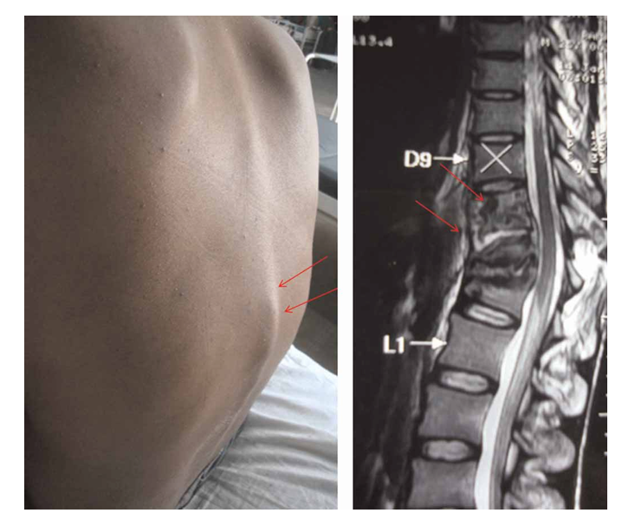
Figure 1. Gibbus Deformity was seen on Physical Examination and Confirmed with MRI (Garg and Somvanshi, 2011)¹⁰
.
- EPIDEMIOLOGY
Tuberculosis (TB), once common worldwide, has shown a decline in prevalence in developed countries thanks to public health programs, improved nutrition, and advances in chemotherapy. However, in the last two decades, the incidence of TB, particularly extra-pulmonary TB, has increased due to factors such as aging, population movement, drug abuse, and AIDS. Manifestations in the skeleton often occur in the spine and large joints, although it can affect other bones or the synovial sheath. Predisposing factors include chronic disorders, diabetes, drug abuse, long-term corticosteroid use, AIDS, and impaired body defense mechanisms¹¹. According to the WHO, global new TB cases exceed 8 million per year, with 20-33% of the world’s population infected. Indonesia contributes 583,000 new cases annually, with 262,000 infectious cases and 140,000 deaths³. In America, the incidence of extra-pulmonary TB reaches 4,000 cases per year, with the spine being the most frequently affected site, accounting for nearly half of extra-pulmonary TB cases¹².

- ETIOLOGY
Spinal tuberculosis generally occurs due to hematogenous spread from an existing infection focus outside the spine, with the pulmonary and genitourinary systems being the most common sources of infection. However, spinal tuberculosis can also arise from lesions in other parts of the skeleton. At the time of presentation, the primary focus of the infection may already be inactive. Spinal involvement can develop through direct spread from visceral lesions. Although *Mycobacterium tuberculosis* is the primary causative agent, other species of *Mycobacterium* can also cause this infection⁷. Salomon et al. identified three stages in the development process of tuberculosis, namely:
- Primary Complex: This stage begins with a small lesion in the lungs, pharynx, or intestines that spreads through the lymphatic system to the regional lymph nodes, forming the primary complex. This initial infection often does not cause significant clinical symptoms, although it can lead to lymph node enlargement in the neck or abdomen. Despite being asymptomatic, the initial infection can persist in the healed or calcified lymph nodes, forming a bacterial reservoir that can cause reinfection with a more destructive immune response¹¹.
- Secondary Spread: If the body has low immunity, the infection can spread through the bloodstream, posing a risk of causing miliary tuberculosis, meningitis, or other tuberculosis lesions. This spread typically occurs several months to years after the initial infection, often when the body's immunity decreases. Mycobacterium bacilli can migrate and lodge in extra-pulmonary tissues, leading to the development of destructive lesions known as "tertiary lesions."
- Tertiary Lesions: In approximately 5% of patients with tuberculosis, lesions involving bones or joints can occur. These lesions are often found in the vertebral bodies or large synovial joints. The difficulty arises in determining whether the infection started in the joint and spread to the surrounding bone, or vice versa, as both share the same blood supply and can be infected simultaneously¹¹.

- PATHOPHYSIOLOGY
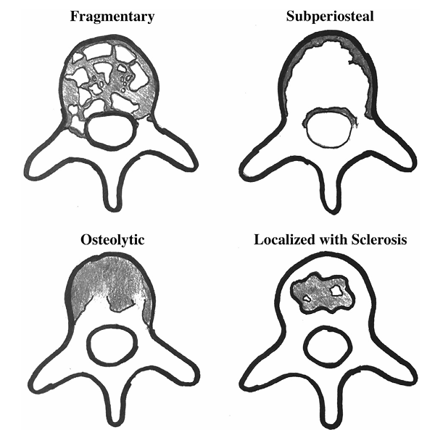
The responsible microbe is the *Mycobacterium tuberculosis* complex bacillus. There are 60 species of this bacillus that have been described, but only a few are associated with the clinical manifestations of the disease. The primary routes of infection are pulmonary or genitourinary, and 50% of all TB patients have a primary pulmonary focus or a history of pulmonary tuberculosis. Spinal tuberculosis is a secondary infection, which usually occurs through hematogenous spread. However, it is unclear whether spinal tuberculosis requires active disease elsewhere or if spinal tuberculosis implies that the patient is contagious¹³. Unlike most spinal infections, 95% of spinal tuberculosis begins in the anterior vertebral body. The infection spreads from arterial dissemination in the paradiscal area, or from the valveless venous plexus, the paravertebral Batson plexus, into the central vertebral body. The infection tends to spread subligamentously beneath the anterior longitudinal ligament and into the posterior vertebral body. The intervertebral disc is often the last to be affected due to the lack of proteolytic enzymes attached to the bacilli. Although in adults the vertebral body is almost always involved, children with more vascular discs may have the disease focus in the disc. If left untreated, bone involvement in spinal tuberculosis eventually destroys the anterior vertebral body, leading to kyphosis. Bone damage in the anterior elements is fragmentary in 47% of cases; osteolytic in 34%, subperiosteal in 30% of cases, and localized damage with sclerotic edges in 10%¹⁴.

Figure 2. Bone damage to the anterior elements was fragmentary in 47% of cases; osteolytic in 34%, subperiosteal in 30% of cases, and localized damage with sclerotic edges in 10% of cases.

- CLINICAL SYMPTOMS AND PHYSICAL EXAMINATION
Anamnesis plays a crucial role in suspecting the diagnosis of spinal tuberculosis, particularly in the early stages before radiological findings become evident. Patients typically present with the main complaint of chronic back pain that is progressive and does not improve with conventional treatment. The pain is often localized to one or two vertebral segments and may be accompanied by stiffness or paraspinal muscle spasms¹⁵. A history of systemic symptoms such as intermittent mild fever, weight loss, night sweats, and fatigue is often present, although not always. In advanced cases, patients may report neurological symptoms such as numbness, tingling, or weakness in the extremities due to compression of the spinal cord or nerve roots (radiculopathy and myelopathy). Risk factors to explore in the anamnesis include:
- A history of close contact with individuals suffering from pulmonary tuberculosis
- A history of latent or active tuberculosis
- Immunosuppression (e.g., HIV/AIDS, long-term corticosteroid use)
- Low socio-economic status¹⁶
Pain is most commonly found in the lower thoracic and upper lumbar regions, consistent with the predilection of spinal tuberculosis. The duration of the complaint is typically chronic, with an average onset lasting several weeks to months before the patient seeks medical attention¹³. Physical examination in patients with spinal tuberculosis usually reveals localized tenderness at the affected vertebral segment, accompanied by paraspinal muscle spasms and reduced mobility in the area. Gibbus deformity or angular kyphosis may be seen in advanced cases, especially if there is collapse of the anterior vertebral body. Signs of systemic infection, such as mild fever, night sweats, and weight loss, should also be noted. Neurological examination becomes crucial, particularly when there is compression of the spinal cord or epidural abscess. Neurological symptoms can include muscle weakness, decreased deep tendon reflexes, paresthesia, and even positive Babinski signs or clonus¹⁷.
In the thoracic and lumbar regions, spinal deformities and postural changes can be visibly apparent. If a cold abscess is present, local swelling may be palpable, especially in the lumbar or paravertebral regions. Palpation of the affected area may cause sharp pain, and in some cases, a soft mass may be found due to the abscess spreading into the surrounding soft tissues¹⁰.

- DIAGNOSTIC EXAMINATION
Supporting examinations play a crucial role in confirming the diagnosis of spinal tuberculosis, especially to detect involvement of spinal structures and exclude other differential diagnoses. Radiological examination is the initial step commonly used. Plain X-rays of the spine can show characteristic findings, including damage to the anterior vertebral body, narrowing of the intervertebral disc, vertebral collapse, and gibbus deformity in advanced cases. However, the sensitivity of plain X-rays is limited in the early stages of the disease⁵.

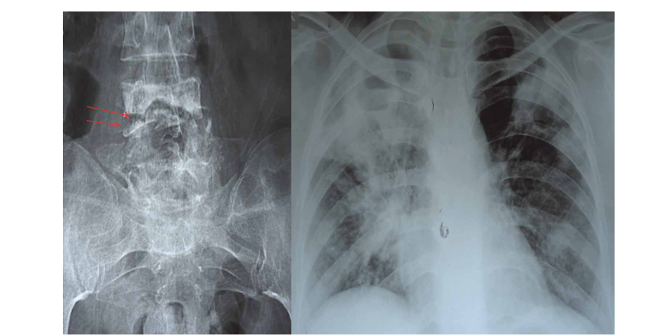
Figure 3. Plain X-ray Examination of the Spine (Garg and Somvanshi, 2011)¹⁰

Magnetic Resonance Imaging (MRI) is the preferred modality due to its high sensitivity and specificity in detecting vertebral infections and surrounding soft tissues, including paravertebral abscesses, epidural abscesses, and spinal cord compression. MRI can also help assess lesion activity and provide guidance for biopsy procedures. CT scans are useful for evaluating bone destruction in greater detail, identifying sequestra, and guiding needle biopsy. Tissue biopsy from the vertebral lesion (either through an open procedure or using imaging-guided biopsy needles) is the gold standard for confirming the diagnosis, with histopathological evaluation and *Mycobacterium tuberculosis* culture examination¹⁸.
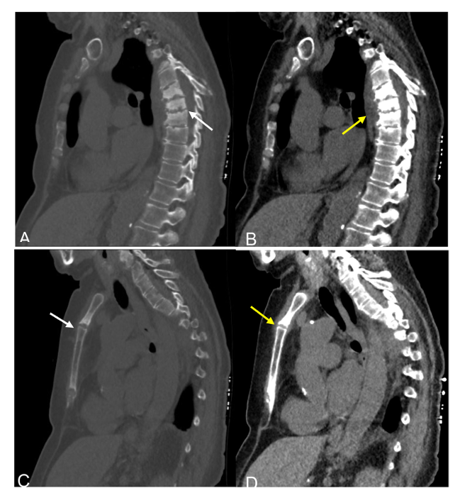
Figure 4 CT-Scan Examination of the Spine in Cases of Tuberculous Spondylitis (Rossell, Kim and Maness, 2025)⁹
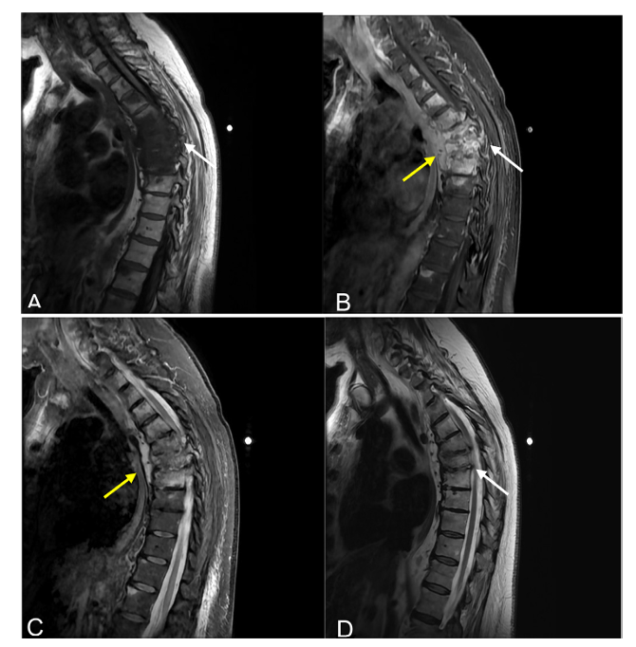
Figure 5. MRI Examination of the Spine in Cases of Tuberculous Spondylitis (Rossell, Kim and Maness, 2025)⁹

Laboratory tests also play a supporting role, such as³:
- ESR and CRP: Increased in the active phase.
- Mantoux test or IGRA (Interferon-Gamma Release Assays): Helps assess TB exposure.
- Molecular testing (GeneXpert MTB/RIF): Can rapidly detect TB DNA and rifampin resistance.

- MANAGEMENT
Treatment of complex cases, tuberculous spondylitis or other chronic musculoskeletal conditions, can be carried out systematically through the following four-step approach¹⁹:

- Step 1: Identify and Clarify the Problem
The first step is to analyze all clinical and non-clinical aspects that affect the patient's condition. This includes the patient's general health status, the presence of multiple lesions, instability, deformity, cold abscesses, pain, infection, pathological fractures, progressive kyphosis, neurological disorders, and systemic complications such as cardiovascular and pulmonary diseases. Socioeconomic and psychosocial factors should also be considered as they can influence the prognosis and adherence to therapy.

- Step 2: Compile a List of Therapy Modalities
Once the problem is identified, the next step is to develop a list of possible therapies, ranging from conservative to aggressive approaches. These modalities include basic therapies such as medication and abscess drainage, as well as various surgical interventions such as costotransversectomy, thoracoscopic debridement, the Hong Kong method, anterior/posterior instrumentation, transpedicular or translational debridement, PLIF, TLIF, PLF, kyphotic deformity correction, cage fusion, and rehabilitation.

- Step 3: Adjustment of Therapy Modalities
Once a list of therapeutic modalities has been compiled, the third step is to tailor the therapy to the patient's previously identified condition. This adjustment is made individually, with the goal of selecting the most effective treatment and appropriate for the patient's clinical condition and functional needs.

- Step 4: Determining Alternative Therapies
The final step is to determine the most appropriate treatment alternative from the various available options. Therapeutic alternatives are selected based on an analysis of the patient's presenting problems and the available interventions, both conservative and surgical. This process results in one or more personalized treatment alternatives tailored to the patient's needs.

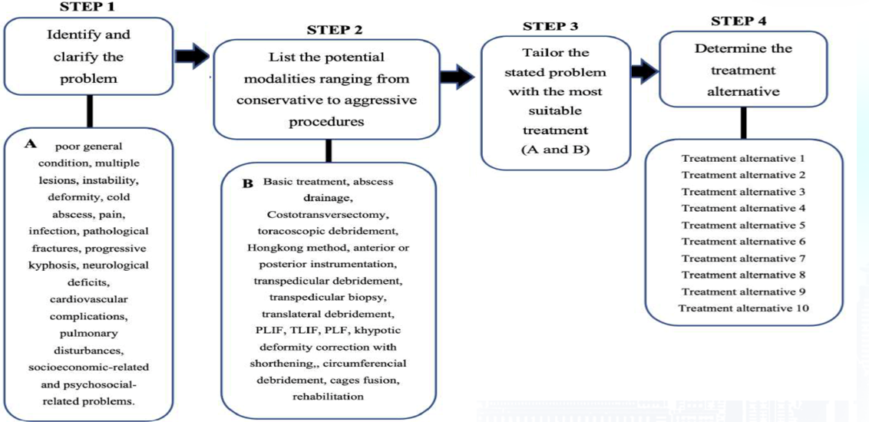

Figure 6. Treatment Management Strategy for Tuberculous Spondylitis

Subroto Sapardan's Total Treatment
According to Subroto Sapardan, total treatment consists of ten therapeutic alternatives tailored to the patient's clinical condition. Therapy begins with non-surgical conservative management (the first alternative) and debridement and abscess evacuation in cases of large, stable abscesses (the second alternative). The Hong Kong method with an anterior approach is applied in the third alternative, while the fourth and fifth alternatives combine anterior and posterior approaches, with deformity correction in the fifth alternative. The sixth and seventh alternatives use a posterior approach, with deformity correction only in the seventh alternative. The eighth alternative is intended for severe kyphosis and requires bone shortening. The ninth and tenth alternatives involve distraction without shortening, with the ninth alternative being used for patients with neurological deficits or paralysis, and the tenth alternative for patients without neurological disorders²⁰.
1. Alternative 1: Non-Operative Conservative
• Anti-TB therapy and external support (brace)
• For first-stage infections, good general condition, minimal complaints, or patients who refuse surgery.
2. Alternative 2: Debridement & Evacuation of Abscess Without Correction
• Performed in cases of large abscesses with a stable spine
• Anterior/posterior debridement and evacuation of the abscess
• Deformity correction is not necessary.
3. Alternative 3: Hong Kong Method (Anterior Approach + Instrumentation)
• Anterior debridement and fusion
• For anterior thoracic/lumbar tuberculous spondylitis with minimal kyphosis.
4. Alternative 4: Combined Anterior-Posterior Approach
• Debridement + fusion (two-stage approach)
• For unstable spine with severe pain
• Anterior for debridement, posterior for stabilization.
5. Alternative 5: Combined Anterior-Posterior with Kyphosis Correction
• Similar to Alternative 4, but with added kyphotic deformity correction
• For tuberculous spondylitis with rigid kyphosis, cervical-thoracic-lumbar region.
6. Alternative 6: Posterior Approach Without Correction
• Debridement and fusion from the posterior side
• For abscesses or accessible posterior instability without kyphosis correction
• Used primarily in the thoracic region.
7. Alternative 7: Posterior Approach with Moderate Kyphosis Correction (<75°)
• Focuses on deformity correction without osteotomy
• Correction with rod and screw manipulation techniques
• For lumbar infections with mild to moderate kyphosis.
8. Alternative 8: Posterior + Shortening Procedure
• Posterior approach with shortening
• For moderate kyphosis (75–89°), usually in the lumbar region
• Involves reduction of one or two vertebral segments.
9. Alternative 9: Posterior with Distraction for Neurological Deficits
• For severe kyphosis (>90°) with paralysis
• Distraction and deformity correction from the posterior side
• Applied to the cervical, thoracic, and lumbar spine.
10. Alternative 10: Posterior with Distraction for Cases Without Deficits
• Same as Alternative 9, but without neurological impairment
• The goal is to prevent neurological deficits
• Maximal correction of severe kyphosis²¹.
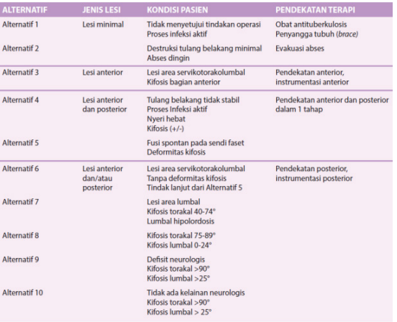
Figure 7. Alternative Total Treatment Subroto Sapardan

a) Non-operative Management
Non-operative management is the mainstay of treatment for tuberculous spondylitis, especially in cases without severe neurological deficits, vertebral instability, or progressive deformity. The mainstay of therapy is long-term anti-tuberculosis chemotherapy (OTT), which aims to eradicate the infection, prevent disease progression, and allow bone healing¹. Standard WHO recommendations and various clinical guidelines suggest a ATT regimen of at least 9–12 months, with an initial intensive phase using a four-drug combination (isoniazid, rifampin, pyrazinamide, and ethambutol) for 2 months, followed by a continuation phase with two drugs (isoniazid and rifampin) for 7–10 months. The duration of therapy can be extended in cases with a slow response, large abscesses, or mild neurological involvement¹². The Indonesian Pulmonary Association has formulated an ATT therapy regimen for TB patients. For category I, namely new cases of pulmonary TB, new cases with extrapulmonary TB, including spinal TB, are given 2 HRZE (HRZS) initial phase followed by 4HR continuation phase, or 2HRZE(HRZS) initial phase followed by 4H3R3 continuation phase, or 2RHZE(HRZS) initial phase followed by 6HE continuation phase. The regimen can be extended according to the patient's clinical response. Meanwhile, for category II, namely cases of treatment failure, relapse, drop-out, are given 2RHZES initial phase followed by 5HRE continuation phase, or 2HRZES initial phase followed by 5H3R3E3 continuation phase²².
In addition to chemotherapy, relative rest and spinal immobilization through the use of a brace (such as a thoracolumbosacral orthosis/TLSO) can help reduce pain, support stabilization of the affected spinal segment, and prevent deformity progression. Gradual mobilization is recommended as clinical improvement and signs of inflammation decrease²³. Regular monitoring through clinical examination, laboratory (ESR/CRP), and imaging (such as serial MRI) is needed to evaluate the response to therapy. Surgical intervention is considered only if conservative therapy fails, there is a progressive neurological deficit, or significant structural instability occurs⁵.

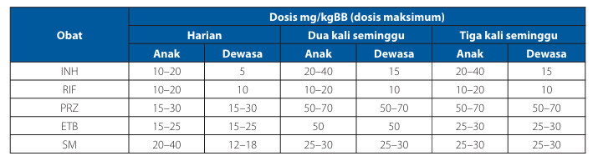
Table 1. Recommended Dosage of OAT for children (under 12 years) and adults

b) Operative Management
Operative management of tuberculous spondylitis is indicated in selected cases, particularly when non-operative treatment is inadequate or when structural or neurological complications are present. The decision to perform surgery is made when the ESR and body temperature return to normal, or when both have decreased significantly, and anemia and hypoproteinemia have been completely corrected or the neurological deficit has improved.
The main indications for surgery include²⁴:
• progressive neurological deficit (Frankel grade A/B paraplegia or Frankel grade C/D paraplegia that does not respond to medical treatment within 3-4 weeks);
• epidural abscess or cold abscess formation;
• destruction of more than 50% of the vertebral body;
• severe kyphotic deformity;
• unbearable pain;
• persistent infection that does not respond to conservative treatment.

The primary goals of surgery are spinal cord decompression, debridement of necrotic tissue, abscess evacuation, deformity correction, and spinal stabilization through fusion and internal fixation. Surgical techniques can be performed using an anterior, posterior, or a combination of both approaches, depending on the location of the lesion, the extent of the damage, and the presence of an abscess²⁵.
The anterior approach is commonly used in cases involving vertebral body collapse, with procedures such as corpectomy and cage or bone graft placement. The posterior approach is more appropriate for lesions involving posterior structures or when additional stabilization is required. A combined anterior-posterior approach is often chosen for severe cases with multi-segment destruction and sharp kyphotic deformity. Surgical management is still accompanied by long-term anti-TB chemotherapy, both before and after surgery, to control active infection and prevent recurrence²⁶.
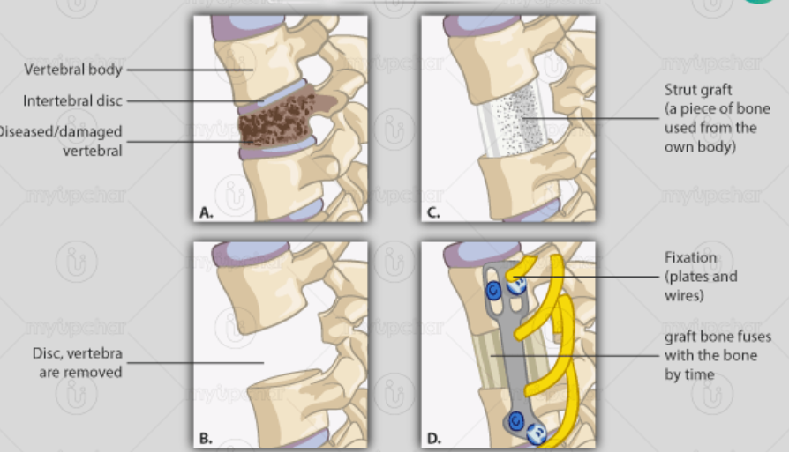
Figure 8. Surgical Technique with Anterior Approach (Corpectomy)
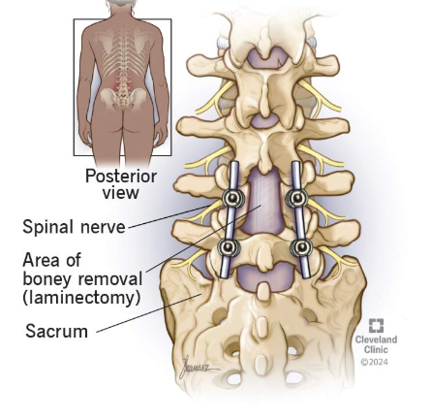
Figure 9. Posterior Approach Surgical Technique with Fusion
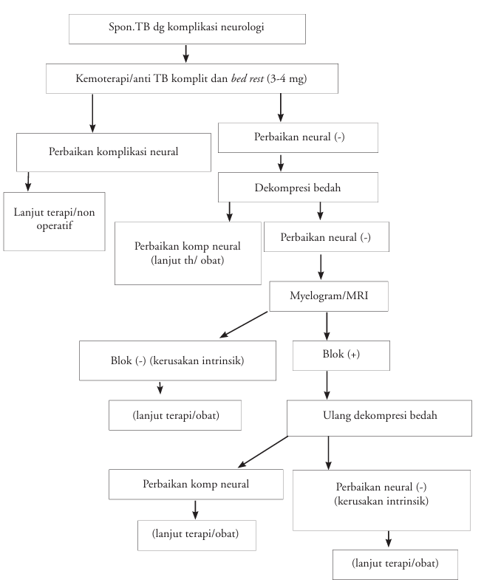
Figure 10. Management Algorithm in Cases of Tuberculous Spondylitis (Paramarta et al., 2016)¹²

- Complication
Untreated tuberculous spondylitis can lead to serious complications, both from infection and structural deformities and neurological involvement. The main complication is neurological deficits due to compression of the spinal cord or nerve roots by epidural abscesses, granulomatous tissue, or bone fragments, which can cause paresthesias, paraparesis, and even Potts' paraplegia, which can be irreversible if not decompressed^{11,27}. Furthermore, progressive kyphotic deformity and spinal instability can disrupt posture and biomechanical function, even leading to lung compression. Undrained abscesses can also lead to fistulas or secondary superinfection¹⁵. Long-term treatment can cause side effects of anti-TB drugs such as hepatotoxicity and gastrointestinal disorders, especially in patients with comorbidities or poor nutritional status²⁸.

CONCLUSION

Tuberculous spondylitis is the most common manifestation of tuberculosis infection in the spine, characterized by vertebral body destruction, disc collapse, and paravertebral abscesses. Diagnosis requires clinical and radiological assessment, along with histopathological or microbiological confirmation. Management includes long-term anti-tuberculosis therapy and surgical intervention if instability, deformity, or neurological deficits are present. Early detection is crucial to prevent permanent complications such as paraplegia. Multidisciplinary collaboration between orthopedic, neurologic, and infectious disease specialists is essential to provide optimal treatment and improve patients' quality of life. Prevention through general TB control remains a key pillar. This research is generally expected to increase public knowledge and can be implemented directly and specifically to researchers regarding the latest definitions of epidemiology, diagnosis and management of tuberculosis.

Disclaimer (Artificial intelligence)

Author(s) hereby declare that NO generative AI technologies such as Large Language Models (ChatGPT, COPILOT, etc.) and text-to-image generators have been used during the writing or editing of this manuscript.

References
- WHO (2022) Tuberkulosis, 2022. Available at: https://www.who.int/indonesia/news/campaign/tb-day-2022/fact-sheets.
- Tutik Kusmiati, H.P.N. (2016) ‘POTT’S Disease’, Jurnal Respirasi, 2(3), pp. 99–109.
- WHO (2017) ‘GLOBAL TUBERCULOSIS REPORT’, WHO, pp. 161–192. Available at: https://doi.org/10.1002/9781119421542.ch7.
- Singh, S. et al. (2017) ‘Functional and radiological outcomes of anterior decompression and posterior stabilization via posterior transpedicular approach in thoracic and thoracolumbar pott’s disease: A retrospective study’, Asian Spine Journal, 11(4), pp. 618–626. Available at: https://doi.org/10.4184/asj.2017.11.4.618.
- Lacerda, C., Linhas, R. and Duarte, R. (2017) ‘Tuberculous spondylitis: A report of different clinical scenarios and literature update’, Case Reports in Medicine, 2017. Available at: https://doi.org/10.1155/2017/4165301.
- Dharmajaya, R. (2018) ‘Tuberculous spondylitis in Haji Adam Malik hospital, Medan’, IOP Conference Series: Earth and Environmental Science, 125(1). Available at: https://doi.org/10.1088/1755-1315/125/1/012095.
- Garvin, S.R. et al. (2018) Rothman-Simeone and Herkowitz The Spine seventh edition, Elsevier.
- Yong, L.N. et al. (2021) ‘Functional Outcomes in Spinal Tuberculosis: A Review of the Literature’, Asian Spine Journal, 15(3), pp. 381–391. Available at: https://doi.org/10.31616/ASJ.2020.0086.
- Rossell, D., Kim, W., Manness, W. and Puthanveedu, N.D.K., 2025. Presumed tuberculosis spondylitis with sternal involvement. Radiology Case Reports, 20(1), pp.829-836.
- Garg, R.K. and Somvanshi, D.S. (2011) ‘Spinal tuberculosis: A review’, Journal of Spinal Cord Medicine, 34(5), pp. 440–454. Available at: https://doi.org/10.1179/2045772311Y.0000000023.
- Apley, A. G. and Solomon, L. (2017) System of Orthopaedics and Trauma: Principles of Fractures. 10th edn. Florida: CRS Press.
- Paramarta, I.G.E. et al. (2016) ‘Spondilitis Tuberkulosis’, Sari Pediatri, 10(3), p. 177. Available at: https://doi.org/10.14238/sp10.3.2008.177-83.
- Salter RB (1999) Textbook of disorders and injuries of the musculoskeletal system Ed.3. Baltimore: Lippincott Williams and Wilkins; 1999.
- Khanna, K. and Sabharwal, S. (2019) ‘Spinal tuberculosis: a comprehensive review for the modern spine surgeon’, Spine Journal, 19(11), pp. 1858–1870. Available at: https://doi.org/10.1016/j.spinee.2019.05.002.
- Rajasekaran, S. et al. (2018) ‘Spinal Tuberculosis: Current Concepts’, Global Spine Journal, 8(4_suppl), pp. 96S-108S. Available at: https://doi.org/10.1177/2192568218769053.
- Adjiou, D.K.F. de P. et al. (2022) ‘Cervical Pott’s disease: case report and review of the literature’, Pan African Medical Journal, 42. Available at: https://doi.org/10.11604/pamj.2022.42.299.33951.
- Kennedy, D., Arifin, J. and Nathaniel, D.G. (2024) ‘Epidemiological , clinical , and laboratory findings for patients of different age groups with tuberculous spondylitis in East Indonesia’, 15(3), pp. 1014–1018. Available at: https://doi.org/10.15562/ism.v15i3.2135.
- Liu, Y.X. et al. (2023) ‘A diagnostic model for differentiating tuberculous spondylitis from pyogenic spondylitis: a retrospective case–control study’, Scientific Reports, 13(1), pp. 1–8. Available at: https://doi.org/10.1038/s41598-023-36965-w.
- Ramang (2023) ‘Spondilitis Tuberkulosis’, The Journal of Indonesian Orthopaedic & Traumatology [Preprint].
- Kawiyana, I. et al. (2020) Buku Panduan Orthopedi Traumatologi, Paper Knowledge . Toward a Media History of Documents.
- Rahyussalim (2018) ‘Spondilitis Tuberkulosis Diagnosis, Penatalak sanaan, dan Rehabilitasi sitasi’, Jakarta : Media Aesculapiu, 47(10), pp. 2189–2194. Available at: https://doi.org/10.1016/j.injury.2016.04.042.
- Zuwanda and Janitra, R. (2013) ‘Diagnosis dan Penatalaksanaan Spondilitis Tuberkulosis’, Cdk, 40(9), pp. 661–673.
- Gede Ricky Ananta Herryadi, Su Djie To Rante, I.M.O.M. (2025) ‘Comparison of the Effectiveness Between Surgical Therapy and Conservative Therapy in the Management of Tuberculosis Spondylitis: A Comprehensive Systematic Review and Meta-Analysis’, 6(1), pp. 1–11.
- Martínez-Gutiérrez, Ó.A. et al. (2023) ‘Comparison of four surgical techniques in the management of tuberculous spondylitis of the thoracic spine in adults’, Cirugía y Cirujanos (English Edition), 89(3), pp. 289–295. Available at: https://doi.org/10.24875/cirue.m20000320.
- Inês Almeida Pintor, Flávio Pereira, Susana Cavadas, P.L. (2022) ‘Pott’s Disease (Tuberculous Spondylitis)’, International Journal of Mycobacteriology, 6(3), pp. 239–245. Available at: https://doi.org/10.4103/ijmy.ijmy.
- Yin, H. et al. (2018) ‘Surgical approach and management outcomes for junction tuberculous spondylitis: A retrospective study of 77 patients’, Journal of Orthopaedic Surgery and Research, 13(1), pp. 1–8. Available at: https://doi.org/10.1186/s13018-018-1021-9.
- Sahputra RE and Munandar I (2015) ‘Laporan Kasus Spondilitis Tuberkulosa Servikal’, Fakultas Kedokteran Universitas Andalas, 4(2), pp. 639–648.
- IDI, P.B. (2017) Buku Panduan Praktek Klinis (PPK).
- Tuli SM. “Tuberculosis of the Spine: A Historical Review.” Clinical Orthopaedics and Related Research, 2007.
- Jain AK, Dhammi IK. “Tuberculosis of the Spine: A Review.” Clinical Orthopaedics and Related Research, 2007.
- Updated WHO TB reports (2023 edition).

