Thoracic Intramedullary Venous Haemangioma Presenting with Progressive Myelopathy: A Case Report

.
ABSTRACT

Introduction: Hemangiomas are vascular tumors that are not malignant and arise from the aberrant growth of blood vessels. Primary CNS tumors can occur in any part of the central nervous system, including the brain and spinal cord
AIM: The aim of this case report is to emphasize the diagnostic challenge of intramedullary venous hemangiomas, which often mimic common intramedullary tumors, and to highlight the role of early surgical intervention with histopathological confirmation and rehabilitation in achieving favorable neurological outcomes in patients with rare spinal vascular lesions.
CASE PRESENTATION: A 21-year-old male who presented with progressive bilateral lower limb weakness of one month’s duration. MRI of the spine revealed an encapsulated intramedullary lesion at the D4–D5 vertebral level with contrast enhancement and areas of hemorrhage, initially suggestive of a spinal ependymoma. The patient underwent D3–D6 laminoplasty with near-total excision of the lesion under intraoperative neuromonitoring. Histopathological analysis confirmed the diagnosis of an intramedullary venous hemangioma. Postoperatively, the patient received structured neurological rehabilitation and showed gradual improvement in motor function with no complications.
DISCUSSION: Intramedullary venous Hemangiomas are rare benign vascular lesions of the spinal cord, often misdiagnosed as more common intramedullary tumors such as ependymomas or astrocytomas due to overlapping clinical and radiological features. Surgical resection is the only effective treatment, though challenging, requiring early intervention to prevent irreversible neurological deficits.
CONCLUSION: This case highlights the importance of considering vascular lesions such as intramedullary venous hemangiomas in the differential diagnosis of spinal cord tumors. MRI remains a vital diagnostic tool, but histopathological confirmation is essential. Early surgical intervention with neuromonitoring, followed by multidisciplinary rehabilitation, can lead to favorable neurological outcomes even in rare spinal cord pathologies

Keywords: D4–D5 lesion, Intramedullary venous haemangiomas, Laminoplasty, Neurological rehabilitation

1. INTRODUCTION
Hemangiomas are vascular tumors that are not malignant and arise from the aberrant growth of blood vessels. Primary CNS tumors can occur in any part of the central nervous system, including the brain and spinal cord. The majority of these lesions in the spinal area are found inside the vertebral bodies, while they can also occasionally spread into the extradural space. While there are instances of extradural haemangiomas resulting in neurological injury, real intradural haemangiomas are extremely rare. Haemangiomas are considered the third most common type of intramedullary spinal tumour ^{[1]}. Patients may present with non-specific symptoms such as bladder problems, increasing motor weakening, sensory abnormalities, and localized back discomfort. Since these lesions grow slowly, they may go for long stretches of time without causing any symptoms before eventually compressing the spinal cord and resulting in delayed neurological symptoms and classified as low grade (grades I and II) according to the World Health Organization (WHO) pathology classification. The three main histological subtypes of spinal cord haemorrhages are capillary, cavernous (venous), and mixed ^{[2]}. Capillary Haemangiomas consist of tightly packed, normal-sized capillary vessels with minimal stromal tissue, while cavernous Haemangiomas are defined by groups of dilated, thin-walled blood vessels that are surrounded by only one layer of endothelium and devoid of any neural tissue in between ^{[3]-[4]}. Only 3-5% of all CNS vascular lesions are intramedullary cavernous haemangiomas, and 5-12% are intracranial, despite knowing that the majority of cavernous haemangiomas are found intracranially in the spinal cord. MRI findings, including the classic spindle-shaped hematoma sign, can aid in diagnosis ^{[3]}. Capillary Haemangiomas are typically seen in neonates and commonly affect the skin or soft tissues, with spinal involvement being extremely rare. When present, they may exist in intradural extramedullary or intramedullary locations and can cause neurological deficits by compressing or infiltrating the spinal cord ^{[4]}. Primary spinal tumors are rare and represent about 2–4% of all CNS tumors. Since they are uncommon, intrusive, and close to important brain structures, they present substantial diagnostic and treatment problems. The only effective treatment is surgical resection; nevertheless, total excision is frequently challenging and includes a risk of neurological morbidity. To minimize irreparable spinal cord damage and improve patient outcomes, prompt identification and intervention are essential ^{[2]}.

2. PRESENTATION OF CASE
A 21-year-old male initially presented with complaints of low back pain persisting for two months. On examination, he was conscious and oriented, with reduced motor strength in the right lower limb and spasticity in both lower limbs. MRI of the whole spine revealed a well-encapsulated intramedullary lesion at the T4–T5 vertebral level, appearing hypointense on T1-weighted images, isointense on T2, and showing post-contrast enhancement findings suggestive of a spinal ependymoma as shown in figure 1(a). The patient was admitted to the neurosurgery ward and scheduled for laminectomy and excision. However, upon request, he was discharged for elective admission later. Approximately one month later, he re-presented with worsening back pain and progressive difficulty in walking for the past three months, with notable deterioration over the previous two weeks. He also reported increased urinary frequency and urgency. Routine biochemical investigations were performed and found hemoglobin (Hb): 11.9 g/dL (↓), platelet count: 87,000/cu mm (↓), ESR: 25 mm/hr (↑), and urine analysis: pus cells 8–10/hpf. Serum creatinine, TSH, and electrolytes were within normal limits. A series of investigations were conducted where frozen section analysis was suggestive of a schwannoma, while permanent section histopathology confirmed a vascular neoplasm composed of dilated, anastomosing vascular channels, without features of malignancy. Repeated MRI was performed in Figure 1(b) which showed a well-defined, encapsulated intramedullary lesion at the T4–T5 level with T1 hypointensity, T2 isointensity, and post-contrast enhancement. Additionally, there was evidence of hemorrhagic areas both cranially and caudally, supporting a neoplastic etiology with venous hemangiomas as a differential diagnosis. Under general anesthesia and intraoperative neuromonitoring (IONM), the patient had D3–D6 laminoplasty with near total lesion excision. Postoperatively, he was continued on dexamethasone and demonstrated gradual improvement in bilateral lower limb strength. However, he experienced reduced sensation of defecation and urinary incontinence. He was able to ambulate with assistance. At the time of discharge, he was advised to continue rehabilitation and supportive care. Currently, the patient has been admitted to our hospital for neurological rehabilitation and physiotherapy. During admission, he received the following medications: Inj. Broadspect 1.5g IV – 1-0-1, Inj. Gardzole 20mg IV – 1-0-1, Tab. Lycovene Forte PO – 0-1-0, Tab. Calstick PO – 0-1-0. He has been undergoing regular physiotherapy for over one week and is showing gradual symptomatic improvement in motor function and mobility.

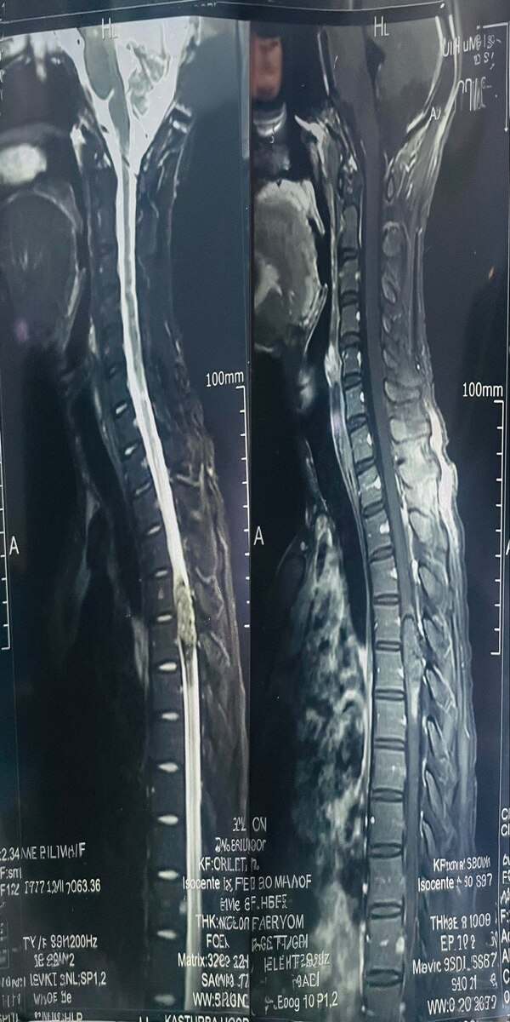
b
a
Figure no 01 [a] Image Shows clear expansion of the spinal cord, Suggestive of Spinal Ependymoma. [b] A lesion involving the vertebral body and possibly extending into epidural space, Suggestive of Venous Hemangioma
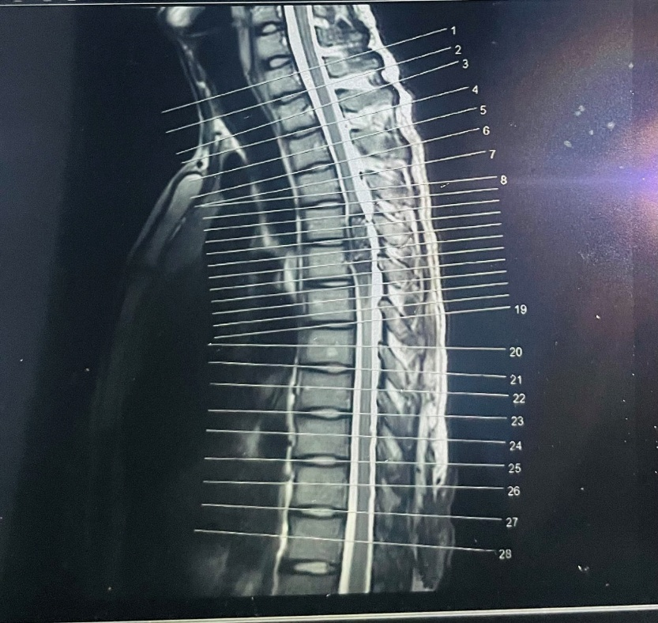
Figure no 02 Localizer sagittal MRI image with vertebral level markings from C1 to L1, aiding in precise anatomical localization of the T4–T5 lesion.

3. discussion
The intramedullary venous hemangiomas are very rare benign vascular tumors of the spinal cord that are one of the very few intramedullary spinal disorders. These tumors may cause progressive neurological deficits, primarily motor weakness, with or without autonomic or sensory involvement because they are situated in the intramedullary region. Our patient experienced, firstly, back pain for 2 months, later an increased urge to micturate with increased frequency of micturition, and bilateral lower limb paralysis over the course of a month, which is a common symptom of other reported cases of spinal cord hemorrhages and vascular abnormalities ^{[1]-[2]-[4]}.
The preferred test for these lesions is magnetic resonance imaging (MRI). They usually exhibit contrast enhancement, T1 hypointense appearance, and T2 iso-to hyperintense appearance, frequently accompanied by bleeding. However, because of overlapping imaging features, it is still difficult to differentiate these from other intramedullary neoplasms such as astrocytomas or ependymomas ^{[3]-[5]-[6]}. In our instance, histological analysis verified the diagnosis of an intramedullary venous hemangioma after imaging first indicated a malignant etiology.
The main goal is to eliminate the lesion as much as possible while maintaining neurological function. Somatosensory elicited potentials (SSEP) and motor elicited potentials (MEP) are two intraoperative neuromonitoring (IONM) approaches that have bettered surgical issues by lowering the threat of intraoperative neurological injury ^{[7]-[9]}. Under IONM supervision, our case had D3–D6 laminoplasty with near-total excision of the lesion, and the recovery period went easily.
Recovery from surgery varies for these patients. While some people report residual problems, others exhibit full neurological improvement. Enhancing functional results requires rehabilitation. The patient in our instance started physical treatment early and has demonstrated a slow motor improvement, which is in line with research showing positive outcomes from early intervention and organized rehabilitation ^{[6]-[11]}.
This case serves as more evidence that when making a differential diagnosis of spinal intramedullary masses, vascular tumors such as intramedullary hemorrhages should be considered. In order to achieve the greatest result, it also emphasizes how crucial prompt diagnosis, histological confirmation, and multidisciplinary care-including imaging, surgery, and rehabilitation ^{[5]-[12]-[15]}.

4. Conclusion

For a precise diagnosis and the best possible treatment of intramedullary spinal lesions, early surgical excision with histological confirmation is crucial, particularly in cases where imaging is unclear. To improve functional outcomes and avoid irreversible neurological damage, a multidisciplinary approach and a high index of suspicion are essential.

Consent

The patient addressed in this case report has provided consent for publishing, acknowledging the report’s nature and understanding that their identity will be kept confidential.

Disclaimer (Artificial intelligence)
Author(s) hereby declare that generative AI technologies such as Large Language Models, etc. have been used during the writing or editing of manuscripts. This explanation will include the name, version, model, and source of the generative AI technology and as well as all input prompts provided to the generative AI technology
Details of the AI usage are given below:
1. ChatGPT
2. perplexcity.ai

References

- Truong Faulds T, Milan V, Sharifi-Amina S, Stout C, Bui D. Intramedullary spinal cord haemangiomas: A rare case report. Radiol Case Rep. 2023;19(1):223–6. doi:10.1016/j.radcr.2023.10.006.
- Rahyussalim AJ, Situmeang A, Safri AY, Fadhly ZI. Intradural Intramedullary Mixed Type Hemangioma: Optimizing the Surgical Management through Intraoperative Neurophysiological Monitoring. Case Rep Surg. 2015;2015:984982. doi:10.1155/2015/984982.
- Ye Z, Ma G, Liu H. Presentation of lumbar intramedullary cavernous haemangioma by spindle-shaped hematoma sign on the spinal MRI: a case report. J Med Case Rep. 2024;18(1):555. doi:10.1186/s13256-024-04885-6.
- Zhao Z, Zheng J, Zhou Y. Intradural extramedullary capillary haemangioma with intramedullary component: A case series. Medicine (Baltimore). 2022;101(30):e29862. doi:10.1097/MD.0000000000029862.
- Kucia, Elisa J MD*; Bambakidis, Nicholas C MD†; Chang, Steve W MD*; Spetzler, Robert F MD*. Surgical Technique and Outcomes in the Treatment of Spinal Cord Ependymomas, Part 1: Intramedullary Ependymomas. Operative Neurosurgery 68():p ons57-ons63, March 2011. | DOI: 10.1227/NEU.0b013e318208f181
- Tong, X., Deng, X., Li, H., Fu, Z., & Xu, Y. (2012). Clinical presentation and surgical outcome of intramedullary spinal cord cavernous malformations. Journal of Neurosurgery: Spine, 16(3), 308-314.
- Rijs K, Kloet A, Schoevers J, et al. Intraoperative neuromonitoring in patients with intramedullary spinal cord tumour: a systematic review and meta-analysis. J Neurophysiol Monit. 2024.
- Tong X, Deng X, Li H, et al. Clinical presentation and surgical outcome of intramedullary spinal cord cavernous malformations. J Neurosurg Spine. 2012; 16:308–14.
- Jallo GI, Freed D, Zareck M, et al. Clinical presentation and optimal management for intramedullary cavernous malformations. Neurosurg Focus. 2006;21(1): e10.
- Sala F, Palandri G, Basso E, Lanteri P, Deletis V, Faccioli F, Bricolo A. Motor evoked potential monitoring improves outcome after surgery for intramedullary spinal cord tumors: a historical control study. Neurosurgery. 2006 Jun 1;58(6):1129-43.
- Tian A, Cui Z, Ren J, Ren Y, Ye M, Li G, He C, Li X, Zeng G, Hu P, Ma Y. Surgical timing and long-term outcomes in patients with severe haemorrhagic spinal cord cavernous malformations. Stroke and Vascular Neurology. 2024 Aug 1;9(4).
- Früh, A., Wasilewski, D., Hallek, L., Wessels, L., & Vajkoczy, P. (2025). Treatment of Spinal Cavernous Malformations: A Single-Center Case Series. World Neurosurgery, 196, 123758.
- Lu, D. C., & Lawton, M. T. (2010). Clinical presentation and surgical management of intramedullary spinal cord cavernous malformations. Neurosurgical Focus, 29(3), E12.
- Ye Z, Ma G, Liu H. Presentation of lumbar intramedullary cavernous hemangioma by spindle-shaped hematoma sign on the spinal MRI: a case report. Journal of Medical Case Reports. 2024 Nov 20;18(1):555.
- Choi GH, Kim KN, Lee S, Ji GY, Oh JK, Kim TY, Yoon DH, Ha Y, Yi S, Shin H. The clinical features and surgical outcomes of patients with intramedullary spinal cord cavernous malformations. Acta Neurochir (Wien). 2011 Aug;153(8):1677-84; discussion 1685. doi: 10.1007/s00701-011-1016-3. Epub 2011 Jul 2. PMID: 21720938.

