Should high dose corticosteroids be abandoned in the treatment of post traumatic optic neuropathy? : A case report

.
ABSTRACT

Aims: Post-traumatic optic neuropathy (TON) is an uncommon but potentially devastating complication of head trauma. Its management remains controversial, and the role of systemic corticosteroids is increasingly questioned. The aim of this report is to describe the clinical presentation and spontaneous recovery in a patient with TON.
Presentation of Case: We report the case of a 27-year-old male who sustained a head trauma following a road traffic accident, resulting in bilateral severe visual loss. Initial ophthalmologic examination revealed visual acuity limited to light perception in both eyes, with a relative afferent pupillary defect and normal anterior segments. Fundus examination showed a normal optic disc in the right eye and sectoral pallor in the left eye. Electrophysiological testing demonstrated delayed and reduced visual evoked potentials, and optical coherence tomography confirmed optic nerve fiber loss. Magnetic resonance imaging revealed an edematous contusion of the optic nerve within the optic canal, associated with a temporal contusion. Conservative management with close monitoring was adopted. At one-month follow-up, visual acuity improved to 10/10 in the right eye, while the left eye remained stable at light perception.
Discussion: TON primarily affects young adults, most often following high-energy trauma. Visual prognosis depends largely on initial visual acuity. The pathophysiology may involve optic canal fracture, microvascular injury, or direct nerve contusion. Management remains debated: neither surgical decompression nor high-dose systemic corticosteroids have demonstrated clear benefit, and corticosteroids may even be harmful. Our case illustrates the potential for spontaneous visual recovery under observation alone.
Conclusion: High-dose systemic corticosteroids are not recommended in TON due to their lack of efficacy and possible harmful effects. Careful monitoring and individualized management appear to be the safest strategy until further evidence clarifies optimal treatment.

Keywords: Traumatic optic neuropathy, Visual outcome, Optic nerve injury, Corticosteroids, Conservative treatment

1. INTRODUCTION

Post-traumatic optic neuropathy (TON) is a well-recognized cause of visual impairment following head trauma. Despite its clinical relevance, radiological evidence of a lesion along the visual pathway is detected in only approximately 5% of affected patients (Levin, 1999). The optimal management of TON remains a subject of debate, with available therapeutic options yielding unsatisfactory outcomes. High-dose systemic corticosteroids, once widely advocated, are now regarded as ineffective and potentially harmful (Steinshapir, 2020). The objective of this study is to report the clinical features and the spontaneous favorable course observed in a case of traumatic optic neuropathy.

PRESENTATION OF CASE
We report the case of a 27-year-old male patient, with no significant past medical history, who sustained a road traffic accident resulting in head trauma. The trauma was associated with an initial loss of consciousness and a sutured eyebrow laceration. Following the injury, the patient experienced a persistent bilateral decrease in visual acuity.
Initial ophthalmologic examination revealed best-corrected visual acuity limited to light perception in both eyes. The anterior segment and intraocular pressure were within normal limits. Assessment of pupillary responses demonstrated a relative afferent pupillary defect associated with poorly reactive mydriasis. Extraocular motility was normal. Fundus examination showed a normal optic disc in the right eye, while the left eye exhibited sectoral optic disc pallor (Figure 1).

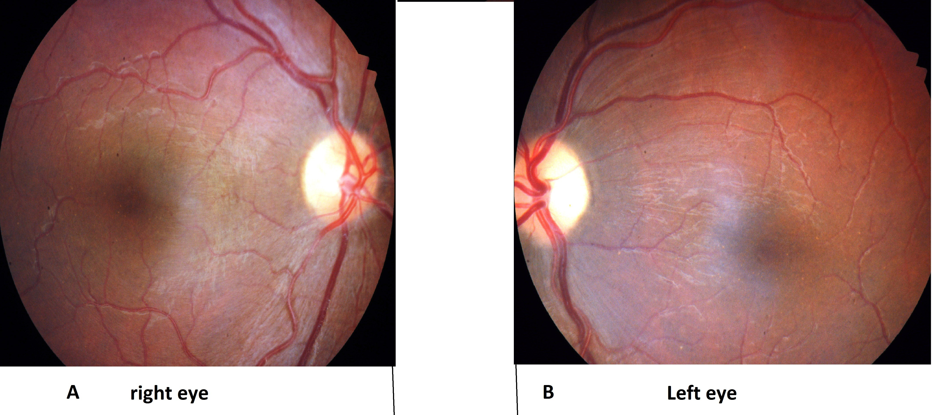

Figure 1. Fundus examination of right and left eye

The profound bilateral visual impairment (meeting the criteria for legal blindness) precluded visual field testing.
Electrophysiological evaluation using visual evoked potentials (VEPs) revealed delayed responses with reduced amplitudes (Figure 2):
- Right eye: preserved waveforms with P100 latency delay at 30° and 60° checkerboard stimulation; hypovolted, disorganized responses to both checkerboard and flash stimuli.
- Left eye: severely reduced and disorganized responses to checkerboard and flash stimuli.
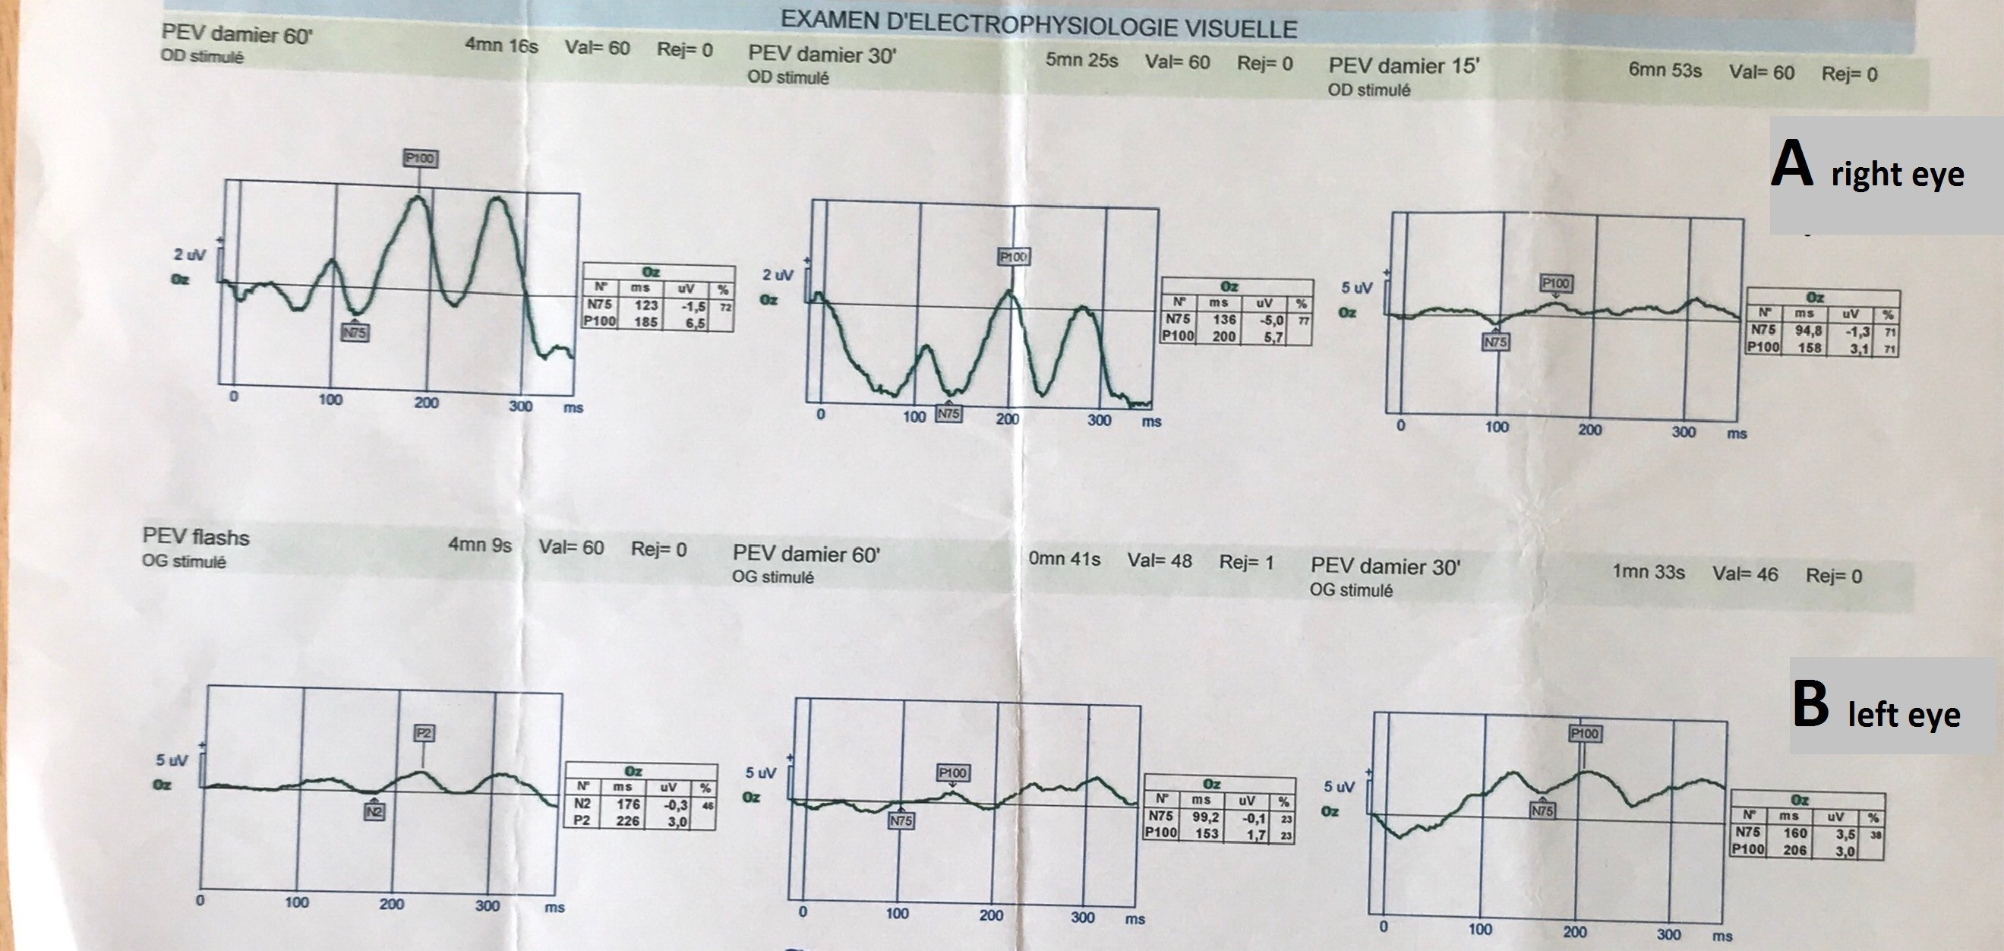

Figure 2. Visual evoked potentials (VEP). Delayed responses with reduced amplitudes were observed:
(A) Right eye: preserved waveform with P100 latency delay at 30° and 60° checkerboard stimulation; hypovolted and disorganized responses to both checkerboard and flash stimuli.
(B) Left eye: markedly reduced and disorganized responses to checkerboard and flash stimuli.

Magnetic resonance imaging (MRI) revealed an edematous contusion of the optic nerve within the optic canal measuring 4 mm in its long axis, associated with a temporal edemato-hemorrhagic contusion measuring 20 mm (Figure 3).

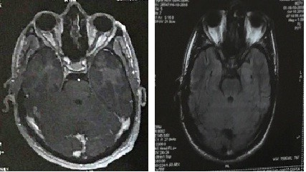

Figure 3. Axial MRI demonstrating an edematous contusion of the optic nerve before and after gadolinium contrast administration.
Given these findings, a conservative approach with close observation was adopted. Follow-up at one month showed significant functional recovery in the right eye, with visual acuity improving to 10/10, while the left eye remained stable with only light perception.

3.discussion

Post-traumatic optic neuropathy (TON) predominantly affects young adults, particularly males under the age of 30, with road traffic accidents representing the leading cause. Loss of consciousness is reported in nearly half of the cases (Steinsapir & Goldberg, 1994). The degree of visual impairment varies considerably and does not always correlate with the severity of trauma; however, absence of light perception at presentation is observed in approximately 40% of patients, and initial visual acuity remains the most reliable predictor of the final visual outcome (Levin et al., 1999). The underlying mechanisms of TON include optic canal fracture, disruption of the optic nerve microvasculature, neuronal stretching, or direct contusion of the nerve. In our patient, the clinical and radiological findings were most consistent with optic nerve contusion.
The management of TON remains controversial, as no universally accepted guidelines currently exist. Various strategies, including surgical decompression, high-dose corticosteroid therapy, or simple observation, have been proposed, but the supporting evidence remains inconsistent. Early studies suggested a potential benefit of high-dose corticosteroids extrapolated from spinal cord injury protocols, but the International Optic Nerve Trauma Study demonstrated no significant advantage, and subsequent randomized controlled trials confirmed the absence of consistent efficacy (Levin et al., 1999). Furthermore, the CRASH trial reported increased mortality and severe disability at six months among head-injured patients treated with high-dose corticosteroids, raising major concerns about their safety in TON (Edwards et al., 2005). More recent analyses have reinforced these findings, suggesting that the risks associated with corticosteroids may outweigh any potential benefit (Hosseini Siyanaki et al., 2023).
The role of surgical decompression is equally debated. While it has been considered in cases with radiological evidence of bony fragments or hematoma compressing the optic nerve, most studies show no clear advantage over conservative management. A systematic review emphasized that surgery should be restricted to patients with documented mechanical compression, whereas conservative treatment appears reasonable in cases of mild injury or absence of structural impingement (Hosseini Siyanaki et al., 2023). More recent reports have explored combined approaches such as endoscopic optic nerve decompression with corticosteroids, which may provide some benefit in patients presenting with no-light perception, although the overall level of evidence remains low and results inconclusive (Wang et al., 2022). Conversely, a recent analysis highlighted that patients presenting with residual light perception had significantly better chances of visual recovery compared to those with no-light perception, and that surgical treatment appeared more effective than corticosteroids in this subgroup, whereas no significant difference between treatment options was observed in patients with complete vision loss (Zhang et al., 2024).
In the present case, we adopted a conservative strategy of close clinical monitoring without intervention. Remarkably, the patient exhibited dramatic spontaneous recovery in the right eye, with visual acuity improving from light perception to 10/10 within one month, while the left eye remained stable at light perception. This outcome illustrates the unpredictable natural history of TON and highlights the importance of individualized management strategies, guided by initial clinical presentation, imaging findings, and the risk–benefit profile of available interventions.
4. CONCLUSION

The management of post-traumatic optic neuropathy remains challenging and controversial. Current evidence discourages the use of high-dose systemic corticosteroids, as they appear to be ineffective and may even be associated with increased morbidity and mortality in patients with head trauma. Observation and individualized patient-centered management remain the most reasonable approach until more conclusive therapeutic strategies become available.

CONSENT
All authors declare that ‘written informed consent was obtained from the patient for publication of this case report and accompanying images.
ETHICAL APPROVAL
As per international standards or university standards written ethical approval has been collected and preserved by the author(s).
Authors’ Contributions

Lotfi Chaabani designed the study, performed the statistical analysis, wrote the protocol,
and wrote the first draft of the manuscript, Yosra Doulemi, Saifedine Ksouri managed the literature searches.
All authors read and approved the final manuscript

Disclaimer (Artificial intelligence)
Option 1:
Author(s) hereby declare that NO generative AI technologies such as Large Language Models (ChatGPT, COPILOT, etc.) and text-to-image generators have been used during the writing or editing of this manuscript.
Option 2:
Author(s) hereby declare that generative AI technologies such as Large Language Models, etc. have been used during the writing or editing of manuscripts. This explanation will include the name, version, model, and source of the generative AI technology and as well as all input prompts provided to the generative AI technology
Details of the AI usage are given below:
1.
2.
3.

References

1. Steinsapir KD, Goldberg RA. Traumatic optic neuropathy. Surv Ophthalmol. 1994;38(6):487-518. doi:10.1016/0039-6257(94)90140-6.
2. Levin LA, Beck RW, Joseph MP, Seiff S, Kraker R; The International Optic Nerve Trauma Study Group. The treatment of traumatic optic neuropathy: The International Optic Nerve Trauma Study. Ophthalmology. 1999;106(7):1268-1277. doi:10.1016/S0161-6420(99)00707-2.
3. Anderson RL, Panje WR, Gross CE. Optic nerve blindness following blunt forehead trauma. Ophthalmology. 1982;89(5):445-455. doi:10.1016/S0161-6420(82)34704-6.
4. Spoor TC, Hartel WC, Lensink DB, Wilkinson MJ. Treatment of traumatic optic neuropathy with corticosteroids. Am J Ophthalmol. 1990;110(6):665-669. doi:10.1016/S0002-9394(14)77068-2.
5. MRC CRASH Trial Collaborators. Final results of MRC CRASH, a randomized placebo-controlled trial of intravenous corticosteroid in adults with head injury—outcomes at 6 months. Lancet. 2005;365(9475):1957-1959. doi:10.1016/S0140-6736(05)66552-X.
6.Yu-Wai-Man P, Griffiths PG. Steroids for traumatic optic neuropathy. Cochrane Database Syst Rev. 2013;(6):CD006032. doi:10.1002/14651858.CD006032.pub3.
7.Wang Y, Li J, Han S, et al. Effectiveness of endoscopic optic nerve decompression for traumatic optic neuropathy: A systematic review and meta-analysis. Front Neurol. 2022;13:972588. doi:10.3389/fneur.2022.972588.
8.Zhang Y, Wang X, Chen S, et al. Prognostic factors and treatment outcomes in traumatic optic neuropathy: A systematic review and meta-analysis. Front Med (Lausanne). 2024;11:1358974. doi:10.3389/fmed.2024.1358974.

