A 3D P-Wave Model of the Crust and Uppermost Mantle Beneath the Malay Peninsula

Abstract
This study employed a computationally efficient Fortran algorithm to construct a three-dimensional P-wave velocity model of the crust and uppermost mantle beneath the Malay Peninsula (MP). Earthquake datasets from both the International Seismological Centre and the Incorporated Research Institutions for Seismology are used to calculate travel-times. Station corrections are determined prior to inversion based on the ak135 model, considering four back-azimuthal directions. The resulting model, validated against previous regional tomographic studies provide enhanced resolution through finer grid parameterization. The inversion results reflect the complex geological and tectonic framework of the MP. At shallow depths (5–10 km), localised velocity variations correspond to known geological formations. The low-velocity anomalies (LVAs) in the crust are consistent with extensive Cenozoic sedimentary basins and reactivated fault zones. The presence of numerous hot springs along the western belt of the MP suggests elevated thermal activity as a key contributor to the LVAs. Deeper anomalies in the lower crust and upper mantle are attributed to multiple subduction and accretion events, remnant subducted slabs, and mantle flow processes. The result of this study reinforces the hypothesis of asthenospheric upwelling and lateral flow beneath the MP, as proposed by previous researchers. The final P-wave velocity model is used to derive S-wave velocity, density, and Poisson's ratio using established empirical relationships. The algorithm offers a cost-effective and rapid solution for seismic tomography, making it useful for foundational studies in regions with sparse station networks and poor azimuthal coverage, such as the MP and other areas with regional proximity to earthquake-prone zones.
Keywords: Algorithm; seismic tomography; P-wave; first-arrival; Malay Peninsula.

1. Introduction
Seismic tomography is a powerful tool for investigating the Earth's internal structure at varying scales. By deriving velocity models from seismic arrival times along raypaths, it provides insights into subsurface properties. This process involves solving large matrix equations that link velocity parameters with observed travel-times. Several algorithms have been developed for seismic tomography, with varying applicability. Local earthquake tomography (LET) techniques, such as those by Thurber (1993), SIMULP (Evans et al., 1994), and LOTOS (Koulakov, 2009), have demonstrated effectiveness in regions with dense seismic networks. Conversely, regional and teleseismic tomography algorithms like TOMOG3D (Zhao et al., 1990) and its extension by Nakajima et al. (2001) have been widely applied but remain underexplored in areas with sparse station coverage and poor azimuthal distribution such as the Malay Peninsula (MP).
The MP, comprising Peninsular Malaysia and Singapore, is uniquely positioned near the active Sumatra Subduction Zone (SSZ, Fig. 1, blue thick line). The geology of the MP (Fig. 2) is distinguished by three prominent north-south trending tectonic belts: the western, central, and eastern belts, which are differentiated by rock types, ages, and tectonic histories. Variations in stratigraphy, magmatism, and geologic evolution across these belts have been widely documented by researchers (e.g., Metcalfe, 2013). A key geological feature, the Bentong-Raub Suture Zone (BRSZ), separates the western belt from the central and eastern belts. The existence of many hot springs (Fig. 2, blue filled circles) located close to the major faults have been associated with tectonic activities within the peninsula (Samsudin et al., 1997). While the sources of heat for the hot springs remain unclear, different models have been proposed (Samsudin et al., 1997; Baioumy et al., 2015). These models provide plausible explanations but their validation would require detailed imaging of the subsurface. Seismic tomography could offer valuable insights into the subsurface structure.
The MP hosts broadband seismic stations (Fig. 1, blue triangles) that have been recording both local and regional earthquakes around the seismically active SSZ. Although seismic tomography is widely used for velocity model building, its application within the MP—despite its proximity to the SSZ remains underexploited. The data recorded by these stations present an excellent opportunity for imaging the crust and upper mantle beneath the peninsula. Existing studies have either focused on broader regional scales (e.g. Huang et al., 2015; Zenonos et al., 2019; Zhao et al., 2020; Osagie and Abir, 2020; Toyokuni et al., 2022) or primarily targeted the Sumatra region (e.g., Pesicek et al., 2008, 2010; Liu et al., 2018, 2019, 2021). Other investigations, such as receiver function (RF) analysis, have provided valuable but localised insights into crustal thickness, reporting values ranging from 24 to 34 km beneath stations in Singapore and southern Peninsular Malaysia (e.g., Din, 2011; Macpherson et al., 2013; Latiff and Khalil, 2018).

Figure 1 Distribution of earthquake epicenters and seismic stations (blue triangles). The study area is enclosed in dashed rectangular line.
This study employs a Fortran-based algorithm (VELMODE) designed for fast and efficient seismic travel-time tomography. VELMODE integrates the standard computational stages to develop a 3D P-wave velocity model of the crust and uppermost mantle beneath the MP. The process involves grid parameterization, ray tracing, and inversion using the Least Squares QR (LSQR) factorization algorithm with damping and smoothing regularizations (Paige and Saunders, 1982). The model resolves velocity perturbations at grid nodes, with initial conditions based on the ak135 reference model. Resolution tests, including checkerboard and structural resolution, validate the ray coverage and spatial resolution, accounting for the constraints imposed by the sparse station distribution. This work provides a more detailed view of a large part of the MP's subsurface and offers a valuable comparison with existing regional and global tomographic models.
Figure 2 Geologic map of Peninsular Malaysia showing rock distributions, key tectonic features, seismic stations (purple triangles), and identified hot springs (blue filled circles).

2. Data and Methodology

2.1. Data
Earthquakes used in this study span latitudes 8.0º N – 1.0º S and longitudes 97.0º E – 107.5º E and are confined to the top 100 km in focal depths (Fig. 1). Arrival time datasets are obtained from the International Seismological Center (ISC) archives in the period from 1982 to 2022 for earthquakes with magnitude (m_{b}) greater than or equal to 3.0. Additionally, waveforms are retrieved from the online repository of the Incorporated Research Institutions for Seismology (IRIS) for events in the period from 2006 to 2018. Arrival times are picked manually using the SEISAN software (Havskov and Ottemoller 1999). A total of twelve seismic stations within the MP and one in the Island of Sumatra (Table 1) are considered in this study. After combining the dataset from the ISC and the hand-picked arrival times from the IRIS waveform 7,015 first arrival P waves are obtained from 1,663 events.
Table 1 Seismic stations and their location within the study area.
Sn | Station  Code | Latitude  (deg) | Longitude  (deg) | Elevation  (m) |  | Country
1 | BESC | 1.3422 | 103.8513 | 3 | Singapore
2 | BKNI | 0.3262 | 101.0396 | 65 | Indonesia
3 | BTDF | 1.3608 | 103.7729 | 64 | Singapore
4 | FRIM | 3.2370 | 101.6250 | 98 | Malaysia
5 | IPM | 4.4795 | 101.0255 | 247 | Malaysia
6 | JRMM | 3.8867 | 102.4767 | 72 | Malaysia
7 | KGM | 2.0157 | 103.3190 | 103 | Malaysia
8 | KLM | 3.1025 | 101.6450 | 46 | Malaysia
9 | KTGM | 5.3280 | 103.1340 | 56 | Malaysia
10 | KULM | 5.2900 | 100.6500 | 74 | Malaysia
11 | MYKOM | 1.7900 | 103.8500 | 0 | Malaysia

2.2. Method
Consisting of numerous subroutines, VELMODE incorporates standard tomographic processes which include model parameterization, forward calculation, inversion, and analysis of the solution (Rawlinson and Sambridge 2003; Zhao 2015). Figure 3 is a flowchart that illustrates the entire process.
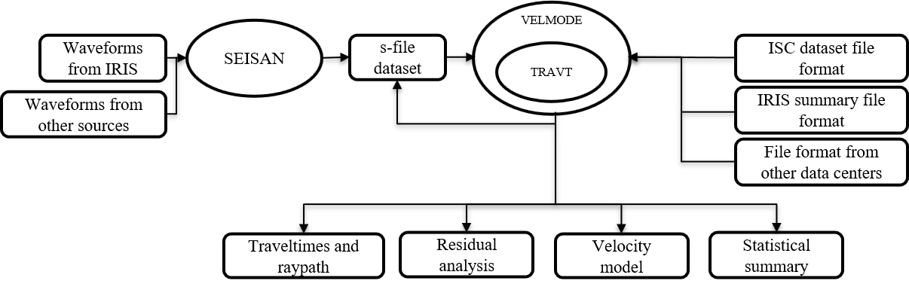
Figure 3 A flowchart of the tomographic inversion process.

2.2.1. Model Parameterization
The study employs the ak135 seismic velocity model to construct a 3D grid mesh beneath the study area (Fig. 4, gold circles). The model spans latitudes 1.0°–7.0° N and longitudes 100.0°–104.5° E, with vertical layers extending from 2 km to 70 km depth. To investigate the effect of cell size to anomaly imaging, this study considered two set of equilateral grids— 0.25º and 0.5º spacing in both latitude and longitude directions, for the same depth layers (Fig. S1 in Appendix). The grid-based parameterization defines a system of nodes where velocities are assigned, representing the 3D velocity structure of the subsurface. Velocities at grid nodes—located at gridline intersections—are held constant within each cell, enabling simplified ray tracing by approximating raypaths as straight-line segments within individual cells. This method enhances computational efficiency and supports accurate modeling of both first-arrival and secondary seismic phases (Rawlinson et al., 2010). To determine velocities at arbitrary points (P) within a cell, trilinear interpolation (Thurber, 1983; Zhao et al., 1994; Haslinger et al., 1999) is applied, leveraging the velocities at the eight surrounding grid vertices (N1–N8, Fig. S2 in Appendix). Due to sparse seismic station coverage and limited azimuthal sampling relative to earthquake locations (Fig. 1), grid nodes are restricted to the sampled region to minimize overparameterization. While this strategy risks artifacts or oversimplification of complex structures (Rawlinson et al., 2014), prior studies confirm that grid-based approaches can resolve critical geological features, such as mantle plumes and subducting slabs (Bijwaard et al., 1998; Zhao, 2004).
Figure 4 Study area showing raypaths for P (blue lines) and Pn (black line) phases from earthquake hypocenters (red circles) to seismic stations (blue filled triangles). Gold (filled) circles are grid nodes in the model volume. The purple and light blue columns are artificial low- and high-velocity anomalies for synthetic reconstruction tests. The ak135 model is used to calculate the raypaths (depth axis is about 5 times exaggerated).

2.2.2. Forward Calculation
This study use hypocentral parameters from ISC, determined via the Engdahl, van der Hilst, and Buland (EHB) method (Engdahl et al., 1998), while the SEISAN software is used to determine hypocentral parameters from IRIS arrival time picks. Afterwards, the ray tracing algorithm by Osagie and Okwokwo (2022) is used to compute raypaths and absolute travel-times for earthquake-to-station wave propagation, taking the station elevations into account. The algorithm uses a two-point ray-shooting approach (Kim and Baag, 2002) where the epicentral distance $X\left(θ_{s}\right)$is a function of take-off angle at the source ($θ_{s})$for a layered model (Eq. 1).
 | $X\left(θ_{s}\right)=$ $\sum_{i=1}^{N}{\left(h_{i}*\frac{(v_{i}/v_{s}) sinθ_{s}}{\sqrt{1-(v_{i}/v_{s}) \sin^{2}θ_{s}}}\right)}$ | (1)
where $v_{s}$ is the velocity of the source layer, $θ_{i}$ is the takeoff angle, $v_{i}$ is the velocity and, $h_{i}$ is the thickness, respectively, for the i-th layer. If we let ${θ_{s}=θ}_{s}^{i}+\text{Δ}θ$, where $θ_{s}$ is the true value of takeoff angle at the source, $θ_{s}^{i}$ is the initial value in the i-th iteration, and $\text{Δ}θ$ is the correction angle ($\text{Δ}θ « 1$), then applying Taylor’s series expansion up to the second order of $X\left(θ_{s}\right)$about $θ_{s}^{i}$ yeilds a quadratic equation in terms of $\text{Δ}θ$ (Eq. 2). The coeefiicients of $\text{Δ}θ$ (Eq. 2) are determined easily after a few iterations, providing a stable and rapid convergence (Kim and Baag, 2002).
 | $\left(θ_{s}\right)$= $X$($θ_{s}^{i}$ + $\text{Δ}θ$ ) ≈ $X\left(θ_{s}^{i}\right)+{X^{'}(θ}_{s}^{i})\text{Δ}θ +\frac{1}{2}X^{''}{(θ}_{s}^{i}){(\text{Δ}θ)}^{2}$ | (2)
The forward calculation iteratively adjusts ray trajectories to connect source and receiver positions while minimizing travel-time. Ray paths are confined to the lower portion of each layer between interfaces. These rays may either reflect upward at the top boundary of a layer or bend back within the layer to preserve the shortest possible travel-time trajectory. In addition to boundary conditions, the positions of points along the ray paths are determined by a fixed step-length parameter, which governs the incremental progression of the rays as they travel from the source to the stations. The absolute travel-time residuals ($τ_{ij}$) are determined from the i-th event to the j-th station (Eq. 3).
 | $τ_{ij}$= $t_{ij}^{o}-t_{ij}^{c}$ | (3)
where $t_{ij}^{o}$ and $t_{ij}^{c}$ represent the observed and calculated arrival times, respectively. This shooting method has been applied in previous studies (e.g., Osagie and Kim, 2013; Osagie et al., 2017). Figure 4 visualizes the computed raypaths for P phases (blue lines) and mantle-refracted P_{n} phases (black lines), originating from earthquake hypocenters (red circles) and propagating to seismic stations (blue triangles) within the 3D model volume of the study region. In this study, earthquake epicentral distances span 23–1,052 km, with raypaths discretized into 5 km intervals from hypocenters to seismic stations. To enhance data reliability, events are retained for analysis only if recorded by at least three stations exhibiting travel-time residuals within ±3.5 seconds (Fig. 5a and 5b).

2.2.3. Inversion
After computing travel-times and raypaths, partial derivatives of travel-time are calculated analytically for hypocentral parameters (Engdahl and Lee, 1976) and numerically for velocity parameters (Thurber, 1983). The inversion uses only first-arrival P-waves, employing the LSQR algorithm (Paige and Saunders 1982) to solve the sparse linear system linking travel-time residuals to velocity perturbations. P-wave velocity structure is recovered by minimizing arrival time residuals under the assumption of isotropy. To optimize damping values, the widely used trade-off curve method (e.g., Syracuse et al., 2015; Du et al., 2022) is adopted, where L-shaped curves relate mean solution amplitude to residual deviation across damping parameters. The optimal damping factor (20) is selected at the curve’s maximum curvature (Fig. 5c), balancing resolution of velocity anomalies with geophysical plausibility and avoiding overfitting. Based on prior analysis of the data, a 3% perturbation (Δv_{p}) is applied to the P-wave velocity. To enhance robustness, grid cells are included only if traversed by 10 or more rays, as measured by the hit count metric (Haslinger et al., 1999).

Figure 5 (a) Distribution of travel-time residuals, (b) Histogram of traveltime residuals with an interval of 0.5 s, and (c) Trade-off curve of RMS traveltime residual and velocity perturbation.

3. Results

3.1. Direction-Based P wave Travel-time Residual Estimation
Before performing inversion, VELMODE is utilised to compute station corrections across four back-azimuthal directions for each seismic station. To validate these calculations, absolute travel-time residuals calculated in this study are compared with results from the ISC, available in the supporting information (Residuals.txt). The residuals for the present study (RCAL) and those from ISC (REIN) are listed in columns 9 and 10, respectively, for corresponding events and arrivals. Travel-time residuals for SEISAN-located events are assigned an arrival ID of "20000001." The comparison, detailed in Table 2, reveals a strong correlation between the residuals computed in this study (ATR1) and those from ISC and SEISAN (ATR2). This consistency underscores the reliability of the travel-time residual estimation process, providing a robust foundation for subsequent tomographic analysis.
Table 2 Calculated average travel-time residual (ATR) at four back-azimuthal directions (Columns 8–11). Columns 12 and 13 are the overall calculated (ATR1) and from both the ISC and SEISAN ISC (ATR1), respectively for the 13 stations distributed around the region.
Number of Arrivals |  |  |  |  |  |  | Average Travel-time Residual (s)
Sn | Station  Code | No of Arrivals | θ ≤ 90º | 90º < θ  ≤ 180º | 180º < θ  ≤ 270º | 270º < θ  ≤ 360º | θ ≤ 90º | 90º < θ  ≤ 180º | 180º < θ  ≤ 270º | 270º < θ  ≤ 360º | ATR1 | ATR2
1 | BESC | 244 | 2 | 0 | 111 | 131 | 0.06 | 0.00 | -0.26 | -0.72 | -0.50 | 0.01
2 | BKNI | 626 | 2 | 4 | 201 | 419 | 0.54 | 0.55 | 0.18 | 0.08 | 0.12 | 0.57
3 | BTDF | 442 | 2 | 0 | 254 | 186 | -0.21 | 0.00 | -0.25 | -0.61 | -0.40 | 0.12
4 | FRIM | 233 | 0 | 1 | 226 | 6 | 0.00 | 1.03 | -0.09 | -0.85 | -0.11 | 0.81
5 | IPM | 1583 | 1 | 26 | 1495 | 61 | -0.09 | -0.17 | 0.12 | -0.47 | 0.10 | 0.94
6 | JRMM | 12 | 0 | 0 | 12 | 0 | 0.00 | 0.00 | 0.60 | 0.00 | 0.60 | 1.37
7 | KAPK | 115 | 2 | 0 | 56 | 57 | 0.07 | 0.00 | -0.25 | -0.61 | -0.42 | 0.00
8 | KGM | 673 | 0 | 0 | 618 | 55 | 0.00 | 0.00 | 0.39 | 0.46 | 0.39 | 1.22
9 | KLM | 54 | 0 | 0 | 45 | 9 | 0.00 | 0.00 | 0.47 | -1.41 | 0.16 | 0.81
10 | KTGM | 252 | 0 | 0 | 252 | 0 | 0.00 | 0.00 | -0.15 | 0.00 | -0.15 | 0.88
11 | KULM | 1542 | 1 | 44 | 1489 | 8 | 1.19 | -0.96 | -0.67 | -0.01 | -0.67 | 0.26
12 | MYKOM | 1041 | 0 | 1 | 751 | 289 | 0.00 | -0.02 | -0.16 | -0.50 | -0.25 | 0.41
13 | NTU | 288 | 0 | 0 | 136 | 152 | 0.00 | 0.00 | -0.36 | -0.74 | -0.56 | -0.05

3.2. Synthetic Tests
To evaluate the resolution limits of the dataset and station configuration, and to assess the resolving power of the inversion process, two synthetic tests are conducted: the Checkerboard Resolution Test (CRT) and the Structural Resolution Test (SRT). In both tests, random errors with a standard deviation of 0.2 seconds were added to synthetic data to simulate observational uncertainties.

3.2.1. Checkerboard Resolution Test (CRT)
The CRT (Lévěque et al., 1993), employing alternating ±3% slowness anomalies, was used to assess ray coverage adequacy and quantify horizontal smearing and vertical leakage. Although the CRT has inherent limitations, such as introducing dominant wavelengths and an inability to test linearization accuracy (Nolet, 2008, pp285; Rawlinson and Spakman, 2016), it remains a valuable tool for characterizing spatial resolution. Two grid configurations—0.25°×0.25° (Fig. 6a) and 0.5°×0.5° (Fig. 6b)—are tested across six depth layers (5–70 km) to evaluate resolution trade-offs. The results (Fig. 6) demonstrate pronounced spatial variability in resolution, strongly influenced by seismic station density and ray path geometry. Over 90% of seismic events originated from the southwest and northwest (180º < θ ≤ 360º) of stations (Fig. 1 and Table 2), resulting in predominantly parallel ray paths and azimuthal gaps. Consequently, resolution is highest in the central, western, and southern regions of the MP, including the Singapore Strait (SS), where intersecting rays constrain anomalies effectively (Fig. 6: 35–70 km depths). In contrast, the East Coast of Peninsular Malaysia (PME) exhibits poor or no resolution due to sparse station coverage. Additionally, the volume beneath stations in these regions is well resolved in the upper and middle crust, while other areas show little to no resolution (Fig. 6: 5, 10, and 20 km depths).
East-West and North-South vertical cross-sections (Figs. S3 and S4 in Appendix) provide further insight into the limitations, including smearing, leakage, and spatial variability. The depth axis (Figs. S3 and S4), exaggerated by a factor of five for visualisation, highlighting vertical distortions and necessitating careful interpretation of deeper structures. The figures reveal minimal overall leakage; however, the 0.25°×0.25° grid may amplify leakage in deeper layers (>40 km), particularly beneath Sumatra (Fig, S3a in Appendix: EWVC along 1.0º N and 1.5º N), where sparse ray paths create spurious vertical connectivity between anomalies. The 0.5°×0.5° grid (Fig. S3b in Appendix) mitigates leakage to some extent but at the expense of obscuring thin, vertically discrete structures. These results underscore the direct influence of station density on resolution: finer grids provide better detail where ray coverage is dense, while coarser grids enhance stability in marginal regions. This trade-off emphasizes the need for a balanced grid selection strategy based on tectonic targets and data availability.
(a)
(a)

(b)

Figure 6 Results of checkerboard resolution test at six depth layers with a horizontal grid spacing of (a) 0.25º × 0.25º and (b) 0.50º × 0.50º. Seismic stations are denoted by purple triangles.

3.2.2. Structural Resolution Test (SRT)
The SRT, conducted within the well-resolved region identified in the CRT, introduced three vertical synthetic spike anomalies: two low-velocity anomalies (A1 and A3) and one high-velocity anomaly (A2) (Fig. 7a). The P-wave perturbation (Δv_{p}) is -3% for A1 (60 km height, 80 km lateral extent) and A3 (45 km height, 90 km lateral extent), while A2 had a +3% perturbation, with an 85 km height and 120 km lateral extent (Fig. 4: purple and light blue columns). The recovered anomalies (Fig. 7b–f) reveals that the synthetic anomalies are generally recovered within the well-resolved regions. The low-velocity spikes, A1 and A3, are clearly visible at shallow depths but absent at 70 km, consistent with their maximum depths. In contrast, the high-velocity anomaly A2, with a height of 85 km, remains evident even at the 70 km level. These results confirm the algorithms’ ability to reproduce the spatial and depth-dependent characteristics of the imposed anomalies.

Figure 7 Result of structural resolution test using spike low-velocity (A1 and A3) and high-velocity (A2) anomalies, and adding random noise with a standard deviation of 0.2 seconds. (a) is the input while (b-f) are the outputs at five depth layers.

3.3. Tomographic Inversion
Figures 8–10 present tomographic images at multiple depths, East-West and North-South vertical cross-sections, illustrating velocity variations. Red and blue colours indicate low and high seismic velocity anomalies, respectively. To enhance visualization, the depth axis is exaggerated by a factor of five in the vertical cross-sections. The final P-wave velocity model is used to derive S-wave velocity $v_{s}$ (Eq. 4), the ratio of P-wave velocity to S-wave velocity ($v_{p}v_{s}$) (Eq. 5), density ρ (Eq. 6), and Poisson's ratio σ (Eq. 7) using established empirical relationships (Brocher, 2005; Ludwig et al., 1970). The detailed results (Model_3D.txt) are available in the supporting information.
 | $$v_{s}=0.7858-1.2344v_{p}+0.7949v_{p}^{2}-0.1238v_{p}^{3}+0.0064v_{p}^{4}$$ | (4)
 | $$v_{p}v_{s}=v_{s}/v_{p}$$ | (5)
 | $ρ=1$.6612$v_{p}-0.4721v_{p}^{2}+0.0671v_{p}^{3}-0.0043v_{p}^{4}+0.000106v_{p}^{5}$ | (6)
 | $$σ=0.8835-0.315v_{p}+0.0491v_{p}^{2}-0.0024v_{p}^{3}$$ | (7)

3.3.1. Horizontal Cross-sections
Figures 8a and 8b display similar velocity anomaly distributions but with different lateral extents. A prominent low velocity anomaly (LVA) is observed in the crust (5-20 km depth) beneath seismic stations in western and southern MP. The high-velocity anomaly (HVA) imaged in the middle crust (20 km depth) beneath station KULM appears to extend into the uppermost mantle. The 0.25° × 0.25° grid resolution (Figs. 8a) provides a more detailed view of the subsurface structure, revealing fine-scale velocity variations and sharp transitions between high and low velocity zones. In contrast, the 0.50° × 0.50° grid (Figs. 8b) presents a more smoothed representation while still capturing the major velocity patterns, although some of the finer details are lost due to the increased spatial averaging. Both grid resolutions demonstrate systematic changes in velocity patterns with depth, from localized anomalies in shallow and middle layers (Fig. 8: 5-20 km) beneath seismic stations to a complex velocity structure in deeper layers (35-70 km).
(a)

(b)

Figure 8 Inversion result at six depth layers with a horizontal grid spacing of (a) 0.25º × 0.25º and (b) 0.50º × 0.50º. Seismic stations are denoted by purple triangles.

3.3.2. Vertical Cross-sections
Figure 9 shows tomographic images of the 0.25º (Fig. 9a) and 0.5º (Fig. 9b) equilateral grids at eight East-West cross-sections (EWVCs). Comparing figures 9a and 9b, the anomalous patterns are largely similar but appears broader for the larger cell size. The EWVCs reveal distinct patterns from Sumatra (Su) to the East coast of Peninsular Malaysia (PME). Moving southward from the EWVC along 5.0º N, the crustal HVA beneath station KULM in the previous paragraph extends into the uppermost mantle, where the checkerboard model (Fig. S3b) shows good resolution. The HVA is suggestive of an oceanic crust which also appears at lower crustal depths beneath IPM, (Fig. 9b: 4.5ºN), lower crustal depths beneath Malacca Straits (MS) (Fig. 9b: 2.5ºN), upper crustal depths beneath the southernmost part of the MP and Singapore (Fig. 9b: 1.5ºN and 1.0ºN). The EWVC along 5.0º N also shows a large LVA in the crust beneath the Malacca Straits and Peninsular Malaysia boundary (MS/PM) which extends south (Fig. 9b: 4.5ºN-3.0ºN), passing through the Island of Ketam and central Selangor in West Malaysia. This large LVA extends into the uppermost mantle beneath stations FRIM and KLM (Fig. 9: 3.0ºN) in the western part of the peninsula.
Viewing from the east, figure 10 shows tomographic images of the 0.25º (Fig. 10a) and 0.5º (Fig. 10b) equilateral grids at eight North-South cross-sections (NSVCs). The major LVA in the crust beneath station KULM (Fig. 10: 100.5º E) extends southeastward beneath stations FRIM and KLM (Fig. 10:101.5º E) along the western shores of the MP. Distinct regions of LVA can be seen beneath the central and southeast MP (Fig. 10: 102.0º– 103.5ºE). The LVA in the crust and upper mantle (Fig. 10: 103.0ºE) beneath station KTGM and the boundary between the peninsula and the South China Sea (MP/SCS) is not an artefact because the original CRT showed good resolution (Fig. S4). The HVA in the upper crust (Fig. 10b: 103.5ºE) beneath the southernmost part of the MP and Singapore appears to excess 100 km in horizontal extent along longitude.

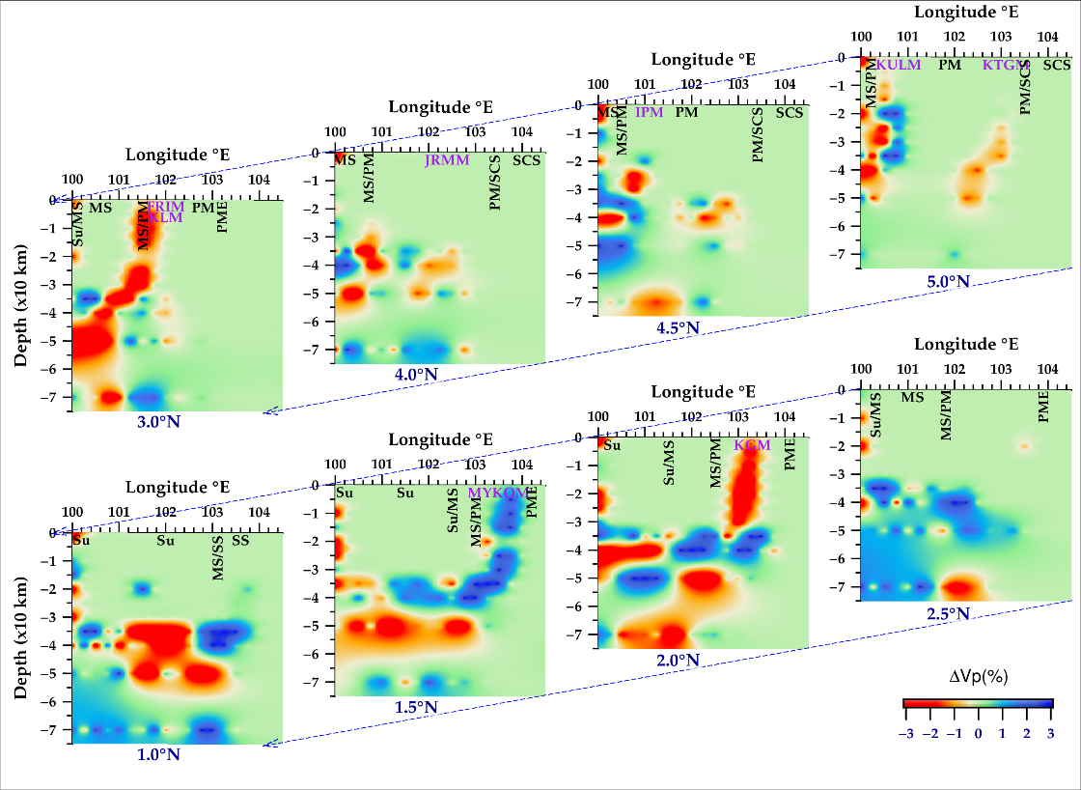
(a)

(b)

Figure 9 East-West vertical cross-sections (EWVC) along latitudes 1º-5º N for (a) 0.25º × 0.25º and (b) 0.50º × 0.50º grid spacings. The depth axis is about 5 times exaggerated. MS (Malacca Strait), PM (Peninsular Malaysia), PME (East coast of Peninsular Malaysia), SCS (South China Sea), SS (Singapore Strait) and Su (Sumatra). The forward slash between the character symbols denotes their boundary. Letters in purple are station codes.
(a)
(b)

Figure 10 North-South vertical cross-sections (NSVC) along longitudes 100.0º-103.5º E for (a) 0.25º × 0.25º and (b) 0.50º × 0.50º grid spacings. The depth axis is about 5 times exaggerated. MS (Malacca Strait), PM (Peninsular Malaysia), PME (East coast of Peninsular Malaysia), SCS (South China Sea), SS (Singapore Strait), Su (Sumatra) and TH (Thailand). The forward slash between the character symbols denotes their boundary. Letters in purple are station codes

4. Discussion
The sparse distribution of seismic stations within the MP and poor azimuthal coverage relative to earthquakes around the SSZ inherently result in poor ray coverage. This limitation is expected to affect the ability of seismic inversion algorithm to have a well-resolved model. Although the ray tracing algorithm computes travel-times and raypaths fast and accurately, the ak135 used as initial 1D model has horizontal discontinuities and isotropy is assumed in the velocity model. Furthermore, the width-to-height ratio of the 0.25º equilateral grid changes from approximately 5:1 in the crust to 5:4 in the uppermost mantle (Fig. S1a in Appendix)). For comparison and to investigate the effect of a larger cell size, this ratio doubled in favour of the widths (Fig. S1b in Appendix)). This ratio is not expected to force a systematic difference in resolution capabilities for sub-horizontal rays relative to sub-vertical rays in the solution. With these important points noted, the synthetic tests were helpful in providing insight into the spatial resolution and the extent of smearing as well as the resolving power of the inversion process.
At shallow depths (Fig. 8a: 5 km and 10 km), the finer grid spacing (0.25º × 0.25º) reveals localised velocity variations beneath seismic stations with greater detail. The 0.50º × 0.50º grid spacing provides a broader picture of the LVA in the crust (Fig. 8b: 5 km and 10 km), aligning with the NNW–SSE geological trend of the predominantly Quaternary sedimentary and Triassic/Jurassic plutonic formations (Fig. 2). The observed LVAs can be attributed to several geological factors, including extensive Cenozoic sedimentary deposits (Metcalfe, 2013), reactivated fault zones, and magmatic intrusions within the upper crust (Macpherson et al., 2013). However, the presence of numerous hot springs along the western belt of the MP suggests elevated thermal activity as a key contributor to the LVAs. These hot springs have been linked to tectonic activity in the MP (Samsudin et al., 1997). Asthenospheric upwelling may heat metamorphic fluids, which can infiltrate fractured or faulted zones, such as the Bentong-Raub Suture Zone, and interact with magmatic intrusions, providing heat to sustain the hot springs. This supports existing models proposed for the heat sources of the springs (Samsudin et al., 1997; Baioumy et al., 2015). Given that regions of LVA in the crust connect to the uppermost mantle beneath the MP, this study attributes the presence of hot springs in the region to mantle dynamics.
The LVA observed beneath station JRMM in central MP (Fig. 8: 20 km) is not an artifact of resolution, despite the limited number of ray paths reaching the station due to fewer seismic arrivals. The original CRT model was successfully recovered (Fig. 6a: 20 km) in the lower crust beneath this station, confirming the validity of the anomaly. In contrast, HVA beneath the southernmost tip of the MP, including Singapore, corresponds to crystalline basement rocks in the subsurface. Previous studies (e.g., Oliver and Prave, 2013) have documented extensive Mesozoic granitic intrusions, particularly the Bukit Timah Granite beneath Singapore. These intrusions are known to extend deep into the crust (Leslie et al., 2019), further supporting the presence of the HVA in this region.
The heterogeneous anomalies in the lower crust and upper mantle (Fig. 8: 35–70 km depth) beneath the MP have been attributed to multiple interrelated geological processes, including subduction, collision, and accretion, which have left behind remnant slabs, accreted terranes, and varying metamorphic compositions (Metcalfe, 2017). Variations in crustal composition and thermal regimes due to Cenozoic rifting and magmatic intrusions further contribute to lateral heterogeneities (Latiff and Khalil, 2018). Slab tear-induced mantle flow from the Indo-Australian Plate's subduction beneath Sumatra drives mantle upwelling and lateral flow, creating low-velocity zones linked to hot asthenosphere and high-velocity zones associated with detached slab fragments (Song et al., 2021). Additionally, major fault zones, such as the Bentong-Raub Suture Zone, act as geological boundaries influencing velocity distributions. In the upper mantle, temperature variations significantly impact velocity heterogeneity, though mantle composition must also be considered for a complete understanding (Goes et al., 2000: Perry et al., 2006).
The comparison between the two grid resolutions presents an important trade-off in subsurface imaging: while the 0.25° grid offers enhanced detail and better resolution of small-scale geological features, it may be more susceptible to noise and artifacts. The coarser grid spacing (0.50º × 0.50º) provides a smoother representation of velocity anomalies, with the overall patterns remaining consistent but with less pronounced details. This smoothing effect is particularly noticeable at greater depths where the anomalies are more diffuse and may reflect larger-scale mantle processes. Despite these differences, both resolutions effectively capture the major velocity patterns that reflect the fundamental geological framework of the MP, with their utility depending on specific research objectives and data quality considerations.

4.1. Comparison with Previous Work
The resolving power of the algorithm is tested with the Pn arrival times published by Lu et al, (2022) for the Hainan region of China. Figure S5 in Appendix shows the travel-time residuals, results of both checkerboard resolution and the inversion at a depth of 50 km. Using the ak135 as starting model, the velocity variations show a pattern similar to their figure 10a. The arrival times (Hainan_data.txt) and seismic stations (Hainan_stn.txt) are provided in the supporting information.
The anomaly pattern at 50 km in the present study is consistent with the regional tomographic image of Toyokuni et al., (2022) extracted for the study region at the same depth (Fig. S6 in Appendix) but provides enhanced resolution through finer grid parameterization. The results of other regional tomographic inversion studies (e.g., Pesicek et al., 2010; Zhao et al., 2020; Liu et al., 2018, 2019) also offer images for comparison.
Previous subsurface investigations of MP have largely relied on RF analyses. The LVAs imaged in this study are consistent with the slower velocity zones reported by Latiff and Khalil (2018), which they attributed to the high crustal complexities. For example, the LVA observed beneath station JRMM in central MP (at approximately 20 km depth) corroborates Latiff and Khalil’s (2018) findings of low velocities at similar depths. Similarly, the HVA beneath station KULM (also at 20 km depth) aligns with the faster velocity zone (12–26 km depth) identified as KUM in their work. The HVA detected beneath station MYKOM (Fig. 9: 1.5°N) further supports the increased P-wave velocities at 12 and 34 km depths reported by Latiff and Khalil (2018), while the HVA in the crust beneath the southernmost part of the MP is consistent with the enhanced velocities noted by Macpherson et al. (2013).

5. Conclusion
In this study, a Fortran scheme is used for seismic travel-time tomographic inversion of local and regional arrival time dataset to constrain a 3D model beneath the Malay Peninsula (MP). The earthquake data is obtained from both the International Seismological Center and the Incorporated Research Institutions. The sparse distribution of seismic stations and poor azimuthal coverage inherently limit resolution, particularly in the East Coast of Peninsular Malaysia. Despite these limitations, the synthetic tests provide valuable insights into the spatial resolution and extent of smearing in the inversion. The comparison between the two grid resolutions highlights a trade-off between detail and stability, with the 0.25° grid offering enhanced resolution of small-scale features and the 0.5° grid providing a more stable, regional-scale representation.
The inversion results reflect the complex geological and tectonic framework of the MP and are consistent with previous regional tomographic studies. At shallow depths (5–10 km), localized velocity variations correspond to known geological formations, including crystalline basement rocks and Mesozoic granitic intrusions beneath Singapore. The low-velocity anomalies (LVAs) in the crust are consistent with extensive Cenozoic sedimentary basins and tectonic reactivations. But the distribution of hot springs along the western belt of the MP suggests elevated thermal activity as a major contributing factor to the observed LVAs. In the lower crust and upper mantle, heterogeneous anomalies are attributed to multiple tectonic processes, including subduction, collision, and accretion. The result of this study aligns with previous research suggesting asthenospheric upwelling and lateral flow beneath the MP. Given that regions of LVA in the crust connect to the uppermost mantle beneath the MP, this study attributes the presence of hot springs in the region to mantle dynamics. The study lay claims to the idea that asthenospheric upwellings heat up metamorphic fluids which infiltrate fractured or faulted zones, such as the Bentong-Raub Suture Zone, providing heat to sustain hot springs that are distributed along the western belt of the MP. This supports existing models proposed for the heat sources of the springs. The algorithm used in this study provides a cost-effective and efficient approach to seismic tomography, making it particularly valuable for foundational studies in regions with limited station networks and poor azimuthal coverage.

Declaration of competing interest
The author declares no conflicts of interest relevant to this study.

Data Availability Statement
Supplementary information provided in this study are available at https://data.mendeley.com/datasets/xh62fn8yrp/2. The arrival-time data are downloaded from the ISC-EHB Bulletin (http://www.isc.ac.uk/iscbulletin/).
Disclaimer (Artificial intelligence)

The author hereby declares that NO generative AI technologies such as Large Language Models (ChatGPT, COPILOT, etc.) and text-to-image generators have been used during writing or editing of this manuscript.

References
Baioumy, H., Nawawi, M., Wagner, K., and Arifin, M. H. (2015). Geochemistry and geothermometry of non-volcanic hot springs in West Malaysia. Journal of volcanology geothermal research, 290, 12-22.
Bijwaard, H., Spakman, W., and Engdahl, E. R. (1998). Closing the gap between regional and global travel time tomography. Journal of Geophysical Research, 103(B12), 30055-30078. doi:10.1029/98JB02467.
Brocher, T. M. (2005). Empirical relations between elastic wavespeeds and density in the Earth's crust. Bulletin of the Seismological Society of America, 95(6), 2081-2092. doi:10.1785/0120050077.
Din, Z. A. (2011). Determination of crustal structure beneath a broadband station in Malaysia using receiver function analysis. Bulletin of the International Institute of Seismology Earthquake Engineering, 45, 19-24.
Du, M., Lei, J., Zhao, D., and Lu, H. (2022). Pn Anisotropic Tomography of Northeast Asia: New Insight Into Subduction Dynamics and Volcanism. Journal of Geophysical Research: Solid Earth, 127(1), e2021JB023080. doi:https://doi.org/10.1029/2021JB023080.
Engdahl, E., and Lee, W. (1976). Relocation of local earthquakes by seismic ray tracing. Journal of Geophysical Research, 81(23), 4400-4406. doi:10.1029/JB081i023p04400.
Engdahl, E. R., van der Hilst, R., and Buland, R. (1998). Global teleseismic earthquake relocation with improved travel times and procedures for depth determination. Bulletin of the Seismological Society of America, 88(3), 722-743.
Evans, J. R., Eberhart-Phillips, D., and Thurber, C. (1994). User's manual for SIMULPS12 for imaging Vp and Vp/Vs; a derivative of the" Thurber" tomographic inversion SIMUL3 for local earthquakes and explosions (2331-1258).
Goes, S., Govers, R., and Vacher, P. (2000). Shallow mantle temperatures under Europe from P and S wave tomography. Journal of Geophysical Research: Solid Earth, 105(B5), 11153-11169. doi:10.1029/1999JB900300.
Haslinger, F., Kissling, E., Ansorge, J., Hatzfeld, D., Papadimitriou, E., Karakostas, V., . . . Peter, Y. (1999). 3D crustal structure from local earthquake tomography around the Gulf of Arta (Ionian region, NW Greece). Tectonophysics, 304(3), 201-218. doi:10.1016/S0040-1951(98)00298-4.
Havskov, J., and Ottemoller, L. (1999). SEISAN earthquake analysis software. Seismological Research Letters, 70(5), 532-534.
Huang, Z., Zhao, D., and Wang, L. (2015). P wave tomography and anisotropy beneath Southeast Asia: Insight into mantle dynamics. Journal of Geophysical Research: Solid Earth, 120(7), 5154-5174. doi:https://doi.org/10.1002/2015JB012098.
Kim, W., and Baag, C.-E. (2002). Rapid and accurate two-point ray tracing based on a quadratic equation of takeoff angle in layered media with constant or linearly varying velocity functions. Bull. Seism. Soc. Am, 92(6), 2251-2263. doi:https://doi.org/10.1785/0120000059.
Koulakov, I. (2009). LOTOS code for local earthquake tomographic inversion: Benchmarks for testing tomographic algorithms. Bulletin of the Seismological Society of America, 99(1), 194-214.
Latiff, A. H. A., and Khalil, A. E. (2018). Crustal thickness and velocity structure of Malay Peninsula inferred from joint inversion of receiver functions and surface waves dispersion. Journal of Asian Earth Sciences, 169, 105-116. doi:https://doi.org/10.1016/j.jseaes.2018.08.011.
Leslie, A. G., Dodd, T. J. H., Gillespie, M. R., Kendall, R. S., Bide, T. P., Kearsey, T. I., . . . Chiam, K. (2019). Ductile and brittle deformation in Singapore: A record of Mesozoic orogeny and amalgamation in Sundaland, and of post-orogenic faulting. Journal of Asian Earth Sciences, 181, 103890. doi:https://doi.org/10.1016/j.jseaes.2019.103890.
Lévěque, J.-J., Rivera, L., and Wittlinger, G. (1993). On the use of the checker-board test to assess the resolution of tomographic inversions. Geophysical Journal International, 115(1), 313-318.
Liu, S., Suardi, I., Xu, X., Yang, S., and Tong, P. (2021). The Geometry of the Subducted Slab Beneath Sumatra Revealed by Regional and Teleseismic Traveltime Tomography. Journal of Geophysical Research: Solid Earth, 126(1), e2020JB020169. doi:https://doi.org/10.1029/2020JB020169.
Liu, S., Suardi, I., Yang, D., Wei, S., and Tong, P. (2018). Teleseismic traveltime tomography of northern Sumatra. Geophys Res Lett, 45(24), 13,231-213,239.
Liu, S., Suardi, I., Zheng, M., Yang, D., Huang, X., and Tong, P. (2019). Slab Morphology Beneath Northern Sumatra Revealed by Regional and Teleseismic Traveltime Tomography. Journal of Geophysical Research: Solid Earth, 124(10), 10544-10564. doi:https://doi.org/10.1029/2019JB017625.
Lu, H., Lei, J., Zhao, D., Xu, Y. G., Sun, C., and Hu, X. (2022). Pn anisotropic tomography of Hainan Island and surrounding areas: New insights into the Hainan mantle plume. Journal of Geophysical Research: Solid Earth, 127, e2021JB023609. doi:10.1029/2021JB023609.
Ludwig, W., Nafe, J., and Drake, C. (1970). Seismic refraction (A. E. Maxwell Ed. Vol. 4). New York: Wiley-Interscience.
Macpherson, K. A., Hidayat, D., Feng, L., and Goh, S. H. (2013). Crustal thickness and velocity structure beneath Singapore’s seismic network. Journal of Asian Earth Sciences, 64, 245-255. doi:https://doi.org/10.1016/j.jseaes.2012.12.027.
Metcalfe, I. (2013). Tectonic evolution of the Malay Peninsula. Journal of Asian Earth Sciences, 76, 195-213.
Metcalfe, I. (2017). Tectonic evolution of Sundaland. Bulletin of the Geological Society of Malaysia, 63(June 2017), 27-60.
Nakajima, J., Matsuzawa, T., Hasegawa, A., and Zhao, D. (2001). Three‐dimensional structure of Vp, Vs, and Vp/Vs beneath northeastern Japan: Implications for arc magmatism and fluids. Journal of Geophysical Research, 106(B10), 21843-21857. doi:10.1029/2000JB000008.
Nolet, G. (2008). A breviary of seismic tomography : imaging the interior of the earth and sun. Cambridge, UK ; New York: Cambridge University Press.
Oliver, G., and Prave, A. (2013). Palaeogeography of Late Triassic red-beds in Singapore and the Indosinian Orogeny. Journal of Asian Earth Sciences, 76, 214-224. doi:https://doi.org/10.1016/j.jseaes.2013.01.022.
Osagie, A., Nawawi, M., Khalil, A. E., and Abdullah, K. (2017). Regional travel-time residual studies and station correction from 1-D velocity models for some stations around Peninsular Malaysia and Singapore. NRIAG Journal of Astronomy Geophysics, 6(1), 19-29. doi:10.1016/j.nrjag.2016.11.002.
Osagie, A. U., and Abir, I. A. (2020). Seismic tomographic imaging of p wave velocity perturbation beneath Sumatra, Java, Malacca Strait, Peninsular Malaysia and Singapore. Journal of earth system science, 130(23 (2021)). doi:10.1007/s12040-020-01530-w.
Osagie, A. U., and Kim, W. (2013). Relocation of Earthquakes that Occurred Beneath Parkfield Region of California using VELHYPO. IOSR Journal of Applied Geology and Geophysics, 1(3), 66-81.
Osagie, A. U., and Okwokwo, I. O. (2022). Traveltime Residual Estimation for some Seismic Stations within Southeast Asia using a New Ray Tracing Algorithm. IOSR Journal of Applied Geology and Geophysics (IOSR-JAGG), 10(1), 12-20. doi:10.9790/0990-1001011220.
Paige, C. C., and Saunders, M. A. (1982). LSQR: An algorithm for sparse linear equations and sparse least squares. ACM Transactions on Mathematical Software, 8(1), 43-71.
Perry, H., Jaupart, C., Mareschal, J. C., and Shapiro, N. (2006). Upper mantle velocity‐temperature conversion and composition determined from seismic refraction and heat flow. Journal of Geophysical Research: Solid Earth, 111(B7). doi:10.1029/2005JB003921.
Pesicek, J., Thurber, C., Widiyantoro, S., Engdahl, E., and DeShon, H. (2008). Complex slab subduction beneath northern Sumatra. Geophys Res Lett, 35(20). doi:https://doi.org/10.1029/2008GL035262.
Pesicek, J. D., Thurber, C. H., Widiyantoro, S., Zhang, H., DeShon, H. R., and Engdahl, E. R. (2010). Sharpening the tomographic image of the subducting slab below Sumatra, the Andaman Islands and Burma. Geophysical Journal International, 182(1), 433-453. doi:https://doi.org/10.1111/j.1365-246X.2010.04630.x.
Rawlinson, N., Fichtner, A., Sambridge, M., and Young, M. K. (2014). Seismic Tomography and the Assessment of Uncertainty. In Advances in Geophysics (Vol. 55, pp. 1-76).
Rawlinson, N., Pozgay, S., and Fishwick, S. (2010). Seismic tomography: a window into deep Earth. Physics ofthe Earth and Planetary Interiors, 178, 101–135. doi:10.1016/j.pepi.2009.10.002.
Rawlinson, N., and Sambridge, M. (2003). Seismic traveltime tomography of the crust and lithosphere. Advances in Geophysics, 46, 81-197.
Rawlinson, N., and Spakman, W. (2016). On the use of sensitivity tests in seismic tomography. Geophysical Journal International, 205(2), 1221-1243. doi:10.1093/gji/ggw084.
Samsudin, A. R., Hamzah, U., Rahman, R. A., Siwar, C., Jani, M. F. M., and Othman, R. (1997). Thermal springs of Malaysia and their potentialdevelopment. Journal of Asian Earth Sciences, 15(2-3), 275-284.
Song, W., Yu, Y., Gao, S. S., Liu, K. H., and Fu, Y. (2021). Seismic Anisotropy and Mantle Deformation Beneath the Central Sunda Plate. Journal of Geophysical Research: Solid Earth, 126(3), e2020JB021259. doi:https://doi.org/10.1029/2020JB021259.
Syracuse, E. M., Maceira, M., Zhang, H., and Thurber, C. H. (2015). Seismicity and structure of Akutan and Makushin Volcanoes, Alaska, using joint body and surface wave tomography. Journal of Geophysical Research: Solid Earth, 120(2), 1036-1052. doi:https://doi.org/10.1002/2014JB011616.
Thurber, C. H. (1983). Earthquake locations and three‐dimensional crustal structure in the Coyote Lake area, central California. Journal of Geophysical Research, 88(B10), 8226-8236.
Thurber, C. H. (1993). Local earthquake tomography: velocities and Vp/Vs-Theory. In Seismic tomography: theory practice (pp. 563-583).
Toyokuni, G., Zhao, D., and Kurata, K. (2022). Whole-Mantle Tomography of Southeast Asia: New Insight Into Plumes and Slabs. Journal of Geophysical Research: Solid Earth, 127(11), e2022JB024298. doi:https://doi.org/10.1029/2022JB024298.
Wessel, P., Luis, J. F., Uieda, L., Scharroo, R., Wobbe, F., Smith, W. H. F., and Tian, D. (2019). The generic mapping tools version 6. Geochemistry, Geophysics, Geosystems.
Zenonos, A., De Siena, L., Widiyantoro, S., and Rawlinson, N. (2019). P and S wave travel time tomography of the SE Asia-Australia collision zone. Physics of the Earth and Planetary Interiors, 293, 106267. doi:https://doi.org/10.1016/j.pepi.2019.05.010.
Zhao, D. (2004). Global tomographic images of mantle plumes and subducting slabs: insight into deep Earth dynamics. Physics of the Earth Planetary Interiors, 146(1-2), 3-34. doi:10.1016/j.pepi.2003.07.032.
Zhao, D. (2015). Methodology of Seismic Tomography. In Multiscale Seismic Tomography (pp. 21-54).
Zhao, D., Hasegawa, A., and Horiuchi, S. (1992). Tomographic imaging of P and S wave velocity structure beneath northeastern Japan. Journal of Geophysical Research, 97(B13), 19909-19928. doi:10.1029/92JB00603.
Zhao, D., Hasegawa, A., and Kanamori, H. (1994). Deep structure of Japan subduction zone as derived from local, regional, and teleseismic events. Journal of Geophysical Research, 99(B11), 22313-22329. doi:10.1029/94JB01149.
Zhao, D., Horiuchi, S., and Hasegawa, A. (1990). 3-D seismic velocity structure of the crust and the uppermost mantle in the northeastern Japan arc. Tectonophysics, 181(1-4), 135-149. doi:10.1016/0040-1951(90)90013-X.
Zhao, D., Toyokuni, G., and Kurata, K. (2020). Deep mantle structure and origin of Cenozoic intraplate volcanoes in Indochina, Hainan and South China Sea. Geophysical Journal International. doi:https://doi.org/10.1093/gji/ggaa605.

APPENDIX

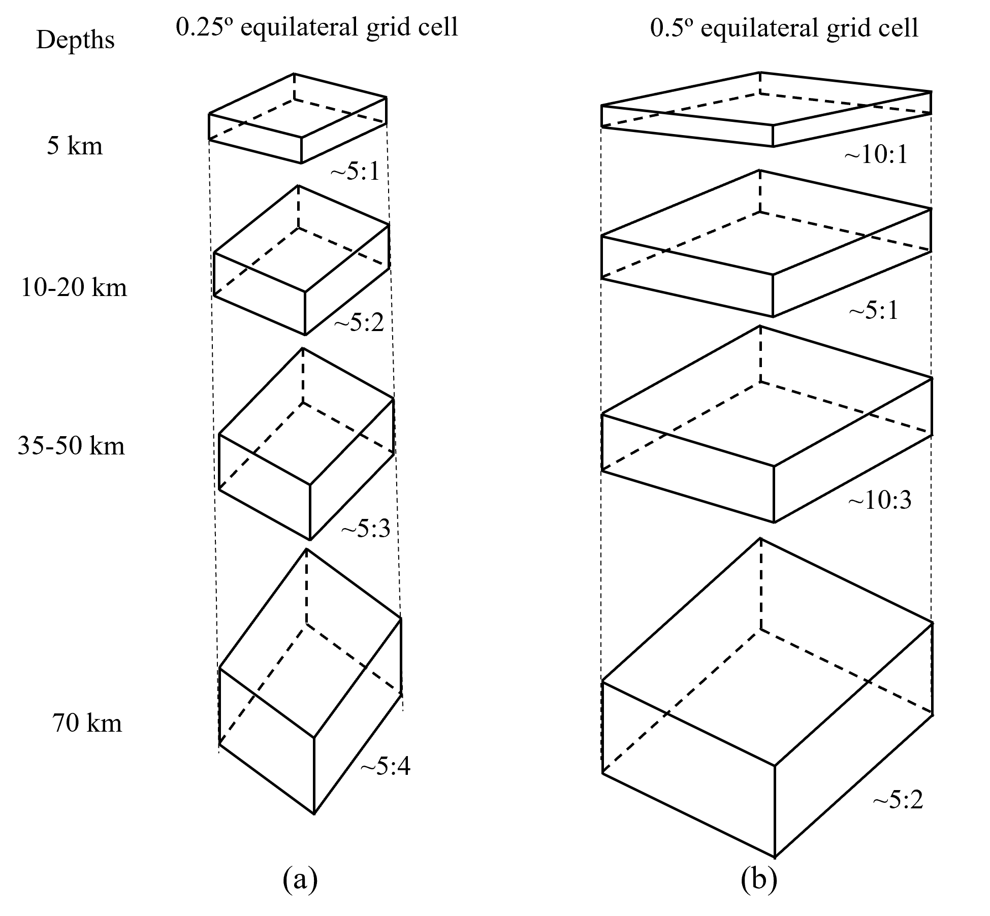

Figure S1 A schematic representation of widths to height ratios (not to scale) for the (a) 0.25º and (b) 0.5º equilateral grid cells at different depths.

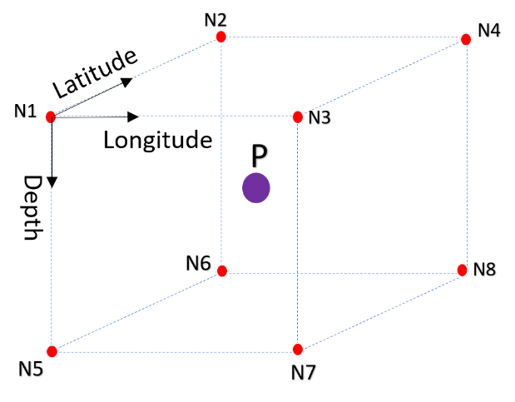

Figure S2 Grid nodes around a point (P) within a block with the eight vertices denoted by N1, N2, N3, N4, N5, N6, N7, and N8.

(a)

(b)

Figure S3 East-West vertical cross-sections (EWVC) through the checkerboard resolution for (a) 0.25º × 0.25º and (b) 0.50º × 0.50º grid spacings. The depth axis is about 5 times exaggerated. MS (Malacca Strait), PM (Peninsular Malaysia), PME (East coast of Peninsular Malaysia), SCS (South China Sea), SS (Singapore Strait) and Su (Sumatra). The forward slash between the character symbols denotes their boundary. Letters in purple are station codes.
(a)
(b)

Figure S4 East-West vertical cross-sections (EWVC) through the checkerboard resolution for (a) 0.25º × 0.25º and (b) 0.50º × 0.50º grid spacings. The depth axis is about 5 times exaggerated. MS (Malacca Strait), PM (Peninsular Malaysia), PME (East coast of Peninsular Malaysia), SCS (South China Sea), SS (Singapore Strait), Su (Sumatra) and TH (Thailand). The forward slash between the character symbols denotes their boundary. Letters in purple are station codes.

Figure S5 Inversion result of using stations and Pn arrival published by Lu et al. (2022) for Hainan Island in China. (a) Histogram of traveltime residuals with an interval of 0.5 seconds. (b) Results of checkerboard resolution at a depth of 50 km. (c) The tomographic model at a depth of 50 km.

