Original Research Article
CONSERVATION VALUE OF THE FLORISTIC DIVERSITY IN THE MABI-YAYA RESERVE (SOUTHEAST OF CÔTE D'IVOIRE)

ABSTRACT:

Background: The Mabi-Yaya nature reserve, created in 2019, is a protected area located in the Mé region in the southeast of Côte d'Ivoire, precisely towards the city of Alépé and covers an area of 61,282,559 ha. This reserve is rich in biodiversity and plays an important role in the conservation of many endemic and threatened species. The regression of forest cover in Côte d'Ivoire appears spectacular over time and space.
Aims: The present study analyzed the floristic diversity and conservation value of species recorded in the nature reserve of Mabi-Yaya.
Methodology:Conservation, restoration and management of forest landscapes and natural and anthropized ecosystems.
Nature reserve of Mabi-Yaya; February to July 2023
The data were collected according to surface and itinerant survey methods. A total of 20 plots of 2000 m2 (100 m x 20 m) were randomly installed on the site. All vascular species present in the sample surface were identified and the diameter at breast height (dbh) greater than or equal to 2.5 cm of woody plants 1.30 m from the ground was measured. The data was collected according to the methods of surface survey and itinerant.
Results: This study identified 556 species in the massif, divided into 404 genera and 99 families, of which the most important were Fabaceae, Rubiaceae and Euphorbiaceae. Regarding the conservation attribute of biodiversity, 45 species with a special status have been identified. These are: 38 West African endemic species (GCW), 02 Ivorian endemic species (GCi). Eighteen (18) species on the IUCN red list (2025) and 09 species on the Aké-Assi list (1998). Among the 18 species on the IUCN red list, 16 species are vulnerable (VU) and 2 species are endangered (EN), including Placodiscus pseudostipularis Radlk. (Sapindaceae). The mode of dissemination of diaspores of species from the Mabi-Yaya reserve is endozoochory.
Conclusion: Conservation efforts for endemic, rare and endangered species of the forest must be prioritized. At the end of this study, we can retain that the Mabi-Yaya nature reserve has a floristic richness estimated at 556 species. The reserve is characterized by a dominance in Guinean-Congolese species and phanerophytes. It is a rather diverse forest reflecting a great stability of the flora of the reserve.

Keywords: Nature reserve of Mabi-Yaya, Biodiversity, Conservation attributes, Ivory Coast, Tropical forests

1. INTRODUCTION

Tropical forests are considered the essential links in the chain of life. Indeed, they alone host 70% of the world’s biodiversity (plants and animals combined), or more than 13 million distinct species (Alroy, 2017). Forests across the tropics (30°N−30°S) are crucial for the functioning of the Earth system by storing vast amounts of carbon, for global ecology by harbouring much of the planet's terrestrial biodiversity, and for humans' livelihoods by providing a range of products and many other ecosystem services (Flores & Staal, 2022). It also contains 70% of the world’s vascular plants, 30% of all bird species and 90% of invertebrates. In light of these data, tropical forests appear as one of the greatest "biological treasures" on the planet (Atta, 2009). According to N'Guessan (2018), they constitute an invaluable wealth for most countries that possess them in abundance. They provide the local populations with fruits and seeds, meat, construction materials, medicines and a resource with a strong export vocation, notably timber. However, it is clear that, despite the importance of the role played by forests at national and international level in the fight against poverty and environmental protection, deforestation and the degradation of forests, especially tropical ones, are continuing at alarming rates (Marie, 1992). Rapid loss of forests is occurring across the tropics. Tropical deforestation warms the climate at local-to-global scales by changing the surface energy balance and through emissions of carbon dioxide (Smith et al., 2023; Hoang & Kanemoto, 2021). Thus, the regression of forest cover in Côte d'Ivoire appears spectacular over time and space. Attests to the situation of the state of deforestation over the past forty years revealed by the National Forest and Wildlife Inventory (IFFN, 2021), which places the area of Ivorian forest cover at less than 3 million hectares. For Kassi (2006), the disappearance of the Ivorian forest is mainly explained by the exploitation of marketable tree species and the need for land for cash crops (cocoa, coffee, pineapple, banana, rubber, etc.). In addition, population growth and migration, clearing for food crops, mainly intended for the local population have also contributed to pressure on the forest (Ademola-Ouattara et al., 1999). In order to halt this decline, the Ivorian state has established a network of protected areas comprising nearly 231 classified forests, about 8 national parks and 6 natural reserves (Kra, 2019). The Mabi-Yaya nature reserve, created in 2019, is a protected area located in the Mé region in the southeast of Côte d'Ivoire precisely towards the city of Alépé and covers an area of 61,282,559 ha. This reserve is rich in biodiversity and plays an important role in the conservation of many endemic and threatened species. Biodiversity guarantees that nature, the biosphere, and life on Earth stay diversified. It is quite environmentally friendly. If life on this planet did not exist, it would perish. The cornerstone of world food and nutrition security is biodiversity (Mishra et al., 2024). It is one of the few forest massifs in Côte d'Ivoire that is not degraded thanks to the promotion of REDD+ activities. This protected area can only be maintained at its current stage if the stresses and disturbances exerted do not go beyond their usual norm, allowing its resilience to express itself (Delabre, 1998). It is today in Côte d'Ivoire, a reference for evergreen forest because it is a natural environment subject to less disturbing anthropogenic pressures. Thus, this work will allow us to answer the following research questions: what is the impact of conservation on the floristic richness of the Mabi-Yaya nature reserve? What are the conservation attributes in terms of plant diversity?
The general objective of this study is to contribute to the sustainable management of the Mabi-Yaya nature reserve. More specifically, it is about (1) assessing the richness and floristic composition of the Mabi-Yaya nature reserve; (2) identify the conservation attributes of this reserve’s diversity.

2. MATERIAL AND METHODS

2.1. Study site

This study was conducted in the southern part of the Mabi-Yaya nature reserve (formerly classified forest of Yaya), located in the Mé region in the southeast of Côte d'Ivoire (Figure 1). The former classified forest of Yaya is located between 5°37'40 and 5°48'28 north latitude and between 3°40'50 and 3°27'50 west longitude and covers an area of 23 873 hectares. The merger of this former classified forest and that of the former Mabi classified forest with an area of 59,614 ha gave birth in 2019 to the Nature Reserve of Mabi-Yaya with an area of 61,282.559 ha rather than 83,487 ha due to the declassification of degraded areas into peripheral areas. The climate of the zone is of the subequatorial type (Eldin, 1971) characterized by four seasons: two rainy seasons and two dry seasons. The rainy season covers the periods from March to July and September to November. As for the dry season, it extends over the periods from December to February and the month of August. It is characterized by average annual temperatures of 26.5° C since 2010 with a low amplitude of 3 to 4° and average annual precipitation of 1645.35 mm. The average annual relative humidity is around 75%, with an average insolation of 2000 hours per year (INPROBOIS, 2013). The relief of the Region of Mé is dominated by the hills of which the Mafa is the highest point with 200 m. The average altitude is 115 m. There are several lowlands and vast plateaus with an average altitude of 150 m descending gently towards the Comoé and certain rivers. (SODEFOR, 2015). The Mabi-Yaya reserve presents different types of soil in the interbasin, in the shallows and on the lower slopes. Most of the coarse elements (ferruginous chippings and quartz fragments) are found at the highest parts. At the level of the slopes, the soils are gravel-like from the surface or more deeply, well drained but generally deep. The Mabi-Yaya reserve belongs to the Guinean domain and is located in the rainforest sector characterized by the dense humid evergreen forest (Aubréville, 1958).

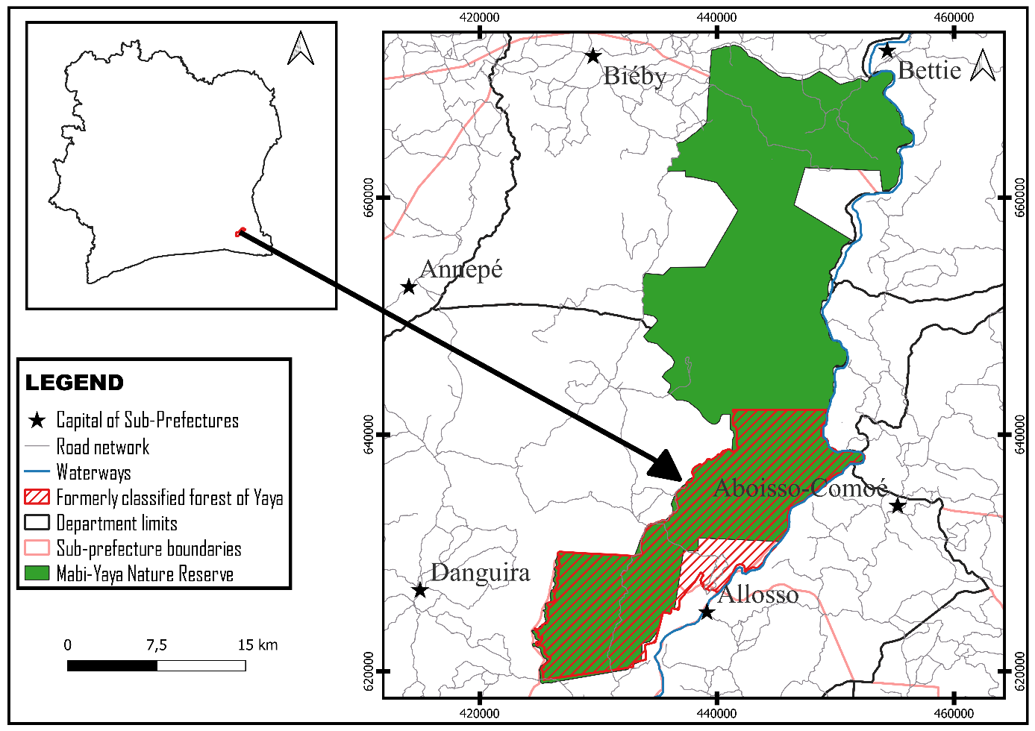

Fig 1. Geographical situation and location of the Mabi-Yaya reserve and the study site

2.2. Data collection
The data was collected according to the methods of surface survey and itinerant. The first consisted of a surface survey. The plots of 2000 m2 were randomly arranged according to the methodology of Senterre (2005); N'Guessan et al. (2019) and Amani (2022), in the areas of forests and fallows encountered on the site. A total of 20 plots of 2000 m2 (100 m x 20 m) have been installed on the site. Such a surface allows to take into account the minimum area of plant communities (Senterre, 2005). All vascular species present in the sample surface were identified and the diameter at breast height (dbh) greater than or equal to 2.5 cm of woody plants 1.30 m from the ground was measured. The mobile survey made it possible to travel through the biotopes in all directions in order to identify species not inventoried by the method of surface surveys. The combination of these two methods has allowed to obtain more information on the floristic composition of the site. The inventoried species were identified in the field or subsequently at the laboratory. The names of the inventoried species have been updated according to Lebrun and Stork (1997-1999). The nomenclature adopted for families is that of APG IV (2016).

2.3. Data analyses
2.3.1. Richness and floristic composition

The total floristic richness was determined by counting all the species listed in the biotopes without taking into account their abundance. A floristic database containing taxonomic data (species, author’s name, family) was established for all the species encountered. This floristic list established served as a basis for synthetic analysis. For each species identified, the biological type, phytochory and mode of dissemination of diaspores were established. The botanical works (Raunkiaer (1934), Adjanohoun (1964), Guillaumet (1967), White (1983, 1986), Lebrun and Stork, 1991-1997; Aké-Assi, 2001-2002) served as a reference. The characterization of these floristic parameters makes it possible to appreciate the type of species present in the reserve and their mode of regeneration and conservation.

2.3.2. Quantitative diversity of the flora
The quantitative diversity of the study site was assessed through the Shannon (1948) and Piélou (1966) indices. The Shannon index (H') measures the species composition of a stand, taking into account species richness and relative abundance. It has a value normally between 0 and 5, when calculated with the Natural Logarithm (ln). If we designate by N the total number of species considered, neither the number of individuals of a species i and ln (nor/N) the relative abundance of the species i.
It is calculated using the following formula:
H’ = - [(ni/N) x ln (ni/N)]

(1)

This index varies from 0 (a single species present) to ln(S) (all the species present have the same abundance, so a good diversity).
For a population, equitability informs us about the distribution of numbers between different species. The equitability index (E) of Piélou (1966), also known as the equipartition index, is the ratio between the Shannon index of the sample and the maximum diversity. Equitability varies from 0 to 1. It tends towards 0 when almost all the numbers are concentrated on one species and towards 1 when all the species have the same abundance. In the case where this index tends towards 1, the medium in question is said to be balanced. This index allows us to highlight the level of balance of the different biotopes of the site.
It is calculated according to the following mathematical formula: (2)
E=H’/ln S

In this formula, E represents the equitability index of Piélou; H', the Shannon index and ln(S) represent the maximum diversity of the biotope with S the total number of species of the given biotope.

2.3.3. Biodiversity conservation attributes
Species of special status will constitute the conservation attributes in this study. These are endemic, rare and/or threatened species of the Ivorian flora, vulnerable (VU) and endangered (EN) according to IUCN (2025). For endemism, we distinguished between endemics to the Ivorian flora (GCi) and endemics to West African forest blocks (GCW). For the characterization of these species, we used the documentation of Aké-Assi (1998; 2001; 2002) and Poorter et al. (2004). The threatened species of the Ivorian flora were listed by comparing the floristic lists with those of Aké-Assi (1998; 2001; 2002) and the IUCN Red List (2025).

2.3.4. Commercially valuable species
The commercial value of a species is related to the technological quality of its wood according to Kouamé (1998). Species with commercial value are also called commercial species. According to Dupuy (1998), in Côte d'Ivoire, marketed species are grouped into three categories based on their technological and commercial values. Category P1: commonly traded species, category P2: sporadically traded species and category P3: species to be promoted. Commercially valuable species were identified to get an idea of their presence in the reserve.

3. RESULTS
3.1. Floristic richness and composition
A total of 556 species have been inventoried in the Mabi-Yaya reserve. These species are distributed among 404 genera and 99 families. The Fabaceae family is the most diverse with 61 species (figure 2), a rate of (10.97%). It is followed by the Rubiaceae (40 species or 7.19%), the Euphorbiaceae (32 species or 5.76%), the Malvaceae (30 species or a rate of 5.40%), Apocynaceae (28 species or a rate of 5.04%), and the Annonaceae (25 species or 4.50%). Some families such as Cyperaceae, Dichapetalaceae, etc., are represented by only two species (a rate of 0.36%). Other families are, for their part, represented only by a single species, namely 0.18%. These are the Asclepiadaceae and Balanophoraceae.
The biological spectrum of species inventoried over the entire study site highlights a clear dominance of phanerophytes with 351 species (figure 3). Among the phanerophytes, it is the microphanerophytes that dominate with 152 species (27.35%). They are followed by mesophanerophytes with 90 species (16.19%), nanophanerophytes with 61 species (10.97%) and Megaphanerophypes with 48 species (8.63%). The other biological types are represented by geophytes with 22 species (3.96%), chamaephytes with 14 species (2.52%) and hydrophytes with 12 species (2.16%). It should be noted that 125 species recorded are vines, or 22.48%.
The flora of the Mabi-Yaya reserve consists mainly of species from the Guinean-Congolese GC zone with 321 species, or 57.55% (figure 4). To these species, one can add the West African endemic Guinean-Congolese GCW species (47 species or 8.45%) and the Ivorian endemics (GCi: 2 species or 0.36%). We have inventoried 46 species (8.27%) of transition GC-SZ. The species of the Afro-tropical zone AT are 45 (8.09%). The distribution of other species according to White’s classification is presented as follows: pantropical (Pan, 30 species) or 5.40%; African multiregional species (PA, 21 species) or 3.78%, introduced species 21 species (or 3.78%). The Sudano-Zambesian (SZ) are less represented.

Fig. 2. Spectrum of the botanical families of the Mabi-Yaya nature reserve

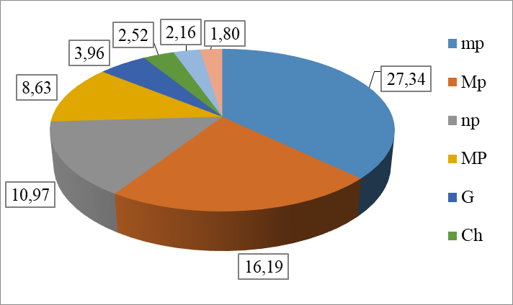

Fig. 3. Spectrum of biological types of flora from the Mabi-Yaya nature reserve
Legend : mp : microphanerophytes, mP : mésophanerophytes, np : nanophanerophytes, MP : megaphonerophytes, G: geophytes, H : hemicryptophytes, Ch : chamephytes, Ep : epiphytes, H: hydrophytes ; Th: therophyte

Fig. 4. Chorological spectrum of the flora of the Mabi-Yaya nature reserve
Legend : GC: Guinean-Congolese, SZ: Sudano-Zambian; GC-SZ: transition GC and SZ, AT: afrotropical; Pan: Pantropical; PA: African pluriregional; I: introduced

3.2. Mode of dissemination of diaspores
The endozoochore species are the most represented with 346 species, or 64 55% (figure 5). They are followed by anemochore species with 131 species (24.44%) and epizoochores with 37 species (6.90%), those of barochors with 18 species (3.36%) and hydrochores are the least represented with only 4 species (0.75%).
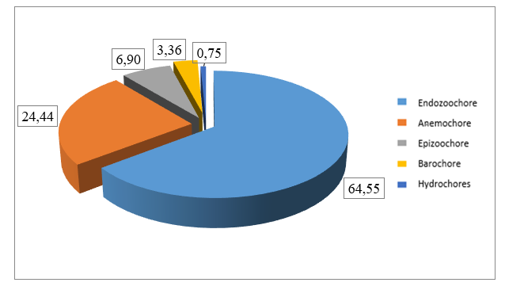

Fig. 5. Spectrum of dissemination of diaspores from the Mabi-Yaya nature reserve

3.3. Quantitative diversity
The calculated Shannon index of the Mabi-Yaya nature reserve is 3.69. This implies that the reserve is quite diverse. The equitability index tends towards 1 and is 0.72. This value reveals that the distribution of species is regular and that there is no dominance of a species within biotopes.

3.4. Biodiversity conservation attribute or Conserving value species
Among the species recorded in the reserve, 38 species (or 6.83%) of the total number are endemic to West Africa (GCW) (Table I). Among these, 2 are endemic Ivorian (GCi). The comparison of the general list of species in the domain with that of IUCN (2025) and that of Aké-Assi (1998) allowed us to identify 35 species (or 6.29%) on the IUCN Red List and 9 species (or 1.61%) on the Aké-Assi (1998) list, including Trichilia dregeana (Sond). (Meliaceae) , and Strophanthus barteri (Franch) (Apocynaceae), species that have become rare or endangered (Table I) and Erythrina vogelii Hook. f, that we only encounter exceptionally in Ivory Coast according to Aké-Assi (1998). Among the 35 species on the IUCN red list, 16 species are vulnerable (VU) and 2 species are endangered (EN), including Placodiscus pseudostipularis Radlk. (Sapindaceae).

3.5. Commercially valuable woody species
The floristic inventory of the reserve has identified a total of 22 commercial species used as raw materials in the wood industry, or 3.96% of the species inventoried. These are: 20 species from category P1, one (01) species from category P2 and one (01) species from category P3. These species are distributed among 17 genera grouped within 9 families (Table I). The most representative families in terms of number of species are those of Meliaceae (8 species, 1.43%), Malvaceae (3 species listed, 0.53%) and Fabaceae (3 species listed, 0.53%).

Table 1. List of special status and commercially valuable species recorded in the Mabi-Yaya nature reserve

N° | Species | Family | Endemism | UICN  (2025) | AA | Category
01 | Albizia ferruginea (Guill. & Perr.) Benth. | Fabaceae |  |  |  | P2
02 | Amorphophallus accrensis N. E. Br. | Araceae | GCW
03 | Baphia bancoensis Aubrév. | Fabaceae | GCi
04 | Cola caricaefolia (G. Don) K. Schum. | Malvaceae | GCW
05 | Cola heterophylla (P. Beauv.) Schott et Endl. | Malvaceae |  |  | AA
06 | Cola nitida (Vent.) Schott & Endl. | Malvaceae | GCW
07 | Cola reticulata A. Chev. | Malvaceae | GCW | VU
08 | Combretum grandiflorum G. Don | Combretaceae | GCW
09 | Copaifera salikounda Heckel | Fabaceae | GCW | VU
10 | Cyphostemma ornatum (A. Chev.) Descoings | Vitaceae | GCi
11 | Dalbergia oblongifolia G. Don | Fabaceae | GCW
12 | Daniellia thurifera Benn. | Fabaceae | GCW |  |  | P1
13 | Dialium aubrevillei Pellegr. | Fabaceae | GCW
14 | Diospyros cooperi (Hutch. & Dalz.) F. White | Ebenaceae | GCW
15 | Diospyros heudelotii Hiern | Ebenaceae | GCW
16 | Diospyros vignei White | Ebenaceae | GCW |  | AA
17 | Ehretia trachyphylla C. H. Wright | Boraginaceae | GCW
18 | Entandrophragma angolense (Welw.) C. DC. | Meliaceae |  | VU |  | P1
19 | Entandrophragma candollei Harms | Meliaceae |  | VU |  | P1
20 | Entandrophragma cylindricum (Sprague) Sprague | Meliaceae |  | VU |  | P1
21 | Entendrophragma utile (Dawe et Sprague) Sprague | Meliaceae |  | VU |  | P1
22 | Erythrina vogelii Hook. f. | Fabaceae |  |  | AA
23 | Euadenia eminens Hook. f. | Brassicaceae | GCW
24 | Eugenia leonensis Engl. & V. Brehm. | Myrtaceae | GCW
25 | Eugenia salacioides Laws. ex Hutch. & Dalz. | Myrtaceae | GCW
26 | Ficus ottoniifolia (Miq.) Miq. subsp. ottoniifolia | Moraceae
27 | Garcinia kola Heckel | Clusiaceae |  | VU
28 | Guarea cedrata (A. Chev.) Pellegr. | Meliaceae |  | VU |  | P1
29 | Guarea thompsonii Sprague et Hutch. | Meliaceae |  |  |  | P1
30 | Hippocratea vignei Hoyle | Celastraceae | GCW
31 | Hunteria eburnea Pichon | Apocynaceae | GCW
32 | Khaya ivorensis A. Chev. | Meliaceae |  | VU |  | P1
33 | Lagenaria guineensis (G. Don.) Jeffrey | Cucurbitaceae | GCW
34 | Landolphia micrantha (A. Chev.) Pichon | Apocynaceae | GCW
35 | Landolphia nitidula Persoon | Apocynaceae | GCW
36 | Lannea nigritana (Sc. Elliot) Keay var. nigritana | Anacardiaceae |  |  | AA
37 | Lophira alata Banks ex Gaertn.f. | Ochnaceae |  | VU |  | P1
38 | Milicia excelsa (Welw.) Berg | Moraceae |  |  | AA | P1
39 | Milicia regia (A. Chev.) Berg | Moraceae | GCW | VU | AA | P1
40 | Millettia lanne-poolei Dunn | Fabaceae | GCW
41 | Myrianthus libericus Rendle | Moraceae | GCW
42 | Nauclea diderichii (De Wild. et Th. Due.) Merrill | Rubiaceae |  | VU |  | P1
43 | Nesogordonia papaverifera (A. Chev.) Cap. | Malvaceae |  | VU |  | P1
44 | Neuropeltis prevosteoides Mangenot | Convolvulaceae | GCW
45 | Placodiscus boya Aubrév. & Pellegr. | Sapindaceae |  | VU | AA
46 | Placodiscus pseudostipularis Radlk. | Sapindaceae | GCW | EN
47 | Pouteria altissima (A. Chev.) Baehni | Sapotaceae |  |  |  | P1
48 | Psychotria subobliqua Hiern | Rubiaceae | GCW
49 | Psydrax manensis (Aubrév. & Pellegr.) Bridson | Rubiaceae | GCW
50 | Pterocarpus santalinoides DC. | Fabaceae |  |  |  | P3
51 | Pycnanthus dinklagei Warb. | Myristicaceae | GCW
52 | Salacia lehmbachii Loes. var. leonensis N. Hallé | Celastraceae | GCW
53 | Samanea dinklagei (Harrns) Keay | Fabaceae | GCW
54 | Scotellia klaineana Pierre var. klaineana | Achariaceae | GCW |  |  | P1
55 | Sherbournia calycina (G. Don) Hua | Rubiaceae | GCW
56 | Strophanthus barteri Franch. | Apocynaceae |  |  | AA
57 | Strychnos dinklagei Gilg | Loganiaceae | GCW
58 | Tarrieta utilis (Sprague) Sprague | Malvaceae |  |  |  | P1
59 | Terminalia ivorensis A. Chev. | Combretaceae |  | VU |  | P1
60 | Tieghemella heckelii Pierre ex A. Chev. | Sapotaceae |  | EN |  | P1
61 | Tiliacora dinklagei Engl. | Menispermaceae | GCW
62 | Trichilia dregeana Sond. | Meliaceae |  |  | AA
63 | Triclisia patens Oliv. | Menispermaceae | GCW
64 | Triplochiton scleroxylon K. Schum. | Malvaceae |  |  |  | P1
65 | Turraeanthus africanus (Welw. ex C.DC.) Pellegr. | Meliaceae |  | VU |  | P1
66 | Urera oblongifolia Benth. | Urticaceae | GCW
67 | Vitex micrantha Gürke | Lamiaceae | GCW

Legend: GCW = West African endemic species; GCi = Ivorian endemic species; VU = vulnerable; En = endangered from the IUCN Red List (2025); AA = rare plants, become rare and endangered or only occur exceptionally according to Aké-Assi (1998)

4. DISCUSSION
The floristic inventories conducted within the Mabi-Yaya nature reserve have allowed for the enumeration of 556 species distributed in 404 genera within 99 families. These species constitute a fairly significant wealth and represent 14.32% of the total Ivorian flora (3,882 species), as recorded by AkéAssi (2001, 2002). The richness obtained during this study is significantly higher than that obtained by Zaouri et al. (2021), which was 167 species during his work in the same area, Ex-classified forest of yaya. This difference is due to the fact that these authors have only inventoried the ligneous contrary to this study. Also, the flora of our study site is lower than that of the classified forest of Haut-Sassandra with 1047 species distributed between 538 genera and 114 families for an area of 102 400 ha (Kouamé, 1998). The most dominant botanical families on the site are Fabaceae, Rubiaceae, Euphorbiaceae, Malvaceae, and Apocynaceae as is the case in the majority of Ivorian forests. Indeed, several Ivorian forests are dominated by the same procession of families (Adingra, 2017; N'Guessan, 2018). When considering the biological types, the phanerophytes (63.14%) constitute the basis of the floristic Parade of the reserve. According to Koffi (2016) and Zaouri et al. (2021), this observation is the same in tropical forests. Our results show that Guinean species (GC: 57.55%) and West African endemics (GCW: 8.45%) are largely dominant, with proportions reaching 66%. For Yongo (2003), the dominance of Guinean species in the floristic background of the reserve is proof that this area belongs to the Guinean-Congolese endemic center.For Koffi et al. (2008), phytogeography is a main tool for species management and conservation. It allows us to make hypotheses about the age, geographical origin, rate of evolution and migration paths of the taxa in the domain. Also this reserve includes 21 introduced species. According to Kouamé (2016), these species easily substitute for hundreds of natural forest species whose niches have been destroyed during human activities. The number of introduced species encountered in our work is greater than the introduced species from the classified forest of Bamo which is 17 species (Adingra, 2017). The spectrum of types of diaspores reveals the dominance of endozoochoric species (64.55%). The majority of forest species in our study site are endozoochores. Nevertheless, the dominance of the Fabaceae, of which many species from the forest vault are anemochores, can justify the 24.44% of anemochor species inventoried in the forest. Indeed, anemochory constitutes a main dissemination strategy for large trees in the canopy of tropical forests (Senterre, 2005). The zoochory of our study site, as in many other studies: Bertault (1986) and Adingra (2017), involves birds and frugivorous vertebrates present in the reserve.The barochore mode is little used by plants (3.36%). These figures are similar to those observed by Adingra (2017) in the classified forest of Bamo (2.17%). This study showed that the Shannon diversity index is high for this reserve. The value of the Shannon diversity index reflects a high stability of the flora of the reserve according to Loubier (2001) and N'Guessan (2016). The calculated equitability index tends towards 1 over the entire area. This means that the distribution of individuals of different species is done regularly in biotopes and that there is no dominance of one group of species over others. According to N'Guessan (2016), the middle is said to be balanced. This work has made it possible to inventory several species with a special status according to Aké-Assi (1998) and the IUCN Red List (2025). For Myres et al. (2000), conservation efforts of endemic species, rare species and endangered species should be a priority because according to N'Guessan (2018) these species constitute the attributes of conservations for forests.

5. CONCLUSION
At the end of this study, we can retain that the Mabi-Yaya nature reserve has a floristic richness estimated at 556 species. The best represented botanical families are Fabaceae, Rubiaceae, Euphorbiaceae, Malvaceae, and Apocynaceae. The reserve is characterized by a dominance in Guinean-Congolese species and phanerophytes. It is a rather diverse forest reflecting a great stability of the flora of the reserve. The conservation attributes or the conservation value of the flora are represented by several species with a particular status such as the Ivorian endemic species (2 species), West African (38 species), and especially those on the IUCN red list. (16 vulnerable and 2 endangered species). The main modes of dispersion of diaspores are zoochory and anemochory. The animals would play a rather important role in the dissemination and indirectly in the proper functioning of the site. This study demonstrates the participation of the Mabi-Yaya nature reserve in the conservation of biodiversity in Côte d'Ivoire.

DISCLAIMER (ARTIFICIAL INTELLIGENCE)

The authors hereby declare that no generative AI technology, such as large language models (ChatGPT, COPILOT, etc.) and image text generators were used in writing or reviewing this manuscript.

REFERENCES

Ademola-Ouattara, M. A., Atta, K., & Pottier, S. (1999). Development of Food Crops and Changes in Land Use in Adioukrou Country (1975-1990).
Cahiers Nantais No. 51,/ GARUN-University of Nantes, pp. 131-149.
Adingra, M. M. A. O. (2017). Population Dynamics and Carbon Stock in the Vegetation Mosaic of the Bamo Classified Forest (Côte d'Ivoire). Doctoral Thesis, Félix Houphouët-Boigny University, Côte d'Ivoire, 158 p.
Adjanohoun, E. (1964). Vegetation of Savannahs and Rocks Discovered in Côte d'Ivoire.
ORSTOM Dissertation, 7, Paris (France), 178 p.
Aké-Assi, L. (1998). Rare and Endangered Species of the Flora of Côte d'Ivoire. Monogr.Syst. Bot. Missouri Botanic Garden, 25, 461-463.
Aké-Assi, L. (2001). Flora of Côte d'Ivoire: A Systematic Catalogue, Biogeography, and Ecology. Conservatory and Botanical Garden, Geneva (Switzerland), Volume 1: 396 p.
Aké-Assi, L. (2002). Flora of Côte d'Ivoire: A Systematic Catalogue, Biogeography, and Ecology. Geneva, Switzerland: Conservatory and Botanical Garden of Geneva. Boisseria, 58: 441 p.
Alroy, J. (2017). Tropical forests support at least two-thirds of the world's biodiversity despite covering less than 10% of Earth's land surface. Proceedings of the National Academy of Sciences, 114(23), 6056-6060.
Amani, B. H. K., N'Guessan A. E., Derroire G., Kassi N. J., Aka G. M. E., Traoré K., Zo-Bi I. C. & Hérault B. (2022). The potential of secondary forests to restore biodiversity of the lost forests in semi-deciduous West Africa. Biological Conservation, 259, 109154-109165.
APG IV. (2016). An update of the Angiosperm Phylogeny Group classification for the orders and families of flowering plants. Botanical Journal of the Linnean Society, 181, 1-20.
Bertault, J.G. (1986). Study of the effect of silvicultural interventions on natural regeneration within an experimental perimeter. Management of the Dense Rainforest of Côte d'Ivoire. Doctoral Thesis, University of Nancy (France), 254 p.
Delabre, E. (1998). Characterization and Evolution of Human-Involved Sahelian Ecosystems: Post-Cultural Environments of Southwestern Niger. Doctoral Thesis, Paris VI, Pierre and Marie-Curie University (France), 286 p.
Dupuy, B. (1998). Foundations for Silviculture in African Dense Tropical Rainforests.
CIRAD-forêt, Baillarguet International Campus, Montpellier (France), 326 p.
Guillaumet, J.L. (1967). Research on the Vegetation and Flora of the Bas-Cavally Region
(Côte d'Ivoire). ORSTOM Memoirs No. 20:1-247.
Eldin, M. (1971). The Climate of Côte d'Ivoire. In: The Natural Environment of Côte d’Ivoire. ORSTOM Memoirs, 50, Paris (France), pp. 73-108.
INPROBOIS (2013). Management Plan for the Besso Classified Forest 2003-2012.
INPROBOIS Activity Report, unpublished document.
National Forest and Wildlife Inventory (IFFN) (2021). Preview of the first results of the project, June 25, 2021.
Kassi, N'. J. (2006). Secondary Post-Cultural Successions in Dense Semi-Deciduous Forest (Côte d’Ivoire): Nature, Structure, and Functional Organization of Vegetation. Doctoral Dissertation, University of Picardie Jules Verne, Amiens (France), 212 p.
Koffi, K. A. D. (2016). Vegetation Dynamics and Conservation Values ​​of Formerly Cultivated Areas in Azagny National Park (South of Côte d'Ivoire). Doctoral
Thesis, Félix Houphouët-Boigny University, Côte d'Ivoire, 185 p.
Koffi, K. J., Champluvier, D., Neuba, F. R. D, Cannière, C., Traoré, D., Lejoly, J., Robbrecht E. & Bogaert J. (2008). Analysis of the distribution of Acanthaceae in Central Africa: Comparison with the phytogeographic theories of Robyns, White, and Ndjele. Sciences & Nature, 5(2), 101-110.

Kouamé, N'. F. (1998). Influence of logging on the vegetation and flora of the Haut-Sassandra classified forest (Central-West Côte d'Ivoire). Doctoral
Thesis, Department of Biosciences, Cocody University, Abidjan (Côte d'Ivoire), 227 p.
Kouame, N'. F. (2016). Vegetation Structure, Flora, and Regeneration of the Duekoué and Scio Classified Forests in the Dense Humid Forest Zone of Western Ivory Coast. Single Doctoral Thesis, UFR Biosciences, Félix Houphouët-Boigny University (Côte d'Ivoire), 282 p.
Kra, K. W. (2019). "Côte d'Ivoire: Protected Areas Between Contrasting Conservation Policies and Social Reinterpretation." Caribbean Studies [Online], 43-44 | August-December 2019, published October 30, 2019, accessed September 3, 2025. URL: http://journals.openedition.org/etudescaribeennes/17124; DOI: https://doi.org/10.4000/etudescaribeennes.17124
Lebrun, J. P. & Stork, A.L. (1991-1997). Enumeration of flowering plants of tropical Africa. Conservatory and Botanical Garden of the City of Geneva, Geneva (Switzerland).
Vol. 1 (249 pp.), vol. 2 (257 pp.), vol. 3 (341 pp.) and vol. 4 (711 pp.).
Loubier, J.C. (2001). Ecology and GIS: A heritage management tool applied to natural tourist areas. es. Fifth meeting of Théo Quant, 14 p.
Marie, A.H. (1992). Convention on Biological Diversity. French Yearbook of International Law, 38 (1), 844-870.
Myers, N., Mittermeier, R.A., Mittermeier, C.G., Da Fonseca, G.A.B. & Kent J. (2000). Biodiversity hotspots for conservation priorities. Nature, 403, 853-858.
N'Guessan, A.E. (2016). Floristic diversity of a private forest in Dianra, northern Côte d'Ivoire. Master's thesis. Félix Houphouët-Boigny University (Côte d'Ivoire), 51 p.
N'Guessan, A.E. (2018). Vegetation dynamics and factors of biomass recovery in secondary forests in the Agbo 1 classified forest (Côte d'Ivoire).
Doctoral thesis, Félix Houphouët-Boigny University (Côte d'Ivoire), 179 p.
N'Guessan, A. E., Kassi, N. J., Yao, N. O., Amani, H. K. B., Gouli, G. Z. R., Piponiot, C., Irie Bi, C. Z. & Hérault B. (2019). Drivers of biomass recovery in a secondary forested landscape of West Africa. Forest Ecology and Management, 433, 325-331.
Pielou, E. C. (1966). The measurement of diversity in different types of biological collections.
J. Theor. Biol., 13, 131-144.
Poorter, I., Bongers, F., Kouame, F. N’ & Hawthorne, W. D. (2004). Biodiversity of West African Forest: An Ecological Atlas of Woody Plant Species. CABI Publishing. Nederland (Netherlands), 521 p.
Raunkiaer, C. (1934). The Life Forms of Plants and Statistical Plant Geography. Oxford
University Press, London (England), 632 p.
Senterre, B. (2005). Methodological Research for Vegetation Typology and Phytogeography of Tropical African Rainforests. Doctoral Thesis, Université Libre de Bruxelles, 345 p.
Shannon, C.E. (1948). A Mathematical Theory of Communication. Bell System Technical
Journal, 27, 379-423.

SODEFOR (2015). Yaya Classified Forest Management Plan 2015-2024. Document
SODEFOR, 98 p.
IUCN (International Union for the Conservation of Nature). (2025). IUCN Red List of Threatened Species. Version 2019-2. [Online] Available: www.iucnredlist.org (Accessed 05/07/2025).
White, F. (1983). The Vegetation of Africa, a Descriptive Memoir to Accompany the UNESCO-
AETFA-UNSO Vegetation Map of Africa. Natural Resources Research No. 20,
UNESCO, Paris (France), 356 p.
White, F. 1986. The Vegetation of Africa. Translated from English by Bamps, Paul. Jard. Nat.
Belg., 383 p.
Zaouri, J. M. G. B., Yao, O. N., Soro, K. & Soro, D. (2021). Plant diversity of the Yaya Classified Forest in southeastern Côte d’Ivoire. International Journal of Biological and Chemical Sciences, 15(6), 2554–2567.
Flores, B. M., & Staal, A. (2022). Feedback in tropical forests of the Anthropocene. Global Change Biology, 28(17), 5041-5061.

Smith, C., Baker, J. C. A., & Spracklen, D. V. (2023). Tropical deforestation causes large reductions in observed precipitation. Nature, 615(7951), 270-275.

Hoang, N. T., & Kanemoto, K. (2021). Mapping the deforestation footprint of nations reveals growing threat to tropical forests. Nature Ecology & Evolution, 5(6), 845-853.

Mishra, N., Pradhan, S. K., Patra, S. K., Padhy, C., Pradhan, K., & Ghosh, S. (2024). Preservation of biodiversity and sustainability of ecosystem. Asian Journal of Agricultural Extension, Economics & Sociology, 42(9), 140–150.

