Investigation on the Protective Effect of Jatropha Tanjorensis on Electrolyte Imbalance in Male Mice Exposed to Dichlorvos

Abstract
Aim: This study aimed at investigating the effect of Jatropha tanjorensis on electrolytes of male mice exposed to Dichorvos.
Study design: The study was a completely randomized design employing relevant statistical tools for analysis and interpretation.
Place and Duration of Study The study was carried out in the Department of Animal and Environmental Biology, Rivers State University. The experiment lasted for 35 days between March and June 2024.
Methodology: A total of thirty (30) male mice were assigned to six groups of five rats each. Group A (Control). Group B was given 5mg/kg/bw/day of Dichlorvos only. Group C was given 250 mg/kg/bw/day of fresh Jatropha tanjorensis. Group D was given 250 mg/kg/bw/day of dried Jatropha tanjorensis. Group E was given 5mg/kg/bw/day and 250 mg/kg/bw/day of fresh Jatropha tanjorensis.. Group F was given 5mg/kg/bw/day and 250 mg/kg/bw/day of dried Jatropha tanjorensis. After 35 days of the experimental study, blood was collected through ocular puncture and analysis of Potassium, Sodium, Chloride, Bicarbonate and Calcium were done using an electrolyte analyzer, Humlyte plus 5, Germany. Data were analyzed using Microsoft excel 365.
Result showed a significant elevation of all selected electrolytes in group B and E compared to other groups. Coadministration of fresh Jatropha tanjorensis (group E) appeared not to have any significant ameliorative effect on production of electrolytes since all the electrolytes assessed increased in group B and E. However, dried Jatropha tanjorensis showed an ameliorative effect against the toxic effect of DDVP on electrolytes in animals exposed to it. Further research is needed establish the efficacy of J. tanjorensis in human subjects while exposure to insecticides should be regulated.

Keywords: Diichlorvos, Electrolytes, Jatropha tanjorensis, Pollution,

- Introduction
Environmental pollution has been of great concern to humans long before civilization These pollution have resulted from the hands of man through the use or misuse of pesticides. Pesticides which are very toxic in nature or by design to man and to its environment also has an advantage but the disadvantage of these pesticide far outweighs the advantages.
The use of herbal medicine has been used to treat various diseases and now they have become an item of global importance both to the medical and economic field. Selecting the right scientific and systematic approach to biological evaluation of plant products, based on their use in traditional medicine is the key to ideal development of new drugs from plant. One of such plant is Jatropha tanjorensisis also know as ‘Hospital too far’ which is a leafy vegetable consumed by many as medicinal plant in Nigeria as it has shown to exhibit, hematological , anti malaria, anti microbial, hypoglycaemic, hypolipidemic and anti hypertensive activities [1] Jatropha tanjorensis is a plant that has been used in traditional medicine for various purposes. Electrolytes are substances that dissociate into ions in solution, allowing them to conduct electricity. All life form requires a complex balance of electrolytes inside and outside their body structure. In humans this balance is regulated by hormones and disruption of this balance leads to health problems and implications.
Electrolyte balance is maintained by oral or intravenous intake of electrolyte containing substances , and it's regulated by hormones such as antidiuretic hormones, aldosterone and parathyroid hormones. Electrolyte disturbances such as dehydration and over hydration may lead to muscle weakness or severe muscle contractions, cardiac and neurological complications [2]
Jatropha tanjorensis has gotten a lot of recognition due to it's potential health benefits, affordability and also it's availability [3,4]. It primarily used for fencing, ornamental and medicine.
The leaf of Jatropha tanjorensis also revealed that it contains bioactive principles such as alkaloids tanins and saponions during phytochemical screening [5]. The leaf also possess some wide range of biological activities, which includes antimicrobial, antimalaria, antioxidant which has been revealed by the plant during pharmacology studies.
However, the plant’s popularity and recognition was doused by unproven claims that the whitish latex emanating from the leaf stem and stalk may be toxic to man [6]. In view of the common use of Jatropha tanjorensis both as food and as herbal medicine, there is need for proper physiological and toxicological tests in order to ensure its safety and how they can affect electrolyte balance in the body and also mitigate the effects of DDVP on these electrolytes.

2.0 Materials and methods

The study was carried out in the animal house of the Department of Animal and Environmental Biology, Rivers State University, Port Harcourt Nkpolu-Oroworukwo Rivers State. The study was conducted from March to June 2024.
2.1 Experimental Animal and Management
A total of thirty (30) matured Swiss male mice were obtained from the animal house of Department of Animal and Environmental Biology, Rivers State University, Rivers State. The mice were housed in wire mesh cages under standard conditions (12hrs: 12hd) and were allowed to acclimatize for fourteen (14) days under favourable atmospheric conditions and fed with standard rodent pellet and cool clean water. The uneaten food and left over water were changed every two days and their bedding at least twice a week which were all in accordance to the institutional protocols of animal care at Rivers State University, Port Harcourt.
DDVP (dichlorvos) was purchased from a reputable chemical store in Port Harcourt. The dosage was calculated based on information of the lethal dose (LD50) from literature [7,8] .

2.2 Experimental Design and Procedure
A total of thirty (30) Swiss matured male mice were assigned to six (6) groups (A - F) of five (5) mice each.
Group A received neither DDVP nor Jatropha tanjorensis extract and so served as control. Group B received 5mg/kg/bw/day of DDVP only. Group C received 250mg/kg/bw of fresh Jatropha tanjorensis extract only. Group D received 250mg/kg/bw/day of dried Jatropha tanjorensis extract only, Group E received 5mg/kg/bw/day of DDVP and 250mg/kg/bw/day of fresh Jatropha tanjorensis extract.
Group F received 5mg/kg/bw/day and 250mg/kg/bw/day of dried Jatropha tanjorensis extract.
All the groups were exposed to their treatment by oral gavage for thirty - five (35) days.
2.3 Collection of Blood Samples
After the 35 days exposure of the mice, feed was withdrawn from the mice 24 hours before termination of the experiment. Blood samples for biochemical analysis were collected individually by ocular puncture into sterile tubes and the serum separated at 250g for 10 minutes and stored for determination of some electrolytes which includes Potassium, Sodium, Chlorine, Bicarbonate and Calcium using an electrolyte analyzer, Humlyte plus 5, Germany according to [9] protocol.
2.4 Statistical analysis
The results were statistically analyzed and expressed as mean± standard deviation (SD). For the comparison between groups, the one-way analysis of variance (ANOVA) and the software used was Microsoft excel 365.
3.0 Result

3.1 The effect of Jatropha tanjorensis on the electrolytes levels in male mice exposed to DDVP

The effect of Jatropha tanjorensis on the electrolytes in male mice exposed to DDVP is shown in figure 1-5.
The effect of Jatropha tanjorensis on the level of potassium in male mice exposed to DDVP is shown in figure 1. The value of potassium in group A was 3.56±0.15mmol/l. This value significantly increased in group B to 4.74±0.11mmol/l, 4.33±0.15 mmol/l in group C , 4.77±0.15 mmol/l in group E , and 4.17±0.06 mmol/l in group F . The value of potassium in group D was similar to that in the control with 3.48±0.24mmol/l
The effect of Jatropha tanjorensis on the level of Sodium in male mice exposed to DDVP is shown in figure 2. The concentration of sodium was 125.20±1.30 mmol/l in the control group . The concentration significantly increased to 144.±40±.67 mmol/l in group B administrated DDVP only and 140.00±1.00 in group C administrated fresh Jatropha tanjorensis. A significant increase to 146.67±2.04mmol/l in group E co-administrated DDVP and fresh Jatropha tanjorensis
However the concentration of sodium in group D and F animals were 132.80±1.67mmol/l and 138.33±1.15mmol/l which was significantly different from that in the control group
The effect of Jatropha tanjorensis on the level of Chloride in male mice exposed to DDVP is shown in figure 3. The concentration of chloride in group A was 65.40 mmol/l. This value significantly increased to 81.40±3.65mmol/l in group B administrated DDVP only. A significant decrease in the concentration of chloride was observed in group C to 66.33±2.08mmol/l similar to the control group, and 74.20±0.84 mmol/l in group D , 72.00±1.00mmol/l in group E and 70.00±1.00mmol/l in group F
There were no significant difference in the concentration of chloride among the group co-administrated fresh or dried Jatropha tanjorensis with DDVP
The effect of Jatropha tanjorensis on the level of Bi-carbonate in male mice exposed to DDVP is shown in figure 4. The concentration of bi-carbonate in group A was 18.60±1.52 mmol/l which significantly increased to 28.60±0.89 in group B and 27.67±0.58 in group E . The values observed among all the other groups were within the same range with 23.67±2.52 mmol/l , 22.80±0.84, 22.67±1.53 in group C,D and F respectively
The effect of Jatropha tanjorensis on the level of Calcium in male mice exposed to DDVP is shown in figure 5. The effect of Jatropha tanjorensis on the concentration of calcium in male mice exposed to DDVP is shown in fig 5
The concentration of Calcium in the control group was 2.42±0.20mmol/l the value increased significantly to 2.84±0.09mmol/l in group B and 2.83±0.06mmol/l in group E co-administrated DDVP and fresh leaves extract of Jatropha tanjorensis however, the value of Calcium did not vary significantly among all the other groups compared to group A with 2.40±0.10mmol/l in group C , 2.43±0.15mmol/l in group F and 2.06±0.11mmol/l in group D, although group D had the lowest concentration of calcium when compared with all the treatment groups and control.

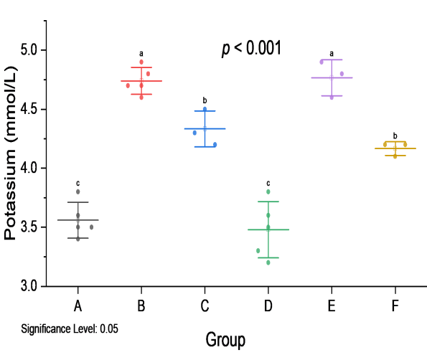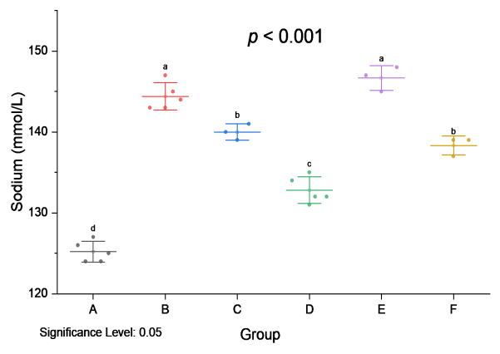

Fig 1: Effect of J. tanjorensis on the level Fig 2: Effect of J. tanjorensis on the level of Potassium in male mice exposed to DDVP. of Sodium in male mice exposed to DDVP

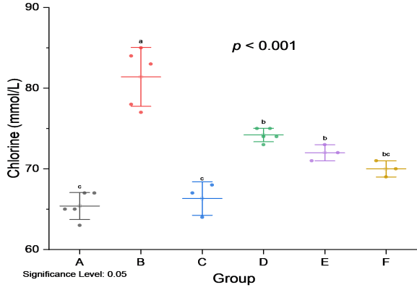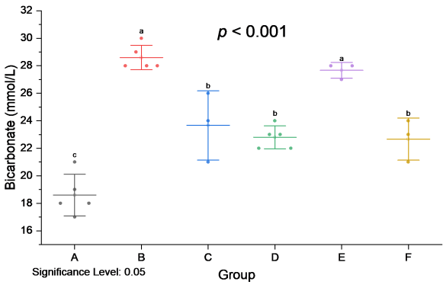

Fig 3: Effect of J. tanjorensis on the level Fig 4: Effect of J. tanjorensis on the level of Chloride in male mice exposed to DDVP. Bicarbonate in male mice exposed to DDVP.

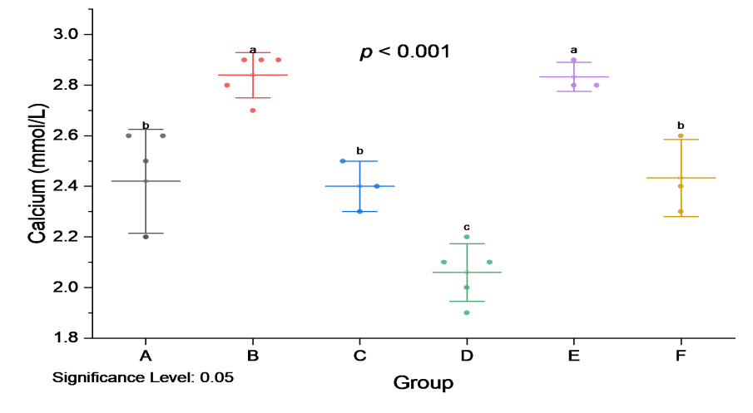

Fig 5: Effect of J. tanjorensis on the level
of Calcium in male mice exposed to DDVP

4.0 Discussion
Electrolyte/ fluid balance is regulated by the renal system which also helps in elimination of waste products. Kidney functions may decline as a result of complications arising from the exposure to toxins.
Potassium was significantly (p<0.001) increased in group B (DDVP only) and E compared to group C, D , and the other coadministered J. tanjorensis. The significant increase could lead to hyperkalemia which is associated with kidney dysfunction, diabetes, muscle weakness, muscle cramps leading to paralysis. However potassium has shown to help in muscle contractions group D showed a reduction in potassium levels while F also showed a reduction when DDVP was co-administrated along with dried Jatropha tanjorensis.
Sodium being the major positive fluid outside of the cell, it regulate the total amount of water in the body and the transmission of sodium into and outside of the cell, it also plays a role in critical body function [10].
In this study there was a significant (p<0.001) increase in group B and E compared to the other groups C,D and F. The observed increase in the exposed group may be attributed to the action of DDVP in group B which may cause hypernatrermia muscle twitching, seizure, coma, and death caused by high blood pressure. Different studies have demonstrated the ability of plant extracts to influence the blood concentrations of Na+. [11,12,13] [14] reported that sodium concentration decreases in heart and liver tissues of rats treated with cypermethrin (non-significantly) while significantly (p < 0.01) in brain tissue. In kidney, blood and spleen there was a non-significant (p >0.05) increase in sodium concentration when compared to control. Also, [16] reported that 10mg/kg/bw of lycopene had no significant effect on the levels of electrolytes in rats.
The bicarbonate ion acts as a buffer to maintain the normal levels of acidity (pH) in
blood and other fluids in the body. Bicarbonate levels are measured to monitor the acidity of the blood and body fluids. [15] shows that there is no significant (P<0.05) difference between the serum bicarbonate levels of the test groups when
compared with the control group. However, from this study, an increase in bi-carbonate level in group B indicate DDVP poisoning , when bi-carbonate level are higher or lower than normal either the body is having trouble maintaining body acid base balance or their electrolyte balance this upset either by loss or retention of fluid but co-administration of dried Jatropha tanjorensis (group F) proved efficacious by restoring of bi-carbonate towards almost normal as seen in the control group.
Calcium was significantly (p<0.001) increased in group B compared to group C , D, E and F. The significant increase in the level of group B lead to hypercalcemia in which exposed individuals may experience bone loss, kidney stone, kidney failure , heart problem, weakness of bones, however fresh and dried Jatropha tanjorensis proved to restore the calcium level towards normal..
Chloride is the most abundant electrolyte in the serum which regulates the body fluids, electrolyte balance and acid base state. This increase in chloride levels can lead to kidney disease, metabolic acidosis and dehydration. Although the co-administration of dried Jatropha tanjorensis and DDVP showed a reduction in the normal amount of chlorine.
- Conclusion
Coadministration of fresh Jatropha tanjorensis appeared not to have any significant effect on production of electrolytes since all the electrolytes assessed increased in group B and E. However, dried Jatropha tanjorensis showed an ameliorative effect against the toxic effect of DDVP on electrolytes in animals exposed to it. Further research is needed to isolate and characterize the active compounds, elucidate the mechanisms of action, and conduct clinical trials to establish the efficacy and safety of J. tanjorensis in human subjects.

Disclaimer (Artificial intelligence)

Author(s) hereby declare that NO generative AI technologies such as Large Language Models (ChatGPT, COPILOT, etc.) and text-to-image generators have been used during the writing or editing of this manuscript.

References

- Ansari, R.A., Rabiu, K.M., Ayuba, V. & Omolabake, O.O. (2020). Review on Jatropha tanjorensis (Hospital too far); Significance as an Anti-Anaemia Plant, International Blood Research & Reviews, 11(4), 1-7.
- Atansuyi K., Ibukun E.O. & Ogunmoyole T. (2012). Antioxidant properties of free and bound phenolic extract of the leaves of J. tanjorensis In vitro. Journal of Medicinal Plant Research, 6(31), 4667-4674.
- Ferreira, K. (2024) Electrolyte Disorders: Understanding Diagnosis, and Management, Journal of Interventional Nephrology, 7(6),332-335.
- Emeka, O.E., Amujiri, A.N., Chigor, C.B., Onaebi, C.N., Nweze, A.E., Obayi, H.C. & Nwafor, F.I. (2023) Review of Chemical Constituents and Medicinal Attributes of Jatropha tanjorensis J.L. Ellis and Saroja Leaves. Natural Products Indian Journal, 19(1),005.
- Oboh , F .O.J. & Masodje H.I. (2009). Nutritional and Antimicrobial properties of Jatropha tanjorensis leaves. American-Eurasian Journal of Scientific Research, 4(1),7-10.
- Omoregie E.S. & Sisodia B.S. (2011). In vitro antiplasmodial activity and cytotoxicity of leaf extracts from J. tanjorensis. Pharmacology Online, 2, 656-673.
- Ogoruvwe O.J. & Kori-siakpere O. (2012). Alterations in the activities of the Nitrogenous waste of Clarias gariepinus after intramuscular injection with aqueous extracts of J. tanjorensis leaves. IOSR Journal of Pharmacy and Biological Sciences, 2(1),35-38.
- Iboroma, M., Orlu, E.E., Ebere, N. & Obulor, A.O.(2018). Androgenic and antioxidant activity of Stelleria media on rat following sub-chronic exposure to Dichlorvos. Journal of Pharmacy and Biological Science, 13(6), 38-46.
- Nalimu, F., Oloro, J., Peter, E.L.& Ogwang, P.E. (2022). Acute and sub-acute oral toxicity of aqueous whole leaf and green rind extracts of Aloe vera in Wistar rats. BMC Complementary Medicine and Therapies, 22,16
10. Wekhe-Emenike, A., Obulor, A. O. & Orlu, E. E. (2022). Influence of Sacoglottis gabonensis Ethanolic Extract on the Electrolytes of Swiss Mice Administered Aspartame. Asian Journal of Biochemistry, Genetics and Molecular Biology,11(4), 35-42.
11.Olayiwola G.O., Iwalewa E.O., Omobuwajo O.R., Adebajo C.O., Adeniyi A.A. & Verspohi E.J. (2004). Anti-diabetic potential of J. tanjorensis leaves. Nigeria J Natural Products and Medicines, 08, 37-40.
12. Rashid, U., Qureshi, I. Z., Jan, S., Khalid, T & Arshad, M.J. (2022). Ameliorative effects of selenium against cypermethrin induced toxicity of tissue minerals in vital organs of Sprague Dawley rats. World Journal of Advanced Research and Reviews, 16(03), 505-517.
13. Kebe, E.O, Victoria, N.I. & Eze, L.I. (2013) The Electrolytic Effect of Sida Acuta Leaf Extract on the Kidney Electrolyte of Adult Wistar Rats. Journal of Biology, Agriculture and Healthcare, 3,10
14. Afolabi B.A., Obafemi T.O., Akinola T.T., Adeyemi A.S. & Afolabi O.B (2014). Effect of ethanolic extract of Alstonia boonei leaves on serum electrolyte levels in Wistar Albino Rats. Pharmacology online, 3, 85-90
15. Obulor, A. O. & Orlu, E. E. (2022). Effect of Lycopene on Selected Electrolytes in Sprague Dawley Rats exposed to Dimethoate. Asian Journal of Biochemistry, Genetics and Molecular Biology, 11(1), 31–37

