Case report

Rare Multifocal Arterial Involvement in Neurofibromatosis Type 1: A Case Report

- ABSTRACT
Neurofibromatosis type 1 (NF1) or Von Recklinghausen disease is an autosomal dominant genetic disease. Its clinical expression, which is extremely variable, is dominated by cutaneous, nervous and ocular manifestations. It corresponds to an abnormality in the development of ectodermal tissue, mainly resulting in various malformations of the neuraxis and development of small tumours (phacomas) involving the skin, nervous system and eye. However, vascular involvement during NF1 is rare. A case report of stenosing and aneurysmal arterial lesions, discovered during a CT scan, in a 26-year-old patient with iron deficiency anaemia at 4 g/dl, is presented. This examination was carried out as part of the etiological assessment of iron deficiency, the initial investigation of which was not conclusive. After eliminating the usual causes, notably infectious and systemic, the arterial damage was attributed to type 1 neurofibromatosis. On the therapeutic side, anaemia responded well to oral iron treatment. For vascular lesions, therapeutic abstention with clinical and radiological monitoring was decided, after the opinion of cardiovascular surgeons. During NF1, the contribution of imaging, in particular computed tomography angiography or magnetic resonance imaging angiography, is crucial in screening, mapping of vascular lesions, which are often multiple during NF1, as was the case in the patient, as well as in their subsequent follow-up.

Keywords: neurofibromatosis type 1, arterial stenosis, aneurysm, genetic disease, imaging

- INTRODUCTION
Neurofibromatosis type 1 (NF1) or Von Recklinghausen disease is a genetic disease with autosomal dominant transmission [1]. It has a worldwide incidence of approximately 1 in 3000 live births. It is caused by autosomal dominant loss-of-function mutations of the NF1 gene (Neurofibromin 1; OMIM 613113) located on chromosome 17q11.2 and encoding for neurofibromin, a negative regulator protein of the Ras/MAPK pathway involved in the control of cell growth and proliferation (Midena & Cosmo, 2025; Sial & George, 2023). It corresponds to an abnormality in the development of ectodermal tissue, mainly resulting in various malformations of the neuraxis and development of small tumours (phacomas) involving the skin, nervous system and eye [2]. On the other hand, vascular involvement during this phacomatosis is exceptional [3]. The National Institutes of Health (NIH) has established a clear set of criteria for diagnosing NF-1. Although the NIH criteria have been established, many papers in the literature contend that modifications are necessary for the pediatric population to ensure the reliability as a diagnostic tool. A study involving 1893 NF-1 patients below the age of 21 revealed that 46% of sporadic NF-1 cases below the age of 1 did not satisfy the diagnostic criteria established by the NIH. However, almost all NF-1 children met these criteria by the age of 8 years (Almuqbil et al., 2024; Pimentel et al., 2022).
We report a particular observation by the fortuitous discovery, during an angiogram, carried out in addition to exploration in the context of iron deficiency anaemia, of aneurysms and arterial stenoses falling within the framework of NF1.

- CASE PRESENTATION
A 26-year-old patient was admitted for a well-tolerated anaemia of 4 g/dl, with mild rectal bleeding. Examination upon admission showed mucocutaneous pallor, a BMI of 19.9 kg/m² and blood pressure of 110/70 mmHg on both sides. Pulses were all present and symmetrical with a heart rate of 98 beats/minute. She had several coarsely rounded, multiple hyperchromic skin lesions on her trunk, abdomen and back. A digital rectal examination showed no abnormalities. The rest of the clinical examination was also unremarkable. Biologically, the blood group was B positive (C + E - c + e + K -). The blood count showed a hypochromic anaemic microcytic anaemia (haemoglobin at 7.5 g/dl, MCV = 68 µ³, TCMH = 29, reticulocytes at 80,000/mm³) without other abnormalities. The ferritin level was low at 8 ng/ml, confirming the iron deficiency. For the etiological assessment of anaemia, several explorations were carried out. The esophagoendoscopy showed a deformed scarred bulb. The colonoscopy showed a 7 mm erosive pedunculated sigmoid polyp with histological features of a tubulovillous adenoma in low-grade dysplasia. The abdominal angiogram revealed several vascular anomalies. This involved a stenosis of the infrarenal abdominal aorta extending over 4 cm, an ostial stenosis of the right renal artery, saccular and fusiform aneurysms of both renal arteries and a saccular aneurysm of the splenic artery of 11 mm (Figure 1). The arterial involvement in our patient was linked to NF1 after eliminating other etiologies. A further exploration by video-capsule, to label the aetiology of iron deficiency anaemia, was planned. However, this examination was not performed due to the unavailability of hospitals in Tunisia and the high cost in private hospitals.
For vascular involvement involving multiple aneurysms and stenoses, infectious causes were first ruled out. Syphilis serology was negative. Tuberculin skin test and sputum and urine tests for Koch's bacillus were negative. The same was true for Widal serology. Atherosclerosis was easily ruled out given the young age and absence of hypercholesterolemia. For systemic diseases, Takayasu's disease was suggested given the gender, age under 40, and type of arterial lesions. However, there were no other systemic signs. The examination did not show any blood pressure asymmetry, pulse asymmetry, or other suggestive signs. There was no biological inflammatory syndrome. Similarly, there was no evidence of Behcet's disease. Namely, there was no evidence of oral or genital aphthosis, no evidence of hypersensitivity at the injection sites, no inflammatory arthralgia, and no redness or blurred vision. There was no pseudofolliculitis or erythema nodosum on physical examination. The pathergy test was negative. There was no evidence of progressive or sequelae of uveitis or retinal vasculitis on ophthalmologic examination. However, this showed the presence of iris Lisch nodules. At this stage, the diagnosis of neurofibromatosis was strongly suggested, especially since café-au-lait spots were observed on physical examination (Figures 2 and 3). Further questioning revealed a positive family history of NF1, with similar cutaneous findings observed in the patient’s father and two paternal uncles. (Figures 4 and 5). The diagnosis of NF1 was made based on the clinical diagnostic criteria established by the National Institutes of Health (NIH). Our patient met three of these criteria: Multiple café-au lait spots (Figures 2), the presence of multiple Lisch nodules on ophthalmic examination and a positive family history of NF1 in the father and two paternal uncles (Figures 3 and 4). The arterial involvement, including aneurysms and stenoses, was linked to this phacomatosis. For the iron deficiency anaemia, additional exploration using a video capsule was indicated, but not performed due to a lack of resources. Therapeutically, for the iron deficiency anaemia, iron therapy was prescribed, with good progress. The haemoglobin level at the last follow-up at one year was 12 g/dl. For arterial lesions, the cardiovascular surgeons' advice was to abstain from treatment and monitor. The CT angiogram repeated at one year showed the stability of the vascular lesions. The patient is currently asymptomatic after 15 months.

- DISCUSSION
NF1 is a rare autosomal dominant genetic disorder affecting 1/3000 births [4]. The clinical expression of NF1 is extremely variable [5]. The most characteristic manifestations are multiple café-au-lait spots, cutaneous neurofibromas, and iris Lisch nodules [6]. These are almost pathognomonic [7]. In our case, the patient presented with café-au-lait spots and iris Lisch nodules. While her father presented with cutaneous neurofibromas.
Vascular manifestations are rare in NF1, with an estimated frequency between 0.4% and 6.4% of patients [8]. However, they represent the second most common cause of mortality in patients followed for NF1, after neoplastic causes. Arterial involvement can be venous, but especially arterial [9]. It includes aneurysms, stenoses and arteriovenous malformations. It preferentially affects large and medium-sized arteries, including: the aorta, mesenteric, pulmonary, cerebral and/or renal arteries [8, 3]. Oderich G.S. et al [3] reported 31 cases of 76 vascular malformations in 31 patients with NF1. These included aneurysms (n=38), arterial stenoses (n=20), arteriovenous malformations (n=5), and arterial compression by nerve tumours (n=5). In addition, cardiac valve abnormalities were found in six cases. These lesions were found mainly in the aorta (n=17), renal arteries (n=12), mesenteric arteries (n=12), and carotid-vertebral circulation (n=10). In our patient, the lesions were multifocal but purely arterial, combining stenoses and aneurysms. Vascular damage associated with NF1 is explained by an alteration of neurofibromin expressed in endothelial cells and smooth muscle cells. This protein abnormality results in an increase in the mitogenic signal, leading to increased cell proliferation or differentiation [8].
Clinically, these vascular abnormalities can remain asymptomatic, as was the case in our patient or result in high blood pressure, a mass with compression of neighbouring organs or an aneurysmal rupture, which remains the most serious emergency. A systematic review conducted by Bargiela et al [8] and covering 59 articles and 66 patients, revealed that 42 of them were admitted urgently for an aneurysm rupture. Among the unruptured aneurysms, 3.1% manifested as a mass associated with compressive symptoms, while 33.3% were asymptomatic. The high blood pressure observed in the context of NF1 can be either essential or secondary, mainly to renal artery stenosis or pheochromocytoma [10].
During NF1, the contribution of imaging, in particular computed tomography angiography or magnetic resonance imaging angiography, is crucial in screening, mapping of vascular lesions, which are often multiple during NF1, as was the case in our patient, as well as in their subsequent follow-up.
Therapeutic options for vascular lesions related to NF1 depend mainly on the age, type, and location of the vascular malformation [8]. In our patient, the decision was to abstain from treatment combined with clinical and imaging monitoring.

- CONCLUSION
NF1 is a disease characterised by significant clinical polymorphism and requiring multidisciplinary management. Its progression is completely unpredictable. Given its often asymptomatic but potentially serious nature, arterial involvement related to NF1 must be systematically investigated. Imaging is crucial in screening and monitoring complications of this disease.

Disclaimer (Artificial intelligence)
Option 1:
Author(s) hereby declare that NO generative AI technologies such as Large Language Models (ChatGPT, COPILOT, etc.) and text-to-image generators have been used during the writing or editing of this manuscript.
Option 2:
Author(s) hereby declare that generative AI technologies such as Large Language Models, etc. have been used during the writing or editing of manuscripts. This explanation will include the name, version, model, and source of the generative AI technology and as well as all input prompts provided to the generative AI technology
Details of the AI usage are given below:
1.
2.
3.

References

- Benjelloun L, El Wady W, Chami B. Neurofibromatose type 1 avec un neurofibrome lingual. Médecine Buccale Chirurgie Buccale. Février 2011; (17)1: 59‑64. https://doi.org/10.1051/mbcb/2010045.
- Hillier J. C, Moskovic E. The soft-tissue manifestations of neurofibromatosis type 1. Clinical Radiology. Sep 2005 (60)9: 960‑67. https://doi.org/10.1016/j.crad.2005.02.008.
- Oderich G S, Sullivan T.M, Bower T.C, Gloviczki P, Miller D.V, Babovic-Vuksanovic D et al. Vascular abnormalities in patients with neurofibromatosis syndrome type I: clinical spectrum, management and Results. Journal of vascular surgery. Sept 2007;(46)3: 475-484.e1. https://doi.org/10.1016/j.jvs.2007.03.055.
- Takeshima Y, Kaku Y, Nishi T, Mukasa A, Yamashiro S. Multiple cerebral aneurysms associated with neurofibromatosis type 1. Journal of Stroke and Cerebrovascular Diseases. 2019 Juil; (28) 7: e83‑91. https://doi.org/10.1016/j.jstrokecerebrovasdis.2019.04.019.
- Angelova-Toshkina D, Holzapfel J, Huber S, Shhimmel M, Wieczorek D, Gnekow A K et al. Neurofibromatosis Type 1: a comparison of the 1997 NIH and the 2021 revised diagnostic criteria in 75 children and adolescents. Genet Med. 2022 Sep;24(9):1978-1985. https://doi.org/10.1016/j.gim.2022.05.013.
- Wolkenstein P. La neurofibromatose 1. Med Sci. Nov 2001; (17)11: 1158‑67. https://doi.org/10.1051/medsci/200117111158.
- Maharaj A, Singh V, Lalchan S. Lisch and the importance of His nodules. West Indian Medical Journal. 29 Octobre 2014. https://doi.org/10.7727/wimj.2013.323.
- Bargiela D, Verkek M, Wee I, Welman K, Ng E, Choong A. The Endovascular management of neurofibromatosis-associated aneurysms: a systematic review. Eur J Radiol. 2018 Mar:100:66-75. https://doi.org/10.1016/j.ejrad.2017.12.014.
- Sheerin U.M, Holmes P, Childs L, Roy A, Ferner R.E. Neurovascular complications in adults with neurofibromatosis type 1: a national referral center experience. Am J Med Genet A. 2022 Oct;188(10):3009-3015. https://doi.org/10.1002/ajmg.a.62931.
- Loponen N, Yla-Outinen H, Kalliopaa R.A, Valtanen M, Auranen K, Jarvelanen H et al. Hypertension in NF1: a closer look at the primacy of essential hypertension versus secondary causes. Mol Genet Genomic Med. 2024 Jan;12(1):e2346. doi: 10.1002/mgg3.2346. g3.2346.
- Midena, E., & Cosmo, E. (2025). Neurofibromatosis Type 1 (NF1)–Related Ocular Signs: New Insights on Their Prevalence, Incidence, and Genotype-Phenotype Correlation in NF1 Children. American Journal of Ophthalmology, 275, 58-73.
- Almuqbil, M., Alshaikh, F. Y., Altwaijri, W., Baarmah, D., Hommady, R. H., Alshaikh, M. Y., ... & AlRumayyan, A. (2024). Epidemiology and outcomes of neurofibromatosis type 1 (NF-1): multicenter tertiary experience. Journal of Multidisciplinary Healthcare, 1303-1314.
- Sial, M., & George, K. J. (2023). A review of spinal lesions in neurofibromatosis type 1 in a large neurofibromatosis type 1 center. World Neurosurgery, 169, e157-e163.
- Pimentel, M. F., Heath, A., Wan, M. J., Hussein, R., Leahy, K. E., MacDonald, H., ... & Vincent, A. (2022). Prevalence of choroidal abnormalities and lisch nodules in children meeting clinical and molecular diagnosis of neurofibromatosis type 1. Translational Vision Science & Technology, 11(2), 10-10.

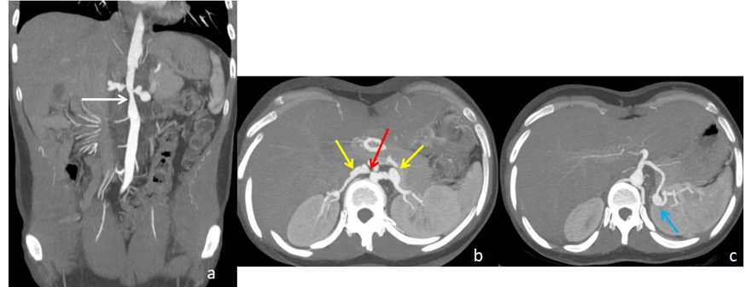

Figure 1: Abdominalcomputed tomography angiography in coronal (a) and axial (b, c) sections showing stenosis of the infrarenal abdominal aorta (white arrow), ostial stenosis of the right renal artery (red arrow), saccular and fusiform aneurysms of the two renal arteries (yellow arrows) and a saccular aneurysm of the splenic artery (blue arrow).

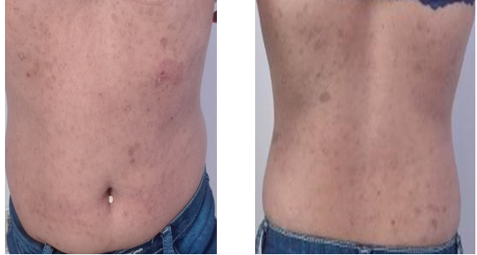

Figure 2 :Café-au lait spots on the patient’s abdomen and back.

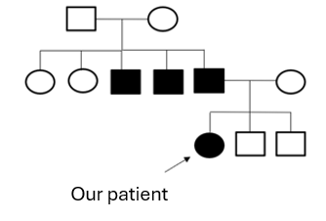 | 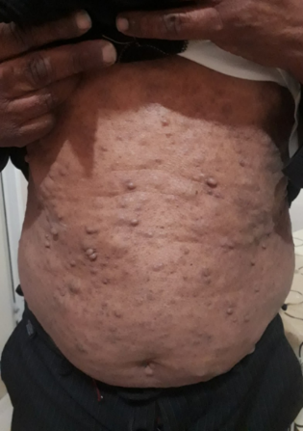
Figure 3: Genealogical tree of our patient. | Figure 4: Neurofibromas on the truck and abdomen in the father.

