Semiotic Representation in Basic Pupils’ Mathematics Textbooks: A Social Semiotic Analysis

Abstract
This study examines how semiotic resources are utilised in primary pupils' mathematics textbooks in Awka, Nigeria. The aim is to show how language, visuals, signs and symbols, as well as colours and framing, serve as veritable tools for examining mathematical practices and those of teaching and learning Mathematics. A descriptive design was adopted to analyse visual representations in the selected Mathematics textbooks. Data for the study, which comprised sixteen images, were randomly selected from Mathematics Expert Book for Basic Education 1 and Modular Mathematics for Primary 2. Pictures/images and texts sourced from the two textbooks were collected with a phone camera. The study is theoretically framed around Halliday’s (1978) view of social semiotics and Kress and van Leeuwen’s (2020) ideology of multimodality as frameworks for analysing mathematical concepts in basic pupils’ Mathematics textbooks. The study’s results show that visual representations in the textbooks contribute significantly to creating a deeper understanding of Mathematical concepts, solving problems, and providing a means for pupils to communicate their mathematical thinking and gain a better understanding during Mathematics classes. The study is significant in that the frameworks and methodological approaches adopted contribute to the study of social semiotics and mathematics education. It thus provides actionable insights for textbook designers, teacher educators, and curriculum developers, advancing both theory and practice in multimodal mathematics education.

Keywords: Awka, basic pupils, Mathematics textbooks, multimodality, semiotic representation, social semiotics
1. Introduction
Mathematics, the study of quantity, shape, and arrangement, is a knowledge-centred study that incorporates concepts such as structural, quantity, space, shapes, addition, and deduction, together with the academic discipline that studies them (Pepin, 2007). In teaching and learning Mathematics at basic levels, research reveals concerns about the need to examine the nature of language and other semiotic systems used in mathematical activities, as well as the potential roles these may play in enhancing pupils’ cognitive abilities and understanding of Mathematics. In this vein, a study highlighting the need for textbook designers to consider factors that enhance pupils' comprehension as they draw meaning from textbook content for improved understanding is indispensable. This is a clarion call for textbook designers to be conscious of resources which draw on such affordances as visuals, images, typography, colour saturation, mathematical signs and symbols that can increase pupils' cognitive reasoning in Mathematics classroom.
As Morgan (2006) notes, the nature of language and other semiotic systems used in mathematical activities, as well as the potential roles these may play in teaching and learning Mathematics by pupils at the basic level of learning, have come to light as a result of the "turn to language" in the theoretical perspectives adopted by researchers in Mathematics. On this note, language, visuals, signs, symbols, colours, and framing, and other meaning making resources, are veritable tools for examining mathematical practices, as well as those of teaching and learning Mathematics. These resources are found to help teachers and pupils learn about language usage in mathematical procedures, which can be beneficial for both teaching and learning at the basic level.
The application of social semiotics to the analysis of Mathematics is relatively less explored compared to other fields (Anderson et al., 2003; Rotman, 2006; & Presmeg, 2006). In several studies, scholars explore the relationship between social semiotics and Mathematics education; however, a Google search reveals that there are limited studies on the application of social semiotics in analysing mathematics textbooks and how such affects or enhances mathematics teaching and learning in Awka and Nigeria in general. Nonetheless, some scholars have discussed the relationship between social semiotics and education as well as other aspect of semiotic representation ((Makinde & Oyewole, 2024; Makinde & Odili, 2023; Makinde & Mgbodi, 2022; Nweze, 2020; Daher & Thabet, 2020); as well as studies on multimodal literacy and textbook design (Unsworth, 2001), multimodal pedagogies in learning (Jewitt, 2008) and Mathematics teaching discourse (Rowland, 2003), all providing insightful contributions to pedagogical discourses.
Among such studies is Nweze’s (2020) Same symbols, different representation: The semiotics of Linguistics and Mathematical notations, which focuses on the disciplinarity of Mathematics and Linguistics through semiotic theory, investigates the different representations of similar symbols found in Linguistics and Mathematics. Findings from her study are restricted to similar symbols in use by both Linguistics and Mathematics. Such similar symbols include the cross/positive (+) symbol, the negative/minus sign (−), the “x” symbol, the symbols of inequality - > < (greater and less than), the superscript symbol (X_{mmm}), the equivalent/equal sign (=), structures, shapes, among others. In all of these analyses, the study fails to pay attention to visual and typographical as well as other affordances common with multimodal analysis.
In another study on ‘Symbolizing and communicating in Mathematics classrooms: Perspectives on discourse, tools, and instructional design’, Cobb et al. (2012) applied social semiotics to study how classroom discourse and materials shape students' mathematical learning. Their study emphasises the social and cultural aspects of Mathematics education, exploring how symbols, gestures, and other semiotic resources are used in the classroom to construct meaning and facilitate mathematical understanding.
Furthermore, Makinde (2023), in his “Visual representation of ASUU strikes in Nigeria: A semiotic analysis of cartoons in selected Nigerian newspapers”, explores the semiotics of cartoons in selected Nigerian newspapers to ascertain how meaning-making resources are employed in the visual representation of Academic Staff Union of Universities (ASUU) strikes in Nigeria. The study adopts Kress and van Leeuwen’s visual semiotics, Halliday’s Systematic Functional Linguistics (SFL) approach, and O’Halloran’s position on metaphorical constructions of meaning as theoretical frameworks for the analysis. Findings from the study show that semiotic resources are veritable tools for analysing visuals, thereby enhancing the use of symbols and visual metaphors to simplify and communicate complex ideas and concepts.
In a recent publication, Javed and Attah (2024) scrutinise the portrayal of diverse cultural and ethnic groups via visual images in Grade 5 textbooks. Their study shows how the textbook designers aligned with the 2020 Single National Curriculum in their incorporation of multicultural values in the selected visual elements. The study employed a mixed-method approach in the analysis of 11 images. Using Nasional’s (2010) model on education’s role in promoting social cohesion cum diversity appreciation as well as Widodo’s (2018) view of CDA, the study reflects on the religious, social tolerance and social awareness in the visuals examined. The findings show a predominant representation of Islamic religion and stereotypical in its depiction of social tolerance. The findings show that the study lays emphasis on cultural rather than semiotic representation.
In another study, Okeke et al (2023) explore the creative skills necessary for achieving sustainable development goals in Mathematics teaching and learning in Anambra State, Nigeria. The study adopts a descriptive survey design. A 20-item questionnaire on creative skill use in teaching and learning Mathematics was administered on a total of 89 Mathematics teachers in Awka Educational Zone which serves as the population of the study. From the findings, the researchers confirm that problem solving skill, effective communication, constructive reasoning skill, computational skill as well as critical thinking were useful for teaching and learning. This study while emphasizing the importance of practical and student-centred learning approach as the key to implanting creative skills in mathematics classrooms failed to show the role of visuals and other mathematical related resources as affordances for teaching and learning.
It is clear from the foregoing that there is a dearth need to examine a semiotic representation of basic pupils’ Mathematics textbooks in Awka from the lenses of social semiotic analysis. This is due in part to the fact that there is limited study, to the best of the researchers’ knowledge, on how pupils at the basic level draw on signs and symbols in mathematical classes to enhance their understanding during and outside classroom settings. Therefore, this study, which aims to examine a semiotic representation of basic pupils’ Mathematics textbooks in Awka: A social semiotic analysis; x-rays how signs, symbols, colours and visual elements as semiotic resources are made to convey meaning.
1.1 Research Questions
The following research questions guide the study under investigation:
- How is meaning constructed in mathematics textbooks for basic pupils?
- What roles do visual images play in pupils’ mathematics learning at the basic level?
- How does Mathematics learning at the basic level support pupils’ cognitive ability to understand Mathematics?
- In what ways do images enhance pupils’ imagination and creativity Mathematics learning?
2. Theoretical Framework
This study draws on Halliday’s (1978) view of social semiotics as well as Kress and van Leeuwen’s (2020) ideology of multimodality as frameworks for the analysis of mathematical concepts in basic pupils’ Mathematics textbooks. In highlighting the role of social semiotics in language, Halliday (1978) notes that languages develop as systems of “meaning potential” or as collections of tools that affect the speaker’s ability to use language in a specific social setting. According to Bezemer and Jewitt (2009), social semiotics studies the processes involved in producing meaning; it examines the channels and modes of communication that people select and build to convey their worldview and negotiate power dynamics with others. Furthermore, social semiotics examines how discourse is produced and shared in a range of social and cultural contexts where meaning is created by drawing on qualitative, fine-grained analysis of records of meaning-making, such as "artifacts," "texts," and "transcripts (Bezemer and Jewitt, 2009).
Social semiotics, therefore, examines nonverbal cues including body language, gestures, and visual communication in addition to words. It considers how various multimodal communication channels and languages interact to create meaning and promote social relationships. The field of social semiotics offers a comprehensive framework for comprehending the social construction of meaning and the ways in which communication practices impact, influence, and are related to social structures, relationships, and cultural contexts. Understanding how signs and symbols shape our social environment is made easier by social semiotics. For the purpose of this study, the theoretical framework will enable the analysis of how meanings are created in basic pupils' Mathematics textbooks through the incorporation of multimodal artifacts. Kress and van Leeuwen’s view of multimodality would enable the analysis of the data from the representation, interactive and compositional lenses.
3. Methodology
This study adopted a descriptive research design in its semiotic representation of basic pupils’ Mathematics textbooks in Awka. The researchers adopted a random sampling technique to select data from the selected texts for analysis. Data for the study, which comprised sixteen images, were randomly selected from two basic pupils’ Mathematics textbooks (Mathematics Expert Book for Basic Education 1 and Modular Mathematics for Primary 2) in Awka, Anambra State. Pictures/images and texts sourced from the two Mathematics textbooks were captured from publicly available textbooks used for classroom instruction. The collection enables us to present the visual elements in these texts for semiotic analysis, and solely for academic purposes. Also, care was taken to ensure that no proprietary or copyrighted designs were commercially reproduced. The study complied with institutional research ethics on educational material use for non-commercial analysis.
The use of a phone camera, while practical for capturing visuals in the field, may present minor limitations in image fidelity. However, all images were verified for clarity and legibility before analysis. Future studies may employ professional scanning tools to ensure consistency and replicability. Furthermore, the analysis is done using Halliday’s (1978) view of social semiotics and Kress and van Leeuwen’s (2020) ideology of multimodality. In terms of data analysis, the researchers categorized the data into segments in line with the objectives of the study to enable easy identification of semiotic resources found in the data under analysis.
4. Data Presentation and Analysis
4.1 Semiotic resources as meaning making in basic pupils’ Mathematics textbooks
Social semiotics, as Halliday (1978) notes, is a field of study that examines how language and other semiotic systems are used to construct and convey meaning within social and cultural contexts. It explores the interrelationship between language and broader social practices, and how these interactions contribute to the creation and negotiation of social identities. This enables the creation of meaning via such resources as images, colours, symbols, gestures, sounds, font size and mapping for better understanding and communication. The figures that follow depict the realization of meaning in the selected basic pupils' Mathematics textbooks.
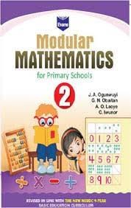
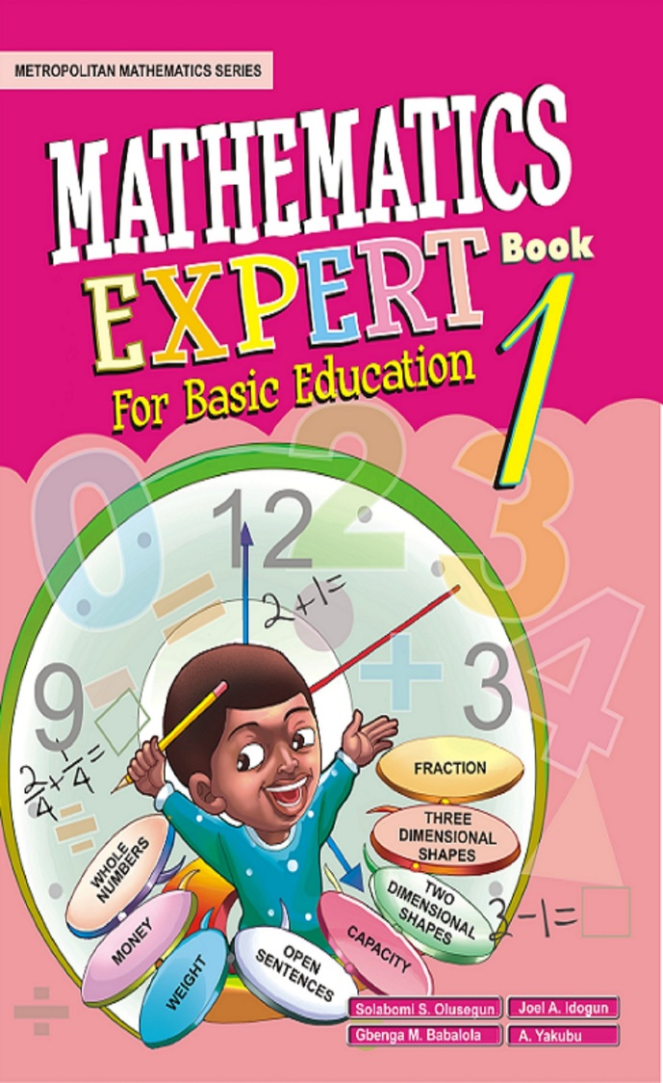

Figure 1a: Shows Mathematics Expert Figure 1b: Shows Modular Mathematics
Textbook for basic 1 Cover Page Book for Basic 2 Cover Page

Figure 1a is captioned Mathematics Expert Book for Basic Education 1. The cover page of the textbook, in its top-down reading direction via framing, is segmented into two worlds of textual and visual representation, depicting its multimodal and attractive nature. The two segments depicted in a top to bottom reading directions showcase the projection of two boundaries. The first is a boundary of textual elements represented via the book series, and the artistic title of the textbook. At the top left of the cover page is the "Metropolitan Mathematics Series" written in bold, which indicates that the book is a comprehensive curriculum designed to teach Mathematics to pupils in elementary and middle schools.
Next is the title of the textbook captioned Mathematics Expert Book for Basic Education 1. This caption is made salient via colours and sizes of different forms in a reduced descending order. The designer makes use of a close display font and capital letters, designed to grab the attention and mind of the reader. Semiotic elements found in the textbook cover page include colour, salience, and visuals. The texts are foregrounded by two shades of pink background, an affordance that helps bring the title of the textbook to the forefront. Thus, the use of multiple colours such as golden for the title and yellow for “Book for Basic Education” help to reinforce the artistic text that shows the level to which the textbook is assigned. The second boundary of Figure 1a presents the visuals of such participants as wall clock, a boy, pencil as well as mathematical symbols and shapes with texts relating to Mathematics on a light pink background.
The use of colours of different sorts as affordances for meaning-making in this figure is unique for a textbook of this level. The pink colour is associated with sweetness, love, nurturing, and femininity; the blue colour on the boy’s clothing represents masculinity, while green represents life, energy, and youth. The use of gold colour here signifies treasure, value, and good academic achievement and accomplishment. Also, the use of yellow depicts various meanings as it is associated with kids, often conveying feelings of joy, energy, and positivity. Its use is commonly linked to sunshine and warmth, prompting thoughts of outdoor play, fun, and happiness. In this way, depiction of yellow symbolizes optimism, friendliness, open-mindedness, cheerfulness, and a sense of adventure, which children often exhibit.
Also, observable in this figure is the visual representation of the pupil and the activities involved at the centre part of the cover page of the textbook. The center cover page of the textbook is written with numbers from 0 to 4. This is followed by a visual representation of a clock showing a little boy at the center of the clock, with both hands lifted. At the left raised hand, the boy is shown holding a pencil; and from compositional view, the participant was shown gazing directly at the audience with eyes wide open.
Another key element of the Fig is its depiction of numbers. The numbers "9, 12, and 3" are written inside the clock: 9 on the right, 12 at the top, and then 3 on the left, which represents the most important part of a clock with a specific meaning. The number "12" on the clock represents midday or midnight; the number "3" corresponds to the right-hand side of the clock face and represents three hours past the number or a quarter past an hour. These numbers "9, 12, 3" on the clock face help instruct the pupils on how to read the time on an analog clock. The dots in between the numbers "9, 12, 3" show the omission of some numbers.
Also, the arrow that runs from the boy's head up to the number 12 represents "hour," while the arrow that runs from the forehead down to the second dot represents "minute". The texts at right hand down to the left-hand side of the boy are written in an oval form to show the content of the textbook (whole numbers, money, weight, capacity, two-dimensional shapes, three-dimensional shapes, and fractions) as mathematical resources for meaning-making. These resources are all depicted via different colours saturation. On the left-down segment of the cover page, there are rectangular shapes with a pink background, and the authors’ names depicted in white colour. All these affordances have been systematically designed as meaning-making resources for representing the textbook for pupils’ consumption.
Also, Figure 1b represents the cover page for Modular Mathematics for Basic 2. The visual is divided into three segments. The multiple layers of framing segmented by colour of different sorts as well as lines and curves help to showcase the multimodal artifacts employed by the designer. The top part is designed with two shades of purple indicating enchantment, feeling of royalty, elegance, and empowerment that creates a world of fantasy for kids. Still at the top center of the figure, the designer uses some worth white colour for the background which signifies the innocent and pure nature which kids exhibit. The white background houses the title of the book, Modular MATHEMATICS for Primary Schools with shapes, sizes and colours of different sorts. Also, there is a boundary of intersection where the textbook's title and company logo intersect at the top of the frame, followed by the list of authors which serve as a means of identification and reference.
At the center segment of the visual, the designer uses yellow and light shade purple which signifies openness and friendliness which kids exhibit in their social interaction. Furthermore, the figure shows two represented participants and other visual elements as numerical symbols. The two participants are pictures of two pupils who are involved in some exercise in a classroom setting. The two pupils (a boy and a girl) depicted are involved in a mental process of gazing. The boy child is looking directly at the book in his hands while the girl child is depicted gazing at the white board. Other participants are books, tables, chairs and whiteboard. Below the boy child are the four basic arithmetic operations (division, multiplication, subtraction and addition) all signifying the symbols of Mathematics elements. Finally, at the down segment, below the represented participants, is the text “Revised in line with the New NERDC 9-Year Basic Education Curriculum”, indicating the author’s compliance with the Nigerian Educational Research and Development Council (NERDC) in designing the basic pupils’ textbook. Therefore, the artistic use of semiotic materials such as framing, colours, font size, artistic designs of different texts, typographical mathematical symbols (÷, x, - and +) and top-down reading direction contribute to creating meanings for pupils’ better understanding.
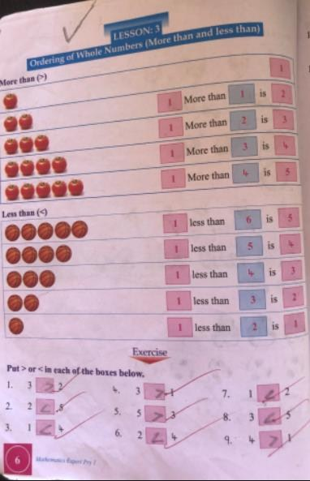
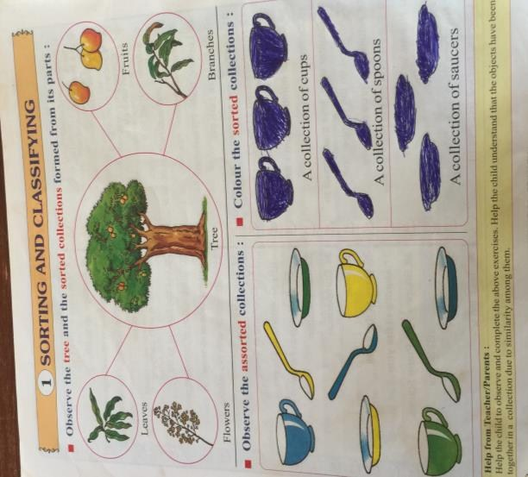

Figure 2: Showing the order of whole numbers Figure 3: Showing sorting & classification
Source: Mathematics Expert Basic1 Source: Modular Mathematics Basic 2

Figure 2 is made up of three segments, which include the top, centre and the down segments. This is achieved via semiotically framing of numerical items to depict the ordering of whole numbers (greater than and less than signs) for pupils’ visual identification. In an image-numeral-textual representation, the author uses images to explain to the pupil how to order whole numbers from ascending to descending order and from descending to ascending order. In the first segment, the designer uses images of tomato (1-5) to illustrate the order of whole numbers from ascending to descending order, while in the second segment, the author uses images of basketball (5-1) to illustrate the order of whole number in a descending and ascending order. Using the visual elements that the pupils are conversant with enables them to relate visuals with mathematical sorting and classification.
From the analysis above, the author depicts visually how "1" added to a whole number is more than the whole number and "1" subtracted from a whole number is less than the whole number to portray the role of less than (<) and greater than (>) as resources for mathematical symbols. The figure employed many affordances such as colour, signs and symbols as depicted in the use of boxes with two colours (pink and blue), with each box having its specific function. The first pink colour boxes indicate the "1" number added or subtracted from the whole number; the blue colour boxes indicate the numbers which are more or less than the whole number, while the last pink boxes indicate the whole numbers. In the last segment, the author gives the pupils exercise that will help them understand and identify when a number is more or less than a number using the symbol greater/less than. The various items employed here are used to enhance the pupils’ cognitive ability, widen their knowledge of comparison, as well as their thinking ability. The complementarity nature of the images helps to create meaning as the pupil compare the elements.
Figure 3 with the captioned “Sorting and Classifying” depicts the action of arranging items or data in a particular order, often based on similarities, differences, or specific attributes. In practical terms, sorting often involves arranging objects from smallest to largest, grouping items by colour, or organizing data in alphabetical or numerical order. By sorting, it becomes easier to identify patterns, analyze information, and locate specific items efficiently. The figure employed a lot of multimodal affordances such as signs, symbols, framing and Top-Down reading composition to drive meaning. At the center top is the image of a tree with an arrow showing the sorted collections formed from its parts; these collections include the leaves and flowers on the left and fruit and branches on the right. The down part is divided into left down and right down order. On the left down, kitchen utensils (cup, plate and spoon) are displayed for the pupils to sort accordingly. As per the right side of the frame, the objects are sorted according to where they belong for the pupils to colour.
4.2 The roles of images in learning Mathematics by pupils at the basic level
Images are representations of objects, scenes, concepts, or ideas that are perceived through the sense of sight. These images can take various forms, including photographs, paintings, illustrations, diagrams, charts, graphs, and any other visual representations that convey information or evoke emotions. In a broader sense, image encompasses the entire visual experience, including elements such as colour, shape, texture, composition, and spatial relationships. They play a crucial role in communication, storytelling, art, design, advertising, and many other aspects of human expression and interaction. Images are often used to capture attention, convey messages, and create a compelling visual narrative. In the figures that follow, a number of these affordances have been employed in the textbook in order to enhance the teaching and learning of Mathematics.

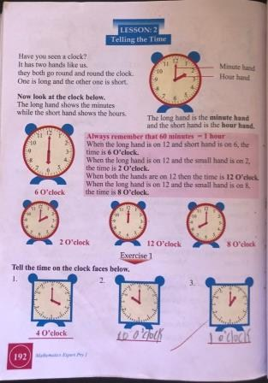
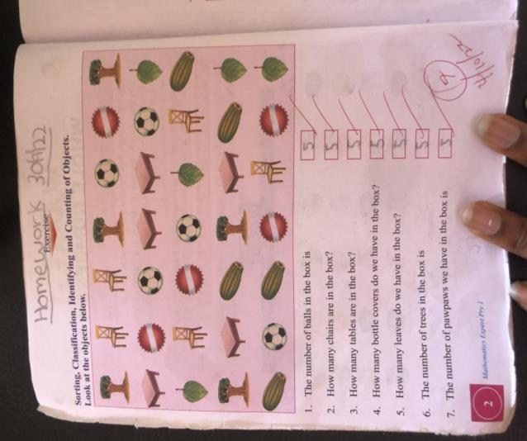

Figure 4: Telling the time Figure 5: Identification & counting of objects
Source: Mathematics Expert Book 1 Source: Modular Mathematics for Primary 2

In Figures 4 and 5, framing and other affordances serve as semiotic resources in the data presented. The figures provide a concrete representation of mathematical concepts, making them easier to understand. Different images represented with different items are depicted here to help the pupils visualize and comprehend geometric shapes, recognize them, and think correctly. Images enhance memory and retention; thus, the designer’s use of visual representation of mathematical concepts enables the pupils to remember and recall the information better, leading to a deeper understanding of the topic.
Figure 4 captioned “Telling the Time” depicts different semiotic devices (colours, lines, and shapes) used to represent a clock, with such affordances as the two long and short lines that run from the center of a clock. The long line represents “minute”, while the short one depicts “hour”. Numbers from 1 to 12 are also arranged in a circular form, starting with the number "1", which runs from the top right backwards to the number "12". There are also tiny lines in between the numbers, which are used to represent "seconds." Colours are used as well to separate the parts and beautify visuals. With the two fingers, the tiny lines, numbers and colours, the pupils can easily identify and tell time correctly.
Also, Figure .5, captioned "Sorting, Classification, Identification and Counting of Objects" depicts object classification. Visuals of items like tree, chair, ball, table, bottle cover, leaves, and pawpaw are displayed for the pupils to identify and count the objects. With a top-down representation of visual-textual depiction in Figure 5, the pupils are exposed to identification and sorting of objects using their shapes and colours, which are elements of visual semiotics. Thus, with such resources as participants in terms of chair, table, leaves, pawpaw, ball couple with colours, shapes, and size, the pupils’ consumption are enhanced via visual elements. These resources help unpack how different objects are classified for pupils’ identification.

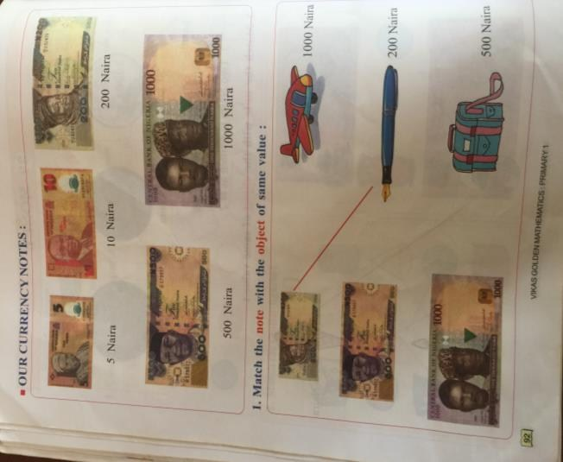
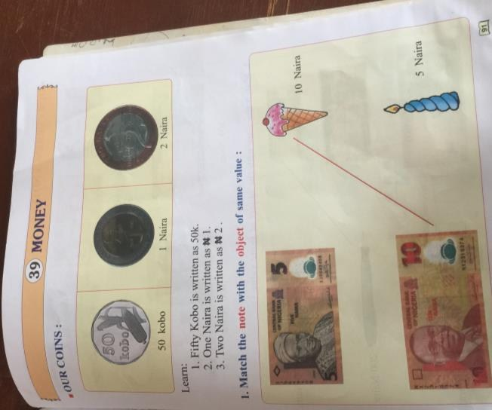

Figure 6. Identifying Nigerian currencies and its value
Source: Mathematics Expert Book for Basic 1

In Figure 6, visual elements are displayed to test the pupils’ ability in relating notes to the objects. The images follow a top-down reading structure to show important information presented, which allows pupils to grasp the main idea and understand the implied meaning in the text. The images provide a concrete representation of mathematical concepts, making them easier to understand. Different denominations of the Nigerian currency are represented using coins and naira notes. The Nigerian currency consists of three coins: the fifty kobo (50k), one naira (N1), and two naira (N2), and eight notes: N5, N10, N20, N50, N100, N200, N500, and N1000, as depicted in the figure above. These currencies are composed of different colours to evoke emotions and convey meaning, as depicted in the use of images of Nigerian heroes. Such representation contributes to the constitution of social identities and facilitates easy recognition. The amounts are written both in words and in figures, with colours to enhance their appearance. In the image, the notes are placed side by side with objects such as ice cream, candles, pens, bags, and airplanes placed at the right side of the frame. In its complementarity, the currency notes were positioned on the left-hand side, alongside the objects, with the cost placed on the right, allowing pupils to identify and match the notes with the objects of the same value. This exercise helps pupils identify Nigerian currencies and their values easily through their sense of sight.

4.3 Semiotic resources as tools for enhancing basic pupils’ cognitive ability and learning of Mathematics
Cognition, which involves perception, attention, language, memory, problem-solving, and creativity, refers to the mental processes involved in acquiring, processing, and storing information. The American Psychological Association defines cognition as “the mental processes of perception, memory, judgment, and reasoning”. In teaching and learning Mathematics, cognitive skills are essential for learning, comprehending ideas, and engage with the world. In the figures below, several semiotic devices that contribute to the cognitive ability of pupils in realising the meaning potential of the texts are found in the basic pupils’ Mathematics textbooks under discussion.
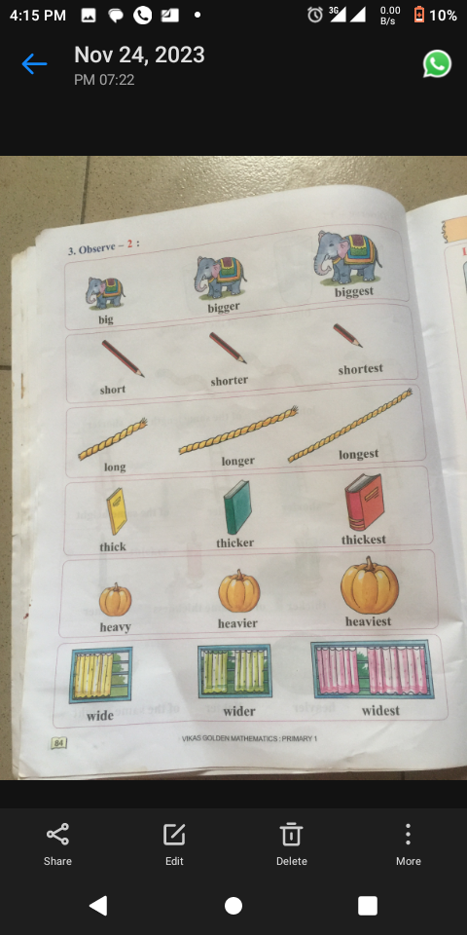
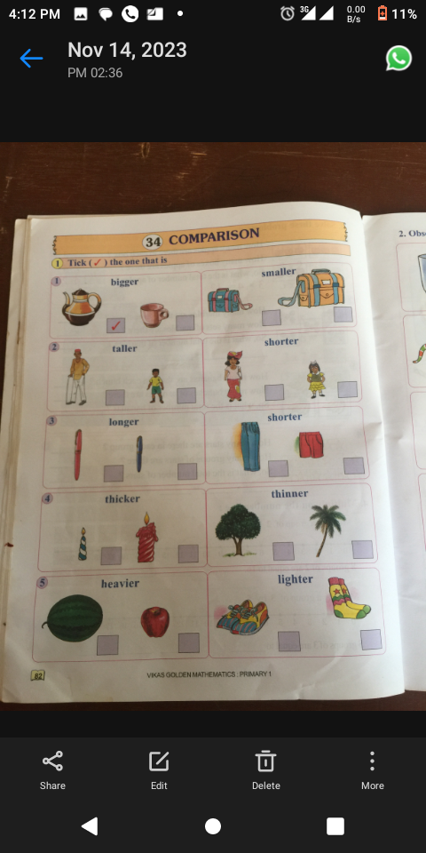

Figure 7a: Showing comparison Figure.7b: Showing Sorting/classification
Source: Mathematics Expert Book for Basic 1

In accounting for semiotic analysis, research showed that a social semiotic approach must focus on the resources available in the corpus, describe how they are used, and locate them within a value system. The figures above provide a top-down direction in their reading composition. In Figure 7, comparison is employed to determine and rate the pupils’ cognitive ability. Comparison is depicted here as the process of examining the similarities and differences between two or more objects. When making a comparison, individuals typically identify the characteristics, features, or qualities of the items being compared in order to evaluate whether they are alike or different. Comparison can be employed in semiotics to analyse and understand the meaning of signs and symbols in relation to other signs and symbols, as shown in the figures above. The use of comparison enables semioticians to identify similarities and differences within a particular sign system, as well as across multiple sign systems.
In Figure 7a, there is a contrast between the analysis of two signs or symbols that are opposites or contrasting to each other for the pupils to identify and show the existing differences via comparison. The contrast between “big” and “small”, “long” and “short”, “thick and thin”, “heavy and light” and objects of the same size are represented for pupils’ cognitive testing. In the figures, painting is employed to convey a significant impact on the overall meaning of the depicted objects. It also shows the degree of comparison, which is used to compare the intensity or extent of something. The comparative degree is used to compare two things, and the superlative degree is used to compare more than two things. In Fig. 7b, the objects, ‘elephant’ (big, bigger, biggest), pencil (short, shorter, shortest), rope (long, longer, longest), book (thick, thicker, thickest), and window (wide, wider, widest) are comparatively depicted to show the size and degrees of the objects. Figure 7 above presents photographs of people engaged in various activities; here, shapes are used in the image to highlight the differences, and with this semiotic device, the pupil can identify objects.
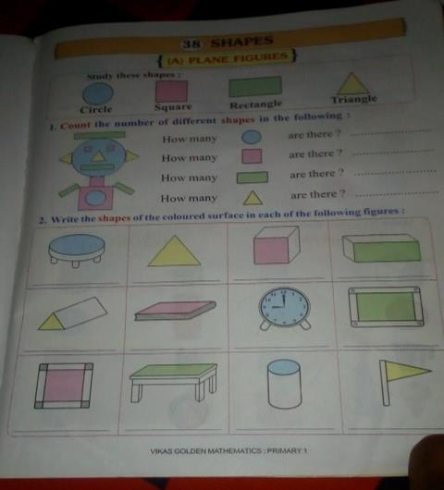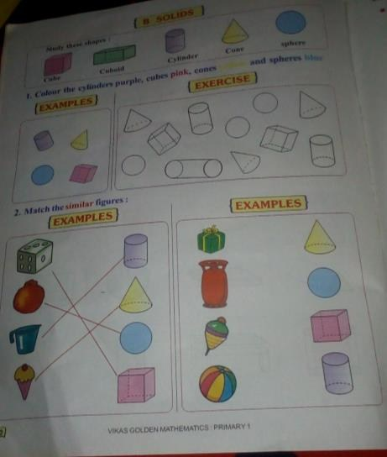

Figure 8: Plane and slide figures

The objects in Fig. 8 above are photographs of solid objects of various shapes and sizes, used to depict the diverse ways pupils at the basic level can be taught. The figures are presented in a top-down reading direction, which is segmented into three parts. At the top is the study of shapes, including the cube, cuboid, cylinder, cone, and sphere. At the center are visuals of shapes and exercises deployed to test the pupils’ cognitive level of colour. At the down part, objects of different shapes are placed side by side for the pupils to match them correctly. These exercises help pupils think critically and strengthen mental processes, such as memory, attention, concentration, cognition, and the ability to understand abstract concepts. Semiotically, the shapes, objects, colours and other resources employed here are designed to help pupils identify and solve mathematical questions.
4.4 Images as enhancer of the power of imagination and creativity of pupils at the basic level in learning Mathematics
Imagination, which involves creation of new ideas, images, and scenarios in the mind, is regarded as the capability to formulate mental images, sensations, and concepts that are not present in one’s immediate environment or experiences. Such creation allows the visualization of things that are not in existent or yet to happen in the real world. In Mathematics classroom setting, such creation plays a crucial role in creativity, problem-solving, and innovation. Thus, mental visuals, which serve as resources for mathematical learning by basic pupils, are represented in the figures below.

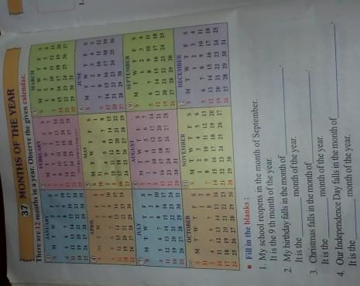
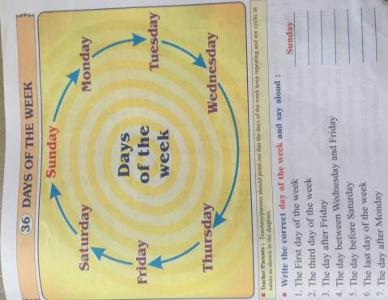

Figure 9: Months of the year. Figure 10: Days of the week
Source: Modular Mathematics for Basic 2

Figure 9 above presents mathematical concepts about the months of the year as a resource for teaching Mathematics to elementary pupils. The mathematical concepts portray through the visual representation of calendar are depicted using various visual semiotic devices such (colour, symbols, and signs), which help stimulate children's imagination and curiosity, sparking their interest in a particular topic or concept while learning Mathematics. This figure also triggers pupils’ imagination by providing them with a concrete representation that they can interact with and interpret in their own unique way. This semiotic device is employed as a means of teaching pupils months of the year as depicted in Fig. 9. The visual applies Kress and van Leeuwen’s (2006, 2020) top-down reading direction in its composition to show the sequence the months of the year follow. Other affordances used in the above figure include a font size display for the title, designed to grab the pupils’ attention and inspire them to express their thoughts, ideas, and emotions through various creative mediums. By engaging with visual content, pupils are inspired to create their own imaginative interpretations and artistic expressions. In the image, colours, rolls, and columns are used as resources to separate the months into segments. All of these put together are found to help ignite a sense of wonder and curiosity, leading pupils to explore and discover new ideas, themes, and concepts. Visual representations, therefore, serve as gateways to further exploration, inquiry, and discovery, fueling pupils' natural inclination to learn and understand the world around them.
In Figure 10, the image depicts in a circular form the days of the week. The frame is segmented into two parts, namely the world of visual and the textual part below the image showing the days of the week. Here, the power of creativity is enhanced in the pupils via the exploration of various linguistic devices. The seven days in a week is represented here using arrows that depict their sequence of occurrence. As part of the affordances use, the circular representation of the days which start from Sunday to Saturday shows the pedagogical approach adopted in teaching pupils how to, in a circular manner, learn the various days in a week. The colours, lines, and sequence adopted in this visual serve as resources for encouraging pupils to think critically and analytically as they interpret and make sense of what they see. This process enhances pupils’ creative thinking by prompting them to ask questions, make connections, and consider multiple perspectives in the process of learning Mathematics. In this way, the visual provides a guide to answer the questions that follow it.
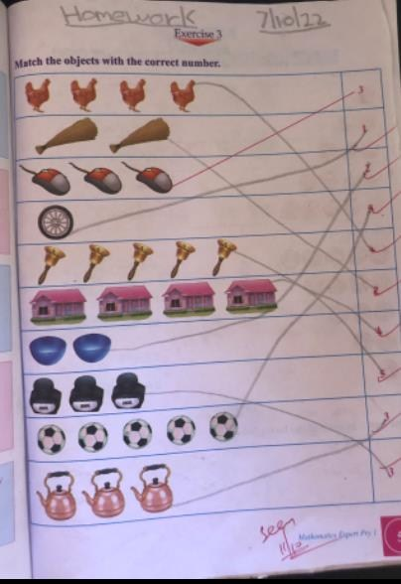
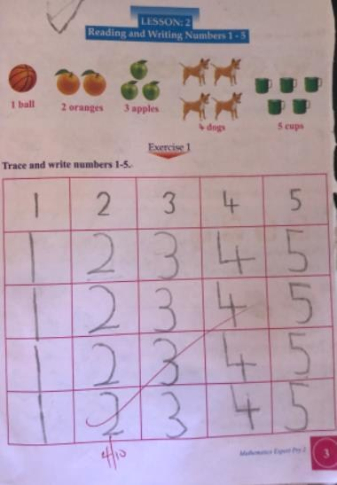

Figure 11: Showing reading and writing numbers Figure 12: Matching objects
Source: Mathematics Expert Book for Basic 1

In Figures .11 and 12 above, framing and other affordances serve as resources in the data presented. Visual elements are displayed to test pupils’ ability in relating objects to numbers. Using two modes (visual images representing numbers and textual elements that contribute to the semantic import of the numbers) as semiotic devices also helps to test the pupils’ knowledge and cognitive ability. The use of signs and symbols to show how different objects are used to teach the pupils calculation via the use of figures, signs, and images. Different items, such as a broom, mouse, clock, bell, house, kettle, and plate, are placed side by side with different numbers for pupils to match them where they fit in. These meaning-making devices help the pupils link objects with numbers correctly and help them identify and locate them.

5. Discussion of Findings and Conclusion
This study attempted to establish the semiotic representation of two selected primary school textbooks (as indicated in the methodology) in Awka, Anambra State, Nigeria, by referring to Kress and van Leeuwen’s (2020) framework as the basis of our analysis. As presented in the data collected, as well as personal observations, the study showed that:
i) The pupils demonstrated different learning preferences, such as imitation or image-based learning.
ii) Some mathematical concepts, such as telling the time and division, were challenging but made it easier with visuals.
- Pupils make use of Mathematics in their everyday lives, especially in their communication outside the school premises.
- Pupils learn faster when teachers use visuals and demonstrations to carry them along.
The study showed how Mathematics textbook designers employ semiotic resources in basic pupils’ texts for pupils to mean, think and interpret sign systems that stand for or represent meanings that are embedded in the textbooks under discussion. In all, visual elements are shown to play crucial roles in enhancing basic pupils’ cognitive ability in learning Mathematics. This study has been shown to be significant in that it serves as a resource for teachers of Mathematics at basic levels in their teaching of Mathematics as they rely on visual representation. Therefore, the study recommends that all teachers at basic levels should endeavour to make use of visuals depicted by textbook designers in the teaching during classroom discourse.
In view of the foregoing, findings from this study hold direct implications for teachers, curriculum developers, including the Nigerian Educational Research and Development Council (NERDC), by highlighting the need for visually inclusive and multimodal materials at the primary school.
The researchers suggest that study on semiotic representation of other subjects should be conducted using the same framework for analysis. Also, considering the pedagogical implication of the study, further studies from a comparative standpoint on semiotic representation of basic pupils’ textbooks between Asia and Africa could be conducted to enable the identification of overt or coverts resources.

Disclaimer (Artificial intelligence)
Option 1:
Author(s) hereby declare that NO generative AI technologies such as Large Language Models (ChatGPT, COPILOT, etc.) and text-to-image generators have been used during the writing or editing of this manuscript.
Option 2:
Author(s) hereby declare that generative AI technologies such as Large Language Models, etc. have been used during the writing or editing of manuscripts. This explanation will include the name, version, model, and source of the generative AI technology and as well as all input prompts provided to the generative AI technology
Details of the AI usage are given below:
1.
2.
3.

References
Anderson, M., Sáenz-Ludlow, A., Zellweger, S. & Cifarelli, V. V. 2003. Educational perspectives on Mathematics as semiotics: From thinking to interpreting to knowing: Ottowa: Legas.
Bernstein, B. 1996. Pedagogy, symbolic control and identity: Theory, research, critique. London: Taylor and Francis.
Bezemer, J. & Jewitt, C. 2009. Social semiotics. In: Handbook of pragmatics: Installment. Jan-Ola Östman, Jef Verschueren and Eline Versluys (eds). Amsterdam: John Benjamins.
Cobb, P., Yackel, E. & McClain, K. eds., 2012. Symbolizing and communicating in mathematics classrooms: Perspectives on discourse, tools, and instructional design. Routledge.
Daher, W., & abu Thabet, I. 2020. Social semiotic analysis of Palestinian Mathematics textbooks for eighth grade. Journal of Research and Advances in Mathematics Education (JRAMathEdu), 5(1), 1-12.
Draper, R. 2015. Using the common core state standards to support disciplinary literacies. Voices From the Middle, 22(3), 58-62.
Halliday, M. H. K. 1978. Language as social semiotic: The social interpretation of language and meaning. London: Edward Arnold.
Javed, Z. & Attah, A. 2024. Representation of multicultural values through images in educational textbooks: A semiotic analysis. Jahan-e-Tahqeeq, 7(1). 81-97.
Jewitt, C. 2008. Multimodality and literacy in school classrooms. Review of Research in Education, 32(1), 241-267.
Kress, G & van Leeuwen, T. 1996. Reading Images: A grammar of visual design (1st ed). London: Routledge.
Kress, G. & van Leeuwen, T. 2001. Multimodal discourse. The modes and media of contemporary communication. London: Edward Arnold.
Kress, G. & van Leeuwen, T. 2006. Reading images: A grammar of visual design (2nd ed.). London: Routledge.
Kress, G. & van Leeuwen, T. 2020. Reading images: A grammar of visual design (3rd ed.). London: Routledge.
Makinde, P. O., & Mgbodi, L. U. 2022. A social semiotic discourse analysis of gender expressions in selected Nigerian newspapers. Language in India, 22(5), 175-189.
Makinde, P. O., & Odili, P. A. 2023. A social semiotic analysis of selected basic pupils’ English textbooks in Awka." International Journal of Systemic Functional Linguistics, 6(2), 62-69.
Makinde, P. O., & Oyewole, J. U. 2024. Carpe diem: A semiotic metaphorical representation of LOVE, SEX, and SEDUCTION in Andrew Marvell’s “To His Coy Mistress”. University of Chitral Journal of Linguistics and Literature, 8(2), 1-6.
Makinde, P. O., 2023. Visual representation of ASUU strikes in Nigeria: A semiotic analysis of cartoons in selected Nigerian newspapers. Language and Semiotic Studies, 9(2), 242-262.
Morgan, C. 2006. What does social semiotics have to offer Mathematics education research? Educational Studies in Mathematics, 61, 219-245.
Nasional, K. P. 2011. Pelaksanaan pendidkan karakter. Jakarta: Badan penelitian dan pengembangan Pusat Kurikulum dan Perbukuan.
Nweze, I. M. 2020. Same symbols, different representation: The semiotics of Linguistics and Mathematical notations. International Journal of Research in Arts and Social Sciences, 5.
Okeke, A. N., Anakpua, B. C., & Egbule, E. E. 2024. Exploring the creative skills necessary for achieving sustainable development goals in Mathematics teaching and learning. AJSTME 9(1), 2971-623.
Pépin, L. 2007. The history of EU cooperation in the field of education and training: How lifelong learning became a strategic objective. European Journal of Education, 42(1), 121-132.
Presmeg, N. 2006. Semiotics and the “connections” standard: Significance of semiotics for teachers of mathematics. Educational Studies in Mathematics, 61(1), 163-182. https://link.springer.com/article/10.1007/s10649-006-3365-z
Rotman, B. 2006. Towards a semiotics of mathematics. In 18 unconventional essays on the nature of Mathematics (pp. 97-127). New York, NY: Springer New York. https://link.springer.com/content/pdf/10.1007/0-387-29831-2_6.pdf
Rowland, T. 2003. The pragmatics of Mathematics education: Vagueness and mathematical discourse. Routledge.
Unsworth, L. 2001. Teaching multiliteracies across the curriculum. Buckingham: Open University Press.
Widodo, H. P. 2016. Language policy in practice: Reframing the English language curriculum in the Indonesian secondary education sector. In Kirkpatrick, R. English education policy in Asia, 127-151. Cham: Springer International Publishing.

