
Original Research Article

Modeling Urban Surface Runoff in Tropical Watersheds Using the SCS-CN Method on Google Earth Engine: Case of the Gourou Basin

ABSTRACT
The Gourou watershed, located in the metropolitan region of Abidjan, is highly vulnerable to flooding due to rapid urbanization and the increasing frequency of extreme rainfall events. To address the challenge of runoff estimation in this ungauged tropical urban basin, this study develops and applies an innovative, spatially explicit methodology that quantifies surface runoff through the Soil Conservation Service Curve Number (SCS-CN) method, integrating pedological characteristics (soil textures) and dynamic land use patterns.
Our approach leverages an automated processing chain implemented in Google Earth Engine, enabling high-resolution land use classification (overall accuracy: 99.58%; Kappa index: 0.97), spatial interpolation of soil data (based on 19 sampling points), computation of Curve Numbers (CN) through matrix cross-referencing of soil texture and land use classes, and refinement of CN values through slope adjustments to enhance hydrological accuracy. Hydrological modeling was performed using the SCS equation.
The analysis reveals alarming hydrological indicators: a significant reduction in effective infiltration, an average runoff rate of 42.6% (runoff coefficient = 0.42), a total runoff volume of 827,113 m³ from cumulative rainfall of 1,941,220 m³, and widespread imperviousness — 77.8% of the watershed consists of built-up areas or bare soils (CN > 78). These conditions drive rapid surface flow concentration, intensifying flood peaks and highlighting the critical need for spatially targeted mitigation strategies in data-scarce urban watersheds.

Keywords: SCS-CN method, Runoff, Curve Number (CN), Urban flooding, Hydrological risk, Google Earth Engine (GEE)

INTRODUCTION
Surface runoff is a complex process influenced by several factors, including precipitation intensity and duration, soil type, land cover, vegetation cover, topographic slope, and hydrographic network density (Ponce, 1996; Mishra, 2003). Within a watershed, this dynamic transform rainfall into concentrated flows, feeding streams and increasing flood risks—particularly in urban areas where soil impermeabilization exacerbates the phenomenon (Brûlé, 2013). Extreme events, such as intense rainfall, can trigger sudden floods with catastrophic consequences, as observed in the Gourou watershed, where rainfall totals of 125 mm (June 21, 2022) and 80 mm (June 18, 2023) caused devastating flooding (Younta, 2024).
Accurate estimation of surface runoff remains a major challenge, especially in ungauged watersheds, where the lack of hydrometric data limits classical modeling approaches. Among available methods, the Soil Conservation Service Curve Number (SCS-CN) method, developed by the USDA (1986), stands out for its simplicity and effectiveness. It relies on a limited number of parameters, primarily the Curve Number (CN), which integrates land cover, soil type, and antecedent moisture conditions (Miller, 2009). Originally designed for rural watersheds, this method has been successfully adapted for urban and forested environments, offering valuable flexibility for hydrological risk assessment (Kumari, 2014).
However, traditional application of the SCS-CN method requires laborious manual processing of geospatial data, which may introduce delays and uncertainties. The emergence of cloud-based platforms such as Google Earth Engine (GEE) has revolutionized this approach by enabling large-scale automated computations. Thanks to access to up-to-date satellite catalogs (e.g., Landsat, Sentinel) and distributed computing power, GEE facilitates rapid extraction of key parameters (land cover, vegetation index, slope) and dynamic runoff calculations.
This study proposes an innovative methodology for mapping surface runoff and identifying high- risk flood zones in the Gourou watershed by combining the SCS-CN method with the capabilities of Google Earth Engine.

Study area
The Gourou watershed (Fig.1) is located in the Autonomous District of Abidjan (Côte d’Ivoire). It lies between latitudes 5°10' and 5°25' North and longitudes 3°59'10" and 4°2'30" West. This watershed covers an area of approximately 27.5 km² (Mélanie Riess (2015), extending along a north-south axis about 9 km in length and 3 km in width from east to west. It is bounded to the east by the Boulevard Latrille, to the west by the Adjamé– Anyama railway line, to the north by the

municipality of Abobo, and to the south by the Bay of Cocody and the Plateau municipality (Coulibaly et al, 2014). Its main drainage canal corresponds to the former bed of the “Gougou” river, as named in the Atchan (Ébrié) language. All surface water within the watershed converges toward its outlet located at the Indénié junction, at the intersection of the municipalities of Plateau, Cocody, and Adjamé, before flowing into the Ébrié Lagoon.

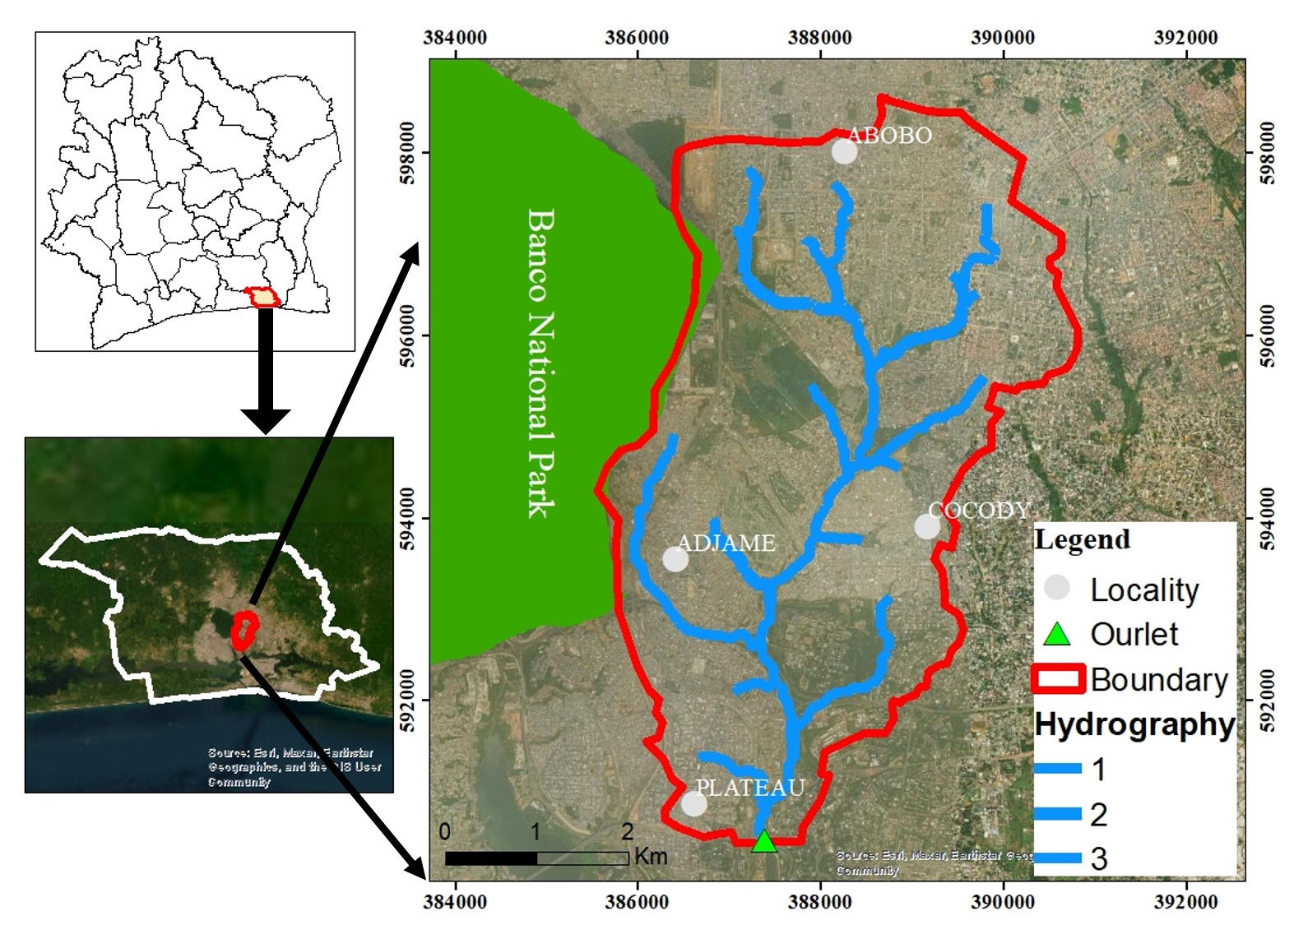

Materials and Methods

  - Materials

Data Used
Fig 1. Gourou watershed

The data used in this study (Table 1) include rainfall data, remote sensing imagery, and pedological (soil) data.

Table 1. Types of data used in the study

Data type and format Source / Sensor Key characteristics Use in the study

Rainfall data (Raster - GeoTIFF)

Satellite image (Raster - GeoTIFF)

Pedological data (CSV)
Climatic data (2022) https://www.chc.ucsb. edu/data/chirps
Landsat 8 – USGS EarthExplorer http://earthexplorer.us gs.gov

Field campaign (19 sampling points)
- Wettest month: June (avg. 266 mm)
- June 2022: 424 mm
- Selected event: June 16–17, 2022
(73.05 mm)
- Spatial resolution: 30 m
- Date: January 20, 2022
- Bands: B4 (0.636–0.673 µm), B5 (0.851–0.879 µm), B6 (1.566–1.651
µm)
- Soil texture analyzed in laboratory
- Sites covering various land cover types and geomorphological units
Selection of extreme event for simulating runoff using the SCS- CN method
Land cover mapping (LCM) used to assign CN values based on soil texture

Classification of soil hydrologic groups for CN calculation

DEM (Raster - GeoTIFF)
ALOS PALSAR
https://search.asf.alas ka.edu
Spatial resolution:
- Elevation model derived from radar interferometry
Determination of slope and flow direction for assessing runoff coefficient and topographic factors

12.5 m
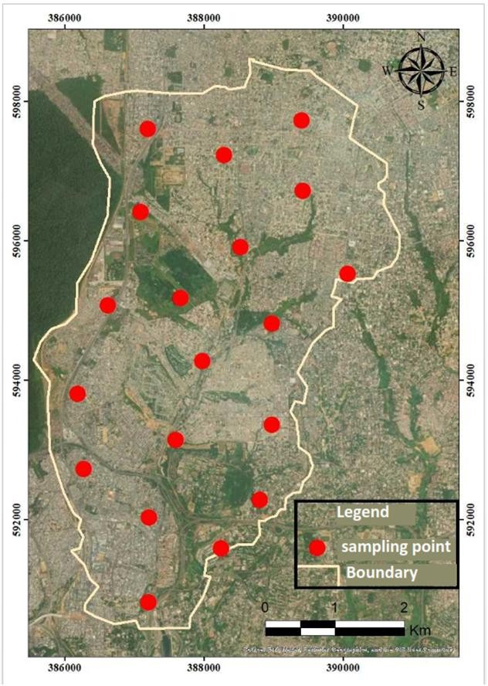

Methods

The methodology adopted in this study combines the SCS-CN model with Google Earth Engine’s (GEE) spatial analysis tools to estimate surface runoff at the watershed scale.

Soil Classification and Hydrologic Group Assignment

Estimation of the runoff coefficient (Cr) in the SCS- CN method critically depends on soil physical properties, particularly texture, which strongly influences infiltration capacity (Shadeed, 2010). To this end, a soil sampling campaign was conducted within the Gourou watershed, targeting
19 georeferenced sites selected for their representativeness in terms of land cover and geomorphological variability (Fig.2). Soil samples were collected using a manual auger at depths ranging from 30 to 100 cm. Each sample, packaged in quantities of approximately 500 g, was transported to the laboratory of the Centre de Recherche en Environnement (CRE) at Nangui Abrogoua University. Granulometric analyses were performed in accordance with the AFNOR NF X31-107 standard to determine the respective percentages of sand, silt, and clay.

Fig 2. Selected soil sampling points

These granulometric data were then used to determine the textural class of each sampling point based on the USDA soil texture triangle. A spatial interpolation was performed using the Inverse Distance Weighting (IDW) method within Google Earth Engine to generate a continuous map of soil texture across the entire watershed.

Based on the identified textural classes, each soil

type was assigned to a hydrologic group (A, B, C, or D) in accordance with USDA (1986) classification guidelines. This grouping is based on estimated soil infiltration rates, defined as follows:

- Group A (Code 1): Highly permeable soils with high infiltration rates (> 25 mm/h); typically, sandy soils.

- Group B (Code 2): Moderately permeable soils with moderate infiltration rates (12.5–25 mm/h); typically, loamy sand or sandy loam.
- Group C (Code 3): Soils with low infiltration rates (2.5–12.5 mm/h); typically, sandy clay loam or silty clay loam.

- Group D (Codes 3 or 4): Soils with very low infiltration rates (< 2.5 mm/h); typically, clay, silty clay, or clay loam.

This hydrologic soil classification serves as a critical input for assigning Curve Number (CN) values in the runoff modeling process.

3.3. Land Cover Mapping Using Landsat 8

Land cover is a key parameter in determining the Curve Number (CN). To produce a recent and accurate land cover map, a supervised classification was performed using a cloud-free Landsat 8 OLI/TIRS image from the dry season of 2022, with a spatial resolution of 30 m Konan-Waidhet, 2022. The processing was carried out in ENVI 5.3 software, following several preprocessing steps: radiometric and atmospheric corrections, selection of relevant spectral bands (Bands 2 to 7 of Landsat 8), and definition of land cover classes based on ground truth data collection. Four main classes were identified: Class 1: Built-up areas / bare soil, Class 2: Dense Forest, Class 3: Degraded Forest, Class 4:
Wetlands / croplands. The Maximum Likelihood Classification (MLC) algorithm was used for image classification. After classification, the resulting land cover map was imported into Google Earth Engine for spatial integration and assignment of CN values based on standard USDA (1986) guidelines (Table 2).

Table 2: Assignment of CN values based on land cover (USDA, 1986)

Code Land Cover CN
- Built-up areas / bare soil 92
- Dense forest 55
- Degraded forest 65
4 Wetlands / croplands 75

3.4. Presentation of the SCS-CN Method
The SCS-CN (Soil Conservation Service – Curve Number) method, developed by the United States Department of Agriculture (USDA), is one of the

Q = (P−Ia)2
(P− Ia)+S

where:

(Eq 1)

most widely used approaches for estimating direct surface runoff generated by a rainfall event, expressed as depth (mm). It is based on an empirical relationship between total precipitation
(P) and runoff volume (Q), taking into account the physical characteristics of the watershed: land cover, soil texture, antecedent moisture conditions (AMC), and, indirectly, topographic slope (Wail, 2016).

The fundamental equation of the SCS-CN method is:
- Q: runoff (mm)

- P: total precipitation (mm)

- S: potential maximum retention (mm)

- Ia: initial abstraction (mm)

The initial abstraction (Ia) represents all losses occurring before runoff begins, including vegetation interception, depression storage, initial evaporation, and early infiltration (Mishra, 2013) In practice, Ia is commonly estimated as 20% of

the maximum retention S:
𝐼𝑎 = 0.2 * S (Eq 2)

Substituting this relationship into Equation (6) yields the simplified form widely used in hydrological applications:
(P−Ia)2
permeability, ranging from highly permeable sandy soils to compacted clay soils; and the antecedent moisture condition (AMC), which represents the initial soil moisture (AMC I: dry, AMC II: average, AMC III: saturated) (Al-Hasan, 2014). In this study, the “Poor” condition corresponds to AMC III, while the “Good” condition corresponds to AMC II.

Q =

(P+0.8*S)
(Eq 3)

Although the SCS-CN method does not explicitly

The value of S is directly related to the Curve Number (CN), an empirical parameter ranging from 0 to 100, according to the formula:
S = 25400 − 254 (Eq 4)

CN

The Curve Number (CN) provides an integrated measure of the hydrological properties of a watershed. Its value increases with runoff potential: a high CN (close to 100) indicates an impermeable, highly urbanized, or saturated soil that generates significant runoff, whereas a low CN (close to 0) corresponds to a highly permeable soil or one with dense vegetation cover, thereby favoring infiltration (Huang, (2007).

Three main factors determine the CN: land use/land cover, which governs vegetation cover and surface imperviousness; the hydrologic soil group (A to D), which reflects soil texture and
incorporate slope, topography plays a critical role in runoff generation by shortening infiltration time and accelerating overland flow. For this reason, CN values were adjusted according to three slope classes: < 3% (flat, promoting infiltration), 3–8% (moderate), and > 8% (steep slopes, considerably enhancing runoff) (Nanfack, 2021). Incorporating slope into the analysis improves the spatial accuracy of runoff estimation, particularly in heterogeneous catchments such as the Gourou basin, where topography exerts a strong influence on water dynamics.

Table 3 presents the Curve Number (CN) values for the different combinations of soil type, aggregated land use (e.g., cultivated land and fallows grouped as agricultural areas; built-up zones, paved roads, and bare soils grouped as artificial surfaces), slope, and hydrologic condition.

Table 3. Curve Number (CN) for different combinations of soil, land use, slope, and hydrologic conditions (provided in USDA–NRCS Technical Release 55 (TR-55))

Soil class (texture)

Land use | Slope (%) | Hydrologic condition | A | B | C | D
 | <3% | Poor  Good | 63  60 | 74  70 | 81  78 | 82  81
Agricultural areas | 3–8% | Poor  Good | 65  63 | 76  75 | 84  83 | 88  87
 | >8% | Poor  Good | 72  67 | 81  78 | 88  85 | 91  89

 | <3% | Poor  Good | 25  22 | 55  53 | 70  65 | 77  74
Dense vegetation | 3–8% | Poor  Good | 41  25 | 63  55 | 75  70 | 81  77
 | >8% | Poor  Good | 47  41 | 68  63 | 80  75 | 84  81
 | <3% | Poor  Good | 73  59 | 83  74 | 88  82 | 90  86
Artificial surfaces | 3 à 8 % | Poor  Good | 73  59 | 83  70 | 88  75 | 90  81
 | >8% | Poor  Good | 73  59 | 81  70 | 88  81 | 91  82

Estimation of Average Rainfall and Associated Hydrological Volumes

To assess the hydrological response of the Gourou watershed, a quantitative analysis of rainfall and surface runoff was conducted using remote sensing data processed on the Google Earth Engine (GEE) platform. The primary objective was to estimate the total volume of rainfall and runoff, followed by the calculation of the runoff coefficient, a key indicator of the watershed’s water balance dynamics. The methodology involved several steps, each grounded in fundamental hydrological principles and spatially explicit data processing, as follows:

Calculation of Total Rainfall Volume (Vp)

The total rainfall volume over the watershed was computed using the following equation:
𝑉𝑃 = 𝑃 × 𝐴 (Eq 5)
𝑉_{𝑃} is the total rainfall volume (m³),

P is the rainfall depth (mm), derived from satellite- based precipitation datasets (CHIRPS),

A is the watershed area (m²), obtained from watershed delineation.

Since rainfall depth is generally expressed in millimeters, it was converted into meters (by dividing by 1,000) to ensure unit consistency when multiplied by the watershed area, yielding a volume in cubic meters (m³).

Calculation of Runoff Volume per Pixel (V_Q)

Runoff depth (QQQ) was estimated using the Soil Conservation Service Curve Number (SCS-CN) method, applied pixel by pixel across the watershed. The runoff volume generated in each pixel was then calculated as follows:

where:
𝑉Q
= Q×𝑆 (Eq 6)
1000

where:

𝑉_{𝑸} is the runoff volume (m³),

Q is runoff depth (mm),

S is the area of each pixel (m²), defined by the spatial resolution of the input imagery (30 m × 30 m for Landsat data).
This measure provides insights into the efficiency of water retention versus runoff generation in the watershed, reflecting land cover, soil type, topography, and antecedent moisture conditions.

Runoff Index (𝐼_{𝑸/𝑃})

The runoff index, defined as the ratio between the total runoff volume and the total rainfall volume (Mathlouthi, 2010), was calculated as:

Division by 1,000 converts millimeters to meters, ensuring dimensional consistency.

𝐼Q/𝑃
= 𝑉𝘘 (Eq 9)
𝑉𝘗

Calculation of Total Runoff Volume (V_Qtotal, m³)

The total runoff volume over the entire watershed was obtained by summing the individual pixel contributions:
This dimensionless parameter serves as a simplified measure of watershed hydrological response and is commonly used in comparative studies across different climatic and geomorphological contexts (Mathlouthi, 2010, Navas Nunez, 2017).

𝑉Q𝑡𝑜𝑡𝑎𝑙
= ∑ 𝑉Q
(Eq 7)

Overview of Google Earth Engine

Google Earth Engine (GEE) is a powerful cloud-based

This summation was efficiently implemented using GEE’s pixel-wise reduction functions, enabling rapid computation across large spatial domains.

Runoff Percentage (%Q)

The proportion of rainfall contributing to surface runoff was determined as:
%Q = (𝑉𝘘) × 100 (Eq 8)
𝑉𝘗
geospatial platform developed by Google, designed for the processing, visualization, and analysis of large- scale spatial datasets. It provides access to an extensive catalog of satellite, climate, and environmental data free of charge. In the context of watershed runoff assessment, GEE offers several advantages, including direct access to spatial datasets (satellite imagery, rainfall, elevation, land use, etc.), automated large- scale and long-term calculations, and rapid visualization of results through interactive maps.

Results and discussion

  - Results

Estimation of Mean Precipitation

The climatological analysis based on CHIRPS (Climate Hazards Group InfraRed Precipitation with Station data) for the year 2022 reveals an exceptional annual rainfall, with a total accumulation of 1743.55 mm, corresponding to a monthly average of 145.30
mm. This trend confirms the highly rainy character of the year 2022 in the Abidjan region. June stands out as the wettest period, with a monthly total of 498.22 mm (Fig.3), which corresponds to a daily average precipitation of 14.12 mm.

This rainfall peak largely exceeds the values observed during the other months of the year, highlighting a strong seasonal variability. More specifically, the period from June 16 to 17, 2022, was marked by an intense rainfall event, with a maximum daily value of 73.05 mm. This extreme episode caused major flooding in several districts of Abidjan, notably Abobo, Adjamé, and Cocody, thereby illustrating the increased vulnerability of the Gourou watershed to extreme precipitation events.


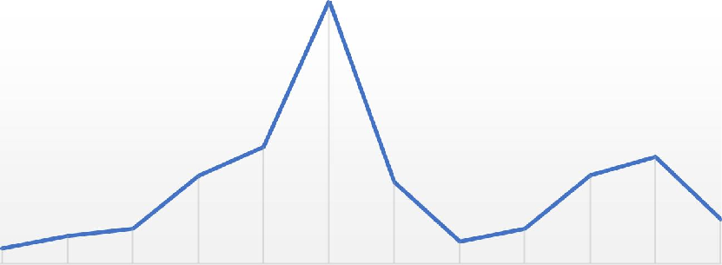



Fig 3. Variation of precipitation in 2022
Variation of precipitation in 2022
600
500
400
300
200
100
0

MOIS

Série1

Soil Classification (Texture)
precipitation
The results presented in Fig. 4 reveal a marked textural diversity, with a predominance of sandy and sandy loam soils, followed by sandy clay soils. Indeed, sandy and sandy loam textures alone account for 42.1% of the watershed area, and are mainly distributed in the central-eastern part of the Gourou basin. These soils are generally well- drained, promoting infiltration and limiting surface runoff.
In contrast, clayey textures (clay, sandy clay, and silty clay), which are concentrated in the northwestern and southern sections of the basin, cover 36.85% of the watershed. These soils tend to retain more water, thereby generating higher runoff during intense rainfall events. Finally, silty textures, mostly located in the central zone, represent approximately 15.79% of the Gourou watershed.

Land Use/Land Cover in 2022
Land use analysis for the year 2022 was conducted using a Landsat 8 image, classified with a remarkably high level of accuracy (Overall

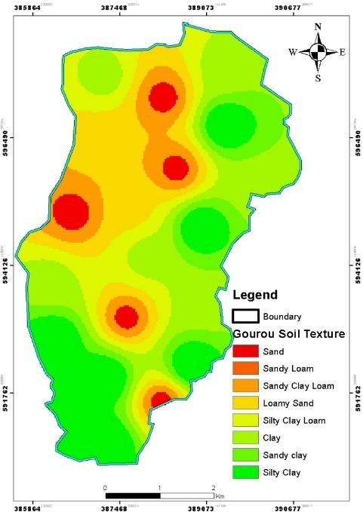

Fig 4. Soil texture map of the Gourou watershed
Accuracy = 99.58%; Kappa Coefficient = 0.97), thereby confirming the reliability of the classification process. Fig.5 illustrates the spatial distribution of the different land use classes within the Gourou watershed.

The results highlight a clear predominance of artificial surfaces, with the Built-up/Bare soil class covering 20.88 km², corresponding to 77.79% of the total area. This high proportion reflects an advanced level of urbanization and deforestation, which considerably reduces the extent of natural surfaces capable of regulating hydrological flows. Degraded forest represents the second most extensive class, covering 5.25 km² (19.56%), thereby indicating significant anthropogenic pressure on forest ecosystems. This fragmentation of vegetative cover promotes erosion and reduces soil infiltration capacity.
By contrast, dense forest, a remnant of the original vegetation formations, accounts for only
0.48 km² (1.79%) of the basin area. Finally, wetlands and agricultural lands, which play a crucial role in hydrological regulation, are highly marginalized, with a surface area of only 0.23 km² (0.86%). The scarcity of these natural buffer zones exacerbates the risk of rapid runoff during flood events.

Curve Number (CN) Values
The Curve Number (CN), a key parameter of the SCS-CN method (Soil Conservation Service Curve Number), is classically categorized into five hydrological groups reflecting soil permeability and land use/land cover characteristics (Fig.6).
Spatial analysis of CN distribution across the Gourou watershed reveals particularly concerning patterns. Approximately 77% of the watershed area exhibits CN values greater than 78, with 57% falling within the critical range of 83–88. These elevated values are primarily associated with road infrastructure (fully impervious surfaces), industrial zones (artificialized areas), and dense unplanned settlements (compacted soils). Such zones generate direct runoff exceeding 70% of rainfall, thereby fostering rapid flood peaks and accelerating soil erosion processes.
Conversely, only 15% of the watershed area presents CN values ranging from 55 to 67, which are linked to forests, permanent grasslands (high infiltration capacity), and residual wetlands. These natural spaces, although crucial for

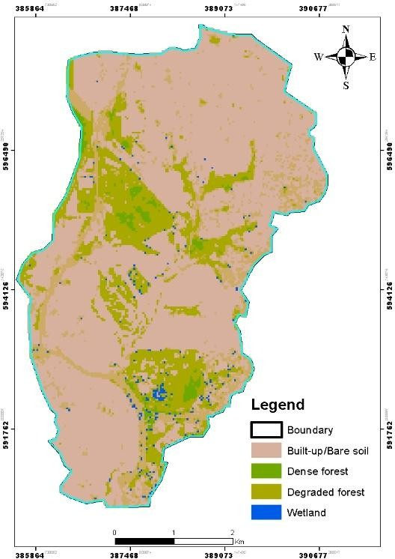
Fig 5. Land use/land cover of the Gourou watershed in 2022

mitigating surface runoff and regulating hydrological dynamics, occupy a surface area far too limited to offset the widespread dominance of impervious land covers.
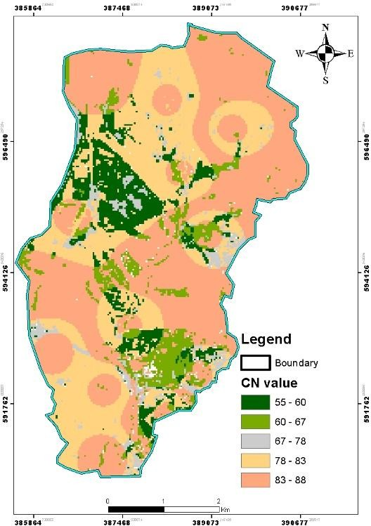
Fig 6. Curve Number (CN) map of the Gourou watershed

Runoff Coefficient Mapping
The mapping of the runoff coefficient, derived using the SCS-CN method from an intense rainfall event of 73 mm that occurred on 16–17 June 2022, reveals a contrasting hydrological response within the Gourou watershed. Three runoff classes were identified (Fig.7): low runoff areas (4–13%), mainly corresponding to dense forest environments or well-drained sandy soils; moderate runoff areas (13–27%), associated with loamy soils or croplands with intermediate infiltration capacity, predominantly located in the south-eastern and central parts of the basin; and high runoff areas (27–44%), largely concentrated in urbanized sectors or clayey soils where surface sealing promotes rapid overland flow. The overall runoff index obtained is 0.42, corresponding to a runoff rate of 42.6%, which represents a runoff volume of 827,113.53 m³ out of a total rainfall volume of 1,941,220.80 m³. These results confirm the dominant influence of urbanization (77.8% of the surface occupied by settlements or bare soils) on the hydrological dynamics of the basin, as
reflected in reduced infiltration capacity, increased erosion processes, and the rapid concentration of surface flows that trigger frequent flood events.
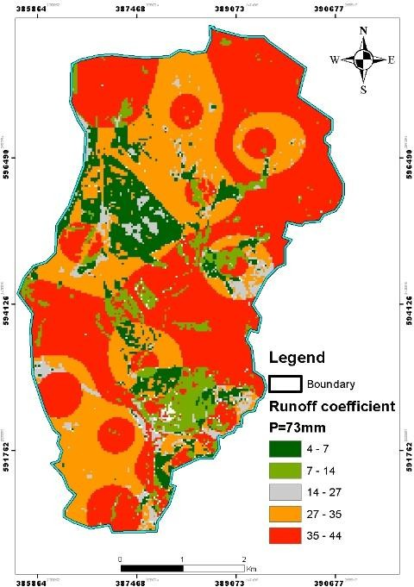
Fig 7. Runoff coefficient map for P = 73 mm

Discussion
The runoff study conducted in the Gourou watershed highlights a strong vulnerability to flooding, resulting from the combination of three major factors: increasing urbanization, marked pedological diversity, and high rainfall variability. The year 2022, which was particularly wet with an annual cumulative rainfall of 1743.55 mm, was dominated by a peak in June representing nearly 30% of the annual precipitation. The extreme event of June 16–17 (73.05 mm in 24 hours) triggered major floods, a phenomenon also observed in other West African cities exposed to intense tropical rainfall regimes (Nouaceur, 2020).
From a pedological perspective, granulometric analyses reveal a dominance of sandy soils (42.1%), which are favorable to infiltration but highly sensitive to saturation during heavy rainfall, and clayey or loamy textures (52.64%), with low permeability that accentuate runoff, particularly in the central-eastern and north-eastern parts of the
watershed. These findings are consistent with those reported in a study of the Béni Haroune (Algérie) basin, where compact clay soils were strongly associated with high runoff coefficients (Wail, 2016). In parallel, land-use mapping highlights pronounced artificialization: 77.79% of the surface area is impervious (settlements/bare soil), while dense forests and wetlands, which are essential for hydrological regulation, account for only 1.79% and 0.86% of the basin, respectively. This profile is similar to that observed in urban watersheds of Central and West Africa, particularly in Libreville, Séguéla, Abomey- Calavi and Sénégal (Konan-Waidhet., 2022, Thibaut Fabrice, 2017, Nzigou, 2021, Sy B, 2025).
The application of the SCS-CN method reveals that 77% of the basin exhibits Curve Number (CN) values greater than 78, indicating a high propensity for runoff. The calculated runoff rate reaches 42.6%, representing a volume of more than 827,000 m³ for 73 mm of rainfall, thereby confirming the hydrological impact of imperviousness. These results are comparable to

those obtained by Mathlouthi & al, (2010) in the Northern Tunisia basin, where runoff rates of 35 to 45% were observed under degraded forest cover.
However, it is important to recognize certain methodological limitations of the SCS-CN approach. First, the method assumes a uniform spatial and temporal distribution of rainfall over the watershed, which may not fully reflect the convective and highly localized nature of tropical rainfall events. Second, the concept of initial abstraction (Ia = 0.2S) used in the model may not always accurately represent real hydrological processes such as interception, surface storage, and early infiltration, especially in urbanized basins with heterogeneous land uses. Third, the Curve Number values are highly sensitive to land-use and soil classification, meaning that uncertainties in mapping or interpolation may propagate into runoff estimates. These limitations suggest that while the SCS-CN method provides a valuable framework for runoff estimation, its results should be interpreted with caution and, where possible, complemented by calibration with observed data or more physically based hydrological models.

Conclusion
This study analyzed the dynamics of runoff in the Gourou watershed (Abidjan) using an integrated approach combining soil texture, land use, and the SCS-CN method. The results highlight a marked spatial variability of the runoff coefficient (Cr), ranging from 4.13% to 44.35% for a rainfall event of 73 mm, representative of the region’s extreme events. The findings reveal that the predominance of urbanized areas and bare soils (77.79%), combined with a very limited residual forest cover (1.79%), leads to widespread impermeabilization, resulting in Curve Number (CN) values exceeding 78 over 77% of the watershed. This configuration promotes high runoff rates, surpassing 70% of total precipitation.
Furthermore, the spatial distribution of soil textures accentuates hydrological contrasts: sandy and sandy-loam soils (42.1%), concentrated in the central-western sector, tend to limit runoff (Cr < 13%), whereas clay soils (36.85%), predominant in the northwest, south, and central-east, significantly increase surface flows. This spatial heterogeneity contributes to the polarization of flood-prone areas, particularly in densely urbanized northeastern sectors, where the combined effect of high population density and low soil permeability generates elevated coefficients (27–44%). These results, consistent with the flash floods observed in June 2022, confirm the structural vulnerability of the basin and underline the urgency of integrating land-use planning and sustainable management strategies to strengthen the hydrological resilience of the territory.
In this context, it is necessary to promote integrated stormwater management measures, such as the implementation of green infrastructure (infiltration swales, retention basins, green roofs), the restoration of wetlands, and the preservation of remaining forest patches, which play an essential buffering role in hydrological regulation. At the same time, urban planning should incorporate non-buildable zones in the most vulnerable sectors and improve soil permeability through the use of permeable materials. More concretely, local authorities could implement such green infrastructures through pilot projects integrated into neighborhood development plans, the rehabilitation of flood-prone areas into multifunctional retention parks, or the gradual inclusion of permeable paving in road renovation programs. Partnerships with universities, NGOs, and local communities would further facilitate the technical design, awareness-raising, and long-term maintenance of these infrastructures.

I declare that NO generative AI technologies such as Large Language Models (ChatGPT, COPILOT, etc.) and text-to-image generators have been used during the writing or editing of this manuscript.

References

Al-Hasan, A. A. S., & Mattar, Y. E. S. (2014). Mean runoff coefficient estimation for ungauged streams in the Kingdom of Saudi Arabia. Arabian Journal of Geosciences, 7(5), 2019–2029. https://doi.org/10.1007/s12517-013-0892-7

Cai, S., Geng, H. P., Pan, B. T., et al. (2020). Topographic controls on the annual runoff coefficient and implications for landscape evolution across semiarid Qilian Mountains, NE Tibetan Plateau. Journal of Mountain Science, 17, 464–479. https://doi.org/10.1007/s11629-019-5584-7

Coulibaly, T. J. H., Coulibaly, N., Koffi, D., Camara, M., & Savané, I. (2014). Cartographie des zones à l’origine de l’ensablement des canaux du bassin versant du Gourou (Abidjan-Côte d’Ivoire). International Journal of Innovation and Applied Studies, 6, 642–653.
Dovonou, T. F., Mama, V. J., & Chabi Adimi, O. S. (2017). Analyse géo-spatiale de la dynamique de l’occupation du sol de la commune d’Abomey-Calavi, Bénin. Afrique SCIENCE, 13(6), 97–113. http://www.afriquescience.info
Huang, J. L. (2007). Characterization of surface runoff from a subtropics urban catchment. Journal of Environmental Sciences, 19(2), 148–152. https://doi.org/10.1016/S1001-0742(07)60024-2

Konan-Waidhet, A., Kouassi, K., & Kanga, K. (2022). Land Use Dynamics in the Department of Séguéla, Northwestern Côte D’Ivoire. Advances in Remote Sensing, 11, 63-79. https://doi.org/10.4236/ars.2022.113005

Kumari, M., Diksha, Kalita, P., Mishra, V. N., Choudhary, A., & Abdo, H. G. (2024). Rainfall-runoff modelling using GIS based SCS-CN method in Umiam catchment region, Meghalaya, India. Physics and Chemistry of the Earth, Parts A/B/C, 135, 103634. https://doi.org/10.1016/j.pce.2024.103634

Mathlouthi, M., & Lebdi, F. (2010). Modélisation de la relation pluie-ruissellement par durée d’épisode pluvieux dans un bassin du nord de la Tunisie. Hydrological Sciences Journal, 55(7), 1111–1122. https://doi.org/10.1080/02626667.2010.512471

Miller, K., & Clancy, K. (2017). Improving Curve Number Runoff Estimates Using Dual Hydrologic Soil Classification and Potential Contributing Source Areas Delineation Methods. Journal of Water Resource and Protection, 9, 20-39. https://doi.org/10.4236/jwarp.2017.91003

Mishra, S. K., & Singh, V. P. (Eds.). (2013). Soil Conservation Service Curve Number (SCS-CN) methodology. Springer. https://doi.org/10.1007/978-94-017-0147-1

Nanfack, G. (2021). Évaluation de la susceptibilité des sols au ruissellement dans le bassin versant du Knam (Ouest Cameroun), en appliquant la méthode Services de Conservation des Sols Numéro de Courbe. Revista de Geomorfologie, 23, 39–53. https://doi.org/10.21094/rg.2021.136

Navas Nunez, R. (2017). Modélisation hydrologique distribuée des crues en région Cévennes-Vivarais : impact des incertitudes liées à l'estimation des précipitations et à la paramétrisation du modèle [Doctoral dissertation, Université Grenoble Alpes (ComUE)]. HAL Archives Ouvertes. http://theses.hal.science/tel-01653538

NF X 31-107 (2003). Soil Quality—Particle Size Determination by Sedimentation—Pipette Method. AFNOR.

Nouaceur, Z. (2020). Rain resumption and floods multiplication in western Sahelian Africa. Physio-Géo, 15, 89–109. https://doi.org/10.4000/physio-geo.10966

Nzigou Boucka, F., Obame, C. V., Manfoumbi, F., & Nzué Mba, A. (2021). Cartographie de l’occupation du sol du Gabon en 2015 – changements entre 2010 et 2015. Revue Française de Photogrammétrie et de Télédétection, 223, 118–128. https://doi.org/10.52638/rfpt.2021.567

Riess, M. (2015). Assainissement et gestion intégrée du Bassin Versant du Gourou (Côte d’Ivoire). Sciences de l’ingénieur [physics]. dumas-03619558

Sy, B., Sow, M., & Toure, L. (2025). Analyse spatiotemporelle par Google Earth Engine de l’extension de la ville de Saint-Louis, Sénégal de 1980 à 2024. European Scientific Journal, ESJ, 21(14), 135.
https://doi.org/10.19044/esj.2025.v21n14p135

USDA. (1986). Urban Hydrology for Small Watersheds. USDA, NRCS, CED, TR55.
https://www.nrcs.usda.gov/Internet/FSE_DOCUMENTS/stelprdb1044171.pdf

Wail, F., & Benkhaled, A. (2016). Détermination du ruissellement dans le bassin versant Sigus par la méthode du SCS-CN à l’aide d’un système d’information géographique. Larhyss Journal, 27, 257–276. ISSN 1112-3680

Youn Ta, M., Njeugeut Mbiafeu, A. C., Kamenan Satti, J. R., Assoma, T. V., & Jourda, J. P. (2023). Cartographie Automatique des Zones Inondées et Évaluation des Dommages dans le District d’Abidjan depuis Google Earth Engine. European Scientific Journal, ESJ, 19(32), 54. https://doi.org/10.19044/esj.2023.v19n32p54

