Spatial Analysis of Nutritional and Health Inequalities Among Adolescents in Kumbakonam Taluk, Tamil Nadu, India

ABSTRACT
Objective: The study aims to assess the nutritional and health status of adolescents aged 13 to 19 in Kumbakonam taluk. it focuses on understanding how wealth, calorie intake, calorie expenditure, and health outcomes vary across different regions, and to identify the socioeconomic and spatial factors behind these disparities. Methodology: A cross-sectional survey was conducted in 2016–2017 with 2,790 adolescents (1,395 boys and 1,395 girls) from 93 panchayat villages, selected through stratified random sampling. data were collected using a structured questionnaire. daily gross calorie intake, calorie expenditure, and net calorie retention were calculated. wealth and health indices were developed based on income, education, occupation, body mass index (BMI), and calorie balance. spatial analysis and Z-score classification were used to map regional differences. Findings: The study found clear regional and gender-based differences in nutrition and health. most adolescents were in the medium range for calorie intake and retention, but many—especially boys—had poor health. wealthier areas showed better health outcomes, while poorer regions had lower calorie intake and more health problems. spatial mapping revealed clusters of both undernutrition and overnutrition. There is a need for targeted, area-specific health and nutrition programs to address the diverse needs of adolescents and reduce inequalities in Kumbakonam taluk.

Keywords: adolescent health, nutritional inequality, spatial analysis, calorie consumption, rural health, Tamil Nadu, health geography, Kumbakonam taluk, youth well-being, public health planning

Introduction
Adolescence is a vital period marked by rapid growth and development, during which nutritional needs increase significantly. This phase is also shaped by various social and environmental factors that affect young people's health. Differences in the availability of food, opportunities for physical activity, and access to healthcare often result in varied health conditions among adolescents. This research focuses on Kumbakonam Taluk in Tamil Nadu, examining how wealth, nutrition, and health are linked across different areas. The goal is to identify local inequalities and understand how they influence the overall health of adolescents in the region.

Materials and Methods
In 2017, a stratified random sampling procedure selected 2790 rural adolescents aged 13-19 in Kumbakonam taluk, Tamil Nadu, India. Their family's annual income measures the wealth index, and parents' occupational and educational status. Gross Calorie Consumed/Day (GCCD) is calculated by the type of food consumed in the past 24 hours. Calorie Burnt/Day (CBD) is measured by their usual physical activity/time spent/and day. The subtraction of calories consumed/Day (CCD) and calories burnt/Day (CBD) is Net Calorie Retained/Day (NCRD). The Body Mass Index (BMI) is measured by weight (kg)/height (m²). Hence, the underlying relationship of adolescents' health status is measured by SPSS, Z-score for the above-cited observed variables.
Study Sample Population
The questionnaire-scheduled survey was carried out between 2016 and 2017 to examine the nutritional health status of adolescents (boys and girls) aged 13-19. Thirty adolescents were selected from each (93) village by stratified random sampling, totalling 2790 (93x30). Of these, 1395 (50.0%) and 1395 (50.0%) are boys and girls, respectively. They are the respondents of the present study. The study aims to investigate socioeconomic conditions, physiological status, and dietary behaviour.
Study Area
Kumbakonam taluk (Figure 1) in Thanjavur District of Tamil Nadu is a well-known religious and cultural centre in South India. The town of Kumbakonam is the second largest in the district and serves as a central hub for agriculture and trade. According to the 2011 Census, the taluk had a population of 435,962, with 216,186 males and 219,776 females, resulting in a sex ratio of 1017 females per 1000 males. The literacy rate was 78.05%, and the child population under six years was 40,447, with a child sex ratio of 1003 girls per 1000 boys. There were 91,470 households in total. Geographically, the taluk lies in the Cauvery Delta region, extending from 9°05' to 9°19' North latitude and 86°00' to 86°50' East longitude, covering an area of 27,589.6 hectares. It consists of 93 panchayat villages. The terrain is a flat deltaic plain that slopes towards the east coast, with an average elevation of 36 meters above sea level. The Coleroon River forms the northern boundary, while the Cauvery and Arasalar Rivers flow eastward through the taluk, shaping a drainage pattern that trends towards the northeast and east.
Review of Literature
The adolescent phase is a vital part of human development, marked by fast-paced changes in physical growth, emotional stability, and social identity. During these years, balanced nutrition and timely healthcare play a crucial role in shaping a person’s future health. Research across disciplines has shown that various factors—ranging from food habits and activity levels to income, education, and living environment—collectively influence adolescent health.
Health geography plays a vital role in analysing the spatial dimensions of child health consequences. Health geography proposes examining environmental, demographic, and socio-economic factors that influence health behaviors and access to and utilization of healthcare facilities (Meade and Emch 2010). In the context of health and nutrition, spatial inequalities in the availability of food, sanitation, and healthcare infrastructure are fundamental for undernutrition and overweight tendencies (Curtis 2004). The study of geospatial mapping to examine malnutrition in India has significant regional discrepancies (Srinivasan and Mohanty 2018). Rural children face higher risks of stunted growth and physical thinness.
Similarly, spatial epidemiology (Bhunia, G.S., & Ghosh, P., 2011) enables the recognition of child health malnutrition trouble spots and highlights where interventions are most needed based on geographic relationships. Building on this approach, Body Mass Index (BMI) at a given age serves as a valuable tool to assess physiological growth and identify nutritional health issues in children (De Onis, M., Onyango, A. W. et al., 2007). The World Health Organisation further reinforces these methods by recommending age- and sex-specific BMI cut-offs for global malnutrition classification (World Health Organization, 2006). In rural India, researchers have demonstrated a high prevalence of undernutrition among children under five years (Sachdev, H. P.S., Kapil, U., and Vir, S. 2005). This geographic perspective also helps to explain disparities in nutritional health status driven by both geographic and socio-economic influences (Meshram, I. I., Laxmaiah, A. et al., 2012).
In contrast to the rural undernutrition patterns discussed above, newer studies propose a rising trend of childhood overweight and obesity, especially in urban communities (Ng, M., Fleming, T., Robinson, M., et al., 2014). Yet, ongoing challenges persist; for instance, a study in Tamil Nadu reported that around 30% of children under five remain underweight, indicating persistent nutritional challenges in southern India (Kumar, A., Rani, A., & Singh, A., 2015). Socio-economic status, maternal education, and food insecurity continue as major determinants of malnutrition among Indian children (Ghosh, S. 2014). In Maharashtra, the contrast remains clear, as significant urban-rural disparities have been observed, with undernutrition predominating in rural settings (Patil, S., and Chavan, R. 2013).
Across the world, adolescents face a combination of health problems related to both poor nutrition and excessive weight gain. The World Health Organization (2022) reported that over 340 million individuals between 5 and 19 years of age were either overweight or obese in 2016, even as millions in poorer regions still suffer from hunger and nutritional deficiencies. These global trends highlight deep inequalities in food access, healthcare, and lifestyle.
In wealthier countries such as the United States and parts of Europe, adolescent health concerns are shifting toward problems linked to overconsumption—such as obesity, early onset of diabetes, and mental health disorders. High screen time, reduced physical activity, and emotional stress are contributing factors (Skinner et al., 2018; Inchley et al., 2020).
Meanwhile, in India and other middle- and low-income countries, the focus remains on issues like stunted growth, anaemia, and limited awareness of reproductive health—especially among adolescent girls. National Family Health Survey data (NFHS-5, 2019–21) show that more than half of Indian teenage girls are anaemic. Despite economic improvements, persistent issues such as poverty, unequal gender norms, and lack of adolescent-focused services continue to affect outcomes (Singh et al., 2021).
There is growing recognition that the places where people live strongly influence their health. Not only do personal habits matter, but the physical and social environment also plays a key role. The idea that geography matters in health has gained momentum, with researchers exploring how access to clean water, healthcare centres, schools, and economic opportunities shape adolescent well-being (Cummins et al., 2007).
For instance, Bhatia and colleagues (2022) used spatial mapping techniques to assess risk levels of anaemia among adolescents across Indian districts, showing that there are significant differences within states. These findings suggest that improving health outcomes requires understanding and addressing local environmental and service-related gaps.
Health geography, a growing academic field, focuses on the links between geographic location and health outcomes. It uses tools like Geographic Information Systems (GIS) to visually map where health problems occur and to identify patterns or neglected areas. Rosenberg (2020) highlighted the importance of these tools in identifying regions that lack basic healthcare services, especially in data-scarce countries.
In India, GIS has been successfully applied to map health disparities. Kumar and Mishra (2023), for example, used spatial techniques to study nutrition issues among children and adolescents in rural Madhya Pradesh, helping to identify high-risk areas that need urgent attention. Similarly, Awasthi et al. (2021) emphasized how environmental and social surroundings can affect adolescent behaviour and health access, pointing to the need for region-based solutions.
Health problems faced by adolescents differ sharply between developed nations and countries like India. While undernutrition, poor hygiene, and anaemia are common in India, adolescents in wealthier countries are more likely to struggle with lifestyle-related diseases and emotional distress (Viner et al., 2019). European studies such as the HBSC (Inchley et al., 2020) have pointed out growing concerns around mental health and digital dependency, despite widespread access to health facilities.
In India, by contrast, the struggle continues with basic health infrastructure, clean sanitation, and reproductive health education. These differences underline the importance of place-specific strategies. The use of health geography offers a way to compare and address these varied challenges, helping ensure that policy responses are tailored to local needs.
Result
Nutritional and Health Status of Adolescents in Kumbakonam Taluk (Ages 13–19)
A detailed analysis of adolescents aged 13 to 19 years in Kumbakonam Taluk reveals several critical insights regarding their nutrition, health indices, and socioeconomic conditions. The study categorises data based on gross calories consumed, calories burnt, net calories retained, wealth and health indices, and overall health status (Table 1).
Calorie Intake and Expenditure
Most adolescents fall within the medium category (3001–4000 calories/day) for calorie consumption, especially among females (66.14%) and males (41.48%). However, a notable portion of males (47.01%) also consume calories at a lower range (2001–3000), indicating possible dietary inadequacy. The most common range of calorie expenditure is medium (601–800 calories/day), especially among females (65.49%), suggesting relatively high physical activity levels. Despite this, many adolescents, particularly females, burn calories in the low and very low ranges, highlighting a potential imbalance between intake and expenditure.
Net Calorie Retention
Medium net calorie retention (3001–4000 calories/day) is most prevalent among both genders, suggesting that most adolescents retain sufficient calories for growth and daily functioning. However, a sizable number of males (38.87%) fall into the low retention category (2001–3000), raising concerns about energy sufficiency in a significant subset of the population.
Wealth and Health Indices
The wealth index indicates that most adolescents come from households with good economic standing (11–20 range), particularly among females (67.82%). However, a non-negligible portion of males (18.49%) are classified as poor, potentially affecting their access to nutritious food and healthcare. The health index shows that while the majority fall in the "good" category (5–7 range), there is a marked gender disparity—males (90.24%) score significantly higher than females (58.10%) in this range, suggesting relatively better health among male adolescents.
Overall, Health Status
Alarmingly, a large majority of adolescents, particularly males (75.63%) and females (46.66%), are classified under "inferior" health status (<11.2 Z-score). Only a minor fraction achieves "good" or "very good" health ratings, reflecting the urgent need for targeted health interventions.
In conclusion, while a moderate level of nutrition and wealth appears prevalent among adolescents in Kumbakonam Taluk, critical gaps in health outcomes, especially among females and economically disadvantaged groups, highlight the necessity for comprehensive nutritional and public health strategies tailored to adolescent needs.
Discussion
Spatial Analysis
Gross Calorie Consumption among Adolescents
The thematic map illustrates the spatial variation in gross calorie consumption per day among adolescents aged 13–19 across Kumbakonam Taluk. Based on a Z-score classification, the regions are colour-coded to represent different calorie intake levels, ranging from very low to very high.
Figure 2 shows the medium-level calorie consumption, indicating that most adolescents have a moderate range of daily energy intake. However, there are significant spatial disparities.
The Pockets of high and very high-calorie consumption are concentrated primarily in the taluk's central, north-central, and southeastern parts. These zones may correlate with economically better-off communities or those with improved access to nutrition and food resources. Conversely, areas representing low and very low-calorie consumption are scattered across the western, southern, and central regions. These could signify nutritionally vulnerable populations, potentially linked to socioeconomic disadvantages or inadequate dietary habits. Overall, the map reflects uneven nutritional status across the taluk, with clusters of both over-nutrition and under-nutrition. This spatial insight is vital for policymakers and health officials to target interventions geographically, ensuring that nutrition programs efficiently focus on areas exhibiting the most critical deficiencies or disparities.
calorie expenditure among adolescents in Kumbakonam taluk
Figure 3 illustrates the daily calorie expenditure of adolescents aged 13–19 across Kumbakonam Taluk. It shows variations in the number of calories burnt daily, categorised into very low, low, medium, high, and very high zones based on Z-score classifications.
The map indicates that most regions experience moderate calorie expenditure levels among adolescents. This suggests a general level of physical activity that is neither minimal nor excessively high.
However, notable spatial patterns emerged, as high to very high-calorie expenditure zones are concentrated in the northwestern, southeastern, and southern fringe areas. Adolescents in these regions may be engaged in more physically demanding routines, such as agricultural labour or regular physical commuting.
The low and very low expenditure areas are more dispersed, with significant clusters in the central and south-central parts of the taluk. These areas reflect sedentary lifestyles, limited outdoor activity, or access to mechanised transport and digital entertainment. The Kumbakonam municipal area, marked as "NA," is excluded from the data, possibly due to urban-specific data collection challenges or its unique demographic characteristics.
This spatial representation of calorie burning highlights apparent geographic disparities in adolescent activity levels. These findings underscore the importance of incorporating localised physical activity promotion strategies in low-energy expenditure areas to balance calorie intake and promote overall adolescent health.
Net Calorie Retention among Adolescents in Kumbakonam Taluk
Figure 4 visualises the daily net calorie intake among adolescents aged 13–19 in Kumbakonam Taluk. This balance between calories consumed and expended is classified into Very Low, Low, Medium, High, and Very High.
The map indicates a geographically varied pattern of net calorie retention:
High and Very High-calorie retention zones are concentrated in the taluk's north-central, south-central, and southeastern regions. These areas reflect a positive energy balance and may correlate with sufficient food intake and moderate physical activity. While this can support healthy growth, sustained high retention could also pose risks of overweight or obesity if not balanced with adequate physical activity.
A significant portion of the taluk is moderate calorie retention. This represents an optimal and healthy energy balance for adolescents, supporting normal growth and development. Conversely, low and very low retention zones are found mainly in the southwestern and parts of the central regions. These areas may reflect either low food intake, high physical activity levels, or a combination of both, potentially placing adolescents at risk of undernutrition or energy deficiency.
This spatial assessment highlights areas where nutritional imbalance—excess or deficiency—is most pronounced. Policymakers and public health planners can use this data to target dietary interventions and physical activity programs to achieve balanced nutrition and health outcomes for adolescents across Kumbakonam Taluk.
Adolescent Wealth Index
Figure 5 illustrates the Wealth Index of adolescents aged 13–19 across Kumbakonam Taluk, segmented into three categories—Poor, Good, and Very Good—based on socioeconomic indicators. The spatial distribution of Very Good wealth zones is prominently concentrated in the northern and northeastern parts and the southeastern corner of the taluk. These regions will likely have better access to resources such as quality education, healthcare, and nutrition, contributing to a higher standard of living for adolescents.
The Good" wealth areas dominate most of the central and southern zones, reflecting moderate socioeconomic conditions. These areas may offer relatively stable living conditions, though not as affluent as the "perfect" regions. In contrast, Poor wealth index regions are primarily clustered in the central-southern and southwestern parts of the taluk. These zones suggest higher economic vulnerability, with adolescents experiencing reduced access to basic services and resources critical for their development.
The map presents a geographically uneven wealth distribution among adolescents, revealing pockets of both affluence and deprivation. These disparities emphasise the importance of targeted socioeconomic interventions, especially in poor wealth zones, to ensure more equitable opportunities and development outcomes for all adolescents across Kumbakonam Taluk.
Adolescent Health Index
Figure 6 presents the Adolescent Health Index for individuals aged 13–19 across Kumbakonam Taluk, highlighting geographic disparities in health outcomes. The health index is categorised into poor, good, and very good.
A clear trend emerges: The "poor" health category dominates many taluks. This widespread presence indicates that the overall adolescent health status across Kumbakonam Taluk is generally unsatisfactory, likely due to inadequate nutrition, limited access to healthcare, or socioeconomic challenges.
However, clusters of good" health status appear in several parts of the central and eastern taluk, suggesting localised improvements, potentially due to better infrastructure, targeted health programs, or community-level awareness.
Most notably, small but distinct pockets of the "Very Good" health index are scattered across the northwestern, eastern, and southern regions, reflecting zones of optimal adolescent health. These areas may benefit from a combination of factors such as a higher wealth index, better education, improved diet, and access to healthcare services. Therefore, the map underscores a predominance of poor health outcomes among adolescents in the taluk, with islands of relatively better health, emphasising the urgent need for targeted public health initiatives and inter-sectoral collaboration to uplift adolescent health standards in the region.
Adolescent Health Status
Figure 7 displays the health status of adolescents aged 13–19 across Kumbakonam Taluk, categorised into five classes: poor, moderate, reasonable, and very good.
The most striking observation is the widespread prevalence of inferior health status covering most taluk. This indicates that a large proportion of adolescents in the region are experiencing suboptimal health conditions, likely due to factors such as poor nutrition, low access to healthcare services, and socioeconomic deprivation. Amid this backdrop, scattered pockets of moderate and reasonable" health status emerge, particularly in the south-central and central-eastern zones.
These areas represent regions with slightly better public health outreach, awareness programs, or improved dietary practices. Notably, clusters of excellent health status are minimal, appearing in isolated southern and western pockets. These zones are exceptions and likely benefit from localised advantages such as better socioeconomic conditions or access to adolescent health and nutrition services.
As a result, the map reflects a distressing picture of adolescent health across the taluk, where the dominance of poor health zones calls for urgent and focused interventions. Programs must prioritise nutrition education, healthcare accessibility, and physical well-being, particularly in underserved rural sectors, to uplift the overall adolescent health landscape in Kumbakonam Taluk.
Conclusion
Adolescent health is a crucial area within public health that calls for dedicated focus and coordinated efforts. This stage of life involves significant changes physically, mentally, and socially, which bring both challenges and opportunities. The study highlights how adolescent well-being is influenced by a combination of biological growth, environmental factors, and social circumstances.
While many adolescents maintain good physical health, they remain susceptible to habits and behaviours that could negatively affect their future health. Problems such as inadequate nutrition, low levels of physical activity, substance use, mental health concerns, and risky sexual behaviours need urgent and comprehensive attention.
It is important to ensure that young people have access to inclusive health education, quality healthcare services, and safe environments that support their growth. Strengthening their knowledge and life skills, alongside support from families, peers, and communities, helps adolescents make better health decisions.
Policymakers, educators, healthcare professionals, and community leaders all have vital roles in developing and implementing strategies that put adolescent health first. By working together, these groups can create programs that enable adolescents to become healthy adults who actively contribute to society.
Investing in the health of adolescents is essential—not only as a social responsibility but also for the future well-being of communities and nations. This study emphasizes the need to integrate adolescent health priorities into broader development plans and to adopt practical, evidence-based approaches tailored to the needs of young people.
Research Gap
This study utilized a cross-sectional design, which limits the ability to observe how adolescent health changes over time or to examine the long-term effects of socioeconomic factors on health outcomes. The focus on calorie consumption, expenditure, and socioeconomic status provides valuable insights but overlooks key psychosocial aspects such as mental health, emotional well-being, and social support, all of which are essential to understanding adolescent health comprehensively. Although gender differences in health status and calorie retention were identified, the deeper causes behind these disparities remain insufficiently explored, pointing to the need for more gender-focused research. Additionally, the study excluded Kumbakonam municipality due to challenges in data collection, leaving a gap in understanding urban adolescent health and limiting comparisons between rural and urban contexts. Important spatial factors such as access to healthcare, sanitation quality, and the presence of school health programs were not incorporated into the geographic analysis, which could have provided a more nuanced understanding of local disparities.
Policy Implications
The findings offer important guidance for health policy and program development. Areas showing very low net calorie retention and poor health indicators should be prioritized within government nutrition initiatives like Poshan Abhiyan or the Mid-Day Meal Scheme, with specific adjustments to address adolescent needs. The evident gender gap in health outcomes calls for targeted interventions focusing on the nutritional and reproductive health needs of female adolescents, supported by empowerment efforts. Spatial mapping of health inequalities can aid decentralized planning at the panchayat level, ensuring that resources are allocated based on localized needs. Schools represent a key setting for health promotion, suggesting the incorporation of routine health screenings, nutrition education, and physical activity programs within curricula. The use of geographic information systems should be formalized within local health authorities to monitor adolescent health trends and enable timely responses.
Recommendations for Future Research
To expand on this study's findings and fill existing gaps, future research should consider longitudinal designs that follow adolescents over time to better understand causal links between socioeconomic status, health behaviours, and outcomes. Incorporating mental health evaluations, emotional resilience measures, and assessments of social support will offer a fuller picture of adolescent well-being. Qualitative methods such as focus groups and interviews can help explore cultural factors influencing girls’ health and nutrition. Including urban populations in future studies will provide a more complete perspective on spatial health disparities and support inclusive regional planning. Evaluating the effectiveness of current adolescent health and nutrition programs at the local level will offer valuable feedback for policy improvements. Additionally, future investigations should integrate environmental, infrastructural, and behavioural data to develop comprehensive spatial models.
Ethical Issues and Standards
This study adhered to stringent ethical guidelines concerning research involving minors. Informed consent was obtained from parents or guardians, and assent was received from adolescent participants after explaining the study’s aims, procedures, and potential risks in Tamil to ensure clear understanding. Participation was voluntary, and both guardians and adolescents were informed about their right to withdraw at any time without penalty. Confidentiality and anonymity were maintained by removing identifying information and securely storing data accessible only to authorized personnel. Interviews and assessments respected participant privacy and cultural norms, particularly when discussing sensitive topics with female adolescents. To minimize psychological distress, the questionnaire was designed to be non-intrusive and administered by trained staff sensitive to participants’ needs. The research protocol was approved by a Research Committee, Bharathidasan University, Tiruchirappalli, Tamil Nadu, India. Data were used strictly for academic and public health purposes, with results reported in aggregate to protect individual and community identities.

Ethics Approval
This study involved the collection of primary data from adolescents. Ethical clearance was obtained from the Institutions (schools). Prior informed consent was obtained from the parents or guardians of all participating boys and girls.
Consent to Participate
Informed consent was obtained from the parents or legal guardians of all individual participants included in the study.
Consent for Publication
It is not applicable, as the manuscript does not contain any personally identifiable information or images.
Data Analysed
The datasets generated and analysed during the current study are available from the corresponding author upon reasonable request.
Acknowledgments
The authors would like to thank the educational institutions and families in Kumbakonam Taluk for their cooperation and participation in the data collection process. We also acknowledge the administrative support from the Department of Geography, Government Arts and Science Colleges.
Statements and Declarations
Funding
The authors received no financial support for the research, authorship, and/or publication of this article.
Competing Interests
The authors declare that they have no known competing financial or non-financial interests or personal relationships that could have appeared to influence the work reported in this paper.
Author Contributions
Dr. Vadivel S: Statistical Analysis, Interpretation of Results, Writing – Review and Editing. Analysis, Writing – Original Draft.
Dr. Suganya. S: Data collection, Literature Review, Data Curation, Visualization, Writing – Review and Editing.
Dr. Mayakannan A: Mapping using ArcGIS
Dr. Sankar. K: Conceptualization, Methodology, Data Collection,
All authors have read and approved the final manuscript.

Disclaimer (Artificial intelligence)
Option 1:
We hereby declare that no generative AI technologies are used for Large Language Models (ChatGPT, COPILOT, etc.) and text-to-image generators during the writing or editing of this manuscript.
Option 2:
We hereby declare that Grammarly software is used for checking grammar and Plagiarism of this manuscript.
Details of the AI usage are given below:
1. Grammarly Proofreader
2. Grammarly Plagiarism Checker

References

- Awasthi, A., Singh, R., & Verma, P. (2021). GIS-based spatial analysis of adolescent nutrition: Insights from Uttar Pradesh. Journal of Health and Place, 68, 102520. https://doi.org/10.1016/j.healthplace.2021.102520
- Bhatia, M., Taneja, G., & Kumar, D. (2022). Mapping adolescent anaemia risk in India: A district-level geospatial approach. Lancet Regional Health – Southeast Asia, 3, 100043. https://doi.org/10.1016/j.lansea.2022.100043
- Bhunia, G. S., & Ghosh, P. (2011). Spatial epidemiology of child undernutrition in India. Annals of GIS, 17(2), 113 120.
- Cummins, S., Curtis, S., Diez-Roux, A. V., & Macintyre, S. (2007). Understanding and representing “place” in health research: A relational approach. Social Science & Medicine, 65(9), 1825–1838. https://doi.org/10.1016/j.socscimed.2007.05.036
- Curtis, S. (2004). Health and Inequality: Geographical Perspectives. Sage Publications.
- De Onis, M., Onyango, A. W., Borghi, E., Siyam, A., Nishida, C., & Siekmann, J. (2007). Development of a WHO growth reference for school-aged children and adolescents. Bulletin of the World Health Organization, 85(9), 660-667.
- Ghosh, S. (2014). Factors contributing to childhood malnutrition: A review of the literature. Indian Journal of Public Health, 58(2), 70–75.
- Inchley, J., Currie, D., Budisavljevic, S., Torsheim, T., Jåstad, A., Cosma, A., & Samdal, O. (2020). Health Behaviour in School-aged Children (HBSC) Study: International Report from the 2017/2018 Survey. WHO Regional Office for Europe.
- Kumar, A., Rani, A., & Singh, A. (2015). Nutritional status of under-five children in Tamil Nadu. Indian Journal of Maternal and Child Health, 17(1), 34-40.
- Kumar, R., & Mishra, A. (2023). Health geography and adolescent malnutrition: A case study from rural Madhya Pradesh. Geographical Review of India, 85(1), 45–59.
- Meade, M. S., & Emch, M. (2010). Medical Geography. Guilford Press.
- Meshram, I. I., Laxmaiah, A., Venkaiah, K., & Brahmam, G. N. V. (2012). Impact of feeding and breastfeeding practices on the nutritional status of infants in a district of Andhra Pradesh, India. National Medical Journal of India, 25(4), 201–206.
- Ng, M., Fleming, T., Robinson, M., et al. (2014). Global, regional, and national prevalence of overweight and obesity in children and adults 1980–2013: a systematic analysis. The Lancet, 384(9945), 766–781.
- Patil, S., & Chavan, R. (2013). Nutritional status of pre-school children in urban and rural areas of Maharashtra. Indian Journal of Pediatrics, 80(10), 745–749.
- Patton, G. C., Sawyer, S. M., Santelli, J. S., Ross, D. A., Afifi, R., Allen, N. B., ... & Viner, R. M. (2016). Our future: A Lancet commission on adolescent health and well-being. The Lancet, 387(10036), 2423–2478. https://doi.org/10.1016/S0140-6736(16)00579-1
- Rosenberg, M. (2020). Health geography: Bridging social theory and public health policy. Progress in Human Geography, 44(1), 3–20. https://doi.org/10.1177/0309132518807595
- Sachdev, H. P. S., Kapil, U., & Vir, S. (2005). The burden of child undernutrition and evidence-based interventions for its prevention. Indian Journal of Community Medicine, 30(4), 145–146.
- Singh, A., Ghosh, D., & Bharadwaj, P. (2021). Inequalities in adolescent health in India: Evidence from NFHS-5. Indian Journal of Paediatrics, 88(6), 557–564. https://doi.org/10.1007/s12098-021-03687-5
- Skinner, A. C., Ravanbakht, S. N., Skelton, J. A., Perrin, E. M., & Armstrong, S. C. (2018). Prevalence of obesity and severe obesity in US children, 1999–2016. Pediatrics, 141(3), e20173459. https://doi.org/10.1542/peds.2017-3459
- Srinivasan, K., & Mohanty, S. K. (2018). Geospatial disparities and determinants of child malnutrition in India. Health & Place, 53, 60–69.
- Viner, R. M., Hargreaves, D., Ward, J., Bonell, C., Mokdad, A., Patton, G., ... & Rahimi, K. (2019). Adolescence and the social determinants of health. The Lancet, 393(10188), 1653–1664. https://doi.org/10.1016/S0140-6736(19)32720-1
- World Health Organisation. (2022). Adolescent health. Retrieved from https://www.who.int/news-room/fact-sheets/detail/adolescents-health-risks-and-solutions
- World Health Organization. (2006). WHO child growth standards: length/height-for-age, weight-for-age, weight for-length, weight-for-height and Body mass index-for-age: methods and development.

Table 1: Nutrition And Health Indicators of Adolescents Aged 13-19: Kumbakonam Taluk
Sl. No | Values | Categories | Adolescent Age in Years |  |  |  |  |  |  | Male  13-19 years | Female  13-19 years | Total  (M&F)  13-19 years
Sl. No | Values | Categories | 13 | 14 | 15 | 16 | 17 | 18 | 19 | Male  13-19 years | Female  13-19 years | Total  (M&F)  13-19 years
Gross Calorie Consumed/Day (Area in Z-score Percentage)
1 | <2000 | Very Low | 6.40 | 0.59 | 0.32 | 3.48 | 2.26 | 1.00 | 0.48 | 1.56 | 1.83 | 1.71
1 | 2001-3000 | Low | 47.01 | 4.02 | 8.55 | 39.33 | 30.24 | 5.15 | 9.26 | 18.54 | 46.58 | 18.75
1 | 3001-4000 | Medium | 41.48 | 71.66 | 52.62 | 45.41 | 56.65 | 50.16 | 75.40 | 67.17 | 46.51 | 66.14
1 | 4001-5000 | High | 4.60 | 23.06 | 34.97 | 11.09 | 10.09 | 41.62 | 14.07 | 11.82 | 4.71 | 12.18
1 | >5001 | Very High | 0.51 | 0.67 | 3.54 | 0.69 | 0.75 | 2.07 | 0.79 | 0.91 | 0.37 | 1.22
Calorie Burnt/Day (Area in Z-score Percentage)
2 | <200 | V.V. Low | 0.20 | 7.83 | 0.21 | 0.60 | 0.35 | 0.47 | 0.29 | 0.43 | 0.70 | 0.45
2 | 201-400 | Very Low | 1.73 | 24.50 | 1.05 | 3.74 | 1.95 | 10.81 | 1.08 | 1.60 | 6.33 | 2.34
2 | 401-600 | Low | 30.24 | 34.31 | 15.53 | 38.54 | 16.56 | 63.20 | 14.60 | 18.71 | 55.79 | 30.24
2 | 601-800 | Medium | 57.05 | 26.49 | 68.34 | 53.97 | 73.27 | 24.75 | 72.73 | 72.18 | 37.08 | 65.49
2 | >801 | High | 10.78 | 6.87 | 14.87 | 3.15 | 7.87 | 0.77 | 11.30 | 7.08 | 0.10 | 1.47
Net Calorie Retained/Day (Area in Z-score Percentage)
3 | <2000 | Very Low | 4.25 | 2.28 | 8.35 | 0.66 | 2.32 | 1.42 | 0.47 | 1.01 | 1.39 | 0.20
3 | 2001-3000 | Low | 38.87 | 13.89 | 23.71 | 6.16 | 31.41 | 7.70 | 26.86 | 16.98 | 56.11 | 6.83
3 | 3001-4000 | Medium | 49.34 | 41.70 | 30.61 | 23.92 | 55.12 | 60.59 | 63.33 | 69.96 | 38.18 | 42.00
3 | 4001-5000 | High | 6.89 | 30.75 | 26.40 | 39.55 | 10.44 | 28.85 | 8.74 | 11.16 | 3.99 | 46.91
3 | >5001 | Very High | 0.65 | 11.37 | 10.92 | 29.71 | 0.71 | 1.45 | 0.60 | 0.89 | 0.34 | 4.06
Wealth Index (Area in Z-score Percentage)
4 | <10 | Poor | 18.49 | 29.18 | 9.39 | 20.43 | 13.14 | 36.23 | 3.47 | 4.02 | 4.28 | 5.64
4 | 11-20 | Good | 71.18 | 51.53 | 81.92 | 75.88 | 80.16 | 62.76 | 72.82 | 75.59 | 57.98 | 67.82
4 | >21 | V. Good | 10.33 | 19.28 | 8.69 | 3.69 | 6.70 | 1.01 | 23.71 | 20.39 | 37.74 | 26.54
Health Index (Area in Z-score Percentage)
5 | <4 | Poor | 2.61 | 28.35 | 12.72 | 36.41 | 42.59 | 10.41 | 14.07 | 23.34 | 54.97 | 65.74
5 | 5-7 | Good | 90.24 | 58.10 | 79.79 | 61.62 | 54.82 | 84.03 | 79.83 | 72.38 | 42.98 | 32.28
5 | >8 | V. Good | 7.15 | 13.55 | 7.49 | 1.97 | 2.59 | 5.56 | 6.10 | 4.28 | 2.04 | 1.97
Health Status of Adolescents (Area in Z-score Percentage)
6 | <11.2 | V. Poor | 75.63 | 46.66 | 66.95 | 56.39 | 65.35 | 78.80 | 74.17 | 77.10 | 37.15 | 44.66
6 | 11.2 - 21.4 | Poor | 16.24 | 23.67 | 14.53 | 26.83 | 17.53 | 8.15 | 14.32 | 13.05 | 52.80 | 43.66
6 | 21.4 - 31.6 | Moderate | 3.88 | 11.17 | 9.40 | 4.10 | 7.81 | 5.49 | 5.63 | 6.53 | 4.70 | 5.87
6 | 31.6 - 41.8 | Good | 1.88 | 14.20 | 7.31 | 11.09 | 6.89 | 4.96 | 3.12 | 2.75 | 1.75 | 4.89
6 | >41.8 | V. Good | 2.38 | 4.30 | 1.81 | 1.59 | 2.42 | 2.60 | 2.76 | 0.57 | 3.61 | 0.92
Compiled by Author

Figure 1 Map of Kumbakonam Taluk in Tamilnadu
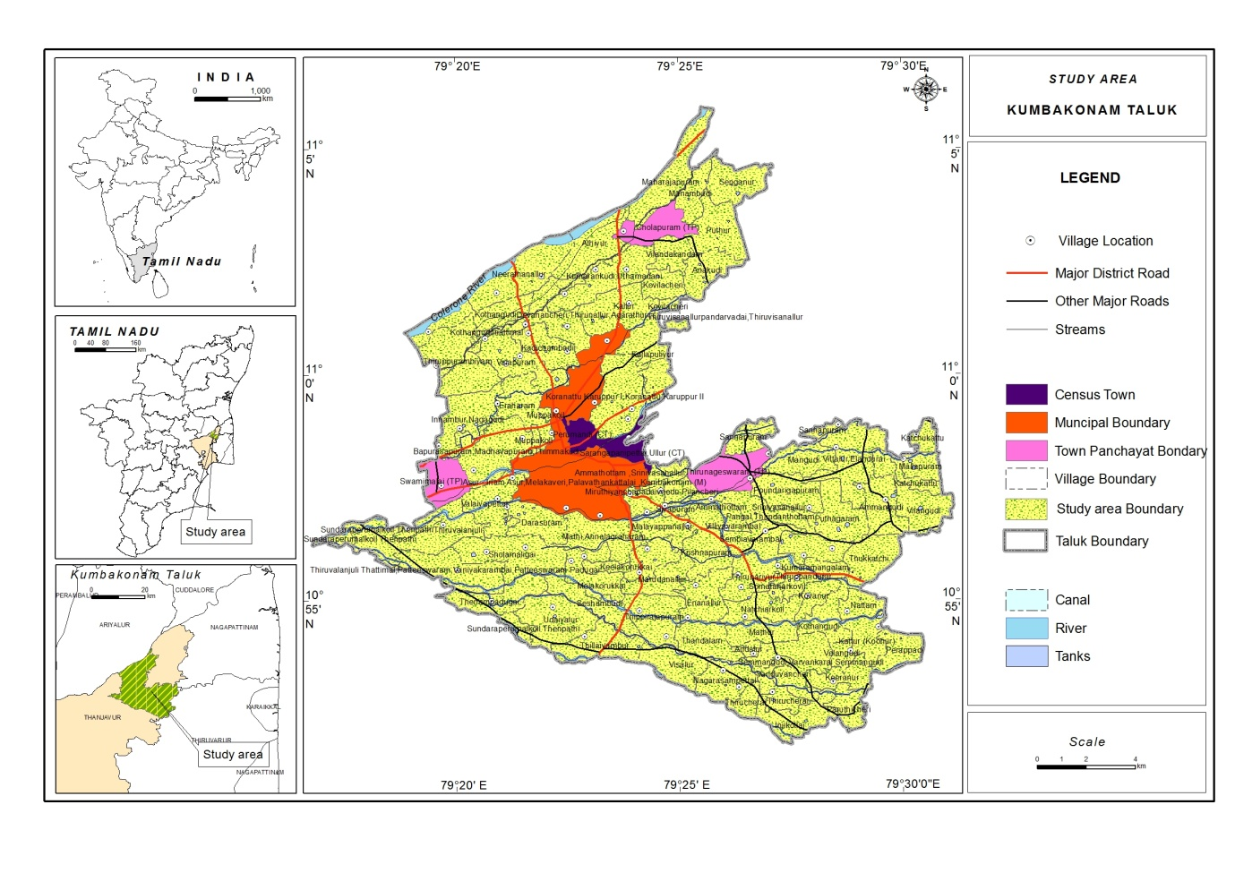

Figure 2 Map represents Adolescent Gross calories Consumed/Day in Kumbakonam Taluk
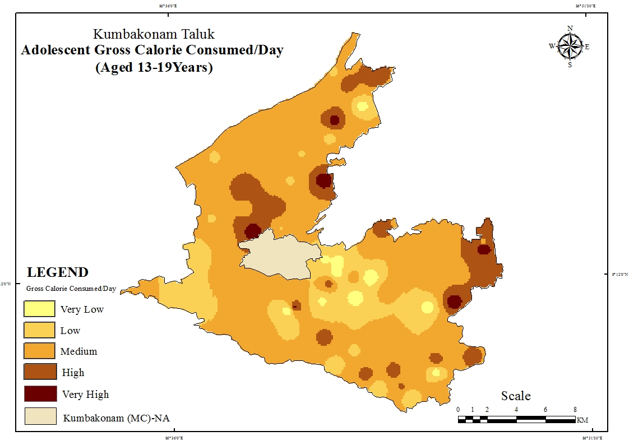

Figure 3 Adolescent Calorie Burnt/Day in Kumbakonam Taluk
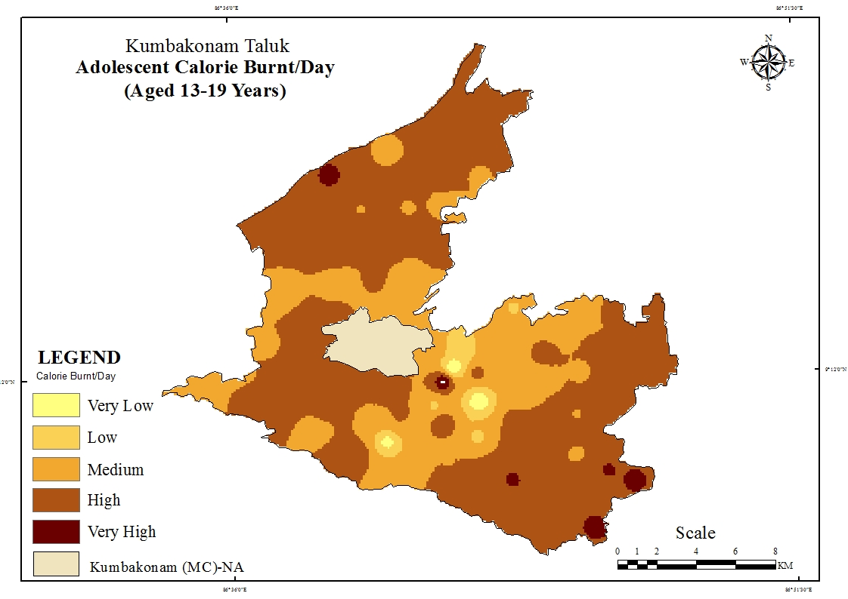

Figure 4 Adolescent Net Calorie Retained/Day
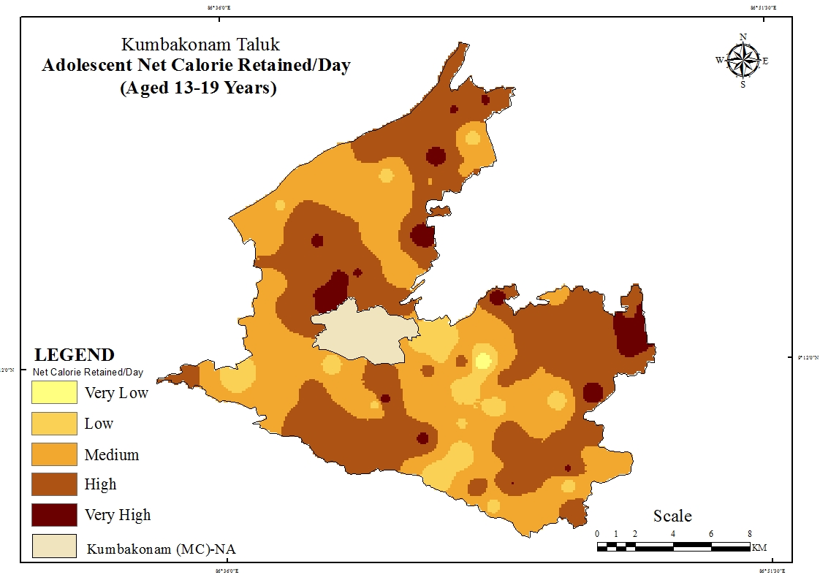

Figure 5 Adolescent Wealth Index in Kumbakonam Taluk
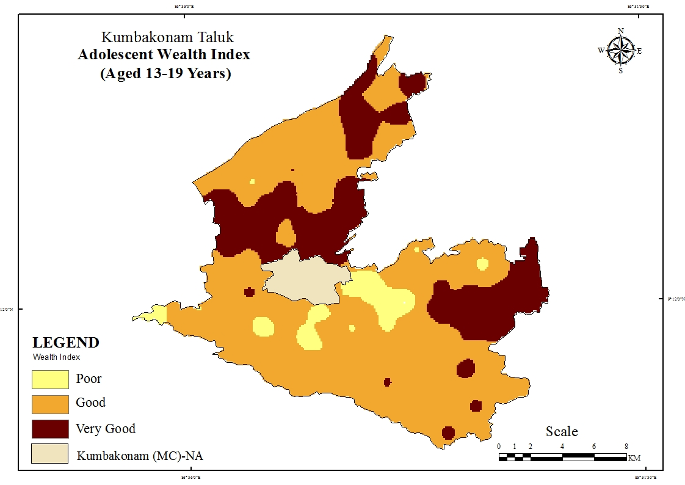

Figure 6 Adolescent Health Index in Kumbakonam Taluk
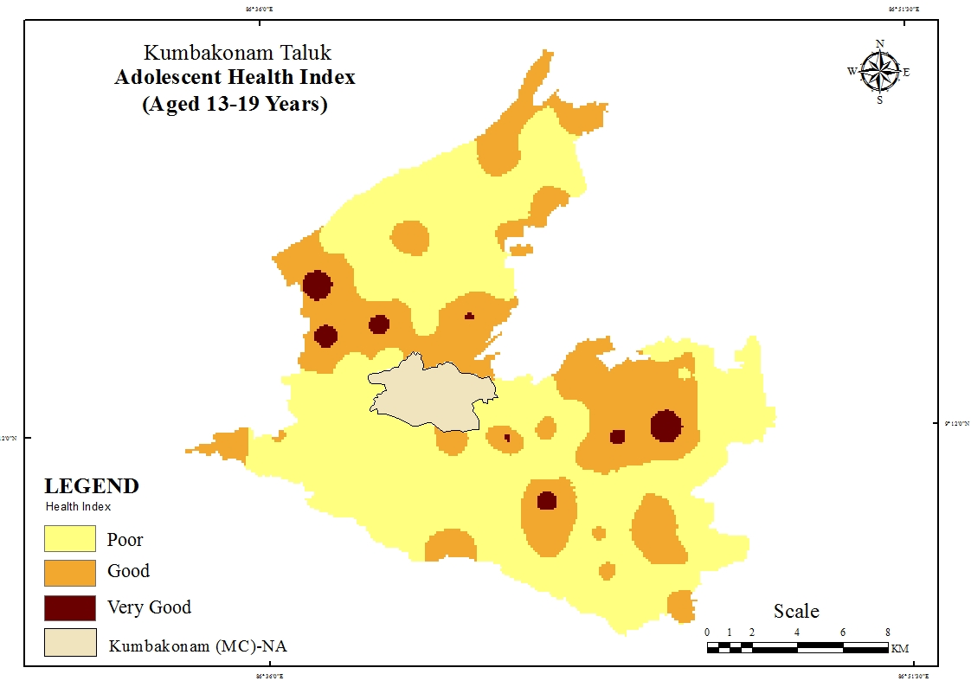

Figure 7 Adolescent Health Status in Kumbakonam Taluk
