Original Research Article
Assessment of Groundwater Physico-Chemical Properties and Water Quality Zonation in Udalguri District of Assam: A Geospatial and WQI-Based Approach

.
ABSTRACT

Aims: The study aims to evaluate the groundwater quality of Udalguri district, Assam, with the application of Water Quality Index (WQI) and Geographic Information System (GIS) tools to determine its suitability for drinking purposes.

Study Design: A field-based water quality assessment was carried out using 38 spatially distributed samples selected through a GIS-based random approach, supported by secondary data collection from existing records and informal field interactions.

Place and Duration of Study: The investigation was conducted in Udalguri district, Assam, India. Groundwater samples were collected and analyzed, and informal interactions were conducted during the study period of 2023-2024.

Methodology: A total of 38 groundwater samples were collected from different sources across the district. Nine physico-chemical parameters like pH, turbidity, hardness, alkalinity, iron, manganese, nitrate, chloride, and fluoride were analyzed following standard protocols. The WQI was computed using the weighted arithmetic index method. Spatial distribution of groundwater quality was mapped using Inverse Distance Weighted (IDW) interpolation in Geographic Information System (GIS), enabling visualization of contamination hotspots and variability across the district.

Results: The findings reveal that approximately 77% of the Udalguri district falls under poor to unsuitable water quality categories. The major factors responsible for deterioration are elevated levels of iron and manganese, surpassing the Bureau of Indian Standards (BIS) permissible limits. In contrast, other parameters such as pH, hardness, nitrate, chloride, and fluoride generally remained within acceptable limits. Spatial analysis showed significant variation in contamination intensity, with certain pockets exhibiting higher risks of groundwater pollution.
Conclusion: The study highlights critical groundwater quality issues in Udalguri district, emphasizing that the majority of the region’s population relies on water sources that are unsuitable for drinking without treatment. Urgent remedial measures, including water treatment initiatives, public awareness campaigns, and long-term monitoring strategies, are recommended to safeguard public health and ensure sustainable water management.
Keywords: Udalguri district, Water Quality Index (WQI), Geographic Information System (GIS), physico-chemical parameters, Inverse Distance Weighted (IDW), Bureau of Indian Standards (BIS)

1. INTRODUCTION

Water, one of the most essential natural resources, is indispensable not only for sustaining ecosystems and public health but also for driving economic development and social stability (Ayoko et al., 2007). Despite covering approximately 71% of Earth’s surface, over 97% of this water is saline, leaving merely 2.5 to 2.7% as freshwater reserves (Gleick, 1993; Shiklomanov, 1998). Of this limited freshwater stock, nearly 68% is sequestered in glaciers and ice caps, and another 30% lies underground as groundwater (U.S. Geological Survey, 2018). Only a meagre 0.3% is readily accessible through surface sources such as lakes, rivers, and reservoirs (Postel et al., 1996). This disproportion highlights the fragility of accessible freshwater resources and underscores the need for effective assessment and management. Global freshwater distribution remains spatially uneven and increasingly stressed by rapid population growth, agricultural intensification, industrialization, and climate variability, particularly in the Global South Asia (Babel & Wahid, 2008). The quality of drinking water, an essential indicator of human wellbeing and economic productivity, continues to deteriorate in many parts of the world. According to the WHO, UNICEF, and the World Bank (2022), over 2 billion people still consume water contaminated with fecal matter, while more than 30% of the global population lacks access to safely managed drinking water. Waterborne diseases claim the lives of over 1.5 million people annually, disproportionately affecting infants and children. In this context, groundwater has emerged as a lifeline, particularly in rural and agrarian economies, due to its comparative reliability and year-round availability (Kumar et al., 2007). In India, groundwater meets nearly 85% of rural drinking needs, supports around 62% of irrigation, and contributes to about 50% of urban water supply (CGWB, 2021). However, this vital resource is increasingly under siege from unregulated extraction, insufficient recharge, and widespread contamination, both geogenic (e.g., iron, arsenic, fluoride) and anthropogenic (e.g., agrochemicals, sewage) (Abanyie et al., 2023; Egbueri et al., 2023).
Assam, situated in the northeastern Himalayan foothills, is no exception. In the Brahmaputra Valley, including districts like Udalguri, groundwater is the predominant source of drinking water due to the absence of updated surface water infrastructure (Kezo, 2021). However, concerns about groundwater quality are escalating. Rapid population growth, shallow tube well proliferation, pesticide and fertilizer use, and localized industrial discharge are deteriorating aquifer health. The situation is exacerbated by naturally occurring toxic elements such as iron, arsenic, and fluoride, which are prevalent in several regions (The Telegraph India, 2017; Times of India, 2025; Udalguri District Administration, 2024). To quantify and communicate groundwater quality comprehensively, the WQI serves as a valuable integrative tool. By combining multiple physico-chemical and microbiological parameters into a single numerical score, WQI simplifies complex datasets into intuitive categories like “excellent,” “poor,” or “unsuitable for drinking” (Dandge & Patil, 2022). The incorporation of GIS enhances the utility of WQI by enabling spatial mapping and visualization of contamination patterns, thereby identifying hotspots and vulnerable zones (Thakuria, 2017; Suryawanshi et al., 2025). Globally, this synergistic approach has been successfully applied to assess water quality and inform mitigation strategies (Kumar & Singh, 2024; Ramakrishnaiah et al., 2009). Notably, seasonal variations significantly influence groundwater quality: post-monsoon periods often see improvements due to dilution, while pre-monsoon periods typically show elevated concentrations of Total Dissolved Solids (TDS), Electrical Conductivity (EC), and trace metals (Dandge & Patil, 2022; Suryawanshi et al., 2023). Frequent exceedances have been recorded for iron, manganese, arsenic, fluoride, nitrates, and coliform bacteria, often breaching both national and WHO permissible limits (Thakuria, 2017).
However, methodological inconsistencies and data limitations present challenges. WQI calculations are often influenced by parameter selection and assigned weights, affecting cross-regional comparability. For instance, studies in Kamrup District emphasized iron, manganese, and fluoride due to their public health relevance, while others rely on standardized weightings that may overlook microbial risks (Dandge & Patil, 2022; Goswami & Bhattacharjya, 2021). Additionally, spatial resolution is constrained by sampling density, and interpolation techniques such as IDW may overlook the geological heterogeneity characteristic of Assam’s alluvial terrain. Importantly, while WQI serves as a practical tool for quality classification, it lacks direct linkage with health outcomes unless supplemented with epidemiological data (Singh et al., 2022).
Against this backdrop, the present study aims to evaluate groundwater quality in Udalguri District using an integrated WQI-GIS approach. By addressing existing gaps in regional hydrogeological data and spatial analysis, the research seeks to generate detailed water quality maps, identify contamination hotspots, and recommend evidence-based mitigation strategies. Ultimately, the findings are expected to support policymakers, enhance water governance, and ensure safer drinking water for the district’s growing population.
2. Study Area
Udalguri district, located in the northeastern state of Assam, India, spans an area of 1990 km² (as per digitization) between latitudes 26°30'N to 27°0'N and longitudes 91°45'E to 92°15'E (Figure 1). Bordered by Bhutan and Arunachal Pradesh to the north, and surrounded by Darrang, Sonitpur, and Baksa districts, the region lies within the fertile Brahmaputra Valley. Predominantly an alluvial plain, it is dissected by hill streams and nourished by tributaries of the river Brahmaputra, such as the Anchnoi, Dhansiri, Jiya Dhanshiri, Mora Dhanshiri, Noa, Kulsi, Dipila, and Bornoi are key to its agrarian economy (Kashyap et al., 2025). The district experiences a humid subtropical climate with high rainfall (avg. 2000 mm annually), mild winters (9*11°C), and monsoon-driven summers. It is characterized by forested lowlands in the south and hilly terrain toward the north. According to the 2011 Census, the population stands at 8,32,769 with a density of 450 persons/km².

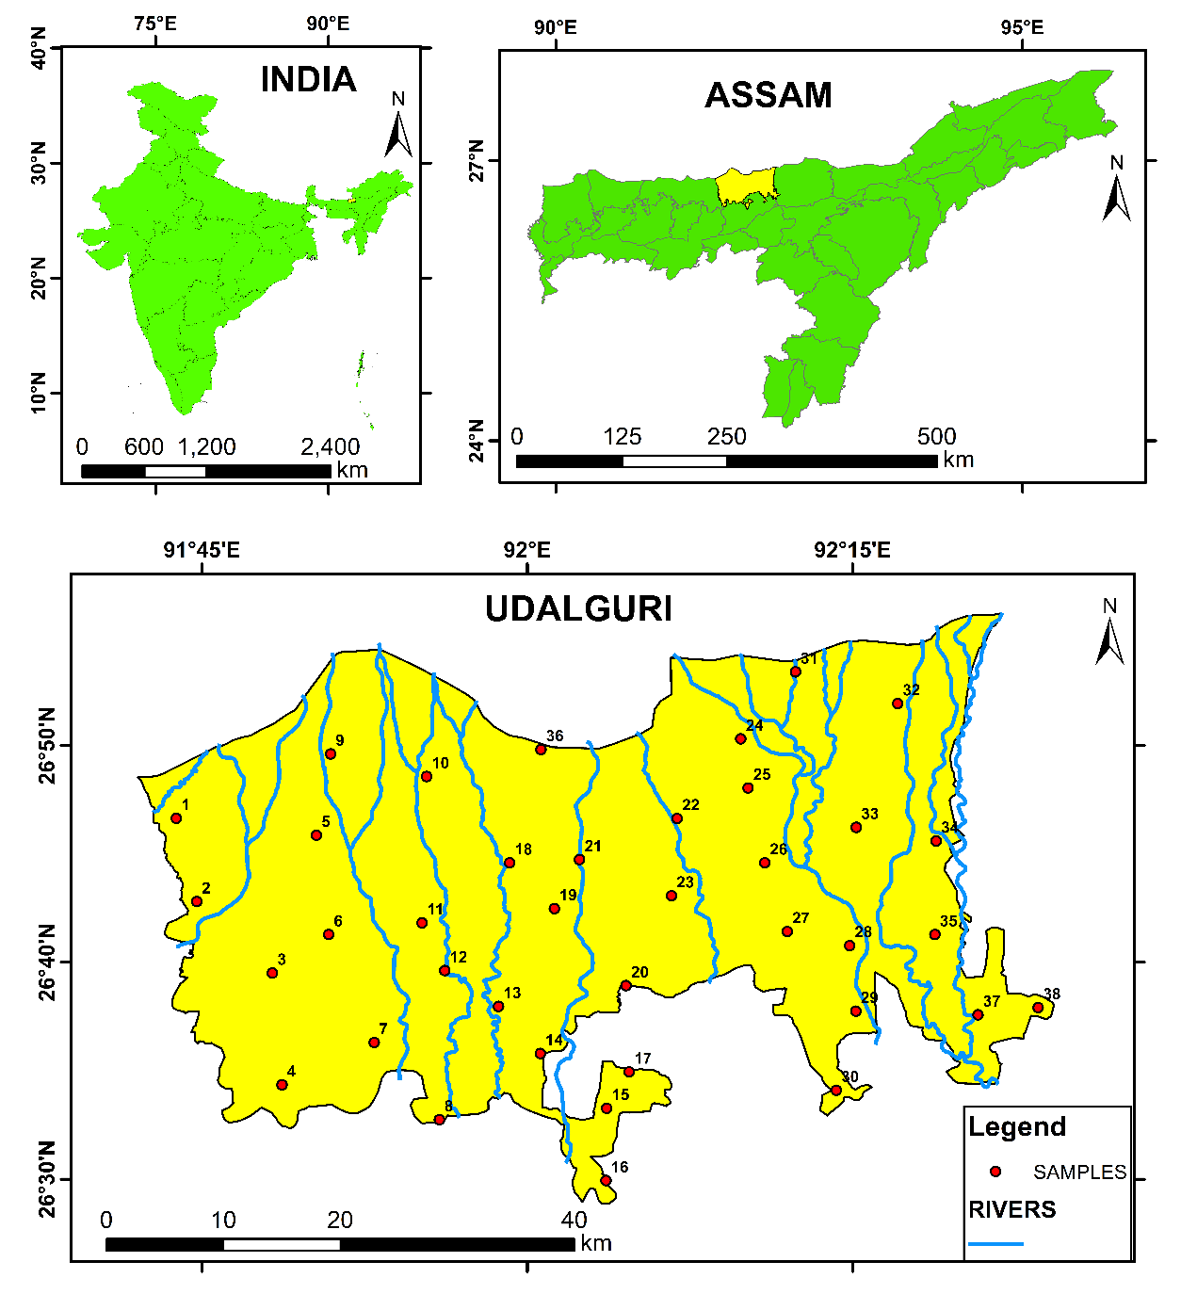
Fig. 1. Study Area

3. material and methods

The study adopts an empirical and descriptive research approach, grounded in both field investigation and secondary data analysis. The research problem was framed based on initial awareness of regional drinking water challenges and corroborated through a review of relevant literature, including academic journals, reports, and other documented evidence. Published and unpublished sources were critically examined to design a workable framework for assessing groundwater quality.
Secondary data were sourced from official publications, statistical records, and thematic maps derived from:

• Jal Jeevan Mission Operational Guidelines (2019),
• WHO Guidelines for Drinking Water Quality (2003, 2008),
• BIS Standards for Drinking Water Quality (2012).

Alongside this, field-based secondary data were collected from 38 spatially distributed locations across Udalguri district from the Public Health Engineering Department, Govt. of Assam. The locations were chosen using a GIS-based random distribution approach while ensuring spatial representation across the entire district. The sites included areas influenced by different hydro-geographical settings such as plains, foothills, riverbanks, agricultural fields, and settlements to capture both natural and anthropogenic variations in water quality. Accessibility and feasibility were also considered, with samples collected from commonly used water sources such as wells, handpumps, and supply points. This approach ensured that the sampling network was representative, unbiased, and suitable for reliable WQI assessment at the district level.

Observations on water quality concerns were also gathered through informal interactions with residents from November 2023 to April 2024, providing valuable socio-perceptual input regarding their access to and trust in drinking water sources. All collected data were processed using Microsoft Excel for statistical analysis. GIS techniques were employed for spatial visualization, utilizing ArcGIS 10.3 to create thematic maps and analyze regional variations. The GIS provides an effective platform for integrating, analyzing, and representing spatial and attribute data, thereby facilitating the assessment of groundwater quality patterns. The WQI was computed using the Weighted Arithmetic Index Method (Brown et al., 1972), incorporating physico-chemical parameters evaluated against permissible limits prescribed by the BIS (see Table 1). Spatial interpolation of the WQI values was performed using the IDW method. IDW is a deterministic interpolation technique based on the principle that points closer to a sampled location have greater influence on the predicted value than those farther away. This method was preferred due to its simplicity, efficiency, and suitability for estimating continuous surfaces from scattered sample points, thereby ensuring a realistic representation of groundwater quality distribution across the study area. The complete methodological workflow is illustrated in Figure 2.

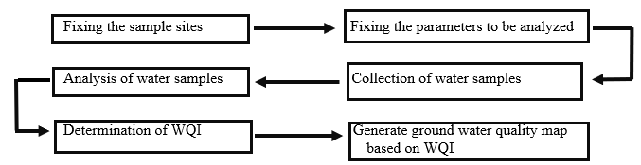
Fig. 2. Methodological Flow Chart

Table 1. Parameters Fixed for the Water Quality Analysis by BIS 2012

Sl. No. | PARAMETERS | UNIT | DRINKING WATER UNIT
1 | pH | - | 8.5
2 | Turbidity | NTU | 1
3 | Hardness | mg/L | 200
4 | Alkalinity | mg/L | 200
5 | Iron | mg/L | 0.3
6 | Manganese | mg/L | 0.1
7 | Nitrate | mg/L | 45
8 | Chloride | mg/L | 250
9 | Fluoride | mg/L | 1

The following formula assesses the suitability of water for drinking (Equation 1-5):
Step 1. Calculate the unit weight (Wn) factors for each parameter by using the formula (Equation 1)

Wn = K/Sn (Eq. 1)

Where,
K= 1/(1/S1+1/S2+1/S3+⋯……+1/Sn) (Eq. 2)
Sn = Standard desirable value of the nth parameter
On summation of all selected parameters unit weight factors, Wn = 1

Step 2. Calculate the Sub-Index (Qn) value by using the formula (Equation 3)
Qn = [(Vn-Vo)]/[(Sn-Vo)] *100 (Eq. 3)
Where,
Vn = Mean concentration of the nth parameter
Sn = Standard desirable value of the nth parameter
Vo = Actual value of the parameters in pure water (generally, Vo = 0, for most parameters except for pH).

QpH = [(VpH-7)]/[(8.5-7)] *100 (Eq. 4)
Step 3. Combining steps 1 and 2, WQI is calculated as follows (Equation 5)
Overall WQI = (∑WnQn)/(∑Wn) (Eq. 5)
Chemical parameters are ranged accordingly as set by the BIS for drinking water quality, and results are being classified based on the WQI value.
Table 2: Drinking Water Quality Classification based on WQI value

SL NO. | WQI VALUE | WATER QUALITY STATUS
1 | <50 | Excellent
2 | 51 – 100 | Good
3 | 101 – 200 | Poor
4 | 201 - 300 | Very poor
5 | >300 | Unsuitable for drinking
Source: BIS (2012)

3. RESULTS

The WQI in Udalguri district was determined through the analysis of key physico-chemical parameters, including pH, turbidity, hardness, alkalinity, iron, manganese, nitrate, chloride, and fluoride (Table 3), and for visualization, the drinking water quality of sampled villages a bar graph was prepared (Figure 3). The findings reveal spatial and qualitative variations in groundwater quality, some of which raise concerns for public health and sustainable water management.
Table 3. Water Quality Analysis
Sample No. | Village | pH | Turbidity | Hardness | Alkalinity | Iron | Manganese | Nitrate | Chloride | Fluoride | WQI | Classification
1 | Dharamjuli khaira Grant | 6.89 | 1.4 | 88 | 130 | 0.03 | 0.04 | 1 | 38 | 0.05 | 37.33 | Excellent
2 | Naobandha Habi | 6.87 | 1.4 | 120 | 140 | 0.08 | 0.09 | 1.1 | 56 | 0.09 | 73.46 | Good
3 | Bhergaon | 7.19 | 3.4 | 0 | 170 | 0.29 | 0.11 | 1.7 | 60 | 0.16 | 114.95 | Poor
4 | Niz Chinakona | 7.31 | 0 | 136 | 165 | 0.7 | 0 | 1.2 | 64 | 0.51 | 53.73 | Good
5 | Duinadir Mukh | 6.81 | 1 | 0 | 125 | 0.02 | 0.03 | 1 | 40 | 0.02 | 27.32 | Excellent
6 | Gala Chuba | 7.35 | 4.4 | 0 | 185 | 2.31 | 0.14 | 3 | 74 | 0.26 | 286.44 | Very poor
7 | No.2 Batabari | 6.97 | 0 | 156 | 140 | 0.54 | 0.16 | 1.46 | 46 | 0.36 | 144.37 | Poor
8 | Jhakuapara | 6.87 | 0 | 152 | 155 | 0.58 | 0.19 | 3.48 | 46 | 0.29 | 166.17 | Poor
9 | Orangajuli T.E. | 6.91 | 1.1 | 0 | 135 | 0.04 | 0.04 | 1 | 48 | 0.03 | 35.57 | Excellent
10 | No.2 Satgharia | 7.18 | 1.7 | 124 | 135 | 0.06 | 0.07 | 1.1 | 48 | 0.07 | 61.07 | Good
11 | Alikhash | 6.86 | 0 | 112 | 145 | 0.22 | 0.11 | 1.36 | 44 | 0.21 | 88.15 | Good
12 | Dakhin Jangalpara | 6.93 | 1.8 | 113 | 140 | 0.15 | 0.06 | 1.1 | 52 | 0.09 | 61.72 | Good
13 | Balipara | 6.88 | 0 | 168 | 140 | 1.59 | 0.26 | 1.65 | 48 | 0.35 | 284.21 | Very poor
14 | Batiamari | 7.19 | 0 | 124 | 135 | 2.11 | 0 | 1.7 | 54 | 0.6 | 155.40 | Poor
15 | Borjhar Bagicha | 7.29 | 1.1 | 152 | 170 | 0.69 | 0 | 1.2 | 60 | 0.55 | 60.37 | Good
16 | Niz Mogalbecha | 7.19 | 0 | 140 | 150 | 1.46 | 0 | 1.7 | 60 | 0.49 | 108.06 | Poor
17 | Kalita para | 7.21 | 1.4 | 132 | 135 | 3.61 | 0 | 1.6 | 50 | 0.7 | 272.71 | Very poor
18 | Kochpara | 6.59 | 0 | 200 | 165 | 0.29 | 0.12 | 1.38 | 56 | 0.19 | 99.38 | Good
19 | Sastrapara | 7.16 | 0 | 136 | 160 | 0.34 | 0.12 | 1.35 | 56 | 0.29 | 103.89 | Poor
20 | Bholabari | 6.91 | 0 | 144 | 155 | 1.39 | 0.31 | 5.21 | 52 | 0.41 | 302.15 | Unsuitable for drinking
21 | Uttar Raona Garh | 6.91 | 0 | 124 | 160 | 0.4 | 0.14 | 1.64 | 52 | 0.17 | 119.79 | Poor
22 | Niz Odalguri | 6.89 | 0 | 196 | 150 | 0.34 | 0.25 | 1.65 | 48 | 0.26 | 187.51 | Poor
23 | Santipur | 6.89 | 0 | 164 | 150 | 0.36 | 0.12 | 1.26 | 46 | 0.36 | 105.64 | Poor
24 | Nepalpara | 6.85 | 0 | 180 | 140 | 0.42 | 0.1 | 1.35 | 40 | 0.09 | 95.27 | Good
25 | No.2 Khomabari | 6.92 | 0 | 152 | 145 | 0.51 | 0.19 | 2.89 | 44 | 0.27 | 160.67 | Poor
26 | Tarabari | 6.91 | 1.2 | 0 | 150 | 0.74 | 0.09 | 1 | 54 | 0.2 | 119.82 | Poor
27 | Aminpara | 6.94 | 0 | 128 | 140 | 0.57 | 0.21 | 1.28 | 48 | 0.46 | 179.48 | Poor
28 | Ai-thanjhar | 6.89 | 0 | 160 | 155 | 2.12 | 0.34 | 3.49 | 48 | 0.24 | 373.19 | Unsuitable for drinking
29 | Bangali Gaon | 7.14 | 2.6 | 136 | 155 | 0.16 | 0.1 | 1.5 | 58 | 0.1 | 93.61 | Good
30 | Khajuabil | 6.87 | 0 | 164 | 145 | 2.12 | 0.49 | 6.81 | 48 | 0.34 | 470.69 | Unsuitable for drinking
31 | No.2 Dhansiri Gaon | 6.89 | 0 | 156 | 140 | 0.84 | 0.21 | 0 | 44 | 0.42 | 198.57 | Poor
32 | Bahipukhuri Gaon | 6.95 | 0 | 144 | 155 | 1.23 | 0.31 | 5.89 | 46 | 0.51 | 291.52 | Very poor
33 | No.5 Beteli T.E. | 6.89 | 0 | 160 | 150 | 0.39 | 0.21 | 5.74 | 46 | 0.26 | 165.27 | Poor
34 | Phuhurabari | 6.89 | 0 | 164 | 155 | 0.88 | 0.3 | 2.89 | 48 | 0.41 | 259.50 | Very poor
35 | Bengenabari Gaon | 6.89 | 0 | 152 | 155 | 0.72 | 0.19 | 3.91 | 48 | 0.31 | 176.35 | Poor
36 | No. 1 Amjuli | 6.98 | 0 | 164 | 130 | 0.38 | 0.2 | 1.36 | 48 | 0.29 | 158.32 | Poor
37 | Kachari Bheti Top | 6.89 | 0 | 132 | 140 | 0.32 | 0.21 | 1.14 | 48 | 0.21 | 159.91 | Poor
38 | Amguri Kachari | 6.94 | 0 | 164 | 150 | 1.95 | 0.31 | 2.16 | 46 | 0.41 | 342.47 | Unsuitable for drinking

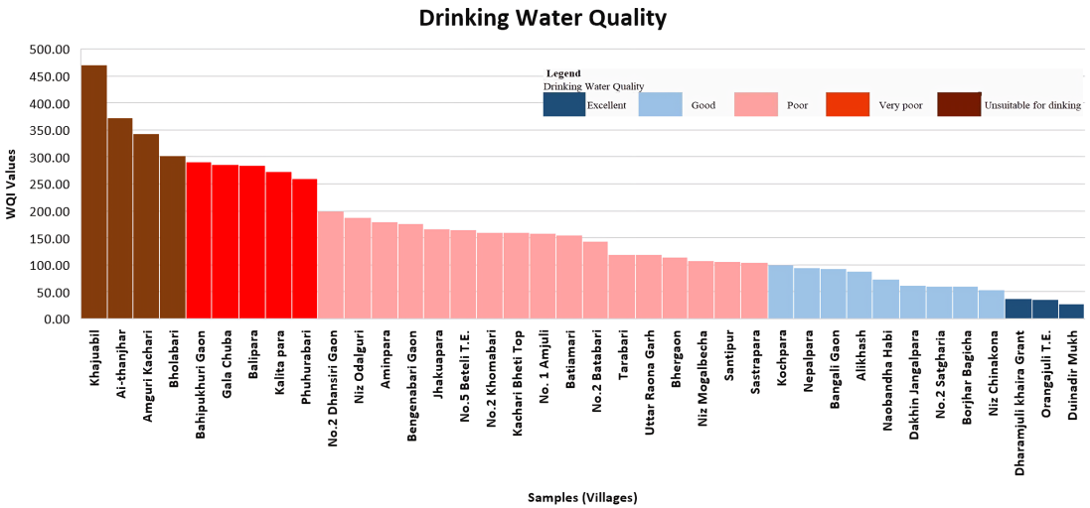
Fig. 3. Drinking Water Quality Index (WQI) values of 38 sampled villages in Udalguri district.

3.1 PHYSICO-CHEMICAL PARAMETERS ANALYSIS

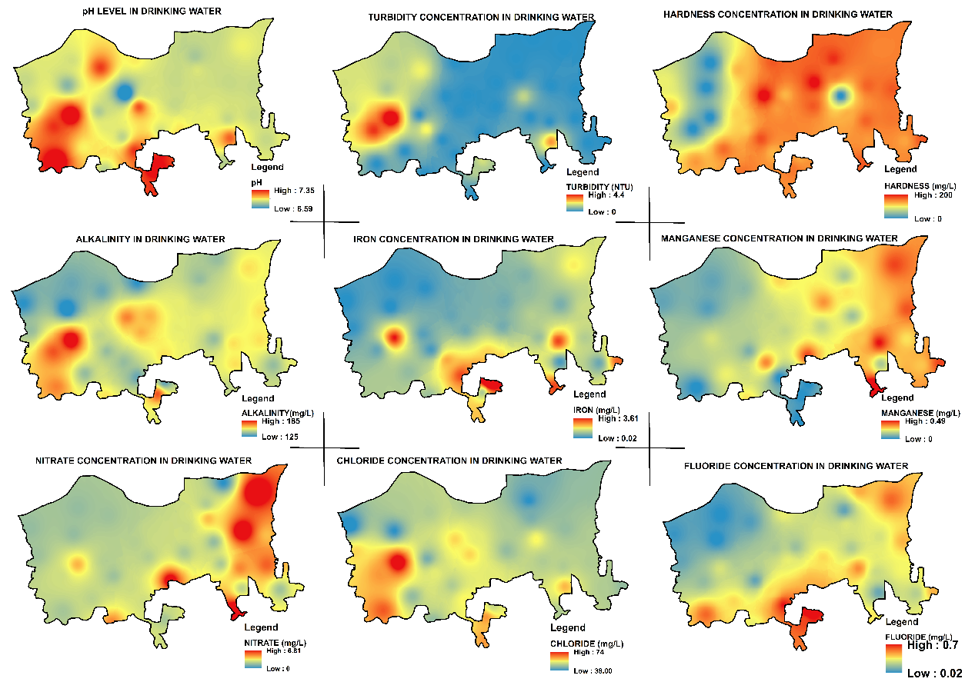
Fig. 4. Physico-Chemical Parameters

3.1.1 pH Levels
According to BIS standards, the acceptable pH range for drinking water is 6.5–8.5. In the study area, pH values range from 6.5 to 7.34, indicating that the water is generally within safe limits. However, approximately 76.76% of the district's area recorded a pH below 7, suggesting a mildly acidic nature, which, although not alarming, may gradually affect taste and infrastructure (Figure 4). Only 23.24% area of the district was within the neutral or slightly alkaline range, typically associated with higher drinking quality.
3.1.2 Turbidity
Turbidity, an indicator of suspended solids, ranged from 0.08 to 4.4 NTU. While 68.87% area of the district fell within the acceptable limit (≤1 NTU), 29.51% were within the permissible range (1–5 NTU), and 1.82% exceeded the upper threshold. Elevated turbidity can interfere with disinfection processes and indicate potential microbial contamination.
3.1.3 Hardness
Water hardness, influenced by calcium and magnesium content, varied between 0.004 mg/L and 200 mg/L. All samples fall within the acceptable limit of 200 mg/L, suggesting that hardness is not a critical issue in the district. The low baseline value in some locations points toward soft water, which, while safe, may be slightly corrosive to plumbing over time.
3.1.4 Alkalinity
Alkalinity levels, which buffer pH changes, ranged from 125.02 to 184.9 mg/L, well within the BIS acceptable limit of 200 mg/L. This indicates a stable pH buffering capacity, offering natural resistance to sudden acidity shifts in most water sources across the region.
3.1.5 Iron Concentration
Iron levels showed significant deviation from standards, ranging between 0.02 to 3.60 mg/L. Alarmingly, 81.48% area of the district exceeded the acceptable limit of 0.3 mg/L. Excessive iron not only affects taste, colour, and odor but can also cause long-term plumbing issues and has minor health implications. This highlights a critical concern in the region’s hydrochemistry, likely influenced by geogenic factors.
3.1.6 Manganese Levels
Manganese concentrations varied between 0.001 to 0.49 mg/L. Only 28.71% area of the district met the acceptable standard (≤0.1 mg/L), while 69.85% were within the permissible range (0.1–0.3 mg/L), and 1.44% exceeded safe levels. Elevated manganese may pose neurological risks if consumed over time and often accompanies iron contamination in groundwater.
3.1.7 Nitrate Content
Nitrate concentrations were found between 0.0003 to 6.81 mg/L, far below the BIS acceptable limit of 45 mg/L. This suggests minimal contamination from agricultural runoff or sewage, often major contributors to nitrate pollution, indicating that such anthropogenic impacts are currently limited in the study area.
3.1.8 Chloride Concentration
Chloride values ranged from 38 to 73.97 mg/L, comfortably within the BIS acceptable limit of 250 mg/L. This confirms the absence of saline intrusion or significant industrial discharge into the aquifers, implying a naturally balanced chloride presence.
3.1.9 Fluoride Levels
Fluoride concentrations varied between 0.02 to 0.7 mg/L, all below the BIS threshold of 1.0 mg/L. This suggests that the district is currently not at risk of dental or skeletal fluorosis, a common concern in many fluoride-rich regions of India.
3.2 WQI ANALYSIS and OVERALL INSIGHTS
The WQI offers a composite measure that simplifies complex physico-chemical datasets into a single value, facilitating intuitive classification of drinking water suitability. In this study, WQI values were calculated using the weighted arithmetic index method (Browm et al., 1972), based on nine key parameters: pH, turbidity, hardness, alkalinity, iron, manganese, nitrate, chloride, and fluoride. The analysis provides a spatial overview of groundwater quality across Udalguri district and highlights zones requiring immediate attention (Figure 5).

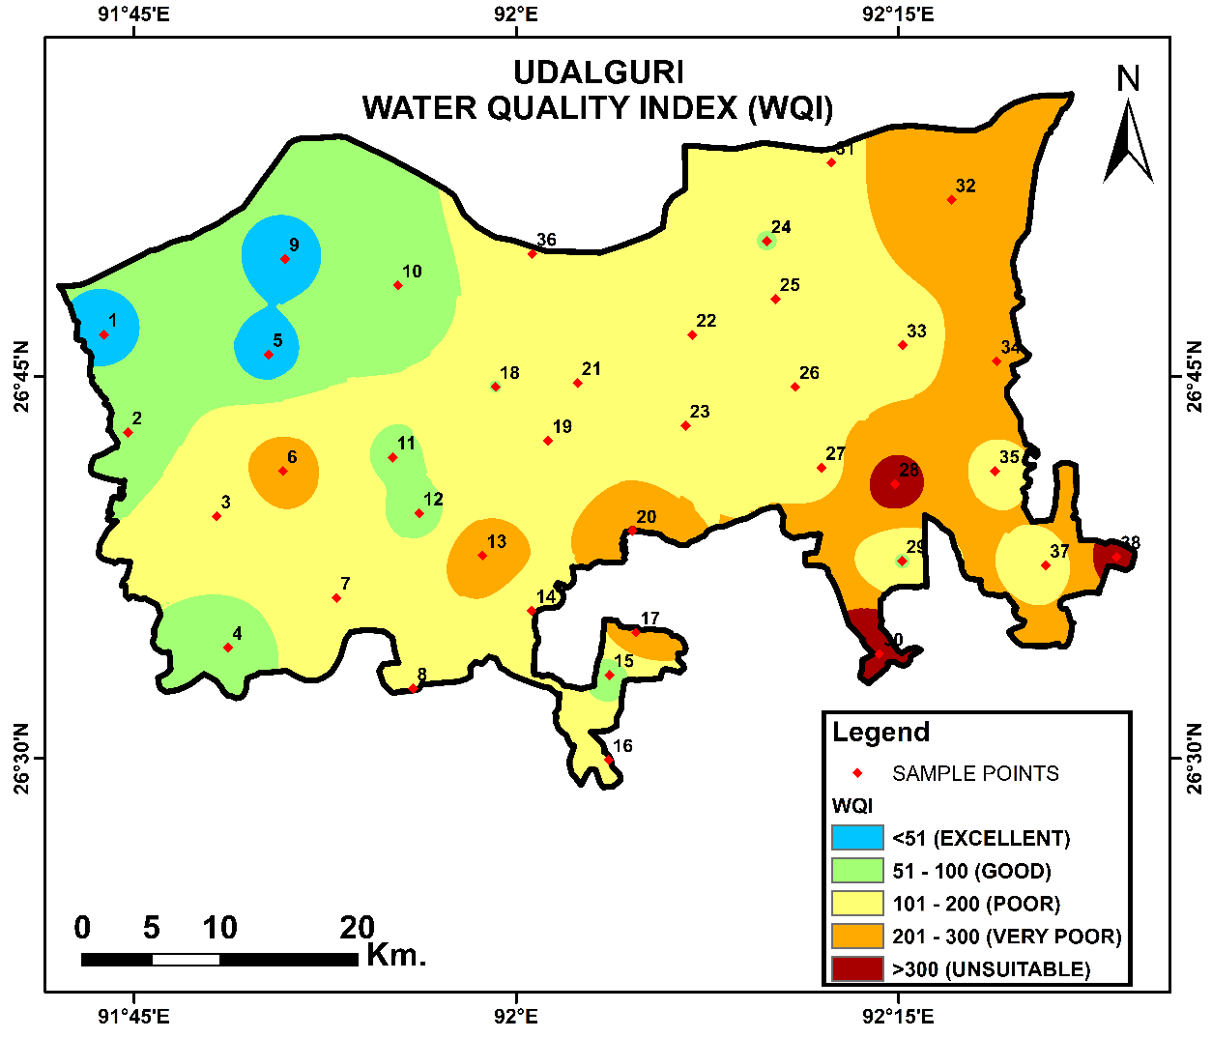
Fig. 5. Water Quality Map

The WQI results indicate that a significant portion of the district’s population is exposed to substandard water quality. Based on BIS classification, the findings reveal the following distribution (Table 2):
• Excellent water quality (WQI ≤ 50): Only 3.13% (62.19 km²) of the study area falls under this category, indicating extremely limited access to pristine groundwater.
• Good quality (WQI 51–100): About 19.69% (391.88 km²) of the area enjoys reasonably safe drinking water, requiring minimal treatment.
• Poor quality (WQI 101–200): A substantial 55.79% (1110.15 km²) of the district falls into this range, suggesting the need for basic filtration and possibly chemical treatment.
• Very poor quality (WQI 201–300): Nearly 20.03% (398.65 km²) of the region falls into this category, indicating health risks and the need for urgent remedial action.
• Unsuitable for drinking (WQI > 300): Alarmingly, 1.36% (27.12 km²) of the area is classified as having impure water that is unsafe for consumption without advanced treatment.
These values reveal that nearly 77% of the total district area falls into either poor, very poor, or unsuitable categories. Such results emphasize a pressing need for intervention in groundwater management and quality control. The spatial distribution of WQI, visualized through GIS-based interpolation (IDW), shows that water quality degradation is not uniform. Northern and northeastern pockets are especially closer to hill bases and sediment-laden zones, and tend to reflect higher concentrations of iron and manganese, which significantly influence the WQI scores. The southern and central plains, in contrast, show relatively moderate WQI values, aligning with better accessibility and infrastructure in those zones.
These WQI results are consistent with individual parameter analysis:
• Iron and manganese, both with widespread exceedance of permissible limits (81.48% and 71.29% respectively), are primary contributors to high WQI scores.
• Elevated turbidity in 31.33% of samples (above acceptable limits) also drives the deterioration in index values, potentially signaling microbial risks.
• Other parameters like nitrate, fluoride, hardness, alkalinity, and chloride remain largely within acceptable ranges and thus contribute minimally to index elevation.
Field observations further affirm these findings. Residents in several parts of the district reported noticeable staining of utensils and a bitter taste in water, both indicative of iron and manganese presence. Community feedback also pointed to a lack of household-level treatment systems and irregular water testing, especially in remote villages. This alignment between empirical data and community perception adds credibility and urgency to the assessment.
4. IMPLICATIONS
The high proportion of the district classified under poor and very poor WQI categories raises major public health and infrastructure concerns. While iron and manganese appear to be the dominant chemical culprits, the broader issue is inadequate water monitoring, treatment access, and awareness, especially in rural belts.
The study not only quantifies the problem but also offers a foundation for policy response. Interventions could include:
- Installation of iron and manganese-specific filters at the household or community levels.
- Regular water quality monitoring integrated into Panchayat-level governance.
- Awareness campaigns to educate communities on the significance of water quality and safe storage.
- GIS-based zoning for priority mitigation, especially in very poor and impure zones.
5. DISCUSSION
Monitoring and evaluating drinking water quality is essential in the face of increasing waterborne health risks, particularly in regions vulnerable to both geogenic and anthropogenic contamination. This study, through the application of WQI and GIS-based spatial mapping, offers a timely assessment of groundwater quality across Udalguri district. By analyzing nine key physico-chemical parameters, it aimed to determine overall water suitability and identify priority areas for intervention. The WQI results reveal a concerning pattern: over three-fourths of the study area falls into poor to very poor water quality categories, with small pockets classified as unfit for drinking. While parameters like pH, turbidity, hardness, alkalinity, nitrate, chloride, and fluoride generally remain within the acceptable BIS limits, iron and manganese concentrations significantly exceed both acceptable and permissible thresholds, contributing disproportionately to poor WQI values. These two elements, often geogenic in origin, are found at problematic levels in multiple sampling sites, presenting long-term risks such as organ damage (iron overload) and neurotoxicity (from manganese exposure), especially among vulnerable groups like children and the elderly. This spatial disparity is also evident in village-level observations. Villages such as Duinadir Mukh, Orangajuli T.E., and Dharamjuli Khaira Grant exhibited excellent water quality, suggesting either favorable hydrogeological conditions or better management practices. Conversely, villages like Bholabari, Amguri Kachari, Ai-Thanjhar, and Khajuabil recorded some of the highest WQI scores, reflecting unsafe conditions that demand urgent attention.
Notably, while nitrate and fluoride, typically linked with anthropogenic sources such as agricultural runoff, were found within acceptable limits, the pervasiveness of iron and manganese underscores the role of natural geological formations and aquifer composition in water quality variation across Udalguri. This makes localized, geology-specific mitigation strategies crucial. Furthermore, residents’ perceptions gathered during field visits corroborate the analytical results. Complaints about water colour, taste, staining of utensils, and gastrointestinal discomfort were most frequent in areas where WQI scores were high and iron concentrations were elevated. This alignment between scientific data and local experiences not only validates the findings but also underscores the urgency of community-informed action.
The discussion also points toward systemic challenges. The absence of widespread filtration systems, irregular monitoring, and limited public awareness contributes to continued reliance on substandard water sources. Despite the operational presence of programs like Jal Jeevan Mission, the gap between infrastructure and actual water quality assurance remains wide. In essence, this study reinforces that WQI, supported by GIS tools and field interaction, is an effective means to simplify water quality assessment and convey actionable insights. However, it also highlights the need for multidimensional approaches, combining hydrogeological investigation, community engagement, regular monitoring, and policy support to secure sustainable and safe drinking water across Udalguri district.
6. CONCLUSION
The study assessed groundwater quality in Udalguri district using WQI and GIS, and results show that nearly 77% of the area falls under poor to unsuitable categories for drinking. High levels of iron and manganese are the major pollutants, with contamination being more severe in sites located near agricultural fields, densely populated settlements, and riverbank areas. These hotspot locations highlight the spatial variability of groundwater quality and indicate where immediate remedial action is required. The findings emphasize the need for regular monitoring, installation of treatment facilities, and public awareness programs to safeguard community health. This study also provides a valuable baseline for water resource management and future planning in the district.

LIMITATIONS
The research is limited by the sample size of 38 locations, which, though spatially distributed, may not capture the full hydrogeological variability of the district. Seasonal variations were not addressed, which could significantly influence parameter concentrations. Additionally, the study relies solely on physico-chemical parameters, while microbiological contamination, a key health risk, was not assessed.
FUTURE RESEARCH DIRECTIONS
Future studies should expand sampling density, incorporate seasonal monitoring, and include microbiological and heavy metal analysis to provide a more comprehensive assessment. Linking WQI results with health outcome data would also strengthen the understanding of risks. Advanced geostatistical models beyond IDW, such as kriging, could improve spatial accuracy. Long-term monitoring and community-based participatory research can further support effective groundwater management and sustainable policy interventions.

DISCLAIMER (ARTIFICIAL INTELLIGENCE)

The authors hereby declare that no generative AI technologies such as Large Language Models (ChatGPT, COPILOT, etc) and text-to-image generators have been used during the writing or editing of this manuscript.

References

Abanyie, S. K., Apea, O. B., Abagale, S. A., Amuah, E. E. Y., & Sunkari, E. D. (2023). Sources and factors influencing groundwater quality and associated health implications: A review. Emerging Contaminants, 9(2), 100207. https://doi.org/10.1016/j.emcon.2023.100207
Ayoko, G. A., Singh, K., Balerea, S., & Kokot, S. (2007). Exploratory multivariate modeling and prediction of the physico-chemical properties of surface water and groundwater. Journal of Hydrology, 336(1-2), 115-124. https://doi.org/10.1016/j.jhydrol.2006.12.013
Babel, M. S., & Wahid, S. M. (2008). Freshwater under threat: South Asia—Vulnerability assessment of freshwater resources to environmental change. UNEP & Asian Institute of Technology. https://www.preventionweb.net/files/7989_southasiareport1.pdf
Brown, R. M., McClelland, N. I., Deininger, R. A., & O’Connor, M. F. (1972). A water quality index—Crashing the psychological barrier. Environmental Science Research, 1, 173–182. https://doi.org/10.1007/978-1-4684-2856-8_15
Bureau of Indian Standards. (2012). IS 10500:2012 – Drinking water – Specification (Second Revision). Manak Bhavan. https://cpcb.nic.in/wqm/BIS_Drinking_Water_Specification.pdf
Central Ground Water Board (CGWB). (2021). National compilation on dynamic groundwater resources of India, 2020. Ministry of Jal Shakti. https://www.cgwb.gov.in/old_website/documents/2021-08-02-GWRA_India_2020.pdf
Dandge, K. P., & Patil, S. S. (2022). Spatial distribution of groundwater quality index using remote sensing and GIS techniques. Applied Water Science, 12(1), 7. https://doi.org/10.1007/s13201-021-01546-7
Egbueri, J. C., Agbasi, J. C., Ayejoto, D. A., Khan, M. I., & Khan, M. Y. A. (2023). Extent of anthropogenic influence on groundwater quality and human health-related risks: An integrated assessment. Geocarto International, 38(1), 1–35. https://doi.org/10.1080/10106049.2023.2210100
Gleick, P. H. (1993). Water in crisis: A guide to the world’s fresh water resources. Oxford University Press. http://www.ibiologia.unam.mx/pdf/directorio/z/introduccion/world_watershed_re.pdf
Goswami, J., & Bhattacharjya, R. K. (2021). Assessment of groundwater-based public drinking water supply system of Kamrup District, Assam, India using a modified water quality index. Pollution, 3. https://doi.org/10.22059/poll.2021.309035.883
Kashyap, P. J., & Podder, S. D. (2025). Menstrual hygiene and associated factors among Bodo community women of foothills region of Himalayas: A case study on Baruah Howly Village, Udalguri District of Assam, India. International Journal of Community Well-Being, 1–13. https://doi.org/10.1007/s42413-025-00276-x
Kezo, V. (2021). Aquifer mapping and management plan of Udalguri District, Assam: Annual action plan, 2019–20. Central Ground Water Board, NER, Government of India. https://www.cgwb.gov.in/cgwbpnm/public/uploads/documents/1675935451583571036file.pdf
Kumar, A., & Singh, A. (2024). Pollution source characterization and evaluation of groundwater quality utilizing an integrated approach of WQI, GIS and multivariate statistical analysis. Water Supply, 24(10), 3517–3539. https://doi.org/10.2166/ws.2024.213
Kumar, M., Kumari, K., Ramanathan, A. L., & Saxena, R. (2007). Comparative evaluation of groundwater suitability for irrigation and drinking in two cultivated districts of Punjab, India. Environmental Geology, 53, 553–574. https://doi.org/10.1007/s00254-007-0672-3
Ministry of Jal Shakti. (2019). Operational guidelines for implementation of Jal Jeevan Mission (Har Ghar Jal). Government of India. https://jaljeevanmission.gov.in/sites/default/files/guideline/JJM_Operational_Guidelines.pdf
Postel, S. L., Daily, G. C., & Ehrlich, P. R. (1996). Human appropriation of renewable freshwater. Science, 271(5250), 785–788. https://doi.org/10.1126/science.271.5250.785
Ramakrishnaiah, C. R., Sadashivaiah, C., & Ranganna, G. (2009). Assessment of water quality index for the groundwater in Tumkur Taluk, Karnataka State, India. Journal of Chemistry, 6(2), 523–530. https://doi.org/10.1155/2009/757424
Shiklomanov, I. A. (1998). World water resources: A new appraisal and assessment for the 21st century. UNESCO. https://caee.utexas.edu/prof/mckinney/ce385d/Papers/Shiklomanov.pdf
Singh, R., Upreti, P., Allemailem, K. S., Almatroudi, A., Rahmani, A. H., & Albalawi, G. M. (2022). Geospatial assessment of groundwater quality and associated health problems in Western India. Water, 14(3), 296. https://doi.org/10.3390/w14030296
Suryawanshi, V., Ramesh, H., & Nasar, T. (2023). Groundwater Quality Evaluation In The Gurupura River Basin Using GIS and Remote Sensing Approach. In 2023 IEEE India Geoscience and Remote Sensing Symposium (InGARSS) (pp. 1-4). IEEE. https://doi.org/10.1109/InGARSS59135.2023.10490433
Suryawanshi, V., Ramesh, H., & Nasar, T. (2025). Geospatial and Hydrogeochemical Insights for Monitoring Water Quality and Salinity in Coastal Regions of Southern Karnataka, India. In: Saritha, V., Pande, C.B., Singh, R., Shahid, M. (eds) Remote Sensing for Environmental Monitoring. Springer, Singapore. https://doi.org/10.1007/978-981-96-5546-5_10
Thakuria, I. H. (2017). GIS-based evaluation of water quality index of groundwater and identification of arsenic vulnerable zone in Nagaon District, Assam (Ph.D. thesis). Assam Agricultural University, Jorhat. http://krishikosh.egranth.ac.in/handle/1/5810109368
The Telegraph India. (2017). Barpeta, Nagaon top toxic water list: Tests reveal high levels of arsenic and fluoride. The Telegraph. https://www.telegraphindia.com/north-east/barpeta-nagaon-top-toxic-water-list/cid/1432881
Times of India. (2025). 17 districts report high iron level, 7 face arsenic contamination. The Times of India. https://timesofindia.indiatimes.com/city/guwahati/17-dists-report-high-iron-level-7-face-arsenic-contamination/articleshowprint/117275484.cms?val=3728
U.S. Geological Survey. (2018). Where is Earth's water? Water Science School. https://www.usgs.gov/special-topics/water-science-school/science/where-earths-water#overview
Udalguri District Administration. (2024). Flood action plan: Udalguri District, 2024–25. Government of Assam. https://udalguri.assam.gov.in/sites/default/files/public_utility/FAP.pdf
World Health Organization (WHO), UNICEF, & World Bank. (2022). State of the world’s drinking water: An urgent call to action. WHO. https://cdn.who.int/media/docs/default-source/wash-documents/water-safety-and-quality/state-of-drinking-water-report-web.2_v-lowres.pdf?sfvrsn=e2479151_3&download=true
World Health Organization. (2008). Guidelines for drinking-water quality: Second addendum to third edition. Vol. 1: Recommendations. WHO. https://iris.who.int/bitstream/handle/10665/204412/9789241547604_eng.pdf?sequence=1

