LAND USE TRANSITIONS AND BAMBOO BASED LIVELIHOOD DIVERSIFICATION IN KARBI ANGLONG, NORTHEAST INDIA
ABSTRACT:
Land use transitions in ecotonal regions of Northeast India illustrate the dynamic interaction between ecological resources, industrial demand, and livelihood change. This study examines three decades of land use and land cover (LULC) change in Karbi Anglong district, Assam, with a focus on bamboo-based systems. Multi-temporal satellite images (1993, 2014, and 2023/24) were classified using the Random Forest algorithm. The 2023/24 map, validated with 700 ground-truth samples, achieved 93.6% overall accuracy and a Kappa coefficient of 0.87. Results indicate three major phases: (i) 1993 – natural abundance, when bamboo was embedded in forest and shifting cultivation systems; (ii) 2014 – plantation expansion, driven by industrial demand and state subsidies, when bamboo became a dominant land cover (24.72%) at the expense of forests and jhum; and (iii) 2023/24 – post-mill diversification, characterized by stable bamboo cover (24.74%), expansion of rubber, tea, and arecanut, and growing built-up areas. These transitions highlight the role of industrial dependence in reshaping landscapes and livelihoods. The study underscores the need for integrated land use policies that balance forest conservation with livelihood diversification and sustain bamboo as both an ecological and cultural resource.
Keywords: Land use transition; Bamboo utilization; Remote sensing and GIS; Plantation expansion; Shifting cultivation decline; Karbi Anglong (Northeast India)

- INTRODUCTION
Land use and land cover (LULC) transitions are among the most visible indicators of human–environment interactions, reflecting changing livelihood strategies, market forces, and ecological pressures (Lambin & Meyfroidt, 2010). Across the tropics, transitions from shifting cultivation to plantations, commercial agriculture, or built-up areas have reshaped forest landscapes, often creating trade-offs between economic opportunity and ecological resilience (Fox et al., 2009; Meyfroidt, 2016). In South and Southeast Asia, the expansion of plantations and the decline of traditional land-use systems are strongly tied to industrial demand, rural development policies, and demographic change (Mertz et al., 2009).
In Northeast India, land use dynamics are especially complex because of the coexistence of shifting cultivation, forest-based livelihoods, and emerging plantation economies. Bamboo, in particular, has played a pivotal role in shaping both landscapes and livelihoods (Kurien, Lele, Nagendra, 2019; Bos et al.,2020; Chanu et al.,2023). As one of the fastest-growing and most versatile non-timber resources, bamboo provides construction material, household goods, and cultural value while also serving as a raw material for industries such as paper and pulp (Belcher, 1999; Nath et al., 2015). However, the sustainability of bamboo as a livelihood resource depends on broader land-use dynamics, including the pressures from forest conversion, resource availability, and market fluctuations (Sundriyal & Joshi 2015), as well as ecological trade-offs linked to land conversion and competition with other forests resources (Sailo et al., 2025).
Karbi Anglong district in Assam represents a critical case for examining such transitions. The district experienced three decades of dramatic land-use change, closely tied to the rise and fall of the Nagaon Paper Mill in Jagiroad, once a major consumer of bamboo in the region (Sarma, 2012). The establishment of bamboo plantations on former jhum fields, the decline of forest cover, and the subsequent diversification into alternative crops such as rubber, tea, and arecanut illustrate the multiple pathways through which livelihoods and landscapes have evolved (Bos et al.,2020). At the same time, population growth and infrastructure expansion have contributed to steady expansion of built-up areas, adding to ecological stress (Aktara & Bhuyan, 2025; Sarkar, 2024).
While earlier research has documented bamboo’s ecological in Northeast India (Bystriakova & Kapos, 2003) as well as its deep cultural and livelihood importance in the region (Nath & Das, 2011). Few studies have systematically examined land-use transitions over multiple decades in relation to industrial demand and livelihood shifts. This paper addresses that gap by analysing land use and land cover change in Karbi Anglong from 1993 to 2023/24. Using multi-temporal remote sensing data, transition matrices, and field-based narratives, the study identifies three distinct phases of transition: (i) natural abundance (1993), (ii) plantation expansion (2014), and (iii) post-mill diversification (2023/24).
The objectives of the study are:
- To map and quantify land use and land cover changes in Karbi Anglong across three decades.
- To examine the drivers and socio-ecological implications of bamboo utilization across different phases.
- To discuss the policy implications of land use transitions for sustainable bamboo management and diversified rural livelihoods.
By situating bamboo within broader trajectories of land-use change, this study contributes to understanding how industrial dependence and livelihood diversification shape ecotonal landscapes in Northeast India.
2. MATERIALS AND METHODS
2.1 Study Area
Karbi Anglong, the largest district in Assam, Northeast India (Fig.1). It covers an area of approximately 10,434 km² at latitude 25°33’ N and 26$°$ 35’N and longitude 92$°$10’E and 93$°$50’ E, with altitudinal range of 47-1370 m above sea level. It is sub-tropical monsoon, characterized by cool winters (6-12$°$ C), warm summers (23-32$°$C), and heavy monsoon rainfall averaging about 2416 mm annually (Government of Assam, n.d). The soil are predominantly red lateritic soils, occurring extensively over the hilly uplands and slopes. In contrast, the valley bottoms and plains contain sandy loam to loam soils. According to Champion and Seth’s (1968) classification, the districts are categorized as Moist Semi-Evergreen (2BC1/b,2BC) and Moist Mixed Deciduous (3C/C 3b) (Champion & Seth, 1968; Karbi Anglong District Forest Department, n.d).
2.2 Demography of the study area
According to the Census of India (2011), the district has a population of 956313 (490167 males, 466146 females i.e. 951 females per 1000 males), with a density population of 93 people km², Rongkhang block being the most populous with 158035, while Socheng block has the lowest population with 27334. The overall literacy rate is 69.25% (Census of India, 2011). The district has a total household of 177646, with Bokajan has the highest number of inhabited villages (419), whereas Socheng block records the lowest (76). The Largest village by population is Nawaibil, under Rongkhang block accomdating 7303 persons (Census of India, 2011). In terms of social composition, Schedules Tribes (STs) constitute with 56.33%, while Schedules Castes (SCs) account for 4.70% (Census of India, 2011; Government of Assam n,d).
2.3 Significance of the Area
The district is ecologically significant, forming part of the Indo-Burma biodiversity hotspot, and socio-culturally diverse, inhabited predominantly by the Karbi and other tribal communities. Bamboo has historically been central to household subsistence, cultural practices, and industrial supply chains. The district’s land-use dynamics are strongly influenced by the Jagiroad Paper Mill (operational until 2017), government plantation schemes, and the gradual decline of jhum (shifting cultivation). The geographical location and multi-functional role of bamboo make Karbi Anglong a representative case for studying land-use transitions in ecotonal landscapes.
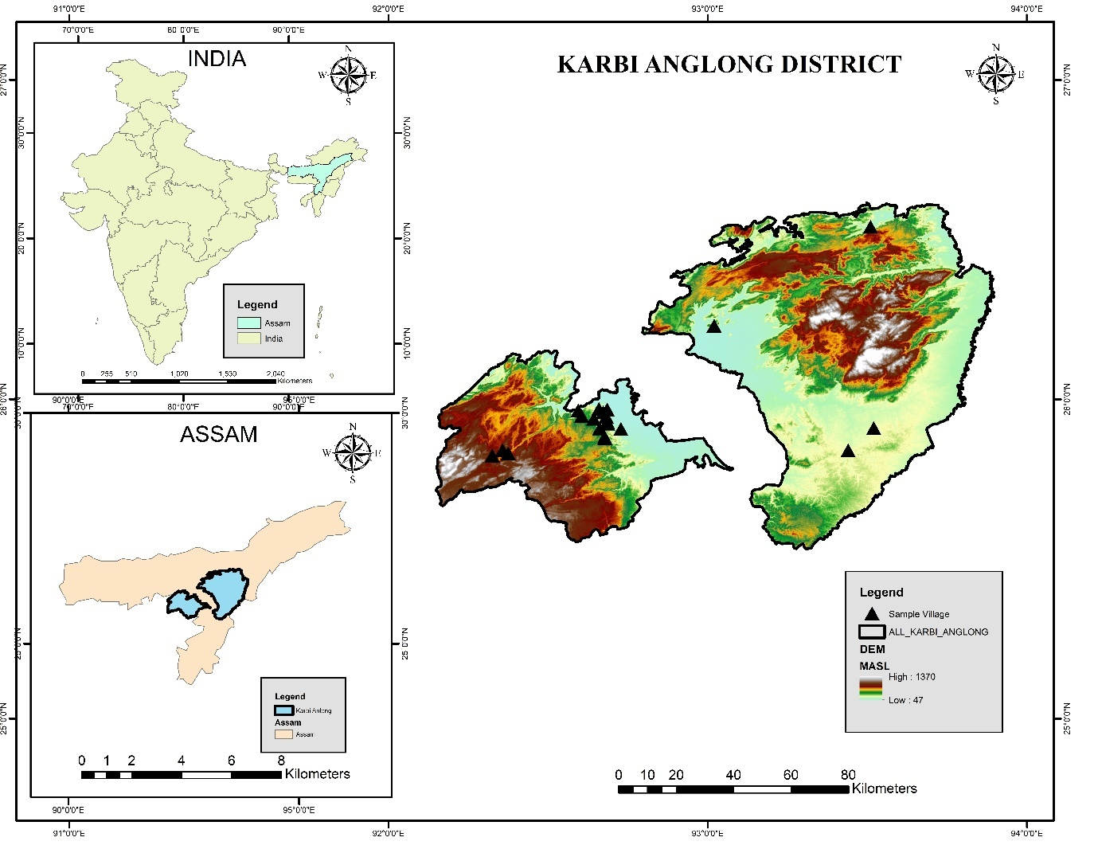
Source: Survey of India (administrative boundaries) and Shuttle Radar Topography Mission (SRTM) DEM from USGS Earth Explorer.
Figure 1. Location map of Karbi Anglong district, Assam, India, showing sample villages.
2.4 Data Sources
The study employed multi-temporal satellite imagery and field-based information for land use and land cover (LULC) analysis:
- 1993: Landsat 5 TM (30 m resolution).
- 2014: Landsat 8 OLI (30 m resolution).
- 2023/24: Sentinel-2 MSI (10 m resolution).
Ground-truth data were collected from field surveys between 2019 and 2024 across ten villages representing different land-use contexts (reserve forests, plantations, and homesteads). Ancillary data, including topographic maps and local knowledge, were used to support classification and validation.

2.5 Land Use Classification
Supervised classification was performed using the Random Forest algorithm, with class definitions adapted to the ecological and socio-economic conditions of each reference year. For 1993, five land cover categories were identified: water bodies, forest, jhum fields, agriculture, and built-up areas. Bamboo was not distinguished separately in this period due to spectral limitations and was included within the broader forest category. For 2014, six categories were classified: water bodies, other forest/plantation, jhum fields, agriculture, built-up areas, and bamboo. By this stage, bamboo emerged as a distinct land cover class due to its expansion as plantations under industrial demand. For 2023/24, classification was refined to capture emerging land-use diversification, resulting in seven categories: bamboo, non-bamboo forest/plantations, rubber, tea and arecanut, agriculture, built-up areas, and water bodies.
The classifications were carried out using multi-temporal satellite imagery (Landsat TM 1993, Landsat OLI 2014, and Sentinel-2 MSI 2023/24), supported by ground-truth data, field observations, and ancillary sources. The evolution of land cover categories across the three phases reflects the changing ecological role of bamboo and the broader trajectory of land-use transition in Karbi Anglong.
2.6 Accuracy Assessment
The classification accuracy of the 2023/24 map was assessed using 700 ground-truth points collected during field surveys. A confusion matrix was generated to calculate producer’s and user’s accuracy for bamboo and non-bamboo classes, along with overall accuracy and Kappa coefficient as showed in Table 1 and Table 2. The classification achieved an overall accuracy of 93.57% and a Kappa coefficient of 0.87, indicating “almost perfect” agreement (Congalton, 1991). Producer’s accuracy was 93.94% for bamboo and 93.24% for non-bamboo, while user’s accuracy was 92.54% and 94.52%, respectively. These results confirm the reliability of the classification for analysing land-use transitions.
Table 1. Confusion Matrix for land cover classification (n=700)
Reference Data | Classified as Bamboo | Classified as non-bamboo | Total Reference | Producer’s Accuracy (%)
Bamboo | 310 | 20 | 330 | 93.94%
Non-Bamboo | 25 | 345 | 370 | 93.24%
Total Classified | 335 | 365 | 700 | —
Note. Data generated by the author from accuracy assessment of the 2023/24 land-use classification (Sentinel-2 MSI).

Table 2. Accuracy statistics of classification
Class | User’s Accuracy (%) | Producer’s Accuracy (%)
Bamboo | 92.54 | 93.94
Non-Bamboo | 94.52 | 93.24
Overall Accuracy | 93.57% | —
Kappa Coefficient | 0.87 (Almost Perfect) | —
Note. Data generated by the author from accuracy assessment of the 2023/24 land-use classification.

2.7 Land Use Transition Analysis
To assess changes over time, post-classification comparison was used to generate transition matrices for 1993–2014 and 2014–2023/24. These matrices quantified conversions between land cover categories, such as forest to bamboo, jhum to bamboo, and forest to built-up. Spatial overlays and change maps were prepared to visualize the magnitude and direction of transitions. The analysis was supported by household narratives that contextualized the socio-economic drivers of land use change, particularly the influence of industrial demand, subsidies, and the post-mill diversification process.
3. RESULTS
3.1 Phase I: Natural Abundance (1993)
In 1993, Karbi Anglong’s landscape was dominated by forests (49%) and shifting cultivation or jhum fields (26.96%), with smaller areas under built-up land (12%), agriculture (5.58%), and water bodies (5%) (Table 3; Figure 2). Bamboo was not separated as an independent land cover category in this period due to spectral limitations but was widely embedded within forest areas and around settlements, as confirmed by field accounts. Bamboo during this phase played a dual role such as sustaining household needs (construction, storage, handicrafts, rituals) and increasingly serving industrial demand following the establishment of the Jagiroad Paper Mill in 1985.
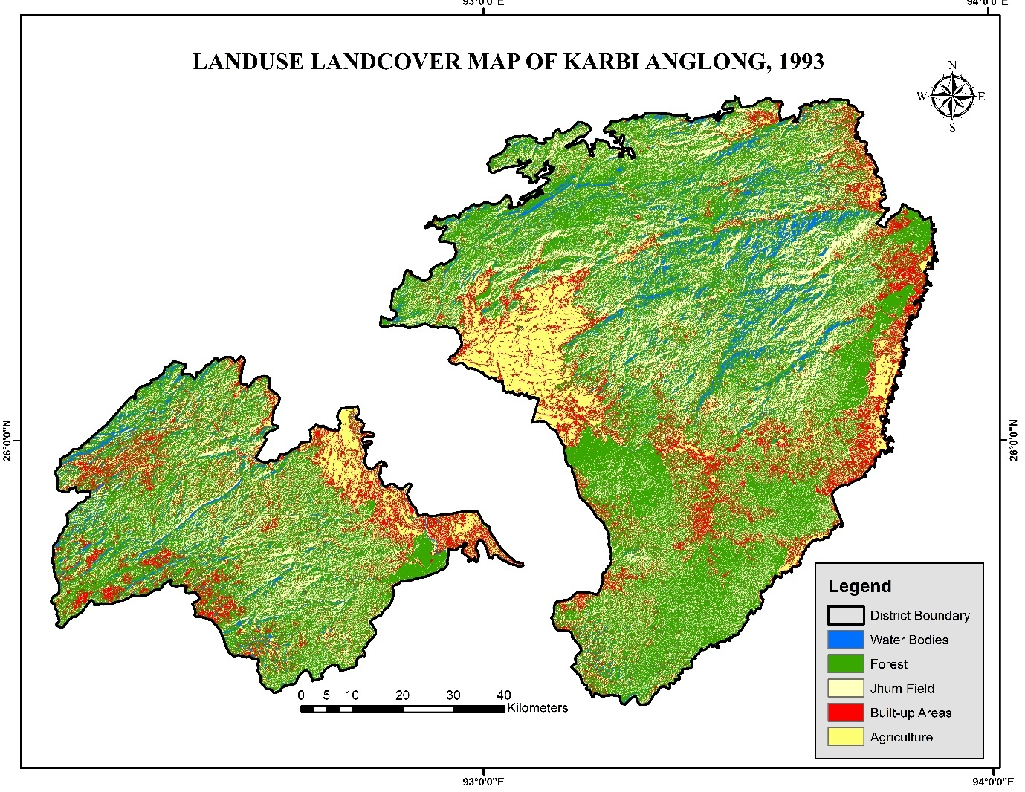

Source: Landsat 5 TM (1993); classification using Random Forest algorithm.

Figure 2. Land use and land cover of Karbi Anglong district, Assam, in 1993, showing major categories of forest, agriculture, jhum fields, built-up areas, and water bodies.

Table 3. Land use Land cover distribution in Karbi Anglong, 1993
Category | Area in Ha | Percentage (%)
Water Bodies | 49319 | 4.73
Forest | 510988 | 48.97
Jhum Field | 270977 | 25.96
Built-up | 122558 | 11.75
Agriculture | 89586 | 8.58
Note. Data generated by the author from classified land-use maps (Landsat TM, 1993). Due to Spectral limitation, bamboo could not be separated; included in Forest
3.2 Phase II: Plantation Expansion (2014)
By 2014, land use patterns reflected the strong influence of industrial demand and subsidy-driven plantation expansion. Bamboo emerged as a distinct land cover class, occupying 257,954 ha (24.72%) of the district. This expansion occurred largely at the expense of jhum fields, which declined sharply from 270,977 ha in 1993 to 76980 ha in 2014 (–18.59%). Forest cover also decreased (–5.68%), while built-up areas grew modestly to 12.33% (Table 4; Figure 3).
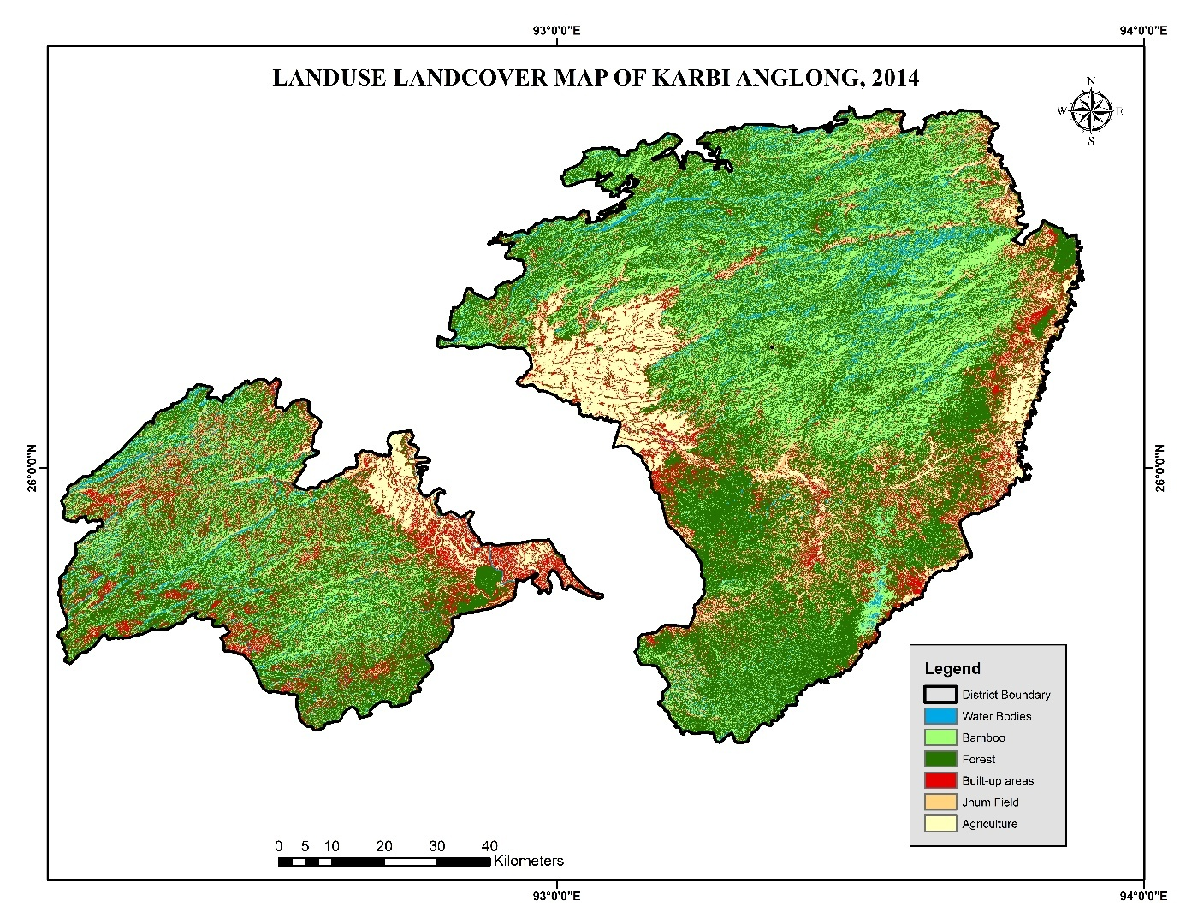

Source: Landsat 8 OLI (2014); classification using Random Forest algorithm.

Figure 3. Land use and land cover of Karbi Anglong district, Assam, in 2014, showing expansion of bamboo plantations and shifts in forest, agriculture, jhum fields, and built-up areas.
Table 4. Land use and land cover distribution, 2014
Category | Area in Ha | Percentage (%)
Water Bodies | 47773 | 4.57
Forest | 452025 | 43.32
Jhum Field | 76980 | 7.37
Built-up Areas | 128661 | 12.33
Agriculture | 80033 | 7.67
Bamboo | 257954 | 24.72
Note. Data generated by the author from classified land-use maps (Landsat OLI, 2014).

3.3 Phase III: Post-Mill Diversification (2023/24)
The closure of the Jagiroad Paper Mill in 2017 marked a turning point in land use trajectories. The 2023/24 Sentinel-2 classification shows that bamboo stabilized at 258,243 ha (25% of the district), while new land-use categories emerged, reflecting diversification into cash crops such as rubber (13.3%) and tea/arecanut (9.5%) (Table 5; Figure 4). Built-up areas expanded further to 14.4%, reflecting population growth and infrastructure development. Agriculture occupied 10.4%, while non-bamboo forests accounted for 27%.
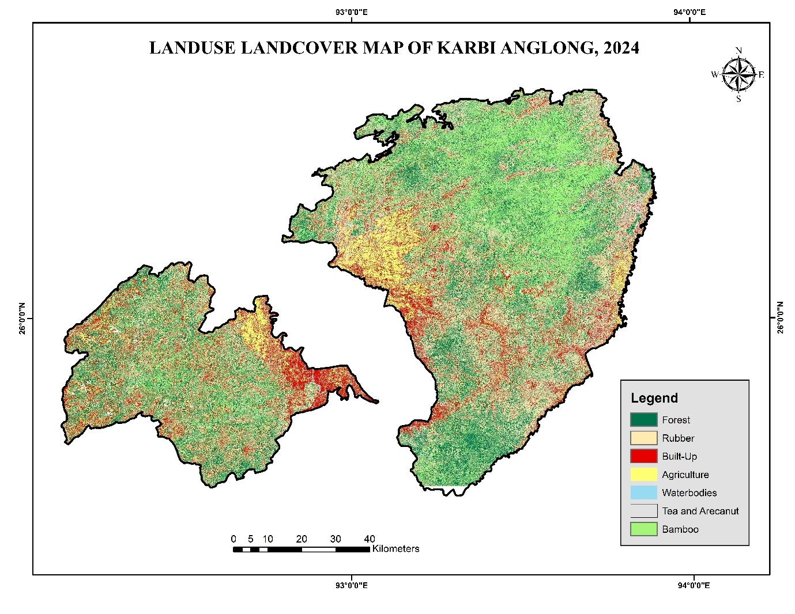
Source: Sentinel-2 MSI (2023/24); classification using Random Forest algorithm in Google Earth Engine; validated with 700 ground-truth samples.
Figure 4. Land use and land cover map of Karbi Anglong district, Assam, in 2023/24, generated from Sentinel-2 MSI imagery using the Random Forest algorithm. Bamboo remains a major land cover type alongside expanding rubber, tea and arecanut, agriculture, built-up areas, and waterbodies.

Table 5. Land use and land cover distribution in Karbi Anglong, 2023-2024
Category | Area in Ha | Percentage (%)
Water Bodies | 6790 | 0.65
Forest | 281438 | 26.97
Jhum Field | --- | ---
Built-up | 150561 | 14.4
Agriculture | 108095 | 10.35
Bamboo | 258243 | 24.74
Rubber | 138940 | 13.31
Tea & Arecanut | 99361 | 9.52
Note. Data generated by the author from classified land-use maps (Sentinel-2 MSI, 2023/24).
Comparative analysis across the three phases (1993, 2014, and 2023/24) shows the near-disappearance of jhum cultivation, stabilization of bamboo plantations, and steady expansion of built-up land (Table 6). The diversification into rubber, tea, and arecanut underscores household adaptation strategies in the post-industrial context, reducing reliance on bamboo alone while reshaping the district into a multi-crop, market-oriented landscape.
Table 6. Percentage distribution of land-use land-cover (LULC) classes in Karbi Anglong for 1993, 2014, and 2023/24
Class | 1993 (%) | 2014 (%) | 2023/24 (%)
Water Bodies | 4.73 | 4.57 | 0.65
Forest | 48.97 | 43.32 | 26.97
Jhum Field | 25.97 | 7.38 | 0.00
Built-up | 11.75 | 12.33 | 14.40
Agriculture | 8.58 | 7.67 | 10.36
Bamboo | — | 24.72 | 24.75
Rubber | — | — | 13.31
Tea & Arecanut | — | — | 9.52

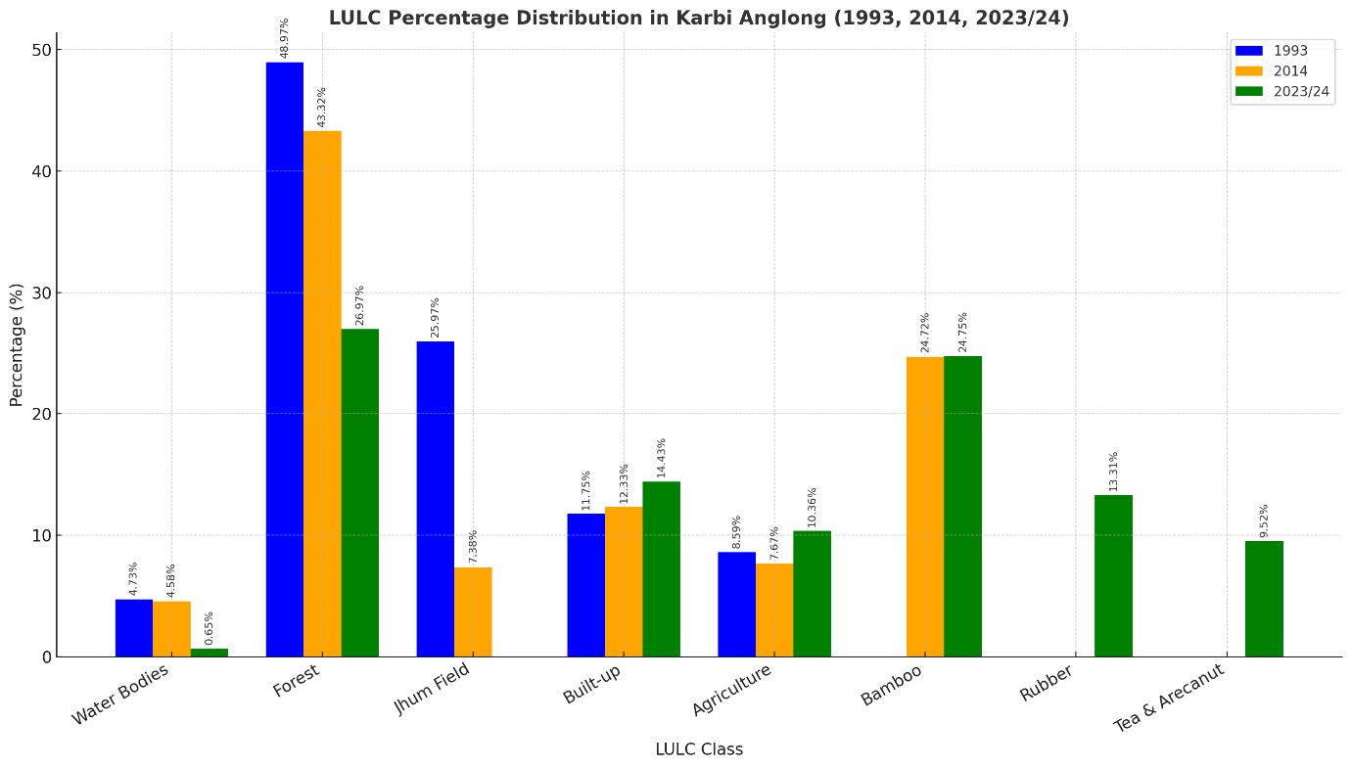
Figure 5. Comparative percentage distribution of land use and land cover (LULC) classes in Karbi Anglong district, 1993 (blue), 2014 (orange), and 2023/24 (green).
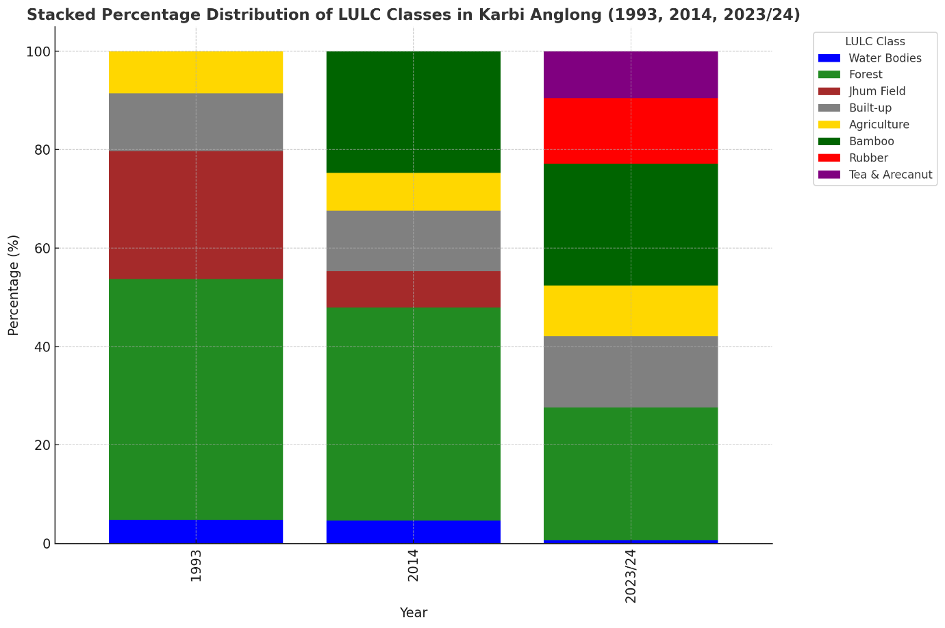
Figure 6. Stacked percentage distribution of land-use and land-cover (LULC) classes in Karbi Anglong district for the years 1993, 2014, and 2023/24, showing relative contributions of each class to the total district area.

3.4 SYNTHESIS: A THREE-PHASE TRAJECTORY
The analysis reveals a clear trajectory of land use transition in Karbi Anglong:
- Phase I (1993): natural bamboo abundance within forest–jhum systems;
- Phase II (2014): plantation expansion under industrial demand, with bamboo emerging as a dominant land-use class;
- Phase III (2023/24): post-mill diversification, with bamboo stabilizing but increasingly complemented by rubber, tea, and arecanut plantations.
These transitions (Figure 7) demonstrate that while bamboo remains ecologically and culturally significant, its economic role has weakened, creating vulnerabilities but also opening pathways for livelihood diversification.
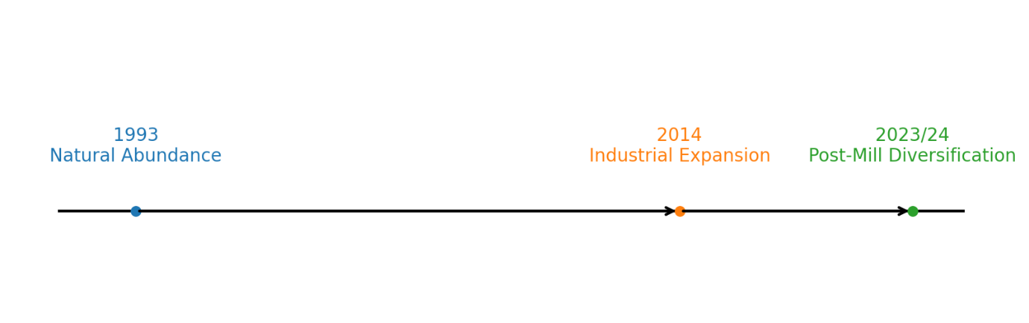
Figure 7. Conceptual timeline of bamboo utilization transitions in Karbi Anglong (1993–2023/24).
4. DISCUSSION
4.1 Land Use Transitions and Shifting Cultivation Decline
The findings demonstrate a clear transition from a forest–jhum dominated landscape in 1993 to plantation-based and diversified systems in 2014 and 2023/24. The progressive decline of shifting cultivation reflects broader regional trends across Northeast India, where state policies, with changing livelihood demands, and demographic pressures have contributed to the decline of jhum (Ramakrishnan, 1992; Mertz et al., 2009). In parts of Karbi Anglong, abandoned jhum fallows are increasingly being converted to planted or natural colonizing bamboo stands (improved bamboo fallows), a trajectory documented in local participatory studies (Bos et al., 2020). Similar transitions away from rotational jhum toward more permanent land uses have been observed in neighbouring states, where policy reforms and targeted programmes, including state bamboo policies and the National Bamboo Mission, have promoted bamboo plantation and value chain development; in several areas, jhum fallows have been directly converted into planted bamboo or improved bamboo fallows, including rehabilitation of shifting cultivators through bamboo cultivation in Tripura (Bos et al.,2020; Sarkar & Keat, 2024; Tripathi et al.,2017; NBM, 2018)
4.2 Bamboo Expansion and Industrial Dependence
The plantation boom that shows from LULC in 2014 highlights how industrial demand, particularly from the Jagiroad Paper Mill, reshaped land-use systems. Similar dynamics have been observed in other parts of Asia, Nigeria where industries drove bamboo expansion at the expense of mixed forests (Saroinsong et al., 2006; Illorkar & Raut 2021; Pavate et al.,2024). In Karbi Anglong, this industrial dependence generated short-term livelihood gains but created structural vulnerability after the mill’s closure in 2017 (Borah et al.,2025). The stabilization of bamboo around 25% of the district in 2023/24, despite declining industrial demand, suggests resilience at the household and cultural level (Singha & Timung., 2015)., but weakened economic viability at the regional scale (Perez et al.,2014). This echoes findings from China and Vietnam, where bamboo remains socially embedded but its market role fluctuates with industrial cycles (Belcher, 1999). Comparable bamboo dynamics were recently mapped in Dima Hasao, Assam, where Sentinel-2 and machine learning classifiers revealed how industrial and agricultural pressures shape bamboo distribution (Tamang et al., 2025). Moreover, new modelling studies from Ethiopia show how industrial drivers and land use change effect highland bamboo resources, reinforcing the global relevance of these transitions (Yirsaw & Nigussie, 2024).
4.3 Post-Mill Diversification and Livelihood Strategies
The post-mill diversification into rubber, tea, and arecanut reflects adaptive strategies to reduce dependence on a single commodity. Such livelihood diversification is consistent with broader agrarian transitions in South and Southeast Asia, where households increasingly adopt plantation crops in response to market opportunities (Kuhling, Alamsay & K.T, 2022; Schroth & Ruf,2014; Longpichati, Parret & Shivakoti, 2012). However, the ecological costs are significant, rubber and tea plantations, like bamboo monocultures, simplify landscapes and reduce biodiversity (Warren, Dolman & Edwards, 2015; Fox et al., 2009; Singh et al., 2021). Recent studies in Northeast India highlight similar risks of biodiversity loss and forest fragmentation linked to plantation expansion (Mahapatra et al., 2025). Built-up expansion, which reached 14.4% by 2023/24, adds further pressure by fragmenting habitats and altering hydrological regimes. Recent LULC analysis in the buffer zone of the Nambor Wildlife Sanctuary, Assam, showed how urban and agricultural expansion significantly threatens habitat connectivity (Kashyap et al.,2025). The Karbi Anglong case thus illustrates both the opportunities of livelihood diversification and the risks of ecological homogenization.
4.4 Policy and Sustainability Implications
The three-phase trajectory underscores the need for integrated land-use policies in ecotonal districts like Karbi Anglong. First, conservation of remaining forests is critical, as continuous decline threatens biodiversity and ecosystem services. Recent work in Northeast India emphasizes the urgent need to address forest fragmentation and the drivers of forest loss (Mahapatra et al.,2025). Second, bamboo management must move beyond industrial supply toward community-based, diversified value chains (e.g., furniture, handicrafts, bamboo-based housing), which can enhance economic resilience. This aligns with findings from Arunachal Pradesh, where perceptions of bamboo ecosystem services highlight the importance of diversified, community-cantered management (Sailo et al., 2025). Third, diversification into multiple crops should be guided by land-use planning that balances income opportunities with ecological integrity. These lessons resonate with global debates on sustainable transitions in resource-dependent regions, where balancing economic, social, and ecological goals remains a central challenge (Meyfroidt, 2016; Gómez-Limón & López, 2020).
5. CONCLUSION
This study traced three decades of land use and land cover (LULC) transition in Karbi Anglong, Northeast India, highlighting the evolving role of bamboo in shaping both ecological and livelihood systems. Using multi-temporal satellite data (1993, 2014, 2023/24), validated classification, and transition matrix analysis, the results reveal a three-phase trajectory: (i) 1993 – natural abundance, when bamboo was embedded in forest–jhum mosaics and supported subsistence alongside emerging industrial demand; (ii) 2014 – plantation expansion, driven by the Jagiroad Paper Mill and subsidy programs, where bamboo emerged as a major land cover class at the expense of forests and shifting cultivation; and (iii) 2023/24 – post-mill diversification, marked by stabilization of bamboo (24.74% of district area) but diversification into rubber, tea, and arecanut plantations, alongside continued built-up growth.
These transitions underscore the dual nature of bamboo, resilient as a cultural and ecological resource, yet vulnerable as an economic commodity tied to industrial cycles. The decline of jhum cultivation reflects broader agrarian shifts in Northeast India, while the post-industrial diversification demonstrates household adaptation strategies but raises ecological concerns about plantation-driven landscape simplification and forest loss.
The findings highlight three policy priorities. First, protecting residual forests to safeguard biodiversity and ecosystem services. Second, revitalizing bamboo-based value chains beyond industrial pulp, focusing on housing, furniture, handicrafts, and climate-resilient uses. Third, integrated land-use planning to balance livelihood diversification with ecological integrity, ensuring that plantation expansion does not undermine long-term sustainability.
By situating bamboo within a broader trajectory of land-use transitions, this study contributes to understanding how industrial demand, livelihood strategies, and ecological pressures interact in ecotonal landscapes. The Karbi Anglong case offers insights not only for bamboo-dependent regions in India but also for other resource-based landscapes in Asia undergoing similar transitions.

Disclaimer (Artificial intelligence)
Option 1: Author(s) hereby declare that NO generative AI technologies such as Large Language Models (ChatGPT, COPILOT, etc.) and text-to-image generators have been used during the writing or editing of this manuscript.
Author(s) hereby declare that NO generative AI technologies such as Large Language Models (ChatGPT, COPILOT, etc.) and text-to-image generators have been used during the writing or editing of this manuscript.
Option 2:
Author(s) hereby declare that generative AI technologies such as Large Language Models, etc. have been used during the writing or editing of manuscripts. This explanation will include the name, version, model, and source of the generative AI technology and as well as all input prompts provided to the generative AI technology
Details of the AI usage are given below:
1.
2.
3.

References
- Aktara, A., & Bhuyan, M. J. (2025). Changing jobs, changing landscapes: Do land use patterns reflect occupational shifts?
- Belcher, B. (1998). A production-to-consumption systems approach: Lessons from the bamboo and rattan sectors in Asia. In M. Ruiz-Pérez & J. E. Arnold (Eds.). Incomes from the forest: methods for the development and conservation of forest products for local communities
- Borah, S. N., Sarma, K., & Parmar, H. (2025). Mapping of bamboo groves in Karbi Anglong District, Assam using geospatial technologies. SSRN Electronic Journal. https://papers.ssrn.com/sol3/papers.cfm?abstract_id=5382507
- Bos, S. P. M., Cornioley, T., Dray, A., Waeber, P. O., & Garcia, C. A. (2020). Exploring Livelihood Strategies of Shifting Cultivation Farmers in Assam through Games. Sustainability, 12(6), 2438. https://doi.org/10.3390/su12062438
- Bystriakova, N., Kapos, V., Lysenko, I. et al. Distribution and conservation status of forest bamboo biodiversity in the Asia-Pacific Region. Biodiversity and Conservation 12, 1833–1841 (2003). https://doi.org/10.1023/A:1024139813651
- Champion, H. G., & Seth, S. K. (1968). A revised survey of the forest types of India. Government of India Press. https://archive.org/details/revisedsurveyoff0000sirh
- Chanu, L.K., De, A., Chakraborty, K., & Paul, S. (2023). CHARACTERIZATION OF SHIFTING CULTIVATION, TRENDS AND DIVERSIFICATION OF LIVELIHOOD PATTERNS: A CASE STUDY FROM FOREST VILLAGES IN BARAK VALLEY, ASSAM, NORTHEAST INDIA. Trees, Forests and People. https://doi.org/10.1016/j.tfp.2023.100420
- Congalton, R. G. (1991). A review of assessing the accuracy of classifications of remotely sensed data. Remote Sensing of Environment, 37(1), 35–46. https://doi.org/10.1016/0034-4257(91)90048-B
- Forest Survey of India. (2011). National forest type mapping. Forest Survey of India. https://fsi.nic.in/uploads/documents/doc_1051_national_forest_type_mapping.pdf
- Fox, J., Fujita, Y., Ngidang, D., Peluso, N., Potter, L., Sakuntaladewi, N., Sturgeon, J., & Thomas, D. (2009). Policies, political-economy, and swidden in Southeast Asia. Human Ecology, 37(3), 305–322.
- Gómez-Limón, J. A., Arriaza, M., & Guerrero-Baena, M. D. (2020). Building a composite indicator to measure environmental sustainability using alternative weighting methods. Sustainability, 12(11), 4398. https://doi.org/10.3390/su12114398
- Government of Assam. (n.d.). District profile: Karbi Anglong. Karbi Anglong District Administration. https://karbianglong.gov.in/information-services/district-profile
https://doi.org/10.1111/area.70018
- Ilorkar, V. M. and Raut, P. D. (2021). Evaluation of Growth, Morphology, Biomass Production of Commercial Bamboo Species under Rainfed Condition on Agricultural Wastelands.Int.J.Curr.Microbiol.App.Sci. 10(1): 193-199. doi: https://doi.org/10.20546/ijcmas.2021.1001.023
- Kashyap, P.J., Sarmah, K., Bose, S. et al. Assessing land use and land cover changes in the buffer zone of Nambor Wildlife Sanctuary (WLS), Assam. Discov Geosci 3, 104 (2025). https://doi.org/10.1007/s44288-025-00217-3
- Kühling, M., Alamsyah, Z., & Sibhatu, K. T. (2022). Agrarian change, livelihood dynamics and welfare outcomes: Evidence from plantation crop farmers in Indonesia. Journal of Environmental Management, 311, 114864. https://doi.org/10.1016/j.jenvman.2022.114864
- Kurien, A. J., Lele, S., & Nagendra, H. (2019). Farms or forests? Understanding and mapping shifting cultivation using the case study of West Garo hills, India. Land, 8(9), 133. https://doi.org/10.3390/land8090133
- Lambin, E. F., & Meyfroidt, P. (2010). Land use transitions: Socio-ecological feedback versus socio-economic change. Land Use Policy, 27(2), 108–118. https://doi.org/10.1016/j.landusepol.2009.09.003
- Longpichai, O., Perret, S. R., & Shivakoti, G. P. (2012). Role of livelihood capital in shaping the farming strategies and outcomes of smallholder rubber producers in Southern Thailand. Outlook on Agriculture, 41(2), 117–124. https://doi.org/10.5367/oa.2012.0096
- Mahapatra, S., Majhi, B. K., Sarkar, M. S., Datta, D., Mishra, A. P., & Rathnayake, U. (2025). Understanding forest fragmentation dynamics and identifying drivers for forest cover loss using random forest models to develop effective forest management strategies in North-East India. Results in Engineering, 26, 104640. https://doi.org/10.1016/j.rineng.2025.104640
- Mertz, O., Padoch, C., Fox, J., Cramb, R. A., Leisz, S., Lam, N. T., & Vien, T. D. (2009). Swidden change in Southeast Asia: Understanding causes and consequences. Human Ecology, 37(3), 259–264. https://doi.org/10.1007/s10745-009-9245-2
- Meyfroidt P (2016) Approaches and terminology for causal analysis in land systems science, Journal of Land Use Science, 11:5, 501-522, DOI: 10.1080/1747423X.2015.1117530
- NASA Jet Propulsion Laboratory. (2013). Shuttle Radar Topography Mission (SRTM) Global 30 arc-second DEM. NASA EOSDIS Land Processes Distributed Active Archive Center. Retrieved from https://earthexplorer.usgs.gov
- Nath, A. J., Lal, R., & Das, A. K. (2015). Managing woody bamboos for carbon farming and carbon trading. Global Ecology and Conservation, 3, 654–663. https://doi.org/10.1016/j.gecco.2015.03.002
- Nath, A., & Das, A. (2011). Carbon storage and sequestration in bamboo-based smallholder homegardens of Barak Valley, Assam. Current Science, 100(2), 229–233. https://www.jstor.org/stable/24073051
- National Bamboo Mission. (2018). Operational guidelines. Ministry of Agriculture & Farmers Welfare, Government of India. National Bamboo Mission
- Pavate, V., Jagdale, A., Shinde, R., Manechikkannara, N., & Patil, D. (2024). Study on bamboo industry. http://dx.doi.org/10.22214/ijraset.2024.60085
- Pérez, M. R., Rodríguez, L. G., Yang, X., Xie, J., & Fu, M. (2014). From basic raw material goods to cultural and environmental services: The Chinese bamboo sophistication path. Ecology and Society, 19(3), 3. https://doi.org/10.5751/ES-06709-190303
- Ramakrishnan, P. S. (1992). Shifting agriculture and sustainable development: An interdisciplinary study from North-Eastern India. UNESCO-MAB, Paris & Parthenon Publishing Group. cabidigitallibrary.org/doi/full/10.5555/19930665418
- Sailo, R. L., Sarkar, B. C., Apshahana, K., Dabral, A., Jilen, A., Marak, A. D., & Chakravarthy, S. (2025). Perceptions of ecosystem services and disservices of bamboo by indigenous communities in Northeast India. Advances in Bamboo Science, 10, 100135. https://doi.org/10.1016/j.bamboo.2025.100135
- Sarkar, S. (2024). Growth and challenges of rubber plantation in North-Eastern states of India. Journal of Global Economy, 20(1), 13–18 http://dx.doi.org/10.1956/jge.v20i1.717
- Sarkar, S., & Keat, T. T. (2024). Poverty eradication of shifting cultivators through bamboo cultivation: A case study of North District of Tripura, India. International Journal of Management, Public Policy and Research, 3(1), 45–56. https://doi.org/10.55829/ijmpr.v3i3.221
- Sarma, S. (2012, February 15). Bamboo glitch worries paper mill. The Telegraph. https://www.telegraphindia.com/north-east/bamboo-glitch-worries-paper-mill/cid/454181
- Saroinsong, F. B., Sakamoto, K., Miki, N. H., & Yoshikawa, K. (2006). Stand dynamics of a bamboo forest adjacent to a secondary deciduous broad-leaved forest. Journal of the Japanese Society of Revegetation Technology, 32(1), 15–20. https://doi.org/10.7211/jjsrt.32.15
- Schroth, G., & Ruf, F. (2014). Farmer strategies for tree crop diversification in the humid tropics: A review. Agronomy for Sustainable Development, 34(1), 139–154. https://doi.org/10.1007/s13593-013-0175-4
- Singh, A. K., Liu, W., Zakari, S., Wu, J., Yang, B., Jiang, X., Zhu, X., Zou, X., Zhang, W., Chen, C., Singh, R., & Nath, A. J. (2021). A global review of rubber plantations: Impacts on ecosystem functions, mitigations, future directions, and policies for sustainable cultivation. Science of the Total Environment, 796, 148948. https://doi.org/10.1016/j.scitotenv.2021.148948
- Singha, K. N., & Timung, L. (2015). Significance of bamboo in Karbi culture: A case study among the Karbi tribes of Assam (India). International Journal of Social Science Research, 3(2), 1–10. significanceofbambooinkarbiculture_acasestudyamongthekarbitribesofassamindia1425559311-libre.pdf
- Sundriyal, M., & Joshi, K. (2015). Bamboo status and trade vulnerability: A Central Himalayan case study. Journal of Bamboo and Rattan, 14(1), 1–14. Bamboo Status and Trade Vulnerability : A Central Himalayan Case Study | Semantic Scholar
- Survey of India. (2010). Topographic and administrative boundary maps of Assam and Karbi Anglong District (1:50,000 scale). Survey of India. Survey of India
- Tamang, M., Nandy, S., Srinet, R., Vanlalhruaii, V., Choudhury, P., & Deka, J. (2025). Impact of anthropogenic disturbance and climate on bamboo distribution in shifting cultivation landscapes of Northeast India. Scientific Reports, 15, 28290. https://doi.org/10.1038/s41598-025-13075-3
- Tripathi, S. K., Vanlalfakawma, D. C., & Lalnunmawia, F. (2017). Shifting cultivation on steep slopes of Mizoram, India: Impact of policy reforms. In M. Cairns (Ed.), Shifting cultivation policies: Balancing environmental and social sustainability (pp. 393–413). CABI. https://doi.org/10.1079/9781786391797.0393
- Warren‐Thomas, E., Dolman, P. M., & Edwards, D. P. (2015). Increasing demand for natural rubber necessitates a robust sustainability initiative to mitigate impacts on tropical biodiversity. Conservation Letters, 8(4), 230–241. https://doi.org/10.1111/conl.12170
- Yirsaw, E., & Nigussie, W. (2024). Land use/land cover change modeling and evaluating the spatiotemporal dynamics of highland bamboo species in the southern highlands of Ethiopia. Journal of the Indian Society of Remote Sensing, 52(1), 153–165. https://doi.org/10.1007/s12524-023-01799-6

