Nexus between Crop Diversification, Agricultural Development and Level of Urbanization in Bihar: A Regional Level Study

ABSTRACT
Background: Crop diversification has become an important factor in the agrarian economy for increasing agricultural growth, farmer income, and the utilization of natural resources. At both the district and regional levels, crop diversification has progressed unevenly and shown significant variations. Diversification of highly valuable crops is positively associated with the level of urbanization and the development of the economy and infrastructure. Crop diversification in Bihar varies significantly across the region due to distinct regional features. Policymakers must determine the nature and extent of crop diversification in Bihar at the regional level for making agriculture-related policies. Because of this, the main objective of this research is to examine the variations within regions in Bihar's agricultural development and crop diversification, as well as the extent to which urbanization affects crop diversification at the district and regional levels.
Methods: At the regional and district levels, an Agricultural Development Index and a Simpson Index of Diversification have been developed using secondary data obtained mainly from the Directorate of Economics and Statistics, Government of Bihar. Cluster and regression method have been used for deep analysis.
Results: According to the findings of the study, there are significant variations both at the district and regional levels, making it impossible to draw a comprehensive generalization about the extent of crop diversification and agricultural development across the region of Bihar. A positive but weak relationship exists between crop diversification and agricultural development. Crop diversification is also positively influenced by urbanization.
Key Words: Crop Diversification, Agricultural Development index, Simpson Index of Diversification, Level of Urbanization

1. INTRODUCTION
Crop and agricultural diversification encourage agricultural expansion in the agrarian economy (Singh et al., 2006; Pingali and Rosegrant, 1995; Von Braun, 1995; Birthal et al., 2005; Ryan and Spencer, 2001). Crop diversification not only reduces the risk of total crop failure but also provides some alternative sources of income for farmers. If farmers are engaged in a single-crop farming system, they are not protected from high risks due to crop failure, price shocks, etc. As a result, crop diversification has emerged as an important tool for the farming community to use in the agrarian economy to reduce distress and would assist in promoting sustainable livelihoods in rural areas.

Since economic liberalization, Indian agriculture has seen a significant shift from traditional to high-value farming. The economy's quick growth has also caused a change in consumer behaviour, moving away from traditional cereals and toward a more substantial and nutrient-dense diet of fruits, vegetables, and other foods. Consequently, India's agricultural diversification has expanded to include high-value commodities (Kumar & Gupta, 2015). India's agricultural diversification differs greatly from state to state due to unique regional features in terms of climate, infrastructure, and resource endowments. The eastern part of India, which comprises the states of Bihar, Odisha, Jharkhand, and West Bengal, is among the most backward. It is characterized by high population pressure, high rates of poverty, small landholdings, and inadequate rural infrastructure. Although Bihar's crop production is more diverse than that of other eastern Indian states, it still exhibits some regional characteristics in terms of agricultural development (Kumar et al. 2012).

The Bihar agrarian economy is in a transition phase, and the composition of the agrarian structure in terms of sharing income, size of landholding, and land use pattern has changed. These changes have occurred along with crop diversification from the cultivation of cereals to high-value products, the development of new marketing opportunities, the expansion of urbanization, and linkages with the non-farm sector (Pohit et al. 2019). In the state economy, almost 24% of the GSDP is covered by agriculture, whereas 70% of the workforce in rural Bihar still depends on agricultural activities (GOB). The status of agriculture in terms of level of agricultural development and diversification has followed an uneven path of development over a period of time and indicated huge variations among different geographical locations across the region in Bihar. During the last couple of years, the pace of agricultural diversification has become very fast due to the expansion of irrigation facilities, infrastructural development, increasing rural market facilities, and rapid urbanization. The expansion of urbanization and the high growth rate of population, along with changes in the consumer food basket, are also responsible for crop diversification (Singh, 2011). Urbanization has also changed land use and cropping patterns, decreasing fertile agricultural land. Because of rapid urbanization, farm households in a peripheral urban region have become more diverse in their revenue sources and livelihood methods as a result of the shrinking farmland areas (Dadi et al. 2022).

Crop diversification usually varies across the region due to different regional characteristics in terms of level of urbanization, infrastructure development, and utilization of agricultural resources. Hence, it is very important to examine the levels of crop diversification at the district level and regional level as well for making specific strategies to improve the agrarian condition of the farmers. The primary objective of this paper is to examine the relationship between crop diversity, agricultural development, and urbanization at the regional level in Bihar. Additionally, it aims to identify the key factors that influence crop diversification at the regional level. The Simpson Diversification Index, Agricultural Development Index, and Geographical Information System have been used for analysis purposes. A nexus between diversification and level of urbanization has been explained after using the GIS technique, cross-tab, and regression analysis in the result and discussion section. This section also explains how crop diversification is affected by the level of agricultural development. The conclusion and solution are provided in the final section.

2. METHODS AND MATERIALS
The magnitude and nature of crop diversification have been examined using a few suitable statistical methods.

  - Simpson Index of Diversification
The term "crop diversification" refers to the practice of distributing agricultural resources, primarily cultivated land, in different crop productions so that the farmers can mitigate their risk and boost farm revenue. There are several methods to calculate the degree of crop diversification. The Directorate of Economics and Statistics, Department of Planning and Development, Government of Bihar, is the primary source of district-level secondary data (2018-19) employed to calculate the Simpson Index of Diversification, which is used to understand the ground reality of regional dimensions and variations in crop diversification. The Simpson Index is simple to understand and utilize because it shows how crops are distributed across cultivated land. The Simpson Crop Diversification Index (SID) is provided by

SID = 1- $\sum_{i=1}^{n}{Wi}²$
Where, W𝒊 = $\frac{Xi}{∑Xi}$

Wi represents the ith crop's proportionate area to the overall cropped area, whereas Xi represents the ith crop's area. The Simpson index has a range of 0 to 1, with the highest value (1) denoting a high degree of diversification in the study area and the lowest value (0) denoting no diversification.

  - Level of Agricultural Development
For measuring the degree of agricultural development in the study area, a development index has been measured on the basis of some suitable variables (Table 1). The district-level data on these variables have been collected from the latest available (2021-22) statistics, mostly from the Directorate of Economics and Statistics, Department of Planning and Development, Government of Bihar. For the computation of the agricultural development index, normalization procedures have been conducted. For the normalization procedures, goalposts of the indicators have been chosen within the sample. The normalized value has been calculated as follows:
Table 1. List of Variable (Level of Agricultural Development)
S.N. | Indicators | Sym. | Unit | Relation with Agricultural Development
1 | Cropping Intensity | I₁ | Ratio | +
2 | % of Cultivators to Total Main Workers | I₂ | % | +
3 | % of Net Sown Area to Cultivable Land | I₃ | % | +
4 | Per Head Food Grain Production | I₄ | Kg (Yearly) | +
5 | Food grain Productivity | I₅ | Kg/Hect | +
6 | Per Head Agri. Loan Distribution | I₆ | Rs. | -
Source: Computed by Researcher

$Normalized Value=\{$ $\frac{(Actual value - Minimum value)}{ (Maximum value - Minimum value)}$}…(1)

If Indicator is negatively associated, then equation has been changed to

$Normalized Value=\{ 1-$ $\frac{(Actual value - Minimum value)}{ (Maximum value - Minimum value)}$}….(2)

Table 2. Goalpost (Maximum and Minimum value of variables)
S.N. | Variable | Maximum Value | Minimum Value
1 | Cropping Intensity | Sheohar (188.0) | Darbhanga (107.0)
2 | % of Cultivators to Total Main Workers | Gopalganj (38.27) | Munger (12.39)
3 | % of Net Sown Area to Cultivable Land | Rohtas (96.40) | Jamui (32.71)
4 | Per Head Food Grain Production | Rohtas (464.09) | Jamui (70.65)
5 | Food grain Productivity
5.1 | Foodgrain Productivity (Wheat) | Samastipur (2916.5) | Madhubani (1452.5)
5.2 | Foodgrain Productivity (Rice) | Rohtas (4057.5) | Madhubani (1238)
5.3 | Foodgrain Productivity (Maize) | Araria (4968.5) | Buxar (1437)
6 | Per Head Agri. Loan Distribution | Buxar (7925.52) | Darbhanga (2073.68)
Source: Computed by Researcher

Finally, the arithmetic mean has been used for calculating agricultural development index.
  - Level of Urbanization
To establish a nexus between the level of urbanization and crop diversification, a percentage of the urban population (Census 2011) of the total population at the district level has been taken to measure the level of urbanization.

  - Regression Analysis
The factors that influence and determine crop diversification have been identified and quantified through the use of regression analysis methods.
Y= A + B₁ X_{i}+ B₂ X₂ + B₃ X₃ + …………….. + B_{n} X_{n}+ u_{t}
Y indicates the dependent Variable
X₁, X₂, X₃,…X_{n} represents independent Variable
A = intercept
B₁, B₂, B₃,…B_{n} = Parameters
  - Cluster Analysis
In order to analyze how different districts of the state are situated and the degree to which they are close to each district in terms of diversification, agricultural development, and urbanization, a cluster analysis has been done. A hierarchical cluster (Ward’s method) has been used for this purpose. For obtaining a number of clusters, a hierarchical clustering method has been used. For this purpose, the agglomeration schedule has been computed, and proximity matrix and dendrogram techniques have been used to provide the optimum number of clusters.

  - ANOVA
To examine which classifying variables the difference between the clusters is significant, a one-way ANOVA has been used. To determine if any of these mean differences are significant, the ANOVA provides F values and significance levels.

F= MST/MSE………………………(2)

$$MST=\{(\sum_{i=1}^{k}{\left({Ti}^{2}/ ni\right)-G^{2}/n ) / (K-1)\}}$$
$$MST=[\sum_{i=1}^{k}{\sum_{j=1}^{ni}{Y^{2}ij -\sum_{i=1}^{k}{T²i/ ni}}] / [n-K]}$$

F is the overall ratio's variation ratio, MST is mean squire between group, MSE is mean squire within group, Y_{ij} is an observation, T_{i} = total for the group, G is the sum of all observations, n_{i} is the number in group I, N is the sum of all observations

2.7 The Study Area
Bihar is situated in the plains of the Ganga River basin and endowed with alluvial soil with plentiful water resources, especially groundwater resources. The main source of employment in the countryside is still agriculture. However, Bihar is known to have weather inconsistencies at a regional level. Droughts and floods have devastating effects on farmers, livestock, and crop diversification. In the northern part of Bihar, the volatile nature of climate conditions is one of the major challenges of agricultural activities. While southern Bihar is more likely to experience drought, northern Bihar is often more likely to experience flood (Government of Bihar, 2012). Based on agro-climatic conditions, Bihar can be divided into four regions for analysis purposes (Table 3).

Table 3. Agro- Climatic Region of Bihar
SN | Region | District
1. | Northern West | East Champaran, West Champaran, Saran, Siwan, Sheohar, Sitamarhi, Muzaffarpur, Madhubani, Vaishali, Samastipur, Darbhanga, Begusarai, Gopalganj
2. | Northern East | Katihar, Purnea, Supaul, aharsa, Khagaria, Madhepura, Kishanganj, Araria
3. | Southern East | Munger, Sheikhpura, Lakhisarai, Jamui, Bhagalpur & Banka.
4. | Southern West | Bhojpur, Rohtas, Bhabhua, Buxar, Patna, Arwal, Nalanda, Jehanabad, Nawada, Gaya, Aurangabad,
Source: Economics &Statistics Division, Planning Department, GOB

The area of the Northern West region, which covers 13 districts of Bihar (fig. 1), is highly fertile for agriculture.
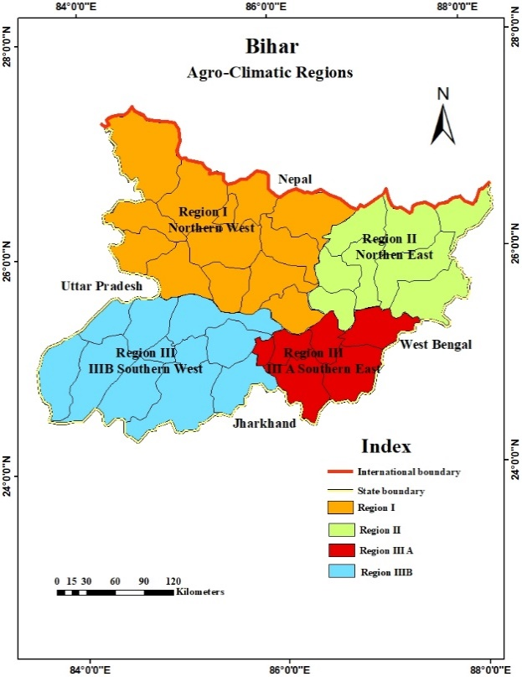
Fig.1. Agro-Climatic Regions of Bihar

It is the most backward in terms of socio-economic indicators, despite having extremely fertile land and a favorable climate. Whereas the northeastern region of Bihar (which covers 8 districts) is mainly known as the producer of horticulture and commercial crops. The Southeast region consists of 6 districts of the state. It is a mostly hilly area, has a high percentage of fallow land, and contributes little to food grain production compared to other parts of the state (Khan & Sadaf, 2022). Due to its high level of socio-economic development and rapid urbanization, the Southern West region of the state has some advantages in the agricultural sector.

Rice, wheat, and maize have been considered major cereal crops in Bihar. Rice is the main monsoon crop and is cultivated in all regions of Bihar. After the Green Revolution, the production of wheat increased at a faster rate and covered the status of the main crop of the rabi season. Pulses such as mung beans, lentils, and peas are mostly cultivated crops in the southern region of Bihar (Ahmad et al. 2017).

3. RESULTS AND DISCUSSION
Historical rural stagnation and agrarian distress were largely caused by Bihar's exploitative agrarian relations (Sharma, 2005). In terms of socioeconomic development, Bihar is the most backward state in India. For the past few years, the structure of Bihar's economy has been stagnant. According to Table 4, agriculture still accounts for nearly 24 percent of Bihar's GDP, whereas the service sector accounts for 60 percent of Bihar's economy. Only 15% of the share is based on the manufacturing sector, which proves that the pace of industrialization and manufacturing in Bihar is very slow. Moreover, over half of Bihar's working population is dependent on agriculture, even though it only makes up 25% of the state's GDP.
Table 4. Sector-wise % Share in GSDP
S. N. | Sector | 2011-12 | 2015-16 | 2020-21
1 | Primary | 25.76 | 23.88 | 24.17
2 | Secondary | 18.76 | 17.31 | 15.07
3 | Tertiary | 55.48 | 58.81 | 60.76
Source: Economics &Statistics Division, Planning Department Government of Bihar

If we discuss the contribution of various components of the primary sector, it is clear that in the last decade, the contribution of crop production has decreased from 68.43% to 49.94% in the agricultural sector, and the contribution of livestock has increased from 19.32% to 33.59% (Table 5).

Table 5. Contribution in Primary Sector (%)
S. N | Sector | 2011-12 | 2015-16 | 2020-21
1 | Crops | 68.43 | 56.34 | 49.94
2 | Livestock | 19.32 | 26.08 | 33.59
3 | Forestry and Logging | 6.72 | 6.70 | 7.09
4 | Fishing and Aquaculture | 5.21 | 7.81 | 8.21
5 | Mining and Qarring | 0.32 | 3.07 | 1.16
Source: Economics &Statistics Division, Planning Department Government of Bihar

While other components' contributions remain unchanged. In other words, about 84% of the income in the agricultural sector comes either from crop production or livestock; the contribution of other components is very limited, which indicates that the level of agricultural diversification in Bihar is very low. In terms of agricultural diversification, Bihar scored moderately at the state level, while Maharashtra, Gujarat, and Andhra Pradesh all had high levels. The level of urbanization and infrastructural development is very high in these states as compared to others. Agro-climatic conditions are also favorable for crop diversification in these areas. The analysis of crop diversification and its determinants at the regional level in Bihar will be impressive.

Table 6. State-wise Crop Diversification (SID)
State | SID | State | SID | State | SID
Andhra Pradesh | 0.792 | Madhya Pradesh | 0.786 | Karnataka | 0.776
Assam | 0.511 | Maharashtra | 0.827 | Kerala | 0.598
Bihar | 0.746 | Odisha | 0.553 | Uttar Pradesh | 0.729
Chhattisgarh | 0.558 | Punjab | 0.599 | West Bengal | 0.639
Gujarat | 0.819 | Rajasthan | 0.763 | Jharkhand | 0.757
Haryana | 0.759 | Tamil Nadu | 0.766 | Telangana | 0.734
Source: Calculated by Researcher

3.1 Land Use Pattern at Regional Level
Before analyzing the level of agricultural development and crop diversification, it is a prerequisite condition to explain the land use pattern in Bihar. The pattern of the land use is the backbone of the agrarian economy and determines the mobilization of resources, technological progress, and mode of investment. For reducing any fluctuation in the data, triennium ending (TE) data has been taken.Table 7 provides a comprehensive view of land use patterns across the region of Bihar. Although all the indicators related to land use are favorable for the northern region of Bihar, during the last couple of years the performance of agriculture in this region has deteriorated.

Table 7. Agro-Climate Region wise land Use Pattern
S. N. | Region | TE03 |  |  | TE20
S. N. | Region | CI | % of NSA  to TCL | % of TFL to TCL | CI | % of NSA  to TCL | % of TFL to TCL
1. | Northern West | 143.90 | 87.92 | 6.26 | 151.71 | 76.84 | 18.25
2. | Northern East | 160.88 | 86.25 | 9.01 | 143.88 | 76.24 | 18.34
3. | Southern East | 119.18 | 76.03 | 19.29 | 141.99 | 71.04 | 23.62
4. | Southern West | 131.10 | 86.20 | 12.45 | 133.28 | 79.78 | 17.70
Source: Economics &Statistics Division, Planning Department Government of Bihar

In this region, the cropping intensity is higher than other regions of Bihar. Followed by the Northern West, while the Southern East has lagged behind. But an important fact comes from table 8. The southeast region of Bihar has recovered much faster than other parts of the state over time. The northeast region of Bihar has maintained a high level of cropping intensity despite having high levels of fallow land and flood-prone areas. This indicates that this region has high levels of potential for agricultural development. Fallow land is a very crucial element for the development of the agrarian economy. During the last decade, fallow land has increased in Bihar, which implies that either non-agricultural activities have increased on the land or it has become barren.

Table 8. Region wise Rate of Change in land Use Pattern
S.N | Region | Rate of Change (%)
S.N | Region | CI | % of NSA to TCL | % of TFL to TCL
1. | Northern West | 5.43 | -12.60 | 191.53
2. | Northern East | -10.56 | -11.60 | 103.55
3. | Southern East | 19.14 | -6.56 | 22.44
4. | Southern West | 1.663 | -7.45 | 42.17
Source: Source: Calculated by Researcher
The northern part of Bihar has the highest rate of growth in the ratio of fallow land to total cultivable land, despite its high cropping intensity. This is a concerning indication for this area.
3.2 Crop Diversification and Level of Agricultural Development
The Simpson Index has been used to calculate crop diversification at the district and regional levels (Table 9). A northern region of Bihar has some advantages in terms of crop diversification despite being prone to flooding. Particularly, the Northern West region had the highest SID (0.608), followed by the Northern East region (0.590).

Table 9. District and Region Wise Crop Diversification (SID)
District | SID | District | SID | District | SID | District | SID
Patna | 0.719 | Saran | 0.603 | Munger | 0.520 | Khagaria | 0.597
Nalanda | 0.611 | Siwan | 0.591 | Sheikhpura | 0.675 | Saharsa | 0.623
Bhojpur | 0.551 | Gopal Ganj | 0.639 | Lakhisarai | 0.601 | Supaul | 0.598
Buxar | 0.538 | Muzaffarpur | 0.597 | Jamui | 0.540 | Madhepura | 0.554
Rohtas | 0.514 | E. Champaran | 0.647 | Bhagalpur | 0.679 | Purnia | 0.600
Kaimur | 0.530 | W. Champaran | 0.661 | Banka | 0.498 | Kishanganj | 0.506
Gaya | 0.573 | Sitamarhi | 0.622 | Southern East | 0.585 | Araria | 0.625
Jehanabad | 0.643 | Sheohar | 0.590 | Southern East | 0.585 | Katihar | 0.616
Arwal | 0.485 | Vaisali | 0.662 | Southern East | 0.585 | Northern East | 0.590
Nawada | 0.550 | Darbhanga | 0.582
Aurangabad | 0.531 | Madhubani | 0.462
Southern West | 0.568 | Samastipur | 0.643
Southern West | 0.568 | Begusarai | 0.612
Southern West | 0.568 | Northern West | 0.608
Source: Calculated by Researcher

Remarkable, highly developed infrastructure-wise regions of Bihar, such as the Southern West, have the lowest SID (0.568), while the plateau region of Bihar (Southern East) has presented a better picture of crop diversification (fig. 2). Table-9 provides an ambiguous form of crop diversification at the regional level, especially for the Southern East region, which is a highly drought-prone region of the Bihar and obtained a high level of diversification index. On the basis of the above information, it would be very difficult to reach any conclusion about the nature of crop diversification at the regional and district levels. Thus, agricultural development and level of urbanization have been taken as explanatory variables for further analysis.

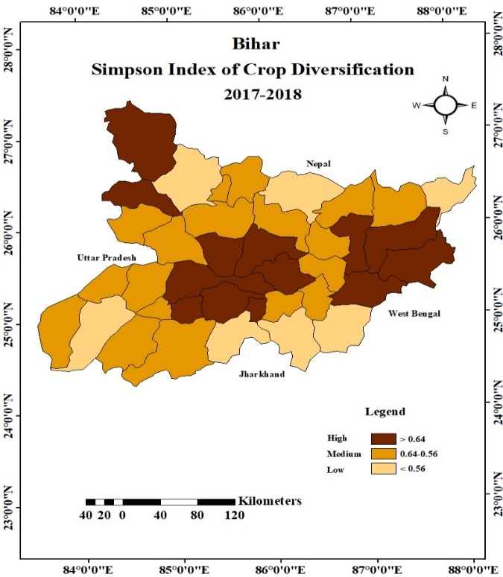
Fig. 2 Agro-Climatic Region wise Simpson Index of Crop Diversification

Table 10. Region wise Agricultural Development Index
District | Index | District | Index | District | Index | District | Index
Saran | 0.486 | Khagaria | 0.501 | Munger | 0.363 | Patna | 0.382
Siwan | 0.614 | Saharsa | 0.738 | Lakhisarai | 0.464 | Bhojpur | 0.488
Gopalganj | 0.567 | Supaul | 0.605 | Sheikhpura | 0.568 | Nalanda | 0.579
Muzaffarpur | 0.476 | Madhepura | 0.657 | Jamui | 0.316 | Buxar | 0.503
Vaishali | 0.580 | Purnia | 0.360 | Bhagalpur | 0.421 | Rohtas | 0.690
Sitamarhi | 0.573 | Araria | 0.594 | Banka | 0.532 | Bhabhua | 0.520
Sheohar | 0.599 | Kishanganj | 0.459 | Southern East | 0.444 | Gaya | 0.400
E. Champaran | 0.486 | Katihar | 0.594 |  |  | Jehanabad | 0.618
W. Champaran | 0.485 | Northern East | 0.563 |  |  | Arwal | 0.489
Darbhanga | 0.425 |  |  |  |  | Nawada | 0.533
Samastipur | 0.564 |  |  |  |  | Aurangabad | 0.676
Madhubani | 0.484 |  |  |  |  | Southern West | 0.534
Begusarai | 0.353
Northern West | 0.515
Source: Computed by Researcher

For the larger viewpoint, the Agricultural Development Index has been computed at the regional as well as the district level, using appropriate techniques. According to Table 10, the Southern East region of Bihar has a low level of agricultural development (0.444), whereas the Northern East region has a high level of agricultural development (0.563). The Southern East region has a very low gross cropped area due to poor irrigation and topographical conditions. As a result, this region has the lowest cropping intensity, followed by the Southern West. The southern parts of Bihar have been facing a drought-like situation for the last few consecutive years. For that reason, irrigation facilities are mostly dependent on groundwater. Floods and droughts have become a recurrent feature in Bihar. Paradoxically, South Bihar is ravaged by drought and North Bihar by flood in the same year (Task Force Report, GOB, 2015).

Table 11. Cross tab between Level of Agricultural Development index and Crop Diversification Index
SID | Cross Tab | Level of Agricultural Development
SID | Cross Tab | High | Medium | Low
SID | High | Madhepura, Katihar, Vaishali, Nalanda, | Sheikhpura, Gopalganj, Samastipur, W. Champaran, | Bhagalpur, Patna, Purnia, Begusarai
SID | Medium | Saharsa, Aurangabad, Jehanabad, Siwan, Supaul, Sheohar, Araria, Sitamarhi | Bhabhua, Buxar, Khagaria, Arwal, Bhojpur, Saran, Muzaffarpur | Lakhisarai, Darbhanga, Gaya, Munger,
SID | Low | Rohtas, | Nawada, Banka, E. Champaran, Madhubani, | Kishanganj, jamui,
Source: Computed by Researcher

A cross-tab and regression (OLS) analysis have been used to examine a link between crop diversification and agricultural development. A normal perception is that a high level of agricultural development leads to a high level of crop diversification and vice versa. At the state level, a positive but weak relationship has been found between crop diversification and agricultural development (fig. 3).

Fig. 3 Regression Analysis between Crop Diversification Index and Level of Agricultural Development Index

A similar conclusion could be drawn from the cross-tab. Only 13 districts out of 36 falls under the same level of agricultural development and crop diversification, which implies that a weak relationship exists between diversification and agricultural development. The parametric value (0.084) and R-square value (0.014) of the regression analysis explain that there are some other factors that are responsible for crop diversification at the regional level as well as the district level.

3.3 Crop Diversification and Level of Urbanization
On the demand side, the level of crop diversification is mostly determined by the degree of urbanization. Increasing urbanization and incomes lead to a crop diversification that differs greatly from traditional agriculture. Low-value commodities are giving way to high-value commodities as a result of this transition of rural areas.

Table 12. Cross tab between Level of Urbanization and Crop Diversification Index
SID | Cross Tab | Urbanization
SID | Cross Tab | High | Medium | Low
SID | High | Patna, Bhagalpur, Begusarai, Sheikhpura, Nalanda, | Purnia, West Champaran, Katihar, | Vaishali, Samastipur, Gopalganj, Madhepura
SID | Medium | Munger, | Lakhisarai, Bhojpur, Gaya, Jehanabad, Muzaffarpur, Darbhanga, Buxar, Aurangabad, Saran, Saharsa, Arwal | Araria, Khagaria, Sitamarhi, Bhabhua, Siwan, Supaul, Sheohar
SID | Low | Rohtas, | Nawada, Kishanganj, jamui, East Champaran, | Madhubani, Banka
Source: Computed by Researcher

Fig. 4a. Regression Analysis between Crop Diversification Index and Level Urbanization

Coefficients
Model |  | Unstandardized Coefficients |  | Standardized Coefficients | t | Sig.
 |  | B | Std. Error | Beta | t | Sig.
1 | (Constant) | .561 | .016 |  | 35.413 | .000
1 | Level of Urbanization | .003 | .001 | .337 | 2.149 | .038
a. Dependent Variable: Level of Crop Diversification
Fig. 4.b Regression Analysis between Crop Diversification Index and Level Urbanization
The similar conclusion was reached by Joshi et. al., 2004, who discovered that demand patterns for high-value items were positively impacted by structural alterations (urbanization). At the regional level of Bihar, a positive and moderate level of relationship exists between the level of urbanization and crop diversification (fig. 4). This is explained by cross-tab and regression analysis. According to the value of R-squared (0.14), the degree of urbanization accounts for 14% of the variation in crop diversification. Although this figure is less significant, it cannot be ignored. A similar conclusion could be found by cross-tab analysis. Out of 36 districts, 17 have similar levels of urbanization and crop diversification.

3.4 Cluster Analysis of Crop Diversification, Urbanization, and Level of Agricultural Development
Cluster analysis has been carried out in order to provide an explanation for the features that are shared by districts spread across four agro-climatic regions. Based on Ward's method, three clusters have been delineated. Cluster 1 only includes two districts, the majority of which are located in areas with a high level of urbanization. Cluster 2 includes nine districts, the majority of which are located in the Southeast. Cluster 3 is made up of 27 districts in Bihar. These districts are located in the northern part of the state, where urbanization is low but crop diversity and agricultural development are very high.

Table 13. Cluster of Districts of Bihar Based on Level of Urbanization, Agricultural Development Index and SID
SN | Cluster-1 | SN | Cluster-2 | SN | Cluster-3 | SN | Cluster-3 | SN | Cluster-3
1 | Patna | 1 | Bhojpur | 1 | Buxar | 10 | Vaishali | 19 | Banka
2 | Munger | 2 | Nalanda | 2 | Bhabhua | 11 | Sitamarhi | 20 | Khagaria
 |  | 3 | Rohtas | 3 | Arwal | 12 | Sheohar | 21 | Saharsa
 |  | 4 | Gaya | 4 | Nawada | 13 | E. Champaran | 22 | Supaul
 |  | 5 | Jehanabad | 5 | Aurangabad | 14 | W. Champaran | 23 | Madhepura
 |  | 6 | Begusarai | 6 | Saran | 15 | Darbhanga | 24 | Purnia
 |  | 7 | Lakhisarai | 7 | Siwan | 16 | Samastipur | 25 | Araria
 |  | 8 | Sheikhpura | 8 | Gopalganj | 17 | Madhubani | 26 | Kishanganj
 |  | 9 | Bhagalpur | 9 | Muzaffarpur | 18 | jamui | 27 | Katihar
Source: Computed by Researcher

One-way ANOVA has been used to understand the basis on which the difference between the clusters is significant.
Table 14. ANOVA
 |  | Sum of Squares | df | Mean Square | F | Sig.
Agricultural Development Index | Between Groups | 0.050 | 2 | 0.025 | 2.747 | 0.078
Agricultural Development Index | Within Groups | 0.317 | 35 | 0.009
Agricultural Development Index | Total | 0.367 | 37
Simpson Index of Diversification | Between Groups | 0.017 | 2 | 0.008 | 1.682 | 0.201
Simpson Index of Diversification | Within Groups | 0.174 | 35 | 0.005
Simpson Index of Diversification | Total | 0.191 | 37
Level of Urbanization | Between Groups | 1814.500 | 2 | 907.250 | 96.860 | 0.000
Level of Urbanization | Within Groups | 327.832 | 35 | 9.367
Level of Urbanization | Total | 2142.332 | 37
Source: Computed by Researcher

Table 14 clearly shows that there is no significant difference (except for level of urbanization) among the three clusters. Additionally, the analysis reveals that Clusters 1, 2, and 3 differ significantly in terms of urbanization level.
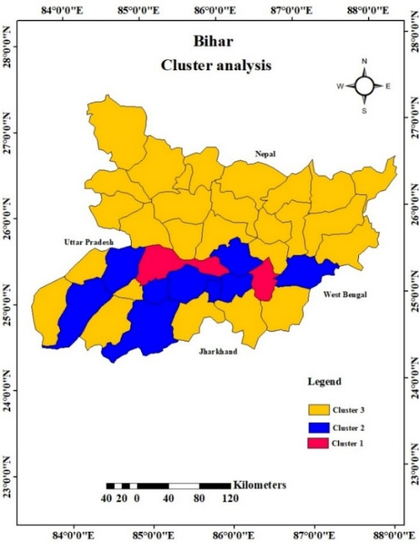
Fig.5 Cluster Analysis
Fig. 5 clearly depicts that although the northern part of Bihar has some advantages in terms of crop diversification and agricultural development, more similarities have been found among the districts of the northern part of Bihar. Whereas, the southern part shows there are huge disparities among the districts and covers all clusters. The government should be more attentive to policymaking in this region.

4. CONCLUSION
The analysis of crop diversification and agricultural development clearly demonstrates that Northern Bihar, particularly the Northeast region, has a slight advantage over other regions of Bihar in terms of agricultural development and crop diversification. Usually, agricultural development and crop diversification influence each other simultaneously. However, there has been a positive but weak correlation between these two variables in Bihar. One more variable, such as urbanization, which is the most important factor influencing demand-side crop diversification, has been included in the analysis. The analysis reveals that the impact of the level of urbanization on crop diversification is low but cannot be ignored. The entire analysis of the paper presents that each agro-climatic region in Bihar has unique characteristics regarding crop diversification, most of which are influenced by the region's topography. The extent to which the topographical condition of the region influences the nature and degree of crop diversification as well as the level of agricultural development will be the subject of additional research.

Competing interests
Authors have declared that no competing interests exists.

DISCLAIMER (ARTIFICIAL INTELLIGENCE)
Author(s) hereby declare that no generative AI technologies such as large language models (ChatGPT, etc.) have been used.

REFERENCES
Ahmad, Nasim & Sinha, D.K.Sinha & Singh, K. & Kumar, Amlendu. (2017). Determinants of Crop Diversification in Bihar Agriculture–An Economic Analysis. SSRN Electronic Journal. 35. 10.2139/ssrn.3052110.

Birthal, P.S., & Joshi, P.K., & Gulati, A. (2005). Vertical Coordination in High Value Commodities: Implications for Smallholders. MTID Discussion Paper No. 85. International Food Policy Research Institute, Washington.

Dadi, W., Mulegeta, M., & Simie, N. (2022). Urbanization and its effects on income diversification of farming households in Adama district, Ethiopia. Cogent Economics & Finance, 10(1), 2149447.

Joshi, P.K., & Gulati, A., & Birthal, P.S., & Tiwari L. (2004). Agriculture Diversification in South Asia: Pattern, Determinants and Policy Implications, Economic and Political Weekly, Vol. XXXIX, No. 24, pp. 2457-67.

Khan, K. A. & Sadaf (2022). Inter-Reginal Variation in the status of Agriculture in Bihar, India, Asisan Profile, Vol. 50, No.3.

Kumar, A., Kumar, P., & Sharma, A. N. (2012). Crop diversification in Eastern India: Status and determinants. Indian Journal of Agricultural Economics, 67(902-2016-66732).

Kumar, S., & Gupta, S. (2015). Crop diversification towards high-value crops in India: A state level empirical analysis. Agricultural Economics Research Review, 28(2), 339-350.

Pingali, P.L., & Rosegrant, M.W. (1995). Agricultural commercialization and diversification: Processes and policies. Food Policy, 20(3): 644-651.

Pohit, S., Kannan, E., Singh, R., Bandyopadhyay, S., Alawadhi, A., & Sayal, L. (2019). Study on Agricultural Diagnostics for the State of Bihar in India. National Council of Applied Economic Research: New Delhi, India.

Ryan, J.,G., & Spencer, D.C. (2001). Future Challenges and Opportunities for Agricultural R&D in the Semi-Arid Tropics. International Crops Research Institute for the Semi-Arid Tropics, Patancheru, Telangana.

Singh, A. (2011). Diversification in Agriculture, Retrieved from www.eoearth.org/view/article/151757.

Singh, N.P., & Kumar, R., & Singh, R.P. (2006). Diversification of Indian Agriculture: Composition, Determinants and Trade Implications, Agricultural Economics Research Review, Vol. 19.

Sharma, A. N. (2005). Agrarian relations and socio-economic change in Bihar. Economic and Political Weekly, 960-972.

Von Braun, J. (1995). Agricultural commercialization: Impacts on income and nutrition and implications for policy. Food Policy, 20 (3): 187-202.

