`IDENTIFICATION OF GROUNDWATER POTENTIAL ZONES USING GIS TECHNIQUES IN EAST KARBI ANGLONG DISTRICT, ASSAM
ABSTRACT:
Concept: Over exploitation of groundwater and remarkable changes in climatic history over the years have posed immense pressure on the global groundwater resources. The need of potable water enhanced across the globe for human consumption, industrial purpose, irrigation, agricultural activities. With the increased use of groundwater for various purposes, there is a need to evaluate the groundwater potentiality and productivity of aquifers.
Objective: Due to expanding population and its use for different purpose, the district has experienced groundwater issues lowering its potentiality. Therefore, the present study aims to develop the objective of delineation of groundwater potential zones in East Karbi Anglong district.
Methods: Thematic layers such as Geomorphology, Soil, Slope, Drainage Density, Rainfall, were prepared and studied for demarcation of groundwater potential zone using Weighted Overlay Analysis. In the present scenario, remote sensing and GIS have gained much more prominence in the groundwater exploration. The thematic parameters were then verified with depth to groundwater level.
Results: The groundwater potential zone map thus, obtained was categorized under very low, low, moderate, high and very high categories. The study reveals that maximum areas under groundwater potential zones are occupied under low, moderate and high including 2295 sq km, 4313 sq km and 549 sq km area respectively. The accuracy assessment analysis shows 85% indicating good accuracy using Kappa coefficient.
Conclusion: The district has moderate groundwater potential representing moderate groundwater recharge due to hilly terrain. The groundwater potential zone map provides a future plan to the decision makers in order to appropriate proper planning, development and management of groundwater for urban and other agricultural purposes.
Keywords: GIS, Thematic maps, Weighted Overlay, Groundwater Potential Zones

1. INTRODUCTION

One of the major issues faced by the inhabitants of developing countries is the insufficient water supply. The developing countries could not provide adequate amount of water to the inhabitants besides its economic prosperity and industrial development (Akinwumiju, 2015). Groundwater is one of the significant and dynamic assets stored in the sub-surface of the earth’s crust. It serves as a source of water for drinking, irrigation as well as helps to ensure sufficient water supply providing the growth of industrial needs and constant irrigational use even in adverse climatic conditions. With the ever-increasing population, the demand of water for meeting human needs has posed huge pressure on the limited water resource. As mentioned earlier, the sub-tropical developing country like India suffers the problem of groundwater where surface water is not available for the year round. In India, about 65% of the total geographical area is covered by hard rock formation with low porosity index (less than 5%) and very low permeability (Saraf and Choudhury, 1998). Over and continuous extraction of groundwater has aggravated the problem leading to decline in groundwater level (Waikar and Nilawar, 2014). This sharp decline in the water level has eventually dried up the wells. The factors like geology, rate of infiltration property, precipitation affects the groundwater conditions of the area (Godbole, 2019). Therefore, groundwater investigation requires continuous information on rainfall pattern, geomorphic setup, surface water conditions and topographic changes.
In the recent years, remote sensing and GIS has gained acceptance in understanding the potential changes in the environment (Jha et.al., 2007) as it provides multi-date satellite imageries of the earth’s surface (Choudhury et.al., 2003). One of the greatest advantages of this technique for hydrological investigations is its ability to monitor and generate spatial and temporal information. Hence, a systematic planning and management is required for assessing the groundwater potential zones. Usefulness of remote sensing techniques for delineation of ground water potential zones for water resources development plan has been demonstrated in the Yamuna flood plain in Uttar Pradesh (Rao et. al. 2009). Triantafilis et al. (2009) has attempted to study the mapping of groundwater table depth using Krigging and IDW (Inverse Distance Weightage) methods. The interpolation methods are needed to determine spatial variety of groundwater levels and are powerful tools to be used to predict surface values. Similarly, in my study IDW method will be used to analyze the rainfall variability. Yeshodha et. al. (2010) has conducted a study on assessment of groundwater potential in Krishnagiri District of Tamil Nadu. The authors calculated the quantity of discharge and recharge. They conclude that the magnitude of annual rainfall and groundwater potential had a decreasing trend. The discharge rate was more than the recharge rate, leading to depletion of the groundwater level. Basavaraj et.al. (2011) made an attempt to identify groundwater potential zone using Geoinformatics in Ghatapraba basin, North Karnataka, India. Using GIS and RS technology, an attempt had been made to delineate possible groundwater potential zones in the Ghatapraba sub basin of Krishna river, Karnataka, prepared using the Google earth imagery and conventional data. Nagarajan et. al. (2009) has conducted a study for the assessment of GWPZ in Kattakulathur block, Tamil Nadu using Weighted Overlay Analysis under GIS environment. Akinwumiju et. al. (2015) has adopted to assess about the groundwater potential of Osun drainage basin of Southwestern Nigeria. The study concluded that groundwater potential was actually low in Osun basin whereas, the upland areas were identified with high potential. Saraf and Choudhury (1998) attempted to study about the groundwater exploration and identification of artificial recharge sites in Sironj area of Vidisha district of Madhya Pradesh using RS techniques. Arya (2019) studied the groundwater potential mapping and quality modelling for Vattamalaikarai river basin of Tamil Nadu. The study tried to assess to delineate the ground water potential zones, identification of recharge zones, suitable sites for the construction of artificial recharge structures and quality variations thereby evaluating the impact of land use land cover changes on groundwater system. The study concludes that the groundwater is exploited and water quality is not good for drinking and irrigation purpose. Godbole (2019) made an assessment on the impact of geomorphology on groundwater potential of Kasari river basin, Kolhapur district, Maharashtra. Waikar and Nilawar (2014) studied about the identification of GWP zones using GIS in Parbhani district of Maharashtra. The study was performed using the parameters like geology, slope, drainage density, lineament density and integrated with Weighted Overaly in ArcGIS. Suitable ranks are assigned to each of the layers depending on their water holding capacity and groundwater potential zones are reclassified into poor, moderate, excellent categories. Choudhury et.al. (2003) conducted a study on groundwater assessment in large irrigation areas using an integrated decision support system in GIS. Arivalagan et.al., (2014) studied the delineation of groundwater potential zones in Eastern part of Krishnagiri district of Tamil Nadu. Thematic layers are prepared (slope, drainage density, geomorphology, soil, rainfall) and ranks are assigned to each of the classes. The thematic layers are then integrated using Weighted Overlay in order to generate groundwater potential zone map. This can be efficient for groundwater management plan as well as for sustainable utilization of groundwater resources. Hence, this study attempts to study the groundwater potential in East Karbi Anglong district of Assam using Weighted Overlay integrating all the thematic layers with remote sensing and GIS techniques. Handique et.al. (2025) has evaluated and assessed the landscape modification pattern by analyzing soil type, rainfall distribution under remote sensing and GIS environment. Identifying groundwater potential zones is very crucial for efficient water resource management, agricultural development thereby ensuring sustainability through locating drilling wells, developing artificial recharge and mitigating water scarcity issues. East Karbi Anglong district has been taken into consideration for the study as it is affected by vast landscape changes, agricultural practices, growing anthropogenic activities that deteriorate the groundwater scenario. Secondly, due to various commercial and non-commercial activities the consumption of groundwater is enhancing in order meet the demands of rising population lowering the groundwater potentiality. However, no such significant study has been conducted on groundwater resources. Therefore, this paper aims to examine the groundwater potential and analyze how the geomorphology, drainage density, slope, soil type, rainfall pattern, and validating those layers with groundwater level of the district.

1.1 STUDY AREA
East Karbi Anglong district is located between 25⁰ 33′ N to 26⁰ 35′ N latitude and 92⁰ 10′E to 93⁰ 50′ E longitudes (Fig.1) in the south central part of Assam. The region is beautificially surrounded by forests, rivers, nature, environment, lands inhabited by tribal population. It is bounded by Golaghat district in the east, West Karbi Anglong district in the west, Nagaon district in the north, and North Cachar Hills and Nagaland in the south. The total geographical area of East Karbi Anglong district is about 7320 square km representing isolated hillocks thereby separating from the Brahmaputra alluvial soils. The East Karbi Anglong district has two administrative divisions as per 2011 census namely; Diphu sub-division and Bokajan sub-division with its largest
administrative headquarter in Diphu. It is well connected with other districts NH-37 and NH-39 as well as NFR, Dimapur 54 km away from Diphu, the nearest airport.
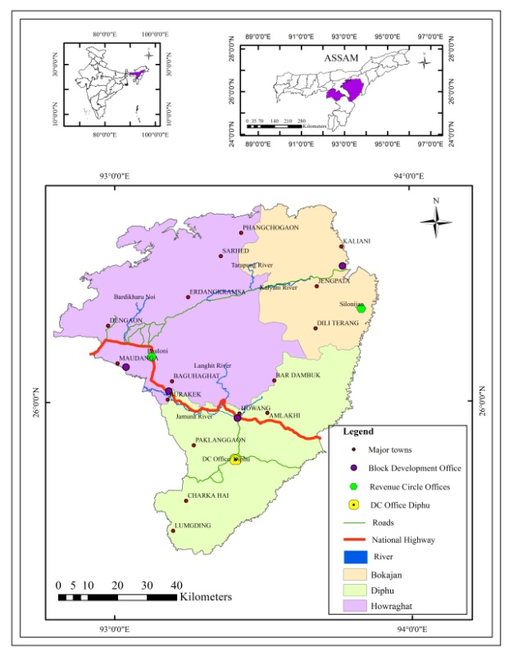
.

Fig.1: Location Map of the study

1.2 HYDROLOGY

The district in the north is bounded by the mighty river Brahmaputra. Among the important rivers in the district, Dhansiri in the north east,Kapili and Jamuna in the west constitutes the major drainage of the district. The drainage pattern in the district is radial where all the rivers and streams flow towards Jamuna valley, Kapili valley and north to Brahmaputra. The river Diphu is also a tributary of Jamuna flowing towards northern slopes, Deopani, Kaipani towards north-western slopes of the district. The district has a humid sub-tropical climate, characterized by rainfall during summer and comparatively dry during winter months (Handique et.al. 2025).

1.3 AIMS AND OBJECTIVE
The main objective of this research is to geographically study the groundwater potential by preparing the thematic layers and further integrating those layers assigning weight and rank.
1. To assess the groundwater potential zones in the district using Weighted Overlay Analysis.
2. MATERIALS AND METHODS
2.1 DATABASE
Primary Data:
Primary data (Tabulated data) has been collected for groundwater depth (pre-monsoon, monsoon and post-monsoon) during a field survey for 12 locations in the district.
Secondary Data:
- SRTM DEM (30m resolution) data used to prepare Slope map and Drainage Density map.
- Geomorphology map of 1:50,000 scale from Bhuvan.
- Soil map used to prepare from National Bureau of Soil Survey and Land Use Planning (NBSS & LUP).
- Rainfall data collected from CHRS portal and rainfall variability map is prepared.
- Data sources for preparing various thematic layers such as soil, geomorphology, drainage density, slope, rainfall and water level data will be collected in order to generate Groundwater Potential Zones (GWPZ) (Arya, 2019).
2.2 METHODOLOGY FOR GROUNDWATER POTENTIAL ZONES
In order to generate groundwater potential zones of the study, thematic layers such as soil, geomorphology, drainage density, slope and rainfall variability map will be integrated by Weighted Overlay Method using Spatial Analysis Tool in Arc GIS. The below flow chart (Fig. 2) depicts the structure and organization of the work.

Collection of Maps

Conventional Data
SOI Toposheet
Spatial and non-spatial data integration and Thematic map preparation
Georeferenced and Digitization of base map

Geomorphology, Drainage density, Soil, Slope, Rainfall, Depth to Water Level

Raster conversion
Weighted Overlay Analysis
Groundwater Potential Zones Map

Fig.2: Flow Chart of Groundwater Potential Zones (GWPZ)
3. RESULTS AND DISCUSSIONS
For the identification of groundwater potential zones, five thematic layers prepared in Arc GIS
and validated with groundwater depth. Each of the maps is reclassified and by using Weighted Overlay Analysis tool, groundwater potential zones are classified. The different physiographic characteristics are explained below with respective figures.
Slope: Slope is defined as the ratio between vertical rise to horizontal distance, mostly expressed as percentage or degrees. The study area comprises gentle slope of 12.09º to very steep slope of 60.43º indicating a low and high gradient respectively. The slope (in degrees) map (Fig.3) has been prepared from SRTM DEM (30m resolution) denoting a moderate slope in the district.
Drainage density: Drainage density defines how the landscape is drained by number of channel streams in a per unit area. A higher drainage density indicates well established network of channels whereas, low drainage density indicates less drained number of streams. Due to steeper slopes, the district possess moderate to high drainage density indicating that water drains quickly thereby reflecting less infiltration rates. The drainage density map (Fig.4) clearly depicts the ranges from 0.09 (very low) to 4.52 (very high) km/km² significantly affecting the landscape.
Geomorphology: The geomorphology of the district shows a diverse nature influencing its unique geological background and ongoing tectonic activity. The geomorphology map has been prepared from Bhuvan at 1:50,000 scale. The map (Fig.5) represents the various landforms present in the district that incorporates- water bodies, pediment pediplain complex, moderately dissected plateau, highly dissected hills and valleys, moderately dissected hills and valleys, low dissected hills and valleys, flood plain and alluvial plain. The area between hills and flood plain is occupied by Pediment pediplain complex. The north-central and south-eastern part of the district occupies dissected hills and valleys and dissected plateaus. Alluvial plains are confined along the banks of Dhansiri river and also towards Dokmoka-Langhing area.
Rainfall: Rainfall map of the district has been collected from CHRS portal indicating average annual rainfall of 1551mm in the district (Fig.6). The district enjoys a sub-tropical monsoon climate accounting majority of rainfall in the area. Due to variations in topography, this hilly terrain experiences different climate in different parts. The rainfall is not evenly distributed over the period of six months from April to September. About 60% of the annual rainfall is received during July to September (CGWB).
Ground water level: The groundwater depth to water level has been taken for three seasons (pre-monsoon, monsoon and post-monsoon) for 12 well locations. The hydrogeology of the district mainly comprises sand and mixed formation. The below table.1 provides the details of groundwater level depth for all the surveyed locations.
Table:1 Water level data of dug wells
Sl. No | Locations | Longitude | Latitude | Nov | Aug | Mar | Jan
1 | Dengaon | 92.9725 | 26.2180 | 1.02 | 1.57 | 3 | 3.5
2 | Amlokhi | 93.6113 | 26.05222 | 0.54 | 1.21 | 1.6 | 1.89
3 | Bokajan | 93.78 | 26.02 | 8.75 | 12.15 | 11.4 | 11.59
4 | Bokuliaghat | 93.3505 | 26.095 | 2.43 | 3.1 | 3.51 | 3.97
5 | Deopani | 93.8127 | 26.2122 | 10.8 | 5.66 | 11.48 | 11.68
6 | Diphu | 93.43 | 25.83 | 19.03 | 22.66 | 23.09 | 20.34
7 | Donkabey | 93.5927 | 25.8775 | 23.3 | 23.47 | 25.98 | 26.96
8 | Hidipi | 93.1066 | 26.49 | 2.23 | 2.2 | 3.87 | 8.06
9 | Langhing | 93.1302 | 26.2052 | 1.9 | 1.33 | 3.76 | 3.66
10 | Manja | 93.4369 | 25.9675 | 1.32 | 1.16 | 2.06 | 2.06
11 | Phuloni | 93.1377 | 26.1777 | 0.84 | 0.82 | 8.4 | 2.1
12 | Silanijan | 93.8644 | 26.3322 | 5.49 | 6.3 | 6.01 | 5.49
Source: Field Survey, 2024
The post-monsoon depth to water level (Fig.7) in the district shows that the water level in 7 dug wells is below 5.1 mbgl, 2 wells has water level between 5.1 to 9.64 mbgl, 1 well shows the water level from 9.65 to 14.19 mbgl and the other 2 wells records the water level of maximum 23.3 mbgl. Very low depth to water level of 0.52 mbgl has been recorded in Amlokhi and high depth to water level of 23.3 mbgl in Donkabey. In the district, during monsoon season 7 dug wells shows water level (Fig.8) less than 5.34 mbgl, 2 dug wells records the depth of water level between 5.35 to 9.85 mbgl, 1 dug well have water level between 9.86 to 14.36 mbgl and the other 2 wells i.e., Diphu and Donkabey records the deeper water level above 14.36 mbgl.

In East Karbi Anglong district, during pre-monsoon, 7 dug wells shows depth to water level (Fig.9) less than 6.88 mbgl, 3 dug wells shows water level between 6.89 to 11.88 mbgl, 2 key wells have water level above 11.88 mbgl. The minimum water level of 1.6 mbgl was recorded in Amlokhi dug well whereas; maximum water level of 25.98 mbgl was recorded in Donkabey. Diphu, being the headquarter of the district also records deeper water level more than 11.88 mbgl. The average groundwater depth (Fig.11) of all the seasons records water level of below 5.81 mbgl for 8 dug wells, 1 dug well between 5.82 to 10.41 mbgl,1 dug well from 10.42 to 15.41 mbgl and the other two dug wells (Diphu and Donkabey) records water level above 15.41 mbgl.
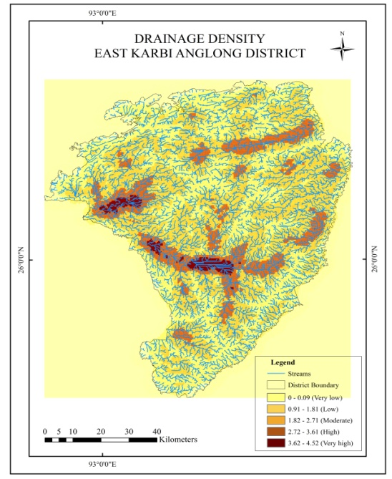
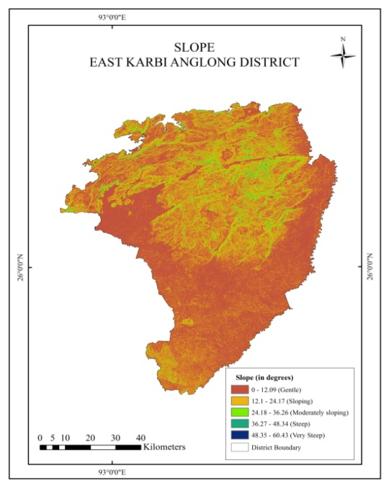
Soil: Soil type in the district is not very favourable for agriculture due to highland slopes. The major soil type map (Fig.11) in the district includes younger riverine alluvial soil, older riverine alluvial soil, laterite soil, red sandy and red loamy soil. Soil map has been prepared from NBSS & LUP indicating that various factors like heavy rainfall, floods, soil erosion and uneven terrain affect the soil formation process providing diverse classification of soils in the district.

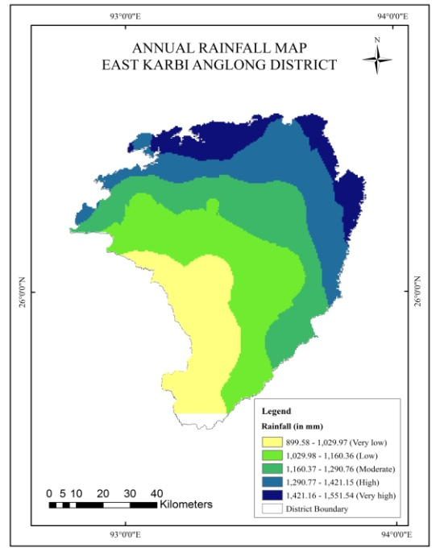
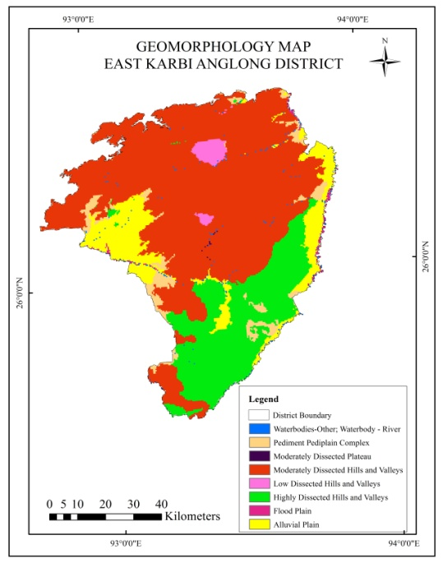
Fig.6: Annual Rainfall
Fig.5: Geomorphology
Fig.4: Drainage Density
Fig.3: Slope
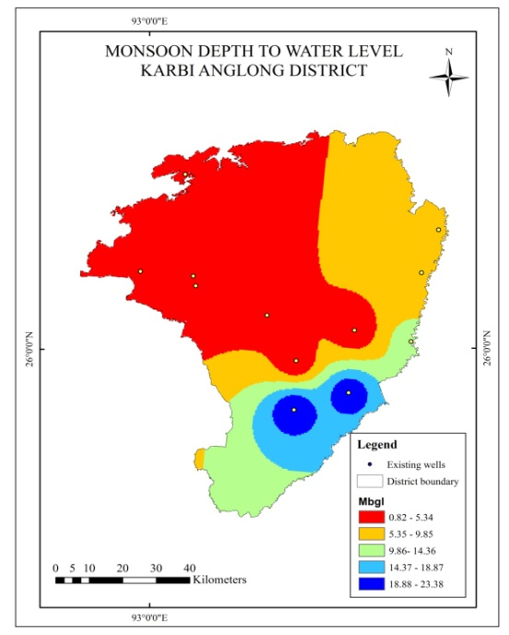
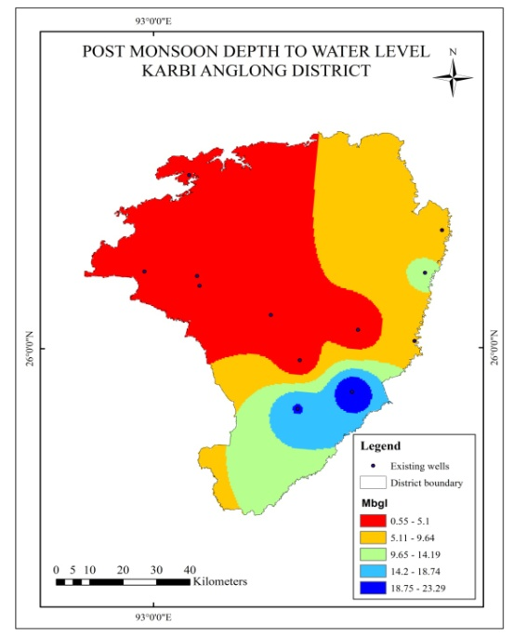

Fig. 7: Post Monsoon Depth
Fig. 8: Monsoon Depth
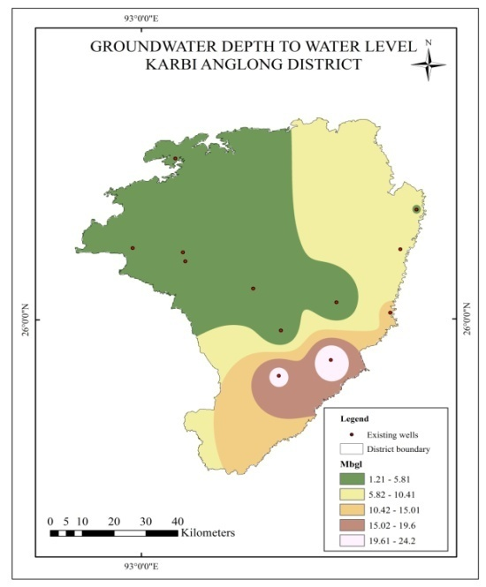
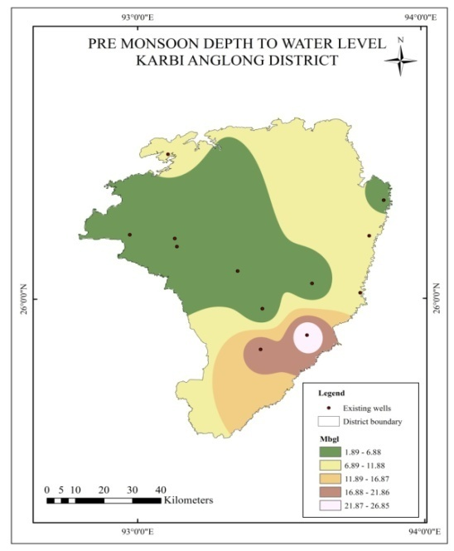

Fig.10: Average Groundwater Depth
Fig. 9: Pre Monsoon Groundwater Depth
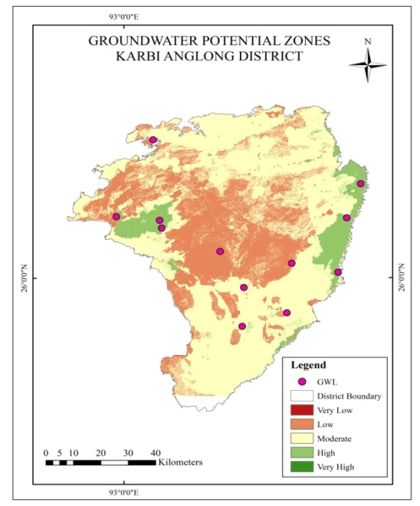
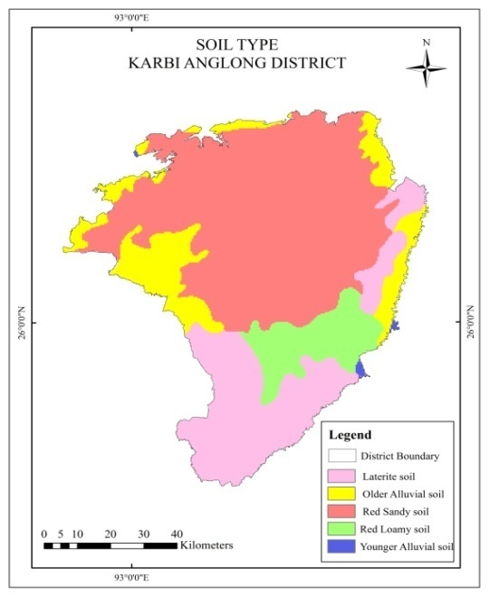

Fig.12: GWPZ
Fig.11: Soil Types
3.1 ASSESSMENT OF GROUNDWATER POTENTIAL ZONES
The groundwater potential zones map (Fig.12) is obtained by overlaying all the thematic layers using Weighted Overlay method under spatial analyst tools in Arc GIS environment. During the analysis, individual thematic parameter has been ranked and weightage is being assigned as per the influence of various considered parameters. The rank and weights has been taken by considering the works of various researchers (Krishnamurthy et.al., 1996, Saraf & Chowdhary 1998). All the thematic maps are converted to raster format and thereby superimposed using Weighted Overlay method (rank and weight wise thematic maps and integrated with one another through Arc GIS environment) (Waikar & Nilawar, 2014). The below table.2 represents the rank and weight for different parameters depending on the influence of the topographic nature.
Table:2 Rank and Weight for different parameters of GWPZ
PARAMETER | CLASSES | GROUNDWATER PROSPECT | WEIGHT (%) | RANK
Geomorphology | Pediment Pediplain Complex  Plains  Water bodies  Moderately Dissected Hills & Valleys  Low Dissected Hills & Valleys  Moderately Dissected Plateau  Highly Dissected Hills & Valleys | Very good  Very good  Good  Moderate  Poor  Very poor  Very poor | 30 | 5  5  4  3  2  1  1
Slope (in degree) | 0-12.09 (Gentle)  12.1-24.17 (Sloping)  24.18-36.26 (Moderately sloping)  36.27-48.34 (Steep)  48.35-60.43 (Very steep) | Very good  Good  Moderate  Poor  Very poor | 25 | 5  4  3  2  1
Drainage density  (km/sqkm) | 0-0.09 (Very low)  0.91-1.81 (Low)  1.82-2.71 (Moderate)  2.72-3.61 (High)  3.62-4.52 (Very high) | Very good  Good  Moderate  Poor  Very poor | 20 | 5  4  3  2  1
Soil | Younger Alluvial soil  Older Alluvial soil  Laterite soil  Red Sandy soil  Red loamy soil | Very good  Very good  Moderate  Good  Poor | 10 | 5  5  3  4  2
Rainfall (mm) | 899.58-1029.97 (Very low)  1029.98-1160.36 (Low)  1160.37-1290.76 (Moderate)  1290.77-1421.15 (High)  1421.16-1551.54 (Very high) | Very poor  Poor  Moderate  Good  Very good | 15 | 1  2  3  4  5

Table:3 Groundwater Potential zones of study
Sr. No | Potential zones | Area (sqkm)
1 | Very low | 0.60
2 | Low | 2295
3 | Moderate | 4313
4 | Good | 549
5 | Very good/ Excellent | 0.39

Source: Computed from GWPZ

Weighted Overlay is the suitable method for identification and delineation of groundwater potential zones as it systematically integrates multiple thematic layers in order to produce a comprehensive single model. The tool allows the user to perform the analysis by combining multi-influencing factors and providing weighted scores against each cell in the study. The ranks and weights (Krishnamurthy et.al., 1996, Saraf & Chowdhary 1998) assigned to each layer and classes are based on its correspondence with groundwater and potential zones. The final weight for each thematic layer is determined by its relative importance to groundwater occurrence in the study. Within each thematic parameter, the individual classes are assigned ranks based on the retention capacity of groundwater classified into five categories: very poor, poor, moderate, good and very good. The six parameters considered in the study are geomorphology, drainage density, slope, rainfall, soil types, and groundwater depth to water level. The Weighted Overlay method has been applied to generate the groundwater potential zones (Fig.12) in the district. The potential zones were divided into five classes – very low, low, moderate, high and very high and the spread of these zones are categorized into 0.60 km², 2295 km², 4313 km², 549 km² and 0.34 km² respectively. As seen from the figure, the groundwater in the district is dominantly occupied by low, moderate and high zones. Very low and low potential zones spread mainly in the highlands with steep gradient, high drainage density with low infiltration capacity and dense forest covers. Moderate potential zones generally take place in the valleys and areas of moderate drainage density. High and very high potential zones are confined to low/nearly level slope with low drainage density having high infiltration capacity resulting in good groundwater recharge.

The groundwater potential zones in the study area are cross validated with the observation wells data of Central Ground Water Board (CGWB). In order to study the groundwater depth of water level, a total of 12 observation wells are studied and further analyzed. A total number of 8 observation wells are located in the highlands with rugged topography and 1 observation well is located in Deopani. The other one observation well is located in Bokajan having moderate groundwater potential zone with moderate infiltration capacity whereas, the other 2 observation wells have high infiltration capacity with low drainage density.

4. CONCLUSION

A total of 6 thematic layers were used in the present study to analyze the groundwater potential zones. According to the final layout, the map has been classified into five categories – very low, low, moderate, high and very high groundwater potential zones. The district has moderate groundwater potential representing moderate groundwater recharge due to hilly terrain. The groundwater potential zone map provides a future insight to the decision makers and planners for proper planning, development and management of groundwater for urban and other agricultural purposes. Since less part of the area is under agricultural land, this will help to improve the irrigation facility and the agricultural productivity of the area to some extent.

ACKNOWLEDGEMENTS

I extend my sincere gratitude to the institution of Rajiv Gandhi University whose support has been fundamental in the completion of research endeavor. I would like to express my appreciation to the dedicated research lab for their immense efforts. The facilities provided by the University were indispensable in carrying out experiments and data collection in fostering a conducive research environment.

COMPETING INTERESTS

Authors have declared that no competing interest exists.

AUTHOR’S CONTRIBUTION

The sole author has conceptualized, designed the research topic, conducted the experiments, performed the analysis and wrote the first draft of the manuscript. The second author has critically reviewed the manuscript, supervised the research work and made final approval of the work.

REFERENCES

Akinwumiju, A. S., Olorunfemi, M. O., & Afolabi, O. (2016). GIS-Based Integrated Approach to Groundwater Potential Assessment of Osun Drainage Basin, South Western Nigeria. Ife Journal of Science, Vol.18, no.1, 316 pp. Institute of Ecology and Environmental Studies, Obafemi Awolowo University, Ile-Ife, Nigeria.
Arulbalaji, P., Padmalal, D., & Sreelash, K. (2019). GIS and AHP Techniques based delineation of groundwater potential zones: a case study from South Western Ghats, India. Scientific Reports, 9:2082, https://doi.org/10.1038/s41598-019-38567-x.
Arulbalaji, P., & Gurugnanam, B. (2016). An Integrated study to assess the Groundwater Potential Zone using geospatial tools in Salem district,
Tamil Nadu. Journal of Hydrogeology, Hydrological Engineering.

Arivalagan, S., Kiruthika, A. M., & Sureshbabu, S. (2014). Delineation of Groundwater potential zones using RS and GIS techniques: A case Study for Eastern part of Krishnagiri district, Tamil Nadu. IJARSE, Vol.3, no.3, pp.51-59.

Arya. S. (2019). Groundwater Potential Mapping and Quality Modelling for Vattamalaikarai River Basin, Tamil Nadu, India. Doctoral Thesis, Anna University.
Basavaraj, H., & Nijagunappa, R. (2011). Identification of Groundwater Potential Zone using Geoinformatics in Ghataprabha basin, North Karnataka, India. International Journal of Geomatics and Geosciences, Vol.2, No.1. Environmental Science Department, Gulbarga University.
Chang, P.H., Hsu, K.C., Lee, C.H., et.al. (2009). GIS for the assessment of the groundwater recharge potential zone. Environmental Geology, 58:185-195, https://doi.org/10.1007/s00254-008-1504-9.
Chowdhury, A., Jha, M.K., Chowdary, V.M., & Peiffer, S. (2007). Groundwater management and development by integrated remote sensing and GIS: prospects and constraints. Journal of Water Resource Management, Vol.21, pp. 427-467.
Chowdhury, A., Jha, M.K., Chowdary, V.M., & Mal, B.C. (2009). Integrated remote sensing and GIS based approach for groundwater potential in West Medinipur district, West Bengal, India. International Journal of Remote Sensing, Vol.30, pp 231-250.
Godbole, Y.S. (2019). Impact of Geomorphology on Groundwater Potential of Kasari river basin, Kolhapur district, Maharashtra, India. Doctoral Thesis, Marathwada University.
Handiue, A., Dey, P. & Bhujel, S. (2025). Geospatial Assessment of Soil Loss using Revised Universal Loss Equation (RUSLE) in Dibrugarh District, Assam, India. Asian Journal of Geographical Research, Vol.8, Issue 3, 136-152. https://doi.org/10.9734/ajgr/2025/v8i3282.
Kaur, H., Guin, S., Gupta, S. & Thapa, R. (2017). Assessment of Groundwater Potential Zones using Multi-Influencing factor (MIF) and GIS: a case study from Birbhum district, West Bengal. Applied Water Science, 7:4117-4131, https://doi.org/10.1007/s13201-017-0571-z.
Kumar, R., Kumar, A., Bhagat, B.D. & Jasrotia, A.S. (2013). Remote sensing and GIS approach for Delineation of Groundwater Potential and Groundwater Quality zones of Western Doon Valley, Uttarakhand, India. Journal of Indian Society of Remote Sensing, 41(2):365-377. https://doi.org/10.1007/s12524-012-0220-9.
Maity, K.D. & Mandal, S. (2019). Identification of the groundwater potential zones of the Kumari river basin, India: an RS & GIS based semi-quantitative approach. Environmental Development Sustainability, 21:1013-1034, https://doi.org/10.1007/s10668-017-0072-0.
Nagarajan, M. & Singh, S. (2009). Assessment of Groundwater Potential Zones using GIS technique. Journal of Indian Society Remote Sensing, Vol.37, pp 69-77.
Rao, S.Y. & Jugran, D.K. (2003). Delineation of groundwater potential zones and zones of groundwater quality suitable for domestic purpose using Remote sensing and GIS. Hydrological Sciences Journal, 48:5, 821-833, https://doi.org/10.1623/hysj.48.5.821.51452.
Sankar, Ravi, M.N. & MOohan, G. (2006). Assessment of groundwater potential and quality in Bhatsa and Kalu river basins of Thane district, Western Decaan Volcanic Province of India. Environmental Geology, 49: 990-998, https://doi.org/10.1007/s00254-005-0137-5.
Saha, D., Dhar, Y.R., & Vittala, S.S. (2010) Delineation of groundwater development potential zones in parts of marginal Ganga Alluvial Plain in South Bihar, Eastern India. Journal of Environment Monitoring Assessment. Vol.165, 179-191.
Saraf, A.K., & Choudhury, P.R. (1998) Integrated remote sensing and GIS for groundwater exploration and identification of artificial recharge sites. International Journal of Remote Sensing. Vol.19, pp 1825-1841.
Senanayake, I.P., Dissanayake, D., Mayadunna, B.B. & Weerasekera, W.L. (2016). An approach to delineate groundwater recharge potential sites in Ambalatonta, Sri Lanka using GIS techniques. Geosciences, Front. Vol.7, pp 115-124.
Waikar, M. L. & Nilawar, A.P. (2014). Morphometric Analysis of a drainage basin using GIS: a case study. International Journal of Multidisciplinary and Current Research, Vol.2, pp 179-184.
Waikar, M. L., & Nilawar, A.P. (2014). Identification of Groundwater Potential Zone using Remote Sensing and GIS Technique. International Journal of Innovative Research in Science, Engineering and Technology, Vol.3, Issue 5, pp. 12163- 12174.
Yeshodha, L., Thirumoorthy, M. & Rajakumara, H.N. (2010). Assessment of groundwater potential in Hosur Union in Krishnagiri District, Tamil Nadu, India. Nature Environment and Pollution Technology, Vol.9 (4), pp, 683-686.

