Original Research Article
BACTERIOLOGICAL SAFETY OF LOCALLY PRODUCED ‘UGBA’: A FERMENTED PRODUCT OF PENTACLETHRA MACROPHYLLA SOLD IN ABAKALIKI METROPOLIS, EBONYI STATE,Nigeria

.

ABSTRACT
Introduction: Fermented Pentaclethra macrophylla (ugba), a product from African oil bean cotyledons, is widely consumed among the Igbo and other ethnic groups in southern Nigeria. It is typically prepared through indigenous household practices and serves as an accessible source of plant protein.
Aim: This study investigated the bacteriological quality of locally processed Pentaclethra macrophylla sold within Abakaliki Metropolis, Ebonyi State.
Methodology: A total of 3 samples of ready-to-eat African oil bean (Pentaclethra macrophylla) were purchased from different sellers in Presco Market, Abakiliki, Ebonyi state Nigeria. Morphological characterization of bacterial isolates were carried out using standard microbiological procedures. Total viable counts were determined with a colony counter, while antimicrobial susceptibility was assessed by the Kirby–Bauer disk diffusion method.
Results: The predominant isolates included Escherichia coli, Klebsiella spp., and Salmonella spp. The total bacterial count of samples from Pentaclethra macrophylla 1, Pentaclethra macrophylla 2 and Pentaclethra macrophylla 3 were 12 x 10⁴ cfu/ml, 54 ×10³ cfu/ml, 67 X 10³ cfu/ml respectively. Susceptibility testing indicated that the isolates were sensitive to ciprofloxacin and imipenem but resistant to piperacillin/tazobactam and cefotaxime.
Conclusion: The findings demonstrate the limited shelf stability of Pentaclethra macrophylla, largely due to uncontrolled fermentation and inadequate packaging. Improved hygiene and adherence to Good Manufacturing Practices (GMP) are recommended to minimize microbial contamination and enhance product safety.

Keywords: Pentaclethra macrophylla, Escherichia coli, Klebsiella spp., Salmonella spp

1. INTRODUCTION
A variety of plant seeds are traditionally fermented and consumed in Nigeria, notably the African oil bean, Pentaclethra macrophylla known locally in Igbo as ugba. This alkaline-fermented delicacy, produced via solid-state fermentation of boiled, shredded seeds, is prized for its protein-rich composition, affordability, and cultural significance—especially among the Igbo population. Recent studies have focused on enhancing fermentation by utilizing specific starter cultures such as Bacillus subtilis and Lactobacillus fermentum, which influence the physicochemical properties of ugba, potentially increasing its nutrient profile and shelf-life [1]
The African oil bean tree (Pentaclethra macrophylla Benth.), belonging to the family Leguminosae and subfamily Mimosoideae, is native to the rainforest regions of West and Central Africa. Its oval, flat seeds are typically black or grey and are composed of 44–47% oil, 36.2–43.89% protein, and 4–17% carbohydrates. In their raw state, the seeds are bitter and contain several anti-nutritional factors such as paucine, cyanide, oxalates, saponins, phytic acid, phytates, and tannins. Processing involves a series of steps including boiling, dehulling, shredding, further boiling, sieving, wrapping in banana or plantain leaves, and fermentation. These treatments enhance nutrient bioavailability and digestibility, while significantly reducing anti-nutritional compounds and increasing micronutrient content, particularly iron, calcium, potassium, thiamine, and riboflavin [2]. Additionally, controlled fermentation enhances microbial and nutritional quality; for instance, starter culture fermentation resulted in improved protein and ash content compared to traditional methods [1,3].
Fermentation driven by enzymes from microorganisms, induces biochemical transformations in food substrates, thereby improving texture, flavor, aroma, and nutritional quality. In legumes such as Pentaclethra macrophylla, fermentation eliminates undesirable beany flavors, enhances digestibility, improves food safety by reducing toxins and anti-nutritional factors, and decreases cooking time [4]. For African oil bean seeds, fermentation softens the cotyledons, reduces astringency, improves palatability, and develops a meaty flavor [5]. Fermentation significantly impacts amino acid composition. In one recent study, total amino acids increased from around 82.7 g/100 g protein in raw seeds to approximately 109.2 g/100 g protein after 120 hours (5 days) of fermentation—a 32% rise, including enhanced essential amino acids such as isoleucine and leucine [6].
Traditionally, the fermentation of African oil bean seeds is a natural, uncontrolled process involving complex microbiological and biochemical changes that vary according to the raw material, processing techniques, and the producer [7]. Although the product remains an affordable source of protein, it is often produced on a small-scale household basis, resulting in non-uniform quality. Studies have also revealed high microbial loads during traditional processing, reflecting poor sanitary conditions and suggesting that fermented ugba may serve as a vehicle for foodborne pathogens linked to gastroenteritis and other health issues [8,9]. Microbial investigations have revealed the complex flora involved in ugba fermentation. A 2021 study monitoring fermentation over 96 hours identified key microbial players including Bacillus spp., lactic acid bacteria, Staphylococcus, Escherichia coli, Pseudomonas, fungi, and yeasts, with Bacillus being especially predominant in ugba compared to other fermented foods [10]. Further concerns arise from a 2023 assessment of ugba sold in Owerri, which revealed high levels of bacterial and fungal contamination—indicative of poor sanitation and potential health hazards [11].
Finally, advanced microbial profiling using 16S rRNA phylogenetic analysis (2025) uncovered the presence of potentially pathogenic bacteria such as Klebsiella pneumoniae, Proteus mirabilis, and Enterococcus faecalis—underscoring the need for improved hygiene and controlled fermentation practices.

2. material and methods

2.1 Materials

2.1.1 Media
The following media were used: Nutrient agar, Salmonella-shigella agar, Eosine Methylene Blue (EMB) agar, Nutrient broth, Mannitol salt agar and Mueller-Hinton agar. All media were prepared following manufacturer’s instructions.

2.1.2 Food Sample
The food sample used was Ugba’, a fermented product of Pentaclethra macrophylla.

2.1.3 Antibiotics
The following antibiotics were used; piperacillin/tazobactam (TZP-110 µg), cefotaxime (CTX-30 µg), ciprofloxacin (CIP-5 µg), polymyxin B (PB-300 µg), imipenem (IMI-10 µg).

2.2 Methods

2.2.1 Study Area
The study was conducted at Presco Market, located in Abakaliki, the capital city of Ebonyi State in southeastern Nigeria. Abakaliki lies approximately 64 kilometers (40 miles) southeast of Enugu, between latitude 6.32818°N and longitude 8.07831°E. The region experiences an average temperature range of 25°C to 30°C, a climatic condition that provides a favorable environment for the research.

2.2.2 Collection of Pentaclethra macrophylla samples
A total of 3 samples of ready-to-eat African oil bean (Pentaclethra macrophylla) were purchased from different sellers in Presco Market, Abakiliki, Ebonyi state Nigeria. The samples were collected in clean polythene bag and transported immediately to the Microbiology Laboratory of Alex Ekwueme-Federal University Ndufu Alike Ikwo (AE-FUNAI) for analysis.

2.2.3 Media Preparation
The following culture media were used. They include: Nutrient agar, Nutrient broth, Eosin Methylene Blue Agar, Mannitol agar, Salmonella-Shigella agar and Muller-Hinton Agar. All culture media used were prepared following manufacturer instructions.

2.2.4 Sample preparation and serial dilution
Samples of Pentaclethra macrophylla were aseptically collected from locally processed oil bean purchased from market women from presco market. One gram of the sample was homogenized in 9 ml of sterile distilled water contained in a test tube to obtain a stock solution. From this preparation, tenfold serial dilutions (10⁻¹ to 10⁻⁵) were performed by aseptically transferring 1 ml of the preceding dilution into 9 ml of sterile diluent using a sterile syringe, with thorough mixing at each step to ensure uniformity.

2.2.5 Isolation of Pure Culture
From the prepared serial dilutions, 0.1 ml of each dilution was aseptically transferred into sterile Petri dishes. The samples were pour-plated with appropriately sterilized molten culture media and allowed to solidify. The inoculated plates were then incubated at 37 °C for 24 hours to allow for microbial growth.

2.2.6 Total Bacteria Count
For total bacterial enumeration (cfu/ml), 0.1 ml of the 10⁻³ to 10⁻⁴ dilution of each sample was aseptically pour-plated onto 20 ml of molten nutrient agar in sterile Petri dishes. The plates were appropriately labeled, inverted, and incubated at 37 °C for 24 hours. After incubation, the colonies were counted with the aid of a colony counter and the total population was expressed as colony forming unit per gram (cfu/ml).

2.2.7 Characterization of Isolates
Identification and characterization of isolates were carried out using standard microbiological method. The colonial morphology of the bacterial isolates were carefully observed following growth on the different media. The shape and arrangement of the cells were observed using Gram staining techniques. Other biochemical tests were further used to characterize the isolates which includes; Catalase, Oxidase, Indole and Methyl-red tests.

2.2.8 Antibiotic Susceptibility Testing
The antibacterial susceptibility of the bacterial isolates was determined using the Kirby–Bauer disc diffusion method. Test inocula were prepared by transferring the bacterial isolates into sterile nutrient broth and incubating at 37 °C for 24 hours. The turbidity of the cultures was then adjusted to match the 0.5 McFarland standard for uniformity. Using sterile cotton swabs, excess inoculum was removed by pressing against the wall of the test tube, after which the swabs were aseptically streaked across the entire surface of sterile Mueller–Hinton agar plates. The procedure was repeated twice with continuous rotation to ensure even distribution of the inoculum. The inoculated plates were left to stand for approximately 15 minutes to allow absorption of surface moisture before antibiotic discs were applied.

The antibiotic discs were carefully placed on the agar surface using sterile forceps, ensuring proper contact and maintaining a minimum distance of 15 mm between discs. The plates were allowed to equilibrate at room temperature for 15 minutes before incubation at 37 °C for 24 hours. Following incubation, the plates were examined for zones of inhibition surrounding the antibiotic discs. The diameters of the inhibition zones were measured using a meter rule, and the results were interpreted as either “sensitive” or “resistant” based on the standard guidelines for antibiotic susceptibility testing.

3. results

3.1 Morphology and Biochemical Test Characterization of the Isolates.
Table 1 showed the morphology and biochemical characterization of the various isolates from the locally produced Pentaclethra macrophylla samples. The result indicated the presence of diverse species of bacteria including Salmonella species, Klebsiella species and Escherichia coli.

Table 1: Morphology and Biochemical Test Characterization of the Isolates.

 | Microorganisms identified in Pentaclethra macrophylla (ugba) samples
 | Salmonella spp | Klebsiella spp | E. coli
Morphology | Short rods | Short rods | Short rods
Gram reaction | - | - | -
Catalase | - | + | +
Oxidase | - | - | -
Indole | - | - | +
Methyl red | - | + | +
Colonial features | Colourless colonies with black centers | Slightly pink , mucoid colonies | Small pink colonies

Keys; + = positive, - = negative

3.2 Total bacteria count (CFU/ml) in Pentaclethra macrophylla samples
Table 2 showed the total bacteria count of locally produced Pentaclethra macrophylla samples on nutrient agar. From the results, PM 1 had a total bacterial count of 12 x 10⁴ cfu/ml, PM 2 had a total bacterial count of 54 ×10³ cfu/ml while PM3 had a total bacterial count of 67 X 10³ cfu/ml.

Table 2: Total bacteria count (CFU/ml) in Pentaclethra macrophylla samples

Food Samples | Number of colonies | Dilution | Bacterial Counts | Isolated Bacteria
PM 1 | 12 | 10⁴ | 12 x 10⁴ | Salmonella species, Klebsiella species
PM 2 | 54 | 10³ | 54 X 10³ | Escherichia coli
PM 3 | 6 | 10³ | 67 X 10³ | Escherichia coli
Keys: PM - Pentaclethra macrophylla

3.3 Results from Antibiotic Susceptibility Testing on E.coli and Klebsiella specie isolated from Pentaclethra macrophylla 1, Pentaclethra macrophylla 2 and Pentaclethra macrophylla 3.
Results from table 3, table 4 and table 5 revealed that the convectional antibiotics Tazobactam/Piperacillin, Polymyxin, Ciprofloxacin, Imipenem, Cefotaxime were evaluated against the isolated microorganisms (Salmonella spp., Klebsiella spp. and E. coli) to determine their antibacterial susceptibility. The findings showed that both Salmonella spp. and Klebsiella spp. were resistant to Tazobactam/Piperacillin and Cefotaxime but susceptible to Ciprofloxacin and imipenem. Moderate levels of susceptibility was observed for polymyxin B in Klebsiella spp. Also, from table 4 and 5, the E. coli isolated were resistant to Tazobactam/Piperacillin and Cefotaxime but susceptible to Ciprofloxacin and imipenem.

Table 3: Results from Antibiotic Susceptibility testing of Salmonella and Klebsiella species from Pentaclethra macrophylla 1.

 | Inhibition Zone Diameter (mm)
Isolates | TZP (110 µg) | PB (300 µg) | CIP (5 µg) | CTX (30 µg) | IMI (10 µg)
Salmonella spp. | - | - | 28 | - | 18
Klebsiella spp. | - | 16 | 27 | - | 29
Keys: TZP - Tazobactam/Piperacillin, PB - Polymyxin, CIP - Ciprofloxacin, IMI - Imipenem, CTX – Cefotaxime, “-” – No inhibition

Table 4: Results from Antibiotic Susceptibility Testing on E.coli isolated from Pentaclethra macrophylla 2

 | Inhibition Zone Diameter (mm)
Isolates | TZP (110 µg) | PB (300 µg) | CIP (5 µg) | CTX (30 µg) | IMI (10 µg)
Escherichia coli | - | 16 | 30 | - | 28
Keys: TZP - Tazobactam/Piperacillin, PB - Polymyxin, CIP - Ciprofloxacin, IMI - Imipenem, CTX – Cefotaxime, “-” – No inhibition

Table 5: Results from Antibiotic Susceptibility Testing on E.coli isolated from Pentaclethra macrophylla 3

 | Inhibition Zone Diameter (mm)
Isolates | TZP (110 µg) | PB (300 µg) | CIP (5 µg) | CTX (30 µg) | IMI (10 µg)
Escherichia coli | - | 15 | 28 | - | 25
Keys: TZP - Tazobactam/Piperacillin, PB - Polymyxin, CIP - Ciprofloxacin, IMI - Imipenem, CTX – Cefotaxime, “-” – No inhibition

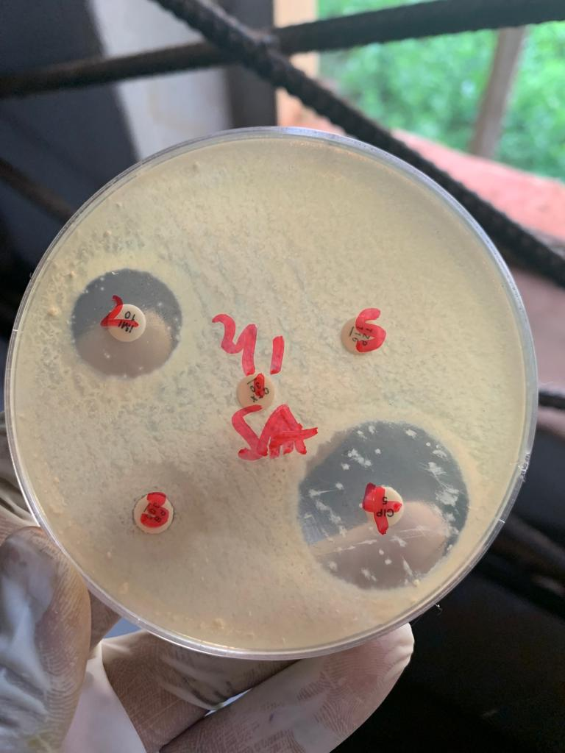
Figure 1: Agar plate showing the different inhibition zone diameter of the tested antibiotics on Salmonella species isolated from Pentaclethra macrophylla 1.

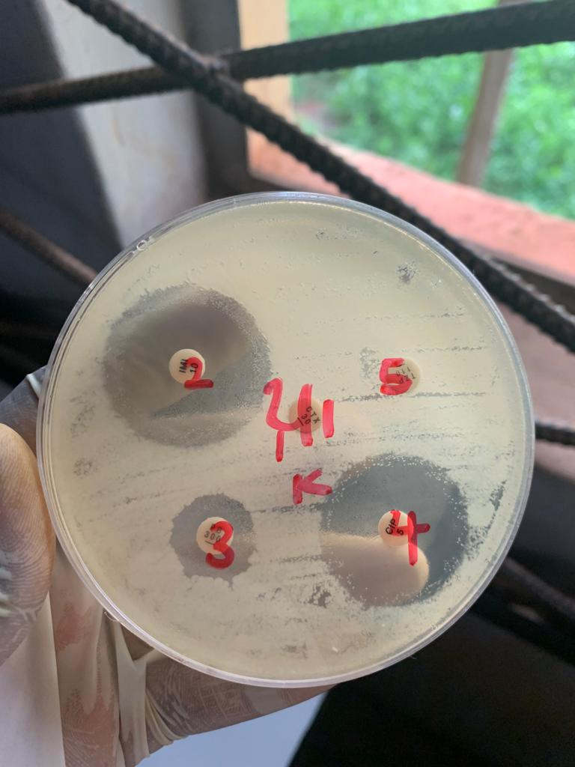
Figure 2: Agar plate showing the different inhibition zone diameter of the tested antibiotics on Klebsiella species isolated from Pentaclethra macrophylla 1.

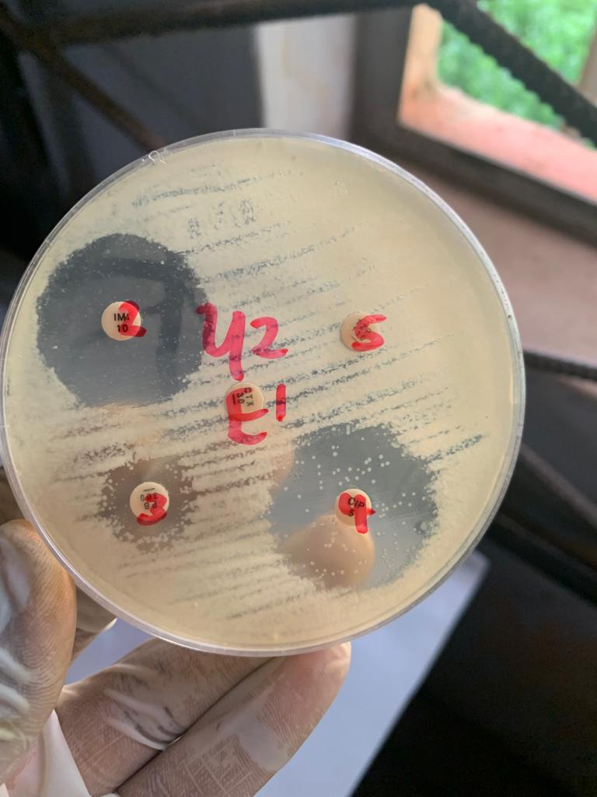
Figure 3: Agar plate showing the different inhibition zone diameter of the tested antibiotics on Escherichia coli isolated from Pentaclethra macrophylla 2 sample.

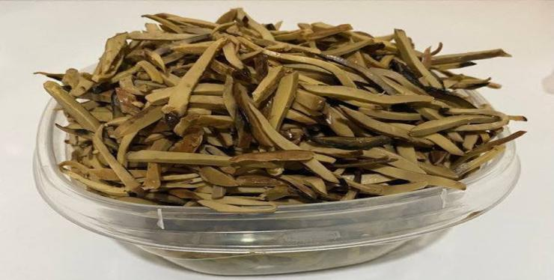

Figure 4: Ugba, a fermented product of Pentaclethra macrophylla.

4. DISCUSSION
The microbiological quality of Pentaclethra macrophylla (African oil bean) sold for public consumption within the Abakaliki metropolis was examined. A total of three samples were collected from three different vendors. At Presco Market, one of the samples (Pentaclethra macrophylla 1) showed a 100% occurrence of Salmonella spp. and Klebsiella spp., whereas another sample (Pentaclethra macrophylla 2 and 3) demonstrated the presence of Escherichia coli. The detection of diverse bacterial populations was considered indicative of poor hygienic practices during production and handling. Furthermore, the presence of enteric bacteria such as E. coli, Klebsiella, and Salmonella spp. suggests possible contamination from fecal sources. Since many of the isolated organisms are well-documented causative agents of foodborne illnesses, their presence represents a significant potential health risk to consumers. The bacterial species identified from the locally processed African oil bean seeds were comparable to those reported in previous studies [12]. Similar investigations on the safety of traditionally fermented Nigerian foods have indicated the presence of pathogenic microorganisms of public health importance, including Staphylococcus aureus, Klebsiella spp., Escherichia coli, Bacillus subtilis, Salmonella spp., and Enterococcus faecalis. These findings emphasize the necessity for stringent food safety measures, particularly through the application of reliable pathogen detection and monitoring techniques, to assess and minimize risks associated with the consumption of such foods.

The total bacterial count of PM 1, PM 2 and PM 3 were 12 x 10⁴ cfu/ml, 54 ×10³ cfu/ml, 67 X 10³ cfu/ml respectively. The result showed that Pentaclethra macrophylla 1 from a separate vendor has the highest microbial load 12 x 10⁴ cfu/ml, while Pentaclethra macrophylla 2 from another vendor has the lowest microbial load. The presence of some food pathogens have been reported in locally produced african oil bean seed and it has included Escherichia coli and species of Staphylococcus, Klebsiella and Proteus [8,13,14,15]. Food pathogens such as Clostridum perfringens, Clostridium botulinum, Shigella specie and Vibrio specie were not isolated in this study. This concurs with previous studies by [16,17]. However, three genera of bacteria like Escherichia coli, Salmonella species and Klebsiella species were isolated. These are bacteria capable of causing food-borne infections. This is risky, since no heating process is involved in the preparation of ugba from processed Pentaclethra macrophylla, thus, ruling out the possible eliminating of these bacteria during preparation. Nevertheless, its processing from oil bean seeds and/or its addition as condiment to soup involves heating, which could eliminate these pathogens.

Microbial load of food is affected by many factors such as method of production, level of sanitation of producers and their environment, handling by both primary and secondary sellers, etc. Severally the Pentaclethra macrophylla samples from the second vendor (Pentaclethra macrophylla 2) at Presco market had lower microbial load than those from another vended market (Pentaclethra macrophylla 1) at Presco junction. This was attributed to the fact that the Pentaclethra macrophylla 2 seller at Presco market was mainly a primary seller whereas the other first vendor in the other market is either a secondary or tertiary sellers involved in the case whereby the Pentaclethra macrophylla must have been opened severally during repackaging thus making room for microbial invasion by chance inoculation.

From antibiotic susceptibility test, it was observed that imipenem and ciprofloxacin were the most effective antibiotics against the isolates (Salmonella spp, Escherichia coli and Klebsiella spp) that were examined. However, the isolates demonstrated a significant level of resistance to the antibiotics, Tazobactam/Piperacillin and Cefotaxime antibiotics. The no inhibition observed for Piperacillin–Tazobactam in this study for all the isolates tested indicated resistance. This is in agreement with reports that Enterobacterales isolated especially from environmental and food-related sources, frequently harbor extended-spectrum β-lactamases (ESBLs) and other resistance mechanisms that compromise β-lactam/β-lactamase inhibitor combinations [18]. Resistance to TZP suggests possible plasmid-mediated mechanisms, such as TEM, SHV, or CTX-M enzymes, which are increasingly prevalent in Enterobacteriaceae across Africa [19]. Also, cefotaxime resistance observed suggests ESBL production which hydrolyzes third-generation cephalosporins [20]. Resistance to cefotaxime is of major concern, as cephalosporins are widely used in both human and veterinary medicine in Nigeria contributing to selection pressure and spread of resistance.
All the isolates tested were susceptible to ciprofloxacin. This showed that ciprofloxacin remains effective against these organisms. Given the rising fluoroquinolone resistance among Gram negative isolates in clinical and foodborne settings [21]. These findings are encouraging as it suggest that the isolates have not yet acquired common resistance mechanisms such as mutations in gyrA and parC, or plasmid-mediated quinolone resistance genes (qnr, aac(6’)-Ib-cr). Moreover, the isolates were susceptible to imipenem. Carbapenems remain among the most reliable agents against multidrug-resistant Enterobacteriaceae. This finding is significant because carbapenem-resistant Enterobacterales (CRE) are increasingly reported globally, including in Africa [22]. The absence of carbapenem resistance in these isolates suggest that carbapenemase genes may not be present.

4. Conclusion

The bacterial isolates identified include Salmonella spp., Klebsiella spp., and Escherichia coli, suggesting that the consumption of Pentaclethra macrophylla prepared or sold under unhygienic conditions may pose significant risks of food poisoning and gastroenteritis. The proliferation and persistence of these organisms in Pentaclethra macrophylla highlight a major public health concern. To enhance the microbiological quality and extend the shelf life of this fermented product, adherence to proper hygienic practices, the use of sterile water, and maintenance of a clean processing environment are strongly recommended. Processors and vendors of Pentaclethra macrophylla should be educated on the importance of maintaining strict hygienic practices to minimize microbial contamination. Food safety regulations of fermented food products sold in open markets should be enforced by public health authorities. Future research should focus on molecular characterization of the bacterial isolates to understand their virulence factors, resistance genes, and potential health impacts. Also, investigations into novel shelf-life improvement methods such as the use of natural antimicrobials or controlled fermentation techniques could help extend the shelf life of P. macrophylla while maintaining its nutritional value. Policy development between researchers, public health agencies, and policymakers aimed at formulating guidelines for the safe processing, packaging, and distribution of P. macrophylla and related traditional foods should be implemented.

Competing interests

Authors have declared that no competing interest exist.

Disclaimer (Artificial intelligence)
Option 1:
Author(s) hereby declare that NO generative AI technologies such as Large Language Models (ChatGPT, COPILOT, etc.) and text-to-image generators have been used during the writing or editing of this manuscript.
Option 2:
Author(s) hereby declare that generative AI technologies such as Large Language Models, etc. have been used during the writing or editing of manuscripts. This explanation will include the name, version, model, and source of the generative AI technology and as well as all input prompts provided to the generative AI technology
Details of the AI usage are given below:
1.
2.
3.

References
1. Nwangaba, N. L., Ojimelukwe, P. C., & Ezeama, C. F. (2020). Effect of fermentation of African oil bean seeds (Pentaclethra macrophylla) using Bacillus subtilis as starter and Lactobacillus fermentum as adjunct on its physicochemical properties. International Journal of Food Science and Technology, 10(1), 7–22.
2. Ike, C. C., & Ike, E. P. C. (2016). Bacteriological quality of processed African oil bean (Pentaclethra macrophylla) seed ugba sold in Umulolo and Ihube communities in Okigwe, Imo state, Nigeria. International Journal of Scientific Engineering and Applied Science (IJSEAS), 2, 5.
3. Agbo, N. J. (2024). Comparative nutritional and mineral analysis of fermented Pentaclethra macrophylla (ukpaka), fermented Ricinus communis (ogiri), and fermented Prosopis africana seed (okpeye). FUDMA Journal of Sciences, 8(3), 344–347. https://doi.org/10.33003/fjs-2024-0803-2351
4. Kabuo, N. O. Uzuegbu, I. O, Ubbaonu, C. N & Onyeka, E. U. (2013). The microorganisms and compounds influencing the organoleptic properties of Pentaclethra macrophylla (Fermented Pentaclethra macrophylla benth seeds). African journal of Food science, 7(2), 25-30.
5. Enujiugha, V. N., & Akanbi, C.T. (2010). Quality evaluation of canned fermented oil bean seed slices during ambient storage. African Journal of Food Science, 2, 54-59.
6. Ogbuagu, M. N., Ubani, L. O., & Ezenobi, V. U. (2020). Effect of extent of fermentation on the amino acid composition of African oil bean (Pentaclethra macrophylla, benthan) seed. Journal of Chemical Society of Nigeria. Journal of Chemical Society of Nigeria, 43(3). https://journals.chemsociety.org.ng/index.php/jcsn/article/view/204
7. Steinkraus K. H (1938). Handbook of indigenous Fermented foods. New York, NY, Marcel Dekker 73.

8. Isu, N. R & Njoku, H. O. (1997). An evaluation of microflora association with fermented African oil bean (Pentaclethra macrophylla) seed during Pentaclethra macrophylla production. Plant foods for Human Nutrition. 51, 145 – 157.

9. Njoku, H. O. Ogbulie, J. N. & Nnubia, C. (1990). Microbiological study of the traditional processing of African oil bean (Pentaclethra macrophylla) for ugba production. Food microbial. 7, 13 – 26.
10. Itaman, V. O., & Nwachukwu, E. (2021). Microbial profile of fermented maize flour (Ogi) and African oil bean (Pentaclethra macrophylla) seeds. Journal of Advances in Microbiology, 21(8), 16–27. https://doi.org/10.9734/jamb/2021/v21i830373
11. Eluchie, C., Amandikwa, C., Alagbaoso, S., Odimegwu, E. N., & others. (2023). Microbiological quality of fermented African oil bean seed (Pantaclethra macrophylla) sold in Owerri metropolis. Proceedings Of The 47th Nifst Conference & Annual General Meeting 2023 “Ebeano”.
12. Olasupo, N. A, Smith, S. I, Akinsinde, K. A, (2002). Examination of microbial status of selected indigenous fermented foods in Nigeria. Journal Food Safety, 22, 85-93.

13. Anyanwu, N. C., Okonkwo, O. L., Iheanacho, C. N., & Ajide, B. (2016). Microbiological and nutritional qualities of fermented ugba (Pentaclethra macrophylla, Bentham) sold in Mbaise, Imo state, Nigeria. Annual Research Revised Biology, 9(4), 1-8.

14. Eze V. C, Onwuakor C. E, & Ukeka E. (2014). Proximate composition, biochemical and microbiological changes associated with fermenting African oil bean (Pentaclethra macrophylla Benth) seeds. American Journal of Microbiology, 2(5), 674-81.

15. Ogbulie, T. E, Nsufor, C. A, Nze, F. C, (2014). Bacteria species associated with ugba (Pentaclethra macrophylla Bentham) produced traditionally and in the laboratory and the effect of fermentation on product of oligosaccharide hydrolysis. Nigerian food journal, 32(2), 73-80.

16. Obeta, J. A. N. (1983). A note on the micro-organisms associated with fermentation of seeds of the African oil bean tree. Journal of Applied Bacteriology, 54,433.
17. Ogueke, C. C., & Aririatu, L.E. (2004). Microbial and organoleptic changes associated with Pentaclethra macrophylla stored at ambient temperature. Nigerian Food Journal, 22,133-140.

18. Okomo, U., Tetteh, J., Oyo-Ita, A., & Okebe, J. (2022). Extended-spectrum β-lactamase-producing Enterobacteriaceae in sub-Saharan Africa: Epidemiology and resistance mechanisms. Frontiers in Microbiology, 13, 876543. https://doi.org/10.3389/fmicb.2022.876543

19. Irek, E. O., Amadi, E. S., & Ugwu, M. C. (2020). Prevalence and molecular characterization of extended-spectrum β-lactamase-producing Enterobacteriaceae in Nigeria: A systematic review. Journal of Global Antimicrobial Resistance, 22, 124–133. https://doi.org/10.1016/j.jgar.2020.02.012

20. Kassim, A., Omuse, G., Premji, Z., & Revathi, G. (2020). Comparison of clinical laboratory standards institute and European committee on antimicrobial susceptibility testing guidelines for the interpretation of antibiotic susceptibility at a university teaching hospital in Nairobi, Kenya: A cross-sectional study. Annals of Clinical Microbiology and Antimicrobials, 19(1), 5. https://doi.org/10.1186/s12941-020-0349-2

21. Akinlabi, O. C., Dada-Adegbola, H. O., & Odetoyin, B. W. (2021). Fluoroquinolone resistance mechanisms in Escherichia coli from clinical and environmental sources in Nigeria. African Journal of Infectious Diseases, 15(1), 1–10. https://doi.org/10.21010/ajid.v15i1.1

22. Faleye, T. O. C., Akinyemi, K. O., Dada-Adegbola, H. O., & Odetoyin, B. W. (2021). Carbapenem resistance among Enterobacteriaceae in Nigeria: Current status and emerging threats. African Journal of Clinical and Experimental Microbiology, 22(1), 1–12. https://doi.org/10.4314/ajcem.v22i1.1

