COMPARATIVE STUDY OF THE NUTRIENTS, ANTI-NUTRIENTS AND PHYTOCHEMICAL PROPERTIES OF TWO VARIETIES OF OKRA (Abelmoschus esculentus) CONSUMED IN SOUTHWEST OF NIGERIA

ABSTRACT
Okra (Abelmoschus esculentus) is a widely consumed vegetable in Nigeria that is prized for its excellent nutritional value. This study presents a comparative analysis of the nutritional, anti-nutritional, and phytochemical properties of long and short varieties of okra commonly consumed in southwestern Nigeria. Proximate composition was determined using standard AOAC methods. Calcium, iron, potassium, zinc, phosphorus, sodium, magnesium, manganese, copper and cobalt composition were quantified by Atomic Absorption Spectrophotometry. Fatty acid composition was analyzed by gas chromatography. Standard laboratory procedures were used to quantify phytochemicals and antinutrients. DPPH radical scavenging activity was assessed using the 2, 2-diphenyl-1-picrylhydrazyl (DPPH) radical scavenging assay, and ascorbic acid content was measured using a modified spectrophotometric method based on reduction of 2, 6-dichlorophenolindophenol (DCPIP). The short variety showed higher (p<0.05) moisture (11.20%), protein (17.10%), fat (1.70%), total ash (5.5%) and carbohydrate (63.20%) contents, while the long variety had higher (p<0.05) fibre (24.70%) contents. Mineral analysis indicated higher (p<0.05) levels of calcium, potassium, zinc, sodium and phosphorus in the short variety, whereas the long variety was slightly richer in iron and cobalt. Phytochemical screening revealed that the long variety contained higher (p<0.05) levels of saponins, flavonoids, alkaloids, terpenoids, and phenols, while the short variety had higher (p<0.05) cardiac glycoside content. Fatty acid composition varied slightly between the two, with linoleic and oleic acids being predominant in both. Anti-nutrient studies showed higher (p<0.05) oxalate content in the long variety, whereas the short variety had higher (p<0.05) levels of tannins and phytates. Additionally, the long variety exhibited greater (p<0.05) DPPH radical scavenging activity (85.43%) and higher (p<0.05) ascorbic acid content (0.09 g/100g) compared to the short variety (78.86% and 0.04 g/100g, respectively). The findings highlight distinct variations in the nutritional and phytochemical compositions of both okra varieties, particularly, in optimizing the selection of okra varieties for specific nutritional benefits or for targeted dietary interventions.
Keywords: Abelmoschus esculentus; Antinutrients; Phytochemicals; Malvaceae; Nutritional composition; Southwestern Nigeria

INTRODUCTION
Okra (Abelmoschus esculentus), a member of the Malvaceae family, is a globally significant vegetable crop, particularly in tropical and subtropical regions, valued for its nutritional and economic benefits. Beyond its immature pods, which are consumed as a vegetable, okra’s mature pods serve as animal fodder or a source of mucilage, while its seeds yield oil or a coffee substitute powder (Sha’a et al., 2019). Known as “lady’s finger” in England, “gumbo” in the United States, and by local names like “Ila” (Yoruba), “Kubewe” (Hausa), and “Okwale” (Igbo) in Nigeria, okra is a staple crop (Adamma et al., 2014).
In Nigeria, okra pods are boiled, eaten raw, or used as a thickening agent in soups, contributing vitamins, minerals, calories, and essential amino acids comparable to poultry eggs and soybeans. Its prominence in Nigerian cuisine makes it relatively expensive in local markets (Raimi et al., 2014). Okra’s versatility extends to its leaves, buds, flowers, stems, and seeds, which are used in salads, soups, stews, and industrial applications like confectionery (Hussein et al., 2018). This study evaluates the nutritional, anti-nutritional, and phytochemical differences between long and short okra varieties to inform dietary choices and further research .
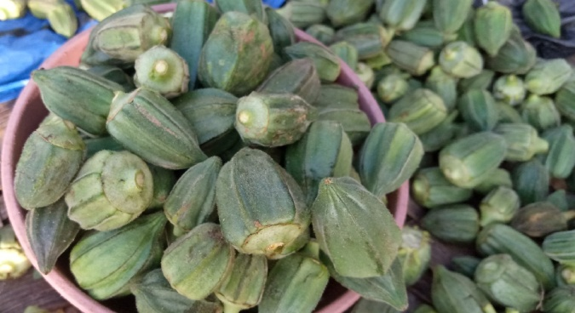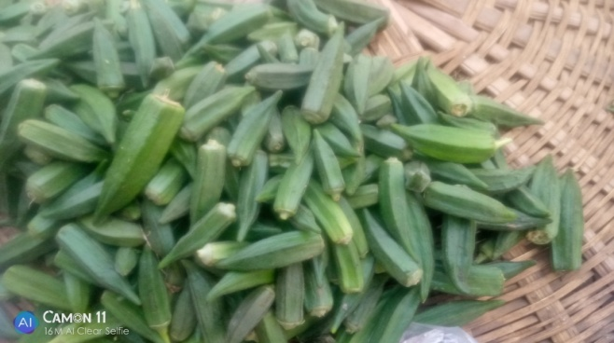
Plate 1Photograph of Short Okra Plate 2: Photograph of Long Okra
pods eaten in Southwestern Nigeria pods eaten in Southwestern Nigeria
taken from Okun-Owa, Ogun State taken from Okun-Owa, Ogun State

MATERIALS AND METHODS
Plant Materials
Fresh pods of two okra varieties; long (LV) and short (SV) were collected from a local farm in Okun-Owa, Ogun State, South-West Nigeria (6.85492⁰ N, 3.81408⁰ E) in Febuary 2021. Pods were selected at the immature stage, pods were washed, sliced into pieces, oven-dried at 50°C for 24 hrs, ground into fine powder, and stored in sterile flasks at 4⁰C for analysis.
Analytical Procedures
Proximate Analysis
Moisture, ash, crude fiber, and fat contents were determined using (AOAC, 2023) methods. Crude protein was quantified via the Kjeldahl method, with nitrogen converted to protein using a factor of 6.25. Carbohydrates were calculated by difference:
Carbohydrate (%) = 100 – (Moisture + Ash + Crude Fiber + Crude Fat + Protein).
Metabolizable energy was estimated using Atwater factors: 4 kcal/g (protein and carbohydrates), 9 kcal/g (fat).
Mineral Analysis
Triplicate 0.5 g samples were digested with 10 mL nitric acid (HNO₃) overnight, heated until nitrogen dioxide fumes ceased, cooled, and treated with 2.5 mL 70% perchloric acid until colorless. Digests were diluted to 50 mL with distilled water and analyzed for minerals using an Atomic Absorption Spectrophotometer (ALPHA 4, Fisons Chem-Tech, UK).
Tannin Content
A 0.2 g sample was extracted with 10 mL 70% acetone, cooled, shaken for 12–15 minutes, and filtered. From the supernatant, 0.5 mL was mixed with 0.5 mL distilled water, 0.5 mL Folin’s reagent, and 2.5 mL 20% sodium carbonate, vortexed, incubated for 40 minutes, and absorbance measured at 725 nm using tannic acid standards (0.01–1.0 mg/mL).
Phytate Content
A 4 g sample was soaked in 100 mL 2% hydrochloric acid for 3 hours, filtered, and 25 mL of filtrate mixed with 5 mL 0.3% ammonium thiocyanate and 53.5 mL distilled water. The mixture was titrated with iron (III) chloride until a brownish-yellow color persisted. Phytate was calculated as:
%Phytic Acid = (8.24 × titre value × 100) / (1000 × sample weight) (AOAC, 2023).
Oxalate Content
A 1 g sample was stirred in 75 mL 1.5N sulfuric acid for 1 hour, filtered, and 25 mL of filtrate titrated hot with 0.1N potassium permanganate until a faint pink endpoint. Oxalate was calculated as:
Oxalate (mg/g) = titre value × 0.9004.
Saponin Content
A 20 g sample was extracted with 100 mL 20% ethanol at 55°C for 4 hours, filtered, and re-extracted with 200 mL 20% ethanol. The combined extract was concentrated to 40 mL, purified with diethyl ether and n-butanol, washed with 5% sodium chloride, and dried. Saponin content was calculated as:
%Saponin = (Final extract weight / Initial sample weight) × 100
Total Phenolic Compounds
A 5 g sample was boiled with 50 mL ether for 15 minutes. From the extract, 5 mL was mixed with 10 mL distilled water, 2 mL ammonium hydroxide, and 5 mL amyl alcohol, diluted, and absorbance measured at 505 nm after 30 minutes. Phenolics were calculated as:
%Phenolic Compounds = A_{blank}- A_{sample} × 100.
A_{blank}
Flavonoids
A 10 g sample was extracted with 100 mL 80% methanol, filtered, and evaporated to dryness. Flavonoid content was calculated as:
%Flavonoids = (Residue weight / Sample weight) × 100
Alkaloids
A 5 g sample was extracted with 200 mL 10% acetic acid in ethanol for 4 hours, filtered, and concentrated to 50 mL. Alkaloids were precipitated with ammonium hydroxide, filtered, washed, dried, and calculated as:
%Alkaloids = (Alkaloid weight / Sample weight) × 100
Cardiac Glycosides
A 1 mL diluted sample was mixed with 10 mL Baljet’s reagent (95 mL 1% picric acid, 5 mL 10% NaOH), incubated for 1 hour, diluted with 20 mL water, and absorbance measured at 495 nm. Glycosides were calculated as:
%Cardiac Glycosides = A_{blank}-A_{sample} × 100
A_{blank}
Fatty Acid Analysis
Fatty acids were extracted from 150 mg samples using 5 mL n-hexane, transesterified with 0.5 M sodium methoxide in methanol, and separated with 7 mL water. The organic layer was analyzed via gas chromatography (Hewlett-Packard 5890 Series II, FID) using an HP-6890 autosampler and FAME standard mix RM-3 (Sigma-Aldrich) for peak identification.
Ascorbic Acid Determination
The ascorbic acid content of the okra samples was determined using a modified spectrophotometric method based on the reduction of 2, 6-dichlorophenolindophenol (DCPIP) (AOAC, 2023). Okra samples (Long and Short varieties) were prepared by homogenizing the edible portions. A known weight of the homogenized sample was mixed with a suitable volume of metaphosphoric acid solution to extract ascorbic acid and prevent its oxidation. The extract was then titrated against a standardized solution of 2, 6-dichlorophenolindophenol (DCPIP) until a faint pink color persisted for at least 30 seconds. The volume of DCPIP consumed was recorded. A standard curve was prepared using known concentrations of L-ascorbic acid and titrating them with the same DCPIP solution. This allowed for the quantification of ascorbic acid in the samples
DPPH Radical Scavenging Activity Assay
The antioxidant activity of the okra samples was determined using the 2, 2-diphenyl-1-picrylhydrazyl (DPPH) radical scavenging assay, following a modified version of the method described by Patel et al., (2023). The two varieties of okra (long and short) were washed, and the edible portions were homogenized to a fine paste with a blender. For each variety, 10.0g of paste was transferred into an amber bottle and extracted with100 mL methanol (1:10 w/v) by maceration for 24 hrs at room temperature on an orbital shaker (150 rpm). The mixture was filtered with Whatman N0. 1. The residue was re-extracted with 50 mL methanol for 2 hrs and refiltered. The filtrate was pooled and concentrated under reduced pressure on a rotary evaporator at 40ºC. A 0.1 mM solution of DPPH in methanol was prepared. For the assay, 1 mL of the okra extract was mixed with 3 mL of the DPPH solution. The mixture was shaken vigorously and left to stand in the dark at room temperature for 30 minutes. The absorbance of the resulting solution was measured at 517 nm using a UV-Vis spectrophotometer. A control sample, containing 1 mL of methanol instead of the extract, was also measured. The percentage of DPPH radical scavenging activity was calculated using the following formula:
% Scavenging Activity = [(A_control - A_sample) / A_control] x 100
Where: A_control is the absorbance of the control sample.
A_sample is the absorbance of the sample with the okra extract.
Statistical Analysis
All experiments were performed in triplicate, and the results were expressed as mean ± standard deviation. Differences between long and short varieties were analyzed using a two-tailed student’s t-test (p<0.05) with GraphPad Prism (version 9.0). Data visualization was performed using bar charts to compare the results of the two okra varieties.

RESULTS
Table 1: Proximate Composition of long (LV) and short (SV) Okra varieties
Parameter | Long variety (LV) | Short variety (SV) | P-value
Moisture (%) | 6.79 ± 0.10 | 11.20 ± 0.15 | <0.01
Protein (%) | 11.17 ± 0.18 | 17.10 ± 0.20 | <0.01
Fat (%) | 0.64 ± 0.05 | 1.70 ± 0.08 | <0.01
Ash (%) | 3.56 ± 0.12 | 5.52 ± 0.15 | <0.01
Crude Fibre (%) | 24.70 ± 0.35 | 22.43 ± 0.30 | <0.05
Carbohydrate (%) | 62.12 ± 0.22 | 63.20 ± 0.25 | <0.05
Metabolizable Energy (kcal/100g) | 301 ± 2 | 338 ± 2.5 | <0.01
Data represent mean ± SD of triplicate analyses. Statistical significance was determined using a two-tailed Student’s t-test.
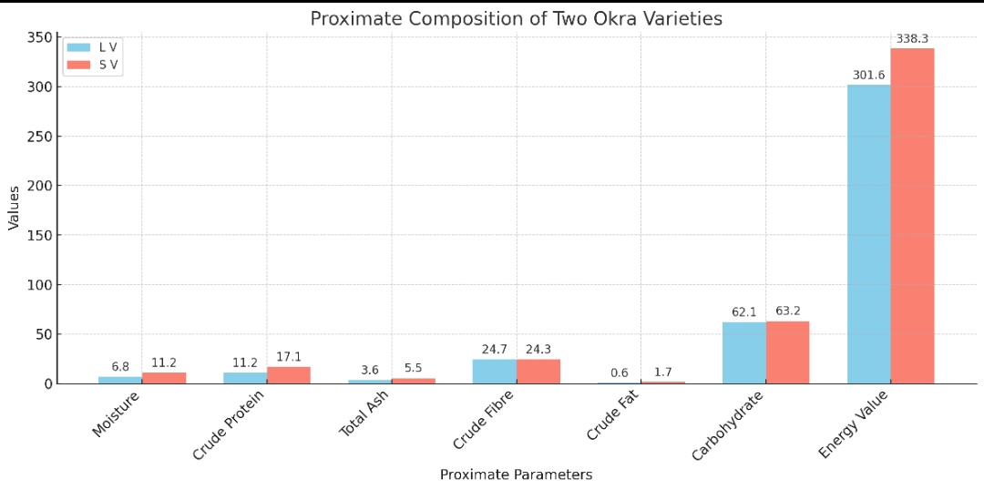
Fig 1: Proximate analysis of long and short okra variety
Table 2: Mineral composition of short and long okra variety (mg/100g)
Minerals | Short variety (SV) | long variety (LV) | P-value
Ca | 142.4 ± 0.5 | 102.6 ± 2.3 | <0.05
Fe | 22.6 ± 0.4 | 23.2 ± 0.2 | >0.05
K | 279.2 ± 8.8 | 180.9 ± 0.4 | <0.05
Zn | 5.71 ±2.2 | 4.5 ± 0.4 | >0.05
P | 53.5 ± 0.5 | 41.4 ±0.6 | <0.05
Na | 5.47 ± 0.1 | 5.02 ± 2.9 | >0.05
Mg | 42.2 ± 0.3 | 39.2 ± 0.3 | <0.05
Mn | 0.69 ± 0.03 | 0.2 ± 0.01 | <0.05
Cu | 0.72 ± 0.04 | 0.7 ± 0.6 | <0.05
Co | 0.02 ± 0.01 | 0.01 ± 0.008 | >0.05
Data represent mean ± SD of triplicate analyses. Statistical significance was determined using a two-tailed Student’s t-test

Fig 2: Mineral analysis of long and short okra

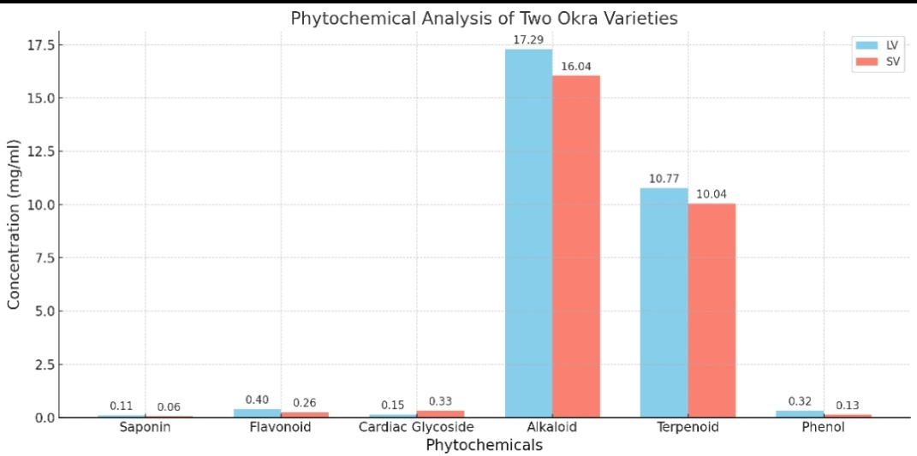
Fig 3: Phytochemical Analysis of Two Okra Varieties

Table 3: Anti-nutrient composition of short and long okra variety (mg/100g)
Antinutrients | Short variety | long variety | P-value
Tannin | 0.24 ± 0.02 | 0.14 ± 0.01 | <0.05
Phytate | 0.56 ± 0.003 | 0.37 ± 0.06 | <0.05
Oxalate | 4.69 ± 0.01 | 11.51 ± 0.01 | <0.05
Data represent mean ± SD of triplicate analyses. Statistical significance was determined using a two-tailed Student’s t-test

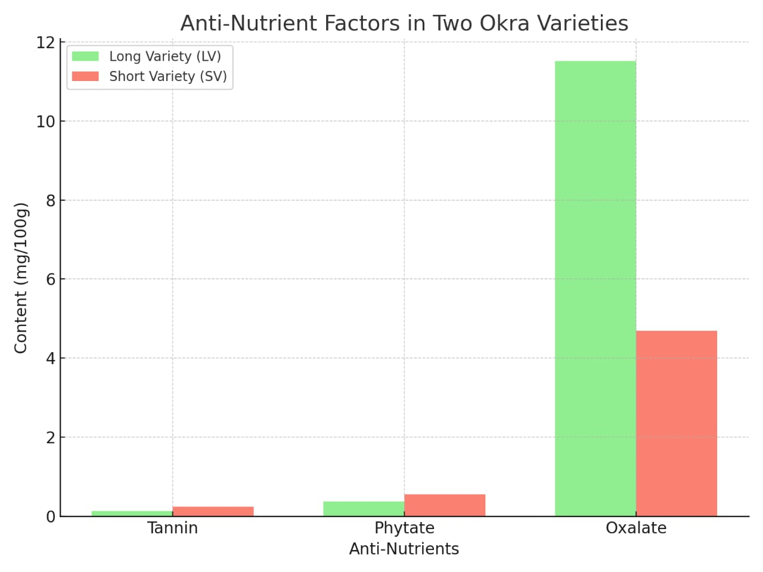
Fig 4: Anti-Nutrient factors in two okra variety
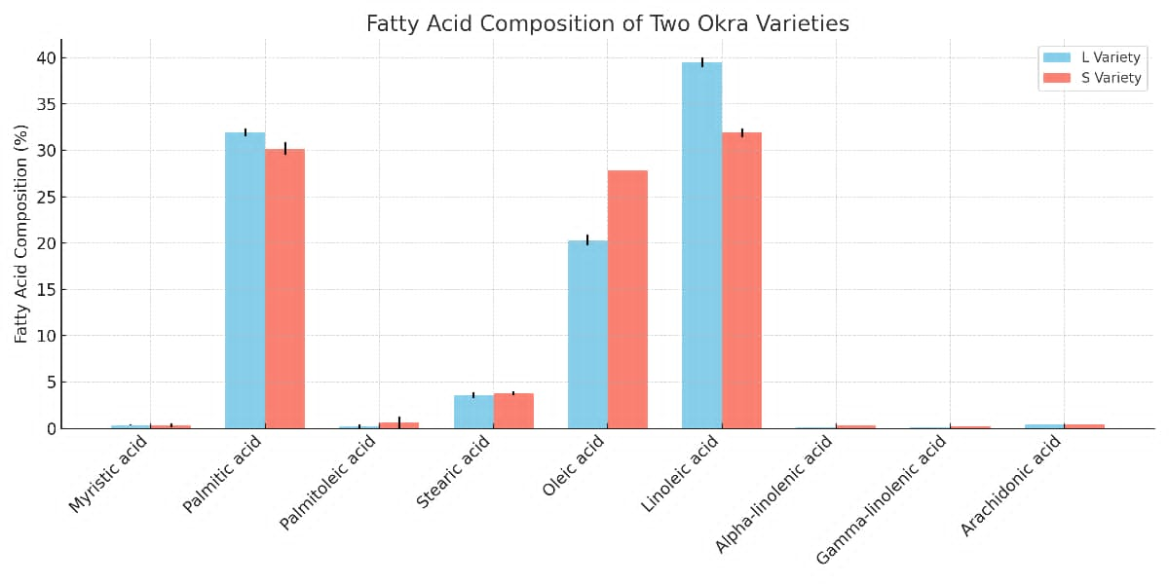
Fig 5: Fatty Acid composition of two okra variety
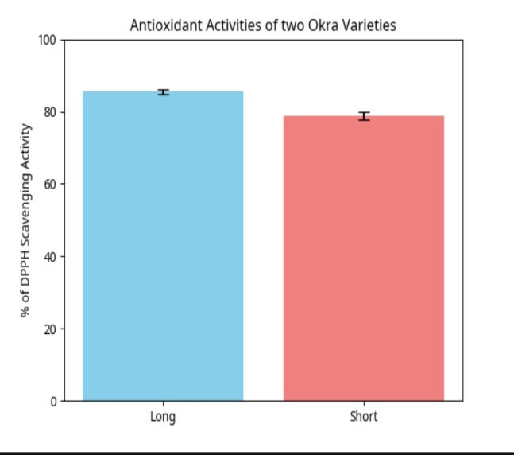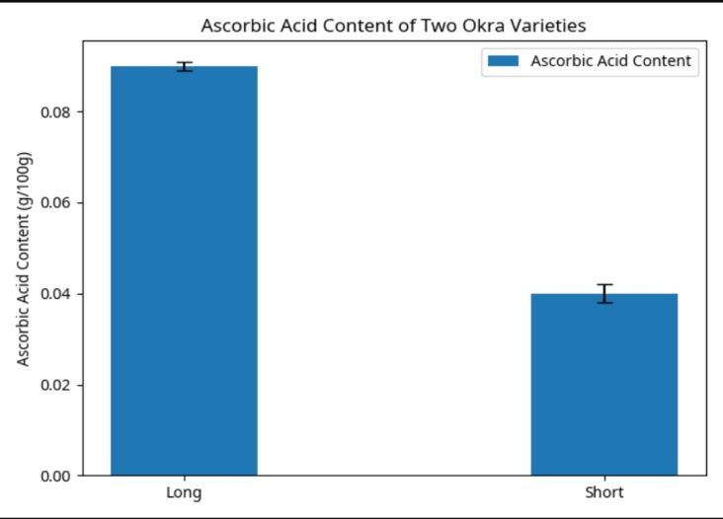
Fig 6: DPPH radical scavenging activity of Fig 7: Ascorbic acid content of two okra variety two okra variety

Discussion
Proximate composition of long and short okra varieties (Figure 1) showed that short variety (SV) exhibited significantly (p<0.05) higher moisture (11.20% ± 0.15 vs. 6.79% ±0.10), protein (17.10% ± 0.20 vs. 11.17% ± 0.18), fat (1.70% ± 0.08 vs. 0.64 ± 0.05%), ash (5.52 ± 0.15% vs. 3.56% ± 0.12) and carbohydrate (63.20% ± 0.25 vs. 62.12% ± 0.22) contents compared to the long variety (LV), while long variety had higher (p<0.05) crude fiber content (24.70% ± 0.35 vs. 22.43% ± 0.30). The metabolizable energy was higher (p<0.05) in short variety (338 ± 2 kcal/100g) compared to long variety (301 ± 2 kcal/100g). High moisture in SV suggests a shorter shelf life due to microbial susceptibility. SV’s elevated protein content (~44% higher than LV) positions it as a valuable protein source. Higher ash in SV indicates greater mineral content, supporting metabolic functions. Both varieties are rich in fiber, promoting digestive health (Anderson et al., 2009). SV’s higher fat content aids fat-soluble vitamin absorption and its metabolizable energy value reflecting its higher nutrient density. These findings align with previous studies reporting variability in okra proximate composition due to varietal differences.
The mineral content revealed that short variety contained more major macrominerals and trace elements like calcium, potassium, zinc, phosphorus, sodium, magnesium, manganese, copper, and cobalt than long Variety, except for iron, which was slightly richer in long variety. This result is in agreement with Gemede et al. (2021), which noted that mineral content of okra pods was extremely variable in terms of genotype, agroecological site, and post-harvesting treatment. Ijarotimi et al. (2022) indicated extreme variation of mineral content among okra accessions, particularly calcium and potassium levels ranging from 111–312 mg/100 g and 123–318 mg/100 g respectively, depending on varieties and conditions.
These minerals play essential physiological roles. Calcium, for instance, plays a crucial role in bone structure and enzyme activity, magnesium is part of the metabolism of ATP, and potassium is necessary for osmotic balance as well as nerve function (FAO, 2020). Thus, the higher mineral composition observed in short variety would enhance its nutritional appeal, especially among populations prone to micronutrient deficiencies.
Anti-nutrient analysis indicated lower tannins, phytates, and oxalates in long variety compared to short variety. These compounds, at observed levels (<1.0 mg/100g), pose minimal risk to mineral bioavailability, especially in a balanced diet or with processing like cooking.
Long variety of okra (Abelmoshus exculentus) in this study exhibited higher ascorbic acid (0.09 g/100g vs. 0.04 g/100g) and DPPH scavenging activity (85.43% vs. 78.86%), enhancing iron absorption and free radical scavenging. This suggests that the long variety may provide greater nutritional and health benefits, particularly in combating oxidative stress-related disorders (Akinmoladun et al., 2019). Such antioxidant potential further supports its dietary importance and aligns with previous findings that highlight the role of vitamin C-rich vegetables in improving overall health status (Oluwafemi and Debiri, 2020).
Fatty acid profiles showed long variety with higher linoleic (39.5%) and palmitic (32%) acids, while short variety was richer in oleic (~28%) and linolenic acids (31.9%). Unsaturated fatty acids like oleic and linoleic support cardiovascular health, with short variety’s profile favoring oil stability and long variety’s suitable for commercial applications.
Conclusion
The long variety of okra (Abelmoshus exculentus) in this study excels in ascorbic acid, antioxidant activity, and linoleic acid, ideal for functional foods, while the short variety offers superior mineral content, oleic acid, and carbohydrate composition enhancing dietary micronutrient intake and oil stability. Both varieties’ moderate anti-nutrient levels support their dietary inclusion. These findings underscore the importance of varietal selection in okra breeding for nutritional and industrial purposes.
Limitation of the study: The okra samples (short and long variety) were obtained from a location; Okun-Owa (one of the major okra farms in southwest Nigeria) within a geographical of southwest Nigeria; therefore, the results may not represent the full variability of okra varieties grown in other regions or under different agro-ecological conditions.

Disclaimer (Artificial intelligence)
Author(s) hereby declare that NO generative AI technologies such as Large Language Models (ChatGPT, COPILOT, etc.) and text-to-image generators have been used during the writing or editing of this manuscript.
References
AOAC. (2000). Official Methods of Analysis (17th ed.). Association of Official Analytical
Chemists. https://www.aoac.
AOAC. (2023). Official Methods of Analysis (22nd ed.). Association of Official Analytical
Chemists. https://www.aoac.
Durazzo, A., Lucarini, M., Souto, E. B., Cicala, C., Caiazzo, E., Izzo, A. A.,. & Santini, A. (2021).
Polyphenols: A concise overview of the chemistry, distribution, and human health. Phytotherapy Research, 35(9), 5223–5238. https://doi.org/10.1002/ptr.7229
FAO. (2020). Human vitamin and mineral requirements. Food and Agriculture Organization of
the United Nations. https://www.fao.org/documents/card/en/c/ca9692en/
Kumar, D. S., Tony, D. E., Kumar, A. P., Kumar, A. K., Rao, D. B. S., & Nadendla, R. (2020). A review on
Abelmoschus esculentus (Okra). International Journal of Current Pharmaceutical Research, 12(4), 10–15. https://doi.org/10.22159/ijcpr.2020v12i4.39043
Patel, K., Gupta, S., & Singh, A. (2023). Okra (Abelmoschus esculentus) antioxidant and anti-
inflammatory activities in functional food uses. Journal of Functional Foods, 108, 105736. https://doi.org/10.1016/j.jff.2023.105736
Adamma, E. P., Sani, S. M., Israel, O. K., & Yusuf, Z. S. (2014). Proximate and anti-nutritional constituents of Abelmoschus esculentus grown in Fadaman Kubanni, Zaria, Kaduna State, Nigeria. J. Sci. Res. Rep, 3, 2015-2027.
Raimi, M. M., Oyekanmi, A. M., & Farombi, A. G. (2014). Proximate and phytochemical composition of leaves of Ceiba pentandra, Manihot esculentus and Abelmoschus esculentus in Southwestern Nigeria. Sci Res J, 2, 30-34.
Hussein, J. B., Ilesanmi, J. O. Y., Filli, K. B., & Sanusi, M. S. (2018). Effects of drying methods on the chemical properties of okra (Abelmoschus esculentus L. Moench) slices. Current Journal of Applied Science and Technology, 26(6), 1-10.
Sha’a, K. K., Clarkson, G. P., & Artimas, S. P. (2019). Phytochemical analysis, proximate composition and antinutritional factors of Corchorus oliterius plant. International Journal of Biological and Chemical Sciences, 13(4), 2147-2157.

