Optimization of Black Plum (Vitex doniana) Foam Mat Drying for Improved Micronutrient Retention

ABSTRACT
Black plum (Vitex doniana) is a sweet, edible perennial shrub widely distributed in tropical West Africa. The fruit is green when matured and changes to dark brown when fully ripened. They are known as a good source of phytochemicals and micronutrients. Foam mat drying is a technique whereby foam is incorporated into food material by addition of an edible foaming agent before subjecting it to drying. Foam formation increases the surface area of product which in turn increases the overall heat and mass transfer, thus reducing the drying time, minimize loss of nutrients. Optimization of foam mat drying of black plum pulp to powder using response surface methodology for micronutrients determination was studied. The fruits were thoroughly washed with distilled water and sorted to remove bad ones. The edible portions of the plum were removed with a clean kitchen knife and the pulp collected was subjected to foaming process using glycerol monostearate (5 to 15%) as foaming agents, carboxymethyl cellulose (3 to 5%) as foam stabilizer and the foamed samples subjected to drying at temperature range of 50ºC to 70ºC till moisture content of less than 10% was achieved. The samples were analyzed for minerals and vitamins using standard analytical procedure. Vitamin A content recorded was in the range of 401.11 to 727.03 mcg RAE, vitamin C 10.56 to 14.06 mg/100g, vitamin E 4.58 to 6.14 mg/100g, vitamin B1 0.29 to 0.72 mg/100g, vitamin B2 0.27 to 0.92 mg/100g, vitamin B6 1.27 to 2.33 mg/100g, calcium 298.77 to 349.87 mg/100g, iron 6.27 to 8.37 mg/100g, potassium 1695. 18 to 2126.74 mg/100g, magnesium 216.78 to 244.32 mg/100g, phosphorus 2.25 to 3.84 mg/100g, sodium 10.16 to 15.32 mg/100g, and zinc 18.03 to 25.88 mg/100g. All the micronutrients investigated varied significantly (P≤0.05) and samples with higher concentration of foaming agent recorded the highest values. The study shows that foam mat drying minimize the rate of loss of micronutrients during drying of the fruit powder and increase the scientific database of black plum fruit to be used as organic antioxidant agents in the management of several chronic diseases.
Keywords: black plum, foam mat drying, foaming agent, micronutrients

1.0 INTRODUCTION
Black plum (Vitex doniana) is a sweet, edible perennial shrub widely distributed in tropical West Africa, the fruit is green when matured and changes to dark brown when fully ripened (Adejumo et al., 2013). The fruit is known as “Uchakiri” in Eastern part of Nigeria, Ori-nla in Western part of Nigeria and Dinyar in Hausa speaking area of Northern Nigeria (Amah and Okogeri., 2019). In Nigeria, various parts of the plant are used by traditional medicine practitioners in the management and treatment of several disorders which include cancer, hypertension, rheumatism, and other inflammatory diseases (Dadjo et al., 2012). Black plum fruit is usually eaten as snack either as fresh or processed into compotes, jams, marmalades, prunes, juices or alcohol beverages and have a sweet prune-like taste with velvet-like texture (Uchenna and Otu, 2019). The fruits are good source of micronutrients including iron, calcium, phosphorus, magnesium, manganese, fluorine, sulfur, potassium, vitamins A, B1, B2, E and C as well as phytochemicals with good antioxidant capacity (Uchenna and Otu, 2019).
Black plum has the potentials to increase the levels of adiponectin (a hormone that plays vital role in regulating blood sugar) thereby helps in lowering blood sugar level (Hassan and Shamsudeen, 2019). Hassan and Shamsudeen (2019) reported that black plum syrup is like honey and the physicochemical and sensory results showed that it can be substituted for other syrups as a nutritive sweetener. Toktam et al. (2020) reported the uses of black plum tree stem bark extract for the control of hypertension and its anti-hepatotoxic effect as well as in the treatment of stomachache, pains, disorders, and indigestion. In Ghana it is used for treatment of colds and cough in children and its bark in the treatment of sterility. In Sierra Leone, black plum fruits are regarded as a remedy for A and B avitaminosis (Adejumo et al., 2013).
Drying is an important food processing operation that preserves raw food materials (Solchansani and Jayas, 2020). Drying process occurs when water vapor is removed from food materials surface into the surrounding space, resulting in a dried product with an extended shelf life and reduced water activity (Adeyeye et al., 2022). During drying processes, the moisture content can be reduced to a level ranging from 1 to 10%, and this prevent or slow down the activity of microorganism and undesirable enzymatic action that could lead to deterioration and eventual spoilage (Adeyeye et al., 2022). In addition to substantial reduction in weight and volume of the food product been dried, drying minimizes packaging requirements, storage and transportation costs of food product (Bag et al., 2011). As drying operation progresses, it creates a new microstructure, and the spatial distribution of the microstructure characteristics is important in texture perception of the resultant product (Bag et al., 2011). The most critical aspect in drying of food materials is to minimize the loss of its quality, keeping in view its nutritional, physical, chemical, microbial properties and sensory attributes (Figiel and Michalska, 2016).
Foam mat drying is a technique in which liquid or semisolid food materials are converted into foam by incorporating air into it through whipping with the addition of an edible foaming agent and stabilizing the emulsion with a foam stabilizer (Franco et al., 2016). The process is simple, economical and time efficient in comparison to other drying processes (Hardy and Jideani, 2017). Foam formation also increases the surface area which increases the overall mass transfer, thus reducing the drying time, minimizing nutritional loss and the organoleptic properties of the resultant food product as well as a reduction in energy need of the entire drying process is achieved (Falade and Okocha, 2010). Shaari et al. (2018) reported a high mineral content for foam mat dried papaya powder with a better reconstitution property than papaya dried using other drying methods. Hossain et al. (2021) also reported stability in the vitamin C content and antioxidant composition of foam mat dried mango powder.
Nutritional attributes of food are sometimes lost during the drying process. For instance, Hossain and Brunton (2010) reported a reduction in the antioxidant properties of vacuum oven-dried Lamiaceae herbs. To preserved antioxidant potentials and other nutritional properties of black plum fruit that might be lost during drying, a drying method with minimal loss to product and cost effective like foam mat drying method need to be adopted for the drying of the fruit. Hence, optimization of the foam mat drying parameters would preserve the rich antioxidant and nutritional status of the resultant black plum powder.
2.0 MATERIALS AND METHOD
Fresh black plum fruits were obtained from local farmers in Adu village, Ajaokuta Local government area, Kogi State, Nigeria. Glycerol monostearate (foaming agent) and carboxyl methyl cellulose (stabilizing agent) a product of Sim Company, Pulau Pinnang, Malaysia was sourced from Mekang Chemicals vendor, Ojota, Lagos State.
2.1 Sample preparation
Foam mat dried black plum powder was prepared according to the method described by (Hossain et al., 2021). Fresh black plum fruits were thoroughly washed with distilled water to remove foreign matters and subjected to sorting process to removed bad unripen ones. The edible portions of the plum were removed manually with a clean kitchen knife and the pulp collected was subjected to foaming process using glycerol monostearate as foaming agents and carboxymethyl cellulose as foam stabilizer at different concentrations as shown in Table 1. Two hundred grammes (200g) of the black plum pulp were mixed and whipped with the foaming and stabilizing using a kitchen mixer for 30 min. Thereafter, the foamed mixture was spread on an aluminum tray and placed in a cabinet dryer for the drying process at different temperature. Fig 1

Fresh black plum

Washing and Sorting

Peeling/Slicing/removal of seed

Pulp collection

Addition of foaming and stabilizing agent (5-15%, 3-5%)

Whipping/Induction of foam (30 min)

Spreading of foamed samples in trays

Drying (50⁰C-70⁰C)

Scrapping from trays

milling/Sieving (125µm)

Black plum powder
Fig 1: Flow chart to produce foam mat dried black plum powder.
Source: (Hossain et al., 2021).
Table 1. Experimental Design
 | Runs | Temperature (⁰C) | Foaming agent (%) | Stabilizing agent (%)
 | 1 | 70 | 15 | 4
 | 2 | 50 | 5 | 4
 | 3 | 60 | 5 | 5
 | 4 | 50 | 10 | 3
 | 5 | 50 | 15 | 4
 | 6 | 70 | 10 | 3
 | 7 | 60 | 15 | 5
 | 8 | 50 | 10 | 5
 | 9 | 70 | 10 | 5
 | 10 | 60 | 15 | 3
 | 11 | 70 | 5 | 4
 | 12 | 60 | 5 | 3
 | Control | 90 | 0 | 0

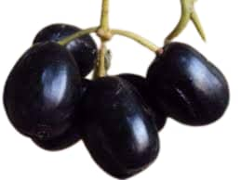
Plate 1. Fresh black plum
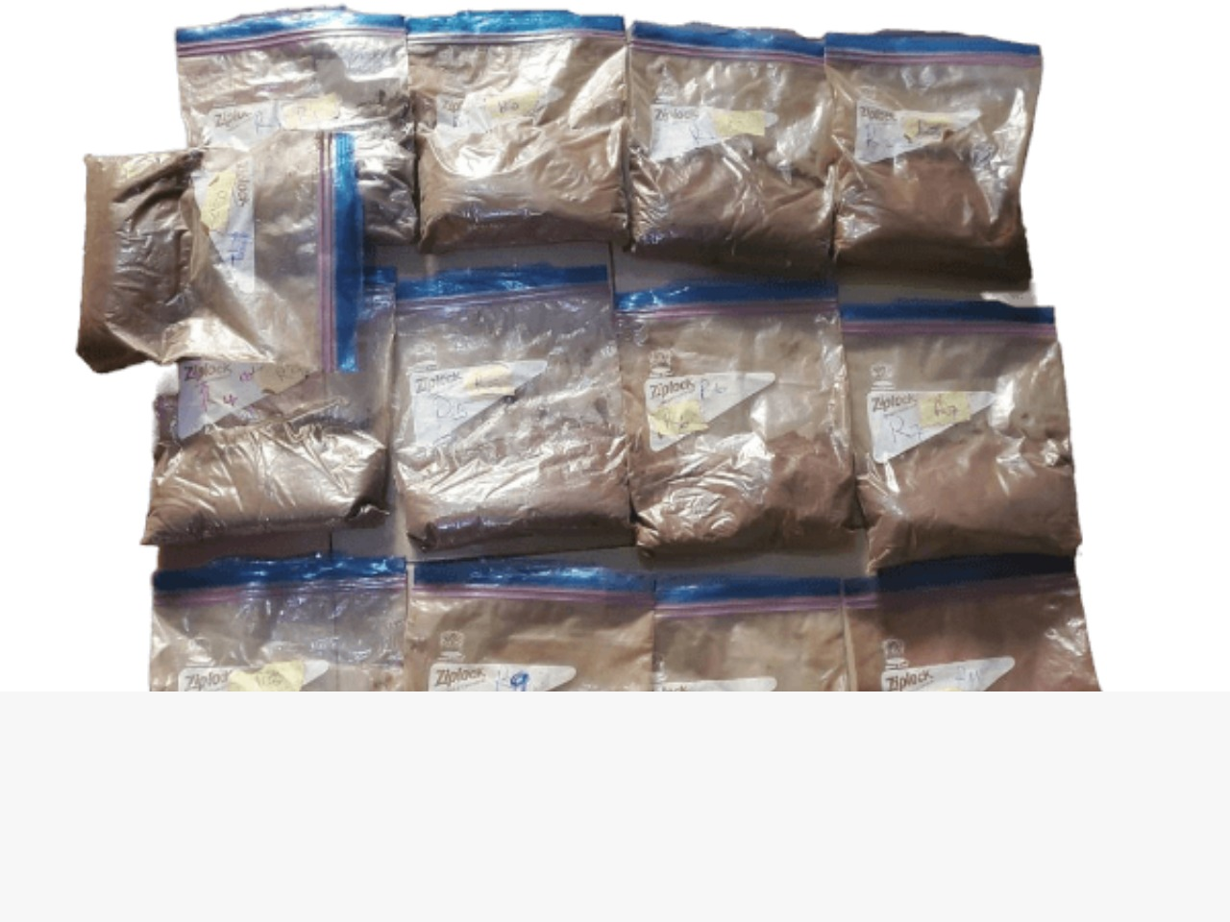
Plate 2. Foam mat dried black plum powder

2.2 Sample analysis
2.2.1 Determination of minerals content
Mineral content of the samples was determined using AOAC (2016). The samples were digested with 24 cm3 mixture of the conc. HNO₃, Conc. H₂SO4 and 60% HClO₃ (9:2:1 v/v). Sodium and Potassium were analyzed using a flame photometer. Calcium, iron, magnesium and zinc were analyzed using Unicam 969 model atomic absorption spectrophotometer, while phosphorus content was determined calorimetrically with Jenway 6100 spectrophotometer.
2.2.2 Determination of vitamin A content
Vitamin A content of the samples was determined as described by (AOAC, 2016). One gram of the sample was mixed with 20 ml of petroleum ether in a beaker for 5min and filtered, the filtrate was evaporated to dryness. Thereafter 0.2 ml chloroform and acetic anhydride (1:1) were added to dissolve it and letter 2 ml (trichloroacetic acid and chloroform in the ratio of 1:1) were added. The absorbance of the resultant solution was measured after 15mins at 620 nm using Spectrophotometer. The calculation was done using the standard calibration graph, stating the graph equation as; y=0.112x + 0.014.
2.2.3 Determination of vitamin C content
Vitamin C was determined using the titratable method described by (AOAC, 2016). About 0.3gram of the sample was weighed and 10mls of extracting solvent (metal sulfuric acid and acetic acid) in the ratio of 2:1, were added and centrifuged for 10min at 3000 rpm, the supernatant was made up to 10ml with the extracting solvent, thereafter two (2 ml) of the filtrate were titrated with dyes solutions to a pink color that lasts for at least 30s. And the titer value was noted. The calculation was done using the standard.
Ascorbic Acid content = C x V x DF/W.T
C = concentration of the ascorbic acid (0.5 mg/g) V = volume of the sample used (20 ml) DF = dilution factor (1) W.T = weight of the sample (3 grams)
2.2.4 Determination of vitamin E content
Vitamin E content was determined as described by (AOAC, 2016). One gram of the sample was weighed into a 100 ml flask and 10 ml of absolute alcohol (ethanol) was added, 20 ml of 1M alcoholic sulphuric acid was added and reflux for 45 min cooled in a reflux condenser (for oil) 10 ml of the clear solution were pipetted into a test tube and heated in a water bath at 90ºC for 30 min and allowed to cool. A standard and blank were prepared, and the absorbance was read at 470 nm. The calculation was done using the standard calibration graph, stating the graph equation as; Y = 0.027X +0.003
2.2.5. Determination of vitamin B1 and B2 content
Vitamin B1 and B2 were determined using high-performance liquid chromatography (HPLC) and a post-column derivatization described Zhang et al. (2015). The mobile phase consisted of a mixture of methanol/water/acetic acid (31/68.5/0.5, v/v/v) containing 5 mM sodium hexane sulphonate. The ow rate was 1.5ml/min and the column temperature was 35ºC. HPLC analyses were performed using a Waters Associates Chromatograph (Waters Associates, Milford, Conn., USA), equip ped with model 510 and model M 45 HPLC pumps, a Rheodine sample injector, a-Bondapak C-18 column (300 3.9 mm i.d, 10 m particle size), C /Porasil B Bondapak guard-column (20 3.9 mm i.d.) and a Waters 470 scanning fluorescence detector set at "360 nm and "435 nm. The detector signal was recorded on a Maxima 820 Chromatography Workstation (Waters Associates).

2.2.6. Determination of vitamin B6 (pyridoxine) content
Vitamin B6 was determined as described by Zhang et al. (2015). The samples were homogenized with trichloroacetic acid and incubated with acid phosphatase, in order to determine the sum of the free and phosphorylated forms of pyridoxal mine, pyridoxal and pyridoxine present in the extracts. Glycosylated pyridoxine was quantized indirectly as free pyridoxine released by enzymatic treatment of pea extracts with b-glucosidase.
2.3 Statistical Analysis
All experiments were carried out in triplicate and data obtained were subjected to analysis of variance (ANOVA) and the means were separated by lowest standard deviation test (SPSS version 16). Significant level was accepted at 5%. All the experimental data were analyzed using multiple regression analysis and the correlation between the independent variables and dependent variables were developed from the model generated using RSM of design expert.The optimized values were statistically obtained at a confidence level of 5% using the numerical tools and the desirability function of the design expert.
3. RESULTS AND DISCUSSION
3.1 Mineral composition of foam mat dried black plum powder
Th results of mineral composition of foam mat dried black plum powder is presented in Table 2. Calcium content recorded was in the range of 298.77 to 349.87 mg/100g, iron content, 6.27 to 8.37 mg/100g, potassium content, 1695. 18 to 2126.74 mg/100g, magnesium content, 216.78 to 244.32 mg/100g, phosphorus content, 2.25 to 3.84 mg/100g, sodium content, 10.16 to 15.32 mg/100g, and zinc content was in the range 18.03 to 25.88 mg/100g. Foam mat dried black plum powders recorded a significantly (p≤0.05) higher values for all the mineral element investigated. Average percentage reduction observed in the mineral composition of foam mat dried black plum powder range between 23 -31%. However, the percentage reduction observed in black plum powder not foam mat fall within 47-51 % for all the mineral studied. Mineral composition of the black plum powder was found to have increased significantly (p≤0.05) with an increase in percentage concentration of foaming agent and a reduction in drying temperature with the sample concentrated at 15% foaming agent recording significantly (p≤0.05) higher values.
The higher values recorded in the foam mat dried black plum powders could be as a result of the fact that they were exposed to large surface areas as a result of form induction thereby making the rate of heat and mass transfer faster and reduction the time of exposing the samples to drying temperature that could have led to significant loss in the mineral composition (Hossain et al., 2021). This suggestion agrees with the report of Kadam et al. (2012) that the more porous the foam structure, the larger the liquid surface area that enhances the rate of heat and mass transfer, shorten drying rate and as a result, a higher nutritional and organoleptic quality established. Several researches have reported the stability or an increase in the micronutrient’s composition of foam mat dried fruits.

Table 2. Mineral composition of foam mat dried black plum powder
Samples | Calcium (mg/100g) | Iron (mg/100g) | Potassium (mg/100g) | Magnesium (mg/100g) | Phosphorus (mg/100g) | Sodium (mg/100g) | Zinc (mg/100g)
NFMD | 298.77e±1.53 | 6.27^{g}±0.02 | 1695.18^{k}±4.92 | 216.78^{h}±1.04 | 2.32^{h}±0.01 | 10.16^{m}±0.21 | 18.03^{j}±0.01
T₇₀F₁₅S₄ | 330.16^{b}±1.03 | 7.92^{b}±0.01 | 2095.98^{b}±1.00 | 231.98^{bc}±3.65 | 2.75^{d}±0.01 | 12.89^{g}±0.03 | 23.74^{c}±0.08
T₅₀F₅S₄ | 301.17e±4.73 | 6.63^{f}±0.04 | 1700.43^{k}±0.31 | 219.28^{gh}±0.96 | 2.25^{i}±0.01 | 11.31^{j}±0.07 | 19.64^{h}±0.26
T₆₀F₅S₅ | 306.31^{d}±3.99 | 6.85^{def}±0.16 | 1799.72^{i}±0.54 | 221.09^{fg}±0.33 | 2.35^{h}±0.01 | 11.99^{i}±0.01 | 20.64^{g}±0.26
T₅₀F₁₀S₃ | 319.13^{c}±2.73 | 7.82^{bc}±0.01 | 1915.79e±2.08 | 230.14^{cd}±0.99 | 2.66e±0.01 | 13.11^{f}±0.10 | 21.98^{f}±0.03
T₅₀F₁₅S₄ | 333.13^{b}±1.01 | 8.01^{b}±0.07 | 2055.63^{d}±1.05 | 234.47^{b}±2.48 | 3.18^{c}±0.01 | 13.96^{c}±0.07 | 24.04^{c}±0.04
T₇₀F₁₀S₃ | 308.88^{d}±3.18 | 7.05^{d}±0.14 | 1837.25^{h}±1.00 | 223.72^{ef}±0.70 | 2.62^{f}±0.01 | 12.39^{h}±0.04 | 21.83^{f}±0.05
T₆₀F₁₅S₅ | 349.87ª±3.25 | 8.37ª±0.10 | 2070.37^{c}±0.64 | 244.32ª±1.31 | 3.84ª±0.05 | 15.32ª±0.01 | 25.88ª±0.58
T₅₀F₁₀S₅ | 328.87^{b}±1.49 | 7.85^{bc}±0.03 | 1901.96^{f}±1.00 | 229.94^{cd}±2.01 | 2.72^{d}±0.01 | 13.73^{d}±0.07 | 22.98^{d}±0.01
T₇₀F₁₀S₅ | 308.65^{d}±1.38 | 7.63^{c}±0.36 | 1882.87^{g}±2.09 | 228.29^{d}±0.78 | 2.62^{f}±0.01 | 13.44e±0.02 | 22.52e±0.06
T₆₀F₁₅S₃ | 345.19ª±6.15 | 8.03^{b}±0.08 | 2126.74ª±5.44 | 241.48ª±2.04 | 3.55^{b}±0.01 | 14.67^{b}±0.18 | 24.67^{b}±0.02
T₇₀F₅S₄ | 307.33^{d}±1.11 | 6.93de±0.03 | 1803.29^{i}±2.70 | 224.37e±0.90 | 2.58^{g}±0.01 | 10.49^{l}±0.05 | 18.61^{i}±0.04
T₆₀F₅S₃ | 300.29e±1.35 | 6.72^{ef}±0.08 | 1770.38^{j}±17.57 | 221.05^{fg}±2.35 | 2.33^{h}±0.01 | 10.96^{k}±0.01 | 18.84^{i}±0.15
Values are mean ± standard deviation of triplicate determinations. Means in the same column with different superscript are significantly different (p<0.05).
Keys:
T= Temperature of drying (ºC); F= Foaming agent Conc (%); S= Stabilizing agent Conc (%)
NFMD = Not foam mat dried

Rajkumar et al. (2006) reported that an insignificant quality changes was observed mineral composition foam-mat dried mango powder as compared to the non-foam mat dried mango powder. Wilson et al. (2012) also reported stability in the mineral composition of foam mat dried mango powder. Khamjae, and Rojanakorn (2018) reported an increase in the micronutrients of foam-mat dried passion fruit aril powder. The results as shown in Table 2 indicated that averagely, foam mat dried black plum powder can supply reasonably percentage of recommended daily allowance by European Union (2011) for the mineral under review, calcium, 38.88%, iron, 76.10%, potassium, ≥100%, magnesium, 71.76%, phosphorus, 0.55%, sodium, 0.8% and zinc, 215%.
Minerals have key roles in the body to perform necessary functions from building strong bones to transmitting nerve impulses for healthy and lengthy life. Calcium (Ca) is essential for healthy and strong bones and teeth, regulate muscle and heart function, blood clotting, transmission of nervous system messages and proper enzyme functions (Affandi et al., 2017). Iron (Fe) is an essential dietary mineral used to support vital human functions, such as erythropoiesis, cellular energy metabolism and immune system development and function (Affandi et al., 2017). Iron Fe deficiency results in a disorder known as anemia. Potassium (K) plays an important roles for proper functioning of the nerves, muscles and heart as well as helps to lower blood pressure (Abbasi et al., 2015). Magnesium plays an important role in the activation of enzymes, membrane function and intracellular signaling. They are also involved in the synthesis and replication of RNA and DNA, as well as the secretion of enzymes and hormones as well as play an important role in a variety of metabolic processes, including oxidative phosphorylation and muscle contraction. Phosphorus plays an important role in the release of energy from your food and helps maintain healthy teeth (Abbasi et al., 2015).
Sodium plays an important role in maintaining the correct volume of circulating blood and tissue fluids in the body. However, too much of sodium can trigger high blood pressure (hypertension) and other health conditions. Zinc is an important mineral involved in growth and development as well as immune function of the body. It also helps to produce the active form of vitamin A and transports it around the body.
3.2. Vitamin composition of foam mat dried black plum powder
Th results of vitamin composition of foam mat dried black plum powder is presented in Table 3. vitamin A content recorded was in the range of 401.11 mcg RAE to 727.03 mcg RAE, vitamin C content, 10.56 mg/100g to 14.06 mg/100g, vitamin E content, 4.58 mg/100g to 6.14 mg/100g, vitamin B1 content, 0.29 mg/100g to 0.72 mg/100g, vitamin B2 content, 0.27 mg/100g to 0.92 mg/100g, and vitamin B6 content was in the range of 1.27 mg/100g to 2.33 mg/100g. Foam mat dried samples recorded a significantly (p≤0.05) higher values for all the vitamins investigated. An average range of 19-27% reduction was observed in the vitamin composition of foam mat dried black plum powder. However, the percentage reduction observed in the sample not foam mat dried was averagely 43-54% for all the vitamins studied. Vitamin composition of the black plum powders was found to have increased significantly (p≤0.05) with an increase in percentage concentration of foaming agent and a reduction in drying temperature with sample the concentrated at 15% foaming agent recording significantly (p≤0.05) higher values. The higher values observed in the foam mat dried black plum powders was probably due to the fact they were exposed to large surface areas as a result of form induction thereby making the rate of heat and mass transfer faster and reduces the time of exposing the samples to drying temperature that could have led to significant loss in the vitamin composition of the sample (Hossain et al., 2021).

Table 3. Vitamin composition of foam mat dried black plum powder
Samples | Vitamin A (mcg RAE) | Vitamin C  (mg/100g) | Vitamin E  (mg/100g) | Vitamin B1  (mg/100g) | Vitamin B2  (mg/100g) | Vitamin B6  (mg/100g)
T₉₀F₀S₀ | 401.11^{l}±3.45 | 10.56^{g}±0.00 | 4.58^{f}±0.06 | 0.29^{m}±0.01 | 0.27^{k}±0.00 | 1.27^{k}±0.04
T₇₀F₁₅S₄ | 687.36^{d}±1.79 | 12.44^{bcd}±0.23 | 5.99^{ab}±0.08 | 0.67^{d}±0.00 | 0.77^{c}±0.00 | 2.29^{b}±0.01
T₅₀F₅S₄ | 503.79^{j}±0.58 | 11.29^{efg}±0.14 | 5.33e±0.07 | 0.39^{j}±0.02 | 0.46^{h}±0.01 | 1.54^{h}±0.04
T₆₀F₅S₅ | 578.09^{i}±1.87 | 11.37^{efg}±0.00 | 5.79^{c}±0.07 | 0.42^{i}±0.00 | 0.59^{g}±0.01 | 1.61^{g}±0.00
T₅₀F₁₀S₃ | 601.83^{g}±0.52 | 11.74^{def}±0.21 | 6.03^{ab}±0.08 | 0.51^{g}±0.00 | 0.68e±0.00 | 1.96e±0.00
T₅₀F₁₅S₄ | 695.96^{c}±0.46 | 12.75^{bc}±1.26 | 6.09^{ab}±0.08 | 0.69^{c}±0.01 | 0.88^{b}±0.05 | 2.33^{b}±0.00
T₇₀F₁₀S₃ | 583.50^{h}±2.83 | 12.09^{cde}±0.22 | 6.03^{ab}±0.08 | 0.47^{h}±0.00 | 0.64^{f}±0.00 | 1.82^{f}±0.02
T₆₀F₁₅S₅ | 727.03ª±2.35 | 14.06ª±0.26 | 6.09^{ab}±0.09 | 0.74ª±0.00 | 0.92ª±0.00 | 2.42ª±0.06
T₅₀F₁₀S₅ | 678.74e±0.32 | 11.92^{cdef}±0.22 | 6.06^{ab}±0.08 | 0.61e±0.00 | 0.74^{cd}±0.00 | 2.24^{c}±0.00
T₇₀F₁₀S₅ | 626.97^{f}±1.59 | 11.71^{def}±0.21 | 5.98^{b}±0.08 | 0.57^{f}±0.00 | 0.71de±0.00 | 2.16^{d}±0.03
T₆₀F₁₅S₃ | 714.12^{b}±1.17 | 13.16^{b}±1.30 | 6.14ª±0.09 | 0.72^{b}±0.00 | 0.89^{ab}±0.01 | 2.31^{b}±0.01
T₇₀F₅S₄ | 487.89^{k}±2.12 | 10.95^{fg}±0.00 | 5.59^{d}±0.03 | 0.34^{l}±0.02 | 0.33^{j}±0.02 | 1.39^{j}±0.01
T₆₀F₅S₃ | 501.11^{j}±2.94 | 11.25^{efg}±0.21 | 5.69^{cd}±0.08 | 0.36^{k}±0.01 | 0.39^{i}±0.02 | 1.46^{i}±0.00
Values are mean ± standard deviation of triplicate determinations. Means in the same column with different superscript are significantly different (p<0.05).
Keys:
T= Temperature (ºC); F= Foaming agent Conc (%); S= Stabilizing agent Conc (%)
NFMD = None foam mat dried

This is line with the report of Kadam et al. (2012) that the more porous the foam structure, the larger the liquid surface area which enhances the heat transfer and drying rate and as a result, a higher nutritional and organoleptic quality will be obtained.
Foam mat drying have varying effects on vitamin composition depending on the specific vitamins, drying parameters and the material subjected to drying especially in comparison to other drying methods (Abbasi et al., 2015). The Significant (p≤0.05) reduction observed in the vitamin composition of the sample not foam mat dried especially may be due to the destructive effect of the prolonged thermal treatment of the sample which caused oxidation of the vitamins (Affandi et al., 2017). Vitamin composition retention in the foam mat dried samples also depends on air circulation and foam expansion when the sample is dry, when the concentration of foaming agent is high, the air bubbles may be stable since a solid interfacial film is form by denaturalizing GMS protein molecules during whipping resulting in the stability of the interfacial film (Samyor et al., 2021).
The variations recorded in the ascorbic acid content of foam mat dried samples at different foaming concentration are likely due to differences in the diluting effects of foaming agents and stabilizers and drying conditions that affect drying time and ultimately, ascorbic acid retention (Hossain et al., 2024).The trends observed in the vitamin composition of the foam mat dried black plum power were in agreement with the findings of Hossain et al. (2021) who reported a stability in the vitamin C content of foam mat dried mango powder at a low temperature. However, the trend differs with the report of Kandasamy et al. (2021) who reported that foam mat dried mango pulp at 70ºC contained more ascorbic acid than those dried at 60ºC. Several researches have reported the stability or an increase in the micronutrient’s composition of foam mat dried fruits. Abbasi et al. (2015) reported increase in vitamin content of cherry powder foam mat dried. Adamade and Olaoye (2021) reported that stability in the vitamin content of mango powder foam mat dried using varying concentration of foaming agent. Demiray et al. (2013) also reported that hot air drying of tomato reduces the ascorbic acid content significantly at high temperature than foam mat dried tomato powder at a lower temperature. Auisakchaiyoung and Rojanakorn (2015) reported similar trend for foam mat dried Gac fruits aril and Kadam et al. (2009) for foam mat dried onion powder. There were also report of an increase in the micronutrient’s contents foam-mat dried passion fruit aril by Khamjae, and Rojanakorn (2018). The results of this study showed that ascorbic and indeed all the vitamin studies faces degradation largely influenced by drying temperature and foaming and stabilizing agent concentration. High drying temperature can lead to significant reduction in number of B vitamins which can result in low intake of the B-vitamins (Akissoé et al., 2021). The results as shown in Table 2 showed that averagely, foam mat dried black plum powder can supply reasonably percentage of recommended daily allowance by European Union (2011) for the vitamin composition under review, vitamin A, 90.87%, vitamin C, 20.08%, vitamin E, 60%, vitamin B1,74%, vitamin B2, 65.71% and vitamin B6, 140%.
Vitamin A help in the proper functioning of the immune system to fight disease and infections, keeps the skin healthy, supports reproduction and growth as well as help in proper vision. Its deficiency in the body can lead to increased risk of infections, night blindness, irreversible blindness (xeropthalmia) and excessive keratin build-up of the skin (Egbi et al., 2018). Vitamin C plays an important role for many metabolic processes, including, Collagen formation, Antioxidant function, Iron absorption, Infection fighting and immune system booster (Das et al., 2018). Its deficiency can lead to scurvy. Vitamin E is an antioxidant that helps protect your body against damage from free radicals, such It is also important for proper vision, immune system boosting, and good skin.
B-vitamins (B-complex vitamins) are a group of eight water-soluble organic compounds that are essential for growth, metabolism, and reproduction. This group includes thiamine, riboflavin, niacin, pantothenic acid, vitamin B6, biotin, folate, and vitamin B12. B-vitamins are micronutrients very essential to maintain cellular life, as they are key intermediates of pathways that generate essential cofactors (Lyon et al., 2020). Each of the B-vitamin is pivotal in human metabolism and energy production. Thiamine (vit B1) involved in immune metabolism which is the interface between immunology and metabolism, maintenance of a healthy nervous system (LeBlanc et al., 2011). Riboflavin (vit B2) is involved in the cellular redox reaction and playing an important role in aerobic respiration; involved in the expression of the G-protein coupled receptor sex pressed on several cells including immune cells, anti-inflammatory properties through the modulation of host immune cells and maintenance of immunological homoeostasis (LeBlanc et al., 2011). Pyridoxine (vit B6) is a coenzyme involved in the metabolism of carbohydrate, lipid and amino acid, and the maintenance of a healthy nervous system, alleviate abiotic, and biotic stress (LeBlanc et al., 2011).
3.3 Response surface analysis for micronutrients composition
All analyses were conducted in triplicates. 3-Dimensional response surfaces were used to illustrate the correlation between the dependent and independent variables. Effect of the independent variables on micronutrients composition were predicted using regression models. The P-values generated for the micronutrients studied were significant with a value ≤0.05 which implies that the model is significant. A value larger than 0.05 means the model or factor is not significant. The R² values also show the level of significance of the model, the closer the R² values to1, the better the model. Likewise, adequate precision value which is desirable measure of signal to noise ratio showed that all the micronutrients had values greater than 4.0 which is an indication of adequate signal as shown in Table 4. The contour plots for the mineral and vitamin composition as shown in fig 2 and 3 indicate that the independent variables foaming agent concentration significantly affected the responses.

Table 4. Analysis of variance for micronutrients
Responses | Model | F-Value | P-Value | R² | Adjusted R² | Predicted R² | Adeq. Precision
Calcium | Linear | 14.00 | 0.0015 | 0.84 | 0.78 | 0.64 | 9.19
Iron | Linear | 22.52 | 0.0003 | 0.89 | 0.85 | 0.76 | 11.77
Potassium | Linear | 30.12 | ˂0.0001 | 0.92 | 0.88 | 0.81 | 12.05
Magnesium | Linear | 10.81 | 0.0035 | 0.80 | 0.72 | 0.55 | 7.66
Phosphorus | Linear | 6.01 | 0.019 | 0.69 | 0.57 | 0.30 | 5.66
Sodium | Linear | 15.45 | 0.0011 | 0.85 | 0.79 | 0.66 | 9.99
Zinc | Linear | 48.46 | ˂0.0001 | 0.95 | 0.92 | 0.88 | 17.60
Vitamin A | 2FI | 19.12 | 0.0026 | 0.95 | 0.90 | 0.75 | 12.02
Vitamin C | Linear | 10.78 | 0.0035 | 0.80 | 0.72 | 0.55 | 7.65
Vitamin E | Linear | 5.37 | 0.0256 | 0.67 | 0.54 | 0.25 | 5.09
Vitamin B1 | 2FI | 43.69 | 0.0004 | 0.98 | 0.95 | 0.89 | 17.71
Vitamin B2 | Linear | 32.47 | < 0.0001 | 0.92 | 0.89 | 0.82 | 14.11
Vitamin B6 | 2FI | 19.04 | 0.0027 | 0.95 | 0.90 | 0.75 | 11.98

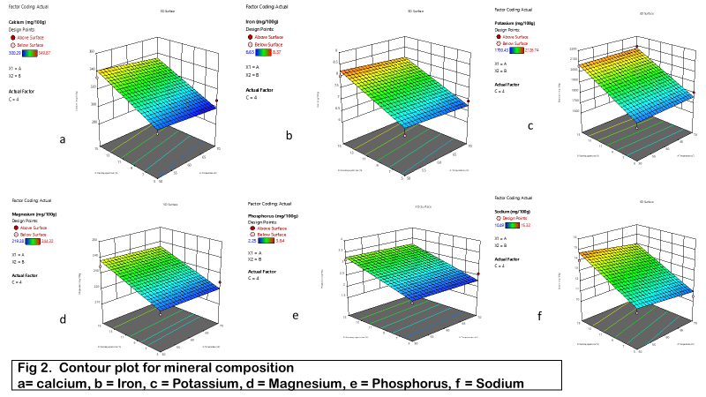

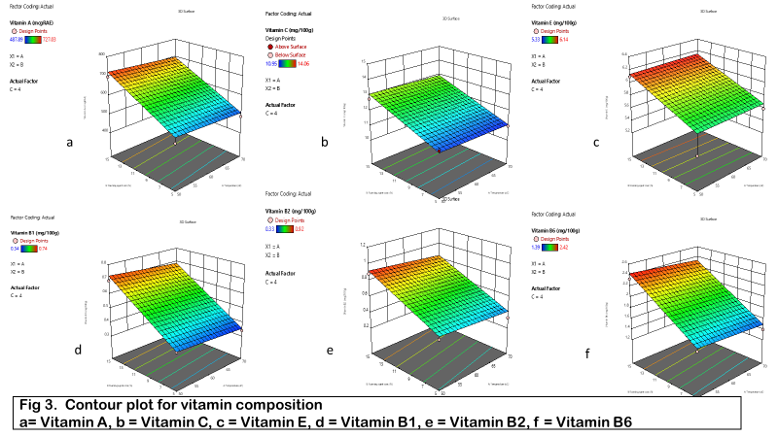

3.4 Determination and validation of the optimal parameters
The independent variables were optimized by response surface methodology using Design-Expert version 13 software. The optimal conditions were obtained on the basis of desirability using the desirability function of Design-Expert’s numerical optimization program. The fitness of the model equations was determined under the predicted conditions and experiments were conducted using the optimized condition to confirm the validity of the optimized solutions. The results are tabulated in Table 5. The residual standard error (RSE) percentages were used to compare the predicted values with the experimental results. For the results to be consistent with the prediction values, RSE values equal to or lower than ±5% were considered. The obtained RSE values for foam-mat dried black plum powder demonstrated no consequential disparities between the predicted and experimental values, which confirms the adequacy of the models. Low RSE is an indication that the model can make accurate prediction, while high RSE indicate less confidence that predicted value is close to experimental value. Also. the closer the desirability function to 1, the better the prediction
In the optimization step, after response surface analysis the foam mat drying process was optimized on the basis of desirability using the desirability function.

Table 5. Summary of the experimental values of response variables under the optimized condition for micronutrients
Responses |  | Target | Predicted Value |  | Experimental Value |  | RSE |  | Desirability Level
Calcium | Maximum |  |  | 343.75 |  | 351.64 |  | 4.5
Iron | Maximum |  |  | 8.37 |  | 10.12 |  | 1.0 | 0.90
Potassium | Maximum |  |  | 2067.63 |  | 2073.39 |  | 3.3
Magnesium | Maximum |  |  | 239.07 |  | 245.87 |  | 3.9
Phosphorus | Maximum |  |  | 3.34 |  | 5.09 |  | 1.0
Sodium | Maximum |  |  | 15.15 |  | 18.65 |  | 2.0
Zinc | Maximum |  |  | 25.52 |  | 29.75 |  | 2.4
Vitamin A (mcgRAE) | Maximum |  |  | 747.83 |  | 752.19 |  | 2.5
Vitamin C | Maximum |  |  | 13.17 |  | 11.42 |  | 1.0
Vitamin E | Maximum |  |  | 6.13 |  | 7.88 |  | 1.0
Vitamin B1 | Maximum |  |  | 0.76 |  | 1.97 |  | 0.7
Vitamin B2 | Maximum |  |  | 0.92 |  | 2.23 |  | 0.7
Vitamin B6 | Maximum |  |  | 2.54 |  | 4.29 |  | 1.0
Optimized condition
Foaming agent (%) |  |  |  | 15
Stabilizing agent (%) |  |  |  | 5
Temperature of drying (ºC) |  |  |  | 50
Experimental values are expressed as mean ± standard deviation(n=3)
RSE: Residual standard error

4.0 CONCLUSION
The study investigated the foam mat drying of black plum pulp at different temperature, foaming and stabilizing agent concentration. Generally, the findings indicate that drying temperature and foaming agent concentration significantly (p=0.05) affect the micronutrients composition of the black plum powder. The ANOVA showed that the average generated models had a higher R² value greater than 80%, significant model F-values (p=0.05), non-significant ‘lack of fit,’ and an adequate precision value greater than 4. The optimized parameters were verified, and there was good agreement between the experimental values and the predicted values as shown by the residual standard error. The study’s findings demonstrate black plum potentials as an ideal fruit for fruit powder production given its high mineral and vitamin content worth and adaptability.

Disclaimer (Artificial intelligence)
Option 1:
Author(s) hereby declare that NO generative AI technologies such as Large Language Models (ChatGPT, COPILOT, etc.) and text-to-image generators have been used during the writing or editing of this manuscript.
Option 2:
Author(s) hereby declare that generative AI technologies such as Large Language Models, etc. have been used during the writing or editing of manuscripts. This explanation will include the name, version, model, and source of the generative AI technology and as well as all input prompts provided to the generative AI technology
Details of the AI usage are given below:
1.
2.
3.

REFERENCES
Abbasi, E., and Azizpour, M. (2015). Evaluation of Physicochemical Properties of Foam‒mat Sour Cherry Powder. LWT‒Food Science and Technology. 68:105‒110. 9)
Adamade, C. A., and Olaoye, J. O. (2021). Modelling and optimization of drying rate and quality parameters of foam mat dried mango powder. Global Journal of Engineering and Technology Advances, 8(3), 032–037.
Adejumo, A.A., Alaye, S.A., Ajagbe, R.O., Abi, E.A. and Adedokun, F.T. (2013). Nutritional and Anti-nutritional Composition of Black plum (vitex doniana). Journal of Natural Sciences Research, 3(12): 144-148
Adeyeye, S. A. O., Ashaolu, T. J., and Babu, A. S. (2022). Food drying: A review. Agricultural
Affandi, N., Zzaman, W., and Yang, T. A. (2017). Production of Nigella sativa beverage powder under foam mat drying using egg albumen as a foaming agent. Beverages, 3(1), 1–15.
Agriculture and Food science, 3(1), 32-36.
Akissoé, L., Madodé, Y. E., Hemery, Y. M., Donadjè, B. V., Icard-Vernière, C., Hounhouigan, D. J., & Mouquet-Rivier, C. (2021). Impact of traditional processing on proximate composition, folate, mineral, phytate, and alpha-galacto-oligosaccharide contents of two West African cowpea (Vigna unguiculata L. Walp) based doughnuts. Journal of Food Composition and Analysis, 96, 103753.
albume concentration. Journal of Food processing and Preservation, 42(2), e13467.
Amah, U. J., and Okogeri, O. (2019). Nutritional and phytochemical properties of Wild Black
and Sinsin, B. (2012). Uses and management of black plum (Vitex doniana Sweet) in
AOAC. (2016). Appendix F: Guidelines for Standard Method Performance Requirements. AOAC Official Methods of Analysis, 1–17.
Auisakchaiyoung, T. and Rojanakorn, T. (2015). Effect of foam-mat drying conditions on quality of dried Gac fruit (Momordica cochinchine) aril International Food Research Journal, 22(5), 2025 2031
Bag, S.K., Srivastav, P.P., and Mishra, H.N. (2011). Optimization of process parameters for foaming of Bael (Aegle marmelos L.) fruit pulp. Food Bioprocess Technol 4:1450–1458. https://doi.org/10.1007/ s11947-009-0243-6
by the drying processes with the assistance of vacuum-microwaves. International
Dadjo, C., Assogbadjo, A. E., Fandohan, B., Kakaï, R. G., Chakeredza, S., Houehanou, T. D., ...
Das, A.B., Goud, V., and Das, C. (2018) Extraction and characterization of phenolic content from purple and black rice (Oryza sativa L) bran and its antioxidant activity. J Food Meas Charact 12:332–345
Demiray, E., Tulek, Y. and Yilmaz, Y. (2013). Degradation kinetics of lycopene, β-carotene and ascorbic acid in tomatoes during hot air drying. LWT-Food Science and Technology, 50(1), 172-176. https://doi.org/10.1016/j.lwt.2012.06.001
drying (pp. 589-625). CRC press.
Egbi, G., Gbogbo, S., Mensah, G. E., Glover-Amengor, M., and Steiner-Asiedu, M. (2018). Effect of green leafy vegetables powder on anaemia and vitamin – A status of Ghanaian school children. BMC Nutrition, 4(27), 1–10. doi:10.1186/s40795-018-0235
Falade, K.O., and Okocha, J.O. (2010). Foam-mat drying of plantain and cooking banana (Musa spp.). Journal of Food and Bioprocess Technology, doi: 10.1007/s11947-010-0354-0
Figiel, A., and Michalska, A. (2016). Overall quality of fruits and vegetables products affected
Franco, T.S., Perussello, C.A., Ellendersen, L.N., and Masson, M.L. (2016) Effects of foam mat drying on physicochemical and microstructural properties of yacon juice powder. LWT- Food Science and Technology. 66: 503-513
Hardy, Z. and Jideani, V.A. (2017). Effect of spray drying compartment and maltodextrin concentration on the functional, physical, thermal, and nutritional characteristics of Bambara groundnut milk powder. Journal of food processing and preservation. 46(11): 178-189
Hassan, A. and Shamsudeen, A.J. (2019). Cottage Processing of Black Plum (Vitex doniana) into Juice in Katsina State, NorthWestern Part of Nigeria. Umoru Journal of Microbiology Research (UJMR). 4(2):88-95
Hossain, M. B., Barry-Ryan, C., Martin-Diana, A. B., & Brunton, N. P. (2010). Effect of drying method on the antioxidant capacity of six Lamiaceae herbs. Food Chemistry, 123(1), 85-91.
Hossain, M.A., Mitra, S., Belal, M., and Zaman, W. (2021). Effect of foaming agent concentration and drying temperature on biochemical properties of foam mat dried tomato powder. Food Research. 5: 291-297.
Journal of Molecular Sciences, 18(1), 71.
Kadam, D.M., Nangare, D.M. and Oberoi, H.S. (2009). Influence of pretreatment on microbial load of stored dehydrated onion slices. International Journal of Food Science and Technology, 44(10), 1902–1908. https://doi.org/10.1111/j.1365-2621.2009.01980.x
Kadam, D.M., Wilson, R.A., Kaur, S. and Manisha. (2012). Influence of foam mat drying on quality of tomato powder. International Journal of Food Properties, 15(1), 211-220. doi.org/10.1080/10942911003763701
Kandasamy, P., Varadharaju, N., and Kalemullah, S. (2012). Foam‒mat Drying of Papaya (Carica papaya L.) Using Glycerol Monostearate as Foaming Agent. Food Science and Quality Management. 9: 8)
Khamjae, T., and Rojanakorn, T. (2018). Foam-mat drying of passion fruit aril. International Food Research Journal, 25(1), 204-212.
LeBlanc, J. G., Laiño, J. E., Del Valle, M. J., Vannini, V. V., Van Sinderen, D., Taranto, M. P., ... and Sesma, F. (2011). B‐Group vitamin production by lactic acid bacteria–current knowledge and potential applications. Journal of applied microbiology, 111(6), 1297-1309.
Lyon, P., Strippoli, V., Fang, B., and Cimmino, L. (2020). B vitamins and one-carbon metabolism: implications in human health and disease. Nutrients, 12(9), 2867.
Plum (Vitex doniana) seed from Ebonyi state. International journal of Horticulture,
Rajkumar, P., Kailappan, R., and Viswanathan, R. (2006). Drying Characteristics of Foamed Alphonso Mango Pulp in a Continuous type Foam‒mat Dryer. Journal of Food Engineering. 79(4):1452‒1459. 7).
reviews, 1(8), 1-8.
Samyor, D., Deka, S.C., and Das, A.B. (2021). Physicochemical and phytochemical properties of foam mat dried passion fruit (Passiflora edulis Sims) powder and comparison with fruit pulp, J. Food Sci. Technol. 58 (2021) 787–796, https://doi.org/10.1007/s13197-020-04596-y.
Shaari, N. A., Sulaiman, R., Rahman, R. A., & Bakar, J. (2018). Production of pineapple fruit (Ananas comosus) powder using foam mat drying: Effect of whipping time and egg albumen concentration. Journal of Food processing and Preservation, 42(2), e13467.
Solchansanj, S., and Jayas, D. S. (2020). Drying of foodstuffs. In Handbook of industrial
Southern Benin. Fruits, 67(4), 239-248.
Uchenna, J.A and Otu, O. (2019). Nutritional and Phytochemical Properties of Wild Black Plum (Vitex doniana) Seed from Ebonyi State. International journal of Horticulture, Agriculture and Food science (IJHAF). 3(1): 32-36
Vunchi, M.A., Umar, A.N., and King, M.A. (2011). Proximate, Vitamins and Mineral Composition of black plum (Vitex doniana) Fruit Pulp. Niger J Basic Appl Sci 2011; 19: 97-101
Wilson, R.A., Kadam, D.M., Chadha, S., and Sharma, M. (2012). Foam mat drying characteristics of mango pulp, International Journal of Food Science and Nutrition Engineering. 2: 63-69 (2012)
Zhang, D. Y., Yao, X.H., Duan, M. H., Wei, F. Y., Wu, G.H., and Li, L. (2015). Variation of essential oil content and antioxidant activity of Lonicera species in different sites of China. Industrial Crops and Products, 77, 772-779.

