Type of article : Short research article
PINEAPPLE (Ananas comosus) BRAN AS A SUSTAINABLE FEED ADDITIVE FOR IMPROVING GROWTH PERFORMANCE OF Clarias Jaensis, ENDOGENOUS FISH IN CAMEROON

Abstract
This study, which lasted approximately 60 days (from May to July 2024), aimed to evaluate the effect of pineapple bran as a feed additive on the growth characteristics of Clarias jaensis. To this end, 225 fry were randomly allocated to five treatment groups (T0, T1, T2, T3 and T4) which corresponded to pineapple bran supplementation levels of 0.25%, 0.50%, 0.75% and 1%, respectively. The fry were fed twice a day at 5% of the ichthyo biomass. Except for the K factor, pineapple bran significantly (P < 0.05) affected the growth characteristics. The highest survival rate (95.55 ± 0.00%), final weight (35.04 ± 0.94 g), weight gain (21.69 ± 0.94 g), daily weight gain (0.38 ± 0.01 g/d), specific growth rate (1.72 ± 0.04), feed consumption (27.92 ± 0.33 g) and the lowest feed conversion ratio (1.28 ± 0.34) were recorded with the T4 ration. Proximate analysis of the flesh showed that the presence of pineapple bran in the feed improved its nutritional quality of the flesh unlike the control treatment. The level of pineapple bran significantly affected the characteristics of the fish carcass except for organic matter and minerals. The highest dry matter (97.89 ± 0.10%) and crude protein (64.46 ± 0.07%) values were recorded with the T1 ration, while the highest fat (14.96 ± 0.03%) value was observed with the T3 ration. Additionally, the T4 treatment had the lowest feed cost of production. Therefore, supplementing pineapple bran at 1% in the Clarias jaensis feed is therefore recommended for better growth.
Keywords : Clarias jaensis, pineapple bran, feed additive, growth
INTRODUCTION
In 2018, global fish production reached approximately 179 million tonnes, 82 million of which came from aquaculture. Of this total, 156 million tonnes were used for human consumption, equivalent to an estimated annual supply of 20.5 kg per person [1]. Currently, 31.4% of fish stocks are overexploited due to increasing demand resulting from population growth [2]. In Cameroon, demand for fish is nearly 500,000 tonnes per year, while the national supply is estimated at 295,000 tonnes per year, only 10,000 of which come from aquaculture [3]. In this context, aquaculture has emerged as a viable alternative to help cover this deficit.
To make aquaculture more sustainable and profitable, it is important to diversify the species raised. In Cameroon, the main species used in fish farming are exotic species: Clarias gariepinus, Oreochromis niloticus and Cyprinus carpio. However, there are indigenous species, such as Clarias jaensis, belonging to the Clariidae family, which could also have good aquaculture potential. Clariidae are one of the most popular families in aquaculture due to their hardiness, high pond-farming density, omnivorous diet with a carnivorous tendency, and highly prized flesh [4]. In recent years, research has begun on this species, particularly concerning its reproductive characteristics in the wild [5] [6]. [7] and [8] have also studied the impact of metabolisable energy and protein levels on the growth performance of Clarias jaensis in a controlled environment.
The development of aquaculture is subject to several major constraints, including feed. Feed accounts for 60–70% of aquaculture production costs [9]. Feed performance is determined by its nutritional properties and digestibility. These properties are generally attributed to food additives, which are substances extracted from plants, animals or minerals, often via chemical reactions. They are added to foodstuffs intended for consumption. One example of an additive from plant extracts is pineapple bran (Ananas comosus), which is obtained after the juice has been extracted in natural fruit juice production plants. Processed fruits generate waste representing 35–85% of the original fruit, which is environmentally problematic [10]. Pineapple residues are rich in insoluble fibre, bromelain (a protein-digesting enzyme) and phenolic and antioxidant compounds that reduce diseases related to oxidative stress [11] [12] [13]. According to the research of [14], bromelain contained in pineapple residues would promote growth and resistance to certain diseases in aquaculture species.
Research into the effect of pineapple residue on the production performance of other fish, such as Oreochromis niloticus, has already been conducted [15] [16]. To our knowledge, no such research has yet been conducted on the Clarias jaensis species. With this in mind, the present study investigated the impact of pineapple bran as a food additive on the survival and growth performance of Clarias jaensis in a controlled environment.
The general objective of this study was to improve fish production by promoting the use of pineapple bran as a food additive.
MATERIALS AND METHODS
Study area
The study took place from May to Jully 2024 at the Nkolandom Fish establishment in Nkolandom village, Ebolowa II district, Mvila department, South region, Cameroon. The geographical coordinates of the village are : 2° 81' 33" - 2° 81' 50" N, 11° 16' 33" - 11° 16' 67" E, at an average altitude of 616 metres.

Animal material
Two hundred and twenty-five Clarias jaensis fry (see picture 1), with an average weight of 11.12 ± 3.20 g, were collected from the Mbô plain of Santchou in a natural environment. They were then transported to the Nkolandom Fish farm, where they were acclimatised in a 2 m³ tank for two weeks and fed a control diet containing 40% crude protein.
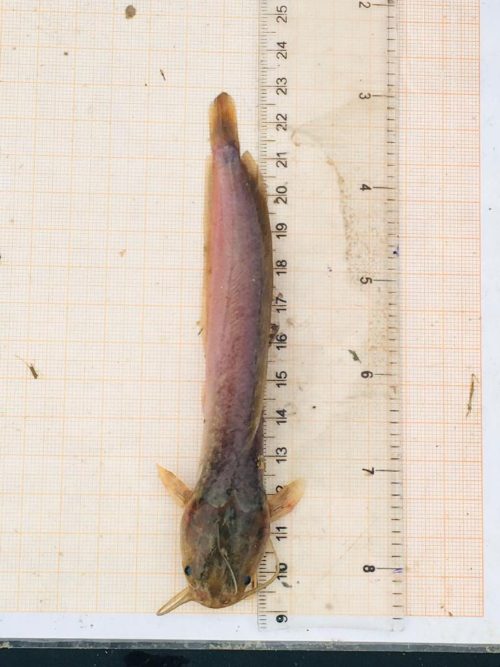
Picture 1 : Clarias jaensis
Plant material
The plant material consisted of pineapple bran residue from the FRUITZAN industry in Loé, which is located in the Moungo Department of the Littoral Region of Cameroon. After the juice had been extracted, the pineapple residues (the fibres only, excluding the crowns and peels) were collected and sun-dried at room temperature for four days (see picture 2), before being crushed to obtain pineapple bran powder.
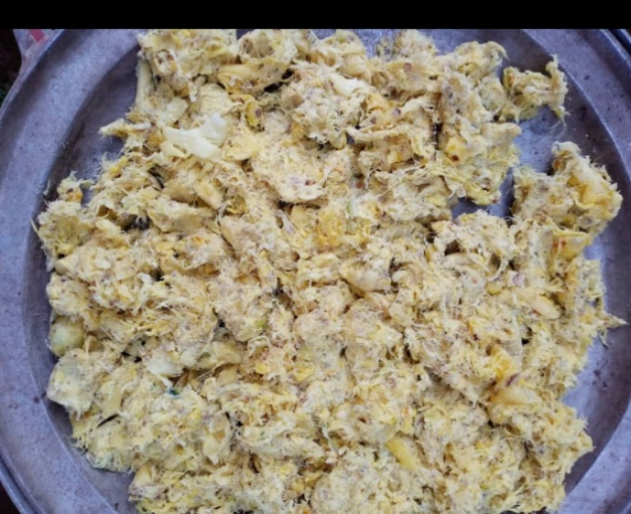
Picture 2 : Drying of pineapple (Ananas comosus) residues

Experimental rations
A control experimental ration that did not contain pineapple bran (T0) was formulated, and four other rations were obtained by supplementing pineapple bran at the following rates: 0.25%, 0.50%, 0.75% and 1%, respectively, for treatments T1, T2, T3 and T4 (see Table 1).
Table 1: Composition of the control ration
Ingredients | Quantities
Pineapple bran (kg) | 0
Corn flour (kg) | 18
Wheat bran (kg) | 4
Soybean meal (kg) | 12,2
Fish meal (kg) | 58
Shell meal (kg) | 0,4
Bone meal (kg) | 0,4
Huile de palme (L) | 5
Premix 2% | 2
Total (kg) | 100
Proximal composition
Crude energy (Kcal/Kg) | 4440
Crude protein (%) | 40,16
Ash (%) | 12,85
The sifted ingredients were weighed in the proportions established in advance, then mixed manually to ensure good homogenisation. 500 ml of water per kg of feed was added to obtain a wet mixture, which was then passed through an electric granulator to produce 3 mm diameter granules. These granules were then sun-dried for two days, packaged in plastic bags, and stored at -20°C when not in use.
Rearing structure and experimental setup
The rearing structure consisted of 1 m³ happas (see Picture 3), which were placed in a 120 m² pond with a depth of 1.2 m and were supplied with water from an upstream lake. The happas were made of 1 mm mesh netting and were cleaned daily to unclog them and facilitate water renewal. Basins with a diameter of 33 cm were installed at the bottom of each happas, and circular feeders with a diameter of 30 cm were placed on the surface of the water, above the basins. This made it possible to collect food waste every day.
As for the experimental design, 225 fry were distributed randomly in 5 comparable batches of weight and length corresponding respectively to treatments T0, T1, T2, T3 and T4 all in a triplicate at the rate of 15 fry/happas or repetition.

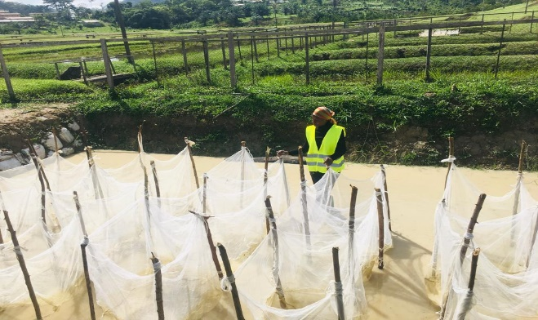
Picture 3 : Experimetal set up
Conduct of the trial
The pellets were distributed manually twice a day (8 a.m. and 6 p.m.) at 5% of the ichthyo biomass of the fry until the end of the test except the monitoring fishing watches which were done every 14 days, and during which the live weight of the fish was measured using a Sartorius brand scale with a precision of 0.01 g. Food refusals were collected every day, dried and weighed to estimate food consumption. The physicochemical characteristics of the pond water (table 2) were controlled every day (morning and evening) a few minutes before feeding.
Table 2 : Physicochemical characteristics of the pond water
Parameters | Period (days)
Parameters | Jour 0-14 | Jour 15-28 | Jour 29-42 | Jour 43-60
Transparency (cm) | 17.6 ± 0.50ª | 15.50 ± 1.00ª | 16.00 ± 2.00ª | 16.80 ± 0.50ª
Ph | 6.80 ± 0.20ª | 7.10 ± 0.40ª | 6.80 ± 0,4ª | 6.50 ± 0.30ª
Oxygen (mg/L) | 12.70 ± 1.00ª | 9.00 ± 1.70ª | 9.00 ± 1.00ª | 10.30 ± 1.50ª
Nitrite (mg/L) | 0.10 ± 0.05ª | 0.10 ± 0.05ª | 0.05 ± 0.05ª | 0.05 ± 0.05ª
Temperature (°C) | 26.50 ± 0.08ª | 25.90 ± 0.50ª | 26.70 ± 1.00ª | 26.90 ± 1.20ª
a: the means with the same letter on the same line are not significantly different (P > 0.05).
Survival Rates and Growth Characteristics of Clarias jaensis
Survival rate (SR) = total final fish count x 100 / total initial fish count
Food consumption (FC) = $Quantity of food served-Quantity of food refused$
Weight gain (WG) = $Final weight-initial weight$
Daily weight gain (DWG) = $\frac{Final weight-initial weight}{Time (number of days)}$
Specific growth rate (SGR) = $\frac{(\ln{final weight-\ln{ initial weight)X100}}}{Time (number of day)}$ ln= neperian logarithm
Feed conversion ratio (FCR) = $\frac{Amount of food consumed}{Final weight-Initial weight}$
condition factor K = $100(W/{LT}^{3 })$ W = weight (g) LT = total length (cm)
Food production cost (FPC) = CFC x CI CFC = Cost of food consumed, CI = Consumption index
Proximal composition of Clarias jaensis flesh
Dorsal and ventral muscle samples were collected [17] and used to determine the proximal composition (dry matter, organic matter, ash, fat and crude protein) using the [18] method.
Results
Effect of Pineapple Bran Supplementation on Survival and Growth Characteristics of Clarias jaensis
Table 3 presents the growth characteristics of Clarias jaensis fry according to the pineapple bran supplementation rate.
Overall, it appears that the pineapple bran supplementation significantly (P < 0.05) affected the growth characteristics, except for condition factor K. The highest values were recorded for survival rate (95.55 ± 0.00%), food consumption (27.2 ± 0.33 g), weight (21.69 ± 0.94 g), weight gain (21.69 ± 0.94 g), daily weight gain (0.38 ± 0.01 g) and specific growth rate (1.72 ± 0.04 %g/d) ​​were recorded with the T4 treatment which contained the highest level of pineapple bran, unlike the other treatments. The lowest feed conversion ratio value (1.28 ± 0.34) was also recorded with the T4 treatment
Table 3: Growth characteristics of Clarias jaensis depending on the rate of pineapple bran supplementation.
Growth characteristics | Treatments |  |  |  |  | P
Growth characteristics | T0 | T1 | T2 | T3 | T4 | P
SR (%) | 82.22±3.84^{b} | 80±0.00^{b} | 91.11±3.84ª | 80±0.00^{b} | 95.55±0.00ª | 0.00
FC (g) | 17.66±0.20^{c} | 17.87±0.35^{c} | 27.13±0.41ª | 23.42±0.51^{b} | 27.2±0.33ª | 0,00
W (g) | 23.92±0.38^{c} | 23.07±0.49^{c} | 34.26±0.5ª | 29.50±0.43^{b} | 35.04±0.94ª | 0.00
WG (g) | 11.24±0.38^{d} | 11.25±0.49^{d} | 20.37±0.55^{b} | 16.00±0.43^{c} | 21.69±0.94ª | 0.00
DWG (g/d) | 0.20±0.006^{d} | 0.20±0.008^{d} | 0.36±0.009^{b} | 0.28±0.007^{c} | 0.38±0.01ª | 0.00
SGR (%g/d) | 1.13±0.02^{c} | 1.19±0.03^{c} | 1.61±0.02ª | 1.39±0.02^{b} | 1.72±0.04ª | 0.00
K | 0.78±084 ª | 0.67±0.11 ª | 0.70±0.27 ª | 0.66±0.14 ª | 0.62±0.01ª | 0.78
FCR | 1.54±0.05ª | 1.58±0.15ª | 1.29±0.36^{b} | 1.53±0.16ª | 1.28±0.34^{b} | 0.01
a, b and c: the means with the same letter on the same line are not significantly different (P>0.05). SR=Survival rate, FC= Food consumption, W=Weight, WG=Weight gain, ADG=Average daily gain, SGR=Specific growth rate, K=Condition factor, FC=Food consumption, FCR=Feed conversion ratio.
Figure 1 shows the evolution of the survival rate of Clarias jaensis fry depending on the rate of pineapple bran supplementation. As can be seen from the figure, the survival rate followed the same trend and pace of evolution regardless of the level of pineapple bran supplementation and the period of the test. However, the T4 treatment produced the highest values ​​throughout the study period.

Figure 1: Evolution of the Survival rate of Clarias jaensis fry depending on the rate of pineapple bran supplementation
Figure 2 shows the evolution of the live weight of Clarias jaensis fry depending on the rate of pineapple bran supplementation. It also emerged that the weight evolved with the same trend and pace regardless of the treatment and the period of the trial. However, the highest weights were observed in treatment T4 from day 28 until the end of the experiment.

Figure 2: Evolution of live weight of Clarias jaensis fry depending on the rate of pineapple bran supplementation
Effect of pineapple bran supplementation on the proximal composition of Clarias jaensis flesh
Table 4 shows the results of the analysis of the flesh of fish subjected to different treatments. As can be seen from the table, the level of pineapple bran supplementation significantly affected (P < 0.05) the chemical characteristics of the flesh, except for organic matter and ash. The highest values ​​of dry matter (97.89 ± 0.10%) and crude protein (64.46 ± 0.07%) were obtained with treatment T1 followed by T4, while the lowest fat content was observed. The highest value (14.96 ± 0.03%) was observed with treatment T3, and the lowest value (13.85 ± 0.05%) with treatment T1.
Proximal composition (%) | Level of pineapple bran |  |  |  |  | P
Proximal composition (%) | T0 (0%) | T1(0.25%) | T2(0.50%) | T3(0.75%) | T4(1%) | P
DM | 96.43±0.18b^{c} | 97.89±0.10ª | 96.63±0.20^{b} | 95.38±012^{d} | 96.23±0.00^{c} | 0.00
OM | 83.12±0.49ª | 83.66±0.67ª | 82.26±1.48ª | 82.26±1.23ª | 83.47±1.06ª | 0.51
Ash | 16.87±0.49ª | 16.33±0.67ª | 17.73±1.48ª | 17.31±1.23ª | 16.53±1.06ª | 0.51
Fat | 14.69±0.29^{b} | 13.85±0.05^{c} | 14.56±0.06^{b} | 14.96±0.03ª | 13.91±0.00^{c} | 0.00
Crude protein | 60.36±0.11^{d} | 64.46±0.07ª | 60.74±0.13^{c} | 60.29±0.08^{d} | 62.22±0.09^{b} | 0.00
Table 4: The proximal composition of fish flesh depending on the level of pineapple bran
a, b and c: the means with the same letter on the same line are not significantly different (P > 0.05), DM = Dry matter, OM = Organic matter
Effect of pineapple bran on the food cost of production of Clarias jaensis.
Table 5 below presents the food production cost of Clarias jaensis. It appears from this table that food production costs varied significantly (P < 0.05) depending on the levels of pineapple bran supplementation. Treatments T0, T1 and T3 recorded the highest costs ($2.46 ± 0.085), ($2.53 ± 0.250) and ($2.45 ± 0.260) respectively. The lowest costs ($2.06 ± 0.058) and ($2.05 ± 0.055) were recorded with treatments T4 and T2. However, the T4 treatment presented a better food production cost.
Table 5: Food production cost
Treatment | FCR | Food production cost ($)
T0 | 1.54±0.05ª | 2.46±0.085ª
T1 | 1.58±0.15ª | 2.53±0.250ª
T2 | 1.29±0.36^{b} | 2.06±0.058^{b}
T3 | 1.53±0.16ª | 2.45±0.260ª
T4 | 1.28±0.34^{b} | 2.05±0.055 ^{b}
a and b: the means with the same letter on the same column are not significantly
different (P > 0.05), FCR=Feed conversion ration.

Discussion
The survival rates recorded during this study ranged from 80.00% to 95.55%. These results are superior to those obtained by [8] in their study of the effect of dietary protein levels on the growth performance of Clarias jaensis fry during pre-growering. Our study corroborates that of [15] who obtained the highest tilapia survival rate with ration containing 10gkg⁻¹ (1%) of pineapple peel powder. However, [16] also obtained high survival rates in Nile tilapia with rations containing pineapple bran. This could be explained by the presence of phenolic compounds and antioxidants present in pineapple bran, which strengthen the fish’s immune system and reduce diseases linked to oxidative stress [15].
In general, the highest growth characteristics were observed in the feed supplemented with 1% pineapple bran. The lowest feed conversion ratio was also recorded with this ration, showing that the food containing 1% pineapple bran was better valued by the fish. These results are similar to those obtained by [13] during their evaluation of the effect of pineapple waste crude extract on growth performance and resistance to Aeromonas hydrophila in Nile tilapia. They found that WG, ADG, SGR, and FCR were significantly higher in the fish group fed a diet supplemented with 1% pineapple peel extract. Similarly, [15] found that incorporating 10 gkg⁻¹ of pineapple peel powder into diets was clearly related to growth rate and feed efficiency in Nile tilapia culture under a biofloc system. Conversely, [19] reported that the adding 30% pineapple waste powder to a formulated diet increased the growth rate of Nile tilapia. The highest average daily weight gain (0.38 g/d) observed in this trial were lower than that (3.3 g/d) obtained by [20] for Clarias jaensis fingerlings raised in a pond fertilised with pig manure, but higher than that obtained by [13]. These results could be due to the difference in species, rearing conditions and types of pineapple residues used during the trials. The highest specific growth rate observed in our study (1.72%g/d) was higher than that obtained by [7] in Clarias jaensis fingerlings fed rations containing various energy levels. This difference in results could be explained by the presence of pineapple bran (Ananas comous) in the food which is rich in insoluble fibre and bromelain, playing an important role in protein digestibility [11]. The condition factor (K), which provides information on the body condition of the fish, did not vary significantly (P > 0.05). However, the extreme values ​​obtained (0.62 and 0.78) were less than 1, which according to [21], indicates that the fish were in poor condition. Similar results were observed by [22] and [8] in Clarias jaensis fingerlings fed at different levels of energy and dietary protein, respectively.
Regarding the proximal composition of the fish flesh, the results obtained showed that the presence of pineapple bran in the feed improved the quality of Clarias jaensis flesh, unlike the control ration. This could be explained by the improved digestibility and absorption of the nutrients in these foods due to fibre content of pineapple bran. These results are similar to those of [16], who evaluated the effect of pineapple residues (peel, crown and bran) as a feed additive on the apparent digestibility, productive performance, carcass yield, liver condition and immune system of Oreochromis niloticus fry. Their results also showed improvements in tilapia flesh quality with rations containing pineapple residue. The lowest recorded food costs for fish production in this study were obtained with the ration containing 1% pineapple bran. This suggests that the T4 ration would lead to better growth of Clarias jaensis fry at a lower cost.

CONCLUSION

In summary, it emerges from this study which focused on the effect of pineapple bran (Ananas comosus) as a food additive on the survival and growth performance of Clarias jaensis fry found that the level of supplementation that produced the best growth characteristics and lowest food production cost was 1%. Proximate analysis revealed that the fry fed rations containing pineapple bran had richer, more nutritious flesh.
DISCLAIMER (Artificial intelligence)
Authors hereby declare that NO generative AI technologies such as Large Language Models (ChatGPT) used in this manuscript.

REFERENCES
1. FAO. La situation mondiale des pêches et de l’aquaculture 2020. La durabilité en action. Rome. 2020;247p https://doi.org/10.4060/ca9229fr
2. FAO (2016). Aquaculture Big Numbers Rome. Available from www.fao.org/3/a-i6317e.pdf
3. Ngala TD. Profil historique de l’aquaculture intensive au Cameroun (2020-2021). JLFID Cameroon Aquaculture FAO.MINEPIA. 2021;30 p.
4. Rukera TS. Production de juvéniles de Clarias gariepinus (Burchell, 1822) à diverses densités de mise en charge, Mémoire de DES. Université de Liège. Facultés Universitaires Notre-Dame de la Paix- Namur. 2004;62 p.
5. Zango P. Caractéristiques de reproduction comparées en milieu naturel Clarias gariepinus et Clarias jaensis, Université de Dschang, Mémoire de Master of Sciences, spécialité : Aquaculture. 2009;98 p.
6. Zango P, Tomedi TEM, Oben ML, Pouomogne V, Nguenga D, Tchoumboue J, Efole ET. Comparing reproductive characteristics of two catfish species Clarias gariepinus and Clarias jaensis in natural environment of western region of Cameroon. Journal of multidisciplinary engineering science and technology. 2015;2: 3437-3441.
7. Tsoupou KSG, Kpoumie NA, Komguep NR, Tchouante TCG, Vemo BN, et al. Survival, growth response, chemical and biochemical characteristics of the carcass of Clarias jaensis (Boulenger, 1909) post fingerlings fed various dietary energy, Journal of Aquaculture Research & Development. 2023;14: 777.
8. Komguep R, Efole T, Defang F, Nana T, Mube K, Tagning Z. Effects of Dietary Protein Level on Growth Performance of Pre-growing Catfish Clarias jaensis (Boulanger, 1909) in Captivity. Journal of Aquaculture Research & Development. 2021;12:658.
9. Defang F, Gnikpo FA, Biaou A, Fagbemi M. Efficacité d’un ingrédient alimentaire probiotique sur la survie et les performances de croissance des alevins de Clarias gariepinus. ournal de la Recherche Scientifique de l'Université de Lomé (Togo), Série A. 2014;16(2) 87-98.
10. Ayala-Zavala J, Vega-Vega V, Rosas-Domínguez C, Palafox-Carlos H, Villa-Rodriguez J, Siddiqui MW, Dávila-Aviña JE, González-Aguilar GA. Agro-industrial potential of exotic fruit byproducts as a source of food additives: Review. Food Research International. 2011; 44: 1866–1874.
11. Li T, Shen P, Liu W, Liu C, Liang R, Yan N, Chen J. Major polyphenolics in pineapple peels and their antioxidant interactions. International Journal of Food Properties. 2014;17: 1805-1817.
12. Das G, Patra JK, Debnath T, Ansari A, Shin HS. Investigation of antioxidant, antibacterial, antidiabetic and cytotoxicity potential of silver nanoparticles synthesized using the outer peel extract of Ananas comosus, PloS One. 2019;14: 1-19.
13. Khumsrisuk P., Mapanao R., Nithikulworawong N. (2022). Evaluation of pineapple waste crude extract in improving growth performance and resistance to Aeromonas hydrophilain Nile tilapia (Oreochromis niloticus). International Journal of Aquatic Biology, 10(5): 417-428.
14. Wing-Keong N, Mei-Ling M. Dietary Bromelain from pineapple extracts enhanced growth performance and modulated stomach microbiota which provides longer-term protection to Penaeus vannamei against acute hepatopancreatic necrosis disease (AHPND) caused by Vibrio parahaemolyticus. Aquaculture Research, volume 2024, issue 1. https://doi.org/10.1155/2024/6492170.
15. Van Doan H, Hoseinifar SH, Harikrishnan R, Khamlor T, Punyatong M, Tapigkae W, Yousefi M, Palma J, El-Haroun E. Impacts of pineapple peel powder on growth performance, innate immunity, disease resistance and relative immune gene expression of Nile tilapia, Oreochromis niloticus. Fish and Shellfish Immunology. 2021;114: 311-319.
16. Attalla RF, El-Serafy SS, Fadda SH. Investigation of Pineapple Remnants Used in Fish Aqua Feeds. Egyptian Journal of Aquatic Biology and Fisheries. 2022;26(1) : 1-22
17. Sujatha K, Anitha A, Joice, Senthilkumaar P. Total protein and lipid content in edible tissues of fishes from Kasimodu fish landing centre, Chennai, Tamilnadu. European Journal of Experimental Biology. 2013;3(5): 252-257.
18. AOAC (Association of Official Analytical Chemists) (2000). Official methods of analysis. Association of Official Analytical Chemists. Washington, DC, USA
19. Sukri SAM, Andu , Harith ZT, Sarijan S, Pauzi MNF, Wei LS, Dawood MAO, Kariet ZA. Effect of feeding pineapple waste on growth performance, texture quality and flesh color of Nile tilapia (Oreochromis niloticus) fingerlings. Saudi Journal of Biological Sciences. 2022;29: 2514-2519.
20. Zango P, Tabi ETM, Efole ET, Tiogue TC, Nguenga D, Kamanke KSM, Mikolasek O, Tchoumboue J. Performance de reproduction du poisson chat endogène du Cameroun clarias jaensis (boulanger, 1909) en milieu contrôlé. International journal of biological and chemical sciences. 2016;10(2): 533-542 doi: http:/dx.doi.org/ijbcs.v10i2.7.
21. Fulton. Rate of growth of seas fishes. Science Investigatory Fisheries Division Scotland Report. 1902;20.
22. Tsoupou KSG., Efole ET, Moussala OJ, Tchoumboue J. Effect of various levels of metabolize energy on growth performance of Clarias jaensis fingerlings (Boulanger, 1909). International Journal of Research – Granthaalayah. 2018;6(5), 65-72.

