Assessing the Effect of UAV Data Acquisition Time and Camera Angle for Mapping Shallow Water Benthic Habitats in Dulanga Beach, Gorontalo Regency, Indonesia

.
ABSTRACT

Aims: This study aimed to evaluate the quality and accuracy of benthic habitat classification results based on drone imagery, verified through field data (ground truthing) based on drone flight time and sensor angle.
Study design: An Experimental field-based remote sensing study using unmanned aerial vehicle (UAV) imagery and object-based image analysis (OBIA).
Place and Duration of Study: Conducted in the Coastal Conservation Area of Dulanga Beach, Gorontalo Regency, Indonesia, between June and July 2025.
Methodology: UAV imagery was acquired using an Autel Evo II Pro V3 drone at four time intervals (08:00, 10:00, 12:00, and 14:00 Ante Meridiem (AM) local time) under two camera angle configurations (90° nadir and 45° oblique). A stratified random sampling design yielded 189 observation points across six habitat strata. Of these, 94 points were used as validation data for accuracy assessment, and 95 points were used as training data in the classification process. Imagery was processed through an OBIA workflow, where contextual editing and Support Vector Machine (SVM) classification were applied, using a segmentation scale of 50 to delineate six benthic habitat classes.
Results: The optimal acquisition was achieved at 10:00 AM local time with a 90° camera angle. Under these conditions, SVM classification with segmentation scale 50 yielded an overall accuracy of 91.75% and a Kappa coefficient of 0.89, indicating almost perfect agreement with field validation.
Conclusion: UAV-based object-oriented classification provides a highly accurate and efficient approach for benthic habitat mapping in shallow waters. The findings highlight the significance of acquisition time and camera angle and offer a methodological framework for improving spatial planning, ecosystem monitoring, and the management of marine conservation areas in Gorontalo Province.

Keywords: Benthic habitats; drone; Dulanga Beach; mapping; OBIA.

1. INTRODUCTION

The Blue Economy concept has emerged as a strategic approach to promoting sustainable marine development by balancing economic growth with marine ecosystem conservation. One of its key pillars is the designation of marine protected areas (MPAs), as legally mandated by the Indonesian Ministry of Marine Affairs and Fisheries through Ministerial Regulation No. 14 of 2016 and reinforced by Regulation No. 31 of 2020 concerning the governance of marine conservation areas. The Indonesian Ministry of Marine Affairs and Fisheries has set a target of marine conservation areas to cover 30% of the total national marine area by 2045. By the end of 2024, the total area of marine conservation areas had reached 29.9 million hectares, equivalent to 9.2% of Indonesia's marine area (KKP, 2024). In Gorontalo Province, conservation areas have been included in the 2024 Regional Spatial Plan, covering more than 159,000 hectares. One of the legally established MPAs is the Gorontalo Bay Marine Conservation Area, designated under Ministerial Decree No. 127 of 2023, with a total area of 76,580.48 hectares encompassing core zones, limited-use zones, and other functional zones.

The success of marine conservation area management largely depends on the availability of accurate spatial data, especially regarding the condition of benthic habitats in shallow waters (Lu et al., 2025; Sullivan et al., 2025). Official conservation area designation documents generally only include general zoning information without detailed habitat classifications. However, in-depth spatial information is crucial for formulating ecosystem-based zoning policies and for more precise monitoring of environmental dynamics. Benthic habitat mapping is critical because it clearly explains underwater ecosystems' distribution, extent, and condition (Purkis et al., 2019). This information serves as a vital scientific foundation for informed conservation decision-making.

Remote sensing technology has become the primary method for mapping benthic habitats. Yet, regarding shallow waters, the limited resolution of satellite images often makes it hard to distinguish finer habitat details. As technology advances, drones (unmanned aerial vehicles/UAVs) offer an alternative solution that can produce high-resolution images and high operational flexibility in coastal areas (Klemas, 2015; Gauci et al., 2020; Rahmani et al., 2022). In addition to providing detailed visual results, drones also enable object-based image analysis (OBIA), which can improve the accuracy of habitat classification. Nababan et al. (2021) also found that taking images at a 45° angle can help minimize visual disruptions like sunlight reflections (sunglint), a common obstacle when mapping shallow-water habitats.

This study focuses on Dulanga Beach, one of the limited-use zones in the Gorontalo Bay Conservation Area (Gorontalo Provincial Regulation No. 2 of 2024), which ecologically has ideal characteristics such as water clarity, minimal human disturbance, and high accessibility. To date, no drone-based benthic habitat mapping studies have been conducted in this area or other coastal areas of Gorontalo. This study aims to evaluate the quality and accuracy of benthic habitat classification results based on drone imagery, verified through field data (ground truthing) based on drone flight time and sensor angle. As an initial study, this research is expected to fill the spatial data gap at Dulanga Beach while also serving as a foundation for developing drone-based benthic habitat mapping methods across the broader coastal areas of Gorontalo.

2. methodology

2.1 Location and Time of Research

Data collection for this study was conducted from June to July 2025 at Pantai Dulanga, located in Gorontalo Regency, Indonesia. Geographically, the study area is situated between 0°29’33.97” N–123°1’44.04” E and 0°29’42.71” N–123°1’47.09” E. The study site map is presented in Fig. 1.
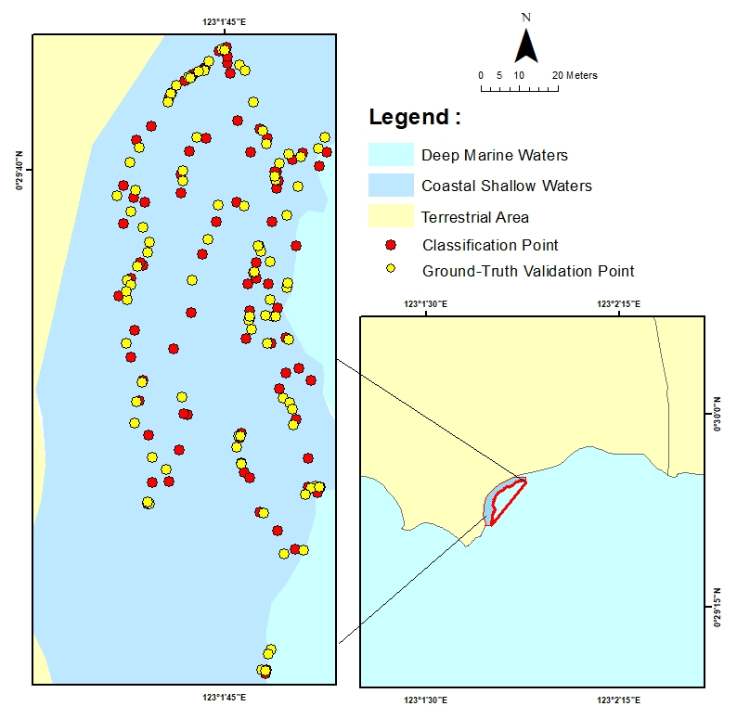

Fig. 1. Study area map and sampling locations

2.2 Data and Equipment

The data used in this study were drone data acquired on 14–15 June 2025 and ground truth data. The drone was an Autel Evo II Pro V3 with an RGB (red, green, blue) camera lens. The application used to operate the drone was the Autel Explorer application installed on the drone's remote control. The equipment used for field data collection included a Garmin 78s Global Positioning System (GPS), snorkelling and scuba diving gear, square transects, an underwater camera, underwater writing tools, and waterproof plastic. Data processing and analysis were conducted using an Intel Core i7 laptop with 16 GB Random Access Memory (RAM), equipped with software such as: Archmap 10.8, Quantum Geographic Information System (QGIS), Ecognition Developer, Agisoft PhotoScan, Global Mapper, and Microsoft Office.

2.3 Data Collection

Benthic habitat data collection in this study used stratified random sampling, in which the study area was divided into several strata based on substrate characteristics such as sand, mud, live coral reefs, dead reefs, seagrass, rubble, and algae. After stratification, sample points were randomly selected from each stratum to ensure proportional representation of all habitat types (Congalton & Green, 2019). Field data was collected through direct visual observation and documentation using 30x30 cm² square transect photographs (Siregar, 2010), with a camera and a Garmin 78s handheld GPS device to record precise location coordinates. Transect size adjustments were made to ensure spatial accuracy based on the accuracy of the GPS device used. A total of 189 observation points were collected for benthic habitat data, divided into two parts: (1) 94 points as accuracy test data from image classification results and (2) 95 points as thematic layer data in the image classification process.

2.4 Drone Image Acquisition

The drone flight path planning followed a grid pattern, which has proven effective for systematic area coverage and supports seamless image mosaicking to produce high-quality visual outputs (Øie et al., 2024). Image acquisition was conducted at an altitude of 100 meters, with a maximum speed of 14 m/s, and both front-lap and side-lap settings set at 80%. Previous studies have suggested that the optimal flight altitude for UAV-based benthic habitat mapping lies within the range of 50–120 m, depending on the trade-off between Ground Sampling Distance (GSD) and spatial coverage (Joyce et al., 2018; Casella et al., 2017; Øie et al., 2024). In this study, a flight altitude of 100 m was selected, yielding a GSD of approximately 2–3 cm/pixel, which provided sufficient spatial resolution for accurate benthic habitat classification while ensuring efficient area coverage and safe UAV operation. The coverage are was adjusted based on the research site conditions and the drone's battery capacity, which directly affected flight duration. The entire aerial photography process took place in June 2025. During this period, environmental conditions, such as wind speed, currents, waves, cloud cover, and sunlight intensity, played a significant role in determining the quality of the images captured. The best results were obtained under calm water, clear skies, low wind speed, and when sunlight was not reflected off the water surface (sunglint). Sunglint can obscure important benthic features in high-resolution UAV imagery, reducing the accuracy of coral reef classification (Qin et al., 2024). It can also create white spots in the images, potentially leading to misclassification of benthic habitats (Nugroho et al., 2024). The process was divided into four time slots to evaluate the optimal conditions for image acquisition: 08:00, 10:00, 12:00, and 14:00 Ante Meridiem (AM) local time. Furthermore, the camera lens was positioned at 90° (vertical) and 45° (inclined) to assess how each angle affected image quality and benthic visibility. In this study, UAV imagery was acquired at 90° (nadir) and 45° (oblique) viewing angles, as these configurations are most commonly applied in benthic habitat mapping. The nadir angle (90°) minimizes geometric distortions and provides spatial consistency, whereas the oblique angle (45°) reduces sunglint interference in shallow waters (Nababan et al., 2021; Qin et al., 2024). Other viewing angles were not adopted, as angles below 45° typically exacerbate geometric distortions, while those above 90° are not applicable for underwater data acquisition.

2.5 Pre-processing of Drone Images (Digital Orthophotos)

Digital orthophotos aim to produce images that have accurate spatial representation and uniform scale (Wolf & Dewitt, 2000). The process begins with image alignment, where Agisoft Metashape processing software was used to identify features or tie points between overlapping images. This process forms an initial three dimensions (3D) spatial structure through the Structure from Motion (SfM) method, which produces sparse point clouds (Westoby et al., 2012). Next, a dense point cloud is formed, representing the surface structure in greater detail. Following this, a digital surface model (DSM) is created to represent the elevation of the surface captured by the camera, which is then used in the orthorectification process. The geometrically corrected images are then combined through a mosaicking process, producing a final product in the form of an orthomosaic or orthophoto, which is a single high-resolution image with a geographic coordinate system that can be used for further spatial analysis (Turner et al., 2012).

2.6 Image Segmentation

Segmentation is a critical stage in the OBIA approach, aimed at simplifying imagery by grouping pixels with similar spectral and spatial characteristics into meaningful objects (Mastu, 2018; Lillesand et al., 2015). In this study, segmentation was performed using the Multiresolution Segmentation (MRS) algorithm developed by Baatz & Schäpe (2000), employing a region-growing method based on homogeneity criteria. Three key parameters in MRS (shape, compactness, and scale) were used to control the form and size of the resulting segments. The shape parameter adjusts the influence of shape versus color, compactness regulates the compactness of the segments, and scale determines the level of segmentation detail, which is adjusted according to classification requirements (Benfield et al., 2007).

The MRS method was selected because it integrates spectral, shape, and compactness parameters, which are essential for accurately delineating benthic habitats. Previous studies have also demonstrated that MRS is particularly robust and reliable for object-based image analysis in marine habitat mapping (Baatz & Schäpe, 2000; Doukari & Topouzelis, 2022). Alternative models such as watershed or mean-shift segmentation were considered; however, they often resulted in over-segmentation or under-segmentation when applied to heterogeneous shallow-water environments. It tends to work better when the sea surface is calm and there are strong color contrasts; those conditions make it easier to separate benthic features. Segmentation can struggle when the water is choppy or the image colors are too similar (Doukari & Topouzelis, 2022). Furthermore, Wahidin et al. (2015) also note that the segmentation scale plays a significant role in shaping the form, size, and number of identified objects. If the segmentation value is too small, oversegmentation can occur, whereby objects that should be one are classified as several segments. Conversely, a segmentation scale that is too large causes undersegmentation, whereby several different objects are combined into one segment.

This study applied a two-level segmentation approach: Level 1 for reef-scale delineation and Level 2 for benthic habitat class segmentation. At Level 1, a scale parameter of 200 is used to distinguish between land, shallow water, and deep water, referring to Nababan et al. (2021). Meanwhile, at Level 2, the segmentation process is carried out with a more detailed scale, namely 50, referring to the approach proposed by Nugroho et al. (2024). This scale is recommended for accurately delineating dominant benthic cover classes in shallow-water environments, aligning with aquatic habitat mapping classification principles.

2.7 Image Classification

Benthic habitat classification is an essential step in shallow water mapping, which aims to group image objects based on spectral and spatial characteristics to produce accurate thematic maps. Benthic habitat classification typically relies on several environmental factors, such as the type of sea floor, the main biological cover, landform features, depth, and how much waves and currents influence the area (Roelfsema et al., 2020). In practice, the process starts by picking out parts of the image that look visually consistent. These areas are then grouped based on shared characteristics and assigned habitat labels that reflect their ecological identity (Green et al., 2000; Lillesand et al., 2015). In this study, the OBIA approach was used as a drone image classification method because it can combine spectral and spatial information simultaneously (Blaschke, 2010). Classification was performed at two levels, where level 1 used the contextual editing method with threshold values obtained through trials, and level 2 used the Support Vector Machine (SVM) algorithm based on field data (Mastu, 2018). The SVM algorithm implemented through the eCognition Developer 8.7 software was developed by Cortes & Vapnik (1995) and is known as one of the most effective machine learning algorithms for optimally distinguishing classes through a separating function (hyperplane).

2.8 Accuracy Assessment

Accuracy assessment of the drone image classification results was conducted to evaluate the reliability of the classification method used in mapping shallow-water benthic habitats. The method applied was the confusion matrix, a standard approach in remote sensing for comparing classified image outputs with ground-reference data (Prayuda, 2014). According to the Indonesian National Standard (BSN, 2011), the minimum acceptable accuracy level for benthic habitat maps is 60%.
The key components of a confusion matrix include Overall Accuracy (OA), Producer Accuracy (PA), User Accuracy (UA), and the Kappa coefficient. Accuracy metrics were calculated using the following formulas (Congalton & Green, 2019):

$OA= \sum_{i=1}^{k}{n_{ii}}$ .................................................................................................................. | (1)

$PA= \frac{n_{jj}}{n_{+j}}$ ......................................................................................................................... | (2)

$UA= \frac{n_{ii}}{n_{i+}}$......................................................................................................................... | (3)

Where k is the number of rows in the matrix, n_{ii} is the number of observations in the column i and row i; n_{jj} is the number of observations in the column j and row j; n_{i+} is the marginal total of the row i; and n_{+j} is the marginal total of the column j. Kappa values ​​range from 0 to 1, where the level of agreement strength is interpreted according to the categories proposed by Fleiss (1981), as shown in Table 1. The calculation of the kappa value can be explained as follows (Green et al, 2000):

$K=\frac{N \sum_{i=1}^{k}{n_{ii}}- \sum_{i=1}^{k}{{(n}_{i}+n_{+i})}}{N^{2}-\sum_{i=1}^{k}{(n_{i}+n_{+i})}}$ ................................................................................................. | (4)
Where K is the kappa coefficient, N is the total observations; k is the number of row in the matrix; n_{ii} is the number of observations in the column i and row i; n_{i+} is the marginal total of the row i; and n_{+i} is the marginal total of the column i.

Table 1. Kappa index categories

Indeks Kappa | Category
< 0  0.1 – 0.2  0.21 – 0.4  0.41 – 0.6  0.61 – 0.8  0.81 - 1 | Poor  Slight  Fair  Moderate  Substantial  Almost perfect
Source: Fleiss (1981)

3. results and discussion

3.1 UAV Image Acquisition Performance

This study's aerial photography acquisition process produced 1,521 photographs. Variations in camera angle, specifically between 90° (nadir) and 45° (oblique), significantly impacted acquisition duration, number of images captured, and the level of detail of different benthic habitats, as shown in Tables 2 and 3. The mapping area of interest was kept constant for all acquisitions. The variations in flight duration were not due to changes in the surveyed area but rather to atmospheric conditions such as wind speed and water current, which influenced the stability and speed of the UAV during data collection (Joyce et al., 2018). These environmental factors occasionally extended the flight duration even under the same altitude and camera angle configurations.

Table 2. Acquisition results (Camera Angle 90°)

Components | Acquisition Times (AM local time)
Components | 08:00 | 10:00 | 12:00 | 14:00
Over-lap | 80%
Side-lap | 80%
Flight height | 100 m
Flight Time (hours:minute:second) | 0:12:55 | 0:14:45 | 0:16:15 | 0:16:48
Number of photos | 163 | 196 | 264 | 281
GSD (cm/pixel) | 3.35 | 2.30 | 2.35 | 2.38

Table 3. Acquisition Results (Camera Angle 45°)

Components | Acquisition Times (AM local time)
Components | 08:00 | 10:00 | 12:00 | 14:00
Over-lap | 80%
Side-lap | 80%
Flight height | 100 m
Flight Time (hours:minute:second) | 0:15:27 | 0:14:25 | 0:12:30 | 0:16:29
Number of photos | 223 | 183 | 156 | 275
GSD (cm/pixel) | 3.29 | 2.64 | 3.12 | 2.85

3.2 Orthophoto

The drone orthomosaic generated using Agisoft Metashape is presented in Fig. 2, illustrating significant visual differences across acquisition times and camera angles. Specifically, variations between vertical (90° nadir) and oblique (45°) camera angle orientations influenced the spatial representation of features, scene coverage, and the degree of geometric distortion observed in the mosaics (James & Robson, 2012). Notably, orthophotos captured at 08:00 using a 90° angle were visually compromised by sun glint, solar reflections on the water surface, which caused image misalignments and inconsistencies in the final mosaic (Doukari et al., 2021).
The presence of sun glint is known to produce inaccurate reflectance values and hinder the image classification process and visual interpretation of benthic habitats (Chong et al., 2021). Conversely, oblique imaging at 45° tends to produce varying GSD, where the front part of the image has smaller pixel sizes than the back part, which can affect spatial homogeneity in orthophotography results (Hohle, 2008). Furthermore, according to Turner et al. (2012), the quality of orthophotography is highly dependent on the accuracy of camera modeling and tie point density in the SfM process, which, if not adequately controlled, can cause local deformation in the mosaic. Therefore, the selection of acquisition time, camera angle, and field data support is crucial in producing accurate and representative orthophotos for spatial analysis of benthic habitats.

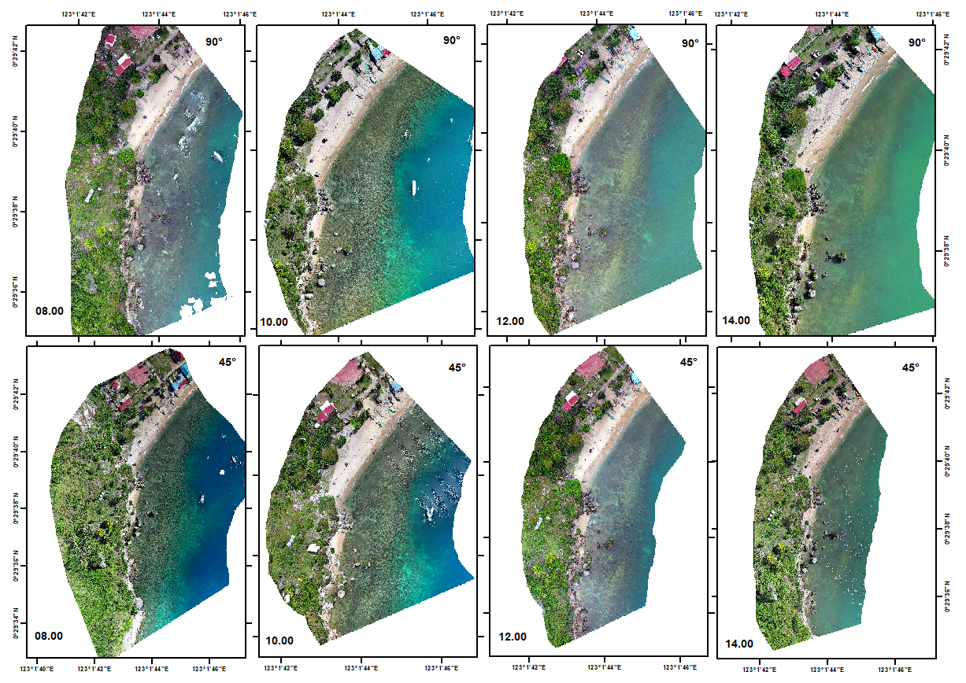

Fig. 2. Orthophoto results from drone acquisition at a 90° and 45° camera angle at 08:00; 10:00; 12:00; and 14:00 AM local time

3.3 Benthic Habitat Classification Scheme

Based on field observations at 189 sampling points, six dominant shallow-water benthic habitat classes were identified in the study area: algae (A), live coral (LC), dead coral (DC), sand (S), seagrass (SG), and rubble (R). This classification scheme was established by referring to the most dominant habitat components in each square transect unit, which were identified visually during the field survey. The frequency of occurrence of each habitat class was as follows: algae (30 points), living coral (42 points), dead coral (35 points), sand (24 points), seagrass (39 points), and rubble (22 points). Of the total observation points, 94 points were used as validation data for testing the accuracy of the classification results, while 95 points were used as thematic layer data in the object-based classification process using eCognition software.

This process aligns with the benthic habitat classification approach that combines remote sensing data with field verification to improve the thematic accuracy of habitat maps (Roelfsema et al., 2020; Panjaitan et al., 2025). According to Blaschke (2010), object-based classification supported by thematic layer data can improve accuracy and reliability in mapping complex habitats such as coral reef systems and seagrass beds. In addition, field test point-based validation is an integral part of avoiding classification bias and ensuring thematic consistency between imagery and ecological reality (Congalton & Green, 2019). The dataset was evenly divided into training and validation subsets to achieve a stratified representation of benthic habitats, minimizing bias and aligning with recommended practices for coastal and marine habitat mapping. This approach follows established standards for accuracy assessment in habitat mapping studies (Congalton & Green, 2019; Roelfsema et al., 2020).

3.4 Image Segmentation and Drone-Based Classification

Image segmentation in this study used the MRS method. This approach breaks the image into objects by looking at how similar the colors and shapes are, based on scale, compactness, and shape. The classification results show significant spatial variation in habitat class distribution between recording angles of 90° and 45° and different acquisition times (Fig. 3).
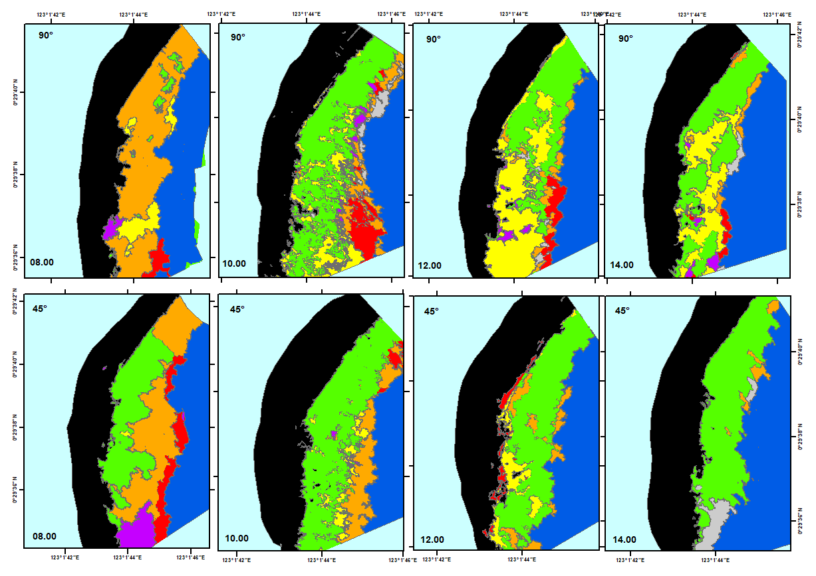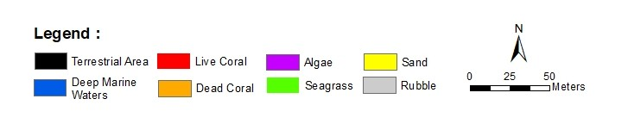
Fig. 3. Benthic habitat classification using 90° and 45° camera angle SVM algorithm

Based on the results of benthic habitat classification using the SVM algorithm, it was found that differences in the angle of the aerial photography camera and the time of acquisition significantly affected the results of habitat cover identification, both in terms of area and spatial distribution. The classification results at 10:00 AM local time, with camera angles of 90° and 45° and a segmentation scale of 50 showed significant differences in the estimated area of each benthic habitat class, as shown in Tables 4 and 5. These variations are primarily attributed to differences in light refraction angles, which are influenced by the sun’s position and atmospheric conditions at the time of image capture, ultimately affecting the visibility of the seafloor (Roelfsema et al., 2020). The amount of light that reaches the camera sensor also plays a key role, as it impacts the quality of reflectance data and how well different features can be distinguished during spatial classification (Joyce et al., 2018). As noted by Eugenio et al. (2017), factors such as sunlight intensity and water clarity significantly affect the accuracy of mapping underwater habitats using drone-based imagery. Therefore, the planning of acquisition timing, camera angle, and segmentation parameter adjustments must be carefully designed to ensure that image classification can accurately and informatively represent benthic habitat conditions.

Table 4. The area of ​​benthic habitat at 10:00 AM local time at a drone camera angle of 90° using the SVM algorithm with a segmentation scale of 50

Benthic Class | Benthic Habitat Area (m²)
A  LC  DC  SG  S  R | 270.32  1,112.56  727.58  4,377.66  1,985.01  450.31

Table 5. The area of ​​benthic habitat at 10:00 AM local time at a drone camera angle of 45° using the SVM algorithm with a segmentation scale of 50

Benthic Class | Benthic Habitat Area (m²)
A  LC  DC  SG  S  R | 385.12  762.11  1,813.51  6,217.98  910.25  228.14

Based on Table 4, the results of benthic habitat classification using the SVM algorithm at the time of recording at 10:00 AM local time. with a drone camera angle of 90° and a segmentation scale of 50, the three dominant habitat classes are seagrass (SG) covering an area of 4,377.66 m², sand (S) covering 1,985.01 m², and live coral (LC) covering 1,112.56 m². Conversely, the classes with the smallest coverage are rubble (R) and algae (A), covering only 450.31 m² and 270.32 m², respectively. Different results were found in the image acquisition with a drone camera angle of 45° (Table 5), where the dead coral (DC) class dominated with an area of 1,813.51 m², seagrass (SG) with an area of 6,217.98 m², and sand (S) with an area of 910.25 m². In contrast, the smallest areas were found in the algae (A) and sand (S) classes. The differences in spatial distribution and area of each habitat class reflect the significant influence of the drone camera angle and segmentation parameters on the classification results. According to Blaschke (2010); Peña et al. (2014); and Ventura et al. (2023), segmentation parameters and camera angle changes can affect the object extraction process and the overall habitat categorization results. Additionally, variations in object appearance in images with oblique and perpendicular angles also affect the spectral and spatial characteristics recorded, thereby impacting the performance of classification algorithms (Roelfsema et al., 2020; Eugenio et al., 2017). As explained by Peña et al. (2014), the success of object-based classification in marine ecosystems is greatly influenced by the suitability between the segmentation scale and habitat heterogeneity, so the selection of segmentation parameters must be adjusted to the ecological characteristics of the study area and supported by adequate field data.

3.5 Accuracy Assessment

Benthic habitat classification using the SVM algorithm with six habitat classes showed significant variations in accuracy levels based on the angle of image capture, acquisition time, and segmentation scale used. The results show that at a drone camera angle of 90°, the highest accuracy was obtained at 10:00 AM local time with a segmentation scale of 50 and an Overall Accuracy (OA) of 91.75%. Conversely, the lowest accuracy at the same angle occurred at 8:00 AM local time with an OA of 73.19% at a segmentation scale of 50. At a recording angle of 45°, the highest OA value was obtained at 14:00 AM local time with a segmentation scale of 50, 76.28%, while the lowest value of 67.01% was obtained at 12:00 AM local time, as shown in Fig. 4. These results support the findings of Green et al. (2000) that OA values above 60% are considered to meet the ideal standard for mapping benthic habitats in shallow waters.

Significant improvements in accuracy at specific times and configurations reflect the algorithm's sensitivity to lighting quality, substrate visibility, and acquisition condition stability. Mastu et al. (2018) noted that SVM provides high accuracy in drone-based benthic habitat mapping with an OA value of 81.1% in classifying linear and non-linear data through transformation to high-dimensional space and using hyperplanes as class separators. A similar study by Nababan et al. (2021) also reported accuracies of 81.1% and 77.4% in classifying 12 and 9 benthic habitat classes using drone imagery, while Wahidin et al. (2015) and Sugara et al. (2017) reported accuracies of 73% and 78%, respectively, on Landsat 8 Operational Land Imager (OLI) and WorldView-2 imagery. This study is consistent with other literature indicating that classification success is highly dependent on the combination of appropriate algorithms, suitable segmentation parameters, and the quality of field reference data (Congalton & Green, 2019; Roelfsema et al., 2020), making it essential to design a comprehensive accuracy testing scheme for benthic habitat mapping in tropical coastal areas.

Fig. 4. Accuracy evaluation of drone camera angles (90° and 45°) across acquisition times

The kappa coefficient is a statistical metric used to assess how closely classification results match reference data, considering agreement that’s not due to chance. It is an important indicator for evaluating the quality of benthic habitat map classification. Based on the classification results using the SVM algorithm at the time of acquisition at 10:00 and a drone camera angle of 90°, the highest Overall Accuracy (OA) was obtained at a segmentation scale of 50, which was 91.75%. Table 6 shows that the Kappa coefficient obtained is 0.89. According to Fleiss’s (1981) classification of Kappa indices, this value falls into the “almost perfect” category (0.81–1), indicating that the classification results using SVM have a high level of reliability.

This study aligns with Congalton & Green (2019), who state that a kappa value close to 1 indicates a high degree of classification agreement with actual data. In the context of benthic habitat mapping, evaluation using the kappa coefficient is crucial as it provides an objective assessment of the consistency of complex multi-class classifications, such as tropical shallow-water habitats with high heterogeneity (Roelfsema et al., 2020). A study by Huanfeng et al. (2020) also showed that the use of the SVM algorithm on underwater habitats produced high kappa values compared to other classification methods, thereby reinforcing the relevance of using SVM in high-resolution image-based mapping.

Table 6. Kappa coefficient results using the SVM algorithm

Drone Flight Times  (Local Time) | Drone Camera Angles | Kappa Coefficient
08:00 | 90° | 0.67
08:00 | 45° | 0.68
10:00 | 90° | 0.89
10:00 | 45° | 0.66
12:00 | 90° | 0.71
12:00 | 45° | 0.59
14:00 | 90° | 0.82
14:00 | 45° | 0.70

4. Conclusion

This study set out to assess how the timing of drone flights and the angle of the camera affect the quality and accuracy of benthic habitat maps created from high-resolution UAV imagery. Conducted in the Coastal Conservation Area of Dulanga Beach, Gorontalo, during June–July 2025, the study used an experimental remote sensing approach combining Object-Based Image Analysis (OBIA) and Support Vector Machine (SVM) classification. Imagery was acquired at four time intervals (08:00, 10:00, 12:00, and 14:00 AM local time) and two camera angles (90° nadir and 45° oblique), with a segmentation scale of 50 applied to delineate six benthic habitat types. The best classification performance was achieved at 10:00 AM with a 90° angle, resulting in an overall accuracy of 91.75% and a Kappa coefficient of 0.89, indicating "almost perfect" agreement with field data. These results highlight how timing and camera positioning can significantly improve habitat classification. However, since the study was limited to a single location and time period, further research in different seasons and environments is needed to test how well the method applies elsewhere. Even so, this approach shows strong potential as a practical tool for marine habitat mapping, especially in areas where detailed spatial data is still lacking.

DISCLAIMER (ARTIFICIAL INTELLIGENCE)

Author(s) hereby declare that NO generative AI technologies such as Large Language Models (ChatGPT, COPILOT, etc) and text-to-image generators have been used during writing or editing of this manuscript.
References

ArcGIS Development Team. (2022). ArchGIS Geographic Information System. Open Source Geospatial Foundation Project. https://www.arcgis.com/index.html
Baatz, M., & Schäpe, A. (2000). Multiresolution segmentation: an optimization approach for high quality multi-scale image segmentation. Proceedings of Angewandte Geographische Informationsverarbeitung XII, 12-23.
Benfield, S. L., Guzman, H. M., Mair, J. M., & Young, J. A. T. (2007). Mapping the distribution of coral reefs and associated sublittoral habitats in Pacific Panama: a comparison of optical satellite sensors and classification methodologies. International Journal of Remote Sensing, 28(22), 5047-5070. https://doi.org/10.1080/01431160701258062
Blaschke, T. (2010). Object based image analysis for remote sensing. ISPRS Journal of Photogrammetry and Remote Sensing, 65(1), 2-16. https://doi.org/10.1016/j.isprsjprs.2009.06.004
BSN (Badan Standardisasi Nasional). (2011). Pemetaan habitat perairan laut dangkal (Bagian 1): Pemetaan terumbu karang dan padang lamun. Jakarta: Badan Standardisasi Nasional.
Casella, E., Collin, A., Harris, D., Ferse, S. C. A., Bejarano, S., Parravicini, V., & Rovere, A. (2017). Mapping coral reefs using consumer-grade drones and structure from motion photogrammetry techniques. Coral Reefs, 36(1), 269-275. https://doi.org/10.1007/s00338-016-1522-0
Chong, W. S., Zaki, N. H. M., Hossain, M. S., Muslim, A. M., & Pour, A. B. (2021). Introducing Theil-Sen estimator for sun glint correction of UAV data for coral mapping. Geocarto International, 37(15), 4527-4556. https://doi.org/10.1080/10106049.2021.1892206
Congalton, R. G., & Green, K. (2019). Assessing the accuracy of remotely sensed data: principles and practices (3rd ed.). Boca Raton: CRC Press. https://doi.org/10.1201/9780429052729
Cortes, C., & Vapnik, V. (1995). Support-vector networks. Machine Learning, 20(3), 273-297. (https://doi.org/10.1007/BF00994018)
Doukari, M., Batsaris, M., Topouzelis, K. (2021). UASea: A Data Acquisition Toolbox for Improving Marine Habitat Mapping. Drones, 5, 73. https://doi.org/10.3390/drones5030073.
Doukari, M., & Topouzelis, K. (2022). Overcoming the UAS limitations in the coastal environment for accurate habitat mapping. Remote Sensing Applications: Society and Environment, 26, 1-13. https://doi.org/10.1016/j.rsase.2022.100726
Eugenio, F., Marcello, J., Martin, J., & Rodríguez-Esparragón, D. (2017). Benthic habitat mapping using multispectral high-resolution imagery: Evaluation of shallow water atmospheric correction techniques. Lensas, 17(11), 1-23. https://doi.org/10.3390/s17112639
Fleiss, J. L. (1981). Statistical methods for rates and proportions (2nd ed.). New York: John Wiley & Sons.
Gauci, A., Deidun, A., Abela, J., Cachia, E., & Dimech, S. (2020). Automatic benthic habitat mapping using inexpensive underwater drones. IGARSS 2020-2020 IEEE International Geoscience and Remote Sensing Symposium, 2213-2216. https://doi.org/10.1109/IGARSS39084.2020.9324241
Green, E. P., Mumby, P. J., Edwards, A. J., & Clark, C. D. (2000). Remote sensing handbook for tropical coastal management. In A. J. Edwards (Ed.). Coastal Management Sourcebooks 3. Paris: UNESCO Publishing.
Hohle, J. (2008). Photogrammetric measurements in oblique aerial images. Photogrammetrie, Fernerkundung, Geoinformation, 1, 7-14.
Huanfeng, S., Jiang, Y., Li, T., Cheng, Q., Zeng, C. & Zhang, L. (2020). Deep learning-based air temperature mapping by fusing remote sensing, station, simulation and socioeconomic data, Remote Sensing of Environment, 240, 1-14. https://doi.org/10.1016/j.rse.2020.111692
James, M. R., & Robson, S. (2012). Straightforward reconstruction of 3D surfaces and topography with a camera: Accuracy and geoscience application. Journal of Geophysical Research: Earth Surface, 117(F3), 1-17. https://doi.org/10.1029/2011JF002289
Joyce, K. E., Duce, S., Leahy, S. M., Leon, J., & Maier, S. W. (2018). Principles and practice of acquiring drone-based image data in marine environments. Marine and Freshwater Research, 70(7), 952-963. https://doi.org/10.1071/MF17380
KKP (Kementerian Kelautan dan Perikanan). (2016). Peraturan Menteri Kelautan dan Perikanan Nomor 14 Tahun 2016 tentang Kriteria dan Kategori Kawasan Konservasi Perairan untuk Wisata Alam Perairan. Jakarta: Kementerian Kelautan dan Perikanan
KKP (Kementerian Kelautan dan Perikanan). (2020). Peraturan Menteri Kelautan dan Perikanan Nomor 31 Tahun 2020 tentang Pengelolaan Kawasan Konservasi. Jakarta: Kementerian Kelautan dan Perikanan
KKP (Kementerian Kelautan dan Perikanan). (2023). Keputusan Menteri Kelautan dan Perikanan Nomor 127 Tahun 2023 tentang Kawasan Konservasi di Perairan di Wilayah Teluk Gorontalo Provinsi Gorontalo. Jakarta: Kementerian Kelautan dan Perikanan RI.
KKP (Kementerian Kelautan dan Perikanan). (2024). Siaran Pers Kementerian Kelautan dan Perikanan. Jakarta: Kementerian Kelautan dan Perikanan RI.
Klemas, V. V. (2015). Coastal and environmental remote sensing from unmanned aerial vehicles: An overview. Journal of Coastal Research, 31(5), 1260–1267. (https://doi.org/10.2112/JCOASTRES-D-15-00005.1)
Lillesand, T. M., Kiefer, R. W., & Chipman, J. W. (2015). Remote sensing and image interpretation (7th ed.). New York: John Wiley & Sons.
Longley, P. A., Goodchild, M. F., Maguire, D. J., & Rhind, D. W. (2015). Geographic information systems and science (4th ed.). New York: John Wiley & Sons.
Mastu, L. O. K. (2019). Pemetaan habitat bentik berbasis objek menggunakan citra unmanned aerial vehicle (UAV) dan satelit Sentinel-2 di perairan Pulau Wangi-Wangi Kabupaten Wakatobi [Tesis]. IPB University, Bogor.
Nababan, B., Mastu, L. O. K., Idris, N. H., & Panjaitan, J. P. (2021). Shallow-water benthic habitat mapping using drone with object based image analyses. Remote Sensing, 13(21), 1-23. https://doi.org/10.3390/rs13214452
Nugroho, A., Nababan, B., Panjaitan, J. P., & Agus, S. B. (2024). Object-based benthic habitat mapping using drones in the waters of Gili Labak Island, Sumenep. Jurnal Kelautan, 17(1), 29-42. https://doi.org/10.21107/jk.v17i1.24518
Øie, K., Gundersen, H., Nøddebo, R., Edward, J., Salberg, A., Esam, M., Buls, T., Bekkby, T., & Hancke, K. (2024). MethodsX drone and ground-truth data collection, image annotation and machine learning : A protocol for coastal habitat mapping and classification. MethodsX, 13, 1-19. https://doi.org/10.1016/j.mex.2024.102935
Panjaitan, J. P., Qirani, J. F., & Agus, S. B. (2025). Analysis of changes in shallow water benthic habitat area using sentinel-2 imagery on the Ujung Genteng Coast, Sukabumi, West Java, Indonesia. Bio Web of Conferences, 168, 1-14. https://doi.org/10.1051/bioconf/202516805006
Pemerintah Provinsi Gorontalo. (2024). Peraturan Daerah Provinsi Gorontalo tentang Rencana Tata Ruang Wilayah Provinsi Gorontalo Tahun 2024-2043. Gorontalo: Pemerintah Provinsi Gorontalo.
Peña, J. M., Gutiérrez, P. A., Torres-Sánchez, J., Hervás-Martínez, C., & López-Granados, F. (2014). Object-based image classification of agricultural systems using machine learning algorithms. Remote Sensing, 6(6), 5019-5041. https://doi.org/10.3390/rs6065019
Purkis, S. J., Gleason, A. C. R., Purkis, C. R., Dempsey, A. C., Renaud, P. G., Faisal, M., Saul, S., & Kerr, J. M. (2019). High-resolution habitat and bathymetry maps for 65,000 sq. km of Earth’s remotest coral reefs. Coral Reefs, 38(3), 467-488. https://doi.org/10.1007/s00338-019-01802-y
Prayuda, B. (2014). Panduan teknis pemetaan habitat dasar perairan laut dangkal. pemetaan habitat dasar perairan laut dangkal. Jakarta: COREMAP CTI LIPI. https://www.scribd.com/document/332370130/p2olipi-pdf
Qin, J., Li, M., Zhao, J., Li, D., Zhang, H., & Zhong, J. (2024). Advancing sun glint correction in high-resolution marine UAV RGB imagery for coral reef monitoring. ISPRS Journal of Photogrammetry and Remote Sensing, 207, 298-311. https://doi.org/10.1016/j.isprsjprs.2023.12:007
Rahmani, E., Karang, I. W. G. A., & Putra, I. D. N. N. (2022). Pemetaan habitat bentik menggunakan citra sentinel-2a dan unmanned aerial vehicle (UAV) di Perairan Pemuteran, Bali. Journal of Marine Research and Technology, 5(1), 29-39. https://ojs.unud.ac.id/index.php/JMRT/article/view/73768
Roelfsema, C. M., Kovacs, E. M., Ortiz, J. C., Callaghan, D. P., Hock, K., Mongin, M., Johansen, K., Mumby, P. J., Wettle, M., Ronan, M., Lundgren, P., Kennedy, E. V, & Phinn, S. R. (2020). Habitat maps to enhance monitoring and management of the Great Barrier Reef. Coral Reefs, 39(4), 1039-1054. https://doi.org/10.1007/s00338-020-01929-3
Siregar, V. P. (2010). The bottom substrate shallow water mapping using the Quick Bird satellite imagery. E-Jurnal Ilmu dan Teknologi Kelautan Tropis, 2(1), 19-30.
Sugara, A., Siregar, V. P., & Agus, S. B. (2020). Benthic habitat classification of shallow water using Worldview-2 Imagery with in-situ and drone data. Jurnal Ilmu dan Teknologi Kelautan Tropis, 12(1), 135-150. https://doi.org/10.29244/jitkt.v12i1.26448
Sullivan, E., Papagiannopoulos, N., Clewley, D., Groom, S., Raitsos, D. E., & Hoteit, I. (2025). Mapping coastal marine habitats using UAV and multispectral satellite imagery in the NEOM Region, Northern Red Sea. Remote Sensing, 17, 1-23. https://doi.org/10.3390/rs17030485
Turner, D., Lucieer, A., & Watson, C. (2012). An automated technique for generating georectified mosaics from ultra-high resolution UAV imagery, based on Structure from Motion (SfM) point clouds. Remote Sensing, 4(5), 1392–1410. https://doi.org/10.3390/rs4051392
Ventura, D., Grosso, L., Pensa, D., Casoli, E., Mancini, G., Valente, T., Scardi, M., & Rakaj, A. (2023). Coastal benthic habitat mapping and monitoring by integrating aerial and water surface low-cost drones. Frontiers in Marine Science, 9, 1-15. https://doi.org/10.3389/fmars.2022.1096594
Wahidin, N., Siregar, V. P., Nababan, B., & Jaya, I. (2015). Object-based image analysis for coral reef benthic habitat mapping with several classification algorithms. Procedia Environmental Sciences, 24, 222–227. (https://doi.org/10.1016/j.proenv.2015.03.029)
Westoby, M. J., Brasington, J., Glasser, N. F., Hambrey, M. J., & Reynolds, J. M. (2012). ‘Structure-from-Motion’ photogrammetry: A low-cost, effective tool for geoscience applications. Geomorphology, 179, 300–314. https://doi.org/10.1016/j.geomorph.2012.08.021
Wolf, P. R., & Dewitt, B. A. (2000). Elements of Photogrammetry with Applications in GIS (3rd ed.). McGraw-Hill.
Yang, L., Lu, W., He, L., Huang, H., Liu, Z., Zhang, Y., Ma, Y., Yu, J., Zuo, G., Ai, Y., Liu, C., & Xu, Y. (2025). Mapping benthic habitats in Bohai Bay, China. Scientific Reports, 15, 1-11. https://doi.org/10.1038/s41598-025-02091-y
Definitions, Acronyms, Abbreviations
% | Percent
< | Less than
A | Algae
AM | Ante Meridiem
cm | Centimeter
DC | Dead coral
DSM | Digital surface model
et al. | Et alia
GPS | Global positioning system
GSD | Ground sampling distance
LC | Live coral
m | Meter
MPAs | Marine protected areas
MRS | Multi-resolution segmentation
OA | Overall accuracy
OBIA | Object-based image analysis
OLI | Operational Land Imager
PA | Producer accuracy
QGIS | Quantum Geographic Information System
R | Rubble
RAM | Random Access Memory
RGB | Red, green, blue
S | Sand
SfM | Structure from motion
SG | Seagrass
SVM | Support vector machine
UA | User accuracy
UAVs | Unmanned aerial vehicles
3D | Three dimensions

