ORIGINAL RESEARCH ARTICLE

Impact of coal mine water on the histology of liver of Clarias batrachus (Linnaeus, 1758)

ABSTRACT

Aim: Increased instances of mining to obtain various sorts of minerals and energy forms have been reported to impose serious ill effects on the environment. Coal is one such energy form which is being extensively mined in the regions of Jharkhand. The following experiment was designed to investigate the effect of coal mine water on the histology of liver of Clarias batrachus.
Study design: Fish were randomly divided into 3 groups with 5 fishes in each. Group 1 was kept as control, whereas fish in group 2 and 3 were exposed to 65% V/V of coal mine water collected from Pachwara North coal mines, Pakur, Jharkhand for 21 and 30 days, respectively.
Place and Duration of Study: The study was conducted in the Department of Zoology, St. Xavier College, Ranchi during March 2025 to May 2025.
Methodology: After 21 and 30 days, fish were sacrificed and liver tissues were procured, blotted free of blood and fixed in Bouin’s solution. The tissues were dehydrated, cleared and embedded into paraffin blocks. 5µm thin sections were cut and stained with H&E stain following routine laboratory protocol. Photomicrography was done using image analyzer for comparative analysis.
Results: Control liver showed normal architecture of intact central vein, roughly hexagonal hepatocytes with centrally placed nucleus alternating with sinusoids of normal diameter. In the treated group for 21 days, congested central vein, vacuolization and irregular sinusoids were notably visible. The damage intensified on exposure for 30 days showing time-dependent increase in the histological damage.
Conclusion: This showed that there were observable alterations in the liver histology upon exposure to coal mine water and the degree of damage intensified as duration of exposure increased. This warrants effective management of coal mine effluents prior to its disposal in the water bodies.

Keywords: Coal mine water, Clarias batrachus, liver, hepatocytes, Central vein, blood vessels.

1. INTRODUCTION

India has a rich reserve of fuels. Out of which, Coal, the black gold of the earth, is a valuable energy resource for commercial and industrial use (Jehan and Khurshid, 2020; Ghugare and Katkar, 2022). Among Indian states, Jharkhand tops the list with maximum coal reserves. Auranga, Bokaro, Dhanbad, Jharia, Giridih, Karanpur, Ramgarh and Hutar are some of the listed coal mining regions of Jharkhand (Jehan and Khurshid, 2020). Coal mining is a crucial economic activity in Jharkhand, especially in the regions of Hazaribagh and Dhanbad playing an important role in energy production, supporting industries and employment. However, the environmental degradation due to mining activities cannot be ignored (Das and Sethi, 2025; Singh and Singh, 2022). The effluents from coal contain a load of TSS, TDS, calcium carbonate and trace metals, which adversely affects the health of soil and water in the vicinity (Ghugare and Katkar, 2022). The coal mining activity has adversely affected the air, water and soil resources in Jharia coalfield, Jharkhand. The oxides of nitrogen and sulfur, fine coal dust, suspended and respirable particulate matter were reported as major air pollutants that caused severe respiratory damages. Physical disruption of aquifers due to underground mining and surface runoff can contaminate the ground water as well as surface water resources. Its damaging effects on soil, vegetation pattern, topography and land use/land cover have also been reported (Saini V, 2018). In the regions of Hazaribag and Dhanbad mines, local people have been documented to be suffering from various air and water borne disease (Jehan and Khurshid, 2020). The coal mining activities including drilling, blasting, crushing and transportation of coal not only affected the air, noise and water environments but also degraded the land and drainage system of the mining area in Chasnalla block, Jharia basin, Jharkhand (Kumar et al., 2009). The calamitous effects of coal mining on quality and availability of surface as well as sub- surface water reserves have been reported by Hasii and Gasii, 2024.
Mining and smelting processes are one of the major anthropogenic sources for heavy metal release in the environment. They tend to enter into the natural water bodies and get accumulated into sediments and biota. As fish is a major food source for humans, the heavy metals can be a part of food chain, causing damages to the human health. In fish, the metal accumulation has been reported to be more in metabolically active tissues, namely, liver, kidney, gills, etc. Among these, liver accumulates comparatively greater percentage of heavy metals due to presence of metal binding proteins (Ali and Khan, 2018). So, in the present study, an effort has been made to investigate the effects of coal mine water exposure on the liver tissues of walking catfish, Clarias batrachus (Linnaeus, 1758). C. batrachus, being a hardy freshwater species, native of South and Southeast Asia is mostly used as a biological model because of its wide distribution, high market value, physiological tolerance and susceptibility to water borne pollutants (Debnath s, 2011).

2. material and methods

2.1 Experimental animal: Live C. batrachus weighing 31.6 to 17.8 g and 13.6 to 16.9 cm in length were obtained from Ranchi’s Hygiene Fish Market. Ranchi, the capital of Jharkhand, India, is located in southern part of Chota Nagpur plateau and has humid sub- tropical climate. Fish were brought to the Department of Zoology, St. Xavier’s college, Ranchi in water filled plastic bag. They were disinfected using KMnO₄ and kept for acclimatization for one week in glass aquaria under standard laboratory conditions (temperature 30 ± 2°C and 12/12 hours light/Dark photoperiod). The fish were fed with commercial pellet food ad libitum (Perfect Fit Fish Food). The water of aquarium was changed on daily basis and left over food and excreta were siphoned off regularly during acclimatization.
2.2 Experimental water: Test water sample was collected from the Pakur, Jharkhand, area surrounding the Pachwara North Coal Mine. Acid-washed bottles were used to collect the sample. For control sample, tap water was used.
2.3 Preparation of Dose: For exposure, 65% V/V of coal mine water was used.

2.4 Animal grouping: Animals were randomly divided into 3 groups with 5 fishes in each group.
Group 1: Treated with normal tap water
Group 2: Treated with 65% V/V of coal mine water for 21 days.
Group 3: Treated with 65% V/V of coal mine water for 30 days.
2.5 Histological analysis: After 21 and 30 days, fishes were sacrificed and liver tissue was procured and blotted free of blood and fixed in Bouin’s solution. Further tissues were dehydrated, cleared in xylene, infiltered and embedded in paraffin wax. 5µ thin sections were cut, spread and stained with H&E stain following routine laboratory protocol. The stained sections were then observed under image analyzer (MX21iLED Biological Microscope).
3. results and discussion

3.1. Anatomical localization of liver
The in-situ localization of liver assists in providing better understanding of position of liver anatomically and its morphology. The liver of C. batrachus was two-lobed and reddish-brown in colour. It was located in the anterior of the gut (Fig I).
3.2. Comparative histo- morphological analysis of liver tissues
Upon histological analysis, the liver sections of control group fish showed normal architecture of hepatic parenchyma with presence of radiating cords of hexagonal hepatocytes, alternating with sinusoidal space. The central vein was of normal shape. Endothelium of the central vein was intact (Fig II). Liver, being a site for metabolism and detoxification, becomes susceptible to damage from environmental changes. In the group treated for 21 days with coal mine water, hepatocytes appeared swollen indicating cellular damage. Presence of large vacuoles in the cytoplasm reflected fatty degeneration. Distortion in central vein was observed, indicating circulatory impairment (Fig III & IV). In the group treated for 30 days with the coal mine water, damage was more severe indicating time- dependent damages. Congestion in Central vein was evident. Irregularity in the shape of hepatocytes was observed as well as presence of severe congested sinusoids were notable (Fig V & VI). Table 1 showed semi- quantitative scoring of the histopathological alterations observed in the liver sections of the fish of different group. The scoring advocated the time- dependent increment in the toxic changes in the liver parenchyma. Most changes were observed in central vein and other blood vessels.

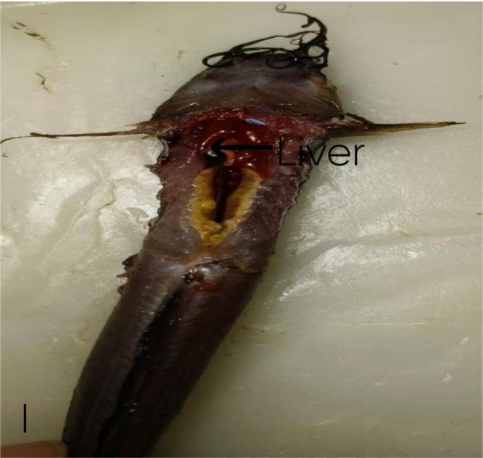

Fig I: In situ localization of liver in C. batrachus

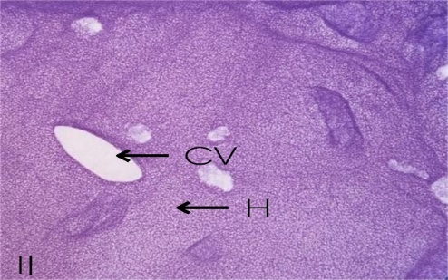

Fig II: Photomicrograph of T. S. of liver of group I showing intact central vein (CV) and regular hepatocytes (H&E; X100).

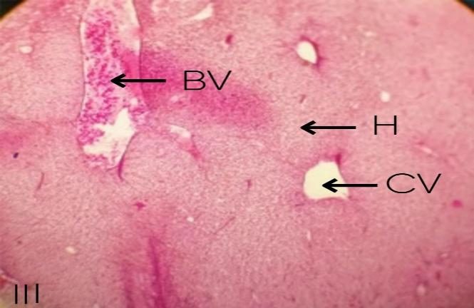

Fig III: Photomicrograph of T. S. of liver of group II fish showing distortion in Central vein (CV) and presence of blood-filled vessels following exposure to coal mine water for 21 days (H&E; x100).
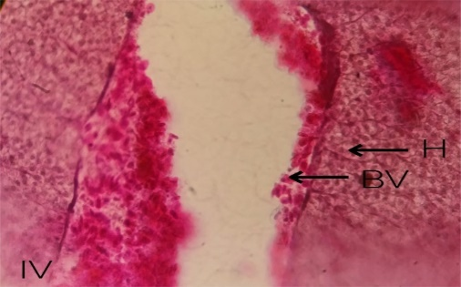

Fig IV: Photomicrograph of T. S. of liver of group II fish showing magnified view of hepatocytes undergoing degenerative changes and blood- filled vessels (H&E; X400).
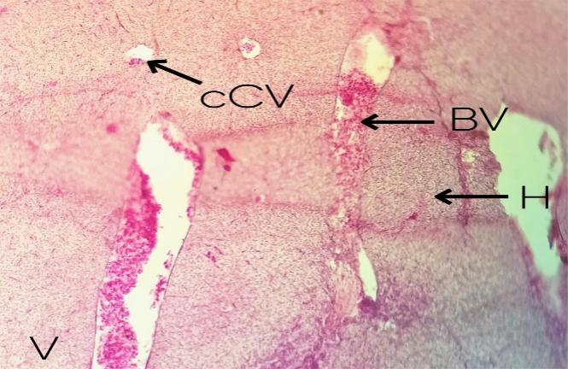

Fig V: Photomicrograph of T. S. of liver of group III fish showing congestion in central vein and blood- filled enlarged blood vessels following exposure to coal mine water for 30 days (H&E; X100).

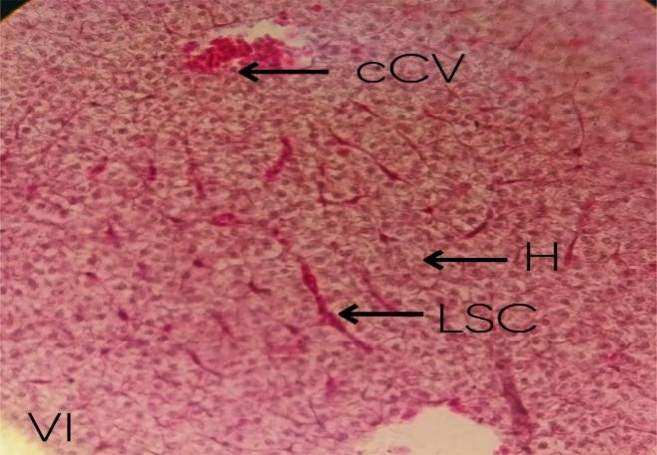

Fig VI: Photomicrograph of magnified view of T. S. of liver showing severe congestion in liver sinusoid space (LSC), central vein (CV) and irregularity in hepatocytes (H) (H&E; X400).

Table 1: Semi- quantitative scoring of the pathological alterations in liver of C. batrachus following exposure to coal mine water for 21 and 30 days.
Histopathological lesions | Group 1 (Control) | Group 2  (21 days exposure) | Group 3  (30 days exposure)
Dilation in central vein | - | + | ++
Congestion in central vein | - | + | ++
Congestion in sinusoids | - | - | ++
Dilation of blood vessels | - | ++ | ++
Haemorrhage | - | ++ | ++
Hepatic necrosis | - | + | ++
Score: (-) No alteration, (+) Mild alteration, (++) Moderate alteration.

The findings of present study were consistent with earlier documentations made on detrimental effects of coal mine activities on the water bodies. Fish can be used as a bioindicator to assess the quality of the aquatic system. Pathological changes in the histological architecture of liver of the fish showed toxic effects of the coal mine water on the biota of the aquatic body. According to a report by Nath et al., 2022, a complete absence of fish fauna was observed in the coal mining areas near Jaintia Hills in Meghalaya, India, possibly due to traces of heavy metals in the water body.
Heavy metals are one of the major concerns among different pollutants released from coal mine effluents, as they are non- biodegradable and can accumulate in the animal tissues (Lakra et al., 2019). A wide range of heavy metal was reported in the lignite coal, slag and fly ash samples collected from thermal power plant situated in Central Anatolian Region of Turkey (Aydan et al., 2022). Coal mining activity results in leaching of acidic mine tailing, also known as, ‘Acid Mine Drainage’ (AMD). AMD can further result into leaching of metalloids, arsenic and heavy metals, such as, Aluminium, Cadmium, Manganese, Chromium, etc (Ekwule et al., 2019; Ghugare and Katkar, 2022). Heavy metal pollution from coal mine effluents have been reported by many researchers (Mishra et al., 2008; Li et al., 2018; Shylla et al., 2020; Kumari and Bhattacharya, 2023; Bi et al., 2024). These heavy metals get accumulated in the tissues of the fish species inhabiting those water bodies. Bioaccumulation of metals in the tissues not only affects the growth and survival of that individual, but can also invoke toxicity in organisms feeding upon them via biomagnification across trophic levels (Ali and Khan, 2018). High concentration of heavy metals (Pb, Zn, Cu and Cd) has been reported in soil and seedlings and mature tree leaves found near Gera coal mine, Korba district, Chhattisgarh (Garg and Singh, 2017). According to reports, geo- accumulation of heavy metals, such as, As, Pb and Cd in the soil samples were associated with various anthropogenic activities including coal mining and combustion (Zhang et al., 2020). Coal mining has been reported to impose huge effects on the local water resources, including both the surface and ground water. Surface water is being contaminated via discharge of acidic mine water, whereas ground water is being contaminated by pilfer of the aquifers (Ray et al., 2020). Toxic effects of heavy metals on physico- chemical properties of the water body and on the health of living organisms inhabiting them have been investigated by many researchers.

There are not much documentations on the effects of coal mine water on different fish species inhabiting in the water body present in the coal mine regions in Jharkhand. However, there are evidences of increased hardness, decreased pH and heavy metal concentration in the coal mine effluents (Saini V, 2018). So, a probable line of connection can be drawn between effects of heavy metals and coal mine water exposure on the tissue of the fish. Supporting the outcomes of this study, congestion of blood cells in the central vein and degeneration of hepatic cells were reported by Lakra et al., 2019 in the liver tissues of C. batrachus inhabiting the pond near Rajrappa coal mine, Jharkhand. The pond water was reported with high concentration of heavy metals, namely, Fe, Zn, Cu, Mn, Ni, Cd, Pb and Cr (Lakra et al., 2019). In the same line, Selvanathan et al., 2013 reported formation of vacuoles in the hepatocytes following the exposure of Cadmium in C. batrachus. In agreement with present findings, loss of characteristics cellular architecture of the hepatic tissue, dilation of blood vessels, congestion in sinusoidal spaces, vacuolization and focal necrosis was observed in Cirrhinus mrigala exposed to sublethal concentrations of mercuric chloride and lead acetate (Chavan and muley, 2014). Similarly, liver sections of Channa gachua exposed to lethal and sub- lethal concentrations of mercury chloride and copper chloride showed disarrayed hepatic cords, rupture of blood sinusoids, vacuolization and nuclear degenerations in the hepatocytes (Deore and Wagh, 2012). Toxic alterations in the liver tissues induced by heavy metals (Fe, Zn, Cu, Hg) have been documented in C. batrachus (Srivastava and Prakash, 2019; Mishra and Behera, 2023) and Cyprinus carpio (Samer et al., 2021). Morphometric and semi- quantitative scoring of alterations in liver of juvenile Clarias gariepinus exposed to silver nanoparticles and silver nitrate for 15 days showed pathological changes which were significantly reduced in recovery phase. This showed that the manageable and controlled application of toxicants can be useful in protection of aquatic ecosystem (Naguib et al., 2020).

The findings of this study can be used as an indicator to show the impact of coal mine water exposure on the functioning of inhabiting fish species. However, the study warrants a thorough investigation of physico- chemical properties of the water body.

4. Conclusion

The following experiment showed that there were observable alterations in the liver histology upon exposure to coal mine water and the degree of damage intensifies as duration of exposure increases. Thus, it is necessary to treat the coal mine water before it is discharged into the water bodies because the contamination of water bodies from coal mine effluents and its impact on the aquatic life is a matter of concern.

Disclaimer (Artificial intelligence)
Option 1:
Author(s) hereby declare that NO generative AI technologies such as Large Language Models (ChatGPT, manuscript.

REFERENCES

- Jehan, R., and Khurshid, I. (2020). Evaluating the causes of illness in the coal mining areas of Jharkhand: A case study of Hazaribagh and Dhanbad mines. International Education & Research Journal, 6(8), 8-9.
- Ghugare, G.S., and Katkar, P.S. (2022). Heavy metals in the coal mines environment, their toxicity and remediation. International Journal of Researches in Biosciences, Agriculture and Technology, 10(3), 118-129.
- Das, R., and Sethy, K. M. (2025). Impact of coal mining sites near Hazaribagh, Jharkhand: A socio-environmental analysis. International Journal of Innovative Research in Technology, 11(9), 892–897.
- Singh, A. K., and Singh, Y. K. (2022). Social and occupational impact of coal mining in Dhanbad (Jharkhand) India – A case study. Asian Journal of Agricultural Extension, Economics & Sociology, 40(10), 66–77. 10.9734/AJAEES/2022/v40i1031041.
- Saini, V. (2018). Impact of coal mining and mine fires on the local environment in Jharia coalfield, Jharkhand. Everyman's Science, LIII(1), 18-22.
- Kumar, G., Singha, P.K., and Kumar, D. (2009). Environmental concerns associated with coal mining activity - a case study. International Journal of Chemical Science, 7(2), 731-752.
- Hasii, O., and Gasii, G. (2024). Coal mining and water resources: impacts, challenges, and strategies for sustainable environmental management. IOP Conference Series: Earth and Environmental Science, 1348, 012017. https://doi.org/10.1088/1755-1315/1348/1/012017.
- Ali, H., and Khan, E. (2018). Bioaccumulation of non-essential hazardous heavy metals and metalloids in freshwater fish. Risk to human health. Environmental Chemistry Letters. https://doi.org/10.1007/s10311-018-0734-7.
- Debnath, S. (2011). Clarias batrachus, the medicinal fish: An excellent candidate for aquaculture and employment generation. Proceedings of the International Conference on Asia Agriculture and Animal (IPCBEE), 13, 32–37.
- Nath, P., Deka, A., and Talukdar, M. (2022). Effects of coal mining on fishes of Meghalaya, India: a review. Uttar Pradesh Journal of Zoology, 43(7), 1-8.
- Lakra, K.C., Lal, B., and Banerjee, T.K. (2019). Coal mine effluent-led bioaccumulation of heavy metals and histopathological changes in some tissues of the catfish Clarias batrachus. Environmental Monitoring and Assessment, 191(136). https://doi.org/10.1007/s10661-019-7229-2.
- Aydan, A., Turhan, Ş., Kurnaz, A., Gören, E., Duran, C., Hançerlioğulları, A., and Uğur, F.A. (2022). Assessment of the Enrichment of Heavy Metals in Coal and Its Combustion Residues. ACS Omega, 7, 21239-21245. https://doi.org/10.1021/acsomega.2c02308.
- Ekwule, O. R., Akpen, G. D., and Ugbede, G. M. (2019). The effect of coal mining on the water quality of water sources in Nigeria. Bartın University International Journal of Natural and Applied Sciences (JONAS), 2(2), 251–260.
- Mishra, V.K., Upadhyaya, A.R., Pandey, S.K., and Tripathi, B.D. (2008). Heavy metal pollution induced due to coal mining effluent on surrounding aquatic ecosystem and its management through naturally occurring aquatic macrophytes. Bioresource Technology, 99, 930-936. https://doi.org/10.1016/j.biortech.2007.03.010.
- Li, F., Li, X., Hou, L., and Shao, A. (2018). Impact of the coal mining on the spatial distribution of potentially toxic metals in farmland tillage soil. Scientific Reports, 8, 14925. https://doi.org/10.1038/s41598-018-33132-4.
- Shylla, L., Barik, S. K., and Joshi, S. R. (2020). Impact assessment of heavy metal contamination on water quality of underground and open-cast coal mines. The NEHU Journal, 18(2), 58–72.
- Kumari, M., and Bhattacharya, T. (2023). A review on bioaccessibility and the associated health risks due to heavy metal pollution in coal mines: Content and trend analysis. Environmental Development, 46, 100859. https://doi.org/10.1016/j.envdev.2023.100859.
- Bi, G., Li, X., Du, X., Sun, X., and Yao, W. (2024). Remediation of heavy metal pollution from coal mine effluent using metal- organic frameworks (MOF): Impact of water media, operational factors and metal characteristics. Minerals, 14, 764. https://doi.org/10.3390/ min14080764.
- Garg, P., and Singh, S.S. (2017). Heavy metal accumulation pattern in soil and seedlings and in leaves of mature tree species at Gevra coal mine area in Chhattisgarh, India. Journal of Industrial Pollution Control, 34(1), 1629-1634.
- Zhang, Y., Wu, D., Wang, C., Fu, X., and Wu, G. (2020). Impact of coal power generation on the characteristics and risk of heavy metal pollution in nearby soil. Ecosystem Health and Sustainability, 6(1). https://doi.org/10.1080/20964129.2020.1787092.
- Ray, S., and Dey, K. (2020). Coal Mine Water Drainage: The Current Status and Challenges. Journal of The Institution of Engineers (India): Series (D). 101, 165–172. https://doi.org/10.1007/s40033-020-00222-5
- Selvanathan, J., Vincent, S., and Nirmala, A. (2013). Histopathology changes in freshwater fish Clarias batrachus (Linn.) exposed to mercury and cadmium. Life Science Biotechnology, 3(2), L11–L18.
- Chavan, V. R., and Muley, D. V. (2014). Effect of heavy metals on liver and gill of fish Cirrhinus mrigala. International Journal of Current Microbiology and Applied Sciences, 3(5), 277–288.
- Deore, S. V., and Wagh, S. B. (2012). Heavy metal induced histopathological alterations in liver of Channa gachua (Ham). Journal of Experimental Sciences, 3(3), 35–38.
- Srivastava, N.K., and Prakash, S. (2019). Effect of Zinc on the Histopathology of Gill, Liver and Kidney of Fresh Water Catfish, Clarias batrachus (Linn.). International Journal of Biological Innovations, 1(1), 8-13. https://doi.org/10.46505/IJBI.2019.1102.
- Mishra, A., and Behera, B. (2023). Effect of mercury on histological alterations in gill, liver and stomach tissues of Indian catfish, Clarias batrachus. Journal of Applied and Natural Science, 15(2), 685-691. https://doi.org/10.31018/ jans.v15i2.4467.
- Samer, S.A., Raesen, A.K., and Najim, S.M. (2021). Effect of heavy metals on physiological and histological status in liver of common carp Cyprinus carpio, reared in cages and wild in the Euphrates River, Babil / Iraq. IOP Conference Series: Earth and Environmental Science, 779, 012066. https://doi.org/10.1088/1755-1315/779/1/012066.
- Naguib, M., Mahmoud, U. M., Mekkawy, I. A., and Sayed, A. E. H. (2020). Hepatotoxic effects of silver nanoparticles on Clarias gariepinus; Biochemical, histopathological and histochemical studies. Toxicology Reports, 7, 133-141. https://doi.org/10.1016/j.toxrep.2020.01.002.
ABBREVIATIONS
AMD: Acid mine drainage
As: Arsenic
BC: Blood Cells
BV: Blood vessels
cCV: Congested Central vein
Cd: Cadmium
Cr: Chromium
Cu: Copper
Fe: Iron
H&E: Hematoxylin and Eosin
H: Hepatocytes
Hg: Mercury
LSC: Liver Sinusoid Space
Mn: Manganese
Ni: Nickel
Pb: Lead
TDS: Total dissolved solids
TSS: Total suspended solids
Zn: Zinc

