Constructing a Collaborative Ecosystem for Holistic Student Development in Higher Education: Integrating Logistics, Student Affairs and Digital Governance

.
ABSTRACT

The increasing complexity of student needs and the acceleration of digital transformation in higher education have revealed critical limitations in traditional student development models. Typically fragmented across logistics, student affairs, and information technology systems, these subsystems often lack integration, resulting in inefficient service delivery and disjointed student support. This study moves beyond technical unification and instead seeks to promote cultural, structural, and procedural transformation of the university as a developmental community. It proposes a triadic collaborative framework that unifies these subsystems into a cohesive ecosystem for holistic student development. Drawing on theories of educational ecology, holistic governance, and smart campus design, the framework emphasizes three integration pathways: shared vision alignment, structural coupling, and operational coordination. While existing research has focused predominantly on academic or instructional integration, this paper addresses a distinct and underexplored area—how non-academic subsystems such as logistics, student support services, and IT infrastructure can be systematically integrated into a coherent governance model for student development. Through this lens, the paper analyzes institutional barriers—including functional misalignment, data silos, governance inertia, and professional discourse gaps—that undermine effective collaboration. It also presents actionable strategies such as redesigning performance incentives, establishing interoperable digital infrastructures, and cultivating a culture of cross-functional engagement. This integrative model provides strategic insights for universities aiming to build student-centered, data-informed governance structures. The findings hold particular relevance for institutions navigating digital transformation while seeking to enhance whole-person education in the post-pandemic era.

Keywords: Higher education governance, Collaborative student development, Smart campus, System integration, Digital transformation

1. INTRODUCTION

In recent years, the governance of higher education has undergone a profound transformation, driven by both policy imperatives for integrated student support and the accelerating adoption of digital technologies(Shen, 2023; Wu et al., 2024;Palma et al., 2023). The traditional approach—where logistics, student affairs, and information systems operated in silos—has proven increasingly inadequate in meeting the evolving and multidimensional needs of students (Ling et al., 2022; Metsäpelto et al., 2022;Bai et al., 2025). These divisions often result in duplicated efforts, fragmented interventions, and missed opportunities to support students holistically throughout their academic journey.At the same time, the vision of “all-staff, all-process, and all-domain education” has become a strategic directive across many universities, particularly in China and other East Asian contexts. However, realizing this vision requires more than rhetorical alignment; it demands a structural rethinking of how various subsystems within the university contribute to student development—not as auxiliary service providers, but as integral parts of an interconnected ecosystem (Xiang et al., 2024; Liu et al., 2021). Existing literature has highlighted the potential of smart campuses and AI-enabled platforms to reshape education delivery and institutional governance (Wang et al., 2024; Hou, 2024). However, research on how non-academic subsystems—such as logistics, student support services, and IT infrastructure—can be integrated into a coherent governance model for student development remains limited (Flori et al., 2025). Few studies have examined how to overcome entrenched institutional boundaries, incompatible data systems, or the lack of shared educational responsibility among departments (Zhao et al., 2023; Liu, 2024).

This paper addresses that gap by constructing a triadic framework that integrates logistics, student affairs, and information systems into a collaborative student development ecosystem. Drawing on educational ecology and holistic governance theories, it explores the underlying logic of inter-system integration, analyzes institutional tensions in current practices, and proposes actionable strategies for building a coordinated and data-driven student support model (Afzaal et al.,2021; Gil et al., 2021). In doing so, it seeks to move beyond technical integration and toward a cultural, structural, and procedural transformation of the university as a developmental community.

While this paper is primarily conceptual, its structure reflects sound scientific methodology. It builds upon established theories, clearly identifies a research gap, and proposes actionable strategies for reform. Although no external validation is presented in this version, the manuscript’s value lies in its ability to bridge theoretical perspectives with strategic institutional design, particularly by highlighting risks such as goal misalignment, governance inertia, data integration challenges, and cultural barriers to implementation.

2. Theoretical Framework

This study is grounded in three interrelated theoretical perspectives: educational ecology, holistic governance, and smart campus architecture. Together, they offer a conceptual lens for understanding how diverse subsystems within a university can be integrated to serve a shared developmental goal.

（1）Educational ecology, first proposed by Bronfenbrenner (1979) and later adapted for institutional environments, views student development as a product of dynamic interactions across multiple nested systems. Within a university, this includes not only academic instruction, but also the socio-technical environments formed by logistics, administration, and digital platforms. Ecological thinking urges a shift from linear, input-output models of education to complex, system-oriented frameworks that emphasize interaction, adaptation, and feedback.

（2）Holistic governance extends this systems perspective into the realm of institutional design and decision-making. Rather than treating governance as the domain of formal administrative hierarchies, holistic governance emphasizes the coordination of actors, processes, and information flows across functional boundaries. It is particularly relevant in the context of higher education, where departmental autonomy often leads to governance fragmentation and accountability silos (Hou, 2024; Liu, 2023).

（3）Smart campus architecture provides the technological infrastructure necessary for such integration. Drawing from advances in AI, big data, and cloud computing, smart campus models aim to centralize services, personalize learning, and optimize operations through real-time data processing and predictive analytics (Wang et al., 2024; Su, 2023；Lin, 2020). However, the deployment of smart technologies alone does not guarantee coordination. Without institutional alignment and shared educational values, digital platforms risk becoming isolated tools rather than catalysts for systemic change.

By weaving these three perspectives together, this study constructs an analytical framework for diagnosing fragmentation in current student development systems and for designing integrative strategies that are both technologically supported and institutionally sustainable.

3. Fragmentation and Coordination Challenges Integration Pathways for a Collaborative Student Development Ecosystem

Despite growing consensus on the importance of whole-person education, many universities continue to operate under governance structures that separate student development into isolated administrative functions. Logistics departments, student affairs offices, and information centers often operate independently, each guided by distinct priorities, technologies, and evaluation metrics. This institutional segmentation results in disjointed services, inefficient information flows, and an overall lack of coherence in addressing student needs.

One core challenge lies in the disalignment of functional logics. While logistics prioritizes service efficiency and cost control, student affairs emphasizes moral development and emotional support, and IT departments focus on technical stability and security. The absence of a unified educational vision leads to role confusion, duplicated interventions, or worse, gaps in support—especially in complex student cases involving health, behavior, or academic risk.Another barrier is the lack of integrated data systems. Although many campuses have adopted digital platforms for student records, facility management, and early warning systems, these tools often lack interoperability. Data silos emerge when departments restrict access, use incompatible formats, or fail to develop shared indicators of student development(Li & Zhang, 2024). Consequently, the capacity for holistic decision-making—such as identifying at-risk students based on behavioral patterns across systems—remains limited (Zhao et al., 2024; Liang, 2023).Organizationally, the absence of cross-functional coordination mechanisms also hinders collaboration. Meetings across departments are rare or perfunctory, and shared governance bodies for student development are often symbolic rather than functional. Without institutionalized processes for horizontal dialogue and joint accountability, most coordination depends on informal relationships or temporary taskforces, which lack continuity and authority.Finally, the professional discourse gap between departments makes collaboration even harder. Different systems develop distinct terminologies, epistemologies, and standards of judgment, making it difficult to form common interpretations of student needs or appropriate interventions. In some cases, educational work is narrowly understood as the responsibility of teachers or counselors, sidelining other actors who interact with students daily.

Together, these challenges illustrate how structural fragmentation undermines the promise of integrated student development and underscore the urgent need for a cohesive framework that bridges institutional, technical, and cognitive divides.

4. Integration Pathways for a Collaborative Student Development Ecosystem

Creating an integrated student development ecosystem requires more than co-locating departments or deploying shared platforms. It demands a reconfiguration of how institutions define educational responsibility, how subsystems interact structurally, and how processes align in practice. Based on the diagnosis of fragmentation, this study proposes a three-layered pathway toward integration: shared vision alignment, structural coupling, and operational coordination (Wang & Zhao, 2024).

The first layer centers on establishing a shared developmental vision across departments. While logistics, IT services, and student affairs may differ in their functional focus, they all contribute—directly or indirectly—to students’ learning environments and life experiences. A collaborative ecosystem begins with recognizing this shared purpose and cultivating a common language that frames all work through the lens of student growth. This does not require eliminating departmental distinctions, but rather reorienting them around a unifying educational mandate.

The second layer involves reconfiguring organizational structures and workflows to promote systemic connectivity. This may include creating hybrid teams that bring together staff from logistics, counseling, and IT to co-design support strategies; integrating key performance indicators (KPIs) that reflect cross-departmental outcomes; and establishing liaison roles that mediate between systems. Structural integration is not merely a managerial task—it also shapes how professionals perceive their roles and responsibilities within the broader institutional mission.

The third layer focuses on building agile and responsive coordination mechanisms. Effective integration requires real-time data sharing, streamlined communication channels, and reflexive protocols that allow for timely joint interventions. For instance, when early warning signs emerge—such as abnormal dormitory access patterns or declines in digital engagement—systems must respond collaboratively to diagnose and support students. Coordination should be embedded not just in crisis response, but in ongoing developmental planning and monitoring.

Ultimately, the goal is to create an institutional environment in which support for student development is not confined to any single unit, but distributed across a well-synchronized ecosystem. Integration, in this sense, is not a one-time reform, but an ongoing institutional learning process—one that evolves as student needs change and new tools become available.The proposed integration framework can be visualized through a triadic pathway model that connects shared vision, structural coupling, and operational coordination (Fig. 1).
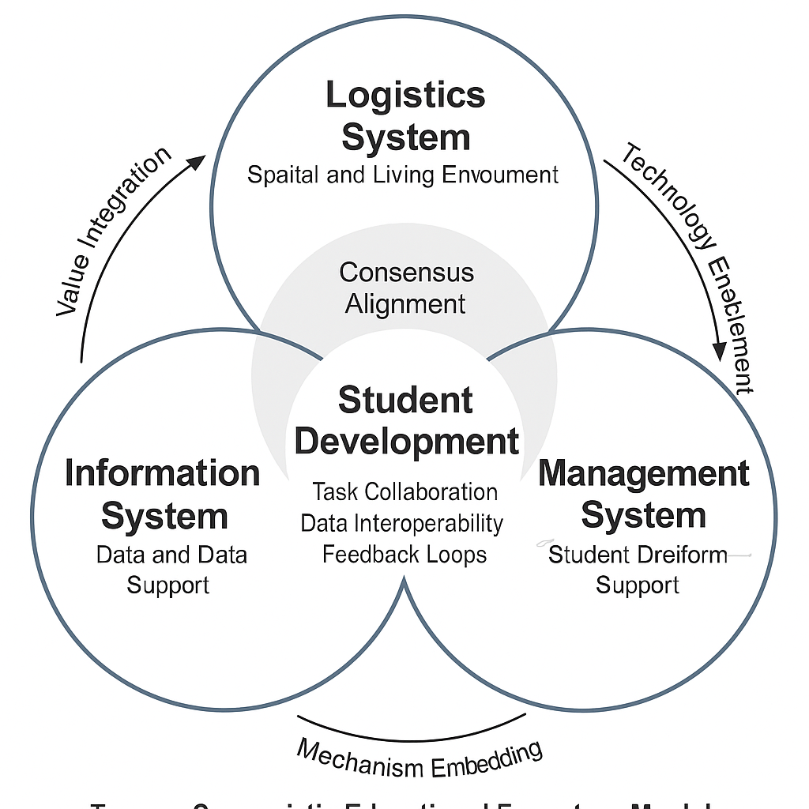

Fig. 1. Integration Pathway for Collaborative Student Development Ecosystem

5. Risks and Implementation Barriers

While the rationale for integration is widely acknowledged, the implementation of a collaborative student development ecosystem is fraught with practical difficulties and institutional resistance. These challenges differ from the previously discussed structural fragmentation; they emerge dynamically during reform attempts, often rooted in path dependencies, professional boundaries, and governance inertia(Han, 2023).

One major barrier is goal misalignment across departments. Although most agree on the overarching aim of student-centered education, different units operationalize this goal in conflicting ways. Logistics departments prioritize efficiency and safety; student affairs emphasize emotional growth and moral development; IT teams focus on system stability and data security. Without a mechanism to reconcile these competing logics, collaborative initiatives often stall at the planning stage or devolve into parallel actions.A second challenge lies in institutional resistance to resource redistribution. Integrated ecosystems require cross-departmental sharing of personnel, budgets, data, and responsibilities. Yet existing systems are often organized around strict lines of administrative control, making any shift toward shared governance a potential threat to established power structures. Reallocation of resources—especially data access and staffing—can trigger defensive responses from departments that fear loss of autonomy or performance visibility.From a technical standpoint, data integration remains a persistent hurdle. Although most universities now have digital platforms for various services, these systems often lack interoperability. Legacy systems, incompatible data formats, and restricted access protocols create informational silos that hinder joint analysis and coordinated intervention. The absence of shared indicators of student well-being further limits data-driven governance.Cultural and communicative barriers also complicate collaboration. Professional discourse divergence—where departments use different vocabularies, norms, and evaluation criteria—makes it difficult to develop mutual understanding or trust. Even when goals are aligned on paper, differing assumptions about what constitutes “student success” or “effective support” can lead to miscommunication and fragmented action.Finally, institutional incentives rarely reward cross-functional collaboration. In most universities, performance evaluations and promotions are tied to departmental metrics. There are few formal mechanisms for recognizing or incentivizing collaborative behavior. Without dedicated time, resources, and symbolic recognition, frontline staff are unlikely to invest in initiatives that fall outside their immediate job scope.

These implementation barriers highlight the importance of designing not only integration plans, but also supportive infrastructures—both material and cultural—that enable sustained cross-system collaboration.

- Strategic Recommendations

Building a truly effective collaborative student development ecosystem requires more than technical interoperability or administrative mandates. It calls for deep structural adjustments, cross-cultural understanding, and sustained institutional commitment. Based on the integration pathways proposed earlier and the risks identified, the following recommendations are offered to guide implementation (Xu, 2024).

6.1 Institutionalize shared governance mechanisms.
Establish formal structures that bring together representatives from logistics, student affairs, and information technology on a regular basis. Rather than relying on ad hoc taskforces or informal coordination, universities should embed joint decision-making bodies into their governance architecture. These structures should have clearly defined responsibilities, access to relevant data, and the authority to make cross-departmental policy adjustments.

To ensure sustainability and legitimacy, shared governance mechanisms should be codified within institutional policy documents, such as university charters or strategic plans. For example, institutions may create a Standing Committee on Holistic Development Governance, chaired by a vice president and comprising mid-level managers across functional areas. These committees can be further supported by a technical working group that conducts data analysis and policy evaluation. Periodic reporting to the university executive board can strengthen accountability.

The importance of formalized cross-functional governance is increasingly emphasized in higher education policies. For instance, the UK’s Office for Students encourages integrated student support governance structures as part of its “whole student lifecycle” approach. Similarly, in China, recent Ministry of Education directives have called for the digital integration of logistics, academic, and mental health services in support of student-centered development. By aligning institutional practice with these policy trends, shared governance structures can move from symbolic coordination to genuine, empowered integration.

6.2 Redesign evaluation and incentive systems.
To overcome motivational barriers, institutions must revise performance metrics to recognize collaborative contributions. This can include cross-departmental KPIs, shared accountability for student outcomes, and reward systems that value inter-unit cooperation. Without such incentives, collaboration risks remaining a rhetorical commitment rather than a practical norm.

However, revising incentive systems requires not only technical adjustments to evaluation rubrics but also a cultural shift in how institutions define success. Traditional performance appraisal models in universities often prioritize siloed achievements—such as department-specific outputs, research publications, or administrative efficiency—over cross-functional collaboration. To address this, institutions can incorporate multi-source feedback mechanisms that capture perspectives from different stakeholders, including students, peers, and partner units. For instance, peer-reviewed collaborative teaching or joint initiatives between student affairs and logistics units can be formally recognized in promotion and tenure decisions.

Additionally, incentives should align with long-term institutional goals, such as enhancing student wellbeing or improving retention rates. Financial bonuses, professional development opportunities, or public recognition at institutional ceremonies can serve as motivators. Moreover, digital platforms can be employed to track and visualize contributions to collaborative initiatives, making them more visible and quantifiable during performance reviews.

Finally, policy-level alignment is essential. University leadership should issue formal guidelines or policy directives that explicitly elevate the value of cross-unit collaboration. Embedding such recognition into strategic plans, accreditation reports, or quality assurance frameworks ensures that the redesigned incentive systems are not just experimental but institutionalized and sustained over time.

6.3 Build interoperable digital infrastructures.
The fragmentation of digital systems across student affairs, logistics, and administrative departments is a major impediment to collaboration. To address this, universities should develop interoperable digital infrastructures that enable seamless data sharing and communication among units.
Interoperability goes beyond mere technical integration—it involves aligning data standards, access protocols, and governance mechanisms to ensure systems can “talk” to each other meaningfully. For instance, a centralized student development dashboard can aggregate data from disparate systems such as course attendance, counseling services, housing assignments, and campus facility usage, thereby providing a holistic view of each student’s engagement and needs. This not only enhances real-time decision-making but also facilitates predictive analytics for early intervention.
A layered architecture is often useful in building such infrastructures. At the foundational layer, institutions should establish common data standards and application programming interfaces (APIs) to enable cross-system data flow. On the operational layer, shared platforms such as student information systems (SIS), learning management systems (LMS), and smart campus IoT sensors should be integrated under unified protocols. At the strategic layer, leadership must ensure that data governance policies uphold privacy, security, and ethical use, particularly when dealing with sensitive student information.
Moreover, successful implementation of interoperable infrastructures requires stakeholder co-design. IT departments should collaborate with student affairs officers, facility managers, and academic units to define system requirements based on user needs. Equally important is ensuring data literacy and system usage training for all staff involved, to reduce the “implementation gap” often observed in technology-driven reforms.
Policy recommendations should also include investing in scalable cloud-based solutions, ensuring mobile accessibility, and enabling AI-driven functions such as smart alerts, personalization engines, and behavior-based nudges. By embedding interoperability into institutional digital transformation roadmaps, universities can create a cohesive ecosystem where every functional unit contributes to—and benefits from—a unified data environment geared toward student development.

6.4 Cultivate a Culture of Collaborative Engagement.
While digital tools and governance structures provide the technical foundation for integration, the cultural dimension remains a decisive factor in sustaining cross-departmental collaboration. A siloed mindset, territorialism, and entrenched administrative routines often hinder coordination, even when technical systems are in place. Therefore, universities must foster a cultural shift that values shared responsibility, mutual respect, and collective ownership of student development outcomes.
First, leadership commitment is essential to signal the institutional importance of collaboration. Senior administrators should not only issue policy directives but also model collaborative behavior by establishing cross-functional leadership teams and holding joint review meetings on student affairs. Including representatives from logistics, student services, IT, academic affairs, and student unions in decision-making processes helps institutionalize cross-boundary dialogue and trust-building.
Second, performance evaluation mechanisms should reflect collaborative priorities. When individual units are solely evaluated based on internal efficiency metrics, there is little incentive to engage in cross-unit collaboration. Universities should adopt multi-stakeholder performance appraisal frameworks that include indicators such as joint project outcomes, interdepartmental communication effectiveness, and student satisfaction with integrated services.
Third, professional development programs should embed collaboration as a core competency. Training modules, workshops, and peer-learning platforms can be designed to cultivate soft skills such as interdepartmental communication, negotiation, and design thinking. Staff secondment programs—where personnel temporarily rotate across different departments—can also foster empathy, role understanding, and horizontal career development pathways.
Fourth, symbolic and ritual mechanisms can reinforce a shared culture. For example, launching an annual “Student Development Innovation Challenge” that invites cross-departmental teams to co-design solutions for campus issues can both motivate innovation and signal cultural alignment. Celebrating team achievements through institutional communication channels can further validate and normalize collaborative behavior.
Finally, student participation should be positioned as a cornerstone of the collaborative ecosystem. Involving students in co-designing service workflows, digital tools, and feedback loops not only improves responsiveness but also cultivates a participatory governance ethos aligned with whole-person development principles.
Ultimately, building a culture of collaborative engagement is not a one-time intervention but an ongoing process of leadership reinforcement, structural alignment, and cultural nudging. When embedded deeply, such a culture transforms institutional inertia into collective momentum, enabling the university to respond more agilely to complex, evolving student needs in the digital era.

Together, these strategies aim to move beyond surface-level integration and foster the kind of cultural and institutional transformation required for sustainable, student-centered governance in the digital era.

7. Conclusion and Future Research Strategic Recommendations

As universities face mounting pressure to deliver holistic, student-centered education in an increasingly complex and digital environment, the integration of logistics, student affairs, and information systems has become not only desirable but essential. This paper has argued that student development must be understood as a systemic endeavor—one that transcends traditional administrative boundaries and reimagines support functions as active participants in the educational mission.

Drawing on theories of educational ecology, holistic governance, and smart campus design, the study has outlined a conceptual framework for constructing a collaborative student development ecosystem. It has identified key barriers to integration, including goal misalignment, data fragmentation, institutional inertia, and professional silos. In response, it has proposed a multi-layered strategy that encompasses governance reform, incentive restructuring, technological interoperability, and cultural transformation.

While the manuscript is grounded in established theoretical frameworks, it is important to note explicitly that the study remains primarily conceptual and would benefit from empirical validation in future research. The framework provides a theoretical foundation and strategic roadmap, several limitations remain. The analysis is primarily conceptual and would benefit from empirical validation across diverse institutional contexts. Future research should explore how these integration models operate in practice—especially in terms of student outcomes, staff engagement, and long-term institutional adaptability. Comparative studies across cultural and governance regimes could further enrich the understanding of what enables or hinders ecosystemic collaboration in higher education.Ultimately, the transition toward integrated student development is not a linear process, nor is it a purely technical challenge. It requires a paradigm shift in how universities understand their own internal ecology—a shift from managing systems in parallel to orchestrating them in concert for the benefit of student flourishing.

AcknowledgEments:

This project was funded by Philosophy and Social Science Research in Colleges and Universities (2020SJA2074). This study thanks the editors and reviewers for the beneficial suggestions that help improve the quality.

Disclaimer (Artificial intelligence):
Author(s) hereby declare that NO generative AI technologies such as Large Language Models (ChatGPT, COPILOT, etc.) and text-to-image generators have been used during the writing or editing of this manuscript.

References

- Bronfenbrenner, U. (1979). The ecology of human development: Experiments by nature and design. Harvard University Press.
- Han, G. (2023). Management innovation and student support strategies in Chinese universities. Journal of Modern Higher Education Management, 15(2), 45–58.
Hou, H. (2024). Holistic governance in the era of generative AI: Toward integrative institutional transformation. AI & Society, 39(1), 22–38.
- Li, N., & Zhang, Q. (2024). Cybersecurity frameworks for higher education in the era of big data. Chinese Journal of Information Security, 20(3), 66–75.
Liang, Q. (2024). Smart libraries and data governance in Chinese universities: Pathways and prospects. Education and Information Technologies, 29(3), 255–274.
- Lin, S. (2020). Evolution of university logistics research in China: Cooperation, development, and future directions. Research on Higher Education Logistics, 10(4), 12–25.
- Liu, J. (2024). Algorithmic governance in higher education: Spatial logic and risk mitigation. Smart Education and Society, 9(2), 76–90.
- Shen, N. (2023). Digitally empowered university governance: Structures and pathways. Digital Higher Education Studies, 8(1), 41–56.
Su, X. (2023). Exploring AI-powered smart campus models: Practice and possibilities. Modern Distance Education Research, 3(2), 21–34.
- Wang, S., & Zhao, J. (2024). Lab-based student safety governance in smart campus contexts. Higher Education Laboratory Management, 12(1), 11–27.
- Wang, S., Zhao, J., & Lin, X. (2024). Building digital twins for intelligent campus management: Insights from recent university cases. Smart Learning Environments, 11(1), 1–19.
- Xu, Y. (2024). Digital technology and ideological-political education in Chinese universities. Technology and Ideological Education, 5(2), 65–81.
- Zhao, J., Liu, W., & Li, Y. (2024). Visual analytics and data governance in smart campus systems: Enhancing education management through big data. Journal of Educational Technology Development, 19(1), 44–58.
- Ling, X., Chen, J., Chow, D. H., Xu, W., & Li, Y. (2022). The “trade-off” of student well-being and academic achievement: A perspective of multidimensional student well-being. Frontiers in psychology, 13, 772653.
- Metsäpelto, R. L., Poikkeus, A. M., Heikkilä, M., Husu, J., Laine, A., Lappalainen, K., ... & Suvilehto, P. (2022). A multidimensional adapted process model of teaching. Educational assessment, evaluation and accountability, 34(2), 143-172.
- Bai, J., Chen, W., Niu, H., Zhu, Q., Zhao, X., & Dong, Y. (2025). Multidimensional factors of depressive symptoms among Chinese undergraduate students: a cross-sectional study using binary logistic regression. Frontiers in Psychiatry, 16, 1546197.
- Xiang, Y., Ma, Y., Ji, M., & Su, Y. (2024). Interconnected knowledge: Examining the evolution of graduate student innovation ecosystems. Journal of the Knowledge Economy, 15(3), 14036-14075.
- Liu, H., Kulturel-Konak, S., & Konak, A. (2021). Key elements and their roles in entrepreneurship education ecosystem: Comparative review and suggestions for sustainability. Sustainability, 13(19), 10648.
- Wu, C., Zhang, H., & Carroll, J. M. (2024). AI governance in higher education: Case studies of guidance at big ten universities. arXiv preprint arXiv:2409.02017.
- Palma, A., Mourato, J., Vinagre, J., Almeida, F., & Pessoa, A. M. (2023). Student Participation: Issues for the Governance of Higher Education. Societies, 13(5), 115.
- Afzaal, M., Nouri, J., Zia, A., Papapetrou, P., Fors, U., Wu, Y., ... & Weegar, R. (2021). Explainable AI for data-driven feedback and intelligent action recommendations to support students self-regulation. Frontiers in Artificial Intelligence, 4, 723447.
- Gil, P. D., da Cruz Martins, S., Moro, S., & Costa, J. M. (2021). A data-driven approach to predict first-year students’ academic success in higher education institutions. Education and Information Technologies, 26(2), 2165-2190.
- Flori, M., Raulea, E. C., & Raulea, C. (2025). Innovative leadership and sustainability in higher education management. Computers and Education Open, 100272. 20.

