**Research on the Development and Educational Value of the Virtual Roaming System for the Yancheng New Fourth Army Memorial Hall**

**Abstract:** Virtual roaming of venues, favored by users for its authenticity, presence, and interactivity, has gained widespread popularity. As a university education and research worker, I analyzed the system requirements for the virtual roaming system of the Yancheng New Fourth Army Memorial Hall from an educational perspective, designs the system development framework, and examines key technologies involved in system development.The completed virtual roaming system was applied to classroom teaching, self-directed learning, and distance education. User feedback data on technical experience, educational effectiveness, emotional stimulation, and other aspects of virtual roaming will be collected and analyzed through a survey questionnaire. Corresponding improvement measures will be proposed to address the shortcomings of the system. It is concluded that the virtual roaming system of Yancheng New Fourth Army Memorial Hall has significant educational value in spreading red culture, enhancing patriotic emotions, and assisting school red education, providing a practical model for the utilization of red cultural resources.

**Keywords:** New Fourth Army Memorial Hall; Virtual Roaming; Educational Value; Questionnaire Survey

**1 Introduction**

As the site where the New Fourth Army reestablished its military headquarters, Yancheng carries the glorious tradition of the Iron Army Spirit and possesses unique regional significance [1]. The Yancheng New Fourth Army Memorial Hall, a comprehensive memorial in China that systematically reflects the history of the New Fourth Army during the War of Resistance Against Japan [1], features seven exhibition areas: “National Crisis and Birth of the Iron Army,” “The Anti-Japanese War Banner Flies Across Central China,” “Rebuilding the Headquarters: and Reborn from the Ashes,” “Soldiers and Civilians Fighting Tenaciously Behind Enemy Lines,” “Overcoming Difficulties to Build Base Areas,” “Launching Partial Counteroffensives to Expand Liberated Areas,” and “Marching Towards Victory and Forging Glory” [2]. It houses over 18,000 cultural relics, historical documents, paintings, and calligraphy works. As one of China's Top 100 Red Tourism Classic Scenic Spots, it serves as a vital base for revolutionary tradition education and patriotic education, undertaking the important mission of recording the history of the War of Resistance in Central China and promoting the Iron Army Spirit.

With the rapid development of information technology, virtual roaming technology is increasingly applied in the cultural education field [8]. In July 2018, the General Office of the Central Committee of the Communist Party of China and the General Office of the State Council issued the "Opinions on Implementing the Project for the Protection and Utilization of Revolutionary Cultural Relics (2018-2022)." The document emphasized "promoting the digitization of revolutionary cultural relic resources," advocating the appropriate use of modern technological means to enhance the interactivity and experiential nature of revolutionary cultural relic exhibitions [3]. It also called for establishing a large database for revolutionary cultural relics, integrating multimedia resources to make them "come alive." In April 2021, the Ministry of Culture and Tourism released the "14th Five-Year Plan for Cultural and Tourism Development," proposing the "construction of smart museums and the development of immersive experience projects," aiming to enhance the display and dissemination capabilities of cultural heritage through technological means and promote the deep integration of culture and tourism. The "Regulations on the Protection and Utilization of Red Resources in Jiangsu Province," adopted by the Standing Committee of the 14th Jiangsu Provincial People's Congress on January 12, 2024, and effective from March 1, 2024, explicitly requires "strengthening the application of digital technology in revolutionary memorial facilities" to promote revolutionary culture and advance the protection and transmission of red resources [9]. Under this background, designing and developing a virtual roaming system for the Yancheng New Fourth Army Memorial Hall using innovative 3D reconstruction technology has become a necessity of the times and a historical inevitability.

**2 Analysis of Virtual Roaming System Requirements and Framework Design from an Educational Perspective**

**2.1 Requirements Analysis**

Schools, Party and government organs have inherent demands for virtual roaming systems centered on red culture, primarily aimed at enhancing the effectiveness of ideological and patriotic education activities [10]. Based on this objective, the design of related virtual roaming systems should consider the following factors: First, providing systematic explanations of red historical and cultural knowledge, introducing important historical events and figures. Second, enabling embodied learning experiences, allowing learners to participate in historical scenarios from a first-person perspective to generate emotional resonance. Third, recording the processes of knowledge acquisition, historical event cognition, and emotional experience, and evaluating learning outcomes. Fourth, enabling targeted design based on the learning needs of different user groups; for instance, elderly users may focus more on details of historical events and stories from participants, while teenagers may be more interested in interactive and novel experiences like role-playing. Fifth, addressing system security and scalability issues. Therefore, the development requirements for the Yancheng New Fourth Army Memorial Hall virtual roaming system mainly include the following aspects.

**2.1.1 Content Requirements**

**Richness, Diversity, and Authenticity of Content:** Deeply explore the connotations of the New Fourth Army Iron Army culture, collect and organize historical materials of the New Fourth Army, especially relevant historical documents, pictures, audio, and video materials from its time in Yancheng, ensuring content accuracy and authority to provide rich and detailed historical materials for the virtual roaming system.

**Storytelling and Contextualization of Content Presentation:** While maintaining historical authenticity, visually present the history and culture of the New Fourth Army in a story format, or allow learners to virtually participate through plot design and scene restoration, enhancing content appeal and impact. This facilitates learners' understanding and acceptance of the spiritual essence of red culture and stimulates their interest in learning about it.

**2.1.2 Functional Requirements**

**Basic Roaming:** Enable virtual roaming of the memorial hall, supporting users in freely exploring the virtual memorial hall, browsing indoor and outdoor scenes and exhibit details (cultural relics, historical materials, sculptures, etc.), with roaming control functions such as pause, backward, and forward.

**Interactive Experience:** On one hand, provide character interaction functions, such as allowing users to converse with virtual characters to understand the background and realities of New Fourth Army historical events, or participate in simulated revolutionary activities. On the other hand, provide exhibit operation functions: support interactive operations like close observation, rotation, and zooming on revolutionary artifacts to enhance engagement and realism.

**Knowledge Explanation:** Provide professional explanation modules in multiple forms (voice, text, pictures), systematically introduce the historical background, important events, and character stories of the Iron Army culture, and can set up Q&A etc sessions to strengthen the memory of key knowledge and deepen learners' understanding and memory of key knowledge.

**Personalized Customization Function:** Based on user interests and learning objectives, intelligently recommend personalized roaming routes and historical content, such as recommending in-depth historical event routes for specific interest groups.

**2.1.3 Technical Requirements**

**Modeling and Rendering:** Utilize PBR (Physically Based Rendering) next-generation high-precision 3D modeling technology to authentically recreate scenes and artifact details of the Yancheng New Fourth Army Memorial Hall. Prioritize image quality and visual effects while optimizing models to adapt to different device performances.

**VR/AR Integration:** Use VR technology to provide users with an immersive roaming experience, enabling them to feel the Iron Army culture firsthand. Combine AR technology to integrate virtual Iron Army cultural elements with real-world scenes, enhancing system interactivity and fun.

**Network Transmission:** Rely on stable and efficient network transmission technology to ensure smooth system operation (especially when handling large amounts of data interaction). Combine with technologies like cloud storage to improve system response speed and stability.

**System Maintenance and Security:** Conduct regular system updates, security maintenance, and performance optimization. Emphasize system scalability, update content promptly, and ensure continuous stable operation and improved user experience.

**User Feedback and Data Analysis:** Establish a user feedback mechanism to collect opinions. Continuously optimize system functions and improve user satisfaction based on user needs and behavioral data analysis.

**Multi-terminal Cross-platform Technology:** Support web and mobile versions, compatible with various platforms such as social media, schools, and museums, to expand the system's visibility and influence.

**2.2 System Framework Design**

Based on the aforementioned requirements analysis and the actual conditions of the Yancheng New Fourth Army Memorial Hall, the following framework design is proposed for this virtual roaming system:

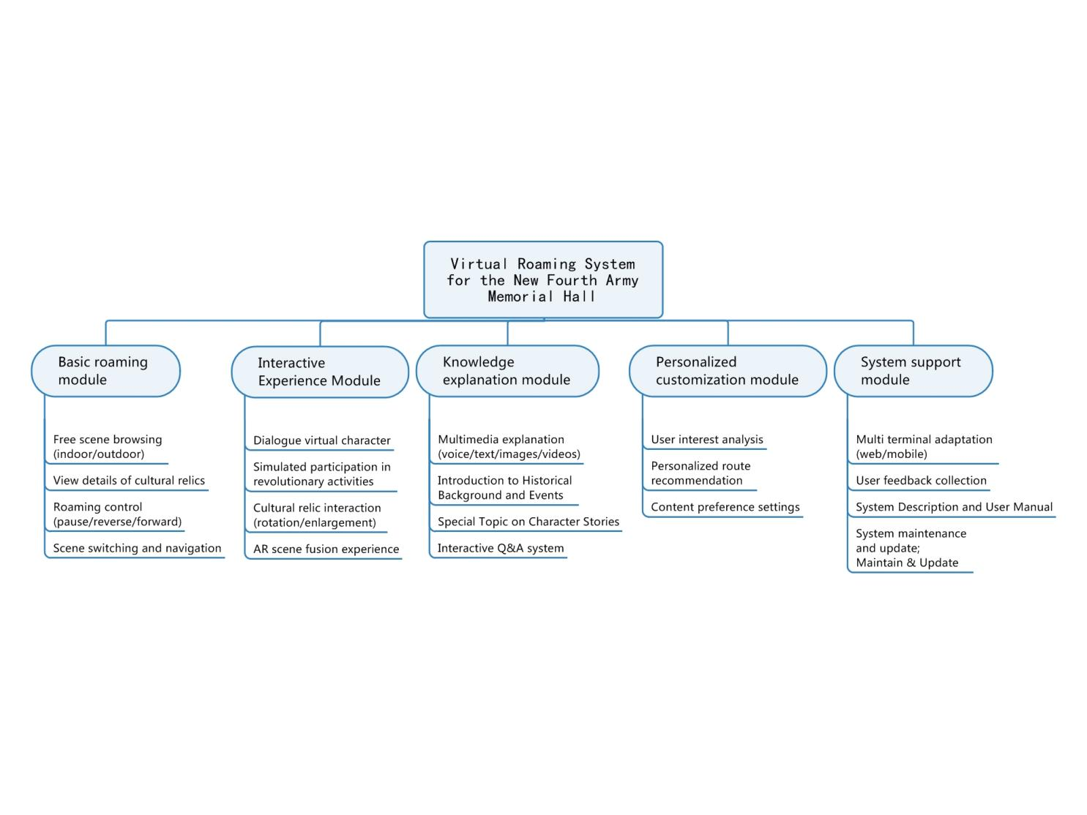

Image 1: Functional Module Diagram of the Virtual Roaming System at the New Fourth Army Memorial Hall

**3 Key Technologies and Requirements for Implementing the Yancheng New Fourth Army Memorial Hall Virtual Roaming System**

The virtual roaming system possesses the 3I characteristics: Immersion, Interactivity[4], and Imagination. High-quality 3D models are the foundation of virtual roaming. Only through the organic combination with lighting effects, material textures, and environmental sound effects can a realistic scene atmosphere be created.

**3.1 Modeling and Texturing**

On one hand, the virtual roaming system needs to use professional 3D modeling software (such as 3ds Max, Maya, ZBrush, etc.) to build high-precision 3D models, ensuring model details and proportions match the actual scenes. For complex architecture and environments, various methods like polygon modeling, patch modeling, and texture modeling can be adopted to reduce polygon count and improve rendering efficiency. On the other hand, optimize models by reducing polygon count, merging objects, and using shared materials to accelerate rendering speed.

High-definition texture mapping is key to enhancing scene realism. Use high-resolution texture maps and select appropriate texture resolutions based on the distance and importance of objects. For environmental details like vegetation, roads, and buildings, texture mapping techniques can be used to enhance visual effects.

The entire model design and production process involves multiple software and professional techniques, requiring consideration of industry norms, production sequence, standards, etc. [5]. From a professional standpoint, the PBR next-generation modeling method is recommended. It is a rendering technique based on the physics of the real world, aiming to present more realistic images by considering the interaction of light on object surfaces. The specific model construction workflow for modeling and texturing is shown in the figure below:

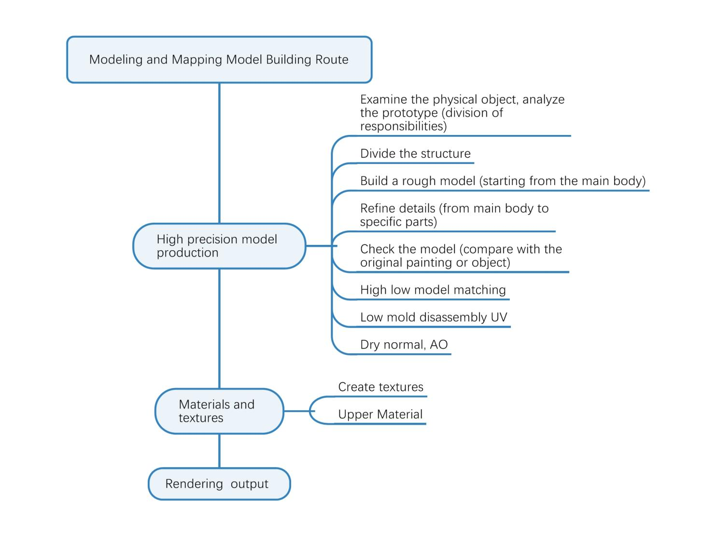

Image 2: Roadmap for Model Building and Mapping

**3.2 Rendering and Lighting**

Apply real-time rendering technology and configure diverse environmental lighting effects (such as sunlight, shadows, reflections) in scenes to enhance visual realism. By dynamically adjusting light/shadow variations and material performance, and setting physically accurate lighting conditions and material parameters within the roaming engine or rendering software, the renderer can more precisely simulate the interaction of light with objects. This ensures scene objects exhibit realistic reflections and refractions, providing learners with real-time interactive feedback.

**3.3 Interaction Design**

**3.3.1 Interaction Function Design**

Design a concise and intuitive user interface, strengthen operational guidance and instant feedback. Integrate diverse interaction modes (e.g., automatic roaming, free exploration, map navigation, auxiliary guidance) to suit different user needs. Support input devices like mouse, keyboard, touch, and be compatible with voice commands and gesture recognition technology to enhance interaction flexibility and immersion. The system needs to respond to user operations in real-time, provide audiovisual feedback, and assist task completion through dynamic prompts.

**3.3.2 Content Interaction Design**

Construct contextual interactive tasks (e.g., historical event simulations, role-playing) to deepen learners' immersive experience; set exploratory challenges (e.g., knowledge quizzes, treasure hunts) to stimulate active learning interest. Embed interactive information points (click/proximity triggered) within virtual scenes, open content retrieval functions for quick resource location, and support multi-user real-time collaboration mechanisms.

**3.3.3 Experience Optimization**

Utilize high-fidelity audio-visuals and VR devices (headsets, controllers) to create a sense of presence. Push personalized content based on user behavior data. Allow custom viewing angles and operation settings. Follow universal design principles to ensure usability across all age groups. Add accessibility features (e.g., voice navigation, hotkeys) to serve users with special needs.

**3.4 Security Assurance**

Ensure system security, network security, data security, and learner privacy protection. On one hand, focus on data security: implement transmission/storage encryption for red cultural resources, strictly set data access permissions, and establish regular backup and disaster recovery mechanisms to ensure data integrity and availability. On the other hand, focus on privacy protection: support anonymous access mode, or implement identity authentication (account/password, digital certificates) and permission hierarchy systems to ensure users only access authorized content, eliminating the risk of privacy leaks.

**4 Teaching Applications of the Yancheng New Fourth Army Memorial Hall Virtual Roaming System**

Based on the system development requirements analysis, technical implementation, and the current state of school education and teaching, the teaching applications of the Yancheng New Fourth Army Memorial Hall virtual roaming system mainly include classroom teaching, self-directed learning, and distance education.

**4.1 Classroom Teaching**

The Outline for Building a Leading Country in Education proposes requirements for promoting the integrated development of ideological and political courses across primary, secondary, and higher education [6]. How to teach these courses in an accessible way and how to make red culture resonate deeply have become themes of the times. Virtual simulation, with its characteristics of situational reproduction, multiple interactions, and project-based inquiry, plays an important role in classroom teaching. Teachers can use the virtual roaming system of the Yancheng New Fourth Army Memorial Hall to guide students to explore the process of the Wannan Incident and the strategic shift of the New Fourth Army. Firstly, they can use augmented reality character walls to understand revolutionary heroes. Then, through virtual roaming, they can watch specific battle scenes restored, allowing students to directly experience the intensity of war and the bravery and fearlessness of the New Fourth Army. Combining abstract theoretical knowledge with vivid virtual scenes can improve classroom teaching and deepen students' understanding and grasp of course content.

**4.2 Self-Directed Learning**

The Yancheng New Fourth Army Memorial Hall virtual roaming system provides students with an excellent platform for self-directed learning. Users can freely choose their visiting paths and learning content within the system according to their own learning pace and interests, gaining an in-depth understanding of the development and combat history of the New Fourth Army. Simultaneously, interactive functions in the virtual roaming system, such as quiz tests and scenario simulations, can effectively stimulate students' learning enthusiasm and cultivate their self-directed learning abilities.

**4.3 Distance Education**

The Yancheng New Fourth Army Memorial Hall virtual roaming system breaks through temporal and geographical limitations, enabling the sharing and dissemination of red cultural education resources. Via the internet, users can engage in virtual roaming learning anytime, anywhere, whether in classrooms or at home. Teachers conducting blended ideological and political teaching now have red resources guaranteed. More people can receive red cultural education online.

**5 Research on the Educational Effectiveness of the Yancheng New Fourth Army Memorial Hall Virtual Roaming System**

Based on the currently developed Yancheng New Fourth Army Memorial Hall virtual roaming system, to evaluate its application effectiveness in educational practice, this study designed a questionnaire using an online survey platform. The questionnaire content included: student basic information (e.g., gender, major); evaluation of the virtual roaming technology experience (including ease of operation, image quality, fluency, richness of interactive functions, usability of the navigation system); the impact of virtual roaming on learning outcomes related to New Fourth Army history (e.g., improvement in understanding New Fourth Army history content, help in understanding its historical contributions); emotional stimulation and values cultivation (e.g., identification with the New Fourth Army Iron Army Spirit, reverence for revolutionary martyrs, enhancement of patriotic sentiment); the suitability of virtual roaming as an educational tool; and suggestions for improvement. After finalizing the questionnaire, the author conducted an online survey among students who used the virtual roaming system. Total views reached 132, with 41 valid responses collected. The reference reliability coefficient was 0.95. Among the 41 participating students, 14 were male (34.1%) and 27 were female (65.9%). Majors covered included Computer Science and Technology, Fine Arts, Business Administration, Geography, etc.

**5.1 Analysis of Virtual Roaming System Technology Experience**

The purpose of developing the virtual roaming system is to allow people to experience the physical visit without leaving home. High-quality, realistic graphics, high frame rates, low visual latency, and convenient operation are prerequisites for ensuring the immersion and stable video experience of virtual roaming. According to the limited survey data statistics: Regarding ease of operation, 58.5% of users found it very convenient, 41.5% found it relatively convenient. Regarding image quality and fluency, 61% rated it as very good, 34.1% as good, and 4.9% as average. Regarding the richness of interactive functions, 61% found it very rich, 34.1% relatively rich. Regarding the usability of the navigation system, 63.4% found it very easy to use, 31.7% relatively easy to use, 2.4% of users consider the ease of use to be average or not very easy. Regarding overall satisfaction with the technical experience of the virtual roaming system (on a scale of 0-10), the highest score was 10, the lowest was 6, with a standard deviation of 1.4 and variance of 1.8. This indicates that the survey data is relatively concentrated, with most user satisfaction scores close to the average, showing low volatility and no extreme differences. Based on the above statistical analysis, the Yancheng New Fourth Army Memorial Hall virtual roaming system provides users with a good and smooth technical experience environment, offering strong technical support for educational activities conducted by Party/government organs and schools.

**5.2 Analysis of Virtual Roaming System Educational Effectiveness**

The development and design of any educational resource product must consider its educational objectives, namely its impact on users in terms of knowledge, skills, emotional attitudes, and values[7]. The knowledge explanation and role experience modules of the Yancheng New Fourth Army Memorial Hall virtual roaming system effectively help students understand the revolutionary course and historical contributions of the New Fourth Army, promote greater reverence for revolutionary martyrs, and deepen understanding of the Iron Army Spirit. Survey data shows: 65.9% and 34.1% of users believed the system was very capable or relatively capable of stimulating learning interest; 73.2% and 26.8% believed the teaching content was very aligned or relatively aligned with course requirements; 63.4% and 34.1% believed their understanding of New Fourth Army revolutionary history significantly improved or somewhat improved through the system; 56.1% and 39% believed the system was very helpful or relatively helpful for students in understanding the historical contributions of the New Fourth Army; 70.7% reported a significant enhancement in their identification with the New Fourth Army Iron Army Spirit, 29.3% reported some enhancement; 69.3% felt very strong reverence for revolutionary martyrs, 29.3% felt relatively strong. Compared with traditional visiting methods, 61% believed the virtual roaming system was more effective, 36.6% believed it was slightly more effective, and 2.4% believed it was about the same; 73.2% believed the system was very important for transmitting red culture, 26.8% believed it was relatively important. These survey results indicate that the Yancheng New Fourth Army Memorial Hall virtual roaming system has significant advantages in imparting historical knowledge of the New Fourth Army, effectively promotes student learning of its revolutionary history, plays an important role in student emotional education and values cultivation, and aids in transmitting the revolutionary spirit and fostering patriotism.

**5.3 Analysis of Virtual Roaming System Applicability**

Due to its immersive, intuitive, and interactive characteristics, the virtual roaming system can be suitable for different groups. As an auxiliary tool for school red education, 70.7% of users found the Yancheng New Fourth Army Memorial Hall virtual roaming system very suitable, 29.3% found it relatively suitable. Regarding the applicability range for students, the selection proportions for primary school, junior high school, senior high school, and university students were similar, all exceeding 60%, indicating strong educational universality. 68.3% of users expressed willingness to recommend others to use the virtual roaming system for learning.

**6 Problems with the Virtual Roaming System and Suggestions**

Although tested and recognized by users, the Yancheng New Fourth Army Memorial Hall virtual roaming system still has problems such as thin content (few scenes, excessive text/images, insufficient dynamic imagery), simplistic interaction, image delay, and suboptimal system stability. Subsequent development can be improved from the following dimensions:

**6.1 Content Optimization**

Dynamically expand red cultural resources based on user feedback and keep pace with the times: Add historical archives, character narratives, era backgrounds, and dynamic imagery to deepen content dimensions and expressiveness, enhancing the system's educational depth and appeal.

**6.2 Technical Upgrade**

Integrate cutting-edge digital technologies like VR/AR, continuously optimize image quality, fluency, and system stability; simplify navigation logic and operation paths; deploy intelligent voice assistants for real-time Q&A and personalized guided tours; strengthen immersive experiences and personalized explanation services.

**6.3 Enhanced Interaction**

First, strengthen scenario simulation: Restore key historical scenes (e.g., battles, meetings), support first-person role-playing (e.g., soldier, civilian), allowing users to experience historical decision-making processes, enhancing understanding of and immersion in historical events. Second, enrich knowledge challenges: Embed diverse question formats (multiple choice, true/false, fill-in-the-blank), set timed scoring mechanisms covering themes like historical events, figures, and strategies, increasing the fun and challenge of answering. Third, increase virtual artifact interaction: Design operable 3D models of revolutionary artifacts (clickable, draggable, rotatable for detailed viewing), or set collection tasks to stimulate user exploration interest. Fourth, strengthen AR integration: Overlay virtual historical information and interactive elements onto real-world scenes, enabling learners using mobile phones or other devices during virtual roaming to gain more interactive experiences. Overlay virtual historical information via mobile terminals to expand cross-spatiotemporal interaction dimensions.

**6.4 Application Promotion**

On one hand, collaborate with educational institutions to integrate the system into the red curriculum system. Strengthen cooperation with education departments and schools to incorporate the Yancheng New Fourth Army Memorial Hall virtual roaming into school red cultural education curricula, promoting its use among a wider student population. On the other hand, conduct special publicity campaigns to raise public awareness and social influence. Simultaneously, expand user group coverage, strengthen the transmission efficacy of the Iron Army Spirit, and attract more people to use the virtual roaming system for learning about New Fourth Army history, culture, and the Iron Army Spirit.

**7 Conclusion**

As a distinctive advanced culture formed during the revolutionary period, red culture carries profound revolutionary spirit and historical connotations. Virtual roaming systems, through 3D modeling and roaming technology, not only avoid damage caused by time and natural factors, effectively protecting endangered red resources, but also break through spatiotemporal constraints to achieve immersive dissemination, enabling more people to access and learn anytime, anywhere. This enhances educational effectiveness and promotes the diversified development of red culture. The article proposes a virtual roaming system for red culture education, clarifies relevant requirements and advanced frameworks, outlines its application in teaching, lists improvement directions and suggestions, and has positive significance in promoting the dissemination of red culture, enhancing patriotic emotions among young people, and assisting school red education. The practice at the Yancheng New Fourth Army Memorial Hall demonstrates that continuously iterating technology and developing more high-quality resources can provide support for the transmission of red culture and the building of cultural confidence.

Conflicts of Interest

The authors declare no conflicts of interest regarding the publication of this paper.

Disclaimer (Artificial intelligence)

Option 1:

Author(s) hereby declare that NO generative AI technologies such as Large Language Models (ChatGPT, COPILOT, etc.) and text-to-image generators have been used during the writing or editing of this manuscript.

**References**

【1】 Liu Bo Research on the Conditions, Problems and Paths of High quality Development of Yancheng Convention and Exhibition Economy under the New Development Pattern [J]. Journal of Yancheng Normal University (Humanities and Social Sciences Edition). September 15, 2023

【2】 Wishing you all the best The New Fourth Army Memorial Hall: Shining with the supreme glory of the Iron Army spirit Xinhua Daily . July 9, 2021

【3】 Xiong Yifang, Li Jian; Ye Fulin Digital technology empowers research on the utilization of red resources Youth Journal. June 25, 2025

【4】 Zhang Decheng, Chen Jinxin Modern Educational Technology "[M]. Shanghai Jiao Tong University Press. July, 2022:87

【5】 Gao Yang, Jiao Hongqiang, Li Yanqiang Design and Implementation of Digital Museum Based on Unreal Engine [J]. Computer and Information Technology, January 31, 2023: 86-88

【6】 Kan Yaqian, Shao Zhihao; Integrated construction of ideological and political education teacher team in primary, middle and high schools: significance, path and strategy. Fujian Education March 20, 2025

【7】 Xu Yulu, Zhang Rongrong, Yin Shijia. Research on the Influence of Immersive Experience on Tourists’ Post-Trip Behavioral Intentions—A Case Study of the China National Silk Museum. Advances in Social Sciences, 2025 Issue 4: Model Building Roadmap for Figures 378-389.

【8】Lin, Z., Yang, Z., & Yuan, J. (2024). Research on the design and image perception of cultural landscapes based on digital roaming technology. *Heritage Science*, *12*(1), 397.

【9】Mao, C., Wan, J., & Yang, M. (2023). Research on Legal Guarantee of Red Natural Resources Protection and Development Based on EOD Model. *Journal of Social Science Humanities and Literature*, *6*(6), 183-194.

【10】Jiang, Y. F., & Song, H. N. (2024, March). Research on VR-Based Interactive Campus Panoramic Roaming System--Take Xuzhou Engineering University as an Example. In *2024 13th International Conference on Educational and Information Technology (ICEIT)* (pp. 452-455). IEEE.

【11】Cao K. Development and design case function comparison of panoramic roaming system of virtual museum based on Pano2VR. Mobile Information Systems. 2022;2022(1):7363221.