Geo-Environmental Impacts of Gully Erosion in Ezeoke Nsu, Southeastern Nigeria

Abstract

In southeast Nigeria, gully erosion is one of the worst types of land degradation, presenting serious problems for the geoenvironment, the economy, and the infrastructure. Examining the geoenvironmental effects of gully erosion in Ezeoke Nsu, a village in Imo State, southeast Nigeria, where intensive land use practices, high rainfall, and weak geology have made soil loss more common, is the focus of this study. The study used GIS tools, laboratory analysis, field surveys, and soil sampling to determine the extent, causes, and effects of gully erosion in the region. Gully start and expansion are largely caused by unconsolidated sandy soils, steep terrain, and human activities such deforestation, inadequate land management, and unplanned settlements, according to the results.Gully erosion in Ezeoke Nsu has a variety of effects. In terms of the environment, it causes biodiversity loss, disturbance of natural drainage systems, and the loss of fertile topsoil. Gully extension has harmed highways, wrecked farmlands, endangered residential buildings, and made communities more susceptible to flooding. In terms of the economy, it damages agricultural output, lowers household income, uproots families, and fuels food insecurity. Additionally, the community's settlement stability and sustainable development are at long-term risk due to the gullies' ongoing growth.The study comes to the conclusion that in order to lessen the damaging impacts of gully erosion, immediate, integrated erosion control measures—such as reforestation, check dam construction, and appropriate land-use planning—are required. Policymakers, environmental managers, and local stakeholders can utilize the findings to inform the development of sustainable land management plans that safeguard livelihoods and the environment in southeast Nigeria.
Keywords: Gully erosion, Geo-environmental impacts, Soil degradation, Land use.

1. Introduction
Gully erosion represents one of the most severe environmental challenges in Southeastern Nigeria, leading to the degradation of land, destruction of infrastructure, and displacement of communities. This phenomenon has become a significant problem in regions with highly erodible soils, poorly managed human activities, and frequent heavy rainfall. The occurrence of gully erosion is not only a result of natural processes but is also heavily influenced by anthropogenic activities such as deforestation, improper land use, and poorly managed infrastructural projects. Southeastern Nigeria, with its sedimentary terrain, is particularly vulnerable to the destructive effects of gully erosion, especially in areas with weak, unconsolidated soils like those found in Ezeoke Nsu, located in Ehime Mbano Local Government Area (LGA) of Imo State.
The area of study, Ezeoke Nsu, lies between latitudes 5°42'N and 5°45'N and longitudes 7°10' and 7°27'E. It is characterized by a young but active gully site, where soil erosion, exacerbated by an abandoned road construction project, threatens the landscape, human habitation, and agricultural productivity. According to Okeke (2015), the nature of the soil in this region, primarily loose sands with minimal clay content, increases the vulnerability of the land to erosion. Soil erosion in these areas is not merely a surface phenomenon; it has deep-seated implications for the environment and the local economy, particularly in the agriculture and housing sectors.
Soil erosion, particularly gully erosion, is a widespread problem in Nigeria, especially in areas like the southeastern region, where poorly consolidated sandy soils dominate. These soils are highly susceptible to erosion when exposed to heavy rainfall, making them prone to rapid degradation. The issue has been extensively studied, with scholars like Onyegbule (2005) and Idah et al. (2008) emphasizing the role of soil characteristics, such as grain size distribution and compaction, in the development of soil erosion. Additionally, the work of Nwajide and Hogue (1979) and Ofomata (1985) has highlighted the impact of natural forces and human activities on the erosion processes in the region. Their studies suggest that soil properties, topography, rainfall intensity, and human activities are all contributing factors to gully erosion.
The Ezeoke Nsu region, like many parts of Southeastern Nigeria, is predominantly affected by water-induced soil erosion, which is facilitated by the region’s high rainfall intensity and poorly managed land-use practices. The climatic conditions, with an average annual rainfall ranging between 2250 mm and 2500 mm, contribute significantly to the erosive forces acting on the soil (Onu, 2011). The increased runoff during the rainy season, combined with deforestation and agricultural activities, accelerates soil degradation and the formation of gullies. The high rainfall intensity, often exceeding 50 mm/h, significantly increases the erosivity of rainfall, leading to greater soil loss (Poesen et al., 2003).
The primary objective of this study is to investigate the geotechnical characteristics of the soils in the gully-prone areas of Ezeoke Nsu and to assess their erodibility. By analyzing the soil's grain size distribution, moisture content, shear strength, and compaction properties, the study aims to provide a comprehensive understanding of how these physical properties influence the soil’s susceptibility to erosion. Furthermore, this study evaluates the role of anthropogenic activities, such as road construction and agricultural practices, in accelerating the erosion processes in the region.
Soil erodibility is a measure of the soil’s susceptibility to erosion, which is influenced by various factors, including the soil’s texture, structure, and moisture content (Igwe, 2003). In areas with loose, sandy soils and limited vegetation cover, soil erosion becomes a serious concern, as these soils are more prone to detachment and transport by water. According to Lal (1998), soil erosion significantly impacts agronomic productivity and environmental quality by reducing the soil’s nutrient-holding capacity, moisture retention, and organic matter content. The consequences of such soil degradation are far-reaching, affecting agricultural production, land availability, and local economies.
This research will provide an in-depth analysis of the geotechnical properties of the soils in Ezeoke Nsu and their contribution to the gully erosion process. By combining laboratory and field-based approaches, including grain size analysis, shear strength testing, and moisture content determination, the study seeks to identify key soil characteristics that influence erodibility. Additionally, the study will assess the impact of human activities, such as the abandonment of road projects and agricultural practices, on the development and intensification of gully erosion. The findings of this research will contribute to the development of effective erosion control measures, including improved land management practices and soil conservation techniques, aimed at mitigating the environmental and economic impacts of gully erosion in the region.
The significance of this study lies in its potential to inform policies and practices aimed at controlling soil erosion in Southeastern Nigeria, where gully erosion is a major environmental and socio-economic challenge. By addressing the geotechnical characteristics and erodibility of soils in gully-prone areas, this research will provide valuable insights into the soil erosion processes and contribute to the sustainable management of land resources in the region.
2. Materials and Methods
The study was conducted in the gully-prone area of Ezeoke Nsu, located within the sedimentary basin of Southeastern Nigeria. This region is characterized by friable and unconsolidated soils, which makes it highly susceptible to gully erosion. The soils in this area are typically sandy and poorly consolidated, which exacerbates the effects of erosion. The study aimed to determine the geotechnical properties of the soils in the region, focusing on their erodibility, which is a key factor in understanding the dynamics of gully erosion. To achieve this, the research employed both field and laboratory investigations to gather comprehensive data.
2.1 Field Study
The field study involved the collection of soil samples from both active gully sites and adjacent, less-eroded areas to compare the properties of soils exposed to gully erosion with those less affected by erosion processes. The soil samples were collected at two different depths, 15 cm and 30 cm, to investigate the variation in soil properties with depth. The samples were carefully labeled to ensure proper identification, and they were preserved in transparent polythene bags to prevent moisture loss, which could affect the results of subsequent laboratory analysis.
Field data, including the topography, slope, and drainage patterns of the study area, were recorded using GPS devices and surveying equipment. These data were crucial in understanding the role of topography and drainage in the gully formation process. Additionally, a geophysical survey was conducted using the Vertical Electric Sounding (VES) method to assess the subsurface soil composition. The VES survey helped to determine the depth of the gully and the nature of the underlying materials, providing insights into the geological layers contributing to the erosion process.
2.2 Laboratory Analysis
Following the field sampling, the soil samples were subjected to various laboratory tests to determine their physical and mechanical properties. These tests provided valuable data on the soil's grain size distribution, moisture content, compaction characteristics, and shear strength—each of which contributes to the soil's erodibility.
Grain Size Distribution:
Sieve analysis was performed to determine the particle size distribution of the soil samples. The sieve analysis method is commonly used to classify soils based on the size of the soil particles. The results of the sieve analysis allow for the classification of the soil as either fine-grained (clay or silt), sandy, or coarse. This classification is crucial in understanding the potential for soil erosion, as finer soils are more susceptible to being washed away by water.
Procedure:
Soil samples were passed through a series of sieves of different mesh sizes, starting from the coarsest to the finest. The mass of soil retained on each sieve was recorded, and the percentage of each size fraction was calculated. The grain size distribution curve was then plotted, showing the proportion of soil that passed through each sieve size.
Moisture Content
The moisture content of the soil samples was determined using the oven-drying method. Moisture content is a critical factor in soil erodibility, as it influences the soil's cohesion and compaction. Higher moisture content can lead to greater soil instability, particularly during periods of heavy rainfall, making the soil more prone to erosion.
Procedure:
A known weight of the soil sample was first measured (wet weight) and then dried in an oven at 110°C for 24 hours. The dried sample was weighed again (dry weight), and the moisture content was calculated using the formula:
Moisture Content(%)=M2−M3M3−M1×100\text{Moisture Content} (\%) = \frac{M_2 - M_3}{M_3 - M_1} \times 100
where:
  - M1M_1 = Mass of the container,
  - M2M_2 = Mass of the wet soil + container,
  - M3M_3 = Mass of the dry soil + container.
Compaction Tests:
The Proctor compaction test was carried out to determine the maximum dry density and the optimum moisture content of the soils. Compaction is the process of reducing the void spaces in the soil to increase its density. Soils with high compaction values tend to be more stable and less susceptible to erosion. The Proctor test determines the moisture content at which the soil achieves its maximum density, which is critical for understanding its resistance to water infiltration.
Procedure:
A specified amount of soil was mixed with water to achieve different moisture contents, and then compacted into a cylindrical mold. The mold was then weighed before and after compaction, and the dry density was calculated. The optimal moisture content is the point at which the soil reaches its highest dry density.
Shear Strength Tests
Direct shear tests were performed to measure the soil's resistance to shear forces, which is critical in understanding its ability to withstand erosion, especially during heavy rainfall. The shear strength of the soil determines how well the soil can resist the forces that act to displace it, such as water flow. This test is essential in determining the stability of slopes and the potential for gully formation.
Procedure:
Soil specimens were placed in a shear box, and a normal force was applied to the sample. The shear force was then applied by moving one half of the box relative to the other. The maximum shear stress at which the soil failed was recorded, and the shear strength was calculated using the formula:
Shear Strength=Cohesion+(Normal Stress×tan⁡(ϕ))\text{Shear Strength} = \text{Cohesion} + (\text{Normal Stress} \times \tan(\phi))
where:
  - ϕ\phi = angle of internal friction,
  - Cohesion\text{Cohesion} = resistance to shear due to internal friction,
  - Normal Stress\text{Normal Stress} = the stress acting perpendicular to the shear plane.
The materials and methods used in this study, including field surveys and laboratory tests, provided a comprehensive analysis of the geotechnical properties of soils in the gully-prone areas of Ezeoke Nsu. The data obtained through these methods were crucial in assessing the soil's susceptibility to erosion and understanding the role of various soil properties in gully formation. The findings of this study are aimed to inform the development of effective soil conservation strategies and erosion control measures for the region.

3. Results
The results from the field investigations, geophysical surveys, and laboratory tests provide critical insights into the geotechnical characteristics of the soils at the Ezeoke Nsu gully site and their susceptibility to erosion. This section presents the results from the preliminary site investigations, geophysical investigations, and geotechnical laboratory tests, including moisture content, grain size distribution, compaction, and shear strength.

3.1 Preliminary Site Investigation
Field surveys and mapping provided essential data on the topography, slope, drainage, and the extent of gully erosion. The study area’s topography and drainage patterns were found to have a significant impact on the erosion process, with gully formation being heavily influenced by human activities, such as abandoned road construction projects that altered natural drainage.
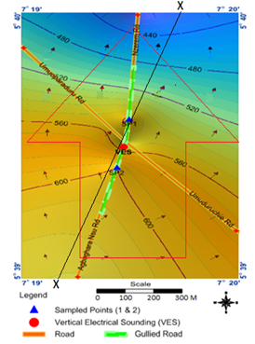

Figure 1: G I S Map of the site showing contours, drainage direction and cross section.

This map illustrates the drainage divides and flow patterns contributing to gully formation, which were exacerbated by improperly constructed roads.
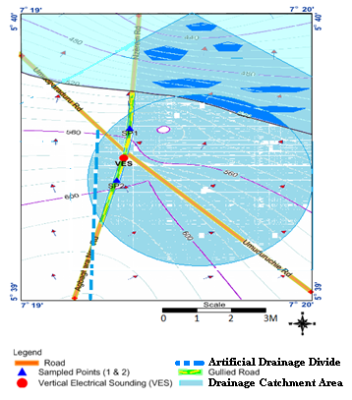
Figure 2: Drainage Analysis Map of the Project Site.
This map shows the direction of water runoff and its contribution to gully formation, highlighting areas of high water flow and erosion intensity.
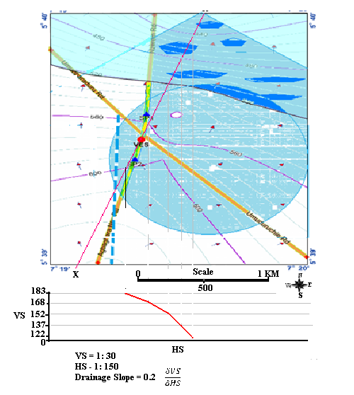
Figure 3: Drainage Slope Determination.
The slope analysis revealed that the study area had a relatively steep slope, contributing to high runoff energy, which exacerbated the soil erosion process and intensified gully formation.
  - Geophysical Investigation Results
A geophysical survey was carried out using the Vertical Electric Sounding (VES) method to assess the subsurface soil composition and determine the depth of the gully and underlying materials. The VES survey provided data on the resistivity of the soil layers and their potential for erosion. The highest resistivity recorded was 146 Ohm-m, which indicates that some parts of the subsurface are more consolidated than others, while other areas are more prone to erosion. The average depth of the erosive material was found to be approximately 9 m, with the underlying material showing minimal resistance to erosion, reinforcing the vulnerability of the region to soil degradation.
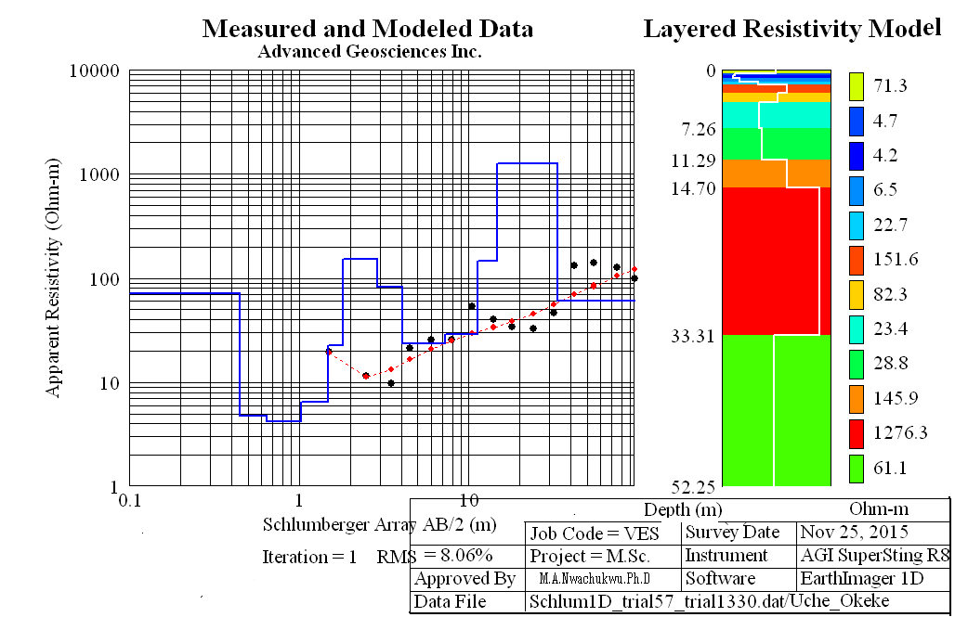
Figure 4: VES Modeled Data.
This figure shows the resistivity model for the subsurface layers, providing insights into the geological composition of the area and highlighting the layers most susceptible to erosion.

3.3 Geotechnical Laboratory Results
The laboratory tests conducted on the soil samples collected at depths of 15 cm and 30 cm provide valuable information on the soil's physical and mechanical properties. These tests help to assess the soil's erodibility and its potential to resist erosion under various conditions.

3.3.1 Moisture Content Test Results
The moisture content test was performed on the soil samples to determine the water retention capacity, which plays a crucial role in soil erodibility.
Table 1: Moisture Content Results for Erosive Material I & II.
Sample | Erosive I | Erosive II
Can No | 3A | 1B
Can + wet soil (g) | 19.9 | 22.0
Can +dry soil (g) | 19.0 | 20.9
Can (g) | 10.2 | 10.5
Dry soil (g) | 8.8 | 10.4
Water (g) | 0.9 | 1.1
Water content (w)% | 10.2 | 10.6
Erosive Material I: Moisture content = 10.2%
Erosive Material II: Moisture content = 10.6%
The results indicate that the soils in the gully-prone areas have moderate moisture content, which suggests that during rainy seasons, the soils become more prone to erosion as they become loose and unstable.

3.3.2 Grain Size Distribution Test Results
Sieve analysis was conducted to determine the particle size distribution of the soils and classify them into various categories, such as fine, sandy, or coarse. The grain size distribution is essential in determining the soil’s cohesiveness and its susceptibility to erosion.

Table 2: Sieve Analysis Results for Erosive Material I.
Sieve size | Mass retained(g) | Mass passing | % passing
2.0 | 0.0 | 60.0 | 100.0
1.18 | 0.3 | 59.7 | 99.5
0.85 | 4.9 | 54.8 | 91.3
0.600 | 6.2 | 48.6 | 81.0
0.425 | 24.8 | 23.8 | 39.7
0.300 | 8.1 | 15.7 | 26.2
0.150 | 3.1 | 12.6 | 21.0
0.075 | 2.1 | 10.5 | 17.5
Pan | 0.7 | 9.8
The majority of the sample was found to be sandy, with a high percentage of coarse particles, which indicates poor cohesion and increased erodibility.
Table 3: Sieve Analysis Results for Erosive Material II.
Sieve size | Mass retained (g) | Mass passing (g) | % passing
2.0 | 0.0 | 60.0 | 100.0
1.18 | 0.2 | 59.8 | 99.7
0.85 | 4.7 | 55.1 | 91.8
0.600 | 5.5 | 49.6 | 82.7
0.425 | 30.1 | 19.5 | 32.5
0.300 | 8.2 | 11.3 | 18.8
0.150 | 2.4 | 8.9 | 14.8
0.075 | 1.0 | 7.9 | 13.2
Pan | 0.1 | 7.8
Similarly, this sample also showed a predominance of sandy particles, with a low percentage of fines. The low percentage of fines in both samples indicates that the soil lacks the cohesive properties needed to resist erosion effectively.
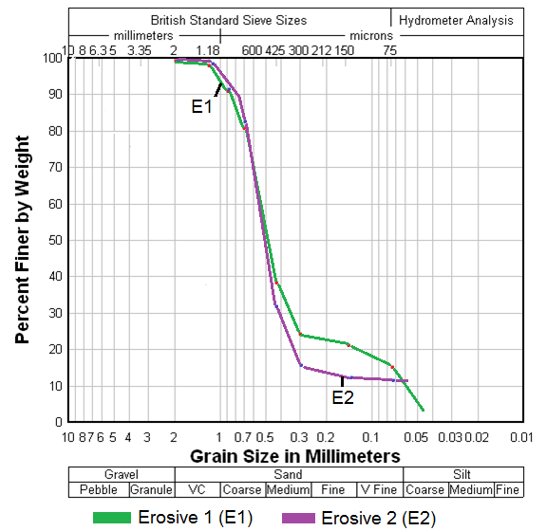
Figure 5: Grain Size Distribution Graph of Erosive Material I & II.
The graph illustrates the distribution of different particle sizes in the soil, showing that both materials have a high sand content, which makes them more prone to erosion under the influence of water.

3.3.3 Compaction Test Results
The Proctor compaction test was conducted to determine the optimal moisture content and maximum dry density of the soils. Compaction is crucial for understanding how soil density affects erosion resistance.
Table 4: Compaction Results for Erosive Material I & II.
Measurements | Erosive I | Erosive II
wt of ring + sample (g) | 258.5 | 255.1
Wt of ring (g) | 95.6 | 95.6
Wt of sample (g) | 162.9 | 159.5
Vol. of ring (cm³) | 98.2 | 98.2
Bulk density (g/cm³) | 1.66 | 1.62
Dry density | 1.51 | 1.47
Erosive Material I: Bulk density = 1.66 g/cm³, Dry density = 1.51 g/cm³
Erosive Material II: Bulk density = 1.62 g/cm³, Dry density = 1.47 g/cm³
The results indicate that both soil samples have low compaction values, which implies that the soils are not well-structured to resist erosion. The low density also suggests that the soils have high porosity, allowing water to infiltrate easily, thereby exacerbating the erosion process.
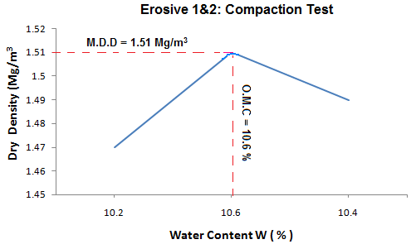
Figure 6: Compaction Graph for Erosive Material I & II.
This graph depicts the relationship between moisture content and dry density, highlighting the low compaction characteristics of the soils.

3.3.4 Shear Strength Test Results
Direct shear tests were conducted to measure the shear strength of the soils, which is crucial in understanding their resistance to shear forces. Low shear strength in soils can lead to slope instability and increase the potential for gully formation during heavy rainfall.

Table 5: Shear Strength Results for Erosive Material I & II.
(1)  Sample | (2)  Load(kg) | (3)  Max.(H.R) | (4)  (3) x 0.002  (mm) | (5)  (4) x 0.88  (KN) | (6)  (5) x a(kn/m²)
Erosive  I | 24 | 104 | 0.208 | 0.183 | 50.8
Erosive  I | 44 | 148 | 0.296 | 0.261 | 72.4
Erosive  I | 64 | 198 | 0.396 | 0.349 | 96.8
Erosive  II | 24 | 107 | 0.214 | 0.188 | 52.3
Erosive  II | 44 | 151 | 0.302 | 0.266 | 73.8
Erosive  II | 64 | 203 | 0.406 | 0.358 | 99.2
Erosive Material I: Maximum shear strength = 50.8 kN/m²
Erosive Material II: Maximum shear strength = 52.3 kN/m²
The shear strength of both materials is relatively low, indicating that the soils in the study area are prone to failure under shear stress. This finding suggests that the soils are vulnerable to displacement by water flow, further contributing to the development of gullies.
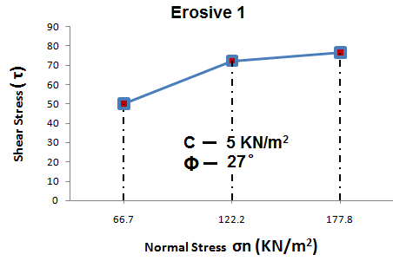
Figure 7: Shear stress graph result for erosive material I.

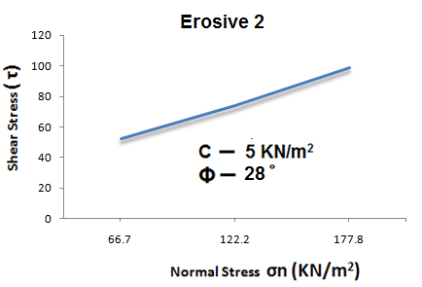
Figure 8: Shear stress graph result for erosive material II.

These figures show the shear stress results for both soil samples, demonstrating their limited ability to resist erosion forces.
The results from the field investigation, geophysical survey, and laboratory tests indicate that the soils in Ezeoke Nsu are highly susceptible to erosion. The primary factors contributing to this high erodibility include the soils' sandy texture, low clay content, low compaction, moderate moisture content, and low shear strength. These findings highlight the critical need for effective soil conservation practices and erosion control measures to mitigate the adverse effects of gully erosion in the region.

4. Discussion of Results
The results from this study offer valuable insights into the geotechnical characteristics and erodibility of soils in the gully-prone areas of Ezeoke Nsu, Southeastern Nigeria. The study incorporated both field and laboratory investigations to understand the underlying factors contributing to gully erosion, focusing on how the physical and mechanical properties of the soil influence its vulnerability to erosion. Below, we discuss the findings from the preliminary site investigations, geophysical survey, and laboratory tests.

4.1. Field Study and Geophysical Results
The field study, including topography, slope, and drainage pattern mapping, provided a strong foundation for understanding the role of surface features in the development of gully erosion. The drainage analysis maps indicated that the soil erosion process is heavily influenced by the slope of the land and the water runoff direction. In areas with steeper slopes, runoff has more energy, which increases the rate at which soil particles are detached and transported, leading to the development of gullies. According to Ofomata (2003), the role of topography is significant in shaping the erosion processes, as the steeper slopes contribute to greater runoff velocity, which accelerates soil erosion. The data from the GIS map of the site showed the drainage divides and the effect of improperly constructed roads, which exacerbated the gully formation by altering natural water flow. Additionally, Sidorchuk (2001) and Poesen et al. (2003) also highlighted that human activities, such as infrastructure development, significantly impact the extent of gully erosion in such areas.
The geophysical investigation, conducted using the Vertical Electrical Sounding (VES) method, revealed that the subsurface layers consist mainly of loose sand and sandstone, with minimal clay content. This finding suggests that the soil in the gully-prone areas is prone to erosion, especially since the sand particles lack the cohesive properties of clay that could help bind the soil particles together. According to Whiteman (1982), such sandy formations are particularly vulnerable to erosion due to their loose texture and lack of binding agents.
The average depth of the erosive material was found to be approximately 9 meters, which aligns with the observed depth of the gully. The finding that the subsurface consists of friable, unconsolidated materials emphasizes the vulnerability of the area to continued erosion. These materials, when exposed to water runoff, are easily detached and transported, contributing to the widening of the gully.

4.2. Laboratory Results: Moisture Content
The moisture content of the soil samples, which were measured using the oven-drying method, was found to be moderate, with values of 10.2% for Erosive Material I and 10.6% for Erosive Material II. These moisture content levels indicate that, while the soils are not excessively saturated, they are still vulnerable to erosion during the rainy season. Lal (1998) and Morgan (1986) emphasize that higher moisture content in sandy soils leads to a reduction in cohesion between soil particles, making them more prone to erosion, particularly during heavy rainfall events.
The relationship between moisture content and soil stability is critical in understanding how these soils behave during rainfall events. When the moisture content increases, the cohesion between soil particles decreases, particularly in sandy soils, making them more susceptible to erosion. This finding supports the hypothesis that rainfall and water infiltration play a significant role in the erosion process at Ezeoke Nsu, as highlighted by Rapp (1976) and Nwajide and Hogue (1979), who emphasized the impact of rainfall intensity on soil loss in tropical regions.

4.3. Grain Size Distribution
The grain size analysis revealed that the soils in Ezeoke Nsu are predominantly sandy, with minimal fines (clay and silt). The lack of fine particles in the soil reduces the soil’s ability to hold together, which is a key factor in soil erodibility. Soils that are rich in sand tend to have low cohesion, which makes them more prone to detachment by water forces. According to Igwe (2003), sandy soils with a high percentage of coarse particles have reduced resistance to erosion because they lack the fine particles that bind the soil together.
The grain size distribution of both erosive material samples showed a high percentage of sand and low fines, indicating poor soil stability under wet conditions. This result is consistent with the high vulnerability of sandy soils to erosion, as they are easily displaced by runoff. This phenomenon has been discussed by Abegunde et al. (2003), who also observed that sandy soils in Southeastern Nigeria are highly prone to gully erosion due to their poor cohesion.

4.4. Compaction Test Results
The results of the Proctor compaction test revealed that the bulk density and dry density of both erosive materials are relatively low, with values of 1.66 g/cm³ for Erosive Material I and 1.62 g/cm³ for Erosive Material II. The dry densities were 1.51 g/cm³ for Erosive Material I and 1.47 g/cm³ for Erosive Material II. These low compaction values suggest that the soils in the study area are loosely packed, which increases their porosity and permeability. As a result, water can easily infiltrate these soils, making them more prone to erosion during periods of high rainfall. The low compaction values also suggest that the soils are not well-structured to resist the forces acting on them, including those generated by runoff during heavy rains.
Low compaction also indicates that the soil particles are not tightly bound together, which enhances the soil’s susceptibility to detachment by water flow. Compaction is an important factor in determining the stability of soil, and the low compaction values observed in this study confirm that the soils in Ezeoke Nsu are vulnerable to erosion. When water infiltrates these soils, it causes them to loosen further, leading to the widening of gullies and further erosion. This finding is consistent with the observations of Igwe (2005), who noted that poorly compacted soils are highly erodible, particularly under heavy rainfall conditions.

4.5. Shear Strength Test Results
The shear strength test results for both erosive materials indicated relatively low values of shear strength, with values of 50.8 kN/m² for Erosive Material I and 52.3 kN/m² for Erosive Material II. Shear strength is an important indicator of soil stability, as it measures the soil’s resistance to internal shear forces that can lead to soil failure. Low shear strength values indicate that the soils in Ezeoke Nsu are prone to sliding or slipping when subjected to external forces such as water runoff. The low shear strength values, combined with the low compaction and high porosity of the soils, further emphasize the vulnerability of these soils to erosion.
The low shear strength values also suggest that the soils are unable to resist the erosive forces exerted by runoff water, which can cause the soil to be displaced easily, further contributing to gully formation. This finding aligns with the work of Lal (1998), who observed that shear strength is a critical factor in determining the stability of soils, particularly in erosion-prone areas. Morgan (1986) also highlighted the importance of understanding shear strength in assessing the potential for soil erosion.
The findings of this study highlight the key geotechnical factors that influence soil erodibility in Ezeoke Nsu and their contribution to the development and intensification of gully erosion in the region. The soils in this area, characterized by their sandy texture, low moisture retention, low compaction, and low shear strength, are highly susceptible to erosion, particularly under conditions of heavy rainfall and improper land use. These results suggest that both natural and anthropogenic factors, including soil properties and human activities, are responsible for the worsening gully erosion in Ezeoke Nsu.
To mitigate further erosion and soil degradation, it is essential to implement soil conservation measures that address these factors. This includes improving agricultural practices, reforestation, and constructing appropriate drainage systems to reduce runoff and protect vulnerable soils from erosion. The study underscores the importance of understanding the geotechnical properties of soils in erosion-prone areas for the development of sustainable land management strategies.

5. Conclusion
The study conducted on the geotechnical characteristics and erodibility of soils in the gully-prone areas of Ezeoke Nsu, Southeastern Nigeria, has provided crucial insights into the factors driving soil erosion in the region. The findings reveal that the soils in this area are highly susceptible to erosion due to their sandy texture, low moisture retention capacity, low compaction, and low shear strength. These physical properties, combined with heavy rainfall and improper land use practices, contribute significantly to the formation and intensification of gully erosion in Ezeoke Nsu.
The results from the grain size distribution, moisture content, compaction, and shear strength tests suggest that the soils lack the necessary cohesion to resist the erosive forces exerted by water runoff. Furthermore, the geophysical survey conducted using Vertical Electrical Sounding (VES) indicated that the subsurface is composed of loose, unconsolidated materials, which further enhances the vulnerability of the area to gully erosion. The combination of these natural and anthropogenic factors has led to significant soil degradation and threatens agricultural productivity, infrastructure, and the livelihood of the affected communities.
Given the critical role of soil characteristics in the erosion process, this study emphasizes the need for comprehensive land management strategies that incorporate both geotechnical and environmental considerations. By understanding the underlying geotechnical properties of the soils in Ezeoke Nsu, more effective and sustainable erosion control measures can be developed.

6. Recommendations
Based on the findings of this study, the following recommendations are proposed to mitigate the impact of gully erosion in Ezeoke Nsu and similar regions:
Implementation of Soil Conservation Practices
Soil conservation practices, such as afforestation, mulching, and contour farming, should be adopted to reduce the vulnerability of the soils to erosion. Planting vegetation, especially grasses and shrubs, on exposed soil surfaces will help protect the soil from the erosive effects of rainfall and runoff. The use of fast-growing plants, such as bamboo and grasses, can improve soil stability and reduce the intensity of soil erosion.
Improvement of Drainage Systems
The study identified poor drainage systems as a major contributor to gully formation in the region. It is essential to construct and maintain proper drainage channels to manage runoff effectively. Stormwater runoff should be directed away from vulnerable areas to prevent further soil displacement. Additionally, the construction of check dams or embankments in strategic locations could help control the flow of water and reduce the erosion potential.
Enhanced Agricultural Practices
Farmers in the region should be educated on the importance of adopting sustainable agricultural practices that reduce soil degradation. This includes avoiding excessive deforestation, practicing crop rotation, and minimizing the use of heavy machinery that compacts the soil. Integrating organic farming practices and maintaining ground cover during the rainy season will help preserve soil structure and reduce water infiltration that leads to erosion.
Community Awareness and Capacity Building
Raising awareness among local communities about the causes and impacts of gully erosion is essential for long-term sustainability. Educational programs and workshops should be organized to teach farmers and landowners about the importance of maintaining vegetation cover, proper land use, and soil conservation techniques. Engaging local communities in soil protection efforts will foster a sense of responsibility and increase the effectiveness of the interventions.
Government and Policy Interventions
The government should prioritize addressing the root causes of gully erosion by investing in infrastructure development that incorporates proper drainage and soil stabilization measures. Additionally, policies promoting reforestation, the use of soil-binding materials, and the construction of erosion control structures should be enforced. Financial and technical support for communities affected by gully erosion is also crucial to help them adopt sustainable land management practices.
Further Research and Monitoring
Continuous monitoring of gully-prone areas and further research into soil erosion dynamics are essential for understanding the evolving nature of gully formation. The data gathered from this study should be used as a baseline for future studies, which could focus on assessing the effectiveness of implemented erosion control measures over time. Long-term monitoring of soil properties, rainfall patterns, and gully expansion will provide valuable insights into the success of soil conservation efforts and guide future interventions.
By implementing these recommendations, it is possible to reduce the extent of gully erosion in Ezeoke Nsu and prevent further degradation of the environment. The integration of geotechnical knowledge with practical erosion control strategies will promote sustainable land management and improve the resilience of local communities to soil erosion.

Disclaimer (Artificial intelligence)
Author(s) hereby declare that NO generative AI technologies such as Large Language Models (ChatGPT, COPILOT, etc.) and text-to-image generators have been used during the writing or editing of this manuscript.

References
Abegunde, A. A., et al. (2003). The impact of erosion on rural economy: The case of Nanka in Anambra State of Nigeria. In Y. Fawehinmi (Ed.), Urban finance and infrastructure development in Nigeria (pp. 227-243). Atlantis Books.
Abegunde, A.A., et al. (2003). The impact of erosion on rural economy: The case of Nanka in Anambra State of Nigeria. In Y. Fawehinmi (Ed.), Urban finance and infrastructure development in Nigeria (pp. 227-243). Atlantis Books.
Idah, P. A., Mustapha, H. I., Musa, J. J., & Dike, J. (2008). Determination of erodibility indices of soils in Owerri West Local Government Area of Imo State, Nigeria. AU, J.T 12(2), 130-133.
Igwe, C. A. (2003). Erodibility of soils of the upper rainforest zone, Southeastern Nigeria. Land Degradation & Development, 14, 323-334.
Igwe, C.A. (2003). Erodibility of soils of the upper rainforest zone, Southeastern Nigeria. Land Degradation & Development, 14, 323-334.
Igwe, C.A. (2005). Erodibility in relation to water-dispersible clay for some soils of eastern Nigeria. Land Degradation and Development, 16, 87-96.
Lal, R. (1998). Soil erosion impact on agronomic productivity and environmental quality. Critical Reviews in Plant Sciences, 17(4), 319-464.
Lal, R. (1998). Soil erosion impact on agronomic productivity and environmental quality. Critical Reviews in Plant Sciences, 17(4), 319-464.
Morgan, R. (1986). Soil erosion and conservation. Co-published in the United States with John Wiley and Sons. New York.
Nwajide, C. S., & Hogue, M. (1979). Gullying processes in South-Eastern Nigeria. The Nigerian Field, 44(2), 64-74.
Nwajide, C.S., & Hogue, M. (1979). Gullying processes in South-Eastern Nigeria. The Nigerian Field, 44(2), 64-74.
Ofomata, G. E. K. (1985). Soil erosion in Nigeria: The views of a geomorphologist. University of Nigeria Inaugural Lecture Series No. 7, University of Nigeria, Nsukka.
Ofomata, G.E.K. (2003). Soil erosion in Nigeria. Paper presented at the Annual Conference of the Nigerian Geographical Association, University of Nigeria, Nsukka.
Okeke, U. E. (2015). Geo-environmental impacts and characteristics of an active gully erosion site in Ezeoke Nsu Mbano, Southeastern Nigeria. Federal University of Technology Owerri.
Onu, N. N. (2011). Training in geophysics: The challenges of oil exploration, gully erosion and water resources development. 18th Inaugural Lecture of the Federal University of Technology, Owerri.
Onyegbule, P. (2005). Geophysiographic factors of Agulu-Nanka gully erosion Southeastern Nigeria. Seminar paper presented to the Department of Geography, Met and Environmental Management, Nnamdi Azikiwe University, Awka.
Poesen, J., Nachtergaele, J., Verstraeten, G., & Valentine, C. (2003). Gully erosion and environmental change: Importance and research needs. Catena, 50(2-4), 91-133.
Poesen, J., Nachtergaele, J., Verstraeten, G., & Valentine, C. (2003). Gully erosion and environmental change: Importance and research needs. Catena, 50(2-4), 91-133.
Sidorchuk, A. (2001). GULTEM – The model to predict gully thermo erosion and erosion (Theoretical Framework). In Stott, D.E., Mohtar, R.H., Steinhardt, G.C (Eds) Sustaining the global Farm. Selected Papers from the 10th International Soil Conservation Organization Meeting held May 24-29, 1999 at the Purdue University and USDA-ARS National Soil Erosion Research Laboratory.
Whiteman, A. (1982). Nigeria: Its Petroleum Geology Resources and Potentials, Vol. 2. Graham and Trotman Publishers, London.

