Original Research Article

Jhum cultivation in relation to slope pattern and elevation in Phek District of Northeast India.

Abstract
This study adds to scientific understanding of how slope and elevation influence jhum cultivation in hilly regions. The site selection often starts before December. From late January to late March, all forest cutting and preparations for a burn must be completed before the monsoon. Later on, dibbling and spreading of seeds began. Due to the rugged topography, it is quite prevalent, providing an opportunity to examine the slope patterns and elevations of Phek district in relation to jhum cultivation, specifically the extent of area covered under various slope degrees and elevations. Supervised Classification utilizing the Maximum Likelihood algorithm was employed for the detection of jhum areas in land use and land cover analysis. The jhum area was exported and underwent post-classification for data rectification and miss classification in ArcGIS Pro. The slope and elevation map was created using ALOS DEM and processed in GIS software. Jhum cultivation is ideal in the study location with a slope degree of 20-40˚, the field covered by this degree measures 3824.46 hectares, over half of the cultivation in Phek region takes place at elevations of 1000–1500 meters. This study contributes to ecological research on deforestation causes and provides practical suggestions for soil erosion conservation, sustainable agriculture, and regional land-use planning in Northeastern India.
Key words – Jhum cultivation, slope and elevation

Introduction
Slash-and-burn is a prevalent agriculture method employed by about 250 million individuals in tropical regions (Metzer 2003). Jhum cultivation is referred to by several names across different regions of the globe. Shifting cultivation is considered a strategy of resource management in which fields are shifted to exploit the nutrient capacity of vegetation (Sarkar 2020). This is referred to as slash-and-burn cultivation, in parts of northeast India it is also called as jhum or jum. Shifting cultivation is characterized by field rotation rather than crop rotation. According to the study area, the region features a rugged terrain that limits the use of machinery and animals for jhum cultivation. A large population in the study area depends on jhum cultivation for sustenance and economic revenue. Slope and elevation are essential characteristics that yield diverse topographical aspects in the study region. Shifting cultivation requires the clearance of land in steep terrains. The site selection often starts before December. From late January to late March, all forest cutting and preparations for a burn must be completed before the monsoon. Later on, dibbling and spreading of seeds began. Depending on the purpose and crop cultivated in the jhum field, the previously cultivated area is rarely reused, resulting in the land remaining fallow until the subsequent cycle. Individuals engaged in jhum cultivation are referred to as jhumians.
Shifting farming is mostly done by hill cultures. Recent studies have emphasized the important influence of land use and elevation on slope stability in mountainous regions (Bobade et al., 2024). It is characterized by a sequence of customary operations that include cultural activities, site selection on hill slopes, clearing of vegetation at the chosen site while preserving beneficial trees and plant varieties. Jhum cultivation in Nagaland is considered an agricultural technique in which a farming community clears the forest in designated areas, burns and cultivates the land for a short period of years. Traditionally, prior to the commencement of the second year of cropping, community members initiate a new jhum cycle for the fresh jhum field for cultivation. A farmer or household simultaneously manages two fields. The land is thereafter left fallow while the community relocates to another site to replicate the process until they return to the original plot. This rotation cycle typically occurs over a span of 8 to 13 years. The practice is also considered to be a primary agricultural method in Nagaland. Of Nagaland's entire geographical area of 1,657,900 hectares, the annual cultivated area for Jhum is 131,349 hectares, constituting 58.95% of the total net cultivated area. The state Nagaland has more than 80% area under forests (Murthy et al. 2013). Whereas, the area is seeing significant deforestation, which is ultimately resulting in the loss of soil fertility (Temjen et al., 2021)
Economic development is significantly dependent on jhum cultivation, as the advent of cash crops and accessible markets is raising profit margins while simultaneously decreasing the fallow period due to continuous cultivation. It has also been examined that understanding the correlation between fallow duration and crop yields in shifting agriculture is crucial to prevent low yields and ongoing soil degradation and nutrient loss (Mertz 2001). The district's topography is predominantly hilly, necessitating agricultural practices that align with the terrain, where jhum cultivation is the sole traditional method practiced. Due to the rugged topography, jhum cultivation is quite prevalent, providing an opportunity to examine the slope patterns and elevations of Phek district in relation to jhum cultivation, specifically the extent of area covered under various slope degrees and elevations.
Objectives, concept and approach
To examine the slope patterns and elevations of Phek district in relation to jhum cultivation, specifically the extent of area covered under various slope degrees and elevations. The study use geographical approach in relation with Remote Sensing and Geographic Information System (GIS)
Study Area
Phek originates from the term “Phekrekedze” which signifies watchtower. It is situated at a latitude of 24° 40' 0.12" N and a longitude of 94° 30' 0.00" E. The summers are moderately warm, with an average temperature of 27°C, not surpassing 32°C.The mean annual precipitation is 1,527 mm. Agriculture serves as the principal occupation, with Jhum cultivation and Terrace Rice Cultivation (TRC) prevailing. As can be seen in Figure 1 in the southern section of the district, it shares a boundary with Myanmar, and in the state, it shares a boundary with Manipur. Additionally, the district shares a boundary with three other districts: Kohima, Zunheboto, and Kiphire.
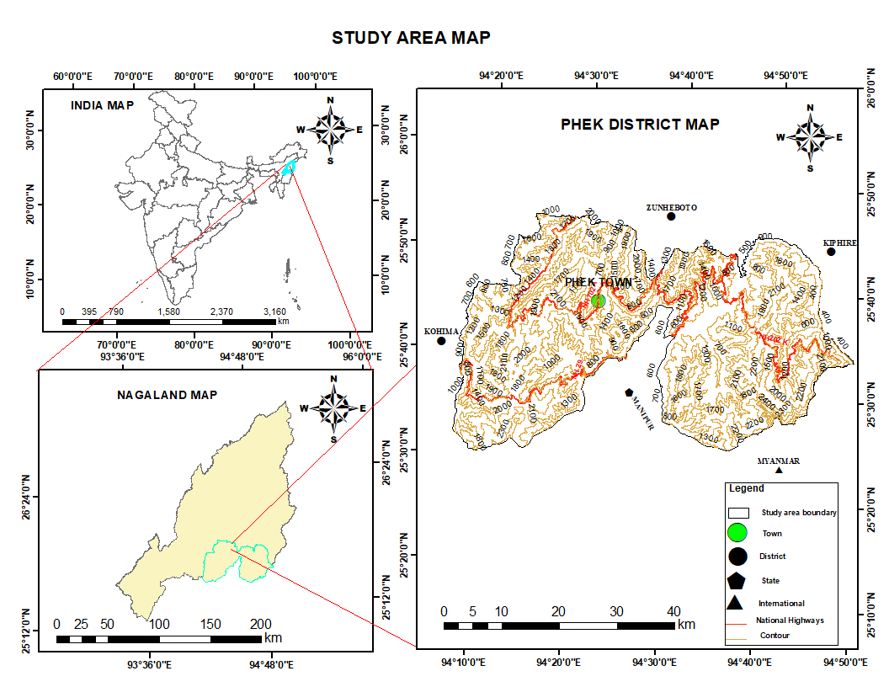
Figure 1. Location map of Phek District
Data and Methodology
Remote sensing is growing as a useful technique for moving from pixels to patterns, allowing the examination of landscape dynamics and land-use change (Mathur & Bhattacharya, 2024). Satellite images from Landsat 8-9 OLI/TIRS (2020) 30 meter resolution and the data was extracted from 2020-02-29, ALOS (Advanced Land Observation Satellite) was utilized for the analysis of slope, elevation, and jhum mapping. All data is easily accessible for complimentary download at a 30-meter resolution. The imagery were sourced from Earth Explorer, a website managed by the United States Geological Survey (USGS) at https://earthexplorer.usgs.gov/. The downloaded data were initially projected to Universal Transverse Mercator (UTM) with the World Geodetic System WGS-1984-UTM-46N datum. The ALOS DEM was obtained from the Japan Aerospace Exploration Agency (JAXA) website, where it is available for free download through the JAXA Earth Observation Research Centre portal. The DEM with 30m spatial resolution was used to extract the slope and elevation parameters of the research region, which were then merged with jhum filed analysis. (Bhat et al., 2022) Stated the use of remote sensing and DEM-based studies to map and monitor jhum, emphasizing the importance of slope/elevation stratification in understanding spatial patterns of shifting cultivation.
Image processing and various band combinations are employed for supervised classification (Debnath et al. 2017). Supervised Classification utilizing the Maximum Likelihood algorithm was employed for the detection of jhum areas in land use and land cover analysis. Training samples were gathered using field surveys and high-resolution Google Earth data. We chose several classes for LULC, including dense forest, water body, built-up, barren, vegetation, and jhum field. The jhum field was then rectified with a high resolution base map for miss classification before being exported for further analysis using the slope map and elevation map. The slope and elevation map was generated using ALOS data and processed in ArcGIS Pro. It was further mosaicked and processed to remove voids and sinks, ensuring correct slope and elevation derivation. Slope analysis was conducted out using ArcGIS Pro's Spatial Analyst extension, with slope values in degrees taken from the ALOS DEM. The slopes were divided into five categories: 0-10˚, 10-20˚, 20-30˚, 30-40˚, and 40-79˚. Elevation was similarly classified as 303-600 m, 600-1000 m, 1000-1500 m, 1500-2000 m, and 2000-3001 m. These categories were layered with jhum field distributions to determine cultivation preferences in relation to slope and elevation. The processed map was verified with a high resolution satellite imagery. The categorized jhum filed map was combined with slope and elevation maps in ArcGIS by spatial overlay analysis. This allows for the identification of the proportion of jhum field cultivation occurring within each slope and elevation category, offering insight into the geological constraints of Jhum cultivation. The more detailed methodology is shown in Figure 2.

Methodology
Area calculation
Landsat 8-9
OLI/ TIRS (2020)
Percentages and field calculator
Zonal and cross-tab analysis
LULC 2020
Pre processing
Loading processing
Export Jhum area
Supervised classification
ALOSE DEM
Classification
Terrain derivatives

Figure 2. Flowchart of Methodology
Results and Discussion
Jhum cultivation is predominantly practiced on sloped hills with fertile soil that has access to forests. The study area indicates that regions with a slope of 20-40 degrees seem optimal for the selection of jhum fields. The 20-40 degree slope area is predominantly cultivated by the jhumians of Phek district, while the 40-69 degree slope as shown in table 3 despite its steepness and challenging terrain, continues to support jhum farming.
The study area features rugged terrain; nonetheless, the ongoing practice of jhum cultivation results in extensive coverage across various slope degrees, from gentle to steep slope. In Phek district, the area classified as 0-10 degrees encompasses 10,052.01 hectares, constituting 5.37% of the entire geographical area. The area with a slope of 10-20 degrees is 41,362.38 hectares, constituting 22.09% of the entire geographical area. The region with a 20-30 degree slope encompasses the largest area, measuring 75,992.4 hectares, which constitutes 40.59% of the study area. The 30-40 degree slope covers 47,900.79 hectares, accounting for 25.58% of the area, while the 40-79 degree slope spans 11,885.04 hectares, representing 6.35% of the total area. Only 5.37% of the territory in Phek district is characterized by a slope of 0-10 degrees shown in table 1 and Figure 3. The current study in Phek district
Slope | Slope Category in Degree | Area Covered (ha) | Percentage of Area in Dem Category
1 | 0-10 | 10052.01 | 5.37
2 | 10-20 | 41362.38 | 22.09
3 | 20-30 | 75992.4 | 40.59
4 | 30-40 | 47900.79 | 25.58
5 | 40-79 | 11885.04 | 6.35
Table1. Regions categorized by varying slope gradients in Phek District.

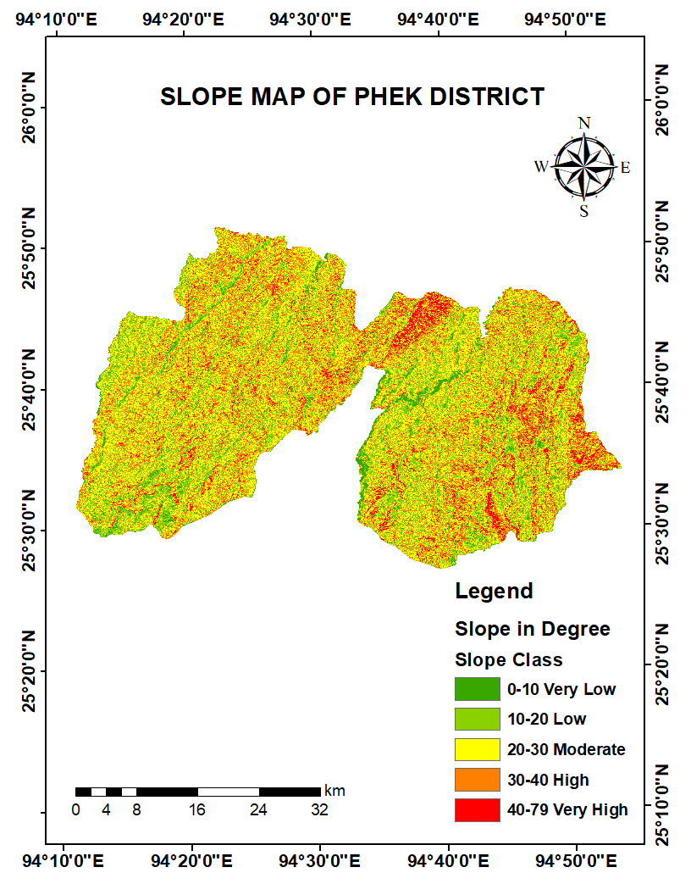
(Nagaland) reveals that jhum farming is largely concentrated on slopes of 20-40˚ and elevations between 1000-1500 meters. This reflects Nagaland's harsh and steep geomorphology, in which cultivable terrain is frequently limited to mid-hill slopes and steep valley slope.

Figure 3. Slope map of Phek District
(Nagaland) reveals that jhum farming is largely concentrated on slopes of 20-40˚ and elevations between 1000-1500 meters. This reflects Nagaland's harsh and steep geomorphology, in which cultivable terrain is frequently limited to mid-hill slopes and steep valley slope. In contrast, Sarkar et al. (2021) found that Jhum fields in the Karbi Anglong district of Assam have gentler slopes (15-35˚) and are typically cultivated at lower elevations. Its geography is characterized by extensive valleys and rolling hills, which provide relatively gentle slopes and larger cultivable regions. Phek feature narrow ridges, steep slopes, and high relief intensity, leaving limited flat space for jhum production. Likewise, the research demonstrates that jhum cultivation is not limited to a specific degree or elevation, but rather depends on topography of the region.
The Digital Elevation Model (DEM) of Phek district illustrates elevation and the region classified under the DEM category. In Phek district 153.45 ha area is under 303-600 meter elevation. Area under 600-1000 meter elevation is 4845.51 ha, 1000-1500 meter elevation is 26993.61 ha, 1500-2000 meter elevation is 43292.16 ha and 2000-3001 meter elevation is 111907.89 meter. The largest area coverage is between 2000-3001 meters, encompassing more than 50% of the total geographical area table 2, while the smallest coverage is between 303-600 meters, and accounting for only 1.8% of the total geographical area in Figure 4.
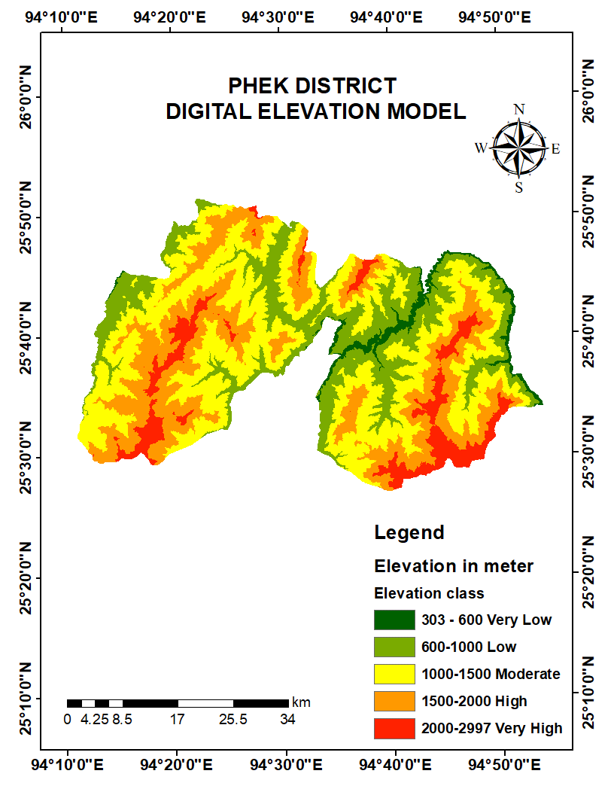
Figure 4. Digital Elevation Model of Phek District
Table 2. Area of several categories of Digital Elevation Models in Phek District
Dem | Dem Category (m) | Area Covered (ha) | Percentage of Area in Dem Category
1 | 303-600 | 153.45 | 1.08
2 | 600-1000 | 4845.51 | 2.55
3 | 1000-1500 | 26993.61 | 14.21
4 | 1500-2000 | 43292.16 | 22.78
5 | 2000-3001 | 111907.89 | 58.38

Jhum cultivation in relation with slope and Digital Elevation Model in Phek District
Jhum cultivation in Phek district is closely correlated with slope and Digital Elevation Model (DEM). Although jhum cultivation predominantly occurs on slopes ranging from 0 to 40 degrees, it expands swiftly in areas with steeper inclines. Despite the steepness of the hill (fig.5.), the Jhumians persist in their cultivation due to the region's rugged topography. In 2020, jhum fields were predominantly located on slopes ranging from 40 to 67 degrees, which comprises an area of 267.93 hectares table 3.
Table 3. Jhum Field distribution on slope 2020
Slope in Degree | Jhum Area in (ha)  2020 | Percentage
0-20 | 1258.11 | 23.51
20-40 | 3824.46 | 71.47
40-69 | 267.93 | 5.00
Total | 5350 | 100

The activity directly or indirectly contributes to the disturbance of the natural setting and forest environment (Lawrence D. et al., 2005). The ecological setting is further affected by the ongoing practice of jhum cultivation; the density of cultivation on mid-slopes raises concerns about soil erosion, land degradation, and biodiversity loss. Shortening fallow cycles can lead to erosion on steeper slopes over 30˚, potentially reducing soil productivity and forest regeneration over time. (Ray et al., 2021) also employed geospatial analysis to link jhum practices and soil degradation risk, demonstrating that steeper slopes are significantly more vulnerable to erosion under shifting cropping regimes.
Elevation-linked farming affects mid-hill forests, which are biodiversity-rich and important for water control. Despite awareness of the negative consequences of jhum activity, the practice persists, since the difficult landscape further encourages individuals to maintain the traditional agricultural method.
Despite the steepness of the hill (figure 5.), the Jhumians persist in their cultivation due to the region's rugged topography. In 2020, jhum fields were predominantly located on slopes ranging from 40 to 67 degrees, which comprises an area of 267.93 hectares table 3. The activity directly or indirectly contributes to the disturbance of the natural setting and forest environment (Lawrence D. et al., 2005). The ecological setting is further affected by the ongoing practice of jhum cultivation; the density of cultivation on mid-slopes raises concerns about soil erosion, land degradation, and biodiversity loss. Shortening fallow cycles can lead to erosion on steeper
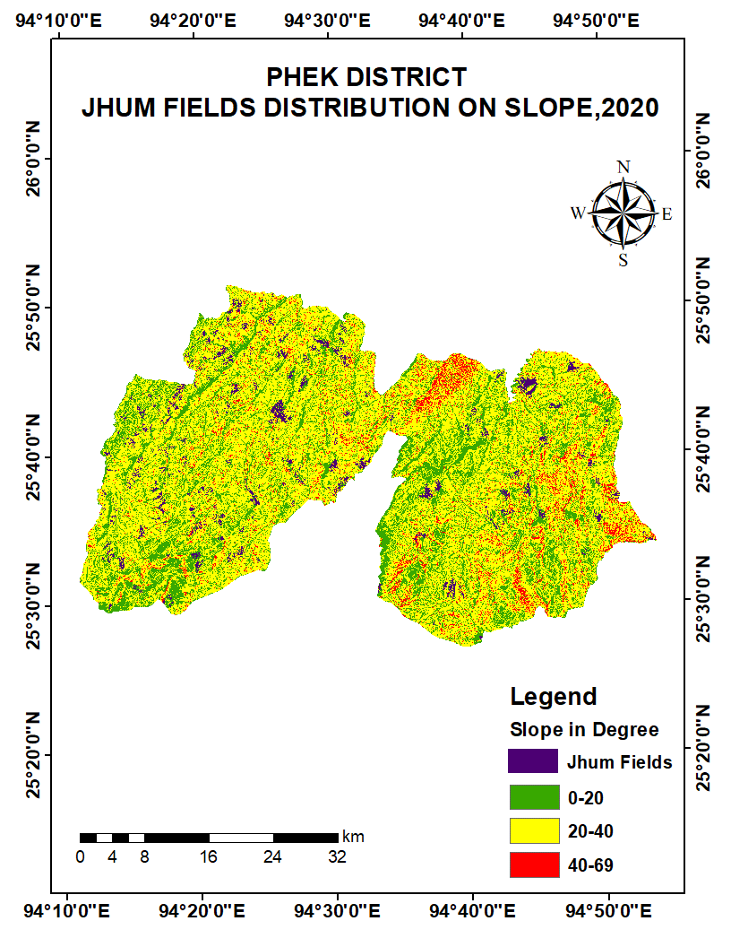

Figure 5. Jhum cultivation distribution on slope map of Phek District
slopes over 30˚, potentially reducing soil productivity and forest regeneration over time. Elevation-linked farming affects mid-hill forests, which are biodiversity-rich and important for water control. Despite awareness of the negative consequences of jhum activity, the practice persists, since the difficult landscape further encourages individuals to maintain the traditional agricultural method. The practice has an impact on the climate, both directly and indirectly. Farmers cultivating jhum in the Indian Himalayas are extremely vulnerable to climate change, necessitating locally adaptive solutions (Hazarika et al., 2024).

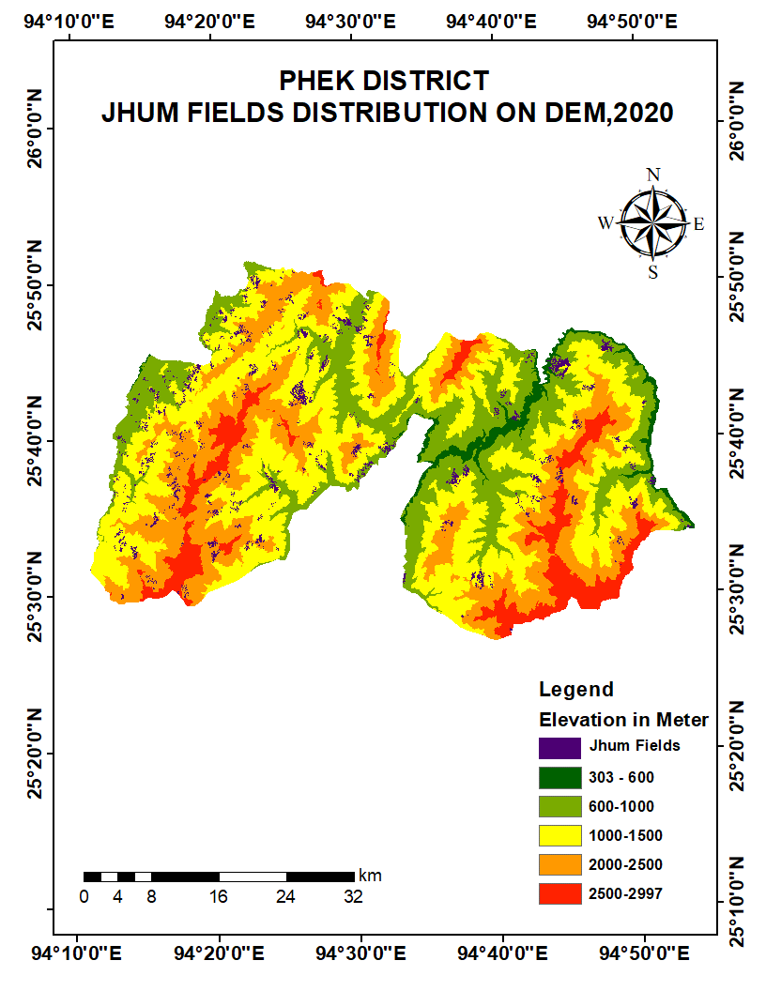
Figure 6. Jhum cultivation distribution on Digital Elevation Model
As seen in figure 6, in Phek district, jhum cultivation predominantly occurs at elevations ranging from 600 to 2000 meters. The Digital Elevation Model indicates that 53.82 hectares of jhum area lies within the 303-600 meter elevation, constituting 1 percent of the total geographical area. The jhum cultivation area between 600-1000 meters is 1190.07 hectares, representing 22.24 percent, while the area between 1000-1500 meters accounts for 48.62 percent, which contains the largest jhum fields. Additionally, the area at elevations of 1500-2000 meters encompasses 1450.26 hectares, and the area between 2000-3001 meters covers 54.54 hectares in Phek district (table 4).

Table.4. Jhum cultivation distribution on Digital Elevation Model (Elevation) in 2020
Dem (Elevation in Meter) | Jhum Area in (ha)  2020 | Percentage
303-600 | 53.82 | 1
600-1000 | 1190.07 | 22.24
1000-1500 | 2601.72 | 48.62
1500-2000 | 1450.26 | 27.10
2000-3001 | 54.54 | 1.01
Total | 5350 | 100

The expansion of jhum farming is increasing due to improved market accessibility and the advent of cash crops, encouraging jhumians to transform jhum fields primarily for economic gain rather than subsistence, Sati (2014) also strongly agrees that jhum has helped reduce the economic disparity for farmers in Mizoram through the establishment of accessible markets and transportation. The area currently exceeds the population, allowing local inhabitants to produce jhum fields to the extent that they can sustain. The research area is economically disadvantaged, prompting farmers to choose jhum agriculture, a low-input farming method that requires no costly machinery, fertilizers, or irrigation systems; thus, the jhumians rely on natural soil fertility. As shown in Figure 7, despite of the steepness of the slope, the photo plate A and B shows that jhum cultivation syill prevail.
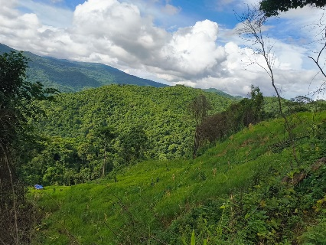
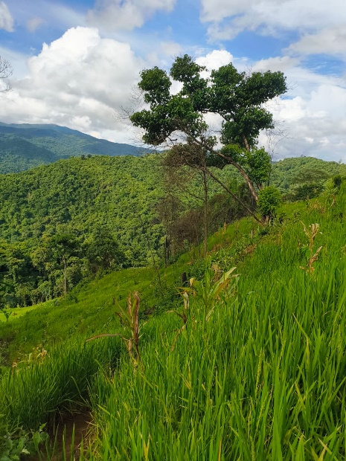
- (B)
Figure 7. photo A and B depict the steepness of the jhum field.
Conclusion
The study reveals that jhum cultivation is situated at a higher altitude, with the ideal elevation for jhum cultivation in the Phek district being 1000-1500. The two types of cultivation that are prevalent in the Phek district are jhum cultivation and terrace cultivation, with jhum covering a larger area. The study also reveals that the practice of jhum cultivation can be conducted in a rugged topography as long as the land is fertile for cultivation. This form of cultivation has both positive and negative effects, as it significantly disrupts the biodiversity and environment. Additionally, the inquiry reveals that the local crops are being preserved and grown organically without the use of any fertilizers. The study's findings give useful insights for sustainable land management and can help policy frameworks aiming at promoting agricultural resilience and ecological sustainability in Northeast India. Additional scientific research is important to identify the agricultural crops that are grown and their diversity in the study area.
Statements and Declarations
Data Availability: The necessary satellite imagery was obtained from Earth Explorer, a website operated by United States Geological Survey (USGS) https://earthexplorer.usgs.gov/.

Disclaimer (Artificial intelligence)

Option 1:

Author(s) hereby declare that NO generative AI technologies such as Large Language Models (ChatGPT, COPILOT, etc.) and text-to-image generators have been used during the writing or editing of this manuscript.

Reference
Murthy K. I, Sharma N and Nijavalli R, 2013, Harnessing REDD+ opportunities for forest conservation and carbon stock enhancement in the Northeastern States of India, Natural Science, 5(3):349-358.
Sarkar R, Bora A.K., and Sarma T. 2020. Shifting cultivation in relation to slope pattern and elevation in Karbi Anglong District of Assam. Eco. Env. & Cons. 27 (May Suppl. Issue): 2021; pp. (S239-S243) ISSN 0971-765X
Sati, V.P. and Rinawma, P. 2014. Practices of Shifting Cultivation and its Implications in Mizoram, North East India: A Review of Existing Research. Nature and Environment. 19 (2):179-187.
Debnath, J., Das (Pan) N., Ahmed, I. and Bhowmik, M. 2017. Channel migration and its impact on land use/ land cover using RS and GIS: A study on Khowai River of Tripura, North-East India. The Egyptian Journal of Remote Sensing and Space Sciences (Article in Press). http://dx.doi.org/10.1016/j.ejrs.2017.01.009
Mertz, O. 2002. The relationship between length of fallow and crop yields in shifting cultivation: a rethinking. Agroforestry Systems 55:149-159.
Metzger, J. P. 2003. Effects of slash-and-burn fallow periods on landscape structure. Environmental Conservation 30(4):325-333.
Lawrence, D., V. Suma, and J. P. Mogea. 2005. Change in species composition with repeated shifting cultivation: limited role of soil nutrients. Ecological Applications 15(6):1952-1967.
Bhat, Y., Nandy, S., Padalia, H., Nath, A. J., & Pebam, R. (2022). Role of Geospatial Technology in Shifting Cultivation Studies in India: A Systematic Review. Journal of the Indian Society of Remote Sensing, 50(12), 2359–2379. https://doi.org/10.1007/s12524-022-01607-7
Bobade, S., Dhawale, A., & Garg, V. (2024). Tempo-spatial impact assessment of landuse land covers on slope stability through GIS modeling at Raigad district of Maharashtra. Innovative Infrastructure Solutions, 9(8), 293. https://doi.org/10.1007/s41062-024-01602-6
Hazarika, A., Nath, A. J., Reang, D., Pandey, R., Sileshi, G. W., & Das, A. K. (2024). Climate change vulnerability and adaptation among farmers practicing shifting agriculture in the Indian Himalayas. Environmental and Sustainability Indicators, 23, 100430. https://doi.org/10.1016/j.indic.2024.100430
Mathur, I., & Bhattacharya, P. (2024). From pixels to patterns: Review of remote sensing techniques for mapping shifting cultivation systems. Spatial Information Research, 32(2), 131–141. https://doi.org/10.1007/s41324-023-00547-9
Ray, P., Chattaraj, S., Bandyopadhyay, S., Jena, R. K., Singh, S. K., & Ray, S. K. (2021). Shifting cultivation, soil degradation, and agricultural land‐use planning in the northeastern hill region of India using geo‐spatial techniques. Land Degradation & Development, 32(14), 3870–3892. https://doi.org/10.1002/ldr.3986
Temjen, W., Singh, M. R., & Jungla, T. (2021). IMPACT OF FALLOW ON SOIL HEALTH IN MOKOKCHUNG DISTRICT, NAGALAND, INDIA. Journal of Environmental Engineering and Landscape Management, 29(4), 410–417. https://doi.org/10.3846/jeelm.2021.15831

