Antioxidant system in species assemblages: species- and stress-specific effects of abiotic stress in secondary meadows of the Caucasus Mountains

ABSTRACT

Plant fitness relies on metabolic adaptability to abiotic stress, in which the antioxidant system plays a crucial role. This system is intensively studied, yet our existing knowledge of the matter is almost entirely derived from experiments at molecular and species levels, whilst studies on multiple species assemblages under a range of abiotic stressors are exceedingly rare. Therefore, here we ask: how does the plant antioxidant system behave at the community scale? We know that although plants experience the same stressor, their metabolic responses can differ substantially, while certain antioxidant metabolites may be associated with specific stress types. We hypothesized that the majority of the forb species in a hay meadow assemblage produce similar antioxidant responses specific to a given abiotic stress, while species-specific effects contribute little to the behavior of the antioxidant system at the community scale. We measured 12 key metabolites in 13 forb species co-occurring at three climatically distinct locations. Using ordination and cluster analyses, we evaluated response patterns. Combining a core set of common forb species with a suite of metabolites across three climatically distinct locations in one study enabled us to show that the majority of the forb species produced similar antioxidant responses specific to a given abiotic stress, thus overriding the species-specific differences. We conclude that a stress-specific pattern prevailed in the subset of forb species representing traditionally managed hay meadows, as predicted by our hypothesis.

Keywords: antioxidants, environmental stress, forbs, multivariate analysis, plant community, stress-tolerance

1.INTRODUCTION

The ability of a plant to survive, grow, and reproduce largely depends on the capacity of its metabolism to respond to the diverse abiotic stresses characteristic of its environment (Lamalakshmi et al. 2017; Shanker et al. 2022; Du et al. 2024). A key protective biochemical mechanism is the antioxidant system, which includes low-molecular-weight organic compounds and enzymes of varied chemical nature. These comprise pigments, amino acids, vitamins, proteins, soluble carbohydrates, catalase, peroxidase, and others (Laxa et al. 2019; Iqbal et al. 2020). Abiotic stress most commonly arises from non-optimal temperatures and their pronounced daily fluctuations, high ultraviolet radiation, and water deficits (Larcher et al. 2010; Fraire-Velázquez and Balderas-Hernández 2013). These stressors trigger the formation of reactive oxygen species in plant tissues, resulting in oxidative stress and metabolic disruption via free radical production (Dumanović et al. 2021). Plants counteract these effects through their antioxidant system (Murai et al. 2015; Rodríguez-Hernández 2019), making its activity a valuable indicator of adaptation to stress (Hashim et al. 2020). The antioxidant system has been extensively studied (for reviews see Arora et al. 2002; Navrot et al. 2007; Laxa et al. 2019). The core findings are that ascorbic acid increases under heat stress, carotenoids and soluble sugars under frost, and anthocyanins and tocopherols under stress caused by UV radiation. Yet, many species also exhibit distinct responses to the same abiotic stress: there are species that seemingly activate different parts of the antioxidant system in response to the same abiotic stress type (Badridze et al. 2023; 2024).
However, this ecophysiological knowledge is almost entirely obtained from work at the molecular and species levels, whilst studies at the community scale — on species assemblages under a range of abiotic stressors — are exceedingly rare (to our knowledge, nonexistent). This gap likely reflects the considerable challenges such investigations entail. First, species composition along ecological gradients varies sharply across locations (Becker et al. 2007; Körner 2024), limiting the number of taxa that can be studied under consistent stress regimes. Second, such studies require metabolite-level laboratory analyses for each plant species, resulting in a prohibitive number of assays when many taxa are involved. Third, plant material must be collected from the field with specimens in optimal physiological condition, necessitating multiple site visits and often leading to incomplete datasets when some species or metabolites cannot be sampled consistently.
To sum up, existing knowledge suggests that certain metabolic responses may be primarily stress-specific, while others are species-specific. Stress-specific responses can manifest similarly in an assemblage of multiple species exposed to the same type of stress, overriding interspecific variation. Species-specific responses may be observed when different species within an assemblage increase different antioxidants in response to the same abiotic stressor. However, these representations remain experimentally untested, and the extent to which metabolic adjustments to abiotic stress are mainly stress- or species-specific within plant communities remains poorly understood. To address these challenges, we selected a moderate number of common herbaceous species (forbs) growing in climatically distinct locations across the Greater and Lesser Caucasus Mountains. All sites represented the same plant community type: semi-natural hay meadows, distinguished by high diversity of forb species. The consistent land use facilitated the presence of numerous shared species across locations despite climatic differences, enabling the selection of target taxa. Ultimately, we assessed 13 forb species (Table 1) at three distinct sites — Bakuriani, Tskhratskaro and Sno (Fig. 1). To examine their metabolic responses to differing abiotic stressors, we focused on 12 widely studied compounds and enzymes with established antioxidative roles (Table 1). In particular, we tested the hypothesis that the majority of forb species in a hay meadow assemblage produce similar antioxidant responses specific to a given abiotic stress. An alternative hypothesis was that antioxidant responses are species-specific and blur the expected stress-specific responses across species. To test these hypotheses, antioxidants were quantified in each species at all three sites of co-occurrence, and the resulting data were examined using multivariate statistical approaches, including ordination and cluster analysis.

2. MATERIALS AND METHODS
2.1 Study locations and target species

Plant material was collected from hay meadow communities widely distributed across the Caucasus region, at three locations (Fig. 1, Table 1). Geographic coordinates and elevation were recorded using a Garmin eTrex 22x GPS receiver. Ultraviolet radiation (bands A and B) was measured at 2:00 p.m. local time using a UVX-Radiometer (UVP Inc., USA). Climatic data for the study sites were obtained from the Global Historical Weather and Climate Data repository (https://weatherandclimate.com).
Despite substantial climatic variation among the sites (see Results) plant community composition overlapped significantly due to similar land-use histories – namely, traditional pasturing and haymaking. From the species shared across all three locations, we selected the most representative taxa for this study (Table1). The nomenclature follows Flora of Georgia (2011), Davlianidze et al. (2018), and Plants of the World Online (Miller and Ulate, 2017).

2.2 Plant Material Collection

Plant material was collected in 2009–2010, primarily in late July to early August, coinciding with the flowering phase of the target species. Individual plants were randomly sampled, placed in paper bags, and transported to the laboratory in a cool box to prevent desiccation. All biochemical assays were conducted using fresh material, with the exception of anthocyanin analysis, which was performed on tissue dried at 75°– 80 °C in a thermostat and subsequently stored under refrigeration.

2.3 Metabolite and Enzyme Activity Assays

The analyzed compounds included anthocyanins, ascorbic acid, carotenoids, chlorophylls (a + b), proline, soluble carbohydrates, soluble phenolics, tocopherols, and total proteins. Enzyme activities – catalase, nitrate reductase, and peroxidase – were assessed in the same laboratory.
Anthocyanins were extracted using 96% ethanol with 1% HCl and quantified spectrophotometrically at 540 nm (Ermakov, 1987, pp. 113–114).
Ascorbic acid was measured via titration with a 0.001 M solution of 2,6-dichlorophenolindophenol (Ermakov, 1987, pp. 86–91).
Catalase activity was determined gasometrically by measuring the volume of oxygen released during the decomposition of hydrogen peroxide. The reaction vessel was connected to a burette to capture and quantify the evolved gas (Pleshkov, 1985, pp. 203–206).
Nitrate reductase activity was assayed spectrophotometrically at 520 nm by quantifying nitrite accumulation resulting from nitrate reduction (Ermakov, 1987, pp. 51–52).
Peroxidase activity was measured spectrophotometrically using guaiacol; the absorbance of oxidized guaiacol products was recorded at 470 nm over 2 minutes (Ermakov, 1987, pp. 41–43).
Plastid pigments (chlorophylls and carotenoids) were extracted from fresh leaves in 96% ethanol and quantified at 560 nm (chlorophylls) and 470 nm (carotenoids) (Lichtenthaler & Buschmann, 2001).
Proline was quantified spectrophotometrically at 520 nm using toluene extracts of ninhydrin-treated samples (Bates et al., 1973).
Soluble carbohydrates were measured at 620 nm in anthrone-treated samples (Turkina & Sokolova, 1971).
Soluble phenolics were quantified at 765 nm in samples treated with Folin–Ciocâlteu reagent (Ferraris et al., 1987).
Tocopherols were measured spectrophotometrically at 470 nm using 96% ethanol extracts (Fillipovich et al., 1982, pp. 40–60).
Total proteins were quantified following the method of Lowry et al. (1951).
All spectrophotometric measurements were performed using a SPEKOL 11 spectrophotometer (KARL ZEISS, Germany).

2.4 Statistical Analyses

All chemical assays were performed in triplicate for each species, and mean values were calculated for subsequent multivariate analyses. To examine stress-specific relationships between climatic variables and metabolite levels, we standardized the data simply by dividing the values of the antioxidant concentrations by their maximum value. Then we pooled metabolite data across species for each location and calculated mean values, which were used in non-metric multidimensional scaling (nMDS) using Euclidean distance for the ordination. Climatic variables (Table 2) served as the environmental matrix in these analyses. To assess interspecific variation in metabolic responses across sites, we applied two-way UPGMA cluster analysis using Euclidean distance.
All statistical analyses were conducted using PAST 4 software (Hammer & Harper, 2001).

3. RESULTS
3.1 The variation of antioxidants at community scale

The climatic conditions at the three study locations were clearly different (Fig. 2). Axis 1 of the nMDS plot explained the bulk of variation in the data (R² = 0.998, Stress = 0). Along this axis, temperature increased (Score = 0.959), as did UV radiation (Score = 0.738), while precipitation declined (Score = –0.999). Axis 2 was associated with continentality (Score = 0.799). These results from the nMDS ordination suggest that abiotic stress in Bakuriani was caused by cold (Score values: –0.293 and –0.297 for Axis 1 and Axis 2, respectively). Cold was also strongly present in Tskhratskaro, but combined with high daytime temperatures that manifested as continentality (Score values: –0.451 and 0.257 for Axis 1 and Axis 2, respectively). In Sno, abiotic stress was likely caused by heat and UV radiation (Score values: 0.744 and 0.039 for Axis 1 and Axis 2, respectively).
Ascorbate was most strongly associated with Axis 1 (Score = 0.241), followed by peroxidase activity and tocopherols (Score values: 0.118 and 0.103, respectively). Chlorophylls, carotenoids, and catalase activity were negatively associated with Axis 1 (Score values: –0.117, –0.119, and –0.159, respectively). Associations with Axis 2 were weak (Score values ranging from 0.032 to –0.017). Thus, the stress-specific responses formed a discernible pattern: ascorbic acid, peroxidase activity, tocopherols, and total proteins were associated with heat stress, while carotenoids, catalase activity, and chlorophylls increased under cold conditions. Other compounds appeared near the centroid of the nMDS chart, showing minimal variation and no clear association with the climatic variables. Overall, this pattern aligns well with existing knowledge on the roles of antioxidants under different types of abiotic stress (see Introduction).

3.2 The antioxidant variation at the species scale

In addition to stress-specific effects, cluster analysis revealed species-specific metabolic responses in plants for which the majority of metabolites were assessed (Fig. 3). The division of plant species into clusters at the three locations was not exactly the same, although species could be roughly divided into two groups. The first group consistently included Veratrum and Achillea, while Rumex, Origanum, and Alchemilla were constant members of the second group across all three locations. Other species changed groups depending on the location. The groupings were more distinct at Bakuriani and Tskhratskaro, but became less clear-cut at Sno.
In Bakuriani, the first group of plants contained relatively lower levels of tocopherols (Bistorta, Veratrum), peroxidase activity (Plantago, Taraxacum), and proline (Bistorta), but exhibited high levels of ascorbate (Taraxacum, Achillea), catalase (Bistorta, Veratrum, Achillea), and nitrate reductase activity (Taraxacum, Achillea). The second group was characterized by generally low ascorbate but high tocopherol levels in Arctium and Thymus.
In Tskhratskaro, the first group showed lower catalase activity (Veratrum) and tocopherol content (Plantago, Achillea), but higher peroxidase activity (Bistorta, Arctium, Veratrum) and phenolics (Bistorta, Hypericum, Valeriana). The second group contained species with lower peroxidase activity (Origanum, Alchemilla, Rumex) and phenolics (Rumex).
In Sno, the species generally exhibited high levels of antioxidants, except for carotenoids and chlorophylls.

4. DISCUSSION

One direction in the study of chemical ecology of multi-species assemblages involves analyzing the interactions among these species (Silva et al. 2018; Raguso et al. 2015). It is safe to say that another major focus is on plant metabolic responses to abiotic stress gradients; however, such studies typically concentrate on a single species or taxon and a narrow class of metabolites (Shanker et al. 2022). A classic example is the well-documented increase in leaf epidermal flavonoids in response to heightened UV radiation (e.g., Tripp et al. 2018; Koski et al. 2024). In contrast, our study simultaneously assessed 13 metabolic responses across 12 forb species exposed to distinct types of abiotic stress.
The Caucasus Mountains provided an ideal setting for such a comparative investigation. Traditionally managed secondary grasslands occupy extensive portions of the landscape (Nakhutsrishvili 2012). These pastures and hay meadows, established by the end of the Late Bronze Age, have been largely maintained to the present day (Kikvidze 2020a, p. 100). Their persistence over more than four millennia and widespread distribution underscore the sustainability of this agricultural system in the region (Kikvidze 2020b, pp. 166–167), which has significantly altered the distribution of potential natural vegetation. As a result, pasture- and meadow-adapted species now occur more broadly than predicted by potential vegetation models, extending into environments characterized by differing abiotic stress regimes, as observed in our study. This enabled us to examine a consistent set of species across climatically diverse sites: Bakuriani, where the potential natural vegetation is mixed montane conifer–beech forest; Sno, located in the subalpine broad-leaved birch forest zone; and Tskhratskaro, situated at the edge of the Javakheti Plateau, a region typified by steppe vegetation (Giorgi Mikeladze, pers. comm.; Nakhutsrishvili 2012).
Our results show that stress-specific responses prevailed in the tested subset of forb species representing traditionally managed hay meadows, as predicted by our main hypothesis. Temperature emerged as the primary climatic driver of this aggregated response. However, metabolic adjustments to cold and heat stress differed markedly, as high levels of ascorbic acid, tocopherols, and peroxidase activity were associated with heat stress. In contrast, carotenoid and chlorophyll levels, as well as catalase activity, were associated with cold conditions. These findings are consistent with knowledge derived from experiments conducted at the species level (as discussed in the Introduction above).
Beyond these stress-specific trends, species-specific metabolic profiles also emerged, which could be roughly divided into two groups with differing levels of various antioxidants. The differences among species largely depended on the type of abiotic stress; however, the contribution of such variation was weak overall and clearly overridden by the stress-specific effect.
Some species showed a wide spectrum of responses, apparently reflecting the strength of their secondary metabolism. For example, Bistorta has a well-established use in traditional medicine (Bussmann et al. 2024a), benefiting from the rich phytochemistry of this species, which likely includes high antioxidant content (Pawłowska et al. 2020). Hypericum, Rumex, Valeriana, and Veratrum are also distinguished by their phytochemistry (see Bussmann et al. 2024b for Hypericum; Bussmann et al. 2024c and Batsatsashvili et al. 2017 for Rumex; Nandhini et al. 2018 for Valeriana; and Taldaev et al. 2022 for Veratrum).
Plant community ecology has benefited greatly from the introduction of the concept of functional diversity (Bishaya et al. 2024; Palacio et al. 2025). It helps link ecosystem functions with species diversity and is based on the quantification and analysis of plant functional traits such as specific leaf area, plant height, seed size, nitrogen content, photosynthesis rate, and others (Díaz et al. 2007; Rao et al. 2024). Effective analytical tools have emerged in the form of functional diversity indices (Casanoves et al. 2011). Since plant survival, growth, and reproduction also depend on defensive compounds such as antioxidants, the content of these key metabolites — varying across species — can be understood as equally important as other functional traits (Freeman et al. 2025). If we accept this, then we must also acknowledge a significant gap in our knowledge: we do not yet understand how antioxidant and other defensive metabolic mechanisms operate at the community scale and contribute to ecosystem functions.
Compared to standard vegetation sampling (e.g., recording species within sampling plots), sampling for functional traits requires direct measurement of these traits in the field and is therefore more complex and labor-intensive. As discussed in the Introduction, sampling for antioxidants is even more challenging. This becomes particularly difficult in species-rich communities such as secondary meadows, although in our study we were able to represent an important group of plants — namely, forbs. Progress in this field will likely depend on the development of novel sampling techniques that allow for measuring multiple metabolites across many plant species in situ. Such advancements appear crucial for improving our understanding of plant community functions..

5. CONCLUSIONS

By combining a core set of common herbaceous species with a suite of metabolites across three climatically distinct locations, this study enabled a nuanced assessment of the stress- and species-specificity of metabolic responses in secondary grassland communities of the Greater and Lesser Caucasus. The majority of forb species in a hay meadow assemblage produced similar antioxidant responses specific to a given abiotic stress, overriding species-specific differences. The knowledge previously gained from experiments at molecular and species levels aligns well with these findings.

Disclaimer (Artificial intelligence)
Authors hereby declare that NO generative AI technologies such as Large Language Models (ChatGPT, COPILOT, etc.) and text-to-image generators have been used during the writing or editing of this manuscript.

REFERENCES
Arora A, Sairam RK, Srivastava GC. (2002). Oxidative stress and antioxidative system in plants. Current Science, 82(9), 1227–1238. Available: http://www.jstor.org/stable/24107045
Badridze G, Chkhubianishvili E, Rapava L, Kikvidze M, Chigladze L, Tsilosani K. (2023). Study of antioxidants in leaves of xerophytes of Georgia. International Journal of Environmental & Agriculture Research (IJOEAR), 9(2), 17–23. Available: https://ijoear.com/assets/articles_menuscripts/file/IJOEAR-FEB-2023-18.pdf
Badridze G, Chkhubianishvili E, Rapava L, Kikvidze M, Chigladze L, Tsiklauri N, Tsartsidze N. (2024). Peculiarities of xerophytes adaptation to drought in Chachuna managed territory and Vashlovani protected area (Eastern Georgia). Plant Biosystems, 158(5), 1105–1114. https://doi.org/10.1080/11263504.2024.2392549
Bates LS, Waldren RP, Teare ID. (1973). Rapid determination of free proline for water-stress studies. Plant and Soil, 39(Nov), 205–207. https://doi.org/10.1007/BF00018060
Batsatsashvili K, Mehdiyeva NP, Fayvush G, Kikvidze Z, Khutsishvili M, Maisaia I, Sikharulidze S, Tchelidze D, Aleksanyan A, Alizade VM, Zambrana NYP. (2017). Rumex acetosa L., Rumex acetosella L., Rumex confertus Willd., Rumex conglomeratus Murray, Rumex crispus L., Rumex tuberosus L. (Polygonaceae). In: Paniagua-Zambrana NY, Bussmann RW (Eds.), Ethnobotany of the Caucasus (pp. 607–617). Springer, Cham. https://doi.org/10.1007/978-3-319-49412-8_131
Becker A, Körner C, Brun JJ, Guisan A, Tappeiner U. (2007). Ecological and land use studies along elevational gradients. Mountain Research and Development, 27(1), 58–65. https://doi.org/10.1659/0276-4741(2007)27[58:EALUSA]2.0.CO;2
Bishaya P, Hazarika V, Sharma N. (2024). Functional Diversity: Part 1: Introduction and Background. Resonance, 29(6), 825–838. https://doi.org/10.1007/s12045-024-0825-7
Bussmann RW, Paniagua-Zambrana NY, Khutsishvili M, Kikvidze Z, Müller L, Batsatsashvili K, Sikharulidze S, Tchelidze D, Maisaia I, Nasab FK, Zeraatkar A. (2024c). Rumex acetosa L., Rumex acetosella L., Rumex alpinus L., Rumex crispus L., Rumex obtusifolius L., Rumex patientia L., Rumex pulcher L., Rumex tuberosus L. (Polygonaceae). In: Paniagua-Zambrana NY, Bussmann RW (Eds.), Ethnobotany of the Caucasus (pp. 1–32). Springer, Cham. https://doi.org/10.1007/978-3-319-50009-6_131-2
Bussmann RW, Paniagua-Zambrana NY, Kikvidze Z, Batsatsashvili K, Khutsishvili M, Müller L, Mehdiyeva NP, Mursal N, Salimov R, Fayvush G, Aleksanyan A. (2024b). Hypericum androsaemum L., Hypericum bithynicum Boiss., Hypericum perforatum L. (Hypericaceae). In: Paniagua-Zambrana NY, Bussmann RW (Eds.), Ethnobotany of the Caucasus (pp. 1–24). Springer, Cham. https://doi.org/10.1007/978-3-319-50009-6_349-1
Bussmann RW, Paniagua-Zambrana NY, Mehdiyeva NP, Alizade VM, Fayvush G, Aleksanyan A, Khutsishvili M, Kikvidze Z, Batsatsashvili K, Sikharulidze S, Tchelidze D. (2024a). Bistorta carnea (C. Koch) Kom., Bistorta officinalis Delarbre (Polygonaceae). In: Paniagua-Zambrana NY, Bussmann RW (Eds.), Ethnobotany of the Caucasus (pp. 1–10). Springer, Cham. https://doi.org/10.1007/978-3-319-50009-6_207-1
Casanoves F, Pla LE, Di Rienzo JA. (2011). FDiversity: An integrated tool to estimate and analyze functional diversity. The Bulletin of the Ecological Society of America, 92(2), 147–152. https://doi.org/10.1890/0012-9623-92.2.147
Davlianidze M, Gviniashvili T, Mukbaniani M, Jinjolia-Imnadze L, Jugheli T. (2018). Nomenclatural checklist of flora of Georgia. Tbilisi: Ilia State University Institute of Botany.
Díaz S, Lavorel S, de Bello F, Quétier F, Grigulis K, Robson TM. (2007). Incorporating plant functional diversity effects in ecosystem service assessments. Proceedings of the National Academy of Sciences, 104(52), 20684–20689. https://doi.org/10.1073/pnas.0704716104
Du B, Haensch R, Alfarraj S, Rennenberg H. (2024). Strategies of plants to overcome abiotic and biotic stresses. Biological Reviews, 99(4), 1524–1536. https://doi.org/10.1111/brv.13079
Dumanović J, Nepovimova E, Natić M, Kuča K, Jaćević V. (2021). The significance of reactive oxygen species and antioxidant defense system in plants: A concise overview. Frontiers in Plant Science, 11, 552969. https://doi.org/10.3389/fpls.2020.552969
Ermakov AI. (1987). Methods of plants biochemical study. Leningrad: Agropromizdat.
Ferraris L, Gentile IA, Matta A. (1987). Variations of phenols concentration as a consequence of stresses that induce resistance to Fusarium wilt of tomato. Journal of Plant Diseases and Protection, 96(6), 624–629. Available: http://www.jstor.org/stable/43385627
Fillipovich IM, Egorova TA, Sevastianova GA. (1982). Practical handbook in biochemistry. Moscow: Prosveshchenie. (In Russian)
Flora of Georgia. (2011). Vol. I–XI, 2nd ed. Tbilisi: Ilia State University Institute of Botany.
Fraire-Velázquez S, Balderas-Hernández VE. (2013). Abiotic stress in plants and metabolic responses. In: Vahdati K, Lesley C (Eds.), Abiotic Stress – Plant Responses and Applications in Agriculture (Vol. 10, pp. 25–48). Vienna: IntechOpen. https://doi.org/10.5772/54859
Freeman EC, Peller T, Altermatt F. (2025). Ecosystem ecology needs an ecology of molecules. Trends in Ecology & Evolution, 40(3), 219–223. https://doi.org/10.1016/j.tree.2024.12.006
Hammer Ø, Harper DA. (2001). PAST: Paleontological statistics software package for education and data analysis. Palaeontologia Electronica, 4(1), 1. Available: http://palaeo-electronica.org/2001_1/past/issue1_01.htm
Hashim AM, Alharbi BM, Abdulmajeed AM, Elkelish A, Hozzein WN, Hassan HM. (2020). Oxidative stress responses of some endemic plants to high altitudes by intensifying antioxidants and secondary metabolites content. Plants, 9(7), 869. https://doi.org/10.3390/plants9070869
Iqbal A, Don Q, Wang X, Gui H, Zhang H, Zhang X, Song M. (2020). High nitrogen enhances drought tolerance in cotton through antioxidant enzymatic activities, nitrogen metabolism and osmotic adjustment. Plants, 9(2), 178. https://doi.org/10.3390/plants9020178
Kikvidze Z. (2020a). Traditional Ecological Knowledge in Georgia: A Short History of the Caucasus. London: Routledge.
Kikvidze Z. (2020b). Ethnobiology of Georgia. Tbilisi: Ilia State University.
Körner C. (2004). Mountain biodiversity, its causes and function. AMBIO, 33(sp13), 11–17. https://doi.org/10.1007/0044-7447-33.sp13.11
Koski MH, Leonard E, Tharayil N. (2024). Foliar flavonoids across an elevation gradient: Plasticity in response to UV, and links with floral pigmentation patterning. Environmental and Experimental Botany, 228, 106036. https://doi.org/10.1016/j.envexpbot.2024.106036
Larcher W, Kainmüller C, Wagner J. (2010). Survival types of high mountain plants under extreme temperatures. Flora, 205(1), 3–18. https://doi.org/10.1016/j.flora.2008.12.005
Laxa M, Liebthal M, Telman W, Chibani K, Dietz KJ. (2019). The role of the plant antioxidant system in drought tolerance. Antioxidants, 8(4), 1–31. https://doi.org/10.3390/antiox8040094
Lichtenthaler HK, Buschmann C. (2001). Chlorophylls and carotenoids: Measurement and characterization by UV-VIS spectroscopy. Current Protocols in Food Analytical Chemistry, 1(1), F4.3.1–F4.3.8. https://doi.org/10.1002/0471142913.faf0403s01
Lowry OH, Rosebrough NJ, Farr AL, Randall RJ. (1951). Protein measurement with the Folin phenol reagent. Journal of Biological Chemistry, 193(1), 265–275. Available: https://www.jbc.org/article/S0021-9258(19)52451-6/fulltext
Miller C, Ulate W. (2017). World Flora Online Project: An online flora of all known plants. Biodiversity Information Science and Standards. Available: https://powo.science.kew.org
Murai Y, Setoguchi H, Kitajima J, Iwashina T. (2015). Altitudinal variation of flavonoid content in the leaves of Fallopia japonica and the needles of Larix kaempferi on Mt. Fuji. Natural Product Communications, 10(3), 1934578X1501000308. https://doi.org/10.1177/1934578X1501000308
Nakhutsrishvili G. (2012). The vegetation of Georgia (South Caucasus). Springer.
Nandhini S, Narayanan KB, Ilango K. (2018). Valeriana officinalis: A review of its traditional uses, phytochemistry and pharmacology. Asian Journal of Pharmaceutical and Clinical Research, 11(1), 36–41. https://doi.org/10.22159/ajpcr.2018.v11i1.22588
Navrot N, Rouhier N, Gelhaye E, Jacquot JP. (2007). Reactive oxygen species generation and antioxidant systems in plant mitochondria. Physiologia Plantarum, 129(1), 185–195. https://doi.org/10.1111/j.1399-3054.2006.00777.x
Palacio FX, Ottaviani G, Mammola S, Graco‐Roza C, de Bello F, Carmona CP. (2025). Integrating intraspecific trait variability in functional diversity: An overview of methods and a guide for ecologists. Ecological Monographs, 95(2), e70024. https://doi.org/10.1002/ecm.70024
Pawłowska KA, Hałasa R, Dudek MK, Majdan M, Jankowska K, Granica S. (2020). Antibacterial and anti-inflammatory activity of bistort (Bistorta officinalis) aqueous extract and its major components. Journal of Ethnopharmacology, 260, 113077. https://doi.org/10.1016/j.jep.2020.113077
Petrén H, Anaia RA, Aragam KS, Bräutigam A, Eckert S, Heinen R, Jakobs R, Ojeda‐Prieto L, Popp M, Sasidharan R, Schnitzler JP. (2024). Understanding the chemodiversity of plants: Quantification, variation and ecological function. Ecological Monographs, 94(4), e1635. https://doi.org/10.1002/ecm.1635
Pleshkov BP. (1985). Practical handbook in plant biochemistry. Moscow: Kolos. (In Russian)
Rao AS, Chhawri R, Chauhan A, Yadav SS, Meena KC, Bansal P. (2024). Plant functional traits: A key framework for understanding and managing ecosystem responses to global environmental challenges. In: Plant Functional Traits for Improving Productivity (pp. 287–299). Singapore: Springer Nature Singapore. https://doi.org/10.1007/978-981-97-1510-7_15
Rodríguez-Hernández D. (2019). Secondary metabolites as a survival strategy in plants of high mountain habitats. Boletín Latinoamericano y del Caribe de Plantas Medicinales y Aromáticas, 18(5), 444–458. https://doi.org/10.35588/blacpma.19.18.5.29
Raguso RA, Agrawal AA, Douglas AE, Jander G, Kessler A, Poveda K, Thaler JS. (2015). The raison d'être of chemical ecology. Ecology, 96(3), 617–630. https://doi.org/10.1890/14-1474.1
Shanker C, Padmavathi C, Himabindu P, Repelle N. (2022). Molecules to ecosystems—recent trends in chemical ecology for combating biotic stresses in a changing climate. In: Shanker AK, Anand A (Eds.), Climate Change and Crop Stress (pp. 361–410). https://doi.org/10.1016/C2017-0-03584-X
Silva RF, Rabeschini GB, Peinado GL, Cosmo LG, Rezende LH, Murayama RK, Pareja M. (2018). The ecology of plant chemistry and multi-species interactions in diversified agroecosystems. Frontiers in Plant Science, 9, 1713. https://doi.org/10.3389/fpls.2018.01713
Taldaev A, Terekhov RP, Melnik EV, Belova MV, Kozin SV, Nedorubov AA, Pomerantseva TY, Ramenskaya GV. (2022). Insights into the cardiotoxic effects of Veratrum lobelianum alkaloids: Pilot study. Toxins, 14(7), 490. https://doi.org/10.3390/toxins14070490
Tripp EA, Zhuang Y, Schreiber M, Stone H, Berardi AE. (2018). Evolutionary and ecological drivers of plant flavonoids across a large latitudinal gradient. Molecular Phylogenetics and Evolution, 128, 147–161. https://doi.org/10.1016/j.ympev.2018.07.004
Turkina MV, Sokolova SV. (1971). Methods for determination of mono- and oligosaccharides. In: Pavlinova OA (Ed.), Biokhimicheskie metody v fiziologii rastenii (Biochemical Methods in Plant Physiology) (pp. 7–12). Moscow: Nauka.

Table 1. Left: Studied forb species and their names used in the text; right: measured substances and their code used in Figures.
Species | Name as used in the text | Substance | Code used in Fig. 2-3
Achillea millefolium L. | Achillea | Anthocyanins | ANT
Alchemilla sericata Rchb. ex Buser | Alchemilla | Ascorbate | ASC
Arctium lappa L. | Arctium | Carotenoids | CRT
Bistorta officinalis subsp. officinalis | Hypericum | Carbohydrates | CRB
Hypericum perforatum L. | Bistorta | Catalase | CAT
Origanum vulgare L. | Origanum | Chlorophylls | CHL
Plantago major L. | Plantago | N-reductase | NRD
Rumex alpinus L. | Rumex | Peroxidase | PRX
Taraxacum officinale (L.) Weber ex F.H.Wigg. | Taraxacum | Phenolics | PHN
Thymus collinus M.Bieb. | Thymus | Proline | PRL
Trifolium pratense L. | Trifolium | Proteins | PRT
Valeriana tiliifolia Troickij | Valeriana | Tocopherols | TOC
Veratrum lobelianum Bernh. | Veratrum

Table 2. Climatic character at study locations and their code used in Fig.2.
Location | Bakuriani | Tskhratskaro | Sno | Code used in Fig. 2
Latitude° | 41.75768 | 41.68583 | 42. 60808
Longitude° | 43.52210 | 43.51763 | 44.63827
Altitude, m above sea level | 1750 - 1800 | 2200 - 2450 | 1750 - 1800
Mean maximum temperature °C | 11.14 | 11.57 | 13.56 | T°C
Annual precipitation mm | 635 | 659 | 470 | Pr, mm
Continentality | 9.86 | 10.24 | 9.86 | Cnt
UV radiation mW/cm² | 4.8 | 5.5 | 6 | UV

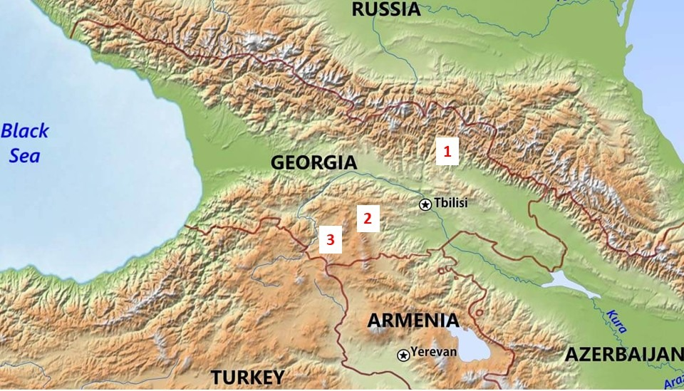

Fig. 1. Study locations indicated by red triangles: 1 – Kazbegi; 2 – Bakuriani; and 3 – Tskhratskaro. (For exact coordinates and altitude see Table 1). The source: https://www.freeworldmaps.net/asia/caucasus/caucasus-countries-hd.jpg
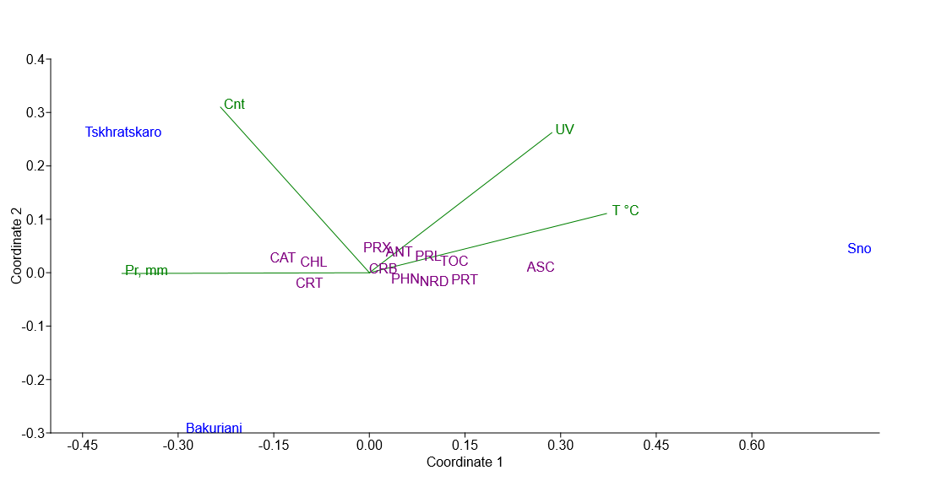
Fig. 2. General pattern of metabolic responses to abiotic stress (nMDS ordination graph).

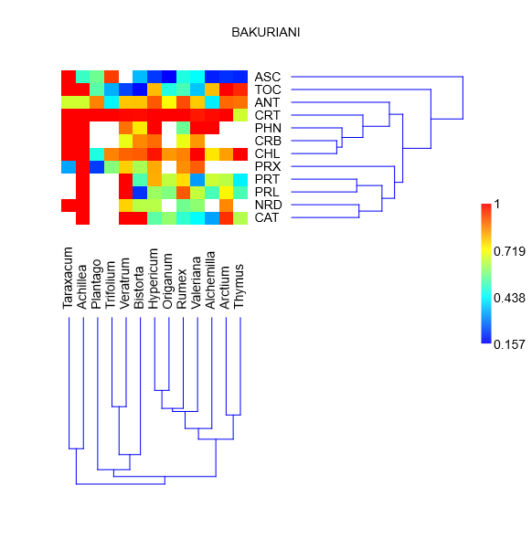 | 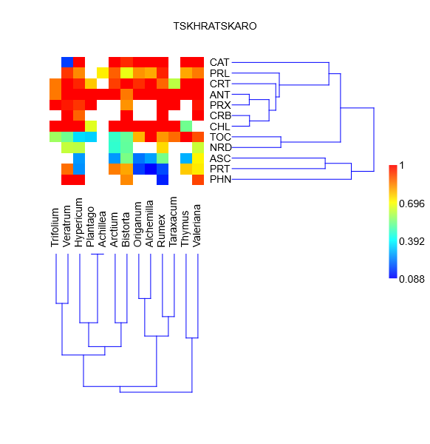
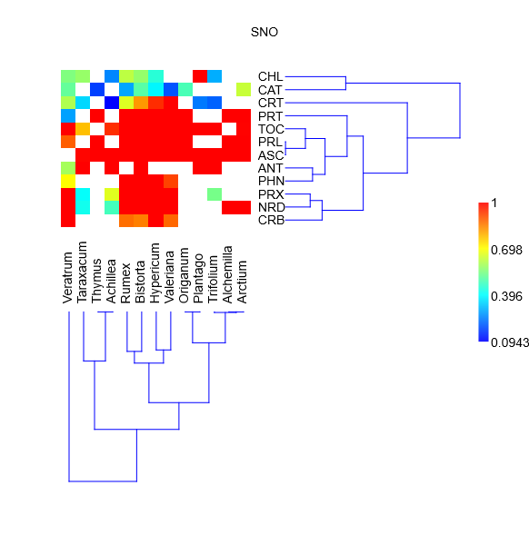 | Antioxidant level  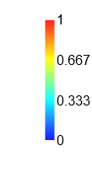

Fig. 3. Two-way cluster analysis of the forb assemblage and the contents of antioxidants in species at three locations. Blank rectangles indicate missing data. Antioxidant level refers to standardized data (see the Materials and Methods).

