Comparative Assessment of Intertidal Macrofaunal Assemblages between Rocky and Muddy Shores in the Gulf of Khambhat, Gujarat, India

ABSTRACT

The dynamic intertidal zones of the Gulf of Khambhat, Gujarat present a mosaic of habitats shaped by pronounced tidal regimes and varied substrate compositions. This study provides a comprehensive comparative analysis of macrofaunal assemblages across two ecologically distinct intertidal sites: the rocky coast at Gopnath and the muddy flats at Koliyak from year April 2024 to March 2025. Using standardized quadrat-based sampling across five assemblages (refers specifically to the biological communities) three at Gopnath coast and two at Koliyak coast, a total of 55 species of macrofauna spanning six phyla Mollusca, Arthropoda, Annelida, Nemertea, Cnidaria, and Chordata were documented. Rocky intertidal habitats at Gopnath supported higher species richness and taxonomic diversity, particularly among mollusks and crustaceans, in contrast to the relatively less diverse communities at Koliyak. Using biodiversity indexes including Shannon– Wiener, Simpson’s diversity, and Pielou’s evenness, the ecological health and community structure of intertidal macrofaunal assemblages were evaluated. The findings showed distinct substrate- driven variations in community composition, with greater species diversity and evenness on rocky coasts as opposed to muddy shores. Additionally, cluster analysis highlighted habitat-specific biological trends by revealing distinct assemblage groupings between Koliyak and Gopnath The findings demonstrate how habitat variability shapes coastal biodiversity and offer crucial baseline information for Gulf of Khambhat protection and management.

Keywords: Intertidal biodiversity, macrofaunal assemblages, community structure, rocky intertidal, muddy intertidal, benthic ecology, habitat heterogeneity, Gulf of Khambhat.

INTRODUCTION
The intertidal zone represents one of the most dynamic marine ecosystems, subjected to regular fluctuations in environmental conditions. Macrofaunal communities play essential roles in ecosystem functioning, such as bioturbation, nutrient cycling, and food web dynamics. (Snelgrove, 1998; Kristensen et al., 2012). The diversity and structure of these communities are heavily influenced by environmental variables such as substrate type, hydrodynamics, and sediment characteristics (Gray, 2002).
Macrofauna comprise various taxonomic groups, including molluscs, cnidarians, echinoderms, and polychaetes (Snelgrove, 1999; Eleftherioo & McIntyre, 2005; Sukumaran et al., 2021). When all taxa are examined collectively, they are typically organized into distinguishable assemblages. Macrofaunal assemblages are dependable indicators for monitoring aquatic environmental responses to stressors. Their sensitivity to environmental disturbances and their roles in ecosystem functioning make them valuable for such studies. (van der Linden et al., 2017). The composition and structure of biotic assemblages emphasizes a mechanical understanding of regional biological interactions and their effects, with a focus on
current species assemblages (National Research Council, 2005).

A prominent example of such biodiversityrich intertidal zones can be found along the Gujarat coast, which hosts some of India's most ecologically important and diverse marine habitats. Gujarat has the longest coastline of any Indian state approximately 1,600 kilometers and features a mosaic of coastal ecosystems including extensive mudflats, sandy beaches, coral reefs (in the Gulf of Kachchh), and some of the country's most expansive mangrove forests. The Gulf of Kachchh, in particular, is renowned for its wide intertidal range and supports a variety of benthic communities, sea grasses, and reef- building corals, making it one of the richest marine biodiversity zones in the region (Nair et al., 2015). These intertidal habitats not only sustain marine life but also support local economies through fisheries, salt production, and tourism. The coastline of Gujarat is geologically diverse, composed predominantly of Tertiary sedimentary formations overlying the Deccan Traps, as well as Pleistocene-age miliolite limestone deposits that are particularly prominent along the Saurashtra coast. In addition, recent alluvial sediments, often calcareous in nature, are found in various parts of the coastal zone. Notably, the Gulf of Khambhat has experienced significant recent alluvial

deposition, contributing to its dynamic sedimentary environment.

Among the various coastal habitats, intertidal rocky shores have been extensively studied within marine ecological research due to their accessibility and the well-documented spatial and temporal variability of their biotic communities, particularly macroalgae and benthic invertebrates. These ecosystems offer valuable insights into ecological processes such as succession, competition, and environmental stress responses (Benedetti-Cecchi et al., 2015; Firth et al., 2016; Maggi et al., 2017; Dal Bello et al., 2017; Thompson et al., 2020; Menge, 2022; Bauer et al., 2024). Their structural complexity and the pronounced environmental gradients they exhibit make them ideal natural laboratories for examining patterns of biodiversity, species distribution, and ecosystem functioning.
The Gulf of Khambhat, located along the western coast of India in Gujarat, features high tidal amplitudes and complex hydrological conditions, creating varied intertidal habitats. Despite extensive research on its geomorphology and tidal dynamics, few studies have focused on macrofaunal diversity within this system. This study compares macrofaunal assemblages between the rocky intertidal zone of Gopnath and the muddy intertidal flat of Koliyak, aiming to assess how substrate heterogeneity influences community structure.

MATERIALS AND METHODS
Study area: The Gulf of Khambhat, located along the western coast of India in Gujarat, is a funnel-shaped embayment of the Arabian Sea. It extends between latitudes 21°00′N– 22°18′N and longitudes 72°15′E–72°45′E, and is characterized by extreme tidal amplitudes, strong currents, and a mix of muddy and rocky intertidal habitats Gopnath and Koliyak are located in Gujarat, western India, along the Gulf of Khambhat. The shoreline of Koliyak (Latitude: 21°35′51.226″N, Longitude: 72°17′33.259″E) is murky with sporadic rocky spots. The intertidal zone here exposes roughly 600 to 900 meters at low tide. Gopnath, which is primarily a rocky shore with few muddy deposits, is located at latitude 21°21′10.56 N and longitude 72°10′62.53 E. Puddles and tide pools of all sizes and forms are scattered across the rocky substratum, each displaying distinct ecological traits. The 350–450 m of intertidal area that is exposed at low tide at this location for in-depth investigation of several microhabitats.
Sampling Method: The study investigated
five distinct macrofaunal assemblage zones: GA1, GA2, and GA3 at Gopnath, and KA1 and KA2 at Koliyak. All sampling sites were situated within the middle to lower intertidal zones. Field surveys were conducted monthly between April-2024 to March-2025, covering all four seasons (winter, summer, monsoon, and post-monsoon).

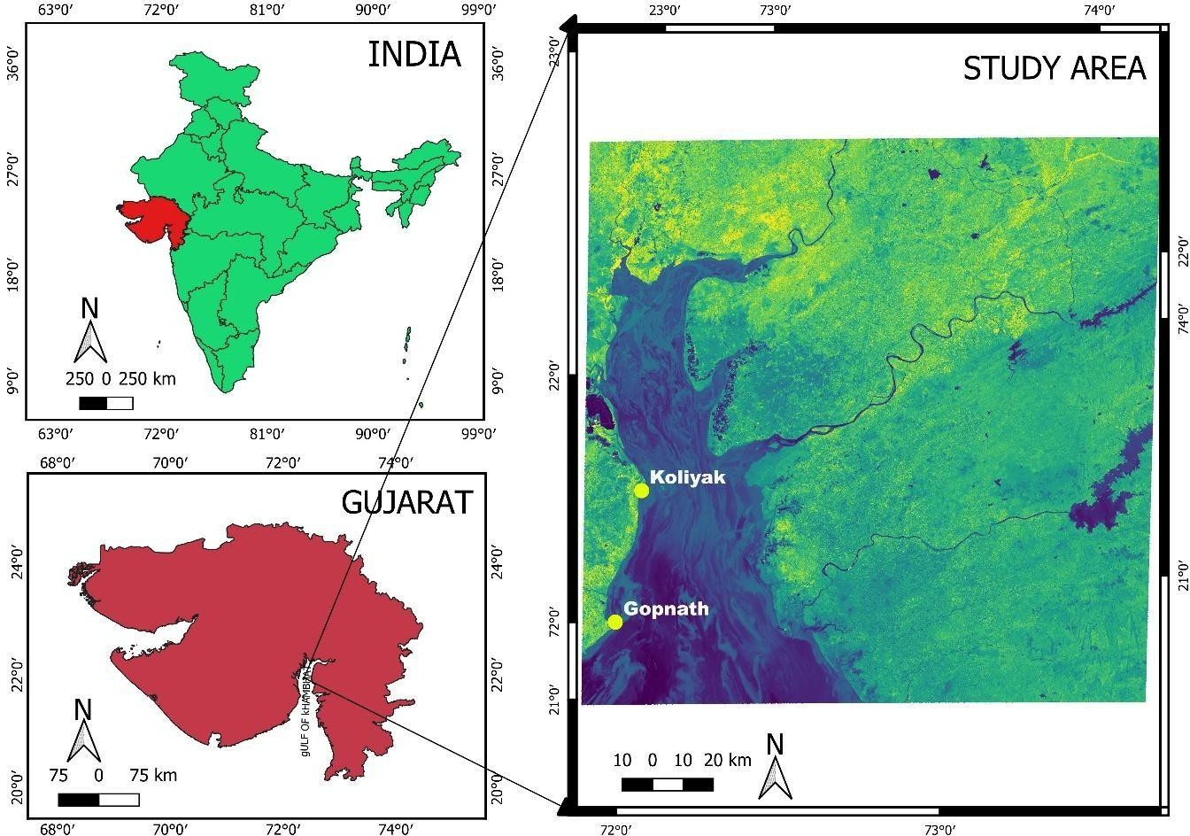
Fig. 1. Location of study sites. (Map generated using QGIS 3.34 with spatial data obtained from DIVA-GIS (https://www.diva-gis.org/)).

Macrofaunal specimens were recorded and collected using a standard quadrat method (0.25 m²) placed randomly along transects. A total of 90 quadrats per site per month were sampled. Species identification was carried out through direct field observation and manual collection, All macrofaunal specimens were identified to the lowest possible taxonomic level using standard monographs and regional identification keys (Fauvel, 1953; Alcock, 1895–1900; Subba Rao, 1991,
2003, 2006; Ramakrishna & Dey, 2003, 2007; Radhakrishnan & Venkataraman, 2006; James, 1986). Species names were further crossverified using the World Register of
Marine Species (WoRMS) database to ensure taxonomic accuracy.
Data analysis: The collected data were analysed for species richness, overall abundance, and phylum-level distribution. A presence–absence checklist of recorded species was prepared to support comparative abundance, and phylum-level distribution. A presence–absence checklist of recorded species was prepared to support comparative assessment. To evaluate the community structure of intertidal macrofaunal assemblages, standard biodiversity indices were employed, including-

Shannon-Weiner index: For the Species diversity assessment Shannon-Weiner index was used (Shannon,1949). H = -
⅀pi * ln(pi) where Pi is the proportion of each species in the sample (Shannon & Wiener, 1963).
Simpson’s dominance index: The dominance of species calculated by Simpson’s index (Simpson,1949) from 0 to 1. D = 1 – (⅀n(n-1)/N(N-1)) (Simpson, 1949).
Pielou’s evenness index: Shannon diversity divided by the logarithm of number of taxa. This measures the evenness with which individuals are divided among the taxa present. It always lay between 0 and 1 (Pielou, 1966).
In addition, Hierarchical Cluster Analysis (HCA) was performed on the species abundance data. Euclidean distance was used as the similarity coefficient, revealing clear distinctions between rocky and muddy habitats and highlighting substrate-driven ecological segregation.

RESULT

A total of 55 macrofaunal species were recorded across all five sampling sites GA1, GA2, and GA3 (Gopnath rocky coast) and KA1 and KA2 (Koliyak muddy coast) — belonging to six phyla: Cnidaria, Nemertea, Annelida, Mollusca, Arthropoda, and Chordata (Table 1). Of these, 53 species were recorded from Gopnath and 35 species from Koliyak, indicating comparatively higher richness along the rocky shore.The species- level data reveal significant spatial variation in diversity and distribution influenced by habitat type (rocky vs muddy). The phylum-level analysis of intertidal macrofauna across the five sampling assemblages: GA1, GA2, and GA3 (located at Gopnath rocky coast) and KA1 and KA2 (situated at Koliyak muddy coast) revealed notable spatial variations in species richness and community composition.

Table: 1. Detailed Checklist of Macrofaunal Species at observed assemblages.
The table below shows species presence (+) in each assemblage: GA1, GA2, GA3 (Gopnath); KA1, KA2 (Koliyak).

Sr. No |  | GA1 | GA2 | GA3 | KA1 | KA2
Phylum- Cnidaria
1. | Anthopleura thallia (Gosse,1854) | + | - | - | - | -
Phylum- Nemertea
2. | Emplectonema sp. | + | + | + | + | +

Phylum- Annelida
3. | Diopatra cuprea (Bosc, 1802) | + | + | + | + | +
4. | Nereis sp. 1 | + | + | - | + | +
5. | Nereis sp. 2 | - | - | - | + | +
6. | Unidentified | + | + | + | - | -
Phylum- Mollusca
7. | Agaronia gibbosa (Born,1778) | - | + | + | + | +
8. | Agaronia nebulosa (Born,1778) | - | + | + | + | +

9. | Aliculastrum cylindricum (Helbling, 1779) | + | + | + | - | -
10. | Amaea minor (Sowerby II,1873) | - | - | - | + | +
11. | Amphicyclotulus dominicensis (Bartsch,1942) | + | + | + | - | -
12. | Assiminea brevicula (Pfeiffer,1855) | + | - | - | + | +
13. | Astralium semicostatum (Kiener,1850) | + | + | + | + | +
14. | Astralium stellare (Gmelin,1795) | - | + | + | - | -
15. | Calliostoma tranquebaricum (Roding, 1798) | + | + | + | + | +
16. | Cantharus spiralis (Gray,1839) | + | + | - | + | +
17. | Cellana karachiensis (Winckworth, 1930) | + | + | + | - | -
18. | Chiton peregrinus (Thiele, 1909) | + | + | + | - | -
19. | Clypeomorus batillariaeformis (Habe & Kosuge,1966) | + | + | + | + | +
20. | Clypeomorus bifasciata (G. B. Sowerby II, 1855) | + | + | + | + | +
21. | Echinolittorina malaccana (Philippi, 1847) | - | + | - | + | -

22. | Gyrineum natator (Roding,1798) | - | + | - | - | -
23. | Lataxiena bombayana (Melvill, 1893) | + | + | - | - | -
24. | Laternula anatine (Linnaeus, 1758) | + | + | + | + | +
25. | Littoraria intermedia (Philippi, 1846) | + | + | - | + | -
26. | Littoraria scabra (Linnaeus, 1758) | + | + | - | + | -
27. | Nerita oryzarum (Recluz, 1841) | - | - | + | - | -
28. | Nerita undata Linnaeus (1758) | - | + | + | - | -
29. | Nassarius dorsatus (Röding, 1798) | + | + | + | + | +
30. | Nassarius reeveanus (Dunker,1847) | + | + | - | + | -
31. | Nassarius stolatus (gmelin,1791) | + | + | + | + | +
32. | Octopus vulgaris (Cuvier,1797) | - | - | + | - | -

33. | Peronia verruculata (Cuvier,1830) | + | + | + | + | +
34. | Pirenella cingulata (Gmelin,1791) | + | + | - | - | -
35. | Planaxis sulcatus (Born,1778) | + | + | + | + | +
36. | Saccostrea cucullata (Born,1778) | + | + | + | - | -
37. | Semiricinula tissoti (Petit de la Saussye,1852) | + | - | + | + | +
38. | Serratina capsoides (Lamarck, 1818) | + | + | + | + | +
39. | Tectus tentorium (Gmelin, 1791) | + | + | + | - | -
40. | Trochus radiates (Gmelin,1791) | + | + | + | + | +
41. | Turbo bruneus (Röding, 1798) | + | + | + | + | -
42. | Turris clausifossata (Kilburn,Fedosov & Olivera,2012) | + | + | + | - | -

43. | Umbonium vestiarium (Linnaeus,1758) | + | + | + | + | +
Phylum- Arthropoda
44. | Amphibalanus amphitrite (Darwin, 1854) | + | + | + | - | -
45. | Clibanarius infraspinatus (Hilgendorf, 1869) | + | + | + | + | +
46. | Clibanarius longitarsus (De Haan,1849) | + | + | + | + | +
47. | Diogenes avarus (Heller, 1865) | + | + | + | + | -
48. | Eriphia smithii (Macleay,1838) | + | + | - | - | -
49. | Euraphia withersi (Pilsbry,1916) | + | + | + | - | -
50. | Macrophthalmus laevis A. (Milne Edwards,1867) | + | - | + | + | +
51. | Matuta victor (Fabricius,1781) | + | + | + | + | +
52. | Metopograpsus thukuhar (Owen,1839) | + | + | - | - | -
53. | Scylla serrata (Forsskal, 1775) | - | - | + | + | -
54. | Scopimera globosa (De haan, 1835) | + | + | + | + | +
Phylum – Chordata
55. | Boleophthalmus dussumieri (Valenciennes, 1837) | + | + | + | + | +

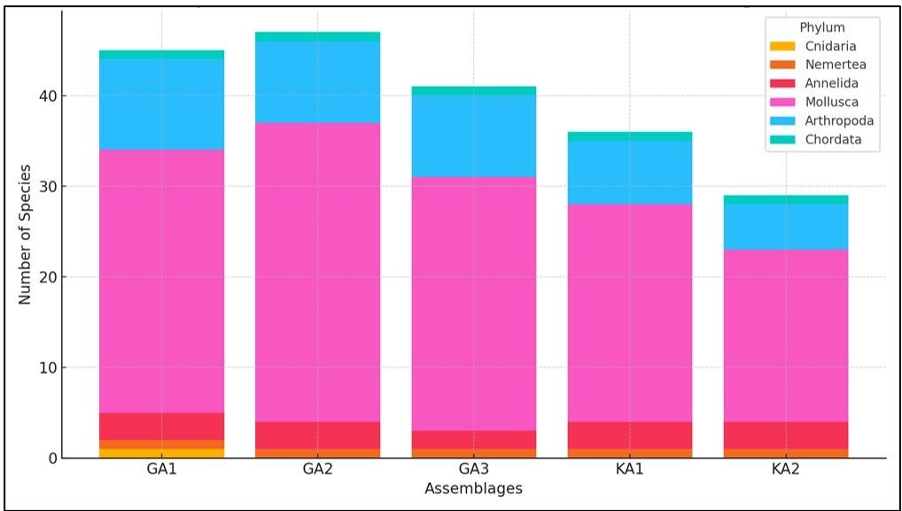

Fig. 2. Phylum-wise Distribution of Macrofauna in different assemblages.
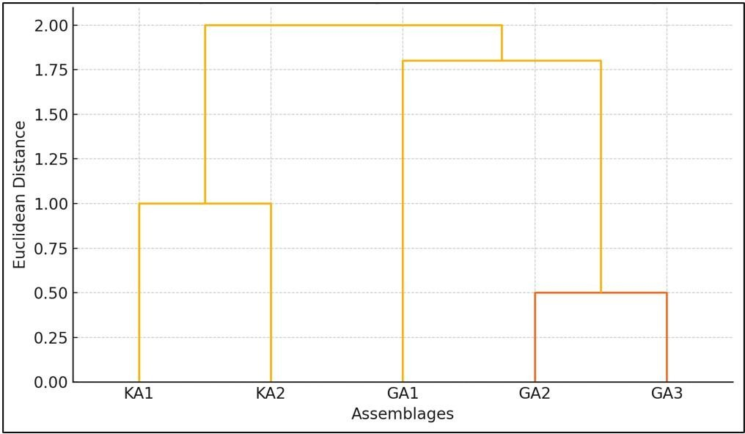

Fig. 3. Cluster analysis of Assemblages Based on Species Composition.

The highest overall species richness was observed at GA2 (46 species), followed by GA1 (44 species), and GA3 (40 species). In contrast, the Koliyak sites showed relatively lower
richness, with KA1 and KA2 supporting 35 and 28 species respectively. (Fig.2)
The dendrogram illustrates the results of a hierarchical cluster analysis based on species composition across five intertidal

assemblages: GA1, GA2, GA3, KA1, and KA2. (Fig. 3)
GA2 and GA3, both located along the rocky intertidal zone of Gopnath, show the highest similarity, clustering together at the lowest linkage distance. This suggests that these two assemblages share a closely related macrofaunal community structure, likely due to comparable substrate types, tidal exposure, and microhabitat complexity.
KA2, one of the muddy shore assemblages from Koliyak, forms the next closest linkage with the GA2–GA3 cluster, indicating some degree of overlap in species composition. This may reflect the presence of generalist or eurytopic species capable of inhabiting both muddy and rocky substrates.
KA1, the other Koliyak assemblage, clusters separately at a slightly higher distance, pointing to greater dissimilarity in its species composition possibly due to localized environmental variation such as sediment characteristics or tidal inundation patterns. GA1, although part of the rocky shore, stands out as the most distinct assemblage, joining the cluster at the highest Euclidean distance. This separation may reflect unique biotic or abiotic conditions at that particular site, such as the presence of Cnidaria
(not found at other locations), unique tide pool features, or species exclusivity.
To assess the ecological structure and health of the intertidal macrofaunal communities, three standard biodiversity indices ShannonWiener Index (H'), Simpson’s Dominance Index (D), and Evenness were calculated for each assemblage.The Shannon-Wiener Index (H'), which accounts for both species richness and evenness, revealed that GA1 (1.0517) and KA2 (1.0470) had the highest diversity among the five assemblages. In contrast, GA2 exhibited the lowest diversity (H' = 0.9043), indicating a community potentially dominated by fewer phyla. The Simpson’s Index (D), which reflects dominance patterns, showed that GA2 (0.5346) had the highest dominance (and thus the lowest diversity), while GA1 (0.4706) and KA2 (0.4721) displayed lower dominance, suggesting a more even representation of species. The Evenness index showed that species were more uniformly distributed at KA2 (0.6506) and KA1 (0.6182), while GA2 again recorded the lowest value (0.5619), reflecting an imbalanced phylum distribution. These index values collectively indicate that KA2 (muddy coast) and GA1 (rocky coast) support more balanced and diverse macrofaunal communities, while GA2 appears to be comparatively less diverse and more taxonomically skewed.

Table: 2 diversity indexes for different assemblages

Assemblages | Shannon-Wiener Index (H') | Simpson’s Dominance Index (D) | Pielou’s evenness index
GA1 | 1.0517 | 0.4706 | 0.5870
GA2 | 0.9043 | 0.5346 | 0.5619
GA3 | 0.9218 | 0.5181 | 0.5727
KA1 | 0.9949 | 0.4907 | 0.6182
KA2 | 1.0470 | 0.4721 | 0.6502

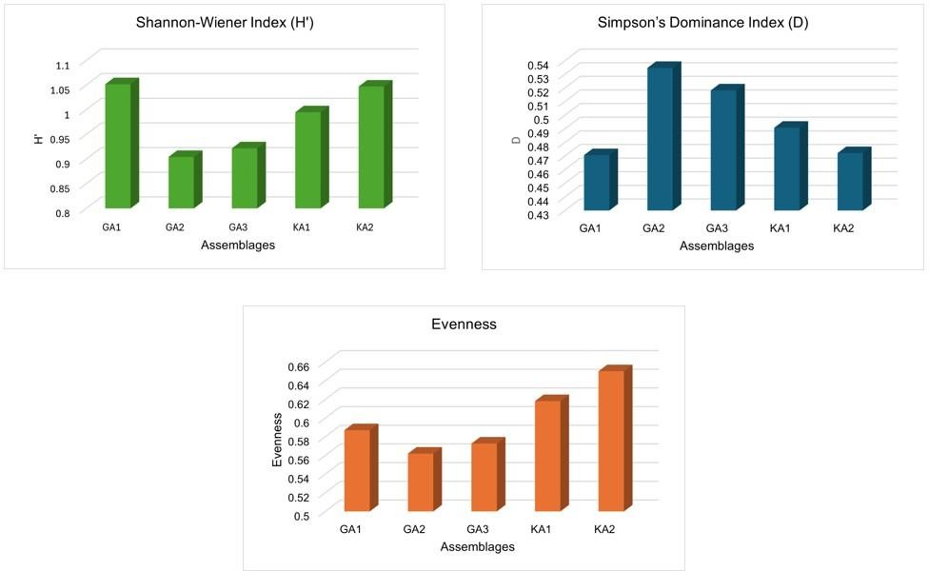

Fig. 4. Bar charts displaying the biodiversity indices for each assemblage.

DISCUSSION

This study demonstrates how the composition, richness, and distribution of macrofaunal assemblages along the Gulf of Khambhat are
significantly influenced by the type of substrate and the structure of the intertidal habitat. Fiftyfive macrofaunal species from six phyla were recorded from five different assemblages

in two different coastal habitats: the muddy flats at Koliyak and the rocky coasts at Gopnath.
Compared to the muddy intertidal flats of Koliyak (KA1 and KA2), the rocky intertidal zones of Gopnath (GA1, GA2, and GA3) consistently had better species richness and taxonomic diversity. Previous studies have shown that structurally complex environments, such as rocky coastlines, tend to maintain more diverse and stable communities due to the abundance of microhabitats and niches available (Benedetti-Cecchi et al., 2015; Benedetti-Cecchi, 2001; Martins et al., 2008). Rock substrates sustain species including gastropods, barnacles, and polychaetes that require hard surfaces for attachment or protection from desiccation during tidal cycles (Blanchet al., 2006).
The most prevalent phylum in all assemblages was Mollusca, which was more prevalent in Gopnath sites. The presence of algae, biofilm, and microhabitats in tidal pools and fissures is responsible for the abundance of molluscs, particularly grazing gastropods and filter feeders. The concept of habitat-specific species sorting, in which environmental filters like sediment type, water retention, and exposure control community assembly, is supported by the presence of several species from Clypeomorus, Nassarius, and Trochus in both habitats, albeit in differing numbers (Gray, 2002).
Additionally, rocky places had a greater diversity of Arthropoda, particularly brachyuran and hermit crabs (e.g., Clibanarius, Scopimera).
This could be because rocky crevices provide security and there are empty shells to hide in (Burrows et al., 2009). On the other hand, Koliyak's muddy intertidal habitat was home to a greater number of infaunal and burrowing species, such as Scylla serrata and polychaetes. This is consistent with patterns observed in soft-sediment ecosystems, where deposit feeders and burrowers typically dominate the fauna (Kristensen et al., 2012).
From an ecological point of view, the combined use of Simpson's Dominance Index (D), Shannon-Wiener Index (H'), and Evenness provides valuable insights into species distribution patterns and community structure. The higher H' values observed in
Assemblages GA1 and KA2 indicate ecologically stable and heterogeneous environments that support a greater variety of ecological niches, promoting species richness and balanced abundance (Magurran, 2004; Gray, 2000). In contrast, GA2 showed the highest dominance (D) and the lowest H' and evenness, indicating ecological stress, possibly due to habitat simplification, environmental disturbance, or microhabitat homogeneity. Such patterns suggest that a few stress-tolerant or opportunistic species dominate these areas, suppressing overall community diversity (Dewenter et al., 2023).
This dominance-driven skewness can result from natural factors like sediment type or tidal exposure, as well as anthropogenic pressures such as pollution or habitat alteration (Thrush et al., 2001).

Different grouping patterns according to species composition were found using cluster analysis. Due to similar rocky habitat structure and environmental circumstances that support similar species assemblages, GA2 and GA3 formed the closest cluster, representing similar faunal communities (Warwick & Clarke, 1991; McCune & Grace, 2002). The presence of eurytopic (generalist) species, which can colonize both stony and muddy substrata and endure a wide variety of circumstances, may be the reason for the intriguing resemblance between KA2 and the Gopnath sites (Gray, 1981; Alongi, 1990). GA1, on the other hand, was the most unique assembly. Localized topography, salinity gradients, or the exclusive occurrence of Anthopleura thallia (Cnidaria), a species frequently linked to tidal pools and specialized microhabitats, could be the cause of its separation (Branch et al., 2008;). These results highlight how structural complexity and microhabitat variety influence the organization of benthic communities throughout varied intertidal zones (Little & Kitching, 1996). These results highlight the critical role of habitat heterogeneity in shaping coastal biodiversity. The differential community structure between the rocky and muddy zones emphasizes how substrate type, hydrodynamic forces, and microtopography jointly influence ecological patterns (Martins et al., 2008; van der Linden et al., 2017).
Furthermore, the macrofaunal diversity found in this study provides a crucial starting point for upcoming biomonitoring initiatives. Longterm research is required to monitor changes in
biodiversity and inform conservation planning in the Gulf of Khambhat due to the increasing anthropogenic pressures of industrialization, sedimentation, and coastal erosion.

CONCLUSION
This study shows that macrofaunal assemblage patterns in the Gulf of Khambhat are significantly influenced by substrate type. Because of their structural complexity, solid attachment surfaces, and variety of microhabitats, the rocky coastlines at Gopnath supported a higher species richness and diversity, especially among molluscs and crustaceans. However, as a result of habitat filtering processes, fewer but more specialized taxa that were adapted to unstable sediments and variable circumstances were found on Koliyak's muddy flats. Biodiversity indices also revealed regional heterogeneity, with reduced diversity at GA2 indicating habitat homogeneity or environmental stress, while other sites (such GA1 and KA2) showed comparatively stable and balanced populations. Cluster analysis revealed modest within-habitat differences associated with local environmental conditions and supported these patterns by categorizing sites based on substrate type.
All things considered, the results highlight the ecological significance of habitat complexity in maintaining resilient and varied intertidal communities. In the Gulf of Khambhat, where the integrity of these dynamic coastal ecosystems is under threat from increasing anthropogenic pressures, they also serve as a baseline for conservation and monitoring.

DISCLAIMER (ARTIFICIAL INTELLIGENCE)

Author here by declared that no generative AI technologies have be used during writing or editing of this manuscript.

REFERENCES:

- Alongi, D. M. (1990). The ecology of tropical soft-bottom benthic ecosystems. Oceanography and Marine Biology: An Annual Review, 28, 381–496.
- Benedetti-Cecchi, L. (2001). Beyond competition: Incorporating positive interactions between species to predict ecosystem invasibility. PLOS Biology, 2(4), e39. (Note: please confirm the correct article as Benedetti-Cecchi has many works in 2001—this one might differ.)
- Benedetti-Cecchi, L. (2001). Variability in abundance of algae and invertebrates at different spatial scales on rocky sea shores. Marine Ecology Progress Series, 215, 79–92. https://doi.org/10.3354/meps215079
- Blanchette, C. A., Miner, C. M.,
Raimondi, P. T., Lohse, D., Heady, K. E., & Broitman, B. R. (2006). Biogeographical patterns of rocky intertidal communities along the Pacific coast of North America.
Journal of Biogeography, 35(9), 1593–
1607. https://doi.org/10.1111/j.1365- 2699.2008.01913.x
- Branch, G. M., Griffiths, C. L., Branch,
M. L., & Beckley, L. E. (2008). Two oceans: A guide to the marine life of southern Africa (3rd ed.). Struik Nature.
- Burrows, M. T., Harvey, R., & Robb, L. (2009). Wave exposure indices from digital coastlines and the prediction of rocky shore community structure.
Marine Ecology Progress Series, 379, 1–12.
https://doi.org/10.3354/meps07856
- Dal Bello, M., Galzin, R., & Claudet, J. (2017a). Effects of local and regional processes on reef fish assemblages in a marine protected area. Marine Ecology Progress Series, 567, 171–
183.
https://doi.org/10.3354/meps12050
- Dal Bello, M., Maggi, E., Rindi, L., Capocchi, A., Fontanini, D., Sanz‐ Lazaro, C., & Benedetti‐Cecchi, L. (2015). Multifractal spatial distribution of epilithic microphytobenthos on a Mediterranean rocky shore. Oikos, 124(4), 477-485.
- Dewenter, J., Yong, J., Schupp, P. J.,
Lõhmus, K., Kröncke, I., Moorthi, S., ... & Rohde, S. (2023). Abundance, biomass and species richness of macrozoobenthos along an intertidal elevation gradient. Ecology and Evolution, 13(12), e10815.
- Dodiya, D., & Poriya, P. (2024). Community Structure of Intertidal Macrofauna: Spatial Autocorrelation of Two Rocky Coasts of Gujarat, India. Asian Journal of Environment & Ecology, 23(10), 59-72.
- Eleftheriou, A., & McIntyre, A. (2005). Methods for the study of marine benthos (3rd ed.). Blackwell Science.
- Gray, J. S. (2000). The measurement of marine species diversity, with an application to the benthic fauna of the Norwegian continental shelf. Journal of Experimental Marine Biology and Ecology, 250(1–2), 23–
49. https://doi.org/10.1016/S0022-
0981(00)00178-7
- Gray, J. S. (2002). Biomagnification in marine systems: The perspective of an ecologist. Marine Pollution Bulletin,
45(1–12), 46–52.

https://doi.org/10.1016/S0025- 326X(02)00187-1
- Kristensen, E., Bouillon, S., Dittmar, T., & Marchand, C. (2012). Organic carbon dynamics in mangrove ecosystems: A review. Aquatic
Botany, 97(1), 1–22.
https://doi.org/10.1016/j.aquabot.2011. 08.007
- Magurran, A. E. (2004). Measuring biological diversity. Blackwell Science Ltd. Martins, G. M., Neto, A. I., & Cacabelos, E. (2016). Ecology of a key ecosystem engineer on hard coastal infrastructure and natural rocky shores. Marine Environmental Research, 113, 88-94.
- McCune, B., & Grace, J. B. (2002). Analysis of ecological communities.
MjM Software Design.
- Menge, B. A., Gravem, S. A., Johnson, A., Robinson, J. W., & Poirson, B. N. (2022). Increasing instability of a rocky intertidal meta-ecosystem. Proceedings of the National Academy of Sciences, 119(3), e2114257119.
- Raffaelli, D., & Hawkins, S. (1996). Intertidal ecology. Chapman & Hall.
- Snelgrove, P. V. R. (1998). The biodiversity of macrofaunal organisms in marine sediments. Biodiversity and Conservation, 7(9), 1123–1132.
https://doi.org/10.1023/A:1008867313 340
- Snelgrove, P. V. R. (1999). Getting to the bottom of marine biodiversity: Sedimentary habitats. BioScience,
49(2), 129–138. (title properly not match)
https://doi.org/10.2307/1313538

- Sukumaran, S., Vijapure, T., Mulik, J., & Ridha, H. (2021). Marine macrobenthos of NorthWest India-Reviewing the known and unknown. Frontiers in Marine Science, 8, 671245.

- Thrush, S. F., & Dayton, P. K. (2002). Disturbance to marine benthic habitats by trawling and dredging: implications for marine biodiversity. Annual review of ecology and systematics, 33(1), 449-473.

- Warwick, R. M., & Clarke, K. R. (1991). A comparison of some methods for analysing changes in benthic community structure. Journal of the Marine Biological Association of the United Kingdom, 71(1), 225–244. https://doi.org/10.1017/S00253154000 37528

- Wilbur, L., Küpper, F. C., & Louca, V. (2024). Analyzing Species Diversity in Rocky Intertidal Communities over Multiple Spatial Scales among Understudied Eastern Pacific Ecoregions. Diversity, 16(8), 498.

