Original Research Article

Efficacy of manual, sonic, and ultrasonic agitation techniques in removal of Calcium hydroxide and Bio C Temp from root canal system: an in vitro SEM analysis

ABSTRACT.
Aim: To compare and evaluate the efficacy of manual, sonic, and ultrasonic agitation techniques in the removal of calcium hydroxide and BioC Temp.
Materials and Methodology
36 extracted human mandibular premolar teeth were collected, and teeth length was standardized to 14 mm. All the root canals were instrumented with Neoendo files to size 6% 25, then the canals were dried and dressed with calcium hydroxide (n = 18) and Bio C Temp (n = 18). Following 1 week of incubation, the intracanal medicaments were removed using one of the three techniques according to tooth group: manual agitation using a rotary file, sonic agitation, or ultrasonic agitation. Scanning electron microscope evaluation was done for assessment of calcium hydroxide and Bio-C Temp removal in the middle and apical third of the root.
Result
BioC Temp removal was more effective than Calcium hydroxide. Ultrasonic agitation was the most effective method, resulting in the highest percentage of material removal and being not statistically significant from sonic agitation in the calcium hydroxide group but significant in the BioC Temp group.
Key words: Intracanal medicament, BioC Temp, Calcium hydroxide, Sonic, Ultrasonic.
Introduction
“The main objective of endodontic treatment in teeth with apical periodontitis and necrotic pulp is to eradicate microbial load from the root canal system.” ¹ “Long-term infections frequently cause bacteria to colonize the whole root canal system, including the dentinal tubules, ramifications, and isthmuses, where chemomechanical instruments have very little impact.” ²
Thus, it is recommended to administer intracanal medicine after root canal instrumentation in order to reduce bacterial load to the levels compatible with periapical health, favor tissue repair, and prevent bacterial recolonization and subsequent infection. ³
“Numerous intracanal medications, including calcium hydroxide (CaOH₂), aldehydes, halides, steroids, chlorhexidine, phenolic compounds, and antibiotics, have been recommended. In endodontics, calcium hydroxide (CH) is one of the most often utilized medications.⁴ Due to its antimicrobial properties, high pH, low solubility, suitable flow, and ability to dissolve tissue and promote hard tissue deposition, it is the most commonly used intracanal drug. There are several distinct commercial CH medications available today, and they vary in terms of both content and CH concentration.” ^{5,6}
“UltraCal XS (Ultradent Products, South Jordan, UT, USA) is a widely used CH that is made up of methylcellulose, barium sulfate, and CH in an aqueous solution.”⁷ Compared to CH in its research grade, Ultracal XS has smaller and more uniform CH particles, which enhances its wetting properties on the dentinal surface and promotes tubular penetration. ⁸
As biomaterials continue to advance and demonstrate encouraging outcomes, scientists are looking for new uses for them. “The first calcium-silicate-based medication for use in between endodontic sessions is Bio-C Temp (Angelus, Paraná, Brazil), which contains polyethylene glycol, titanium oxide, a resin base, calcium tungsten as a radiopacifier, and an active ingredient made of calcium oxide, calcium silicate, and tricalcium aluminate. It has high alkalinity (pH = 12) and radiopacity and is very biocompatible, easy to manipulate, and easy to remove. It has been discovered that Bio-C Temp possesses a bioactive property that promotes periapical healing by favoring osteoblast survival and development.” ^{9,10}
To guarantee that the sealer adheres tightly to the root canal surface and prevent adverse interactions between the medication and the filling material, the intracanal medication should be entirely eliminated prior to root canal obturation. ¹¹
“Several methods have been proposed for the effective removal of intracanal medicaments. The most commonly described method involves removal by instrumentation with a master apical file with sodium hypochlorite (NaOCl) and ethylenediaminetetraacetic acid (EDTA) irrigant solutions. Recently, other methods have been suggested, such as passive ultrasonic irrigation (PUI) and sonic activation, which are used in this study.”¹²
Thus, the purpose of this study was to evaluate the effectiveness of different techniques in removing Bio-C Temp and calcium hydroxide from relatively straight canals.
Materials and Methodology
Thirty-six single-rooted mandibular premolars with completely formed root apices extracted for orthodontic or periodontal purposes were used. The presence of any visible blood or gross debris was cleaned from the teeth surface using an ultrasonic scaler.
Sample preparation
The crowns of the teeth were sectioned with a diamond disk to obtain 14 mm from the apex to standardize their length. A size 10 K-file was introduced into the canal until it was visible at the apical foramen. The WL was determined by subtracting 1 mm from this measurement. The root canals were prepared upto 6% 25 (Neo-Endo S). During the preparation, the root canal was irrigated with 1 mL of 3% NaOCl solution after each instrument, followed by a final rinse of 5 mL of saline.
Intracanal medicament placement
After drying all canals with absorbent paper points, the samples were randomly allocated into two main groups based on the intracanal medicament used. The thirty-six specimens were divided into these two experimental groups (18 samples per group) and further subdivided into three subgroups (n = 6 ) according to the medicament removal technique.
Group I: The specimens were filled with Ca(OH)₂ (Ultradent Products Inc., South Jordan, UT, USA) starting from the apical aspect with the needle slowly advancing coronally until the paste was visualized at the canal orifice.(Figure 3)
Group II: The specimens were filled with Bio-C Temp (Angelus Indústriade Produtos Odontológicos S/A, Londrina, PR, Brazil) inside the root canal. A syringe with an applicator tip was inserted 3 mm from the WL and retracted progressively until the entire canal was filled.
Access to the root canal was temporarily sealed with cotton pellets and temporary filling material (Orafil-G, Prevest DenPro, Jammu, India). All the specimens were finally stored at 37°C and 100% humidity for 1 week. (Figure 3)
Removal of intracanal medicament
The specimens in each group were further randomly divided into three subgroups of 6 each on the basis of the agitation technique used for removal.
After 1 week, the roots were reopened by removing the temporary seal and the cotton pellet with an excavator. Then a size 15 K file was introduced to the working length to loosen the intracanal medicament and create space for the irrigation tips.
In Group IA (n = 6) and Group IIA (n = 6), the medicaments were removed using the MAF (master apical file)- 6%25 file (Neo Endo S), the root canals were irrigated with 2 ml of 3% NaOCl, and the MAF was inserted and moved up and down for 1 min. The agitation was followed by a rinse with 3 mL of a 17% EDTA solution for 1 min and saline. Canals were then dried with paper points.(Figure 4)
In Group IB (n = 6) and Group IIB (n = 6), the medicaments were removed using 2 mL of a 3% NaOCl solution and ultrasonic activation (WOODPECKER ENDO 3). The ultrasonic file (#25 SIZE TIP) was inserted 1 mm short of WL and activated for three 20 s cycles, amounting to a total of 1 min. The activation was followed by a rinse with 3 mL of a 17% EDTA solution for 1 minute and saline. Canals were then dried with paper points.(Figure 5)
In Group IC (n = 6) and Group IIC (n = 6), the medicaments were removed using 2 mL of a 3% NaOCl solution and sonic activation (YOUNIQUE GLIN SONIC PRO). The flexible, non-cutting polymer tip (# 25 ISO) was inserted 1 mm short of WL and activated for three 20 s cycles, amounting to a total of 1 minute. The activation was followed by a rinse with 3 mL of a 17% EDTA solution for 1 minute and saline. The canals were then dried with paper points. (Figure 6)
After irrigant agitation, the roots were divided into two halves buccolingually without perforating the root canal using a diamond disk and split using a chisel. (Figure 7) SEM analysis was performed for one half of each tooth at a magnification of 1,500 at the apical third and middle third. For SEM analysis, the samples were dehydrated, then fixed on aluminum stubs, and finally coated with gold sputtering. Two endodontists who were blinded to the samples being tested evaluated the SEM photomicrographs for cleanliness.
The degree of CaOH₂ and Bio-C Temp medication removal and dentinal wall cleaning was assessed using a five-grade scoring system. They are as follows: Score 1: 80 to 100% removal (total cleanliness); Score 2: 60 to 80% removal (great cleanliness); Score 3: 40 to 60% removal (partial cleanliness); Score 4: 20 to 40% CH removal (light cleanliness); and Score 5: 0 to 20% removal (no cleanliness).¹³
Statistical analysis
Statistical Package for Social Sciences [SPSS] for Windows Version 25.0 Released 2019. Armonk, NY: IBM Corp., was used to perform statistical analyses.
The Kruskal-Wallis test, followed by Scheffe’s post-hoc test, was used to compare the significant difference between 2 groups and 3 subgroups. The level of significance [P-value] will be set at P<0.05.
Results
All removal techniques were able to significantly reduce the quantity of Bio-C Temp and calcium hydroxide in the root canals. No method, however, managed to completely eradicate it. A significant difference was observed between the calcium hydroxide group and the Bio-C Repair group (combined Wilcoxon test, P < 0.05).
Bio-C Temp was removed more effectively than calcium hydroxide.In the calcium hydroxide group, there is a significant difference between the subgroups of the apical third; the ultrasonic agitation technique showed better removal than the sonic and manual agitation techniques, but there is no significant difference between ultrasonic and sonic agitation in the apical third. In the middle third, there is no significant difference between the subgroups (Kruskal-Wallis multigroup comparison test and P value < 0.05 for the apical third and P > 0.05 for the middle third). (Figure 1)(Table 1)
In the BioC Temp group, there is a significant difference between subgroups of Apical Third and Middle Third. Even in Bio-C Temp removal, ultrasonic showed better removal than sonic and manual agitation, and there is a significant difference between ultrasonic and sonic groups in the apical and middle thirds (Kruskal-Walli’s Multi Group Comparison Test and P Value < 0.05). (Figure 2) (Table 2)
Discussion
Intracanal medications are applied in cases of infected pulp and periapical pathologies to promote successful eradication of pathogens from the root canal. The main objectives of intracanal medication are to prevent secondary infection, eradicate bacteria, provide inactive contents of the canal, prevent after-treatment agony, and control the continuing periapical infection. ¹⁴
“Effective removal of intracanal medicaments before root canal obturation is crucial for a proper endodontic seal. Any remaining material can block sealer penetration into dentinal tubules, may interfere with the setting reaction of sealing materials, and thus ease the coronal/apical leakage.” ¹⁵
“Recently, a new calcium silicate-based medicament, Bio-C Temp, has been introduced with manufacturer claims of high and rapid Ca²⁺ ion release and easy removal. Bio-C Temp removal was better than calcium hydroxide, as there was a high concentration of free CaO, low concentrations of C3S and C2S, and the presence of a long-chain polymer may be the reason for better removal of the medicament.” ¹⁶ “The limited presence of C3S and C2S leads to the formation of crystals during the hydration process that are unable to intertwine and solidify the product.” ¹⁷ “As a result, the product becomes easier to remove and improves the bond strength outcomes. Bio-C Temp facilitates optimal surface hardness, which can be explained by the formation of calcium salt deposits in connective tissues by the release of Ca²⁺ and OH⁻ ions during hydration.” ¹⁸
“Likewise, for CH, on the other hand, the alkaline pH of CH and its lower molecular weight cause the collagenous matrix to undergo denaturation. CH causes the significant breakdown of collagen in the outer layer of root canal dentin. The collagen component is widely recognized as the primary factor responsible for the strength of mineralized hard tissues. Therefore, any defect in the collagen component impairs the mechanical properties of the dentin, rendering the tissue more vulnerable to fractures.” ^{19,20} “Furthermore, CH, on the other hand, because of its small size and inorganic structure, penetrates the intrafibrillar structure of the mineralized collagen fibrils and alters the 3-dimensional conformation of tropocollagen. Hence, it becomes difficult to remove it completely from the canal.” ²¹
“The findings of the current investigation also demonstrated that ultrasonic agitation showed better removal efficacy in the apical and middle thirds. The efficacy of PUI can be attributed to its large-scale acoustic microstreaming and cavitation. The streaming pattern also leads to maximum contact of the solution with the walls of canals for removal of medicaments in a large prepared canal space.” ²²
“The Sonic Endo activator uses hydrodynamic phenomena, a negative apical pressure. The vibrating polymer tip causes irrigant activation and produces intracanal waves, which cause the production of bubbles or cavitation that oscillate in the irrigant.” ²³ “This is likely due to the sonic technique causing a streaming effect, although sonic instruments are operated at frequencies below those of ultrasonic instruments. This streaming effect occurs due to an oscillating movement of the tip at high amplitudes, while ultrasonic files vibrate at a high frequency with nodes and antinodes throughout the vibrating tip.” ²⁴
The findings of the current study highlight the importance of selecting an appropriate agitation technique to ensure the effective removal of intracanal medicaments, which is crucial for the success of endodontic treatment. Further research with a larger sample size and a variety of canal anatomies could provide additional insights into optimizing medicament removal and enhancing clinical outcomes in root canal therapy.
Conclusion
Within the limitations of this study, none of the removal techniques were able to completely remove Bio-C Temp and calcium hydroxide from the root canal, but Bio-C Temp removal was better than calcium hydroxide. However, ultrasonic agitation was the most effective method, and was not statistically different from sonic agitation in the calcium hydroxide group, but a significant difference was observed in the Bio-C Temp group.

Disclaimer (Artificial intelligence)

Option 1:

Author(s) hereby declare that NO generative AI technologies such as Large Language Models (ChatGPT, COPILOT, etc.) and text-to-image generators have been used during the writing or editing of this manuscript.

Option 2:

Author(s) hereby declare that generative AI technologies such as Large Language Models, etc. have been used during the writing or editing of manuscripts. This explanation will include the name, version, model, and source of the generative AI technology and as well as all input prompts provided to the generative AI technology

Details of the AI usage are given below:
1.
2.
3.

References

- Wong J, Manoil D, Näsman P, Belibasakis GN and Neelakantan P. Microbiological aspects of root canal infections and disinfection strategies: an update review on the current knowledge and challenges. Front Oral Health. 2021 Jun 25;2:672887.
- Vieira AR, Siqueira Jr JF, Ricucci D, and Lopes WS. Dentinal tubule infection as the cause of recurrent disease and late endodontic treatment failure: a case report. J Endod. 2012 Feb 1;250-254.
- Chong BS and Ford TP. The role of intracanal medication in root canal treatment. Int Endod J. 1992 Mar;25:97-106.
- Bajaj H, Nair R, Ganorkar O, Dole S, Parakh S and Singh ND. Comparative evaluation of removal of oil-based calcium hydroxide intracanal medicaments with two calcium chelators: An in vitro cone-beam computed tomography volumetric analysis. J Conserv Dent Endod. 2024 Nov 1;27:1163-1167.
- Alshargawi, W. K., Alibrahim, W. Y., Bakkar, M. O., Almansour, T. F., Alshanbari, A. M., Alqarni, H. A., et al. An overview of uses and effectiveness of intracanal medicaments in endodontics. Int J Community Med Public Health. 12, 1090–1094.
- Humnabad VK, Hindlekar A, Srinidhi SR, Shivapriya AS, Patil R, Jadhav G. Comparative evaluation of antibacterial property, pH, and drug release of calcium hydroxide-loaded nanoparticles as intracanal medicament–In vitro study. J Conserv Dent Endod. 2025 Jul 1;28:675-686.
- Guerreiro JCM, Ochoa-Rodrígez VM, Rodrigues EM, Chavez-Andrade GM, Tanomaru-Filho M, Guerreiro-Tanomaru JM et al. Antibacterial activity, cytocompatibility, and effect of Bio-C Temp bioceramic intracanal medicament on osteoblast biology. Int Endod J. 2021;54:1155–1165.
- Ballal NV, Shavi GV, Kumar R, Kundabala M and Bhat KS. In vitro sustained release of calcium ions and ph maintenance from different vehicles containing calcium hydroxide. J Endod. 2010;36:862–866.
- Peña-Bengoa F, Magasich MC, Bustamante D, Wastavino C, Niklander SE and Cáceres C. Effect of Ultrasonic Activation on Dentinal Tubule Penetration of Bio-C Temp and Ultracal XS: A Comparative CLSM Assessment. Eur Endod J. 2023 Aug;8:268-273.
- Almohareb RA, Barakat RM, Alreshaidan S, Alluhaidan S, Muwainea A, Bautista LS et.al. Efficacy of various techniques in calcium silicate-based intracanal medicament removal: a micro-CT analysis. Sci Rep. 2024 Aug 24;14:19705.
- Denna J, Shafie LA, Alsofi L, Al-Habib M and AlShwaimi E. Efficacy of the rotary instrument XP-Endo Finisher in the removal of calcium hydroxide intracanal medicament in combination with different irrigation techniques: a microtomographic study. Materials. 2020 May 12;13:2222.
- Kourti E, Pantelidou O. Comparison of different agitation methods for the removal of calcium hydroxide from the root canal: Scanning electron microscopy study. J Conser Dent Endod. 2017 Nov 1;20:439-444.
- Chawla A, Kumar V. Evaluating the efficacy of different techniques and irrigation solutions for removal of calcium hydroxide from the root canal system: A scanning electron microscope study. J Conser Dent Endod. 2018 Jul 1;21:394-400.
- Harsha P Rathi, Manoj Chandak, Payal Chaudhari and Anuja Ikhar, Intracanal Medicaments and Its Recent Advances: A Review, J Res Med Dent Sci, 2022, 10 : 163-167.
- Sahoo KC, Dipallini S and Banerjee S. Effect of Different Intracanal Medicaments on Apical Sealing Ability of BioRoot RCS. J Contemp Dent Pract. 2017 Jun 1;21:47-50.
- Bilvinaite G, Drukteinis S, Simoliunas E, Widbiller M and Sakirzanovas S. Effect of calcium silicate-based intracanal medicament and calcium hydroxide on growth factor TGF-β1 release from root canal dentine. J Funct Biomater. 2024 May 22;15:139.
- Alshamrani A, AlDeeb L, Almohareb T, Alahdal K, Maawadh A and Alrahlah A. Effect of canal medicaments triple antibiotic paste, Bio-C Temp, and Nano-silver gel activated by visible blue light on canal dentin microhardness and extrusion bond strength of AH plus sealer: A SEM and EDX analysis. Photodiagnosis Photodyn Ther. 2024 Jun 1;47:104088.
- Lopes CS, Delfino MM, Tanomaru-Filho M, Sasso-Cerri E, Guerreiro-Tanomaru JM and Cerri PS. Bioactive potential of Bio-C Temp demonstrated by systemic mineralization markers and immunoexpression of bone proteins in the rat connective tissue. J Mater Sci Mater Med. 2024 Feb 14;35:13.
- G.H. Yassen, M.M. Vail, T.G. Chu and J.A. Platt. The effect of medicaments used in endodontic regeneration on root fracture and microhardness of radicular dentine, Int Endod J. 2013 ; 688–695.
- W. Fan, D. Wu, F.R. Tay, T. Ma, Y. Wu and B. Fan, Effects of adsorbed and templated nanosilver in mesoporous calcium-silicate nanoparticles on inhibition of bacteria colonization of dentin, Int J Nanomed.2014;5217–5230.
- G.H. Yassen, T.M.G. Chu, G. Eckert and J.A. Platt. Effect of medicaments used in endodontic regeneration technique on the chemical structure of human immature radicular dentin: an in vitro study, J Endod. 2013; 269–273.
- Van der Sluis LW, Versluis M, Wu MK and Wesselink PR. Passive ultrasonic irrigation of the root canal: a review of the literature. Int Endod J. 2007 Jun;40:415-26.
- Ruddle CJ. Endodontic Disinfection: The Sonic Advantage. Dentistry today. 2017 Jun 1;36:84-86.
- Paixão S, Gomes PS, Fernandes MH, Rodrigues C and Grenho L. Comparative evaluation of ultrasonic and sonic irrigant activation systems: Assessing extrusion risk, debridement, and biofilm removal in distinct apical preparation sizes. Applied Sciences. 2024 May 3;14:3904

Tables

Group | Sub Group | Pair | Difference | H statistic | Critical value | p-value
Calcium Hydroxide | Apical Third | G1-G2 | 1 | 3.9133 | 5.7308 | 0.03812 | S
Calcium Hydroxide | Apical Third | G1-G3 | 0.8 | 4.2295 | 5.7308 | 0.02675 | S
Calcium Hydroxide | Apical Third | G2-G3 | 0.5 | 0.9205 | 5.7308 | 0.3374 | NS
Calcium Hydroxide | Middle Third | G1-G2 | 0.5 | 4.6933 | 5.7308 | 0.0303 | S
Calcium Hydroxide | Middle Third | G1-G3 | 0 | 1.597 | 5.7308 | 0.2063 | NS
Calcium Hydroxide | Middle Third | G2-G3 | 0.5 | 0.6429 | 5.7308 | 0.4227 | NS

Table -1 Post Hoc Mann Whitney Test for calcium hydroxide groups
Group | Sub Group | Pair | Difference | H statistic | Critical value | p-value
Bio C Temp | Apical Third | G1-G2 | 2 | 8.4101 | 5.7308 | 0.0037 | S
Bio C Temp | Apical Third | G1-G3 | 1 | 2.8286 | 5.7308 | 0.0926 | NS
Bio C Temp | Apical Third | G2-G3 | 1 | 7.627 | 5.7308 | 0.0058 | S
Bio C Temp | Middle Third | G1-G2 | 1 | 9.9 | 5.7308 | 0.0017 | S
Bio C Temp | Middle Third | G1-G3 | 0 | 1.597 | 5.7308 | 0.2063 | NS
Bio C Temp | Middle Third | G2-G3 | 1 | 5.3333 | 5.7308 | 0.0209 | S

Table -2 Post Hoc Mann Whitney U Test of Bio C Temp group

GRAPHS
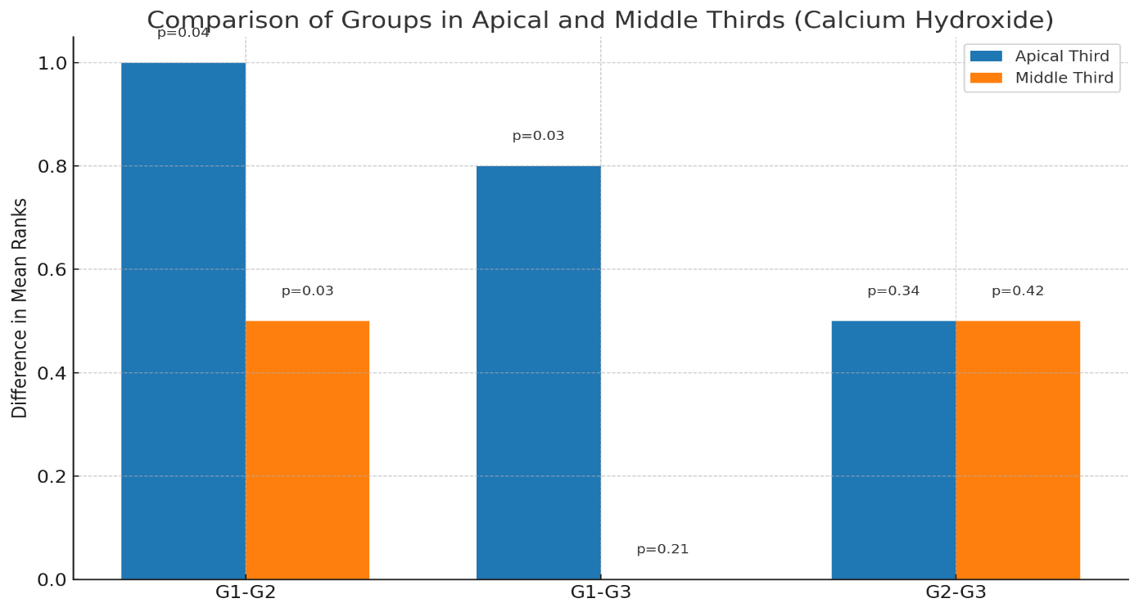
Graph 1- comparison of groups in apical and middle third of calcium hydroxide

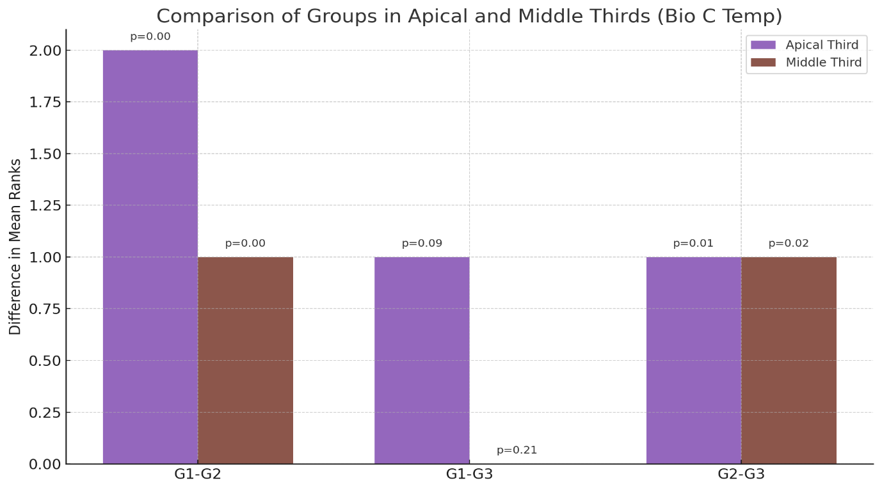

Graph 2- comparison of groups in apical and middle third of Bio C Temp

Figures
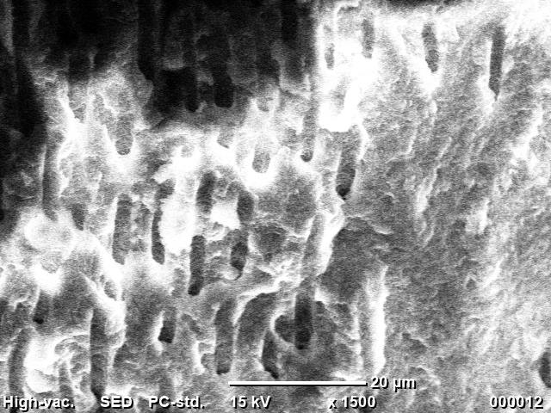
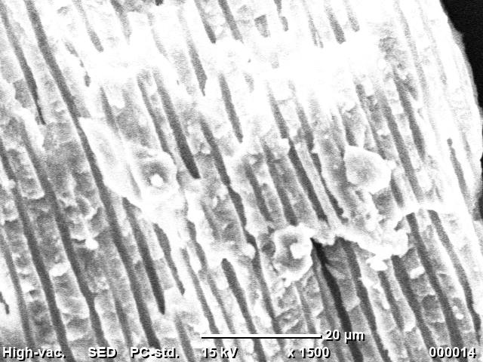

Fig. 1. SEM images of calcium hydroxide removal

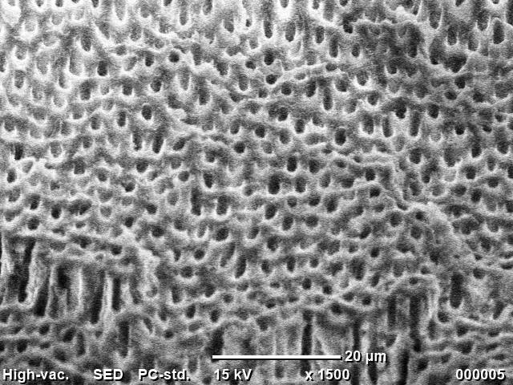
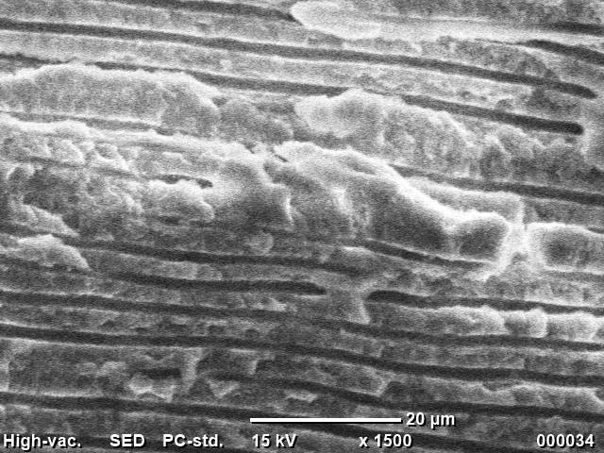

Fig. 2. SEM images of Bioc Temp removal

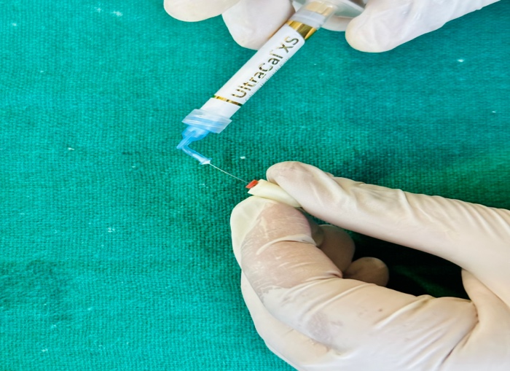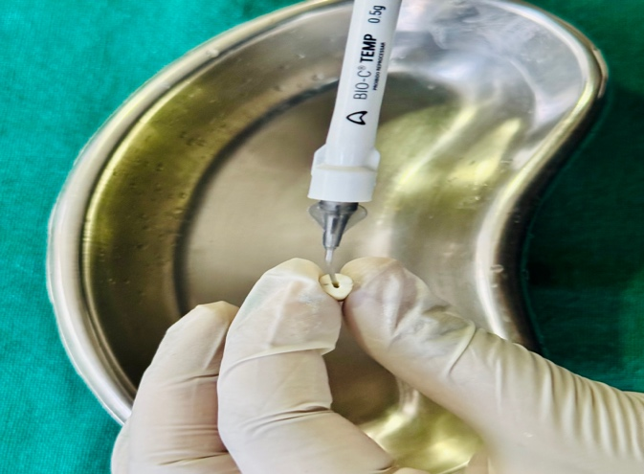

Fig 3– Intracanal Medicament placement according to grouping
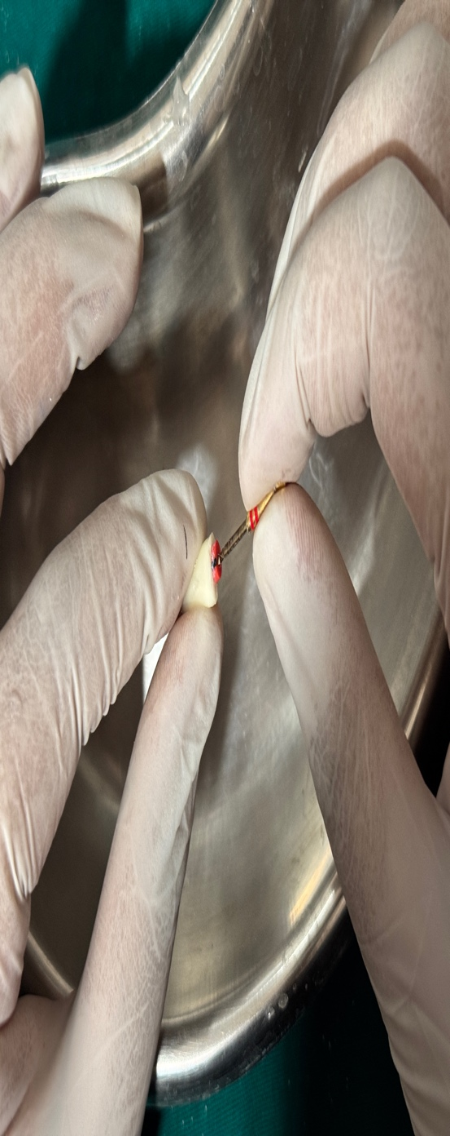
Fig 4- intracanal medicament removal using manual agitation

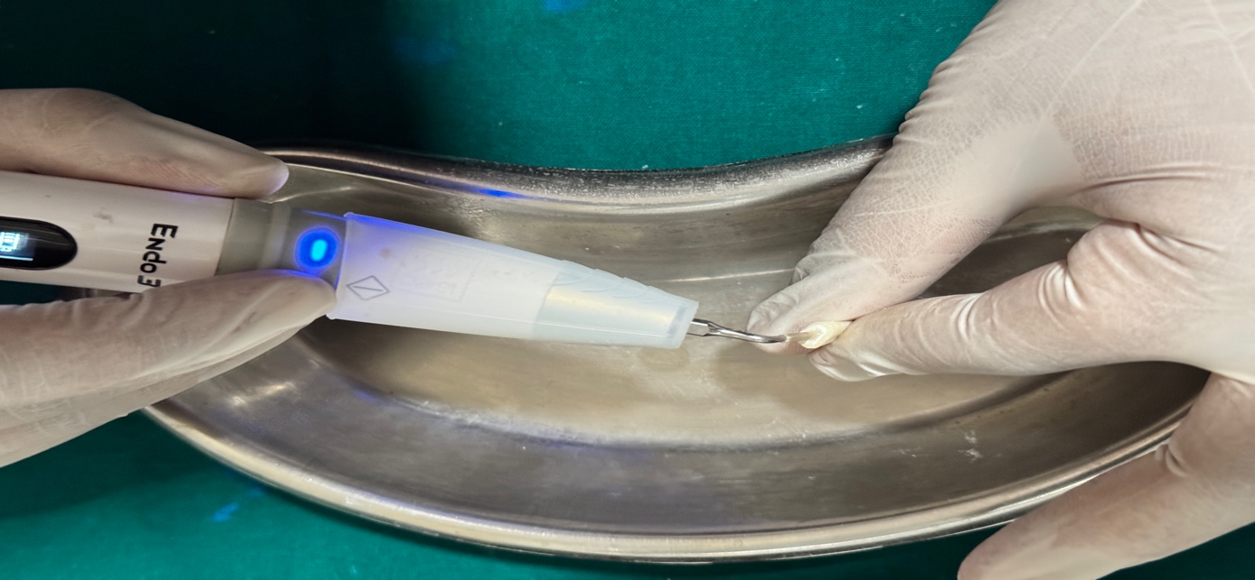
Fig 5- intracanal medicament removal using ultrasonic agitation

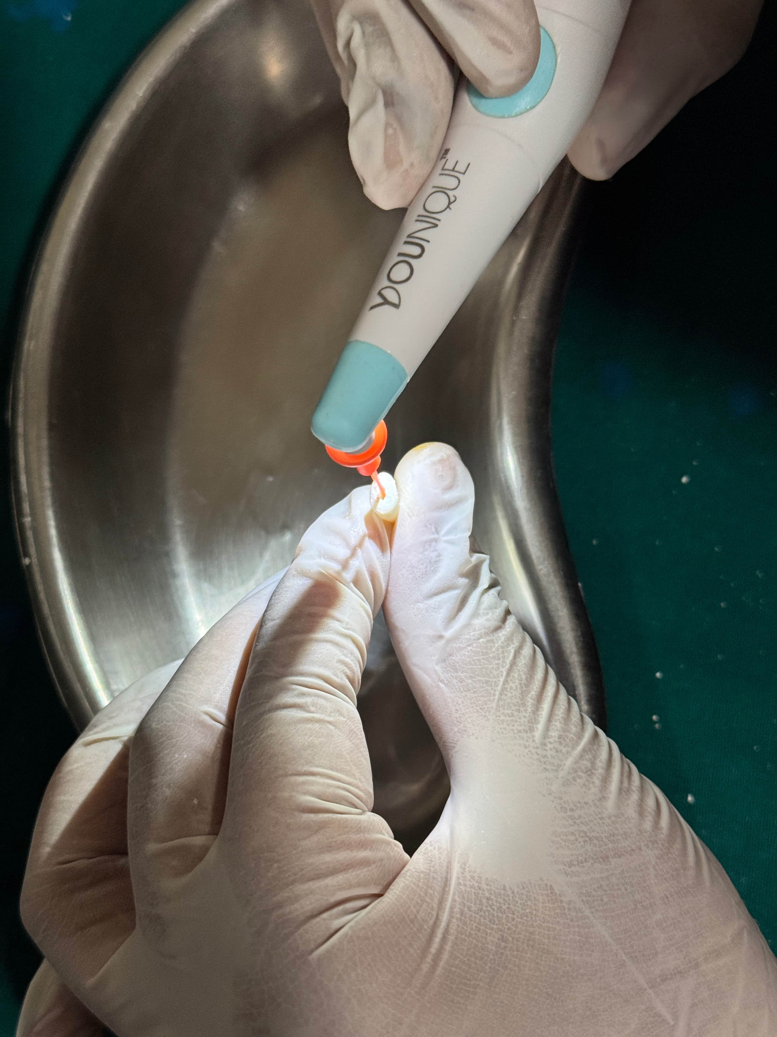
Fig 6- intracanal medicament removal using sonic agitation

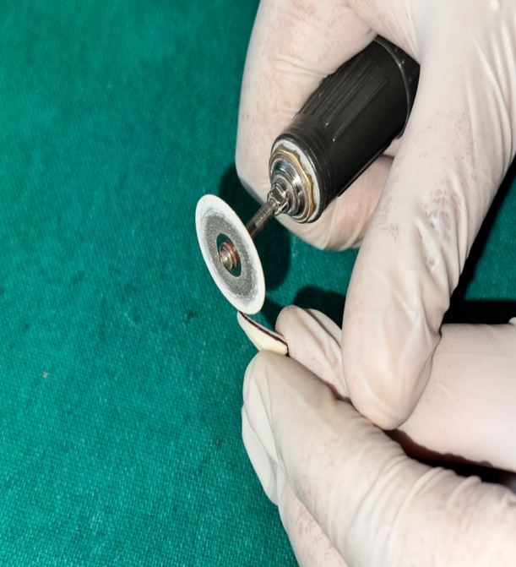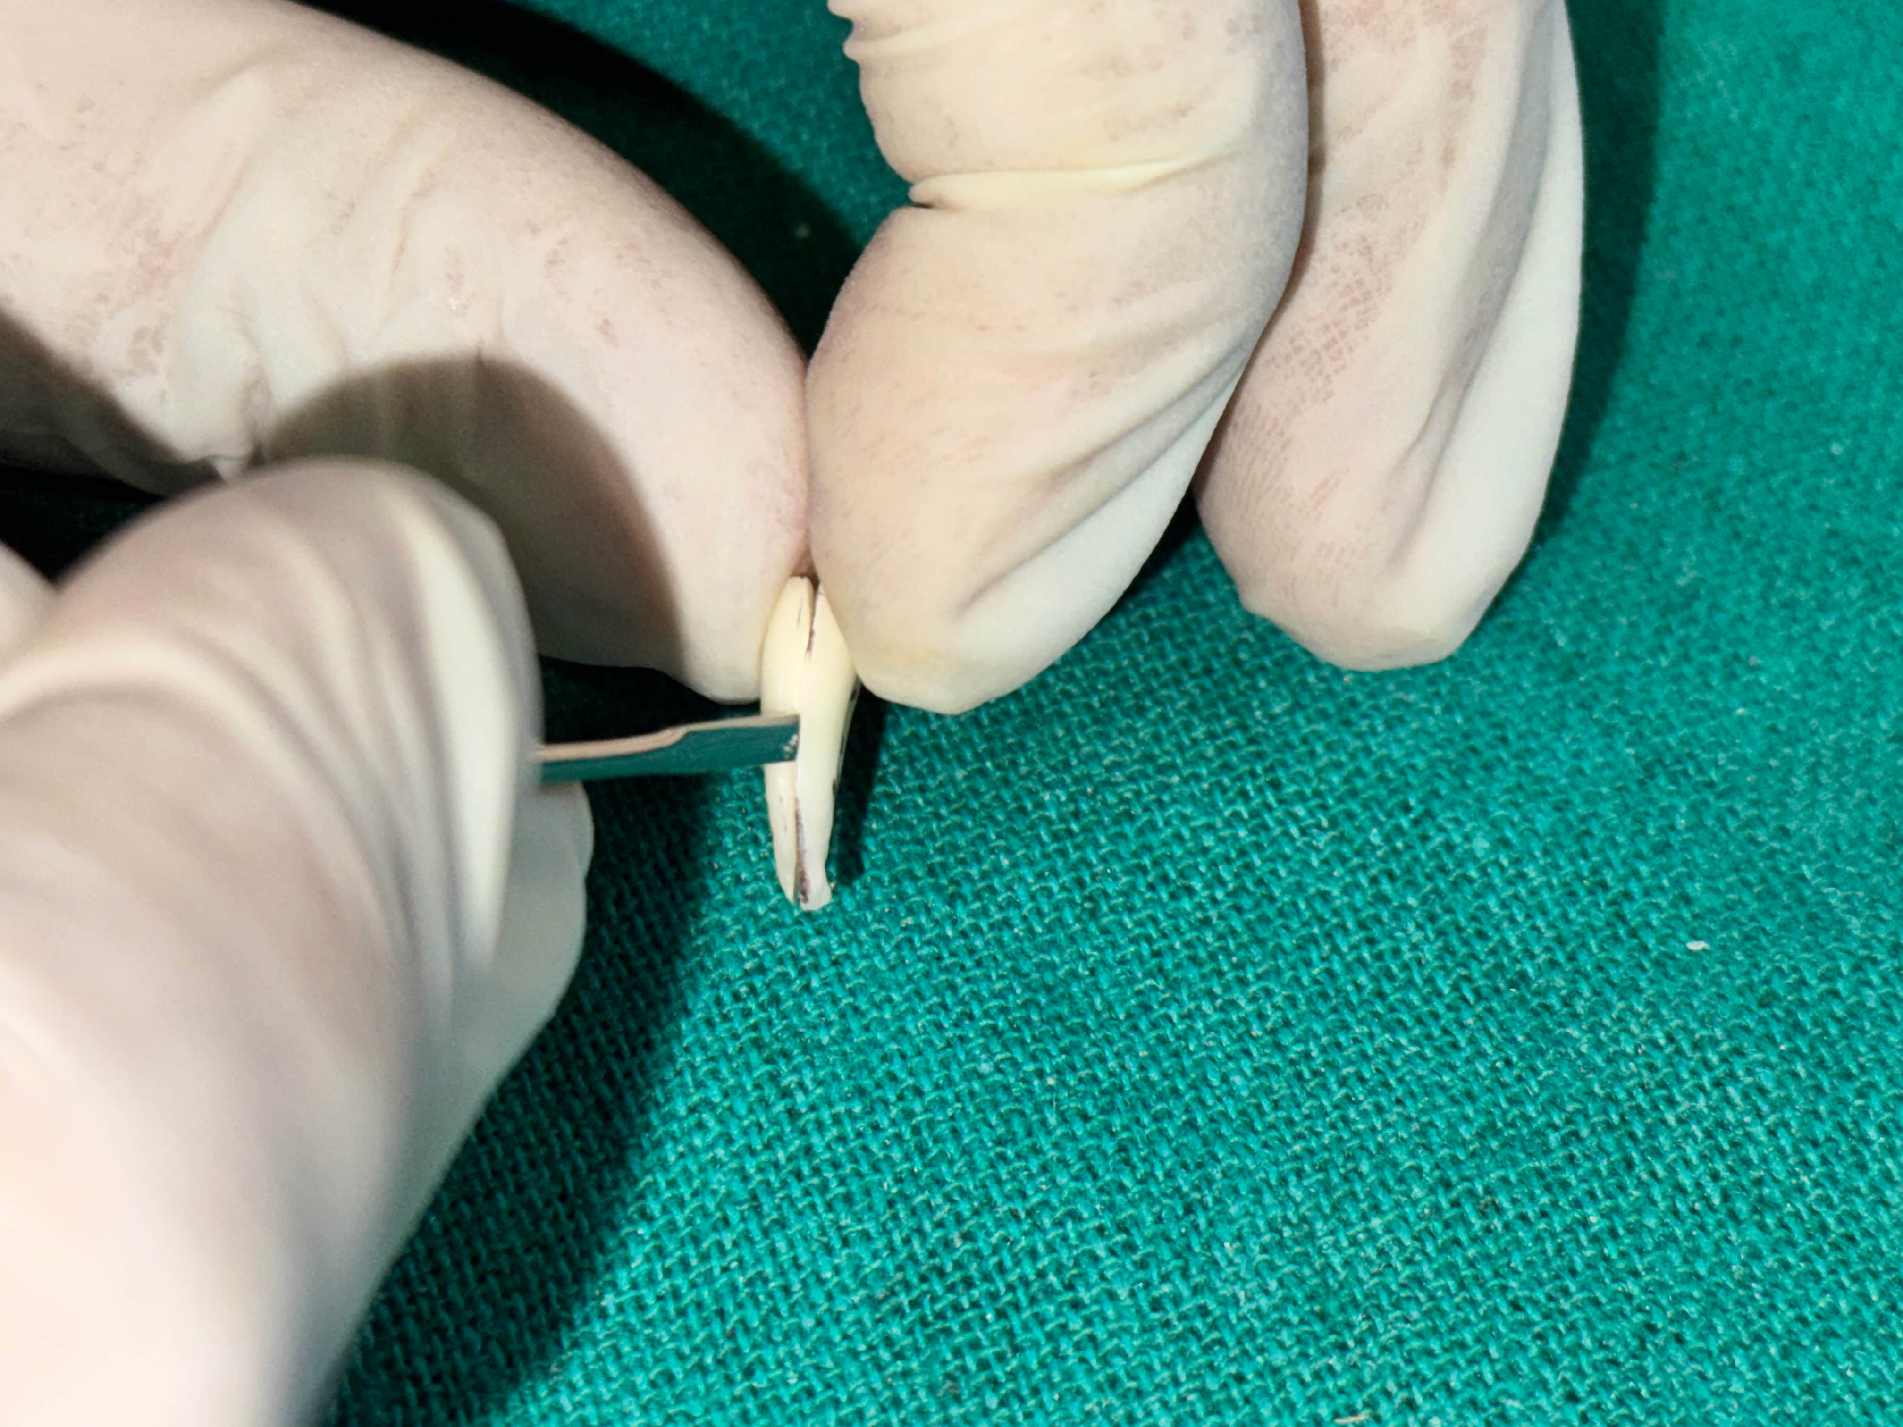
Fig 7- The roots sectioned into two halves buccolingually

