Sustained Ventricular Tachycardia with Preserved Left Ventricular Function and Non-Significant Coronary Lesions in a Patient with a History of Colorectal and Prostate Cancer: Case Report

Abstract
Background: Ventricular tachycardia (VT) typically arises in patients with impaired left ventricular ejection fraction (LVEF). However, VT may also occur in individuals with preserved EF, highlighting the importance of myocardial fibrosis as an arrhythmogenic substrate. Cardiac magnetic resonance imaging (CMR) with late gadolinium enhancement (LGE) has emerged as a key tool in identifying such risk beyond EF assessment.
Case presentation: We report the case of a 79-year-old man with a history of colorectal adenocarcinoma (surgically resected) and prostate cancer treated with radiotherapy, admitted with sustained monomorphic non-syncopal VT. Echocardiography showed preserved EF (68%), and coronary angiography revealed no significant stenosis. CMR demonstrated localized basal septal fibrosis, consistent with post-ischemic scar. During hospitalization, the patient developed rectal bleeding, and colonoscopy confirmed ischemic colitis at the colorectal anastomosis site. After multidisciplinary evaluation, a dual-chamber implantable cardioverter-defibrillator (ICD) was implanted for secondary prevention. Follow-up showed no recurrence of sustained VT and stable gastrointestinal status.
Conclusion: VT can occur in patients with preserved EF when myocardial fibrosis is present. ICD therapy remains indicated for secondary prevention regardless of EF. This case also underscores the importance of multidisciplinary management in patients with complex comorbidities, including gastrointestinal and oncological conditions.
Keywords: ventricular tachycardia, preserved ejection fraction, cardiac MRI, myocardial fibrosis, implantable cardioverter-defibrillator, ischemic colitis, cardio-oncology

Introduction
Ventricular tachycardia (VT) is a life-threatening arrhythmia and a major cause of sudden cardiac death (SCD). Traditionally, impaired left ventricular ejection fraction (LVEF) has been considered the strongest predictor of arrhythmic risk. However, increasing evidence shows that arrhythmias may also arise in patients with preserved EF, particularly when myocardial fibrosis is present.
Late gadolinium enhancement (LGE) on cardiac magnetic resonance imaging (CMR) is a validated marker of myocardial scar and an independent predictor of arrhythmic events. Recent European Society of Cardiology (ESC, 2022) and American Heart Association (AHA/ACC/HRS, 2017) guidelines recommend implantable cardioverter-defibrillator (ICD) implantation for secondary prevention of SCD in patients with sustained VT, regardless of EF, provided the arrhythmia is not due to reversible causes.
Cancer survivors represent a growing population at risk of arrhythmias. Potential mechanisms include systemic inflammation, cardiotoxicity from oncological therapies, cardiac metastases, and shared cardiovascular risk factors such as hypertension, dyslipidemia, and advanced age. This case illustrates the interplay between arrhythmia, myocardial fibrosis, and oncological comorbidities, highlighting the role of multidisciplinary care.

Case Presentation
A 79-year-old man presented on June 21, 2022, with palpitations. His past medical history included:
- Colorectal adenocarcinoma (resected in 2020),
- Prostate cancer (treated with radiotherapy),
- Hypertension and hyperlipidemia,
- Ischemic stroke four years earlier.
On admission, ECG showed sustained monomorphic VT, non-syncopal but associated with hemodynamic compromise. Intravenous amiodarone was initiated along with anticoagulation and dual antiplatelet therapy.
Echocardiography revealed preserved EF (68%), mild septal hypertrophy, and no significant valvular abnormalities. Coronary angiography (June 24, 2022) showed no significant stenosis (proximal LAD lesion <30%). CMR (June 29, 2022) demonstrated basal septal subendocardial fibrosis with LGE, consistent with post-ischemic scar, establishing a substrate for VT despite preserved EF.
During hospitalization, the patient developed rectal bleeding. Colonoscopy revealed ischemic colitis grade II at the colorectal anastomosis site, and CT angiography showed inferior mesenteric artery occlusion with collateral flow. Bleeding was attributed to low-flow states during VT episodes.
After multidisciplinary discussion (cardiology, gastroenterology, oncology), the patient underwent dual-chamber ICD implantation on July 7, 2022. The procedure was uneventful, and follow-up showed no recurrence of sustained VT.
Figure 1: ECG during ventricular tachycardia
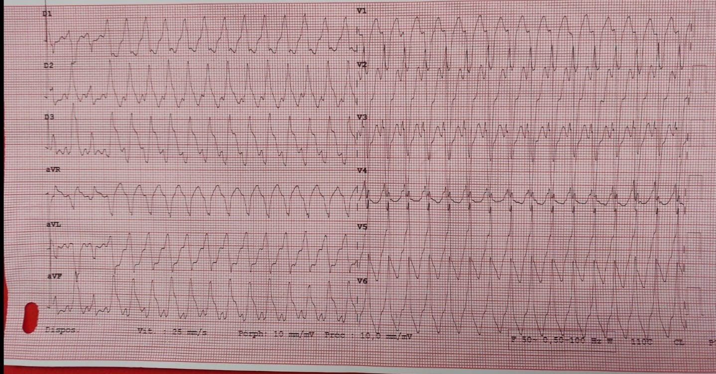
Figure 2: Transthoracic echocardiography (ETT) showing preserved EF
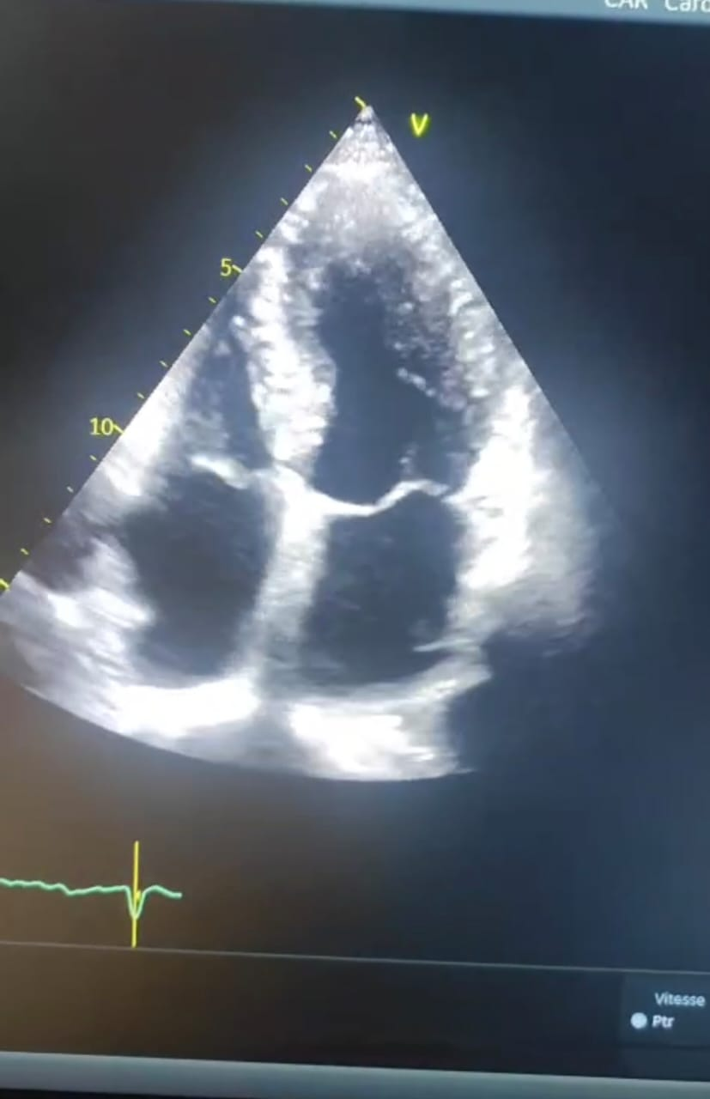
Figure 3: Chest radiograph post-ICD implantation
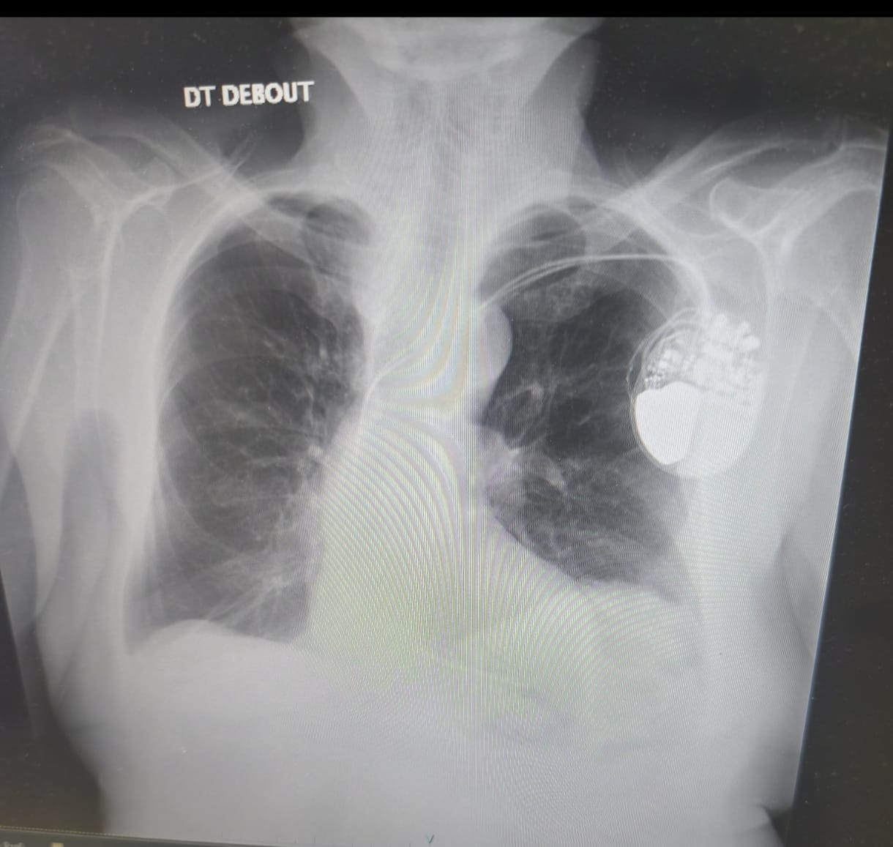

Discussion
This case highlights several key clinical lessons:
1. VT in preserved EF: Although reduced EF remains central to SCD risk stratification, VT can occur in patients with preserved EF when myocardial fibrosis is present. Scar burden on CMR has been shown to predict arrhythmic events independent of EF.
2. Role of CMR: CMR with LGE provides critical information on myocardial substrate, complementing echocardiography and coronary angiography. In this patient, localized septal fibrosis explained the arrhythmic mechanism despite preserved EF.
3. ICD for secondary prevention: Trials such as AVID, CIDS, and CASH established ICD superiority over antiarrhythmic drugs for secondary prevention. Registry data confirm benefit even in preserved EF if sustained VT occurs. Current ESC and AHA/ACC/HRS guidelines recommend ICD implantation in such cases.
4. Oncological and gastrointestinal comorbidities: The patient’s history of colorectal and prostate cancer raised important considerations. Oncological therapies (e.g., radiotherapy, chemotherapy, targeted therapies, immunotherapies) are known to increase arrhythmic risk through cardiotoxicity, systemic inflammation, or promoting myocardial fibrosis. Furthermore, ischemic colitis complicated management by increasing bleeding risk, necessitating careful balance of anticoagulation and antiplatelet therapy.
5. Multidisciplinary approach: Optimal care required coordination between cardiology, oncology, and gastroenterology. This reflects the growing importance of cardio-oncology, recognizing the bidirectional interactions between cancer and cardiovascular disease.
6. Future perspectives: Emerging approaches include quantitative scar burden analysis, T1/T2 mapping, and integration of imaging with electrophysiological testing for refined risk stratification. A paradigm shift from EF-based to scar-based assessment may improve prevention strategies in patients with preserved EF.

Conclusion
We describe a case of sustained VT in a patient with preserved EF and no significant coronary stenosis, in whom CMR revealed localized fibrosis. ICD implantation was indicated for secondary prevention, in accordance with current guidelines. This case emphasizes the importance of CMR in arrhythmic risk stratification, supports ICD therapy regardless of EF, and illustrates the challenges of multidisciplinary management in patients with oncological and gastrointestinal comorbidities.

Disclaimer (Artificial intelligence)
Option 1:
Author(s) hereby declare that NO generative AI technologies such as Large Language Models (ChatGPT, COPILOT, etc.) and text-to-image generators have been used during the writing or editing of this manuscript.
Option 2:
Author(s) hereby declare that generative AI technologies such as Large Language Models, etc. have been used during the writing or editing of manuscripts. This explanation will include the name, version, model, and source of the generative AI technology and as well as all input prompts provided to the generative AI technology
Details of the AI usage are given below:
1.
2.
3.

References
1. Priori SG, et al. 2022 ESC Guidelines on ventricular arrhythmias and the prevention of sudden cardiac death. Eur Heart J. 2022;43(5):399-478. doi:10.1093/eurheartj/ehab726
2. Al-Khatib SM, Stevenson WG, Ackerman MJ, et al. 2017 AHA/ACC/HRS Guideline for management of patients with ventricular arrhythmias and the prevention of sudden cardiac death. Circulation. 2018;138:e272-e391. doi:10.1161/CIR.0000000000000549
3. Muser D, Santangeli P, Marchlinski FE. Ventricular arrhythmias in nonischemic cardiomyopathy: risk stratification and management. Circulation. 2020;141:873-885. doi:10.1161/CIRCULATIONAHA.119.042434
4. Disertori M, et al. Myocardial fibrosis predicts ventricular tachyarrhythmias and sudden death: a meta-analysis. Eur Heart J. 2017;38(44):3359-3367. doi:10.1093/eurheartj/ehx504
5. Gulati A, et al. Fibrosis detected by cardiac MRI and risk of ventricular arrhythmias. JAMA Cardiol. 2022;7(3):264-273. doi:10.1001/jamacardio.2021.5624
6. Halliday BP, et al. Myocardial scar and arrhythmic risk stratification. Heart Rhythm. 2023;20(2):195-205. doi:10.1016/j.hrthm.2022.11.015
7. Klem I, et al. Association between LVEF and risk of sudden cardiac death in VT patients. J Am Coll Cardiol. 2021;77(12):1507-1517. doi:10.1016/j.jacc.2021.01.039
8. Marrouche NF, et al. Imaging-based risk stratification of arrhythmias. Eur Heart J. 2022;43(16):1522-1535. doi:10.1093/eurheartj/ehac073
9. Cronin EM, et al. CMR for substrate characterization in ventricular tachycardia. Circ Arrhythm Electrophysiol. 2021;14:e009564. doi:10.1161/CIRCEP.120.009564
10. Kuruvilla S, et al. Scar quantification by CMR predicts arrhythmic events. Circ Cardiovasc Imaging. 2020;13:e009675. doi:10.1161/CIRCIMAGING.119.009675
11. Saksena S, et al. Studies on left ventricular function during sustained ventricular tachycardia. J Am Coll Cardiol. 1984;4(3):501-508. doi:10.1016/S0735-1097(84)80093-5
12. Srivathsan K, Ng DW, Mookadam F. Ventricular tachycardia and ventricular fibrillation. Expert Rev Cardiovasc Ther. 2009;7(7):801-809. doi:10.1586/erc.09.69
13. Elendu C, et al. Sustained Ventricular Tachycardia: A Review of Treatment and Prognosis. J Adv Med Med Res. 2023;35(6):46-53. doi:10.9734/jammr/2023/v35i64980

