Case report
Solitary Right Atrial Metastasis of Chondrosarcoma: A Case Report Highlighting the Role of Multimodality Imaging and Surgical Management

Abstract
Background: Cardiac metastases, though significantly more common than primary cardiac tumors, are a rare clinical finding. Chondrosarcoma, a chemotherapy-resistant malignant bone tumor, exhibits a peculiar propensity for cardiac metastasis, most frequently to the right atrium. Such lesions can lead to catastrophic complications through valvular obstruction, embolization, or arrhythmias, and their management presents a significant therapeutic challenge.
Case Presentation: A 68-year-old woman with a history of grade II rib chondrosarcoma resected four years prior, presented with a three-month history of progressive dyspnea, chest discomfort, and peripheral edema. Transthoracic echocardiography identified a large, heterogeneous, mobile mass in the right atrium, causing functional tricuspid stenosis and extending into the right ventricle and superior vena cava. Cardiac magnetic resonance imaging (CMR) characterized the lesion as a well-demarcated, lobulated mass, hyperintense on T2-weighted imaging with intense late gadolinium enhancement. The patient underwent successful complete surgical resection with reconstruction of the atrial wall and tricuspid valve using bovine pericardium. Histopathological analysis confirmed the diagnosis of metastatic chondrosarcoma.
Conclusion: This case underscores the critical importance of considering cardiac metastasis in oncologic patients presenting with new cardiovascular symptoms. Multimodality imaging, particularly CMR, is indispensable for tissue characterization and surgical planning. Aggressive surgical intervention remains a viable and potentially life-prolonging treatment option for isolated cardiac metastases, even in the context of metastatic chondrosarcoma, which is notoriously resistant to chemotherapy and radiotherapy.
Keywords: Cardiac Metastasis, Chondrosarcoma, Right Atrial Tumor, Cardiac MRI, Multimodality Imaging, Cardiac Surgery.

1. Introduction
The heart, once considered a sanctuary organ, is now recognized as a potential site for metastatic disease. Autopsy studies indicate that cardiac metastases are found in up to 10% of patients with advanced malignancy, making them 20 to 40 times more common than primary cardiac tumors [1, 2]. The most frequent sources are carcinomas of the lung, breast, and esophagus, as well as melanoma and lymphoma [3]. These metastases can reach the heart via hematogenous spread, lymphatic invasion, or direct extension.
Chondrosarcoma, the second most common primary malignant bone tumor after osteosarcoma, accounts for approximately 20-27% of all skeletal malignancies [4]. It is characterized by its production of cartilaginous matrix and is notoriously resistant to conventional chemotherapy and radiotherapy [5]. Its metastatic spread is primarily hematogenous, with the lungs being the most common site. Cardiac involvement is exceedingly rare, with a strong predilection for the right atrium, as first extensively reviewed by Leung et al. in 1988, who documented 18 cases [6]. The pathophysiology is thought to involve seeding of tumor cells via the venous circulation, where they implant on the endocardial surface [7].
We present a detailed case of a solitary right atrial metastasis from a rib chondrosarcoma, causing functional tricuspid stenosis. This report elaborates on the comprehensive diagnostic workup, the critical role of advanced imaging, and the surgical strategy, thereby contributing to the limited body of literature on the management of this rare and challenging condition.

2. Case presentation
A 68-year-old woman was referred to our cardiology department for evaluation of worsening dyspnea (NYHA Class III) and atypical chest tightness of three months' duration. She also reported recent onset of fatigue and bilateral lower limb edema. Her medical history was significant for a grade II conventional chondrosarcoma of the left 5th rib, which had been completely resected with wide margins (R0 resection) four years prior. She had received no adjuvant therapy and had been under regular surveillance with thoracic CT scans, the most recent of which, six months ago, showed no evidence of local recurrence or pulmonary metastases.
Physical examination revealed a heart rate of 102 bpm, blood pressure of 135/85 mmHg, and elevated jugular venous pressure at 10 cm H₂O with a prominent systolic 'cv' wave suggestive of tricuspid regurgitation. Auscultation revealed a grade 3/6 holosystolic murmur at the left lower sternal border that increased with inspiration, and a low-pitched diastolic murmur. There was tender hepatomegaly and 2+ pitting edema up to the mid-shins.
The electrocardiogram (ECG) showed sinus tachycardia, right axis deviation (+120°), low-voltage QRS complexes in the limb leads, and incomplete right bundle branch block. There were no signs of atrial arrhythmia or ischemia.
Laboratory investigation revealed several key findings. The N-terminal pro-B-type natriuretic peptide (NT-proBNP) was significantly elevated at 2,500 pg/mL, consistent with cardiac strain. In contrast, troponin I levels remained within the normal range, arguing against acute myocardial injury. The full blood count was unremarkable, and renal and liver function panels were within normal limits. A mild elevation in D-dimer was noted at 650 ng/mL
Transthoracic Echocardiography (TTE) revealed a large (approximately 8 x 7 cm), heterogeneous, and highly mobile mass occupying the entire right atrium. The mass prolapsed through the tricuspid valve into the right ventricle during diastole, causing significant inflow obstruction with a mean diastolic gradient of 8 mmHg. It also extended into the proximal superior vena cava. The right ventricle was dilated with mildly reduced systolic function. The left ventricle was structurally and functionally normal.
Subsequent contrast-enhanced chest computed tomography was instrumental in characterizing the tumor’s anatomy and extension. It confirmed a large (53×79×94 mm), heterogeneously enhancing hypodense mass in the right atrium, with broad-based attachments to the interatrial septum and posterior wall. The tumor was seen extending into the superior vena cava over 2.5 cm and prolapsing into the right ventricle. Importantly, the thorax was clear of pulmonary metastases. A subsequent abdominopelvic CT scan completed the staging process and confirmed the absence of other metastatic deposits. (Figures 1 and 2).
Following the CT, cardiac magnetic resonance imaging (CMR) was undertaken for definitive tissue characterization. The CMR depicted a well-demarcated, lobulated mass that was markedly T2-hyperintense, suggesting high fluid content. The lesion showed intense, heterogeneous early gadolinium enhancement as well as late gadolinium enhancement (LGE) on 10-minute post-contrast images (Figures 3A and 3B), a pattern pathognomonic for hypervascular tumor tissue and inconsistent with thrombus. Phase-contrast imaging also confirmed significant tricuspid valve inflow obstruction

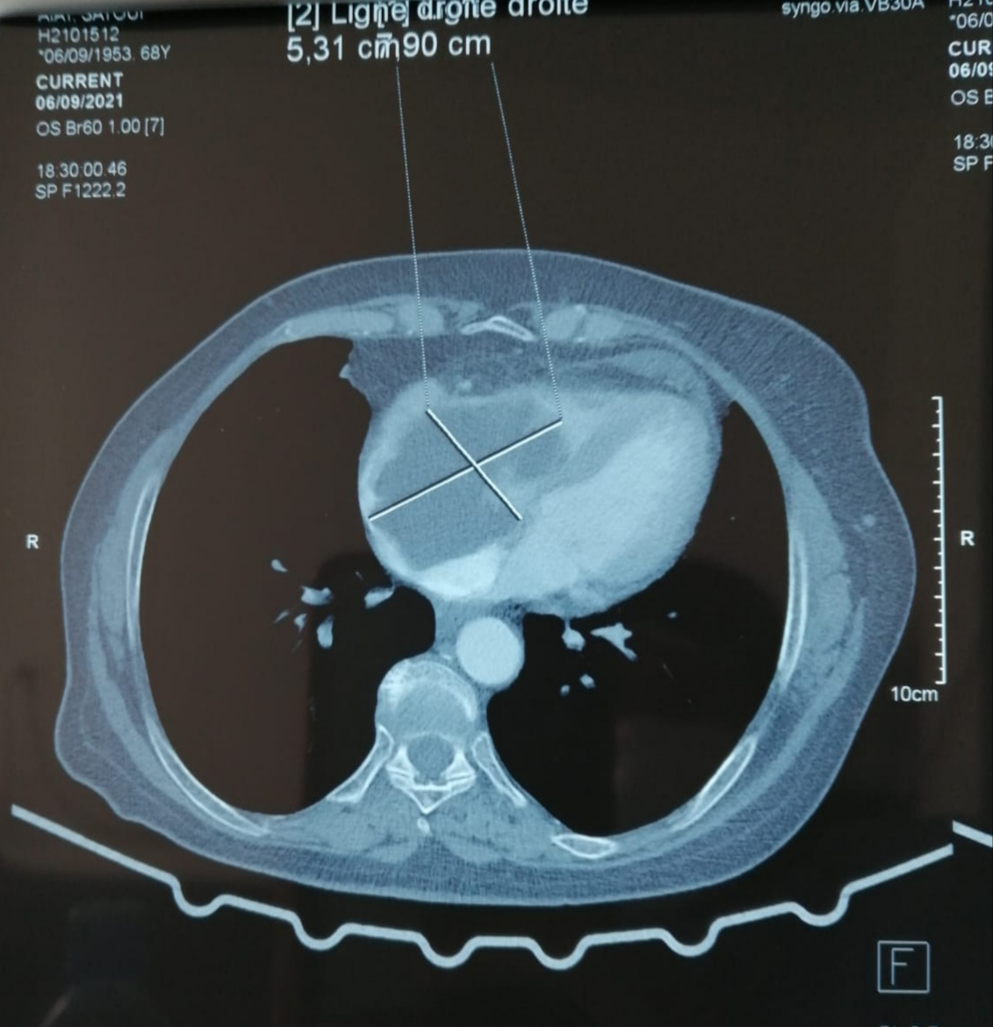
Figure 1 : Contrast-enhanced computed tomography (Axial View) showing the hypodense right atrial mass with caliper measurement confirming a maximal diameter of 5.31 cm.
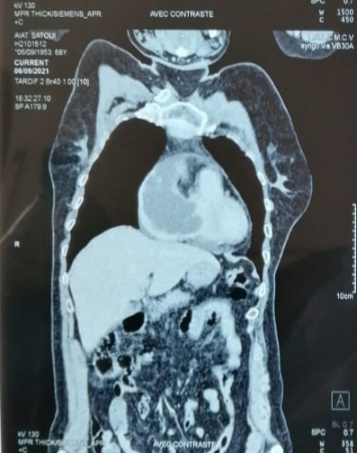

Figure 2 : Contrast-enhanced cardiac computed tomography (Long-Axis View).
Reveals a large, hypodense mass filling the right atrium, with extension across the tricuspid valve annulus into the right ventricle.
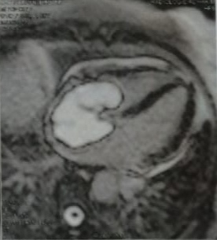
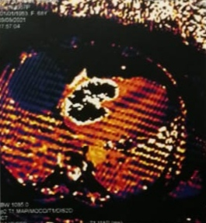
Figure 3A Figure 3B
Figure 3A : Cardiac magnetic resonance (CMR) cine four-chamber view demonstrating a well-defined lobulated mass occupying a large portion of the right atrial cavity, protruding into the atrial lumen and the right ventricle.
Figure 3B : Late gadolinium enhancement (LGE) cardiac magnetic resonance imaging showing heterogeneous enhancement of the right atrial mass, suggestive of malignant infiltration rather than a benign cardiac tumor.

A multidisciplinary tumor board concluded that this was a solitary cardiac metastasis from the patient's known chondrosarcoma. Given the symptomatic obstruction, radio-chemo-resistance of the tumor, and absence of other metastatic disease, the decision was made to proceed with curative-intent surgery.
The patient underwent median sternotomy and cardiopulmonary bypass with bicaval cannulation, carefully placing the SVC cannula beyond the tumor extension. Upon opening the right atrium, a large, gelatinous, whitish-gray tumor with a broad-based attachment to the medial wall and interatrial septum was found. The mass was meticulously dissected and removed en-bloc. Given the extensive resection required, which resulted in a large atrial defect and destruction of the tricuspid valve apparatus, reconstruction was performed, using a bovine pericardial patch for the atrial wall and a bovine pericardial bioprosthesis for valve replacement. (Figures 4 and 5).

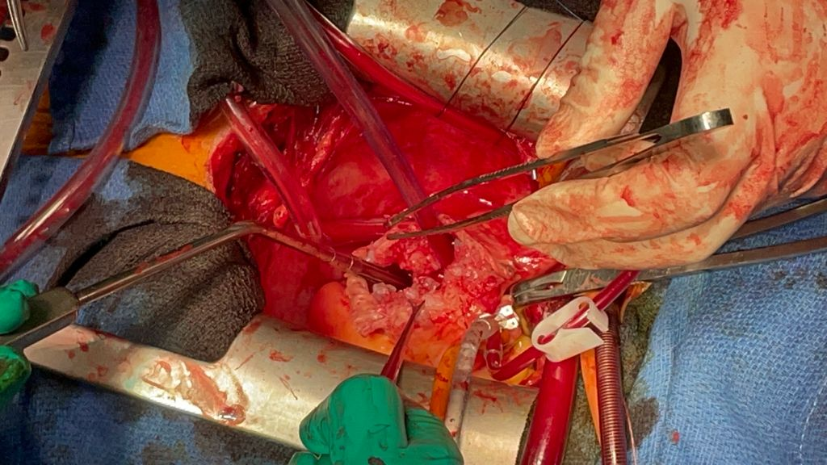
Figure 4 : Intraoperative view during open-heart surgery showing exposure of the right atrium and excision of the metastatic chondrosarcoma mass under cardiopulmonary bypass.

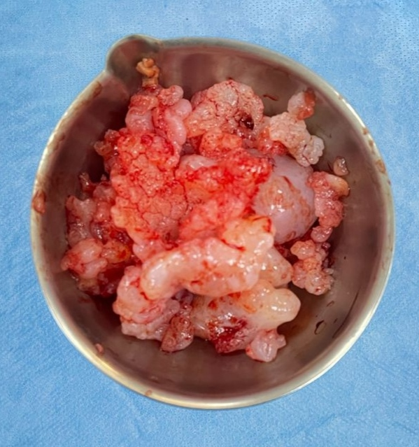
Figure 5 : Resected specimen of the right atrial metastatic chondrosarcoma, showing multinodular lobulated, and gelatinous tumor tissue.

The postoperative course was unremarkable. The patient was extubated within 12 hours and weaned from inotropic support within 24 hours. A postoperative TTE showed a well-seated prosthetic valve with no significant paravalvular leak, normalized right ventricular dimensions, and improved function. Histopathological examination confirmed metastatic chondrosarcoma, with histological features (cellular atypia, lacunae containing atypical chondrocytes) identical to the primary rib tumor. The resection margins were free of tumor.
The patient was discharged on postoperative day 12 on warfarin anticoagulation, and was referred to oncology for long-term surveillance and discussion of adjuvant therapy options, though none are standard.

3. Discussion
This case provides a quintessential example of the diagnostic and therapeutic challenges posed by cardiac metastases from chondrosarcoma. The clinical presentation of right heart failure and the findings on physical exam are direct consequences of the tumor's location, causing inflow obstruction and tricuspid valve dysfunction.
The multimodality imaging strategy employed in this case provided a complete and meticulous evaluation of the cardiac mass, facilitating an accurate diagnosis. While TTE is the initial screening tool of choice, its limitations in tissue characterization are well-known [8]. CT provides excellent anatomical definition for surgical planning and staging [9]. However, as demonstrated, CMR is the non-invasive gold standard for tissue characterization. The combination of T2 hyperintensity (due to the high water content of the cartilaginous matrix) and intense LGE is a hallmark of metastatic chondrosarcoma, and is critical for differentiating it from a thrombus, which is typically avascular and does not enhance [10, 11]. This imaging profile can be so characteristic that it provides a high degree of diagnostic confidence prior to histology [12].
The ECG findings of low voltage and right axis deviation, though non-specific, are consistent with the presence of a large intra-atrial mass and associated right heart strain [13]. The absence of atrial arrhythmias is somewhat surprising given the tumor's location and size, which often irritate the atrial myocardium [14]. The elevated NT-proBNP reflected the increased atrial pressure and right ventricular wall stress.
The management of metastatic chondrosarcoma is primarily surgical, given its resistance to other modalities [5, 15]. The historical median survival after diagnosis of cardiac metastasis is dismal, reported as 2 months for non-surgical management versus 18 months for those undergoing resection [6]. This stark difference underscores the potential survival benefit of aggressive surgery. The primary goals are complete macroscopic resection (debulking), relief of obstruction, and prevention of embolization—either of tumor fragments or of thrombus formed on the tumor surface [16].
Our surgical approach highlights several technical considerations. The use of bicaval cannulation and potentially low-flow cardiopulmonary bypass or brief periods of circulatory arrest can facilitate safe dissection of tumors extending into the vena cavae [17]. The extensive reconstruction required with bovine pericardium is a standard and effective technique for repairing large atrial defects following tumor resection [18]. The choice of a bioprosthesis in the tricuspid position is preferred by many surgeons to avoid the lifelong need for anticoagulation with a mechanical valve, which carries a higher risk of thrombosis in the low-pressure right heart system [19].
The long-term prognosis remains guarded due to the risk of further metastatic spread. However, this case aligns with a growing number of reports that advocate for an aggressive surgical approach in selected patients with isolated, resectable cardiac metastases, as it can provide excellent palliation of symptoms, prevent sudden death from obstruction or embolism, and potentially offer a prolonged disease-free interval [20, 21]. Close lifelong surveillance is mandatory.

4. Conclusion
Cardiac metastasis should be a primary consideration in any patient with a history of chondrosarcoma who develops signs of right heart obstruction or embolic phenomena. A high index of suspicion and a systematic multimodality imaging approach, with CMR as the cornerstone for tissue characterization, are essential for timely diagnosis. As this case illustrates, an aggressive surgical strategy, while complex, is feasible and can be life-saving and life-prolonging. It represents the best therapeutic option for isolated cardiac metastases from radio- and chemo-resistant tumors like chondrosarcoma, emphasizing the critical importance of a dedicated multidisciplinary heart team in managing these rare and challenging cases.

Consent
Written informed consent was obtained from the patient for publication of this case report and accompanying images.
Ethical Approval:
As per international standards or university standards written ethical approval has been collected and preserved by the author(s).
Availability of data and materials
All data analyzed during this study are included in the published articles cited in the section « references »
Disclaimer (Artificial intelligence)
Author(s) hereby declare that NO generative AI technologies such as Large Language Models (ChatGPT, COPILOT, etc.) and text-to-image generators have been used during the writing or editing of this manuscript.

References
- Basso C, Rizzoli G, Valente M, Thiene G. Cardiac masses and tumours. Heart. 2016;102(16):1230-1245. DOI: 10.1136/heartjnl-2015-308143
- Reynen K. Frequency of primary tumors of the heart. Am J Cardiol. 1996;77(1):107. DOI: 10.1016/s0002-9149(97)89349-7
- Silva F, Baumgartner H, Colucci V, et al. Tumours of the heart. In: Camm AJ, Lüscher TF, Maurer G, Serruys PW, eds. The ESC Textbook of Cardiovascular Medicine. 3rd ed. Oxford University Press; 2018:735-761.
- Gelderblom H, Hogendoorn PCW, Dijkstra SD, et al. The clinical approach towards chondrosarcoma. Oncologist. 2008;13(3):320-329. DOI: 10.1634/theoncologist.2007-0237
- van Praag Veroniek VM, Rueten-Budde AJ, Ho V, et al. Incidence, outcomes and prognostic factors during 25 years of treatment of chondrosarcomas. Surg Oncol. 2018;27(3):402-408. DOI: 10.1016/j.suronc.2018.05.009
- Leung CY, Cummings RG, Reimer KA, Lowe JE. Chondrosarcoma metastatic to the heart. Ann Thorac Surg. 1988;45(3):291-295. DOI: 10.1016/s0003-4975(10)62464-4
- Butany J, Leong SW, Carmichael K, Komeda M. A 30-year analysis of cardiac neoplasms at autopsy. Can J Cardiol. 2005;21(8):675-680.
- Kirkpatrick JN, Wong T, Bednarz JE, et al. Differential diagnosis of cardiac masses using contrast echocardiographic perfusion imaging. J Am Coll Cardiol. 2004;43(8):1412-1419. DOI: 10.1016/j.jacc.2003.12.023
- Hoey ETD, Mankad K, Puppala S, Gopalan D, Sivananthan MU. MRI and CT of coronary heart disease: a review. Br J Radiol. 2009;82(984):921-931. DOI: 10.1259/bjr/18209986
- Motwani M, Kidambi A, Herzog BA, Uddin A, Greenwood JP, Plein S. MR imaging of cardiac tumors and masses: a review of methods and clinical applications. Radiology. 2013;268(1):26-43. DOI: 10.1148/radiol.13121239
- Hoffmann U, Globits S, Schima W, et al. Usefulness of magnetic resonance imaging of cardiac and paracardiac masses. Am J Cardiol. 2003;92(7):890-895. DOI: 10.1016/s0002-9149(03)00913-2
- Sparrow PJ, Kurian JB, Jones TR, Sivananthan MU. MR imaging of cardiac tumors. RadioGraphics. 2005;25(5):1255-1276. DOI: 10.1148/rg.255045721
- Gowda RM, Khan IA, Nair CK, Mehta NJ, Vasavada BC, Sacchi TJ. Cardiac papillary fibroelastoma: a comprehensive analysis of 725 cases. Am Heart J. 2003;146(3):404-410. DOI: 10.1016/S0002-8703(03)00249-7
- Aryal MR, Badal M, Mainali NR, et al. Primary cardiac tumors: clinical experience and late results of 23 patients. Asian Cardiovasc Thorac Ann. 2014;22(5):542-547. DOI: 10.1177/0218492313493429
- Grimer RJ, Gosheger G, Taminiau A, et al. Dedifferentiated chondrosarcoma: prognostic factors and outcome from a European group. Eur J Cancer. 2007;43(14):2060-2065. DOI: 10.1016/j.ejca.2007.07.002
- Wang JG, Li YJ, Liu H, Li J, Zhao P, Zhang S. Primary cardiac chondrosarcoma: a case report and literature review. J Cardiothorac Surg. 2013;8:168. DOI: 10.1186/1749-8090-8-168
- Reber D, Birnbaum DE. Cardiac surgery for the treatment of primary cardiac tumors. J Card Surg. 1999;14(4):308-312. DOI: 10.1111/j.1540-8191.1999.tb00997.x
- Vistarini N, Chen C, Mazine A, et al. Surgical treatment of primary cardiac tumors: insights from an 18-year single-center experience. Tex Heart Inst J. 2017;44(1):21-26. DOI: 10.14503/THIJ-16-5852
- Rizzoli G, Guglielmi C, Toscano G, et al. Reoperations for acute prosthetic thrombosis and pannus: an assessment of rates, relationship and risk. Eur J Cardiothorac Surg. 1999;16(1):74-80. DOI: 10.1016/s1010-7940(99)00135-3
- ElBardissi AW, Dearani JA, Daly RC, et al. Survival after resection of primary cardiac tumors: a 48-year experience. Circulation. 2008;118(14 Suppl):S7-S15. DOI: 10.1161/CIRCULATIONAHA.107.783126
- Habertheuer A, Ehrlich M, Wiedemann D, et al. A rare case of primary cardiac chondrosarcoma and review of the literature. J Cardiothorac Surg. 2014;9:119. DOI: 10.1186/1749-8090-9-119

