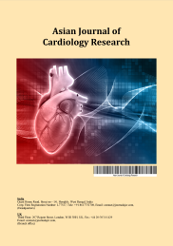
Asian Journal of Cardiology Research

Volume XXX, Issue XX, Page XX-XX, 20YY; Article no.AJCR.135809

From Dilatation to Occlusion: A STEMI Case in Coronary Artery Ectasia

Authors’ Name……………………………………………………

Affiliations……………………………………………………….………………

Authors’ contributions

This work was carried out in collaboration among all authors. ‘Author A’ designed the study, performed the statistical analysis, wrote the protocol, and wrote the first draft of the manuscript. ‘Author B’ and ‘Author C’ managed the analyses of the study. ‘Author C’ managed the literature searches. All authors read and approved the final manuscript.

Article Information

DOI: 10.9734/AJCR/2025/XXXXX

Open Peer Review History:
This journal follows the Advanced Open Peer Review policy. Identity of the Reviewers, Editor(s) and additional Reviewers, peer review comments, different versions of the manuscript, comments of the editors, etc are available here:

Received: DD/MM/20YY
Accepted: DD/MM/20YY
Case Report
Published: DD/MM/20YY

ABSTRACT

Background: Coronary artery ectasia (CAE) is a rare dilation of the coronary arteries, with an incidence of 0.3%–5%. It is most often caused by atherosclerosis and may present with complications such as thrombotic occlusion and acute coronary syndromes (ACS). Case Summary: We report the case of a 51-year-old male smoker presenting with ST-segment elevation myocardial infarction (STEMI) due to thrombosis in an ectatic circumflex artery. Coronary angiography revealed type III CAE with diffuse ectasia and complete thrombotic occlusion of the circumflex artery. The patient was successfully managed with dual antiplatelet therapy, glycoprotein IIb/IIIa inhibitors, beta-blockers, ACE inhibitors, and high-intensity statins. He recovered without complications.
Conclusion: CAE complicates coronary flow dynamics, increasing the risk of thrombotic occlusion. Management strategies include antiplatelets, anticoagulants, and risk factor modification. This case emphasizes the importance of coronary angiography in CAE diagnosis and highlights pharmacological strategies tailored to this condition.
Keywords: Coronary artery ectasia ST-elevation; Myocardial Infarction (STEMI) Thrombosis; dual antiplatelet therapy, coronary angiography.

1. INTRODUCTION

Coronary artery ectasia (CAE) is an uncommon anomaly, representing approximately 0.3%–5% of coronary angiograms (Antoniadis et al., 2008, Markis et al., 1976). Defined as coronary dilation exceeding 1.5 times the diameter of adjacent normal segments, CAE is most commonly caused by atherosclerosis (50% of cases) but can also result from congenital anomalies, inflammatory conditions, or genetic predisposition (Markis et al., 1976).

Patients with CAE are often asymptomatic, but the condition may predispose to acute coronary syndromes (ACS) via thrombus formation, embolization, or impaired coronary flow dynamics, these factors can lead to severe complications such as myocardial infarction, complicating diagnosis and management, especially in cases of ST-segment elevation myocardial infarction. While no consensus guidelines exist for CAE management, the therapeutic approach combines anticoagulation, antiplatelet therapy, and risk factor modification (Esposito et al., 2022). Clinicians must understand the underlying mechanisms of CAE and its interactions with other coronary pathologies to provide targeted therapeutic approaches. This report describes a rare presentation of STEMI in a patient with CAE and reviews evidence-based management strategies.

2. CASE PRESENTATION

A 51-year-old male presented to the emergency department with acute, severe chest pain radiating to the left arm, ongoing for less than two hours. His only cardiovascular risk factor was chronic smoking, with no prior medical or surgical history. The patient was hemodynamically stable on initial examination, with a blood pressure of 120/60 mmHg, heart rate of 70 bpm, and oxygen saturation of 98%. Physical examination revealed no signs of heart failure or other abnormalities.

An electrocardiogram (ECG) performed shortly after presentation revealed ST-segment elevation in the inferior leads (DII, DIII AVF) more pronounced in DII than in DIII. A Q wave of necrosis is present in the inferior leads, consistent with acute myocardial infarction (Fig. 1).

The patient received a loading dose of aspirin (300 mg) and clopidogrel (300 mg), along with low-molecular-weight heparin (0.3 mg/kg) before being transferred to the catheterization laboratory, where the coronary angiography revealed diffuse coronary ectasia of the circumflex artery, consistent with type III CAE based on the Markis classification (Table 1). The ectatic circumflex artery was completely occluded by thrombus (Fig. 2), while the rest of the coronary arteries appeared angiographically normal (Fig. 3).

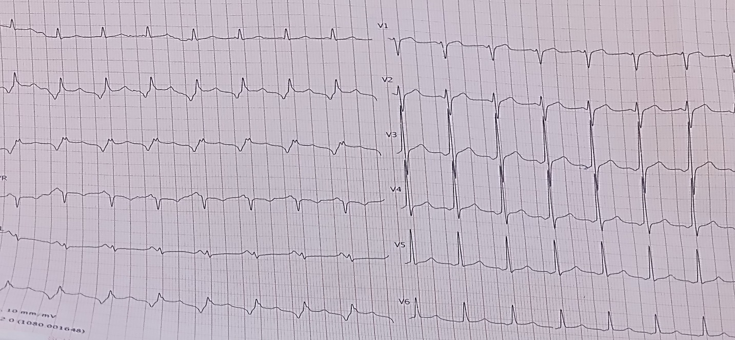

Fig. 1. ST-Segment Elevation in Inferior Leads with Q Waves of Necrosis
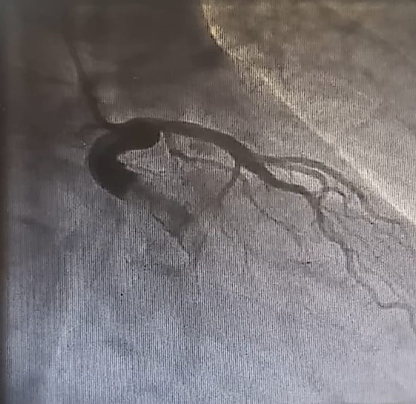

Fig. 2. Coronary ectasia of the circumflex artery was completely occluded by thrombus

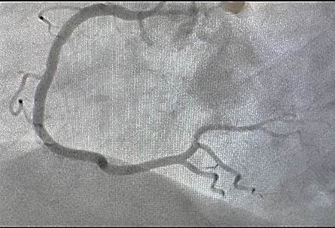

Fig. 3. The right coronary artery appeared angiographically normal

Table 1. Markis classification of coronary artery ectasia (Markis et al., 1976)

Types | Definition
Type 1 | Diffuse ectasia of two or three vessels
Type 2 | Diffuse ectasia in one vessel and localized disease in another
Type 3 | Diffuse ectasia in one vessel only
Type 4 | Localized and segmental involvement

Laboratory tests obtained 2 hours later showed markedly elevated troponin I levels (65,000 ng/L), indicative of myocardial necrosis. Other tests were within normal limits, including a lipid profile, inflammatory markers (C-reactive protein), and renal and hepatic function tests.

Transthoracic echocardiography (TTE) revealed segmental wall motion abnormalities in the lateral wall, with a preserved left ventricular ejection fraction (LVEF) of 56%.

Treatment included an intravenous infusion of tirofiban, a glycoprotein IIb/IIIa inhibitor, for 24 hours, along with Beta-blocker (metoprolol), angiotensin-converting enzyme (ACE) inhibitor (ramipril), and high-intensity statin therapy (atorvastatin 80 mg daily). Thromboaspiration was not performed due to the high risk of distal embolization, and the percutaneous intervention could not be performed due to the unavailability of adequate resources in our catheterization laboratory, and medical therapy was pursued as the primary treatment strategy.

The patient’s symptoms resolved within 24 hours of treatment initiation. During his hospitalization, he remained asymptomatic, and no complications, including arrhythmias or hemodynamic instability, were observed. He was discharged with a treatment plan including dual antiplatelet therapy (aspirin and clopidogrel), high-intensity statins, beta-blockers, and ACE inhibitors, along with smoking cessation counseling.

3. DISCUSSION

Managing STEMI in patients with coronary artery ectasia (CAE) requires a nuanced approach due to the unique structural and functional abnormalities associated with ectatic vessels. The dilated and irregular anatomy of ectatic arteries results in turbulent blood flow, endothelial dysfunction, and a prothrombotic state, increasing the risk of thrombus formation and distal embolization (Esposito et al., 2022, Mavrogeni, 2024). This predisposes patients to acute coronary syndromes (ACS), particularly STEMI, which complicates both diagnosis and management (Buleu et al., 2019).

3.1 Diagnostic Challenges

The diagnosis of CAE relies heavily on coronary angiography, which remains the gold standard for visualizing vessel morphology and identifying complications such as thrombosis or slow coronary flow (Esposito et al., 2022). Markis et al. proposed a classification of coronary artery ectasia based on the extent and number of involved coronary vessels (Markis et al., 1976). In this case, angiography confirmed type III CAE in the circumflex artery, with complete thrombotic occlusion causing STEMI. Advanced imaging techniques such as intravascular ultrasound (IVUS) and optical coherence tomography (OCT) provide insights into plaque morphology and thrombus burden, potentially guiding therapeutic decisions in complex cases (Mavrogeni, 2024, Maehara et al., 2001). Angiographic findings, including delayed contrast clearance and segmental backflow, are characteristic of ectatic vessels, aiding diagnosis (Buleu et al., 2019).

3.2 Interventional Limitations
The management of STEMI in CAE often diverges from standard protocols due to the increased risk of complications with interventional strategies. PCI, though a mainstay in STEMI treatment, poses challenges in ectatic arteries because large thrombi and irregular vessel walls heighten the risk of distal embolization and no-reflow phenomena (Esposito et al., 2022, Bogana Shanmugam et al., 2017). Recent studies, including Shousha et al., have identified the C-reactive protein to albumin ratio (CRP/albumin ratio) as a predictor of no-reflow after primary PCI in patients with STEMI and coronary artery ectasia (Shousha et al., 2020). While thromboaspiration has been proposed as an alternative approach for managing large thrombi, its role in CAE remains controversial. Studies have highlighted the potential for embolic complications, as observed in our case.

In this case, the decision to pursue medical management over PCI or thromboaspiration was influenced by resource limitations and the high thrombotic burden. However, the literature reports similar cases where therapeutic strategies vary according to available resources, with angioplasty or coronary artery bypass grafting sometimes being used (Ahmad et al., 2019). Pharmacologic stabilization using tirofiban, a glycoprotein IIb/IIIa inhibitor, played a pivotal role in reducing thrombus burden and mitigating distal embolization. Glycoprotein inhibitors effectively stabilize thrombotic occlusions, especially in patients with high-risk anatomy like ectatic vessels (Esposito et al., 2022, Baldi et al., 2022, Ozcan et al., 2015).
3.3 Pharmacologic Strategies
Pharmacologic therapy is the cornerstone of management for STEMI in CAE, particularly when interventional strategies are limited. Dual antiplatelet therapy (DAPT) with aspirin and clopidogrel forms the foundation for preventing recurrent thrombotic events, especially in acute thrombotic occlusions (Esposito et al., 2022, Kawsara et al., 2018, Khedr et al., 2021). High-intensity statin therapy is crucial for its anti-inflammatory and plaque-stabilizing effects, as it inhibits matrix metalloproteinase (MMP) activity and reduces vascular wall degradation, a key factor in CAE pathophysiology (Fan et al., 2020, Gülec et al., 2003).

Beta-blockers are frequently used to reduce myocardial oxygen demand and ischemic symptoms; however, their potential to exacerbate coronary vasospasm warrants careful patient selection. Calcium channel blockers are preferable in patients with significant vasospasm or slow coronary flow, as they enhance perfusion without the risk of unopposed alpha-adrenergic stimulation (Sorrell et al., 1998). While nitrates are commonly used for ischemic symptoms, they are generally contraindicated in CAE due to their potential to worsen ischemia in dilated arteries (Gülec et al., 2003, Sorrell et al., 1998).

3.4 Long-Term Management and Prognosis
While CAE itself progresses slowly, studies have shown that atherosclerotic lesions often worsen over time, leading to a higher risk of recurrence of myocardial infarction and angina (Sheikh et al., 2019, Liu et al., 2021). Smoking cessation is particularly important, as smoking exacerbates endothelial dysfunction and chronic inflammation, contributing to the progression of CAE.

The prognosis of CAE patients depends on several factors, including the extent of coronary artery involvement and the presence of additional risk factors. ​Close follow-up with serial imaging and functional testing is essential to monitor disease progression and prevent complications.
Despite advancements in understanding CAE, large-scale studies are needed to evaluate the efficacy of pharmacologic and interventional strategies in this unique population. The development of consensus guidelines for CAE management, particularly in acute settings like STEMI, remains an unmet need. Future research should also explore the role of novel agents, such as direct thrombin inhibitors and anti-inflammatory therapies, in mitigating thrombotic and inflammatory complications associated with ectatic arteries.

4. CONCLUSION

This case highlights the diagnostic challenges and therapeutic strategies in managing thrombotic complications of coronary artery ectasia. Early recognition via angiography and prompt initiation of antiplatelet and anticoagulant therapy are critical for favorable outcomes. Future studies should aim to standardize treatment protocols and explore novel therapies tailored to CAE pathophysiology.

DISCLAIMER (ARTIFICIAL INTELLIGENCE)

Author(s) hereby declare that NO generative AI technologies such as Large Language Models (ChatGPT, COPILOT, etc.) and text-to-image generators have been used during the writing or editing of this manuscript.

CONSENT

Informed written consent was obtained from the patient to publish their clinical data.

ETHICAL APPROVAL

As per international standards or university standards, written ethical approval has been collected and preserved by the authors.

COMPETING INTERESTS

Authors have declared that no competing interests exist.

REFERENCES

Ahmad, A., Roomi, S. S., Ullah, W., Ali, Z., & Hafez, A. (2019, November 11). A giant coronary artery ectasia successfully managed with coronary artery stenting [Abstract 11899]. Circulation. https://doi.org/10.1161/circ.139.suppl_1.11899
Antoniadis, A. P., Chatzizisis, Y. S., & Giannoglou, G. D. (2008). Pathogenetic mechanisms of coronary ectasia. International Journal of Cardiology, 130(3), 335–343. 10.1016/j.ijcard.2008.05.071.
Baldi, C., Rinaldi, A., Venetucci, R., Stabile, G., Masotti, L., Di Marco, F., ... & Rapacciuolo, A. (2022). Clinical outcome of patients with ST-elevation myocardial infarction and angiographic evidence of coronary artery ectasia. Catheterization and Cardiovascular Interventions, 99(2), 340–347. 10.1002/ccd.29738
Bogana Shanmugam, V., Psaltis, P. J., Wong, D. T. L., Meredith, I. T., Malaiapan, Y., & Ahmar, W. (2017). Outcomes after primary percutaneous coronary intervention for ST-elevation myocardial infarction caused by ectatic infarct related arteries. Heart, Lung and Circulation, 26(10), 1059–1068. 10.1016/j.hlc.2016.12.006
Buleu, F., Sirbu, E., Caraba, A., & Dragan, S. (2019). Heart involvement in inflammatory rheumatic diseases: A systematic literature review. Medicina (Kaunas), 55(6), 249. 10.3390/medicina55060249
Esposito, L., D'Ascenzo, F., Saglietto, A., De Filippo, O., Secco, G. G., Gili, S., ... & Moretti, C. (2022). Treatment and outcome of patients with coronary artery ectasia: Current evidence and novel opportunities for an old dilemma. Frontiers in Cardiovascular Medicine, 8, Article 805727. 10.3389/fcvm.2021.805727
Fan, C. H., Hao, Y., Liu, Y. H., Li, X. L., Huang, Z. H., Luo, Y., & Li, R. L. (2020). Anti-inflammatory effects of rosuvastatin treatment on coronary artery ectasia patients of different age groups. BMC Cardiovascular Disorders, 20, 1-9. https://pubmed.ncbi.nlm.nih.gov/32652935/
Gülec, S., Aras, Ö., Atmaca, Y., Akyürek, Ö., Hanson, N. Q., Sayin, T., ... & Oral, D. (2003). Deletion polymorphism of the angiotensin I converting enzyme gene is a potent risk factor for coronary artery ectasia. Heart, 89(2), 213-214. https://pubmed.ncbi.nlm.nih.gov/12527685/
Kawsara, A., Núñez Gil, I. J., Alqahtani, F., Moreland, J., Rihal, C. S., & Alkhouli, M. (2018). Management of coronary artery aneurysms. JACC: Cardiovascular Interventions, 11(13), 1211–1223. 10.1016/j.jcin.2018.02.041.
Khedr, A., Neupane, B., Proskuriakova, E., Jada, K., Kakieu Djossi, S., & Mostafa, J. A. (2021). Pharmacologic management of coronary artery ectasia. Cureus, September, Article 17832.
10.7759/cureus.17832.
Liu, R., Zhao, H., Gao, X., & Liang, S. (2021). Is coronary artery ectasia a progressive disease? A self-controlled retrospective cohort study. Frontiers in Cardiovascular Medicine, 8, Article 774597. 10.3389/fcvm.2021.774597.
Maehara, A., Mintz, G. S., Ahmed, J. M., Fuchs, S., Castagna, M. T., Pichard, A. D., ... & Leon, M. B. (2001). An intravascular ultrasound classification of angiographic coronary artery aneurysms. American Journal of Cardiology, 88(4), 365–370. 10.1016/s0002-9149(01)01680-0.
Markis, J. E., Joffe, C. D., Cohn, P. F., Feen, D. J., Herman, M. V., & Gorlin, R. (1976). Clinical significance of coronary arterial ectasia. American Journal of Cardiology, 37(2), 217–222. 10.1016/0002-9149(76)90315-5.
Mavrogeni, S. (2024). Coronary artery ectasia: Diagnosis and treatment. E-Journal of Cardiology Practice, 8. Retrieved November 30, 2024, from https://www.escardio.org/Journals/E-Journal-of-Cardiology-Practice/Volume-8/Coronary-artery-ectasia-diagnosis-and-treatment
Ozcan, O. U., Turak, O., Canpolat, U., Avci, S., Aydogdu, S., Tok, D., ... & Aras, D. (2015). Effect of diltiazem on coronary artery flow and myocardial perfusion in patients with isolated coronary artery ectasia and either stable angina pectoris or positive myocardial ischemic stress test. American Journal of Cardiology, 116(8), 1199–1203. 10.1016/j.amjcard.2015.07.033.
Sheikh, A. S., Hailan, A., Kinnaird, T., Choudhury, A., & Smith, D. (2019). Coronary artery aneurysm: Evaluation, prognosis, and proposed treatment strategies. Heart Views: The Official Journal of the Gulf Heart Association, 20(3), 101–108. 10.4103/HEARTVIEWS.HEARTVIEWS_1_19
Shousha, M., Elbarbary, Y., Khalfallah, M., & Eldin, S. S. (2020). C-reactive protein to albumin ratio versus coronary artery ectasia as predictors of no-reflow after primary percutaneous coronary intervention for patients presenting with ST segment elevation myocardial infarction. Journal of Advances in Medicine and Medical Research, 32(20), 85–96.
Sorrell, V. L., Davis, M. J., & Bove, A. A. (1998). Current knowledge and significance of coronary artery ectasia: A chronologic review of the literature, recommendations for treatment, possible etiologies, and future considerations. Clinical Cardiology, 21(3), 157–160. 10.1002/clc.4960210304.

Disclaimer/Publisher’s Note: The statements, opinions and data contained in all publications are solely those of the individual author(s) and contributor(s) and not of the publisher and/or the editor(s). This publisher and/or the editor(s) disclaim responsibility for any injury to people or property resulting from any ideas, methods, instructions or products referred to in the content.

© Copyright (2025): Author(s). The licensee is the journal publisher. This is an Open Access article distributed under the terms of the Creative Commons Attribution License (http://creativecommons.org/licenses/by/4.0), which permits unrestricted use, distribution, and reproduction in any medium, provided the original work is properly cited.

