Case report

Gastric Necrosis with perforation following Accidental Acid Ingestion in a toddler: A Rare Case Report
.
ABSTRACT

Accidental ingestion of corrosive substances is common in developing countries in paediatric age group and can result in severe gastrointestinal injuries and lifelong morbidities. Corrosive ingestion can cause progressive and irreversible damage to the upper gastrointestinal tract, with complications ranging from superficial mucosal burns to life-threatening full-thickness necrosis and perforation which eventually can lead to death. While esophageal strictures are a well-documented long-term sequela, acute gastric perforation with necrosis remains a rare and particularly fatal complication that requires high clinical suspicion and immediate surgical management. We present the case of a 4 year old boy with accidental ingestion of toilet cleaning acid, managed successfully with emergency laparotomy with distal gastrectomy with stump closure of duodenum with retrocolic gastrojejunostomy with feeding jejunostomy.

Keywords: gastric perforation, gastric necrosis, acid ingestion, gastrectomy, case report

1. INTRODUCTION

Accidental ingestion of poisoning agent is the most common cause of poisoning in children under the age of 18 in all age groups [1]. Corrosive ingestion in the paediatric population remains a significant cause of morbidity due to their exploratory behavior and inability to distinguish between hazardous substances and non-hazardous substances [2,3], often due to accidental ingestion of household cleaning agents stored in accessible, inadequately labelled containers like empty soft drink bottles. Nearly 60-80% of cases comprises of children under 5 years of age [4]. Acids typically causes coagulative necrosis and subsequent scarring, while Alkali acts by liquefactive necrosis through saponification and causes more tissue damage. Oesophagus is more commonly affected leading to mucosal ulcerations and stricture formation. Gastric injury is less common, acute gastritis and pylorospasm causing gastric outlet obstruction being common among them [5]. Although, majority of corrosive ingestion cases in children result in mild to moderate injuries, severe complications such as gastric perforation, necrosis, and peritonitis can occur, with large-volume ingestion or delayed hospital presentation [6]. Gastric perforation with necrosis is very rare in paediatric population with very high mortality, reaching upto 30% [7,8,9].

2. Case presentation

A 4 year old male patient was brought to the emergency 1 day after accidental ingestion of toilet cleaning acid with complaints of repeated episodes of vomiting, abdominal pain and progressive abdominal distension. There was no history of any chronic illness or any relevant family history. On examination patient was dehydrated with vitals, HR: 142/min, BP: 88/55 mmHg, RR: 30/min, SpO2: 96% on RA. There were no signs of external injury near mouth or on lips, patchy areas of erythema were present on buccal mucosa. Patient was not able to take orally due to pain and repeated episodes of vomiting. On Per abdomen examination abdomen was distended with generalized guarding and tenderness was present and bowel sounds were absent on auscultation. He was resuscitated and investigations were sent.
CBC: Hb: 9.7 g/dl, WBC: 19,200/mm³
ABG: Metabolic acidosis with respiratory compensation
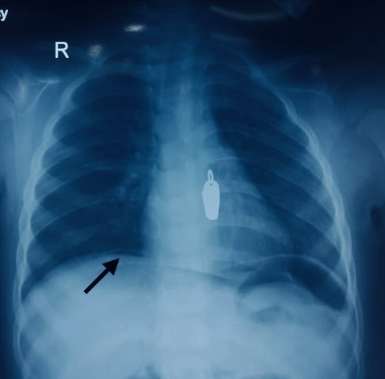
Chest x-ray suggestive of pneumoperitoneum [free gas under diaphragm (Figure 1)]
- Figure 1. Chest x-ray showing free gas under right dome of diaphragm
After resuscitation patient was taken up for emergency laparotomy under general anesthesia. Per op findings revealed: ~300 cc bile mixed peritoneal fluid came out stat on opening abdomen, 2*1 cm perforation near pylorus with gangrene of the pylorus (Figure 2 and 3) and gastroduodenal junction (Figure 4) with necrotic gastric mucosa at pylorus and gastroduodenal junction (Figure 5).
Distal gastrectomy with stump closure of duodenum with retrocolic gastrojejunostomy with feeding jejunostomy was done with drain placement at anastomosis site and in pelvis. Patient was extubated and shifted to HDU.
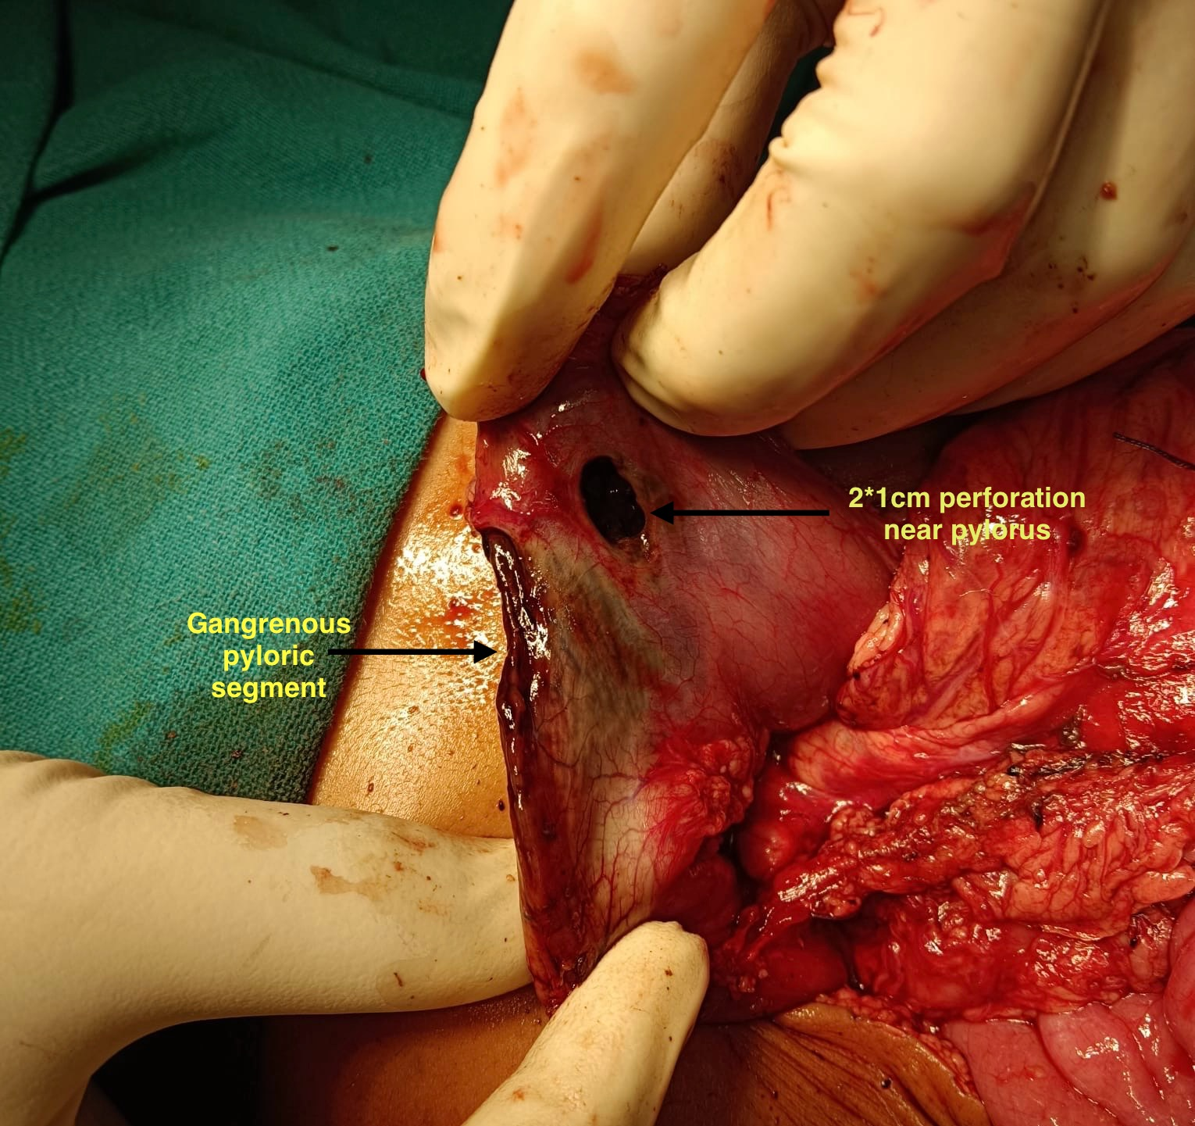
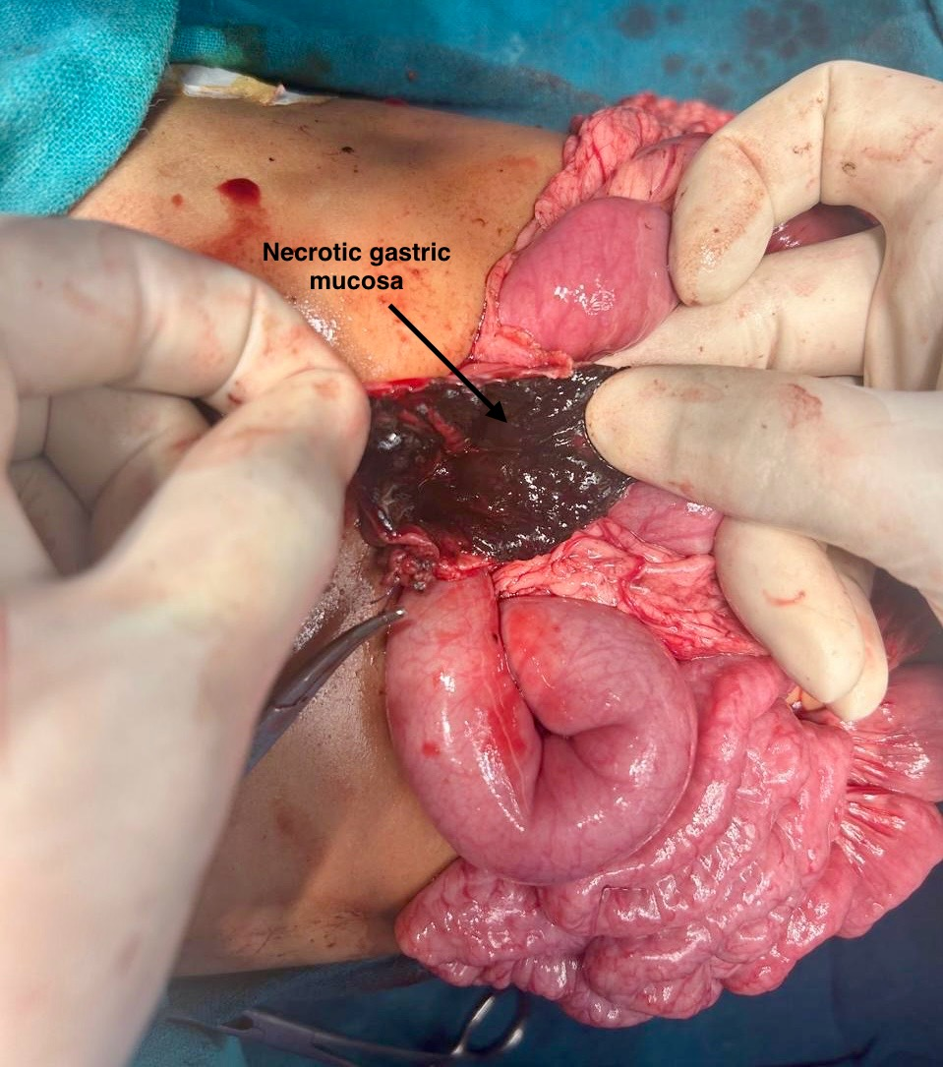
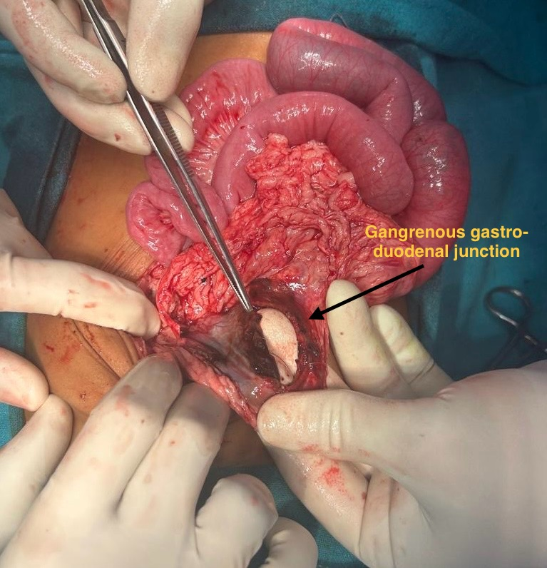
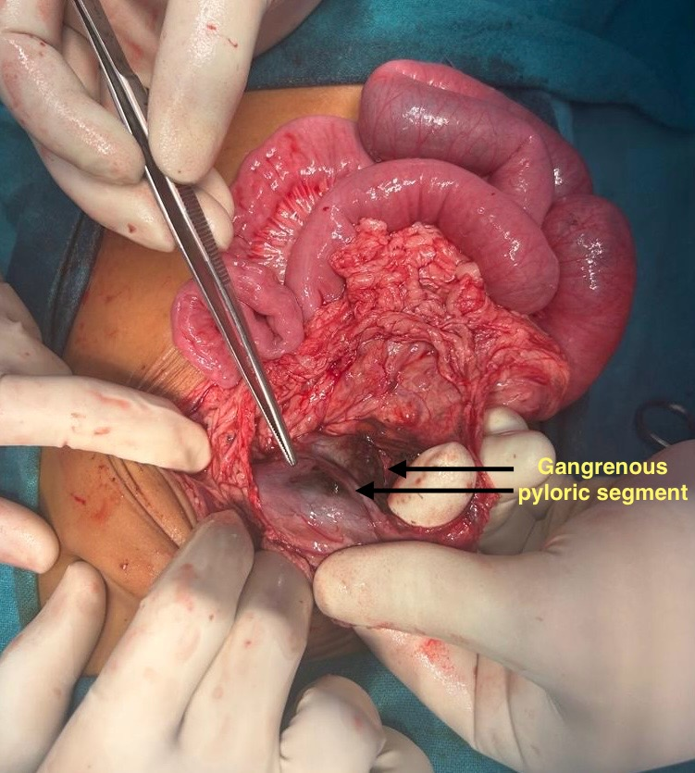
- Figure 2. Showing Perforation near pylorus and gangrenous pyloric segment
- Figure 5. Showing necrotic Gastric mucosa
- Figure 4. Showing gangrenous Gastro-duodenal junction
- Figure 3. Showing gangrenous pyloric segment
Post operatively patient was managed with IV antibiotics, PPI’s and antiemetics. Patient was given oral feeds from 6th post operative day, drains were removed on 7th(Pelvic) and 9th(Anastomotic site) post operative day and patient was discharged in stable condition on 10th post operative day. Feeding jejunostomy was removed after 6 weeks. At 3 months follow-up, patient had normal oral intake and adequate weight gain.

3. discussion

Although corrosive ingestion commonly leads to oesophageal injuries, gastric involvement can occur due to pooling of the corrosive agent in the dependent portion of the stomach. Necrosis is often seen in the antrum or greater curvature, where contact time is prolonged [10].
The clinical presentation may vary and it might be with non-specific symptoms like abdominal pain, vomiting, hematemesis and refusal of oral feeds which can progress to peritonitis, shock, sepsis and multiorgan failure. Choice of surgical procedure depend on the intraoperative findings [11], in patients with limited necrosis wedge resection or primary repair can be done but in patients with extensive involvement partial or total gastrectomy is necessary. Gün et al. in 2002 described a child requiring total gastrectomy following extensive necrosis of stomach post acid ingestion [7]. Agrawal et al. in 2021 reported two cases post acid ingestion with gastric perforation and extensive necrosis of stomach, one required sleeve gastrectomy and another total gastrectomy [8]. Roopeshwar and Meena in 2025 reported a fatal paediatric case post acid ingestion in which autopsy revealed full-thickness gastric perforation with extensive necrosis [12]. Sati et al. in 2024 described similar black necrotic gastric mucosa in adults following hydrochloric acid ingestion [10].
Management requires rapid resuscitation, early diagnosis with timely surgical intervention.
Postoperative morbidity is significant, with potential complications including sepsis, anastomotic leak, nutritional deficiencies, and long-term sequelae such as gastric outlet obstruction or stricture formation requiring long term follow up of the patient.

4. Conclusion

Early recognition and timely surgical management in a case of gastric perforation with necrosis due to corrosive ingestion is crucial in preventing mortality. Raising awareness among general public regarding safe storage and the risks of household corrosives, recognizing early signs of ingestion is essential to prevent such catastrophic injuries in children.

Consent

All authors declare that ‘written informed consent was obtained from the patient (or other approved parties) for publication of this case report and accompanying images.

Ethical approval

Ethical clearance was obtained from the institutional ethics committee.

Disclaimer (Artificial intelligence)
Author(s) hereby declare that NO generative AI technologies such as Large Language Models (ChatGPT, COPILOT, etc.) and text-to-image generators have been used during the writing or editing of this manuscript.

References

- Qureshi AS, Zafar F, Waseem M, Taimor M, Sobia. Risk factors and outcome of acute poisoning in childrens. Asian J Med Health. 2021 Jun 26;19(6):36–44.
- Alaqeli E, Elzwai S, Atia A, Ahmed F, Abuagela M, Alwaseea N, et al. Epidemiological profile of accidental poisoning in children, retrospective study at Benghazi Children’s Hospital, Libya, 2021. Asian J Pediatr Res. 2023;13(4):125–32.
- Raza A, Hakeem M, Zaheer H, Samreen S, Naz F, Afroze B. Factors affecting accidental toxic ingestion among children younger than 5 years. Pak J Med Health Sci. 2022;16(9):795.
- Sarma MS, Tripathi PR, Arora S. Corrosive upper gastrointestinal strictures in children: Difficulties and dilemmas. World J Clin Pediatr. 2021;10(6):124–36.
- Ozcan C, Ergün O, Sen T, Mutaf O. Gastric outlet obstruction secondary to acid ingestion in children. J Pediatr Surg. 2004 Nov;39(11):1651-3.
- Almajed M, Albarrak Y, Aldosari W, Alkhormi M, Alawfi A, Islam H. Post corrosive ingestion in pediatrics; precaution and awareness; retrospective hospital-based study. Medical Science. 2024;28:e15ms3295.
- Gün F, Abbasoğlu L, Celik A. Acute gastric perforation after acid ingestion. J Pediatr Gastroenterol Nutr. 2002;35(3):360-362.
- Agrawal H, Krishnegowda U, Gupta N, et al. Accidental ingestion of acid corrosive agent causing gastric perforation—a rare two case series. Hellenic J Surg. 2021;92(3):189-191.
- Wang K, Cai S, He L, et al. Pediatric gastric perforation beyond neonatal period: 8-year experience with 20 patients. Pediatr Neonatol. 2019;60(6):634–40.
- Sati WO, Abdow M, Sabir DM, et al. Acute gastric necrosis induced by caustic substance ingestion: a case report. Cureus. 2024;16(11):e74719.
- El-Asmar KM, Allam AM. Surgical management of corrosive-induced gastric injury in children: 10years' experience. J Pediatr Surg. 2018 Apr;53(4):744-747
- Roopeshwar, Meena MC. Swallowed danger: a case report of accidental acid ingestion in a child. Asia Pac J Med Toxicol. 2025;14(2):75-78.

