TUMOR MIMICKING SMALL BOWEL MASS: A

CASE REPORT

.

ABSTRACT

|  |
| --- |
| **Aims:**  This report aims to highlight the diagnostic challenges posed by pseudo-tumoral lesions mimicking malignancy in elderly patients presenting with small bowel obstruction (SBO), and to emphasize the importance of histopathological confirmation in guiding appropriate management.  **Presentation of Case:**  An 85-year-old woman with no history of prior abdominal surgery presented with epigastric pain, vomiting, and signs of intestinal obstruction. Laboratory findings showed elevated inflammatory markers. Imaging suggested SBO due to adhesions. However, clinical deterioration with hypotension prompted urgent exploratory laparotomy, revealing a 3 × 4 cm small bowel mass and a 1 × 2 cm mesenteric lymph node. An oncologic resection with manual end-to-end anastomosis was performed. Surprisingly, histopathology showed nonspecific inflammatory thickening with no evidence of malignancy.  **Discussion:**  While SBO in elderly patients commonly results from adhesions or neoplasms, inflammatory pseudo-tumoral lesions can mimic malignancy both clinically and radiologically. These lesions may stem from chronic inflammation or infection, and are indistinguishable from true neoplasms on imaging. In such cases, intraoperative findings often necessitate resection to exclude malignancy, as preoperative differentiation remains limited.  **Conclusion:**  Pseudo-tumoral inflammatory lesions are rare but important differential diagnoses in SBO. Surgical exploration and histopathological analysis are essential for accurate diagnosis. Awareness of these entities can prevent unnecessary oncologic treatment, particularly in elderly patients with nonspecific presentations. |

*Keywords: Small bowel obstruction, Inflammatory pseudotumor; Diagnostic challenge, Non-neoplastic mass*

1. INTRODUCTION

Small bowel obstruction (SBO) in elderly patients is often attributed to adhesions, hernias, or neoplasms. Occasionally, non-neoplastic lesions can present as mass-like formations, clinically and radiologically mimicking tumors, leading to diagnostic uncertainty [1,2]. Such pseudo-tumoral presentations pose a significant challenge, as they may lead to unnecessary concern for malignancy [3]. Accurate diagnosis, often requiring surgical exploration and histopathological examination, is crucial to guide appropriate management and avoid overtreatment.[4]

In recent years, increasing attention has been directed toward rare mimickers of malignancy in gastrointestinal pathology. These pseudo-tumoral lesions—often inflammatory or infectious in nature—can radiologically simulate tumours, making preoperative differentiation particularly challenging. This diagnostic ambiguity is heightened in elderly populations, where imaging findings are often nonspecific, and clinical signs may be blunted. Thus, a high index of suspicion is necessary to avoid misdiagnosis and unnecessary oncologic interventions.[5]

2. PRESENTATION OF CASE

We present the case of an 85-year-old woman with a history of hypertension, currently treated. Underwent a thyroidal right isthmic lobectomy 15 years ago. Patient presents no history of prior abdominal surgery. History of illness goes back 3 days prior to admission in our care, with the onset of epigastric pain and vomiting as well as an obstructive syndrome.

Physical examination reveals an initially stable patient with a slightly distended abdomen as well as epigastric tenderness.

We performed biological tests, that showed White Blood Cells at 25,000 /mm³ and CRP levels at 250 UI/L. Rest of biological exams were within the normal range.

A plain abdominal X-ray was performed and revealed small bowel-type air-fluid levels, which justified an abdominal CT scan that confirmed a small bowel obstruction due to adhesions. **[Fig.1]**

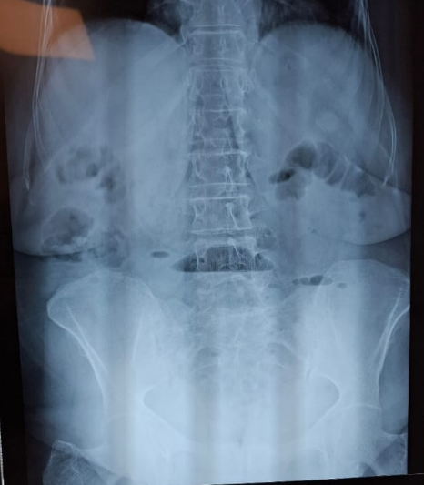

**Fig. 1:** plain abdominal X-ray showing bowel-type air-fluid levels

Patient installed a hypotension (75/43 mmHg) a few hours within admission, which, despite radiological findings in CT-abdominal scan, prompted the decision to perform an urgent exploratory laparotomy.

Exploratory laparotomy revealed a suspicious small bowel mass located 1.80 meters distal to the first jejunal loop, responsible for the intestinal obstruction. The mass measured approximately 3 × 4 cm macroscopically. Associated with the mass was a suspicious mesenteric lymph node measuring 1 × 2 cm. **[Fig. 2]** A decision was made to perform an oncologic resection of the mass and the lymph node. A manual end-to-end resection-anastomosis was carried out. **[Fig.3]**

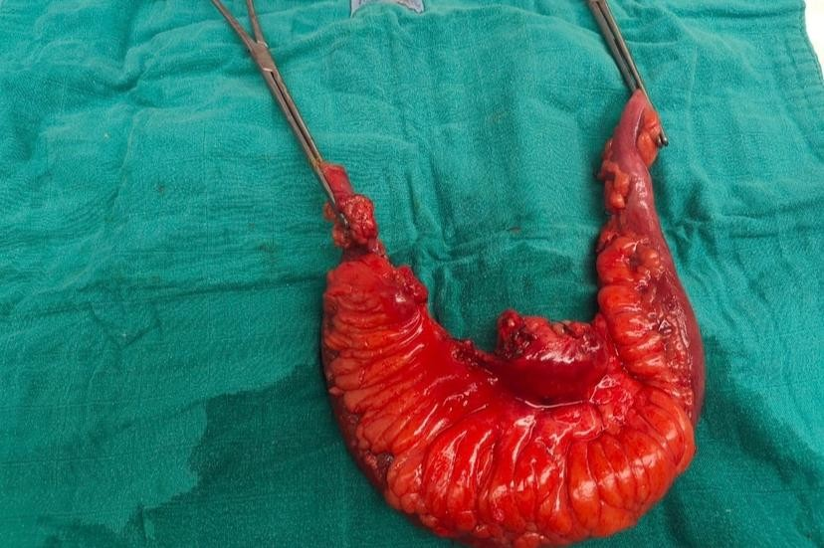

**B**

**A**

**Vascular blush**

**D**

**C**

**Fig. 2: Macroscopic view of the resected specimen (arrow: mesenteric lymph node)**

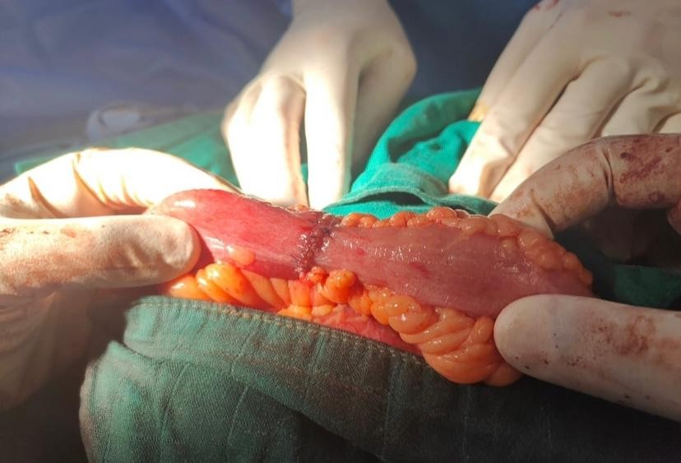

.

**Fig. 3** End-to-end manual resection anastomosis

The postoperative course was uncomplicated. To our great surprise, histopathological analysis revealed a nonspecific inflammatory thickening of the small bowel wall. Postoperative investigations were unremarkable

3. DISCUSSION

Small bowel obstruction (SBO) in elderly patients is a common but challenging clinical scenario, often caused by postoperative adhesions, hernias, or neoplasms. Tumors are a significant concern in this population due to their relatively high prevalence and potential severity [5]. However, as illustrated by this case, not all masses causing SBO are malignant; some may represent non-neoplastic inflammatory lesions that mimic tumors both clinically and radiologically. This pseudo-tumoral presentation can complicate diagnosis and management, particularly in elderly patients.[5]

Elderly patients frequently present with atypical or subtle symptoms, which can delay diagnosis and treatment. In this case, the patient exhibited classic obstructive symptoms—epigastric pain, vomiting, and radiological signs of obstruction—but imaging initially suggested adhesions as the cause. Intraoperatively, a suspicious small bowel mass and an adjacent mesenteric lymph node were found, raising concern for malignancy and leading to an oncologic resection.

In such situations, surgeons often opt for wide resection to ensure oncologic safety, especially in elderly patients where a malignant etiology is strongly suspected. Nevertheless, histopathological analysis revealed only nonspecific inflammatory thickening without evidence of tumor, highlighting the diagnostic challenges of differentiating between inflammatory pseudotumors and true neoplasms based on imaging and gross appearance alone [7,8]. Inflammatory pseudotumors may arise from chronic inflammatory reactions, infections, or autoimmune processes, though in this case, no specific underlying cause was identified.[9]

Various types of lesions can mimic malignancy in small bowel obstruction. Inflammatory pseudotumors are well-documented causes and may result from infections, prior surgeries, or autoimmune conditions. These lesions can grow to significant sizes and may provoke desmoplastic reactions, making them indistinguishable from neoplasms both radiologically and intraoperatively. Another important differential includes foreign body granulomas, especially in patients with prior abdominal interventions, where retained surgical materials may induce mass-forming inflammatory responses. [4]

Other non-neoplastic causes include endometriosis (particularly in younger women), xanthogranulomatous inflammation, and infectious granulomas such as those seen in tuberculosis or Yersinia enterocolitica infections. Rarely, ischemic bowel segments with associated transmural fibrosis may also mimic mass lesions. In elderly patients with a history of cancer, metastatic disease must also be considered, although primary or secondary malignancy is more often suspected based on systemic symptoms or oncologic history. [7]

The management of these pseudo-tumoral lesions is complex. The primary challenge lies in the preoperative diagnosis, as imaging modalities, although advanced, may not reliably distinguish inflammatory masses from malignancies. Thus, exploratory laparotomy remains the definitive diagnostic and therapeutic approach, especially in cases with clinical deterioration or hemodynamic instability, as seen here with the patient’s hypotension. [10]

A systematic review by Rami Reddy and Cappell [11] emphasizes the diagnostic complexity in SBO, especially when imaging fails to provide a definitive etiology. They note that up to 20% of SBO cases require surgical exploration for diagnosis, with some mimicking neoplasms but proving to be inflammatory or fibrotic in origin.

Therefore, clinicians must remain aware of these pseudo-tumoral entities and integrate clinical, radiological, and intraoperative findings with histopathological evaluation to reach an accurate diagnosis. Preoperative tissue diagnosis may not always be feasible, but a cautious approach toward interpreting suspicious lesions in elderly patients can avoid overtreatment.

This case underscores the importance of multidisciplinary collaboration between surgeons, radiologists, and pathologists to optimize patient management and avoid unnecessary oncologic treatments. Histological confirmation is crucial before initiating further oncologic therapies, particularly in elderly and frail patients where the risk-benefit ratio must be carefully considered.

**4. CONCLUSION**

In conclusion, although clinical and radiological findings may suggest malignancy in cases of SBO with mass formation, non-neoplastic inflammatory lesions must be considered in the differential diagnosis. Awareness of such entities can prevent overtreatment and guide appropriate management based on definitive pathology.

Consent

As per international standard or university standard, patient written consent has been collected and preserved by the authors.

Ethical approval

As per international standard or university standard written ethical approval has been collected and preserved by the authors.

Authors’ Contributions

Author MO designed the study as well as collected the data. Author YOT and ABEA wrote the first draft. Author FZB and Author YZK managed the literature searches and overall supervision. All authors read and approved the final manuscript.

Disclaimer (Artificial intelligence)

Author(s) hereby declare that Large Language Models **(GPT-4.1 mini)** have been used during the writing or editing of this manuscript. Main usage has been in order to properly translate medical terminology from author’s original scientific language (French) into English.

References

1. Hwang, F., Crandall, M., Smith, A., Parry, N., & Liepert, A. E. (2023). Small bowel obstruction in older patients: challenges in surgical management. *Surgical Endoscopy*, *37*(1), 638-644.
2. Rosa, F., Covino, M., Fransvea, P., Quero, G., Pacini, G., Fiorillo, C., ... & Alfieri, S. (2022). Management of Small Bowel Obstruction (SBO) in older adults (> 80 years): a propensity scorematched analysis on predictive factors for a (un) successful non-operative management (NOM). *European Review for Medical & Pharmacological Sciences*, *26*(19).
3. Li, R., Quintana, M. T., Lee, J., Sarani, B., & Kartiko, S. (2024). Timing to surgery in elderly patients with small bowel obstruction: an insight on frailty. *Journal of Trauma and Acute Care Surgery*, *97*(4), 623-630.
4. Perrone, G., Papagni, V., Giuffrida, M., Pattonieri, V., Tarasconi, A., & Catena, F. (2021). Small Bowel Obstructions in the Elderly. In *Emergency General Surgery in Geriatrics* (pp. 285-297). Cham: Springer International Publishing.
5. Ahmed M, Buti YJ, Bawahab A, Ghaly H, Elsayed R. Small Bowel Obstruction as a Result of Inflammatory Pseudotumor. Cureus. 2022 Sep 2;14(9):e28707. doi: 10.7759/cureus.28707. PMID: 36204020; PMCID: PMC9527131.
6. Abdominal inflammatory myofibroblastic tumor. Groenveld RL, Raber MH, Oosterhof-Berktas R, Eijken E, Klaase JM. Case Rep Gastroenterol. 2014;8:67–71.
7. Fever of unknown origin as a presentation of gastric inflammatory myofibroblastic tumor in a two-year-old boy. Cho MY, Min YK, Kim NR, et al. J Korean Med Sci. 2002;17:699–703. - PMC – PubMed
8. Perrone, G., Giuffrida, M., Papagni, V., Pattonieri, V., Tarasconi, A., & Catena, F. (2021). Management of acute large bowel obstruction in elderly patients. In *Emergency General Surgery in Geriatrics* (pp. 349-360). Cham: Springer International Publishing.
9. Hussein, A., Arena, A., Yu, C., Cirilli, A., & Kurkowski, E. (2021). Abdominal Pain in the Elderly Patient: Point-of-care Ultrasound Diagnosis of Small Bowel Obstruction. *Clinical Practice and Cases in Emergency Medicine*, *5*(1), 127.
10. González-Arestizábal, T., Morales, Á., Avayú-Zaliasnik, T., Csendes, A., Korn, O., & Figueroa-Giralt, M. (2024). Clinical and surgical dilemmas in octogenarian patients with small bowel obstruction. *ABCD. Arquivos Brasileiros de Cirurgia Digestiva (São Paulo)*, *37*, e1801.
11. Rami Reddy, S. R., & Cappell, M. S. (2017). A systematic review of the clinical presentation, diagnosis, and treatment of small bowel obstruction. Current gastroenterology reports, 19(6), 28. https://link.springer.com/article/10.1007/s11894-017-0566-9