Case report
ACUTE APPENDICITIS DURING PREGNANCY: A
CASE REPORT

.
ABSTRACT

Aim:
Appendicitis during pregnancy is an uncommon but potentially life-threatening condition for both the mother and fetus. Its clinical presentation is often atypical, making timely diagnosis particularly challenging. Accurate imaging and early intervention are crucial to avoid serious complications.
Presentation of Case:
We report the case of a 20-year-old primigravida at 15 weeks and 5 days of gestation who presented with right iliac fossa pain, fever, and elevated inflammatory markers. Initial ultrasound revealed a right lateral and retro-uterine collection, but it was inconclusive in distinguishing between a tubal abscess and an appendiceal abscess. Given the diagnostic uncertainty, an MRI without gadolinium was performed. The MRI demonstrated an inflamed, distended appendiceal tip within the collection, confirming the diagnosis of an appendiceal abscess.
Discussion:
This case highlights the diagnostic limitations of ultrasound in pregnancy and underscores the value of MRI as a safe and effective imaging modality when appendicitis is suspected. A prompt appendicectomy with abscess drainage was performed, resulting in a favorable maternal recovery and continued fetal viability.
Conclusion:
A high index of suspicion, appropriate use of MRI, and early surgical management are essential for achieving optimal outcomes in pregnant patients with suspected appendicitis.

Keywords: Appendicitis, Pregnancy, MRI, Appendiceal abscess

1. INTRODUCTION

Appendicitis during pregnancy is a rare but serious condition that can pose risks to both mother and fetus. It often presents with atypical symptoms, making diagnosis challenging. Prompt recognition and treatment are essential to avoid complications. Understanding its signs and management is crucial for ensuring maternal and fetal health. [1]
The incidence of appendicitis in pregnancy is estimated at approximately 0.05% to 0.13%, with the highest occurrence in the second trimester. Despite its rarity, it remains the leading cause of non-obstetric surgical intervention during gestation. Delayed diagnosis significantly increases the risk of perforation and fetal loss, underscoring the importance of timely imaging and surgical evaluation in any pregnant patient presenting with acute abdominal pain. [6]

2. PRESENTATION OF CASE

We present here the case of 20-years-old patient with no past medical history. Patient is G1P0, current pregnancy estimated at 15 weeks + 5 days of gestation. History of present illness dates back to 3 days prior to consultation in the emergency department in the Maternity’s Emergency department with the onset of right iliac fossa pain radiating to the hypogastric region, associated with dysuria and fever.
Physical exam revealed a guarding in the right iliac fossa as well as fever measured at 38.3 ֯C. We performed biological tests that showed a WBC at 21,000 /mm³ as well as a CRP level at 171 UI/L. Rest of biological exams were within the normal range.

Patient performed a pelvic ultrasound that showed a right lateral and retro-uterine collection. On one hand, this collection envelops the right adnexa, with a thickened appearance of the tubal wall containing echogenic material, while the ovary retains a normal morphology. On the other hand, the tip of the appendix is in contact with the collection, but its proximal portion remains of normal size. Additionally, the examination reveals a gravid uterus containing a single, viable fetus estimated at 15 weeks of gestation, with a positive cardiac activity. [Fig.1,2,3]

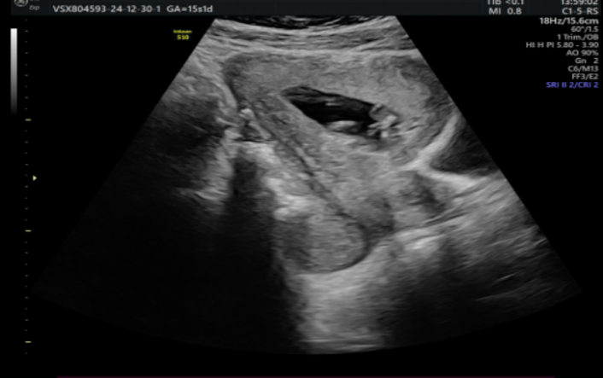
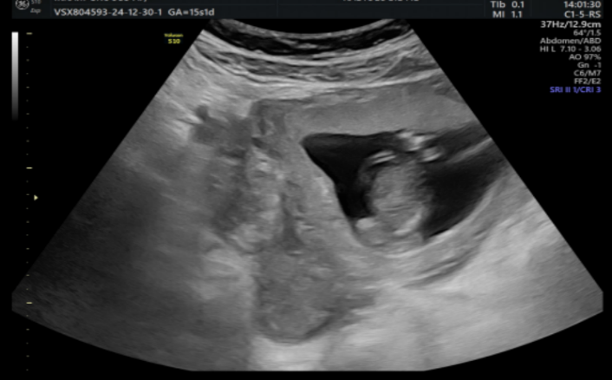

Fig. 1: Axial and coronal views demonstrating a right lateral and retro-uterine collection, as well as a gravid uterus containing a viable pregnancy.
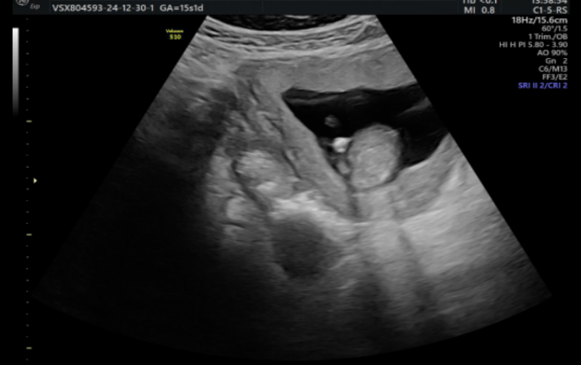
Vascular blush

D

Fig. 2: Axial view showing the tip of the appendix in contact with the collection. (arrow)

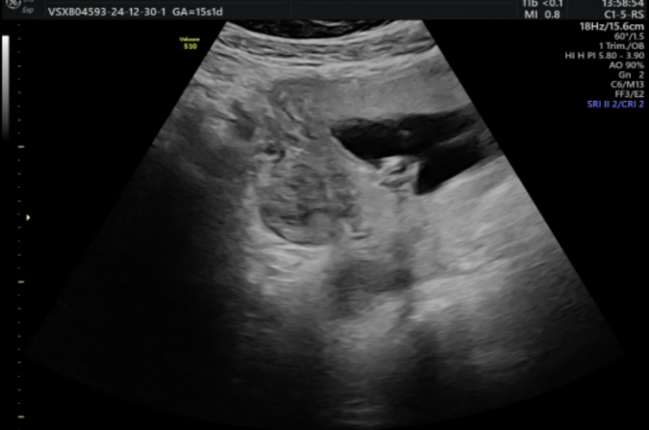

Fig. 3: Ultrasound view showing the right adnexa with a thickened tubal wall and echogenic content.

Due to the difficulty in establishing a definitive diagnosis between a tubal abscess and an appendiceal abscess, it was decided to perform an MRI.

An MRI was performed without Gadolinium injection, revealing a right lateral uterine collection extending posteriorly and inferiorly toward the pouch of Douglas. This collection displays a heterogeneous content, with low T1 signal and high T2 signal intensity, containing areas of low T2 signal. It shows restricted diffusion with low ADC values and includes a blind-ended structure within it.
The appendix is lateral to the cecum, with a descending pelvic course. Its proximal portion retains a normal caliber, measuring up to 6 mm, while its distal tip is swollen, reaching a caliber of up to 18 mm and coming into contact with the right lateral uterine collection. This collection is adjacent to the right ovary, the fallopian tube, and some adjacent small bowel loops.
Additionally, there is significant pelvic fat infiltration associated with reactive lymph nodes which orientated the diagnosis of appendiceal abscess. [Fig. 4,5]
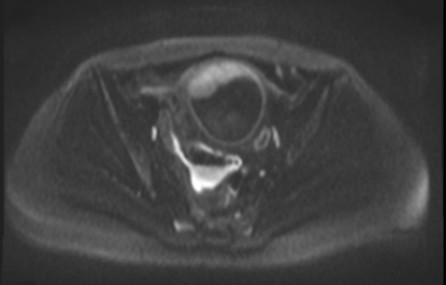
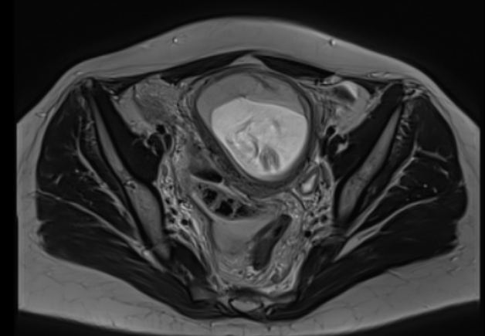

Fig. 4: Axial T2- and restricted diffusion images showing a lateral and retro-uterine collection with heterogeneous content, appearing to contain a blind-ended digestive structure.

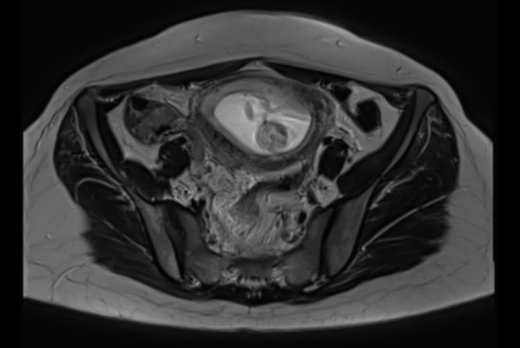

Fig. 5: Axial T2-weighted image showing the proximal portion of the appendix. (arrow)

Patient benefited from large spectrum antibiotics.
Decision for surgical appendicectomy was made. After a Mcburney incision, surgical exploration revealed appendicitis with a suppurative tip, and the associated abscess was located in the recto-uterine pouch. Appendicectomy as wel as Irrigation and drainage were performed. Post-surgery echography revealed a viable fetus. [Fig. 6]

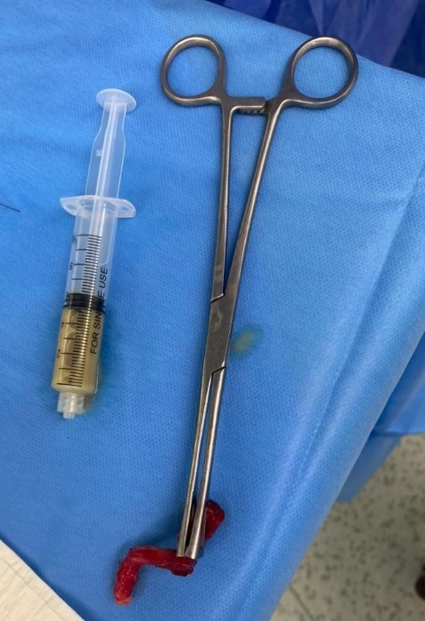

Fig. 6: Macroscopic view of the resected appendix and pus aspirated

The patient was discharged on the fifth day post-surgery with no further complications.

3. DISCUSSION

Acute appendicitis during pregnancy is the most common non-obstetric surgical emergency, though it remains rare, particularly in the second trimester. Diagnosis is often delayed due to overlapping symptoms with normal pregnancy and anatomical changes that shift the appendix upward as the uterus enlarges. [2]

In this case, the patient presented with right iliac fossa pain, fever, and elevated inflammatory markers, which raised suspicion for an intra-abdominal infection. However, imaging findings suggested both a possible tubal abscess and an appendiceal abscess, complicating the diagnosis.

Ultrasound, though non-invasive and first-line in pregnancy, had limited specificity in differentiating between tubo-ovarian pathology and appendicitis. MRI, which is safe during pregnancy when performed without gadolinium, proved to be crucial for confirming the diagnosis by demonstrating a distended, inflamed appendiceal tip in contact with the collection, consistent with an appendiceal abscess. [3,4]
Additionally, this case illustrates the diagnostic ambiguity that can arise due to overlapping sonographic features of pelvic infections. Tubo-ovarian abscesses and appendiceal abscesses may both present as adnexal masses, especially when the appendix is displaced by the gravid uterus. A multidisciplinary approach, involving radiologists, obstetricians, and surgeons, is essential to navigate such complexity and ensure both maternal and fetal safety. [7-11]
Prompt surgical intervention is critical to reduce the risk of rupture, peritonitis, and fetal loss.[5]
This case highlights the importance of maintaining a high index of suspicion for appendicitis in pregnant patients with abdominal pain, and underscores the utility of MRI when ultrasound findings are inconclusive. Early diagnosis and appropriate surgical management allowed for a favorable maternal and fetal outcome.

4. Conclusion

Appendicitis during pregnancy requires a high index of suspicion due to atypical presentations. MRI is a valuable diagnostic tool when ultrasound is inconclusive, enabling accurate diagnosis without radiation risk. Early surgical management is essential to prevent complications and ensure favorable maternal and fetal outcomes.

Consent

As per international standard or university standard, patient written consent has been collected and preserved by the authors.
AUTHORS’ CONTRIBUTIONS
Author MO designed the study as well as collected the data. Author YOT and AC wrote the first draft. Author HR designed the radiological part of the article. Author FZB and Author YZK managed the literature searches and overall supervision. All authors read and approved the final manuscript.”

Ethical approval

As per international standard or university standard written ethical approval has been collected and preserved by the authors.
Disclaimer (Artificial intelligence)

Author(s) hereby declare that Large Language Models (GPT-4.1 mini) have been used during the writing or editing of this manuscript. Main usage has been in order to properly translate medical terminology from author’s original scientific language (French) into English.

References

- Silva, H. R. Kumar, & Soma, M. (2023). Acute Appendicitis in Pregnancy – Current Management (Review Article). Asian Journal of Medicine and Health, 21(10), 69–75. https://doi.org/10.9734/ajmah/2023/v21i10879Gluszek
- Courtney A. Woodfield, Elizabeth Lazarus, Karen C. Chen, and William W. Mayo-Smith, Abdominal Pain in Pregnancy: Diagnoses and Imaging Unique to Pregnancy—Review, Volume 194, Issue 6_supplement, https://doi.org/10.2214/AJR.07.7139
- Konrad J, Grand D, Lourenco A. MRI: first-line imaging modality for pregnant patients with suspected appendicitis. Abdom Imaging. 2015 Oct;40(8):3359-64. doi: 10.1007/s00261-015-0540-7. PMID: 26338256.JA
- Israel GM, Malguria N, McCarthy S, Copel J, Weinreb J. MRI vs. ultrasound for suspected appendicitis during pregnancy. J Magn Reson Imaging. 2008 Aug;28(2):428-33. doi: 10.1002/jmri.21456. PMID: 18666160.
- Management of Complicated Appendicitis during Pregnancy: A Nationwide Analysis. Scientific Forum, American College of Surgeons Clinical Congress 2020, October 3-7, 2020.
- Abbasi N, Patenaude V, Abenhaim HA. Management and outcomes of acute appendicitis in pregnancy—population-based study of over 7,000 cases. BJOG. 2014;121(12):1509–14. doi:10.1111/1471-0528.12707
- Pedrosa I, Zeikus EA, Levine D, et al. MR imaging evaluation of acute appendicitis in pregnancy. Radiology. 2006;238(3):891-899. doi:10.1148/radiol.2383041738
- Lim HK, Bae SH, Seo GS, et al. Appendicitis in pregnant women: focused review of imaging and decision making. J Ultrasound Med. 2010;29(4):621-633. doi:10.7863/jum.2010.29.4.621
- Tracy ET, Fletcher SA, Kimbrough TD, et al. Appendicitis in pregnancy: tailored diagnostic approach and surgical management. J Surg Res. 2011;168(1):5-10. doi:10.1016/j.jss.2010.06.026
- Basaran A, Basaran M. Diagnosis of acute appendicitis during pregnancy: a systematic review. Ultrasound Obstet Gynecol. 2009;33(4):452–459. doi:10.1002/uog.6324
- Gilo NB, Sax HC. Appendicitis and pregnancy. Surg Clin North Am. 2019;99(3):469-477. doi:10.1016/j.suc.2019.01.009

