Intrahepatic subcapsular hematoma due to pseudoanevrysm: A rare complication of laparoscopic cholecystectomy

.
ABSTRACT

Aims:
We report a rare case of intrahepatic subcapsular hematoma (ISH) following laparoscopic cholecystectomy (LC), successfully managed with endovascular embolization, and discuss its clinical implications and treatment options
Presentation of Case:
A 59-year-old male presented with severe right upper quadrant pain 10 days after an uneventful LC. Clinical examination revealed pallor and tachycardia. Laboratory tests showed significant anemia. A contrast-enhanced CT scan revealed a large right-sided subcapsular liver hematoma measuring 21×10×8 cm with active bleeding from a ruptured pseudoaneurysm in segment VIII. The patient underwent urgent endovascular embolization. Post-procedural care included transfusion and close monitoring. He stabilized without the need for surgical intervention and was discharged uneventfully on the fourth day
Discussion:
ISH is an uncommon but potentially life-threatening complication of LC. Its presentation is often delayed, and diagnosis requires a high index of suspicion. Management strategies depend on hemodynamic status, size of hematoma, and etiology. Embolization is a minimally invasive and effective treatment option
Conclusion:
This case emphasizes the importance of early recognition and tailored management of ISH post-LC. It also highlights the role of embolization in avoiding surgical morbidity. Greater awareness of this rare complication can improve outcomes and guide future preventive strategies

Keywords: Intra-hepatic subcapsular hematoma, Laparoscopic cholecystectomy, complication, management

1. INTRODUCTION

Laparoscopic cholecystectomy (LC) is widely regarded as the gold standard treatment for symptomatic gallstones due to its safety, minimal invasiveness, and faster recovery time. It carries an overall complication rate of less than 7%, with bleeding complications reported in fewer than 1% of cases. Most bleeding events are minor and arise from the gallbladder bed, cystic artery, or trocar sites. [1-4]
However, intrahepatic subcapsular hematoma (ISH) is a rare but potentially fatal complication post-LC, with only a few cases reported in the literature. The condition can be overlooked due to its nonspecific symptoms and delayed onset, making timely diagnosis and management challenging.[5]
This case report aims to raise clinical awareness about ISH following LC, present a successful management strategy using endovascular embolization, and contribute to the limited body of evidence regarding its diagnosis and treatment.

2. PRESENTATION OF CASE

We present the case of a 59-year-old male, with no medical history, who underwent a laparoscopic cholecystectomy 10 days before the admission in our emergency care unit. The patient was discharged at post-operative day one and presents severe abdominal pain since post-operative day seven. Physical examination revealed a pale patient, tachycardia at 130 bpm, tenderness in the right hypochondrium.

We performed biological tests, that showed an anemia with hemoglobin levels at 7 g/dl (pre-operative hemoglobin level was at 11g/dl). Rest of biological exams were within the normal range, including coagulation profile.

Patient underwent an abdominopelvic CT scan which revealed a large subcapsular hematoma of the liver measuring 21x10x8 cm as well as a rupture of a false aneurysm of segment VIII 8x8 mm.
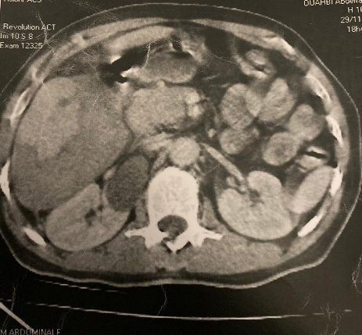
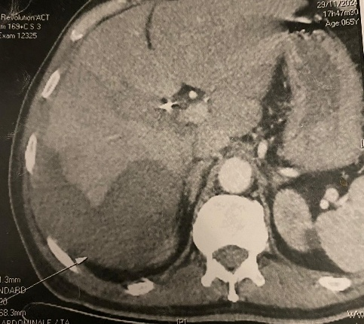
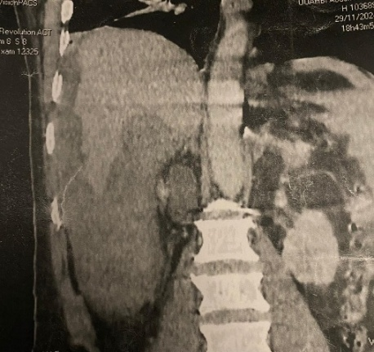

B
A

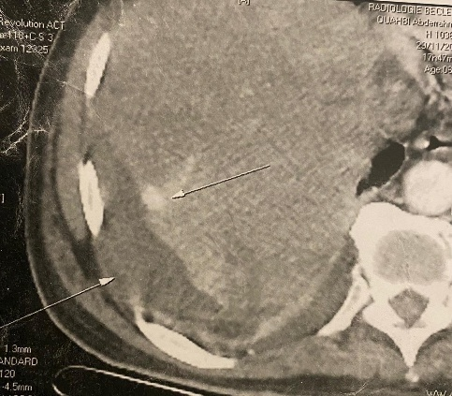

Vascular blush

Hematoma
D
C

Fig. 1: post-operative CT scan showing a subcapsular hematoma surrounding the lateral and inferior surface of the right hemi liver (A,B,C) with an active bleeding in the VIII segment.
After hospitalisation, patient benefited from an arterial embolization due to the active bleeding.

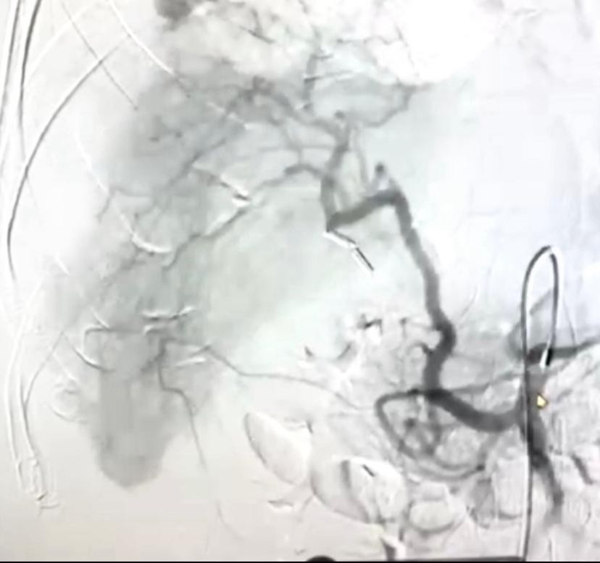
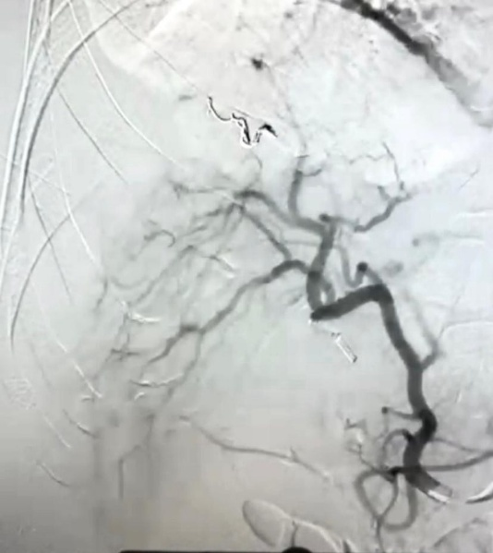

Fig. 2: Arterial embolization of the ruptured pseudo-anevrysm

After the embolization patient benefited from close monitoring in our department, and after being transfused, patient stabilized which prompted surgical abstention.
The patient was discharged on the fourth day upon stabilization with no further complications.

3. DISCUSSION

Large cohort studies have shown that LC is a safe procedure, with an overall morbidity rate of less than 7%. Even more, bleeding is observed in fewer than 1% of cases. The most common sites of bleeding following LC are the gallbladder bed, the falciform ligament, the trocar insertion site and the cystic artery. Bleeding can also occur from tears in the liver capsule. However, even though the occurrence of ISH following LC is rare, it represents a life-threatening complication due to haemodynamic instability from possible rupture. Hematomas are usually located on the right side of the liver (in 75% of cases) and can occur from 24h to several weeks after LC. [6-7]

Some contributing factors have been identified. These include iatrogenic injuries to the liver parenchyma and capsular tears during gallbladder traction or trocar placement. Other factors include the presence of a preoperative pseudoaneurysm or hepatic hemangioma, which could be injured during the procedure. The perioperative administration of non-steroidal anti-inflammatory drugs (NSAIDs) has been reported in several cases of ISH following LC, with a particular focus on the use of ketorolac. Consumption of NSAIDs in the postoperative period has also been proposed as an associated cause, since ketorolac (up to 58.8%) or parecoxib was used by several patients in this period. ISH has also been associated with anticoagulant therapy. [8-9]
Our patient, had no specific underlying cause, as she had no coagulation disorders, nor she was taking anticoagulants or antiplatelet therapy. However the iatrogenic rupture of a pre-existent pseudo-aneurysm cannot be eliminated to the lack of pre-operative imagery (particularly CT-Scan).
When the ISH is small, it is usually asymptomatic. However, if it continues to grow, serious complications may arise. Depending on the symptoms and the patient's condition, various therapies may be employed, ranging from expectant management to emergency surgery

The management of large ISHs is unclear, but several strategies have been proposed: conservative management with strict clinical observation; surgical management, either laparotomy or laparoscopy; percutaneous drainage; and endovascular embolisation. The choice of strategy is mainly determined by the patient's clinical condition, the size of the haematoma, and its cause. Management strategies for ISH depend on hemodynamic stability, hematoma size, and the presence of active bleeding. These include: [3-6]
- Conservative management: Close monitoring, pain control, and correction of anaemia in hemodynamically stable patients with small or self-limiting hematomas. [10]
- Endovascular embolization: Effective for patients with active bleeding or pseudoaneurysm, as demonstrated in our case.
- Percutaneous drainage: Considered when hematoma becomes infected or causes compressive symptoms.
- Surgical intervention: Reserved for hemodynamic instability or failure of non-operative management. [11-12]
Limitations of this case report include the lack of long-term follow-up imaging and absence of detailed intraoperative findings that might have explained the pseudoaneurysm's origin. Despite these limitations, this case adds to the sparse literature on ISH following LC and underscores the value of a multidisciplinary approach, including radiology and surgical teams, for rapid diagnosis and non-surgical management.

4. Conclusion

In conclusion, laparoscopic cholecystectomy (LC) is a generally safe procedure with low morbidity and rare bleeding complications. However, intrahepatic subcapsular hematoma (ISH), though uncommon, remains a serious and potentially life-threatening event. Its management varies depending on the patient’s clinical stability and hematoma characteristics. Early diagnosis and individualized, minimally invasive management are critical to ensuring favourable outcomes in ISH. Further studies are needed to identify patients at increased risk and to develop standardized diagnostic and management protocols to guide clinicians when faced with this rare but dangerous complication. Our patient benefited from endovascular embolization upon diagnosis of vascular rupture which allowed rapid stabilization of the patient as well as surgical abstention.

AcknowledgEments

Authors have declared no sources of funding ofr this study

Competing interests

Authors have declared that no competing interests exist

Authors’ Contributions

Author AC designed the study as well as collected the data. Author YOT wrote the first draft. Author FZB and Author YZK managed the literature searches and overall supervision. All authors read and approved the final manuscript.”

Consent (where ever applicable)

As per international standard or university standard, patient written consent has been collected and preserved by the authors.
Ethical approval (where ever applicable)

As per international standard or university standard written ethical approval has been collected and preserved by the authors.
Disclaimer (Artificial intelligence)

Author(s) hereby declare that Large Language Models (GPT-4.1 mini) have been used during the writing or editing of this manuscript. Main usage has been in order to properly translate medical terminology from author’s original scientific language (French) into English.

References

- E Saad, L O'Connell, AM Browne, et al.: Giant Intrahepatic Subcapsular Haematoma: A Rare Complication following Laparoscopic Cholecystectomy—A. Case Report and Literature Review. Case Reports in Surgery. 2020, 10.1155/2020/6410790
- Gluszek S, Kot M, Nawacki L, et al.: Subcapsular liver haematoma as a complication of laparoscopic cholecystectomy. Videosurgery and Other Miniinvasive Techniques. Videosurgery and Other Miniinvasive Techniques,, 15. 10.5114/wiitm.2015.52059
- S Duca, O Bãlã, N Al‐Hajjar, et al.: Laparoscopic cholecystectomy: incidents and complications. A retrospective analysis of 9542 consecutive laparoscopic operations. HPB. Romanian Journal of Emergency Surgery, 2003. 10.1080/13651820310015293
- Qiao-fei Liu, Ling-ling Bian, Meng-qing Sun, et al.: A rare intrahepatic subcapsular hematoma (ISH) after laparoscopic cholecystectomy: a case report and literature review. BMC surgery. BMC surgery, 2019. 10.1186/s12893-018-0453-9
- Moloney BM, Hennessy N, O Malley E, Orefuwa F, McCarthy PA, Collins CG. Subcapsular haematoma following laparoscopic cholecystectomy. BJR Case Rep. 2016 Dec 23;3(2):20160118. doi: 10.1259/bjrcr.20160118. PMID: 30363274; PMCID: PMC6159231.
- JA Shea, MJ Healey, JA Berlin, et al.: Mortality and complications associated with laparoscopic cholecystectomy. A meta-analysis. Ann Surg. 1996,
- R Badea, L Chiorean, C Mitre, et al.: Spontaneous retroperitoneal and subcapsular liver hematoma. The diagnostic contribution of CT, US, and CEUS. Case report. Med Ultrason. Medical ultrasonography, 2013. 10.11152/mu.2013.2066.152.rb1lc2
- BM Moloney, N Hennessy, EO Malley, et al.: Subcapsular haematoma following laparoscopic cholecystectomy. BJR Case. BJR| case reports, 2016. 10.1259/bjrcr.20160118
- MC Barrios, J Sotomayor, JM Lozano, et al.: Hepatic subcapsular hematoma following laparoscopic cholecystectomy: a case report.. Annals of Mediterranean Surgery, 2023. 10.22307/2603.8706.2023.01.005
- Aliabusunoon M, Baroom A, Abdulghafar H, Alssied H. Intrahepatic subcapsular hematoma after laparoscopic cholecystectomy in a male patient: a case report. J Surg Case Rep. 2024 Aug 9;2024(8):rjae498. doi: 10.1093/jscr/rjae498. PMID: 39132080; PMCID: PMC11314494.
- Brown V, Martin J, Magee D. A rare case of subcapsular liver haematoma following laparoscopic cholecystectomy. BMJ Case Rep. 2015 Jun 25;2015:bcr2015209800. doi: 10.1136/bcr-2015-209800. PMID: 26113588; PMCID: PMC4488630.
- de Castro, Steve M.M. et al., Delayed intrahepatic subcapsular hematoma after laparoscopic cholecystectomy, Clinical Imaging, Volume 36, Issue 5, 629 - 631

