Case Report

Pseudoangiomatous stromal hyperplasia (PASH), A rare benign breast disease: A Case report

Abstract:
Background:Aberration in normal development and involution(ANDI) is a broad term including the disorders and diseases of breast. Pseudoangiomatous stromal hyperplasia (PASH) is a rare disease of the breast mimicking the neoplasm of the breast and has a wide range of symptoms, which can often complicate clinical assessment and lead to inappropriate treatment of a condition that is basically benign. In the present case report we document this rare benign breast condition(PASH) presenting with mixing features of fibroadenoma and neoplasm. Usually, it affects women of reproductive age. It may manifest as a firm, painless mass also known as tumorous or nodular PA(6). Case: a 26 yr old female presented with a lump in left breast for 8 months associated with moderate pain in left breast for 1 month. Breast ultrasound revealed a hypoechoic lesion with multiple coarse foci of calcification and few areas of vascularity- BIRADS IV. Excision and biopsy was done followed by lumpectomy. Histopathology showed terminal duct lobular units with intervening stroma showing dense keloid-like hyalinisation enclosing inter-anastomosing spaces with few endothelial-like lining cells. Focal areas of calcification noted with focal peripheral ductal hyperplasia. Conclusion: Considering the clinical findings and histopathological report with immunochemistry, PASH can be confidently diagnosed and appropriately treated.

Keywords- ANDI, Fibroadenoma, Neoplasm, BIRADS, Lumpectomy.

Introduction:

Breast diseases are among the most common reasons for surgical consultations in India. Most of these are either radiologically or pathologically proven as benign conditions. Benign breast disorders or diseases covered under broad terms as ANDI,which can present with a wide variety of conditions ranging from inflammatory lesions of breast to benign neoplastic tumors.Up to 30% of women experience these conditions at some point in their lives(1).Breast lesions have a wide range of symptoms, which can often complicate clinical assessment and lead to inappropriate treatment of conditions that are basically benign. PASH is a rare disease that may need treatment. A focal, non-tumor-forming PASH may be an incidental microscopic finding in up to 23% of breast biopsies. The pathogenesis is unclear and most recently, the literature postulates that hormonal factors play a role in the development of PASH (2,3). Initially thought to be variants of mammary hamartomas (4), PASH tumors are currently regarded as a benign proliferation of stromal myofibroblasts, which express CD34, vimentin, and at least focally smooth muscle actin, desmin, and bcl-2, but not endothelial markers (CD31, Factor VIII), S100 or cytokeratin. The clinicopathological spectrum of PASH ranges from focal, incidental microscopic findings to clinically and mammographically evident breast masses. In the present case report we document a rare benign breast condition(PASH) which mimics malignancy.

Case Report:

A 26 yr old female presented to general surgery OPD in our hospital with complaints of a lump in left breast for 8 months, gradually increasing in size to attaining present size associated with pain in left breast for 1 month which was mild to moderate in intensity, not associated with menstrual cycle. The patient has no H/O trauma, fever, lactation, nipple discharge, weight loss, OCP intake or hormonal therapy, no past history and no associated family history. On examination patient had a lump of size 3*2cm, mobile, non tender with irregular margin behind the nipple areolar complex at 2 o’clock position with no nipple discharge. Skin ,NAC and axilla were normal. Ultrasound revealed a large multilobulated hypoechoic lesion measuring 2.4*1.4 cm in the retroareolar region left breast with mildly irregular margins with multiple coarse foci of calcification and few areas of vascularity seen within it-BIRADS IV lesion(figure1).

Fine needle aspiration cytology (FNAC) showed clusters of spindle shaped cells in a background of bare nuclei and few cells with atypia. Based on Ultrasound findings which are suspected of malignancy and FNAC findings, the patient was advised for core needle biopsy. But taking the suspicion of malignancy, the patient opted for surgery without any further treatment in followups. So the patient was planned for excision and biopsy sent for the frozen section to rule out malignancy. Under general anaesthesia, a circumareolar incision was given over the left breast at 12-3 o’clock position. Intra-operatively, the lump was densely packed with some areas of calcification with some necrosis, figure 2. The frozen section biopsy reported as uncapsulated relatively circumscribed neoplasm consisting of tubules which were at some places markedly compressed into cords by hyalinized fibrocollagenous stroma. Tubules were bilayered with inner epithelium and outer myoepithelial cell layer. However, in areas where tubules were compressed into cords, the myoepithelium layer was not appreciated. No nuclear atypia, mitosis or necrosis were identified. So lumpectomy was done to clear the margins and proper haemostasis was achieved. Primary wound closure done without drain(figure 3). The patient had an excellent postoperative recovery. The patient was discharged on postoperative day 3 with advice of proper wound care. In follow-up OPD, the wound was healthy with no local postoperative complication. Histopathology report stated that a single soft tissue measuring 4x2.5x1.2cm, grossly appeared yellowish-white. On microscopy, sections showed terminal duct lobular units with intervening stroma with dense keloid-like hyalinisation enclosing inter-anastomosing spaces with few endothelial-like lining cells. Focal areas of calcification noted. The peripheral ducts focally exhibited usual duct hyperplasia-like features. No nuclear atypia/ mitosis/ necrosis noted (figure4). Features are suggestive of Pseudoangiomatous stromal hyperplasia(PASH).

Discussion:
One type of benign mesenchymal breast tumor is pseudoangiomatous stromal hyperplasia (PASH). It resembles low-grade angiosarcoma histologically and clinically to fibroadenoma or benign Phyllodes tumor. It frequently occurs by chance as a focal microscopic finding or when gynaecomastia, fibrocystic changes, fibroadenoma, and Phyllodes tumor are present(5). These findings provide additional evidence that an aberrant reactivity of myofibroblasts to endogenous or exogenous hormones is probably an important factor in the development of PASH. The contention that elevated hormonal levels may contribute to the development of PASH is also supported by the fact that the PASH occurred mostly in hormonally active, premenopausal and perimenopausal women. Another argument for the contribution of estrogen and progesterone to the etiology of PASH is the fact that the smallest PASH masses were seen in menopausal women and the largest ones were in women expected to be at the height of hormonal activity. Occasionally, it may manifest as a firm, painless mass of the breast, also known as tumorous or nodular PASH(6). In terms of gross anatomy, tumorous PASH is a well defined, firm, rubbery mass with a solid, uniform, gray-white cut surface.(7) It is distinguished on histopathological examination by the existence of open, slit-like spaces within a thick layer of collagenous stroma. A layer of myofibroblasts with band nuclei that are flat and spindle-shaped, lines the spaces.(8) It is of note that 95% of the PASH tumors in our study stained positive for ER and/or PR receptors. Most of the reported cases in the literature demonstrate the presence of progesterone receptor activity and weak to no estrogen receptor activity (4). The spindle cells have vimentin, actin, and CD34 positive results and express progesterone receptors.(9,10). Even though their histogenesis and behaviour vary, certain lesions exhibit morphological features that overlap, which makes accurate diagnosis difficult, especially in core needle biopsies(5). In cases where morphology is difficult to diagnose, clinical history and immunohistochemistry can be helpful. Although PASH is a benign entity it must be histopathologically differentiated from low-grade angiosarcoma with which it can be confused, on low magnification, because the slit-like channels lined by spindle characteristic of PASH may resemble endothelial cells (9). The treatment of angiosarcoma is mastectomy, although the literature indicates that breast conserving therapy for small, grade one primary tumors may be appropriate (10). In the present report, the patient also made a choice for excision of lesion with no followup treatment. In a study, it was recommended by the surgeon that lesions greater than 2 cm should be excised otherwise it was the decision of the patient to have the benign tumor removed from her breast or followed up with observation (11). Following excision, the recurrence rate can range from 0% to 22%.(12) In a study conducted by Bowman et. al., the majority of the patients were treated with surgical excision, many were treated with close monitoring and repeat mammography 6 months after diagnosis . On follow-up of mammograms after surgical excision, there was no evidence of recurrence of PASH (4). Re-excision can be done to manage the recurrent lesions, which exhibit benign behaviour. To date, there is only one reported case suggesting a malignant transformation of a PASH lesion (11) and only rare cases have been reported where PASH was associated with malignancy or DCIS, as we found in one of the patients included in this series (4). For some patients with tumorous PASH who have benign pathology and imaging findings, nonoperative management combined with careful clinical monitoring may be an alternate strategy. However, no research has been documented on the long-term results of conservatively managed patients.

Conclusion:
In this case report PASH presents as a lesion with nearly malignant features on radiological study and FNAC findings causing difficulty in proper diagnosis preoperatively. So on the basis of previous studies, it is suggested to keep a broad differential diagnosis for benign breast lesions and understand the various morphological manifestations of PASH in order to make an accurate diagnosis. By careful clinical examination with accompanying radiological findings and with judicious use of immunohistochemistry PASH can be confidently diagnosed in the core needle biopsy, accordingly an appropriate treatment can be given. Based on the reports in the literature, if the diagnosis of PASH is made on core biopsy, surgical excision may not be indicated and close observation with serial mammography to assess interval growth is adequate treatment. However, long term follow up for recurrence and rarely malignant transformation is also documented.

Disclaimer (Artificial intelligence):

Author(s) hereby declare that NO generative AI technologies such as Large Language Models (ChatGPT, COPILOT, etc.) and text-to-image generators have been used during the writing or editing of this manuscript.

References:
1: Sainsbury RC. Bailey and Love’s Short Practice of Surgery. 25th. London: Edward Arnold Ltd.; 2008. Breast In: Norman WS, Bulstrode CJK, P.Ronan O’Connel editors; pp. 827–35. 2.Pruthi S, Reynolds C, Johnson RE, Gisvold JJ. Tamoxifen in the management of pseudoangiomatous stromal hyperplasia. Breast J. 2001;7:434–9.
3.AbdullGaffar B. Pseudoangiomatous stromal hyperplasia of the breast. Arch Pathol Lab Med. 2009;133:1335–8.
4. Bowman, E., Oprea, G., Okoli, J., Gundry, K., Rizzo, M., Gabram‐Mendola, S., ... & Bumpers, H. L. (2012). Pseudoangiomatous stromal hyperplasia (PASH) of the breast: a series of 24 patients. The breast journal, 18(3), 242-247.
5. Levine, P. H., D.Nimeh, A. A.Guth, and J. F.Cangiarella. Aspiration biopsy of nodular pseudoangiomatous stromal hyperplasia of the breast: clinicopathologic correlates in 10 cases.Diagn Cytopathol2005. 32 (6):345–350.
6. Milanezi, M. F., F. P.Saggioro, S. G.Zanati, R.Bazan, and F. C.Schmitt. Pseudoangiomatous hyperplasia of mammary stroma associated with gynaecomastia.J Clin Pathol1998. 51 (3):204–206.
7. Sasaki, Y., S.Kamata, K.Saito, Y.Nishikawa, and J.Ogawa. Pseudoangiomatous stromal hyperplasia (PASH) of the mammary gland: report of a case.Surg Today2008. 38 (4):340–343.
8.Virk RK, Khan A (2010) Pseudoangiomatous stromal hyperpla- sia: an overview. Arch Pathol Lab Med 134:1070–1074.
9.Vuitch, M. F., P. P.Rosen, and R. A.Erlandson. Pseudoangiomatous hyperplasia of mammary stroma.Hum Pathol1986. 17 (2):185–191.
10.Glazebrook KN, Magut MJ, Reynolds C. Angiosarcoma of the breast. AJR Am J Roentgenol. 2008;190:533–8.
11..Nassar H, Elieff MP, Kronz JD, Argani P. Pseudoangiomatous stromal hyperplasia (PASH) of the breast with foci of morphologic malignancy: a case of pash with malignant transformation? Int J Surg Pathol. 2008;18:564–9.
12. Wieman, S. M., J.Landercasper, J. M.Johnson, et al. Tumoral pseudoangiomatous stromal hyperplasia of the breast.Am Surg2008. 74 (12):1211–1214.

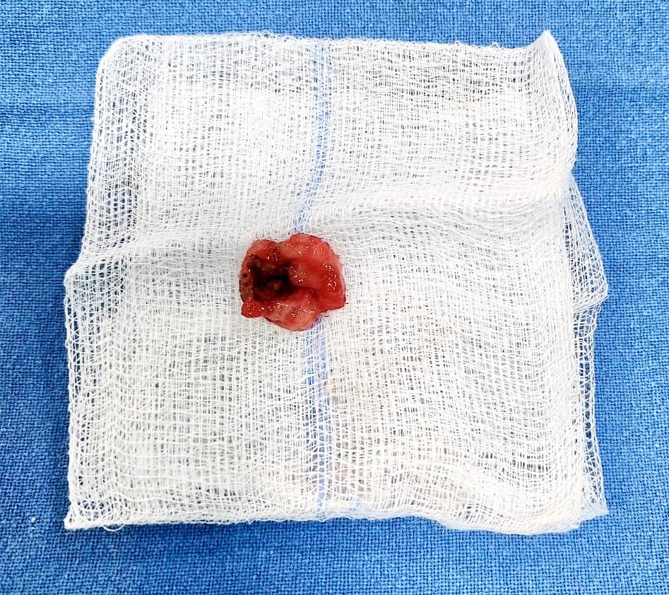
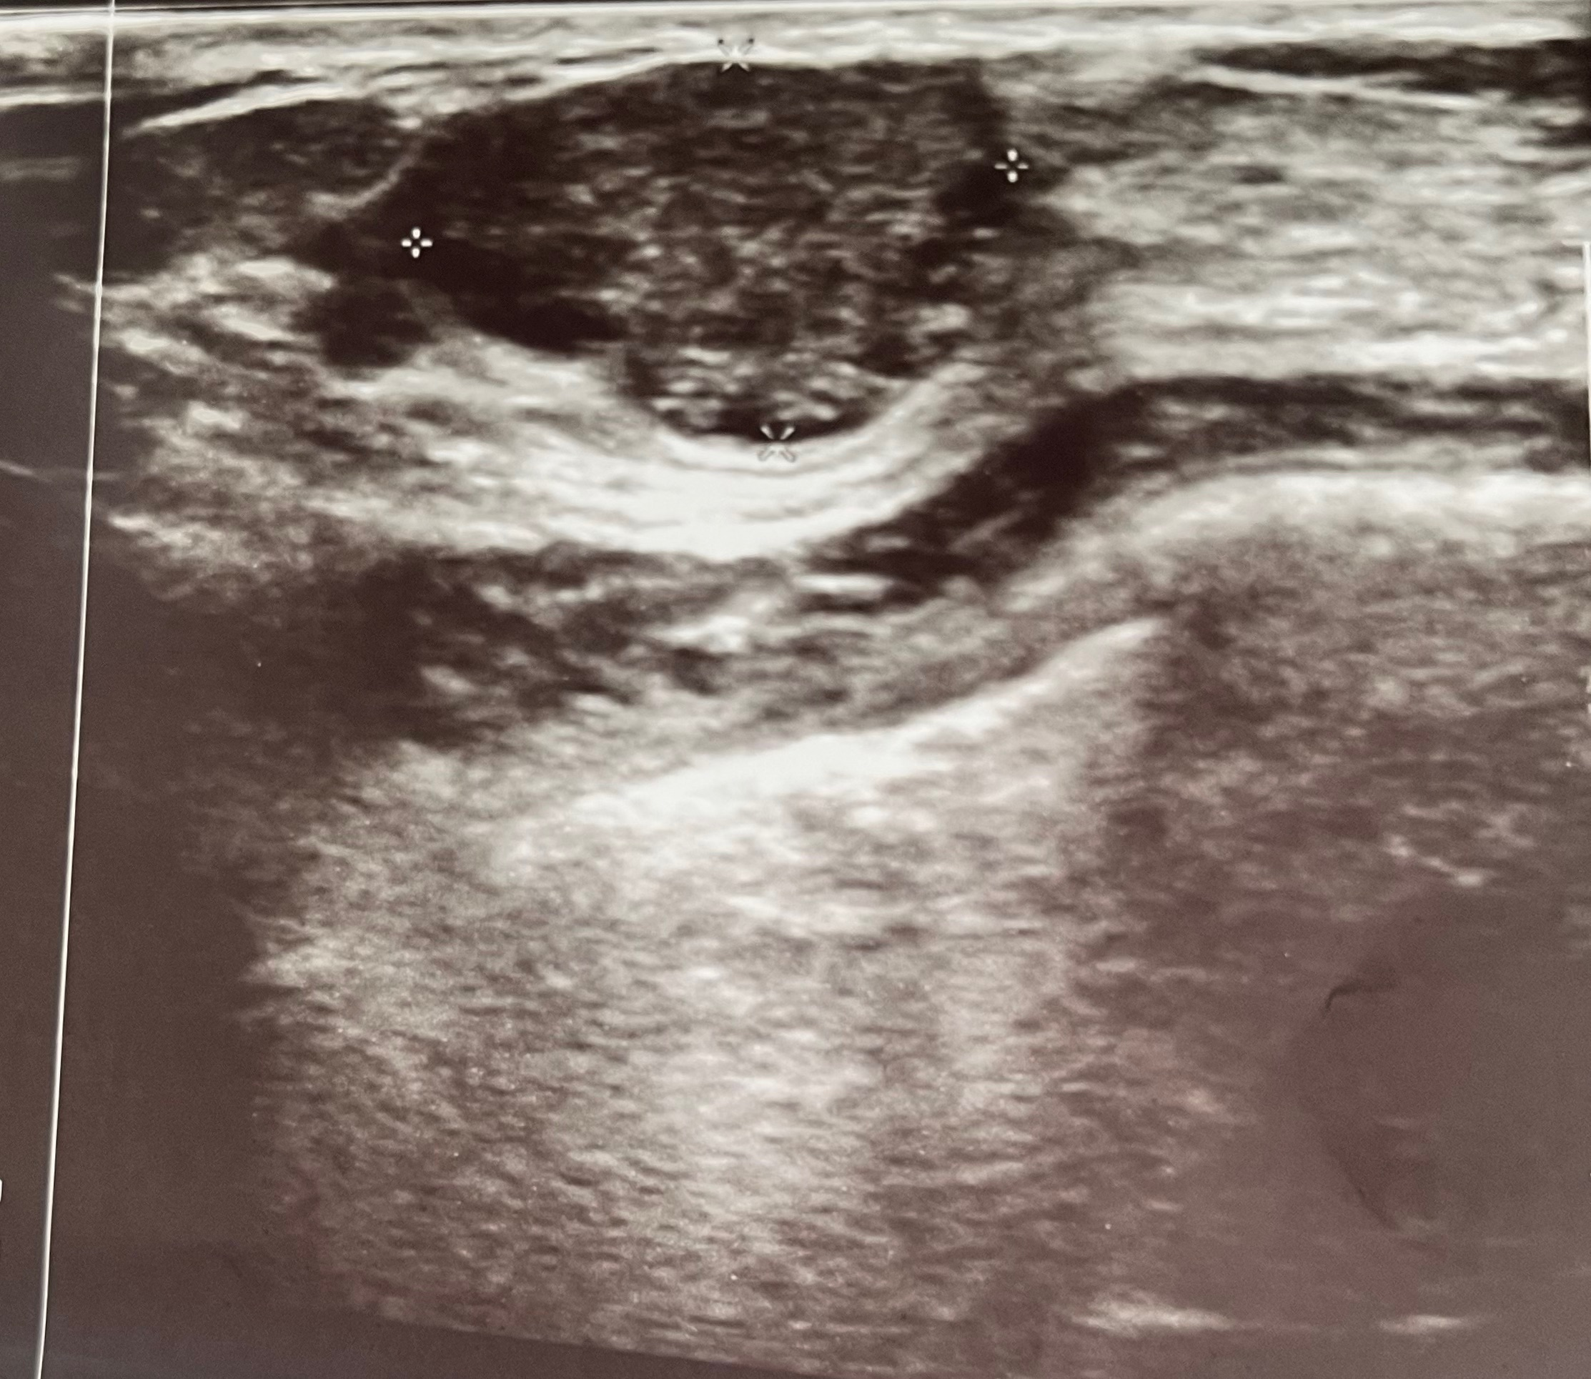

Figure 2. Excised specimen showing some areas of calcification and necrosis

Figure1. Multilobulated hypoechoic lesion m/s 2.4x1.4 cm with multiple coarse foci of calcification and few areas of vascularity within it

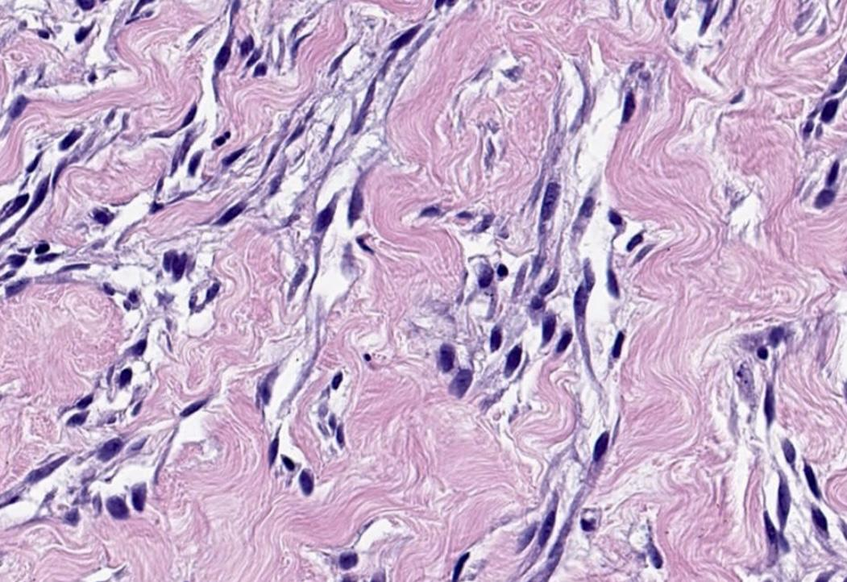
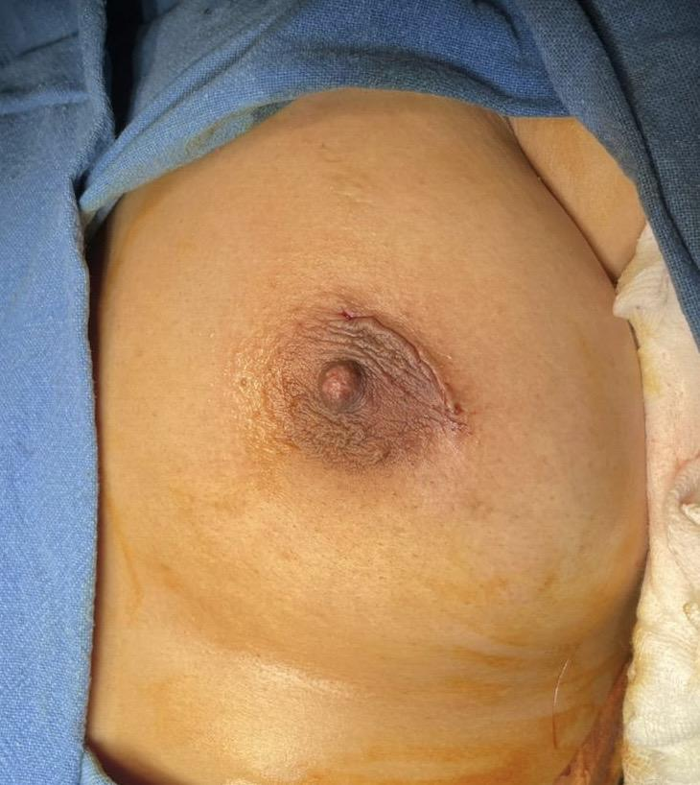

Figure 4:Microscopic examination slide depicting terminal duct lobular units with intervening stroma with dense keloid like hyalinisation enclosing inter anastomosing spaces with few endothelial like lining cells.

Figure 3: post-operative picture showing primary closure without drain.

