Case report

Management of Severely Comminuted Open Floating Knee Injuries using Hinged Ilizarov Frames: A Case Report

ABSTRACT
Floating knee injuries, involving ipsilateral fractures of the femur and tibia, are typically high-energy traumas associated with significant soft tissue damage and poor outcomes. The presence of comminuted, open fractures further complicates management. Traditional internal fixation may not be feasible in such cases, especially when there is risk of infection or soft tissue compromise. The Ilizarov fixator, particularly the hinged construct, provides a viable alternative for limb salvage and functional recovery. We report the case of a 35-year-old male who presented with a gunshot wound causing severely comminuted distal femoral and proximal tibial fractures with hemarthrosis. Clinical and radiographic evaluation confirmed open fractures of the distal femur and midshaft tibia (Gustilo-Anderson type IIIB). Initial management involved aggressive debridement and external stabilization. Due to extensive soft tissue damage and bone loss, definitive fixation was achieved using a hinged Ilizarov external fixator that allowed knee articulation during the healing phase. The patient underwent serial wound inspections, secondary closure, and physiotherapy during follow-up. Radiographic union was achieved, and functional recovery, including partial weight-bearing and knee range of motion, was noted by four months postoperatively. In cases of complex open floating knee injuries with severe comminution and soft tissue involvement, the hinged Ilizarov fixator offers a limb-salvaging option. It enables early joint mobilization, facilitates wound management, and may improve long-term functional outcomes compared to conventional fixation methods in such challenging clinical scenarios.
Keywords: Floating knee injury, Comminuted fracture, Ilizarov frame, External fixation, Hinged fixator

INTRODUCTION
Floating knee injuries represent a rare but complex subset of high-energy trauma, typically defined as concomitant ipsilateral fractures of the femur and tibia.¹⁻³ These injuries are often associated with significant soft tissue damage, neurovascular compromise, and a high risk of infection, particularly when they are open and severely comminuted.⁴ The incidence of floating knee injuries is estimated at approximately 2% to 5% of all femoral fractures and 4% to 10% of all tibial fractures, predominantly affecting young males involved in high-speed motor vehicle accidents or falls from significant height.⁵ These injuries predominantly affect young males⁶ and are frequently associated with other serious injuries, including soft tissue damage, open fractures, and multisystem trauma, which complicate management and worsen prognosis .⁷
The severity of these injuries has been classified by Fraser into Type I (diaphyseal fractures) and Type II (involving the knee joint), with further subclassifications based on soft tissue condition and fracture pattern.⁸ The prognosis worsens with increasing fracture comminution and open wounds.⁹ Open floating knees are commonly associated with Gustilo-Anderson Type IIIB injuries, where there is extensive soft tissue loss, periosteal stripping, and contamination.¹⁰
Traditional management of floating knee injuries involves internal fixation techniques such as intramedullary nailing or plating.¹¹ However, these methods are often unsuitable in cases with severe comminution, bone loss, or compromised soft tissue envelopes.¹² Internal fixation in open injuries increases the risk of deep infections, delayed union, and implant failure.¹³ In contrast, the Ilizarov method of circular external fixation offers unique advantages, especially in complex open fractures.¹⁴ The system allows for stable fixation without further compromising the soft tissues, facilitates gradual deformity correction, and supports early weight-bearing and knee mobilization.¹⁵
Although the Ilizarov technique has been widely studied in Eastern Europe and Asia, its application in sub-Saharan Africa, including Nigeria, remains underreported. In Nigeria, trauma care systems face unique challenges such as delayed presentations, limited access to advanced imaging, shortages in orthopaedic implant inventory, and the burden of managing injuries in under-resourced settings (Akinlade et al., 2024).¹⁶ This report presents the management of a severely comminuted open floating knee injury in a young Nigerian patient using a hinged Ilizarov fixator. It highlights the decision-making process, surgical technique, and functional outcome, while reflecting on the utility of this method in the Nigerian trauma care landscape.

CASE PRESENTATION
A 35 year old male was brought to the emergency department approximately one hour after sustaining a close range gunshot injury to the right knee during an assault. On arrival, the patient was alert, hemodynamically stable, and in significant pain. Examination revealed an entry wound located anterolaterally on the distal third of the right thigh, and a clearly visible exit wound with an associated soft tissue defect over the proximal aspect of the leg. Figure 1 shows a severely comminuted open distal femoral fracture involving extensive soft tissue disruption and visible bone fragmentation. This is consistent with a Gustilo-Anderson Type IIIB open fracture, which is a component of a floating knee injury, a high-energy trauma characterized by fractures of the ipsilateral femur and tibia. Despite the severity of the local trauma, neurovascular examination of the limb was unremarkable. Dorsalis pedis and posterior tibial pulses were present and symmetrical, and there were no sensory or motor deficits in the affected extremity.
Plain radiographs of the femur, knee, and tibia revealed a severely comminuted distal femoral fracture involving both the metaphyseal and epiphyseal regions (Figure 2). The proximal tibia also demonstrated a complex multifragmentary fracture with intra articular extension. Joint distension consistent with traumatic hemarthrosis was noted. Given the complexity of the fracture morphology, the visible soft tissue defect from the exit wound, and the intra articular disruption, a joint preserving and staged surgical approach was indicated. The case was reviewed by the orthopaedic trauma team in consultation with the plastic surgery unit.
MANAGEMENT AND OUTCOMES
Initial care followed standard advanced trauma life support principles. The patient was hemodynamically stable upon presentation, and limb assessment prioritized vascular integrity and soft tissue preservation. After clinical and radiological confirmation of the complex periarticular fracture pattern, the patient was taken to the operating theatre for urgent surgical intervention.
Under general anesthesia, a thorough debridement of the entry and exit wounds was carried out. The soft tissue defect resulting from the bullet exit wound was clearly visualized intraoperatively. The fracture fragments were comminuted but not grossly displaced, and a decision was made to fix them in situ. Given the extent of comminution and intra articular involvement, immediate internal fixation was not feasible.
The intraoperative image (Figure 3) shows a patient’s left lower limb stabilized with a hinged Ilizarov external fixator following debridement and fracture alignment for a floating knee injury. The frame provides rigid fixation while allowing controlled knee motion and access for soft tissue care, making it ideal for managing complex open fractures with extensive soft tissue involvement. Two separate preconstructed Ilizarov circular external fixators were used. One frame was mounted for the femur and another for the tibia. The femoral frame was applied first, followed by the tibial construct. Both frames were anchored using olive wires placed at the zones of comminution to provide secure fixation without fragment displacement. The fixation technique was selected to preserve fracture alignment and reduce additional trauma to already compromised bone. In the absence of commercially available Ilizarov hinges, the team improvised by constructing a hinged mechanism using a combination of male posts and long bolts. These improvised hinges were strategically positioned to align with the anatomical axis of the knee, enabling controlled motion and helping to delay the onset of post traumatic osteoarthritis.
Perioperative antibiotics were administered, and the patient was monitored in a high-dependency unit for the first twenty four hours. Early postoperative care included passive joint mobilisation, limb elevation, and isometric quadriceps exercises. The patient was transferred to the orthopaedic ward for ongoing rehabilitation. The hinged configuration of the external fixators allowed limited knee range of motion within the first few weeks of recovery. Flap coverage of the exit wound was performed later by the plastic surgery team using a local rotational flap to ensure soft tissue healing. Weight bearing was deferred during the early healing phase to allow callus formation. Serial radiographs were obtained at two week intervals to monitor bone healing and frame integrity. Figure 4 shows the postoperative radiograph.

OUTCOMES
The patient’s early postoperative course was uneventful. There were no episodes of deep infection, implant failure, or neurovascular compromise. He remained compliant with pin site care and physiotherapy protocols. Range of motion exercises were introduced early and gradually intensified. At six weeks, radiographic evidence of callus formation was visible at both fracture sites. By twelve weeks, progressive consolidation was observed. Weight bearing was initiated under supervision using crutches, and the intensity of physiotherapy was increased.
The Ilizarov frames were removed at five months after confirmation of fracture union. At the time of frame removal, the patient had regained active knee motion from zero to approximately seventy degrees of flexion. He continued with outpatient physiotherapy focused on gait retraining, strengthening, and balance improvement. At the six month follow-up, the patient maintained independent ambulation and functional joint stability, although with a slightly reduced flexion arc. There were no complications related to the flap or signs of joint subluxation. By one year, he had returned to most daily activities, though deep knee flexion remained limited and mild anterior knee pain was reported during prolonged squatting. The combined use of staged soft tissue coverage, two frame constructs, and an improvised hinged Ilizarov system allowed for effective fracture stabilization and early joint mobilization. This approach proved successful in achieving bony union, preserving joint function, and preventing early onset joint degeneration.
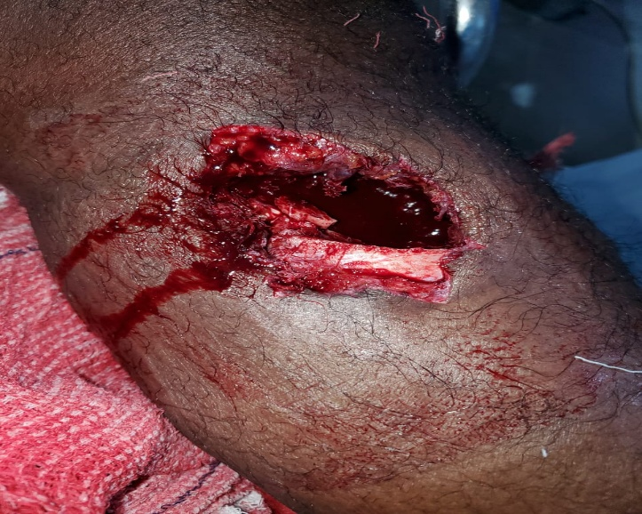
Figure 1: Clinical photograph showing a high-energy open distal femoral fracture with gross comminution and exposed bone, consistent with a Type IIIB open injury in a floating knee pattern. Extensive soft tissue damage and contamination are evident. This image was taken intraoperatively prior to wound debridement and application of a hinged Ilizarov frame for limb stabilization.
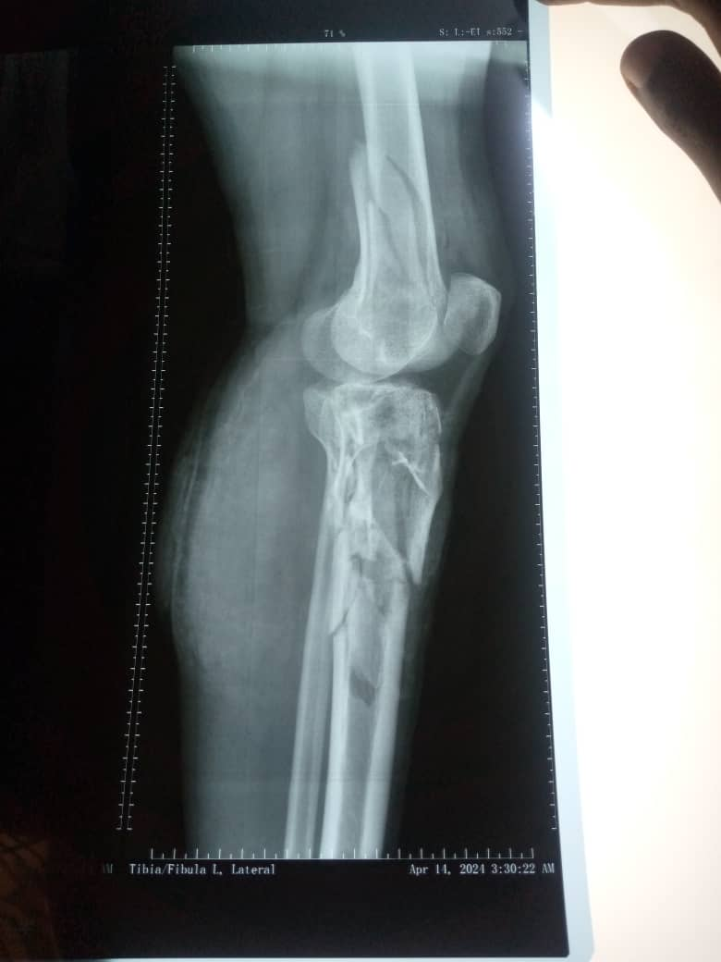
Figure 2: Lateral radiograph of the left leg showing a comminuted distal femoral fracture with associated tibial shaft fracture, consistent with a floating knee injury.
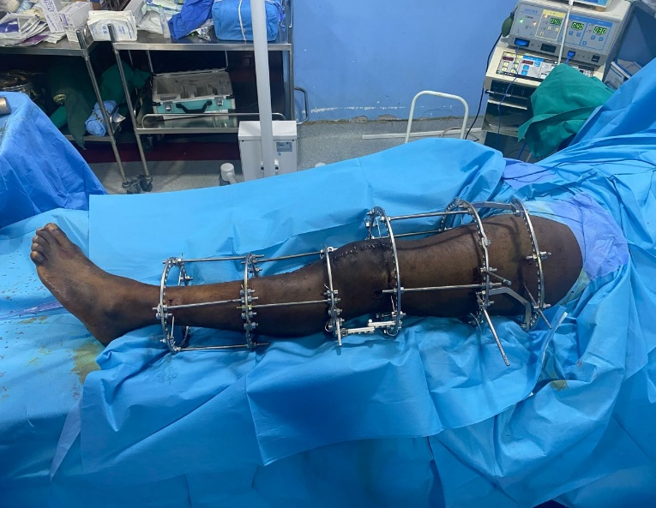
Figure 3: Intraoperative photograph showing application of a hinged Ilizarov fixator spanning the femur and tibia for stabilization of a comminuted open floating knee injury, enabling joint motion and facilitating wound management.
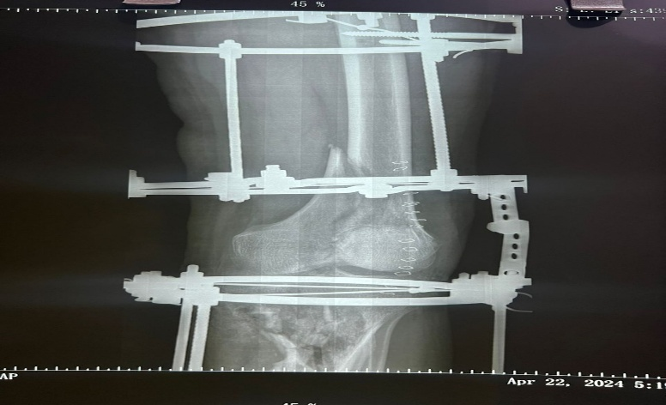
Figure 4: Postoperative AP radiograph showing a hinged Ilizarov fixator spanning the femur and tibia, applied for stabilization of a comminuted floating knee injury while preserving knee joint motion.

DISCUSSION
Floating knee injuries, especially those involving severely comminuted open fractures with intra articular extension, represent a major challenge in orthopaedic trauma care due to the complex fracture patterns, soft tissue compromise, and risk of infection (Vallier and Manzano 2020; Raju et al 2021; Haqash 2023). This case demonstrates the utility of hinged Ilizarov external fixation in the management of a Type II open floating knee injury, offering insights relevant to both clinical practice and health systems operating under resource constraints.
In the classical approach, internal fixation is the standard for diaphyseal and periarticular fractures of the femur and tibia. Intramedullary nailing or plate fixation has been reported to achieve good union rates and satisfactory functional outcomes when soft tissue conditions permit early stabilization (Kumar and Subash 2024; Nouraei et al 2013). However, in open fractures with extensive comminution and soft tissue loss, internal fixation may be contraindicated due to elevated risk of infection, implant exposure, and delayed union or nonunion (Wang et al 2025). In such scenarios, external fixation offers an alternative that minimizes surgical trauma to already compromised tissues.
The use of Ilizarov circular external fixators in managing floating knee injuries is relatively less common but increasingly supported in literature, particularly in settings with limited access to implant inventories and advanced imaging (Naskar et al 2025; Korkmaz et al 2025). The Ilizarov method enables multiplanar stability, permits adjustment during the healing process, and facilitates early joint mobilization without sacrificing soft tissue integrity. In the present case, the use of two separate frames connected via an improvised hinged mechanism allowed adequate stabilization while enabling controlled knee motion. This contrasts with earlier series in which the knee joint was bridged in a fixed position, often resulting in stiffness and poor functional outcomes (Ran et al 2013; Hegazy et al 2011).
Furthermore, while Fraser’s classification highlights the prognostic implications of intra articular extension in Type II injuries, there remains limited consensus on the optimal strategy for joint-preserving fixation in the setting of ballistic trauma (Fraser 1978; Raju et al 2021). Some studies have suggested that early joint-spanning internal fixation followed by delayed reconstruction yields better results, especially when combined with plastic surgical interventions for soft tissue coverage (Rollo et al 2019; Piedra-Calle et al 2021). However, this is often impractical in sub-Saharan Africa where logistical and infrastructural limitations affect timely surgical planning. In this context, the Ilizarov system offers a feasible, modular solution that accommodates staged intervention.
A unique feature of this case was the use of an improvised hinged construct, designed to replicate commercially available hinges that are often difficult to source locally. This innovation allowed for early range of motion without compromising frame stability. Previous reports from low and middle income countries have similarly emphasized improvisation in trauma care to bridge the gap between ideal surgical constructs and what is locally achievable (Akinlade et al 2024; Kenmegne et al 2023).
Postoperative outcomes in this patient were favorable. Complications commonly associated with Ilizarov fixation such as pin site infection, wire loosening, or neurovascular compromise were actively monitored using a structured protocol of weekly reviews, but none were documented in this case. Axis alignment and limb length were assessed clinically and radiographically at two weekly intervals for the first six weeks, then monthly until frame removal. No malalignment, progressive deformity, or length discrepancy was observed throughout follow-up. Absence of deep infection and successful union without joint subluxation supports the efficacy of meticulous wound debridement, soft tissue coverage, and adherence to physiotherapy. While some degree of flexion limitation and mild anterior knee pain remained, these sequelae are consistent with other reports on functional outcomes after complex floating knee injuries, even with internal fixation (Sagar et al 2020; Vallier and Manzano 2020).
This case demonstrates that hinged Ilizarov external fixation is a viable option for managing severely comminuted open floating knee injuries, especially when internal fixation is not feasible. Compared to traditional approaches, it offers advantages in terms of soft tissue preservation, fracture stability, and functional rehabilitation. The approach also aligns with the realities of trauma care delivery in resource-limited environments where adaptability and innovation are essential.
CONCLUSION
This case highlights the effectiveness of hinged Ilizarov external fixation in managing a severely comminuted open floating knee injury with intra articular involvement. Strict pin site monitoring and scheduled assessments for deformity and length ensured safe progression to union. In the context of limited resources, this method provided stable fixation, preserved joint mobility, and enabled satisfactory functional recovery.
Consent
As per international standards or university standards, patient(s) written consent has been collected and preserved by the author(s).
Disclaimer (Artificial intelligence)
Option 1:
Author(s) hereby declare that NO generative AI technologies such as Large Language Models (ChatGPT, COPILOT, etc.) and text-to-image generators have been used during the writing or editing of this manuscript.

REFERENCES
- Vallier HA, Manzano GW. Management of the Floating Knee: Ipsilateral Fractures of the Femur and Tibia. J Am Acad Orthop Surg. 2020 Jan 15;28(2):e47-e54. doi: 10.5435/JAAOS-D-18-00740.
- Haqash, M. (2023). An overview of Floating Knee Injuries, Management Approach. Orthopedics and Rheumatology Open Access Journal. https://doi.org/10.19080/oroaj.2023.21.556051.
- Raju S, Singhi PK, M C, V S, Shanmugasundaram S, Singhi PK. Floating knee injuries - An analytical study using a conglomerated comprehensive classification. Injury. 2021 Oct;52(10):3091-3098. doi: 10.1016/j.injury.2021.06.032. Epub 2021 Jul 10.
- Kenmegne, G., Zou, C., Lin, Y., Yin, Y., Huang, S., & Fang, Y. (2023). The current issues and challenges in the management of floating knee injury: a retrospective study. Frontiers in Surgery, 10. https://doi.org/10.3389/fsurg.2023.1164032.
- Piedra-Calle, C., Garcia-Sanchez, Y., Teixidor-Serra, J., Tomás-Hernández, J., Selga-Marsá, J., Porcel-Vázquez, J., Molero-García, V., & Andrés-Peiró, J. (2021). Challenges and outcomes in the treatment of floating knees. A case series of ipsilateral femur and tibia fractures around the knee. European Journal of Orthopaedic Surgery & Traumatology, 32, 325-331. https://doi.org/10.1007/s00590-021-02981-7.
- Sagar, V., Kumar, N., Kumar, A., & Kumar, S. (2020). Outcomes of Surgical Management of Floating Knee Injuries. International Journal of Contemporary Medical Research [IJCMR]. https://doi.org/10.21276/ijcmr.2020.7.7.5.
- Rollo, G., Falzarano, G., Ronga, M., Bisaccia, M., Grubor, P., Erasmo, R., Rocca, G., Tomé-Bermejo, F., Gómez-Garrido, D., Pichierri, P., Rinonapoli, G., & Meccariello, L. (2019). Challenges in the management of floating knee injuries: Results of treatment and outcomes of 224 consecutive cases in 10 years.. Injury. https://doi.org/10.1016/j.injury.2019.03.016.
- Ran, T., Hua, X., Zhenyu, Z., Yue, L., Youhua, W., Yi, C., & Fan, L. (2013). Floating knee: a modified Fraser's classification and the results of a series of 28 cases.. Injury, 44 8, 1033-42 . https://doi.org/10.1016/j.injury.2012.12.012.
- Nouraei MH, Hosseini A, Zarezadeh A, Zahiri M. Floating knee injuries: Results of treatment and outcomes. J Res Med Sci. 2013 Dec;18(12):1087-91.
- Hegazy AM. Surgical management of ipsilateral fracture of the femur and tibia in adults (the floating knee): postoperative clinical, radiological, and functional outcomes. Clin Orthop Surg. 2011 Jun;3(2):133-9. doi: 10.4055/cios.2011.3.2.133. Epub 2011 May 12.
- Kumar, D. R. S., & Subash, Y. (2024). Functional and Radiological Outcome Following Imil Nailing for Floating Knee. South Eastern European Journal of Public Health, 675–679. https://doi.org/10.70135/seejph.vi.1222
- Kenmegne GR, Zou C, Lin Y, Yin Y, Huang S, Fang Y. The current issues and challenges in the management of floating knee injury: a retrospective study. Front Surg. 2023 May 3;10:1164032. doi: 10.3389/fsurg.2023.1164032. PMID: 37206352;
- Wang B, Zhang J, Han W, Tang X, Tian F. Incidence and Risk Factors of Infection After Fracture Fixation: A Multicenter Cohort Study. Orthop Surg. 2025 Jan;17(1):151-162. doi: 10.1111/os.14278. Epub 2024 Nov 6.
- Naskar AK, Kunwar SS, Mehta MA, Bhowmick L, Ganwir HP, Atram VA. Circular Fixation, Endless Possibilities: Rebuilding a Shattered Tibia using the Ilizarov Technique - A Case Report. J Orthop Case Rep. 2025 Jul;15(7):116-120. doi: 10.13107/jocr.2025.v15.i07.5790.
- Korkmaz M, Kızılkurt T, Pehlivanoglu T, Kahraman A, Balci HI, Sen C. Management of complex tibial plateau fractures: A comparative study of Ilizarov external fixation method with or without minimal internal fixation. Ulus Travma Acil Cerrahi Derg. 2025 Feb;31(2):194-201. doi: 10.14744/tjtes.2024.25755.
- Akinlade O, Adeyeye A, Ellsworth BL, Reynolds CW, Eneh C, Olufadeji A. Exploring trauma surgeons' views on trauma care in Nigeria: A qualitative study. Afr J Emerg Med. 2024 Dec;14(4):520-526. doi: 10.1016/j.afjem.2024.03.001. Epub 2024 Jul 14.
- Wei, G., Niu, X., Li, Y., Chang, T., Zhang, J., Wang, H., Li, X., He, Y., Wang, R., Tian, F., & Xu, Y. (2023). Biomechanical analysis of internal fixation system stability for tibial plateau fractures. Frontiers in Bioengineering and Biotechnology, 11. https://doi.org/10.3389/fbioe.2023.1199944.
- Babu S., N., Dhanraj, P., Sayeed, E. R., & Amatul Ali, S. S. (2023). Tibia fractures managed with minimally invasive internal fixation: a case series of 20 cases . International Journal of Research in Orthopaedics, 9(2), 412–417. https://doi.org/10.18203/issn.2455-4510.IntJResOrthop20230472
- O’Brien, C. L., Menon, M., & Jomha, N. M. (2014). Controversies in the management of open fractures. The Open Orthopaedics Journal, 8, 178–184. https://doi.org/10.2174/1874325001408010178
- Lerner, A., Jakusonoka, R., Jumtins, A., & Rothem, D. (2023). Treatment of Bifocal Periprosthetic Fractures above and below a Knee after Tumor using Spanning Ilizarov Device: A Case Report. Journal of Orthopaedic Case Reports, 13, 33 - 37. https://doi.org/10.13107/jocr.2023.v13.i09.3866.
- Guan, S., Du, H., Wu, Y., & Qin, S. (2024). The Ilizarov Technique: A Dynamic Solution for Orthopaedic Challenges. Orthopaedic Surgery, 16, 2111 - 2114. https://doi.org/10.1111/os.14193.
- Fayed, M., Ayad, W., Awad, M., Hayyawi, F., Alkasmazy, H., Elgalad, H., & Kotb, A. (2021). Cross-leg Ilizarov limb-salvage technique for management of combined bone and soft-tissue distal tibial defect: a case series. Current Orthopaedic Practice, 32, 266 - 272. https://doi.org/10.1097/BCO.0000000000000983.
- Bertrand ML, Andrés-Cano P. Management of the Floating Knee in Polytrauma Patients. Open Orthop J. 2015 Jul 31;9:347-55. doi: 10.2174/1874325001509010347.
- Chouhan D, Chouhan DK, Kanojia RK, Behera P. Comparison of functional outcomes among subtypes of Fraser's type Ⅱ floating knee. Chin J Traumatol. 2021 Feb;24(1):25-29. doi: 10.1016/j.cjtee.2020.11.010. Epub 2020 Nov 24. PMID: 33339679; PMCID: PMC7878454.
- Le ELH, McNamara CT, Constantine RS, Greyson MA, Iorio ML. The Continued Impact of Godina's Principles: Outcomes of Flap Coverage as a Function of Time After Definitive Fixation of Open Lower Extremity Fractures. J Reconstr Microsurg. 2024 Oct;40(8):648-656. doi: 10.1055/a-2273-4075. Epub 2024 Feb 21. PMID: 38382638.
- Noblet, T., Jackson, P., Foster, P., Taylor, D., Harwood, P., & Wiper, J. (2017). SOFT-TISSUE COVERAGE OF COMPLEX OPEN TIBIAL FRACTURES. Journal of Bone and Joint Surgery-british Volume, 10-10.
- Razzak, J., Bhatti, J., Wright, K., Nyirenda, M., Tahir, M., & Hyder, A. (2022). Improvement in trauma care for road traffic injuries: an assessment of the effect on mortality in low-income and middle-income countries. The Lancet, 400, 329-336. https://doi.org/10.1016/S0140-6736(22)00887-X.
- Shukla, R., Jain, A., & Jain, R. (2020). Long-term study of functional outcomes of floating knee injuries. Journal of Orthopedics, Traumatology and Rehabilitation, 12, 23 - 30. https://doi.org/10.4103/jotr.jotr_10_20.
- Kazmi, S., & Ramalingaiah, A. (2019). Functional outcome of the knee after surgical management of floating knee injuries by internal fixation only: A prospective study. International Journal of Orthopaedics Sciences. https://doi.org/10.22271/ORTHO.2019.V5.I3D.1535.
- Rollo, G., Falzarano, G., Ronga, M., Bisaccia, M., Grubor, P., Erasmo, R., ... & Meccariello, L. (2019). Challenges in the management of floating knee injuries: results of treatment and outcomes of 224 consecutive cases in 10 years. Injury, 50, S30-S38.
- Rethnam, U., Yesupalan, R. S., & Nair, R. (2007). The floating knee: epidemiology, prognostic indicators & outcome following surgical management. Journal of trauma management & outcomes, 1(1), 2.

