Perianal tuberculosis, a Rare Extra-Pulmonary Form: A Case Report

ABSTRACT:
Gastrointestinal localizations of tuberculosis account for approximately 1% of cases of extra-pulmonary tuberculosis, and anoperineal localizations are sporadically reported in the literature. In this article, we present a case of tuberculous anal fistula in 64-year-old male, which showed favorable evolution with medico-surgical treatment. Establishing the diagnosis of anal localization is not always easy. We also discuss the diagnostic modalities and management approaches for this pathology.
Key words:
Anoperineal localizations, Extra-pulmonary tuberculosis, medico-surgical treatment, tuberculosis, tuberculosis account, tuberculosis anal fistula.
INTRODUCTION:
Abdominal tuberculosis is defined as Mycobacterium tuberculosis infections of the gastrointestinal tract, peritoneum or intra-abdominal solid organs. It constitutes about 12% of extrapulmonary TB and 1–3% of total tuberculosis. Abdominal TB is relatively uncommon in Taiwan compared with pulmonary tuberculosis, although it still remains a serious health threat. Ano-perianal tuberculosis may be associated with abdominal TB either as an extension of the original lesion or because of its spread via the lymphatics. [1]
The diagnosis of anal tuberculosis is often challenging and requires systematic investigation, particularly in endemic countries and when there is a suggestive clinical context. Histological examination of fistulectomy specimens is crucial for diagnosis[2]. Due to the rarity of this extra-pulmonary form of tuberculosis, we report a case of tuberculous anal fistula and discuss the diagnostic modalities and management strategies based on existing literature.
This case report holds significance because rare cases and their clinical manifestations provide valuable insights for other practitioners who may face similar situations. Detecting the disease at an early stage offers the best chance for cure. Early suspicion also allows doctors to take necessary precautions to protect themselves and the community.
CASE PRESENTATION
Patient Information: A 64-year-old male with no significant medical history and no tuberculosis in his surroundings, presented with symptoms suggestive of tuberculosis, including intermittent fever, especially nocturnal, anorexia, and weight loss, without any other associated signs especially rectal bleeding and diarrhea. Proctologic Examination, the examination revealed an ulcerated-looking and productive anal fistula with an external orifice at 8 o'clock at the posterior aspect of the upper thigh and an internal orifice at 8 o'clock (Figure 1).
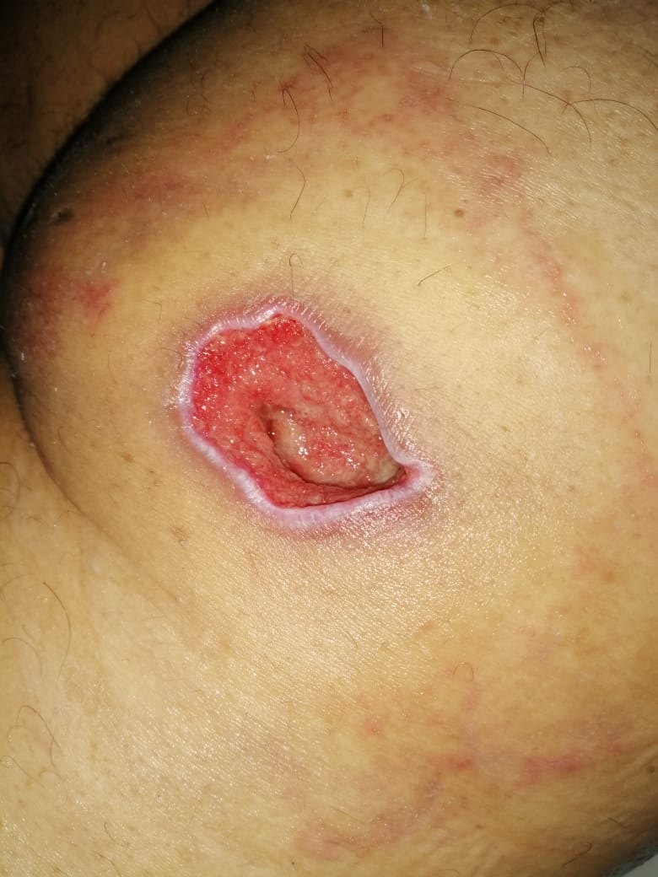
Figure 1: External orifice at 8 o'clock at posterior aspect of the upper thigh
Diagnostic Process: Chest radiography, laboratory tests, and colonoscopy results were normal.
Therapeutic Intervention: Under spinal anesthesia the patient underwent fistulotomy plus seton placement (Figure 2). Samples were taken for routine microbiology culture, which confirmed the presence of tuberculosis.
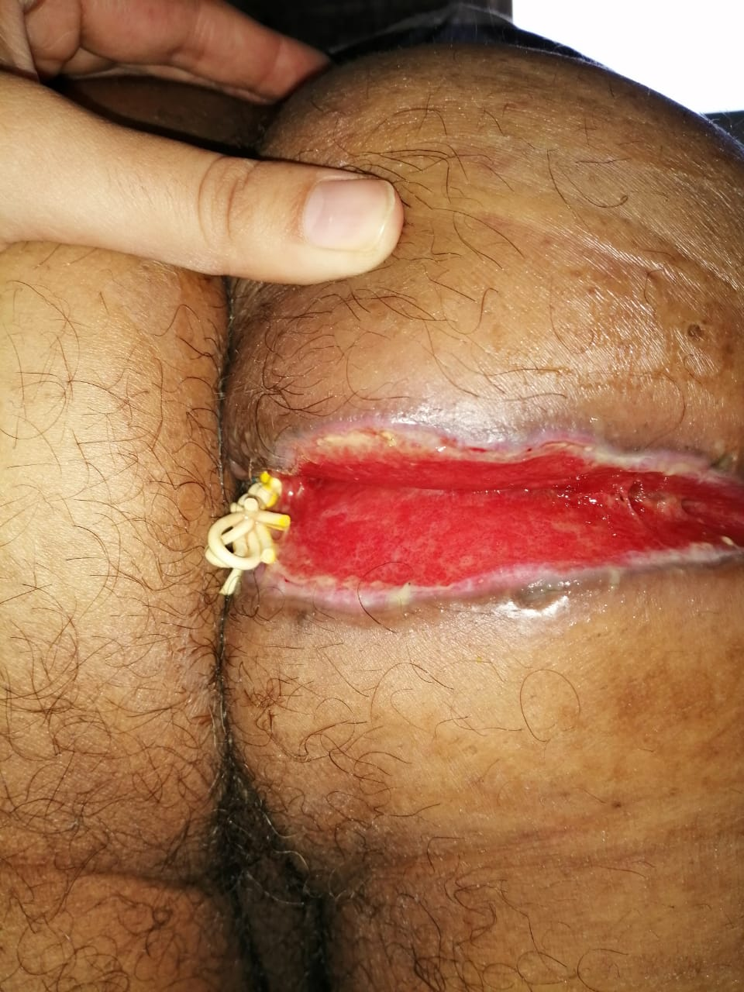
Figure 2: Post-operative appearance of the fistulotomy plus seton
Pathological Study: Histology revealed the presence of epithelioid and giant cell granulomas (Figure 3).
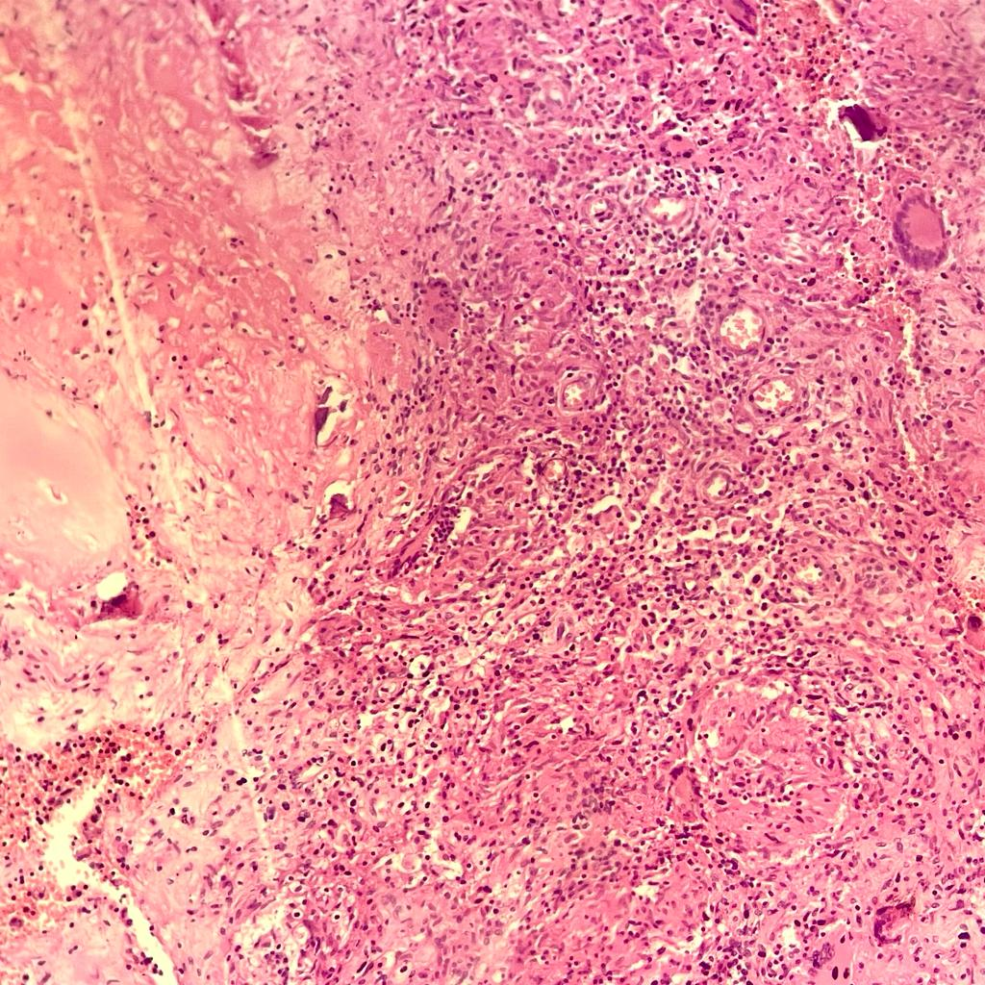
Figure 3: Epithelioid and giant cell granulomas on low power (x40)

Follow-up: At 8 weeks postoperatively, the seton fell off, and the patient received antibacillary treatment for a period of 9 months. The patient was followed up for 8 months after surgery, with no recurrence observed, and complete healing of the wound (Figure 4).
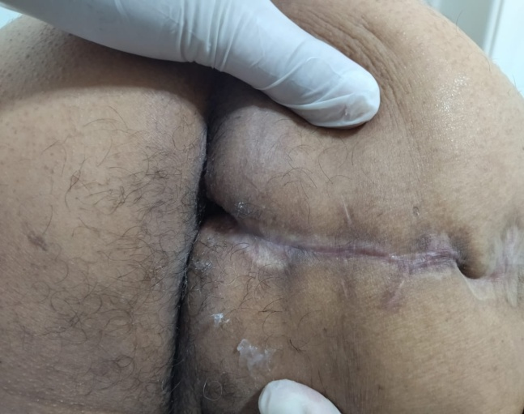
Figure 4: Appearance after complete healing of the wound
HIV status: The diagnostic assessment included HIV status, which was found to be unknown
DISCUSSION:
Tuberculosis can affect various parts of the gastrointestinal tract, including the peritoneum, stomach, duodenum, ileocaecal region, colon, and rectum. Perianal involvement however is a rare extra-pulmonary form of tuberculosis, and most published cases are reported as case reports[1], [3]
Several pathways of tuberculosis dissemination exist. Anal contamination typically arises from the ingestion of respiratory secretions containing significant quantities of Mycobacterium tuberculosis bacilli. Other proposed mechanisms for the presence of tubercle bacilli in the perianal region include hematogenous dissemination from the primary lung focus during childhood, followed by reactivation, and direct extension from nearby organs, facilitated by lymphatic channels originating from infected nodes, occasionally, contamination may occur through inoculation or ingestion of food contaminated with tuberculosis bacilli[4], [5].
Among the reviewed case reports, males were more commonly affected than females, with the majority of cases occurring during the fourth decade of life [1], [3]. Shukla et al. [6] reported that 15.6% of patients undergoing surgical repair of anal fistula in a tuberculosis-endemic region were found to have tuberculosis upon histopathological examination. The incidence of tuberculosis has increased due to the onset of acquired immunodeficiency syndrome [7]. Four clinical forms of anal tuberculosis have been described: verrucous, ulcerated, lupus, and military [8]. Currently, the most common form (60% to 100% of cases) appears to be a simple or complex fistula, often presenting with an abscess at the anal margin [9]. Differentiating tuberculosis fistula from a cryptoglandular fistula is challenging, as there are no specific functional signs or preferred sites [8], [10]. These long-standing fistulas are often complex and recurrent despite appropriate surgical treatment [8], [10]. The tuberculin skin test remains a valuable diagnostic tool, with a positive result in 75% of cases [11]. Histological or bacteriological analysis is essential for the definitive diagnosis of anal tuberculosis. The typical histologic lesion is the presence of epithelioid and giant cell tubercles surrounding a zone of caseous necrosis, although the presence of caseation is not always consistent and can pose diagnostic challenges, particularly in cases of Crohn's disease with anoperineal involvement [9]. Diagnosis can also be achieved by direct examination (Ziehl-Nielsen stain) and culture for Koch's bacillus in anal lesions. To expedite the diagnostic process (which usually takes 3 to 4 weeks), newer techniques such as polymerase chain reaction (PCR), GeneXpert, and histopathology (HPE) have been introduced. PCR-based detection of TB has shown significantly higher sensitivity compared to histopathology and GeneXpert [12].
Surgical treatment of the fistula aims to ensure good drainage of infected lesions and flattening of the fistulous tract. The approach may involve one or multiple stages depending on the location of the fistulous tract relative to the sphincter apparatus [9], [13]. In regions with multi-drug resistant TB, additional antibiotics such as Streptomycin may be added to the standard four-drug antibiotic therapy regimen [14].
Recurrences are infrequent once anti-tuberculous therapy has commenced [15]. Thus, early diagnosis is imperative in such patients to mitigate recurrences and avoid further surgical interventions for this readily treatable condition [4], [15].
Conclusion:
This case illustrates the diagnostic challenges, requiring a combination of clinical suspicion, histopathology, and microbiology. A multidisciplinary approach, including both medical and surgical treatments, proved effective.
Tuberculosis of the anal region, though rare, should be considered in cases of chronic anal fistula, especially in endemic areas, this underscores the importance of early recognition and comprehensive management strategies to prevent recurrences and unnecessary surgical interventions in patients with tuberculous anal fistulas [15].
Ethics Approval and Consent to Publication:
Ethics Approval:
This case is exempt at our institution. Patient confidentiality was maintained, and no identifying information has been disclosed.
Consent
As per international standards or university standards, patient(s) written consent has been collected and preserved by the author(s).
Consent to Publication:
We hereby confirm that written informed consent for the publication of the study's findings has been obtained from the participant patient involved in the research.
Competing interests:
The authors declare that they have no competing interests.
Availability of data and materials:
The datasets generated and analyzed during the current study are not publicly available due to their format as images, and due to their visual nature, they cannot be uploaded to a public repository. Interested parties can access the datasets directly within the article.
Disclaimer
This paper is an extended version of a preprint /repository/ Thesis document of the same author.
The preprint /repository/ Thesis document is available in this link: https://www.researchsquare.com/article/rs-3197477/v1
[As per journal policy, preprint /repository article can be published as a journal article, provided it is not published in any other journal]

COMPETING INTERESTS DISCLAIMER:
Authors have declared that they have no known competing financial interests OR non-financial interests OR personal relationships that could have appeared to influence the work reported in this paper.

Disclaimer (Artificial intelligence)
Author(s) hereby declare that generative AI technologies such as Large Language Models, etc. have been used during the writing or editing of manuscripts. This explanation will include the name, version, model, and source of the generative AI technology and as well as all input prompts provided to the generative AI technology.
Details of the AI usage are given below:
1. ChatGPT (OpenAI) was used for grammar checking, language polishing, and improving the clarity of medical terminology throughout the manuscript.
2. Claude AI (Anthropic) was used for reviewing manuscript structure, formatting consistency, and ensuring proper academic writing style.
3. Both tools were used to enhance the readability and professional presentation of the case report while maintaining the original medical content and clinical observations.
REFERENCES:
[1] K. Bentamaet al., « Les fistules anales d’origine tuberculeuse. A propos de quatre cas », J. Afr. Hépato-Gastroentérologie, vol. 6, nº 1, p. 15-17, mars 2012, doi: 10.1007/s12157-011-0336-5.
[2] W.-C. Tai, T.-H. Hu, C.-H. Lee, H.-H. Chen, C.-C. Huang, et S.-K. Chuah, « Ano-perianal tuberculosis: 15 years of clinical experiences in Southern Taiwan », Colorectal Dis., vol. 12, nº 7Online, p. e114-e120, 2010, doi: 10.1111/j.1463-1318.2009.02057.x.
[3] W. F. Wright, « Infectious Diseases Perspective of Anorectal Abscess and Fistula-in-ano Disease », Am. J. Med. Sci., vol. 351, nº 4, p. 427-434, avr. 2016, doi: 10.1016/j.amjms.2015.11.012.
[4] K. Ibn Majdoub Hassani, S. AitLaalim, I. Toughrai, et K. Mazaz, « Perianal Tuberculosis: A Case Report and a Review of the Literature », Case Rep. Infect. Dis., vol. 2012, p. 852763, 2012, doi: 10.1155/2012/852763.
[5] A. A. R. Takahashi, T. Bassaneze, K. S. Longo, J. G. Batista, et J. Waisberg, « Primary extensive perianal cutaneous tuberculosis: A challenging diagnosis. Case report and a review of the literature », Braz. J. Infect. Dis., vol. 27, nº 1, p. 102722, janv. 2023, doi: 10.1016/j.bjid.2022.102722.
[6] H. S. Shukla, S. C. Gupta, G. Singh, et P. A. Singh, « Tubercular fistula in ano », Br. J. Surg., vol. 75, nº 1, p. 38-39, janv. 1988, doi: 10.1002/bjs.1800750114.
[7] M. Hartstein et H. L. Leaf, « Tuberculosis of the breast as a presenting manifestation of AIDS », Clin. Infect. Dis. Off. Publ. Infect. Dis. Soc. Am., vol. 15, nº 4, p. 692-693, oct. 1992, doi: 10.1093/clind/15.4.692.
[8] M. Kraemer, S. S. Gill, et F. Seow-Choen, « Tuberculous anal sepsis: report of clinical features in 20 cases », Dis. Colon Rectum, vol. 43, nº 11, p. 1589-1591, nov. 2000, doi: 10.1007/BF02236745.
[9] S. Sultan, F. Azria, P. Bauer, M. Abdelnour, et P. Atienza, « Anoperineal tuberculosis: diagnostic and management considerations in seven cases », Dis. Colon Rectum, vol. 45, nº 3, p. 407-410, mars 2002, doi: 10.1007/s10350-004-6191-3.
[10] M. Alyouneet al., « Fistules anales tuberculeuses. A propos de treize cas. », 1994. Consulté le: 2 octobre 2024. [En ligne]. Disponible sur: https://www.semanticscholar.org/paper/Fistules-anales-tuberculeuses.-A-propos-de-treize-Alyoune-Nadir/d5b27523f6a2a543d7cbb1dc0a7dc1edf3a0b7bb
[11] P. C. Jutte, Spinal tuberculosis, a Dutch perspective: special reference to surgery. s.n., 2006.
[12] P. Garg, A. Goyal, V. D. Yagnik, S. Dawka, et G. R. Menon, « Diagnosis of anorectal tuberculosis by polymerase chain reaction, GeneXpert and histopathology in 1336 samples in 776 anal fistula patients », World J. Gastrointest. Surg., vol. 13, nº 4, p. 355-365, avr. 2021, doi: 10.4240/wjgs.v13.i4.355.
[13] F. Candela, P. Serrano, J. M. Arriero, A. Teruel, D. Reyes, et R. Calpena, « Perianal disease of tuberculous origin: report of a case and review of the literature », Dis. Colon Rectum, vol. 42, nº 1, p. 110-112, janv. 1999, doi: 10.1007/BF02235192.
[14] K. J. Seung, S. Keshavjee, et M. L. Rich, « Multidrug-Resistant Tuberculosis and Extensively Drug-Resistant Tuberculosis », Cold Spring Harb. Perspect. Med., vol. 5, nº 9, p. a017863, sept. 2015, doi: 10.1101/cshperspect.a017863.
[15] E. Akgun, F. Tekin, S. Ersin, et H. Osmanoglu, « Isolated perianal tuberculosis », Neth. J. Med., vol. 63, nº 3, p. 115-117, mars 2005.

