Case report
Meningeal Metastases Presenting as Extra-Axial Hematoma: A Diagnostic Pitfall

.

ABSTRACT

Aims: To illustrate a significant diagnostic pitfall where meningeal metastases mimic benign extra-axial hematomas, and to highlight the crucial role of contrast-enhanced magnetic resonance imaging (MRI) in achieving the correct diagnosis.
Presentation of Case: We report two cases. The first is a 44-year-old female with breast carcinoma whose dural metastases presented on computed tomography (CT) as an enhancing dural-based mass. The second is a 38-year-old male with colorectal cancer whose dural metastasis appeared on CT as a collection suggestive of a subacute hematoma. In both cases, MRI was crucial in rectifying the diagnosis by revealing features of a hypercellular neoplasm. Both patients had a poor outcome, with rapid clinical deterioration despite intervention.
Discussion: The radiological presentation of meningeal metastases can be deceptive. Key MRI findings that argue for a neoplastic process include marked diffusion restriction and nodular dural enhancement.
Conclusion: The possibility of meningeal metastases should be considered in the differential diagnosis of any new extra-axial collection in patients with a known history of malignancy. Contrast-enhanced MRI is indispensable to differentiate these lesions and guide appropriate management.

Keywords: Meningeal metastases; Dural metastases; Extra-axial hematoma; Diagnostic pitfall; Breast cancer; Magnetic Resonance Imaging (MRI).

1. INTRODUCTION

Meningeal metastasis, encompassing both dural and leptomeningeal carcinomatosis, is a recognized and severe complication of systemic cancer, often associated with a poor prognosis (Laigle-Donadey et al., 2005). Meningeal metastasis includes two distinct entities: dural metastases, which often present as solid extra-axial masses, and leptomeningeal carcinomatosis, characterized by a diffuse spread within the cerebrospinal fluid pathways. While a wide variety of malignancies can be implicated, this phenomenon is most frequently associated with primary tumors of the breast, lung, and prostate, particularly for dural-based lesions (Kurokawa et al., 2023).
The clinical presentation is typically non-specific, including headaches, cranial nerve palsies, or other focal neurological deficits. Radiologically, the diagnosis is most often confirmed by contrast-enhanced MRI. However, a significant diagnostic pitfall exists wherein these metastases can present with imaging features resembling benign extra-axial hematomas, such as subdural or epidural collections (Ortega-Rodriguez et al., 2021). This mimicry is particularly challenging on initial computed tomography (CT) scans, where dural metastases can appear as isodense or hyperdense crescent-shaped collections, leading to potential misdiagnosis and delayed oncologic management.
This report illustrates this diagnostic challenge through two cases—breast and colorectal carcinoma—where meningeal metastases presented as extra-axial hematoma, with emphasis on CT and MRI findings that helped orient the diagnosis. The two cases presented in this report were selected retrospectively from our institution's clinical archives for their value in illustrating this important diagnostic challenge.

2. PRESENTATION OF CASE
2.1 Case 1

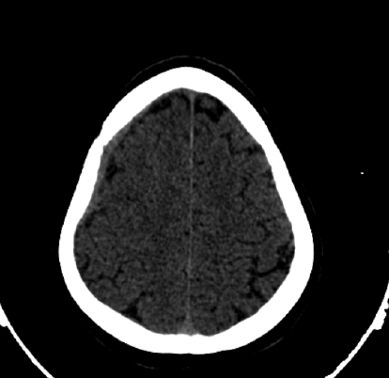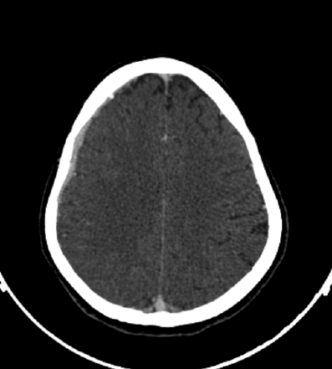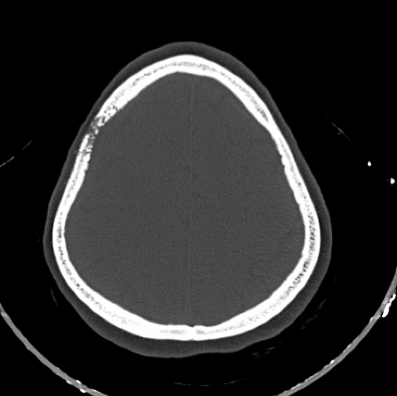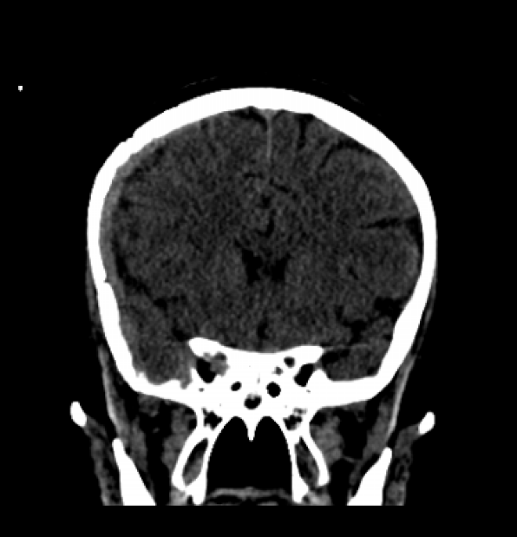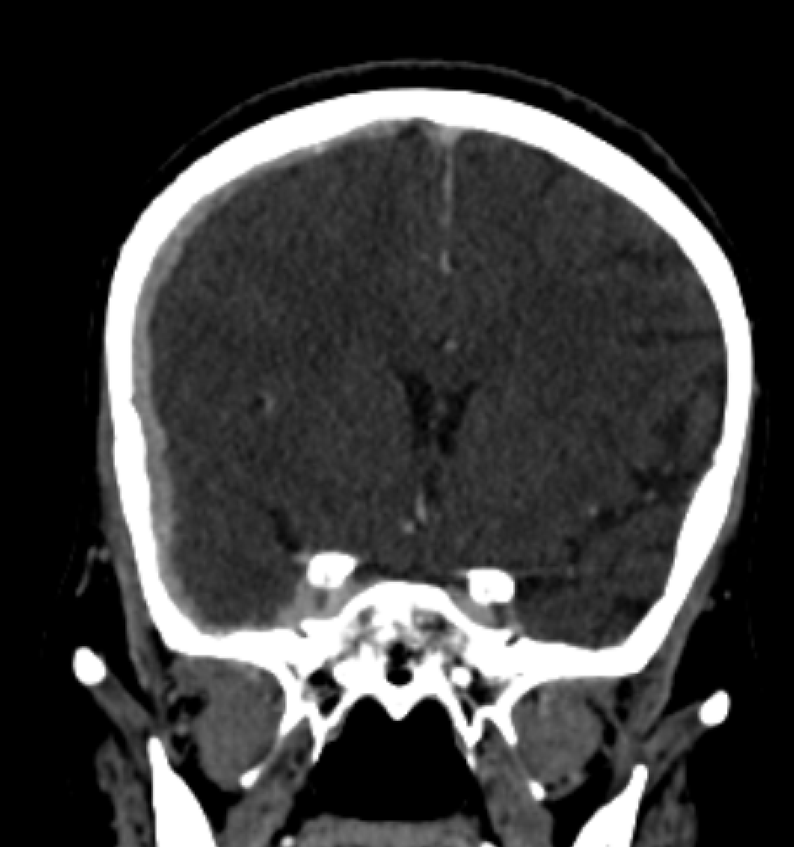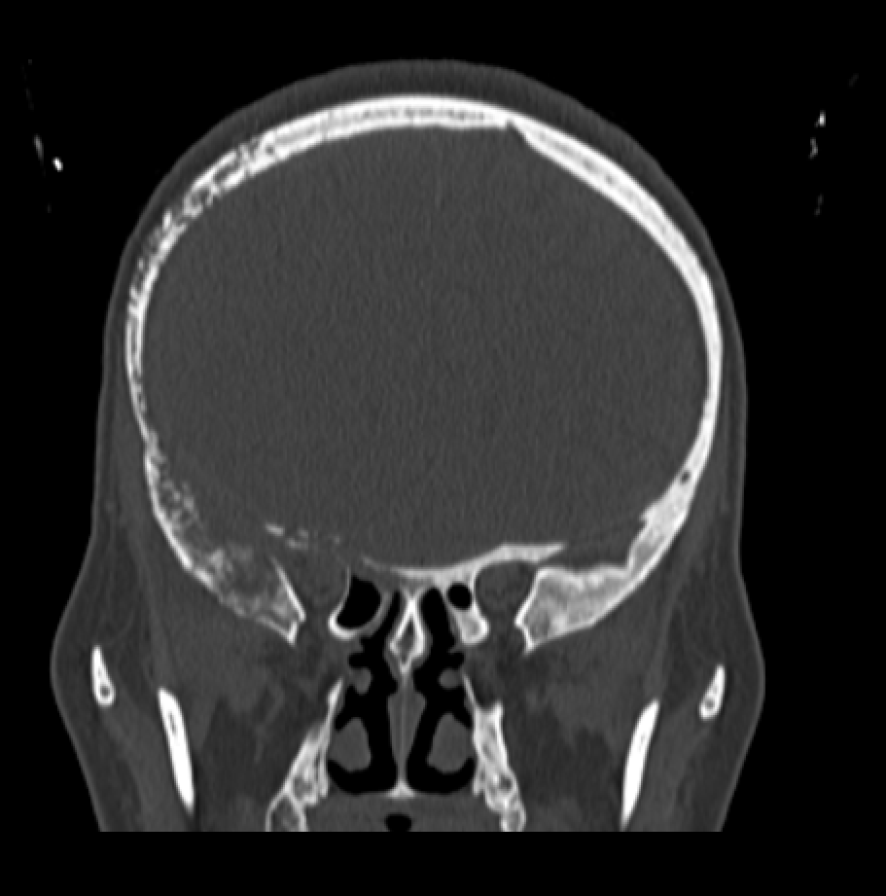A 44-year-old female presented with a one-month history of progressive headaches, fatigue, and confusion. The workup diagnosed a grade III invasive ductal carcinoma (IDC) of the right breast, with an immunoprofile that was hormone receptor-positive (HR+) and human epidermal growth factor receptor 2-positive (HER2+). A comprehensive staging CT revealed a large primary retro-areolar mass measuring 52 x 50 x 59 mm, with local invasion of the skin and pectoral muscle. The scan also confirmed a significant systemic disease burden, with metastases in the lungs, multiple lymph node chains, and skeleton. Cranial imaging revealed the diagnostic challenge: lytic destruction of the right sphenoid and fronto-temporal bones, from which a contiguous, dural-based mass extended into the intracranial space (Figure 1). In light of the complete clinical picture, the dural-based mass was considered a manifestation of carcinomatosis, and the patient was directed toward palliative radiotherapy.
Fig. 1. Dural Metastasis Mimicking an Extra-Axial Hematoma (Case 1). A right fronto-temporal, spontaneously dense extra-axial lesion on non-contrast CT (A, D) mimics a hematoma. Its intense post-contrast enhancement (B, E) is highly suggestive of a neoplastic process. The extensive underlying osteolytic lesion, revealed on the bone windows (C, F), is a hallmark of a malignant origin (Axial findings: blue arrows; Coronal findings: orange arrows).
A
B
C
D
E
F

2.2 Case 2

A 38-year-old male with a history of surgically treated rectal adenocarcinoma presented with acute neurological symptoms, including headache, vomiting, confusion, and a spastic left hemiparesis. An initial non-contrast CT scan revealed a hyperdense, extra-axial collection with an appearance suggestive of a subacute epidural hematoma (Figure 2A). For further characterization of this lesion, a multi-parametric MRI was performed. This advanced imaging provided findings that contradicted the initial hypothesis. While the lesion was iso-intense on T1 and T2-weighted sequences (Figure 2B), it exhibited profound diffusion restriction on diffusion-weighted imaging (DWI)—a hallmark of hypercellularity— (Figure 2C) and intense, heterogeneous enhancement post-gadolinium administration (Figure 2D). Furthermore, the process was complicated by a tumoral invasion and thrombosis of the right sigmoid sinus. This combination of features was inconsistent with a simple hematoma. The definitive diagnosis of leptomeningeal carcinomatosis was established via the cytological identification of malignant cells in the cerebrospinal fluid.
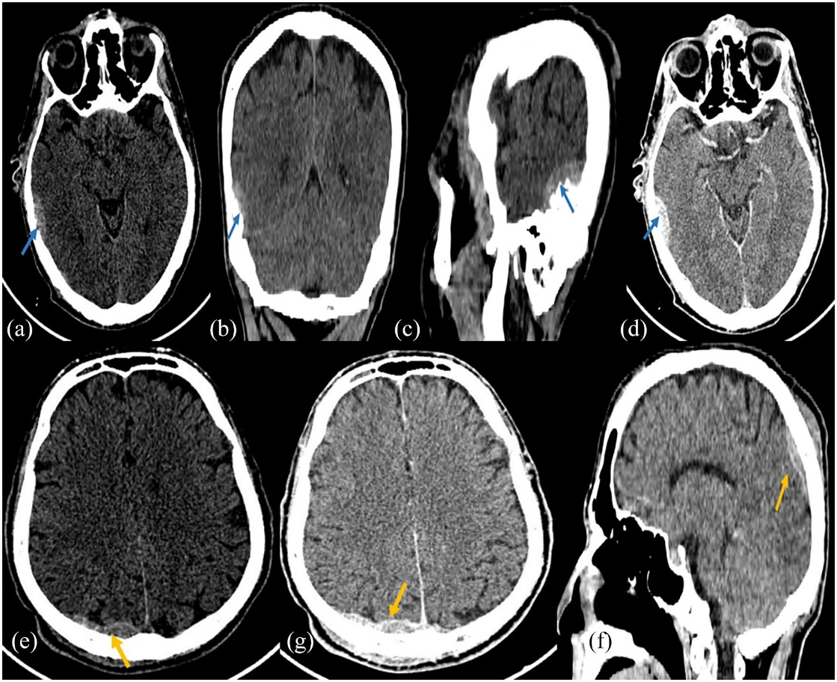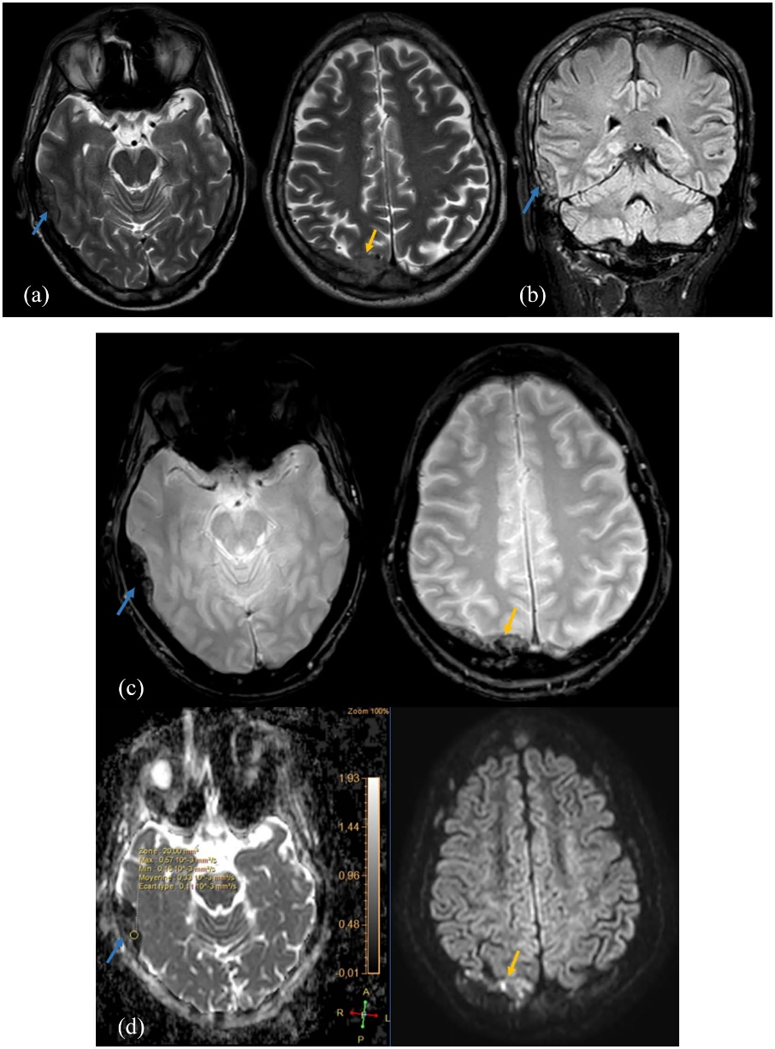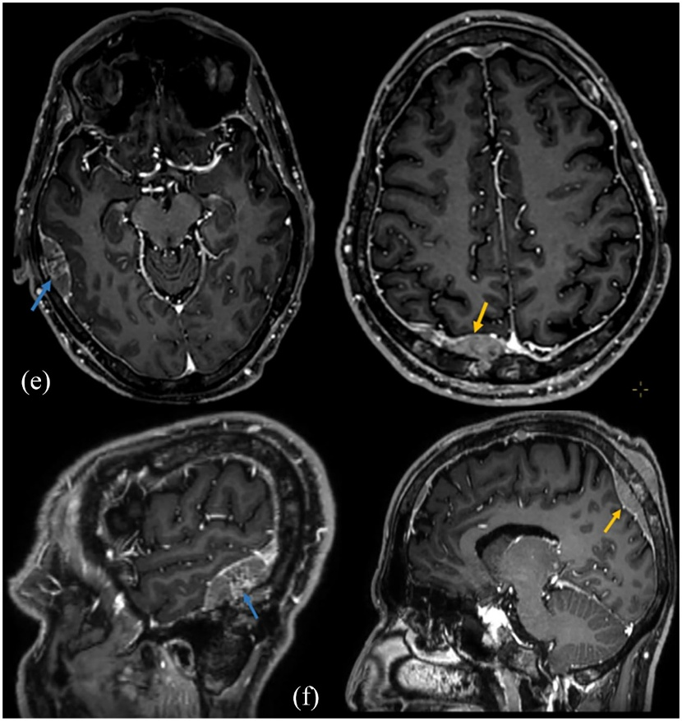
Fig. 2. Hematoma-Mimicking Dural Metastasis (Case 2). Non-contrast CT (A) demonstrates a hyperdense extra-axial lesion in the temporal region, simulating a subacute hematoma. On MRI, this portion of the lesion shows an iso-intense T2 signal (B) and profound diffusion restriction (C) (ADC low at 0.33×10⁻³ mm²/s), indicating high cellularity. The post-contrast T1-weighted MRI (D) demonstrates intense and heterogeneous enhancement, a defining feature of a vascularized neoplasm. (Images from our institution, used with patient consent).
A
B
C
D

3. Discussion

This report highlights a critical diagnostic pitfall through two distinct cases where meningeal metastases presented with features of an extra-axial hematoma. This phenomenon is a well-documented entity in the literature, a phenomenon that is thought to be underdiagnosed (Catana et al., 2016). Misdiagnosis can have significant consequences, potentially leading to unnecessary surgical interventions and delays in appropriate oncologic therapy.
Our first case, a dural metastasis from breast cancer, aligns with findings from several reports identifying breast cancer as one of the most common primaries to present in this manner (Takeda et al., 2019; Ortega Rodriguez et al., 2021). The presentation can be remarkably subtle, at times perfectly mimicking a chronic subdural hematoma even on initial MRI studies (Ortega Rodriguez et al., 2021).
Our second case, originating from a colorectal adenocarcinoma, illustrates that this pitfall is not exclusive to breast cancer. Similar presentations have been reported in patients with colorectal cancer (Siy et al., 2023) and prostate cancer (Yamaguchi et al., 2021; Rios-Vicil & De Jesus, 2025). The inclusion of this case is intended to underscore that this diagnostic pitfall is not exclusive to the most common primary tumors and that a high index of suspicion should be maintained for a wide range of malignancies (Bordia et al., 2021).
Advanced imaging, particularly contrast-enhanced MRI, is crucial to resolve this dilemma. MRI provides superior characterization, as key findings supporting a neoplastic process include diffusion restriction, nodular dural enhancement, and sinus thrombosis or parenchymal invasion (Lahfidi et al., 2022; Lyndon et al., 2019). For clinical practice, imaging criteria distinguishing dural metastases from hematomas are summarized in Table 1.
The potential pathophysiological mechanism for this hematoma-like appearance may involve microhemorrhages from fragile tumor neovessels or venous congestion from sinus invasion. Autopsy and histopathological studies confirm that the obstruction of dural vessels by tumor cells is a key etiological factor (Laigle-Donadey et al., 2005).
Advanced techniques like perfusion MRI may show different vascularity in most dural metastases compared to other mimics like meningiomas, although hypervascular metastases can overlap (Furtner et al., 2020). The prognosis remains poor, with early recurrence and rapid deterioration often reported despite surgical intervention (Siy et al., 2023; Yamaguchi et al., 2021). A multidisciplinary approach is therefore required once diagnosis is confirmed.

4. Conclusion

Meningeal metastases can present a formidable diagnostic challenge by deceptively resembling extra-axial hematomas on initial imaging. A high index of suspicion should be maintained in any oncologic patient presenting with such findings. Contrast-enhanced MRI, with careful attention to DWI sequences and enhancement patterns, is indispensable for accurate characterization. Distinguishing this neoplastic mimicry from a true hematoma is essential for ensuring timely and appropriate patient management and avoiding potentially harmful diagnostic and therapeutic errors.

Consent

All authors declare that ‘written informed consent was obtained from the patient (or other approved parties) for publication of this case report and accompanying images. A copy of the written consent is available for review by the Editorial office/Chief Editor/Editorial Board members of this journal.

Ethical approval

All authors hereby declare that all experiments have been examined and approved by the appropriate ethics committee and have therefore been performed in accordance with the ethical standards laid down in the 1964 Declaration of Helsinki.

DISCLAIMER (ARTIFICIAL INTELLIGENCE)
Author(s) hereby declare that NO generative AI technologies such as Large Language Models (ChatGPT, COPILOT, etc.) and text-to-image generators have been used during the writing or editing of this manuscript.

References

Lahfidi, A., Traore, W.-Y. M., Imrani, K., Jerguigue, H., Latib, R., & Omor, Y. (2022). Leptomeningeal Metastasis Mimicking a Subacute Epidural Hematoma: Case Report. Clinical Medicine Insights: Case Reports, 15, 11795476221121315. https://doi.org/10.1177/11795476221121315
Bordia, R., Le, M., & Behbahani, S. (2021). Pitfalls in the Diagnosis of Subdural Hemorrhage – Mimics and Uncommon Causes. Journal of Clinical Neuroscience, 89, 71-84. https://doi.org/10.1016/j.jocn.2021.02.006
Catana, D., Koziarz, A., Cenic, A., et al. (2016). Subdural Hematoma Mimickers: A Systematic Review. World Neurosurgery, 93, 73-80. https://doi.org/10.1016/j.wneu.2016.05.084
Furtner, J., Oth, I., Schöpf, V., et al. (2020). Noninvasive Differentiation of Meningiomas and Dural Metastases Using Intratumoral Vascularity Obtained by Arterial Spin Labeling. Clinical Neuroradiology, 30(3), 599-605. https://doi.org/10.1007/s00062-019-00808-x
Kurokawa, R., Kurokawa, M., Isshiki, S., et al. (2023). Dural and Leptomeningeal Diseases: Anatomy, Causes, and Neuroimaging Findings. RadioGraphics, 43(9), e230039. https://doi.org/10.1148/rg.230039
Laigle-Donadey, F., Taillibert, S., Mokhtari, K., Hildebrand, J., & Delattre, J-Y. (2005). Dural Metastases. Journal of Neuro-Oncology, 75(1), 57-61. https://doi.org/10.1007/s11060-004-8098-1
Lyndon, D., Lansley, J. A., Evanson, J., & Krishnan, A. S. (2019). Dural Masses: Meningiomas and Their Mimics. Insights into Imaging, 10(1), 11. https://doi.org/10.1186/s13244-019-0697-7
Ortega Rodriguez, A. A., Centeno Haro, M., Caro Cardera, J. L., Joly Torta, C., & De Manuel-Rimbau Muñoz, J. (2021). Dural Metastasis from Breast Carcinoma Mimicking Sub-Acute Subdural Hematoma: A Case Report. Indian Journal of Surgical Oncology, 12(S1), 197-200. https://doi.org/10.1007/s13193-021-01283-y
Rios-Vicil, C. I., & De Jesus, O. (2025). Prostate adenocarcinoma dural metastasis mimicking a subacute subdural hematoma. Surgical Neurology International, 16, 60. https://doi.org/10.25259/SNI_1077_2024
Siy, H. F. C., Pacia, E. M. J. B., Ong, A. O., Ong-Lingan, M., & Rosales, P. P. (2023). Rectal Dural Metastasis Masquerading as Chronic Subdural Hematoma: Illustrative Case. Journal of Neurosurgery: Case Lessons, 5(18), CASE2316. https://doi.org/10.3171/CASE2316
Takeda, H., Ohe, R., Fukui, T., et al. (2019). Rapid Progression of Intracranial Dural Metastases in a Patient with Carcinoma of Unknown Primary Site. Case Reports in Oncology, 12(2), 666-70. https://doi.org/10.1159/000502416
Yamaguchi, I., Kanematsu, Y., Mizobuchi, Y., et al. (2021). Chronic Subdural Hematoma Associated with Dural Metastasis Leads to Early Recurrence and Death: A Single-Institute, Retrospective Cohort Study. Journal of Clinical Neuroscience, 94, 244-49. https://doi.org/10.1016/j.jocn.2021.10.037

Table 1. Summary of key imaging findings distinguishing dural metastases from subdural hematomas.

Feature | Dural metastasis | Subdural hematoma
CT density | Hyperdense | Variable (depending on age)
Contrast enhancement | Intense, often nodular | Usually none (except membrane enhancement in the subacute phase)
Bone reaction | Often lytic destruction (except for prostate cancer) | No lytic destruction, may show fracture
Calcification | Rare | Very rare
MRI diffusion (DWI) | Often restricted (hypercellularity) | Variable, typically not restricted

