Case report
Integrated Pharmacological and Physiotherapy Approach in Chronic Osteosarcoma Pain: A case report

Abstract
Introduction: Chronic bone cancer pain arises from both nociceptive and neuropathic mechanisms, often causing impaired mobility, reduced quality of life, and psychosocial distress. While opioids remain the cornerstone of severe cancer pain management, adjunctive physiotherapy and non-pharmacological strategies provide added benefit. Evidence from India on multidisciplinary approaches to bone tumour pain remains limited.
Case Presentation: A 27-year-old male with recurrent osteosarcoma of the right femur presented with severe pain (VAS 6/10), sleep disturbance, and functional decline. NSAIDs offered limited relief. A multidisciplinary plan was initiated, combining pharmacological and physiotherapeutic measures. Pain was controlled using rapid intravenous morphine titration, then oral morphine (10 mg four-hourly) with paracetamol and gabapentin. Physiotherapy included guided isometric strengthening and low-level laser therapy (LLLT) to the affected site.
Outcome: Over four months, pain scores decreased from 6 to 1. EQ-5D-5L scores improved from 43352 to 22222, and EQ-VAS decreased from 61 to 12, reflecting reduced health burden. No adverse effects were noted, and adherence was excellent, with improvements in mobility, sleep, and overall well-being.
Discussion: This case demonstrates that integrated management combining opioids, adjuvant therapy, and physiotherapy provides effective relief of bone cancer pain. Morphine offered rapid analgesia, gabapentin targeted neuropathic elements, and physiotherapy improved strength, function, and comfort.
Conclusion: A multidisciplinary strategy with pharmacological and physiotherapeutic interventions achieved durable pain control and enhanced quality of life in a young patient with osteosarcoma.

Introduction
Bone pain is one of the most prevalent forms of chronic pain in patients with metastatic bone disease, and most of them feel moderate to severe pain. Despite the fact that bone is not an essential organ, many common cancers, including those of the breast, prostate, thyroid, kidney, and lung, have a significant propensity to spread to several bones at once. The patient’s functional level, quality of life, and lifespan are all compromised by tumour growth in bone, which causes pain, anaemia, hypercalcemia, skeletal fractures, increased susceptibility to infection, spinal cord compression, spinal instability, and diminished mobility. ¹
Bone pain is a mixed mechanism pain condition that usually manifests as a mix of breakthrough (spontaneous and incident) and background cancer pain. Bone pain affects one-third of patients with advanced cancer who have bone metastases, leading to poor quality of life, psychological discomfort, anxiety, and depression. Radiotherapy, radioisotopes, orthopaedic surgery, bisphosphonates, anti-RANK-L antibodies, opioids, and non-opioid co-analgesics such corticosteroids, antidepressants, and non-steroidal anti-inflammatory drugs are among the current treatments for bone pain due to cancer. Opioids continue to be the standard treatment. ²
The most frequent location for bone metastases is the spine. A major clinical problem, bone metastases result in hypercalcemia, spinal cord compression, pathological fractures, excruciating pain, and a marked decline in quality of life. For individuals with bone metastasis, pain continues to be the most common symptom and the primary factor affecting their mobility and quality of life. Many signs point to the beneficial effects of tailored resistance training measures on pain and movement in tumour patients of any source. ³
Low-level laser therapy (LLLT) is a non-invasive technique that is being used more and more to treat chronic bone pain, particularly pain brought on by bone cancer. LLLT was first used in the 1960s and uses low-intensity laser light to ease pain, lower inflammation, and promote cellular healing without producing heat. LLLT has demonstrated efficacy in lowering oedema and enhancing bone regeneration, and it has been approved by the FDA for a number of musculoskeletal diseases. LLLT is a useful adjunct for cancer-related bone pain, reducing the requirement for high-dose analgesics and promoting a multidisciplinary approach to pain management.⁴
Physiotherapy plays a crucial role in the multidisciplinary management of patients with bone metastases who deal with chronic pain. Rehabilitation aims to preserve mobility, reduce fracture risk, and boost function via customized interventions in aerobic exercise, resistance training, flexibility, balance, and patient education. Systematic reviews indicate that both supervised and unsupervised exercise, encompassing resistance and aerobic training, is safe, feasible, and effective in alleviating cancer-related pain as well as improving physical function in individuals with bone metastases, with few adverse events reported.⁵
There are very few study that includes multidisciplinary approach including pharmacological management and Physiotherapy for the management of chronic bone tumour pain in India. This case report includes the use of multidisciplinary approach for management of pain in such patient.
Case presentation
A 27-year-old male patient presents to the outpatient department in the department of Palliative Medicine at tertiary cancer care center, with complain of pain since last 2 months over right lower limb. According to patient, pain is continuous, gradually increasing, aching in nature and partial relieve with Diclofenac 50mg oral tablet. Patient also complains of sleep disturbances, night awakening due to pain. At present NPRS (numerical pain rating scale) score for pain is 6. Patient is known case of Osteosarcoma of right femur, for which he has undergone neoadjuvant chemotherapy, surgical excision and post surgical chemotherapy. Patient developed recurrence and completed 10 fractions of radiotherapy for the same.
The patient’s complete blood count revealed hemoglobin of 9.8 gm/dL, total leukocyte counts of 10,584/cumm, and platelet count of 3,75,000/cumm. Renal function tests, electrolytes, and liver function tests were within normal limits. Chest X-ray demonstrated clear lung fields with a normal cardiac silhouette and no pleural or bony abnormalities. MRI of the right lower limb showed an irregular, enhancing soft tissue lesion at the prior surgical site in the distal right femur, with evidence of marrow involvement and cortical breach, findings suggestive of local recurrence of osteosarcoma.
On examination, the patient was afebrile with a pulse rate of 104/min, blood pressure of 142/84 mmHg, and respiratory rate of 19/min. Local examination of the right lower limb revealed a round-shaped mass over the lower one-third of the thigh, more prominent compared to the left side. The overlying skin was intact with no evidence of edema, redness, fungation, or visible pulsations. Distal pulses were palpable. As the patient opted for symptomatic management only, our focus was on pain relief and functional improvement.
Assessment - The patient was assessed as a known case of recurrent osteosarcoma of the right femur presenting with chronic cancer-related pain, functional limitation, and sleep disturbance. Baseline pain was rated as 6/10 on the VAS, with reduced muscle strength and mobility. Quality of life was markedly impaired, as reflected by an EQ-5D-5L health state of 43352, indicating severe problems in multiple domains.

Treatment – Patient was admitted in ward with the following treatment protocol.
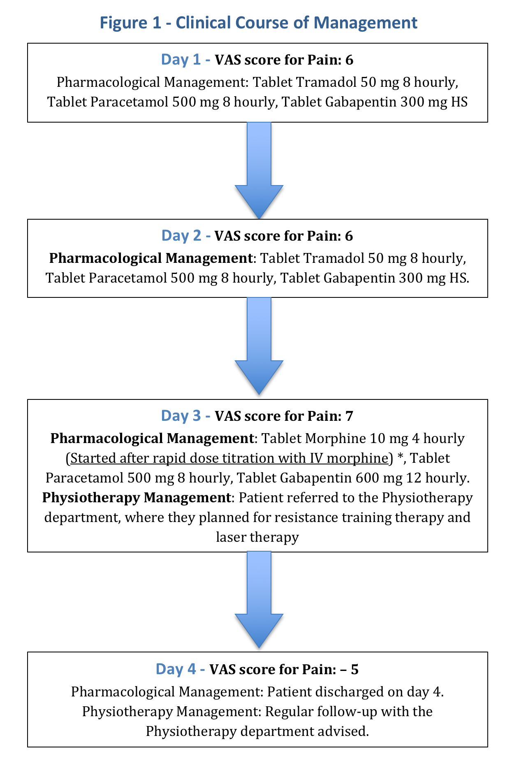

*Rapid titration method for morphine dose (Institute of palliative medicine, India) ⁶ - After obtaining IV venous access, we gave IV 10mg Metoclopramide. 1mg IV Morphine given at every 10 minutes, till pain relief achieved. Patient required 5mg of IV Morphine, which is equivalent to 10mg of oral morphine every 4 hourly. Further patient was started on 10mg oral IR Morphine 4 hourly along with Tablet Bisacodyl 10mg at night.
Protocol of Physiotherapy
- Exercise Therapy
Type: Guided isometric strengthening of local musculature
Frequency: 5 days per week
Intensity: Sub-maximal contraction at 40–60% of maximal voluntary contraction (MVC)
Duration per session: Each contraction held 6–10 seconds with rest for 10–20 seconds; 8–12 repetitions; 2–3 sets (session duration 15–20 minutes)
Program length: 4 weeks
- Low-Level Laser Therapy (LLLT)
Wavelength: Red (~660 nm)
Power output: 200–500 mW
Energy dose: 2–4 J/cm² per treated spot
Duration per point: 30–60 seconds (~3 J delivered at 100 mW)
Sites: Over areas of bone pain, adjacent musculature, and soft tissues
Frequency: 5 sessions per week
Program length: 4 weeks

Patient was discharged on fourth day with T. Morphine 10mg 4hourly, T. Gabapentin 300mg OD, T. Paracetamol 500mg TDS and Physiotherapy protocol was continued. Patient was followed up at every month for pain assessment and quality of life assessment. Pain was measured with VAS score while quality of life was measured with EQ 5D 5L score. ⁷
Table 1 – Details of VAS score and EQ 5D 5L
 | VAS score | EQ 5D 5L | EQ VAS
Day 0 (Baseline) | 6 | 43352 | 61
Month 1 | 5 | 33342 | 53
Month 2 | 4 | 33232 | 36
Month 3 | 2 | 22221 | 18
Month 4 | 1 | 22222 | 12

Patient was followed up in the Outpatient Department of Palliative Medicine every month. Over the 4-month follow-up, the patient experienced a progressive reduction in pain scores and improvement in quality of life. The VAS score decreased from 6 at baseline to 1 at month 4, indicating near-complete pain relief. The EQ-5D-5L descriptive profile improved from 43352 at baseline (severe problems in mobility, self-care, usual activities, pain/discomfort, and moderate anxiety/depression) to 22222 at month 4, reflecting only slight problems in all dimensions. Similarly, the EQ-VAS improved from 61/100 at baseline to 12/100 at month 4, indicating better self-perceived health status. This marked improvement was sustained without any reported adverse events related to morphine, gabapentin, or physiotherapy interventions. The patient adhered to the prescribed exercise therapy and low-level laser therapy regimen throughout the study period.
Discussion
This case highlights the effectiveness of a multidisciplinary approach combining pharmacological and physiotherapeutic interventions in managing chronic bone tumour pain. The rapid titration of morphine provided prompt analgesia, while gabapentin contributed to neuropathic pain modulation. Physiotherapy interventions—particularly targeted resistance training and low-level laser therapy—likely enhanced local muscle strength, reduced inflammation, and promoted functional mobility, which collectively contributed to sustained pain reduction.
Morphine remains the gold standard for opioid therapy in moderate to severe cancer-related bone pain due to its global availability, low cost, and established efficacy. For patients with bone metastases, guidelines recommend initiating a potent pure μ-agonist (such as morphine) according to WHO step III, providing both a baseline opioid (e.g., sustained-release morphine) and an on-demand rescue opioid (e.g., immediate-release morphine) for breakthrough pain. Dose adjustments should follow the temporal pattern of pain, and in cases of activity-related pain, patients may be advised to take breakthrough medication pre-emptively. Morphine can be given orally, subcutaneously, or intravenously depending on patient needs and clinical condition. ⁸
A systematic review done by Bjordal et al to analyzed randomized placebo-controlled trials investigating low-level laser therapy (LLLT) for acute pain relief. The authors discussed proposed mechanisms, such as modulation of inflammation, promotion of cellular repair, and improved microcirculation. Across multiple musculoskeletal conditions, LLLT was associated with significant short-term pain reduction compared to placebo. Treatment was well tolerated, with minimal reported side effects. The review concluded that LLLT can be an effective, non-invasive adjunct for pain management when applied with appropriate wavelength, dosage, and treatment protocols. ⁹ Cormie et al has done a study to assess a 12-week supervised resistance training program in prostate cancer patients with bone metastases. The intervention was tailored to avoid stressing affected bones. Results showed improved muscle strength, physical function, and quality of life. No skeletal-related adverse events occurred, confirming the program’s safety. ¹⁰ Evidence suggests that exercise not only improves function, mitigates disability, and maintains independence in patients with osteosarcoma, but may also enhance treatment efficacy and quality of life. Garcia et al. have highlighted the feasibility of exercise as therapy in osteosarcoma management and survivorship, including its role in both preoperative and postoperative rehabilitation. ¹¹
To our knowledge, there are few published reports from India describing integrated pain management for bone tumour pain that combine WHO step III opioids with structured physiotherapy and adjunctive modalities such as laser therapy. This case underscores the importance of early physiotherapy referral alongside optimal pharmacological pain control to enhance patient outcomes in resource-limited settings.
Conclusion - A multidisciplinary approach combining morphine-based analgesia, adjuvant medications, and targeted physiotherapy can provide effective, sustained relief of chronic bone tumour pain. Early integration of physiotherapy alongside optimal pharmacological management enhances function and quality of life, even in resource-limited settings.

Disclaimer (Artificial intelligence)

Option 1:

Author(s) hereby declare that NO generative AI technologies such as Large Language Models (ChatGPT, COPILOT, etc.) and text-to-image generators have been used during the writing or editing of this manuscript.

Option 2:

Author(s) hereby declare that generative AI technologies such as Large Language Models, etc. have been used during the writing or editing of manuscripts. This explanation will include the name, version, model, and source of the generative AI technology and as well as all input prompts provided to the generative AI technology

Details of the AI usage are given below:
1.
2.
3.

References
- Jimenez-Andrade JM, Mantyh WG, Bloom AP et al. Bone cancer pain. Ann N Y Acad Sci. 2010 Jun;1198:173-81. Doi: 10.1111/j.1749-6632.2009.05429.x. PMID: 20536932; PMCID: PMC5642911.
- Michael Natasha. The role of methadone in cancer-induced bone pain: a retrospective cohort study. Supportive Care in Cancer. 2020; doi:10.1007/S00520-020-05606-7
- Rief H, Welzel T, Omlor G et al. Pain response of resistance training of the paravertebral musculature under radiotherapy in patients with spinal bone metastases--a randomized trial. BMC Cancer. 2014 Jul 5;14:485. doi: 10.1186/1471-2407-14-485. PMID: 24996223; PMCID: PMC4094419.
- Nesioonpour S, Mokmeli S, Vojdani S et al. The effect of low‑level laser on postoperative pain after tibial fracture surgery: a double‑blind controlled randomized clinical trial. Anesth Pain Med. 2014;4(3):e17350. doi: 10.5812/aapm.17350. PubMed PMID: 25237637; PMCID: PMC4165037
- Avancini A, Benato G, Borsati A et al. Exercise and Bone Health in Cancer: Enemy or Ally? Cancers (Basel). 2022 Dec 10;14(24):6078. doi: 10.3390/cancers14246078. PMID: 36551564; PMCID: PMC9776461.
- Kumar KS, Rajagopal MR, Naseema AM. Intravenous morphine for emergency treatment of cancer pain. Palliat Med. 2000 May;14(3):183-8. doi: 10.1191/026921600670697351. PMID: 10858825.
- Herdman M, Gudex C, Lloyd A et al. Development and preliminary testing of the new five-level version of EQ-5D (EQ-5D-5L). Qual Life Res. 2011 Dec;20(10):1727-36. doi: 10.1007/s11136-011-9903-x. Epub 2011 Apr 9. PMID: 21479777; PMCID: PMC3220807.
- Schneider G, Voltz R, Gaertner J. Cancer Pain Management and Bone Metastases: An Update for the Clinician. Breast Care (Basel). 2012 Apr;7(2):113-120. doi: 10.1159/000338579. Epub 2012 Apr 27. PMID: 22740797; PMCID: PMC3376368.
- Bjordal JM, Johnson MI, Iversen V et al. Low-level laser therapy in acute pain: a systematic review of possible mechanisms of action and clinical effects in randomized placebo-controlled trials. Photomed Laser Surg. 2006 Apr;24(2):158-68. doi: 10.1089/pho.2006.24.158. PMID: 16706694.
- Cormie P, Newton RU, Spry N et al. Safety and efficacy of resistance exercise in prostate cancer patients with bone metastases. Prostate Cancer Prostatic Dis. 2013 Dec;16(4):328-35. doi: 10.1038/pcan.2013.22. Epub 2013 Aug 6. Erratum in: Prostate Cancer Prostatic Dis. 2015 Jun;18(2):196. doi: 10.1038/pcan.2015.6. PMID: 23917308.
- Garcia MB, Ness KK, Schadler KL. Exercise and Physical Activity in Patients with Osteosarcoma and Survivors. Adv Exp Med Biol. 2020;1257:193-207. doi: 10.1007/978-3-030-43032-0_16. PMID: 32483741.

