Case report

Catastrophic Wear-Induced Pseudotumor Formation 20 Years Post-Total Hip Arthroplasty: A Rare Complication of Non-Metal-on-Metal (MoM) THR

ABSTRACT
Pseudotumors following adverse reactions to metal debris are most commonly associated with metal-on-metal (MoM) total hip replacements (THRs). However, their occurrence in non-metal-on-metal (non-MoM) THRs, such as metal-on-polyethylene (MoP), is rare. We present a case of pseudotumor formation secondary to catastrophic polyethylene liner wear in a MoP THR two decades after the index procedure. A 68-year-old male presented with progressive pain, stiffness, and swelling around the left hip 20 years after receiving a MoP total hip arthroplasty. Clinical evaluation revealed a firm, non-fluctuant periprosthetic mass. Radiographs demonstrated eccentric femoral head position with a large expansile osteolytic lesion. MRI revealed a heterogeneous soft tissue mass with metal artifact. Serum cobalt and chromium levels were elevated. Aspiration yielded sterile dark fluid, and histopathology showed lymphoplasmacytic infiltrates consistent with an ALVAL-type response. Intraoperatively, complete polyethylene liner wear was noted with metal-on-metal contact between the cobalt-chromium head and titanium shell, generating extensive metallosis and pseudotumor formation. The patient underwent a two-stage revision, including pseudotumor excision and distal femoral replacement. Pseudotumors can develop in non-MoM THRs due to catastrophic polyethylene wear and secondary metallosis. Long-term follow-up is essential for early detection of wear-related complications, even in conventionally inert bearing surfaces. Surgeons should maintain vigilance for late-onset masses in THA patients, regardless of implant type.
Keywords: Pseudotumor, Total Hip Arthroplasty, Polyethylene Wear, Adverse Local Tissue Reaction (ALTR), Metallosis

INTRODUCTION
Pseudotumors are non-neoplastic, aseptic soft tissue lesions that are most frequently associated with metal on metal (MoM) total hip arthroplasty (THA) and adverse local tissue reactions (ALTRs).^{1,2} These lesions typically develop due to the accumulation of wear debris and ion release from cobalt chromium components, which trigger lymphocyte-mediated inflammatory responses and progressive soft tissue destruction.³⁻⁵ Although less common, pseudotumors have also been reported in non-MoM constructs such as metal on polyethylene (MoP) or ceramic on polyethylene implants, often as a result of modular junction corrosion or catastrophic polyethylene liner wear.⁶ Long-term follow-up studies indicate that granulomatous pseudotumor formation can occur even in the absence of significant metal wear when polyethylene debris accumulates in periprosthetic tissues.⁷
The true incidence of pseudotumors remains uncertain, with reported rates ranging from 0.5 to 4.6%.^{8,9} This incidence is likely underestimated, as many patients with stable implants may harbor asymptomatic lesions.^{10,11} While current classification systems primarily focus on radiological characteristics of pseudotumors seen on magnetic resonance imaging (MRI), they provide little insight into implant status or guidance for surgical decision-making.^{12,13} Moreover, the rarity and clinical heterogeneity of pseudotumors make it challenging to obtain meaningful results from studies.¹⁴ Consequently, there are no standardized treatment guidelines, underscoring the need for further research and consensus in managing this complex pathology. Within this context, the present case report highlights a rare instance of catastrophic wear leading to pseudotumor formation in a non-metal on metal total hip arthroplasty, emphasizing the importance of early recognition and comprehensive management.
CASE PRESENTATION
A 68-year-old male presented with a 6-month history of progressive left hip pain and swelling. The pain was dull, insidious in onset, and worsened with activity and prolonged standing. Over the last three months, he experienced reduced walking tolerance and increasing stiffness of the hip joint. There were no constitutional symptoms such as fever, weight loss, or night sweats, and no history of recent trauma. The patient had undergone a left total hip arthroplasty (THA) 20 years earlier for primary osteoarthritis. The initial procedure used a cemented femoral stem with a cobalt-chromium femoral head articulating with a conventional ultra-high-molecular-weight polyethylene liner seated in an uncemented titanium alloy acetabular shell. He had remained pain-free and fully mobile for nearly two decades postoperatively without prior revisions or complications. His medical history included well-controlled hypertension and not diabetic.
On examination, there was a firm, non-pulsatile swelling approximately 9 × 8 cm over the lateral and posterior aspect of the left hip. The swelling was mildly tender, fixed to underlying structures, and non-fluctuant (Figure 1). Overlying skin appeared normal. The hip range of motion was significantly restricted, particularly in flexion, abduction, and internal rotation, all limited by pain. Distal neurovascular examination was intact. Laboratory investigations showed an erythrocyte sedimentation rate (ESR) of 36 mm/hr and C-reactive protein (CRP) of 12 mg/L, while total and differential leukocyte counts remained within the upper normal range. Serum metal ion levels were elevated, with cobalt at 8.7 μg/L and chromium at 7.1 μg/L. Liver and renal function tests were unremarkable.
Plain radiographs of the pelvis revealed an expansile, mixed-density osteolytic lesion encasing the effective joint space, with marked eccentric positioning of the femoral head within the acetabular component suggestive of catastrophic polyethylene liner wear (Figure 1 & 2). There was extensive proximal femoral and periacetabular osteolysis with sclerotic margins. Areas of calcification were visible within the lesion, raising suspicion for chronic inflammatory pseudotumor or a neoplastic process. Computed tomography (CT) provided better delineation, showing a large, lobulated periprosthetic mass extending into the iliopsoas and gluteal regions, while magnetic resonance imaging (MRI) demonstrated a heterogeneous cystic-solid lesion with hypointense foci on T2-weighted imaging consistent with metal debris deposition. Aspiration of the lesion yielded dark, turbid fluid which was negative for bacterial growth on culture. Core needle biopsy of the lesion demonstrated extensive lymphoplasmacytic infiltrate with perivascular cuffing, fibrin deposition, and necrotic tissue fragments, consistent with an aseptic lymphocyte-dominated vasculitis-associated lesion (ALVAL). There was no histological evidence of malignancy. A diagnosis of catastrophic polyethylene wear-induced pseudotumor formation with metallosis in a non-metal-on-metal THA was made. After multidisciplinary discussion, the patient was planned for revision arthroplasty.
Intraoperatively, there was a large pseudotumor occupying the posterior and lateral periprosthetic planes, filled with dark, turbid fluid and necrotic tissue. The polyethylene liner was found to be completely worn through, with the cobalt-chromium femoral head articulating directly against the titanium acetabular shell, generating substantial metal debris and metallosis. There was extensive osteolysis involving the proximal femur and acetabulum. The pseudotumor was excised in total, and the acetabular liner was replaced. Due to severe proximal femoral bone loss, a distal femoral replacement prosthesis was implanted to achieve stability. Postoperatively, the patient was mobilized with partial weight-bearing and showed gradual functional improvement over follow-up.
Treatment
The patient underwent a staged revision total hip replacement due to peri-implant failure secondary to severe wear-induced pseudotumor formation. The first stage involved extensive debridement of necrotic tissues and excision of the pseudomembrane, with evacuation of approximately 800 milliliters of purulent effluent from the hip joint. The metal-on-metal articulating surfaces were removed, revealing widespread infiltration of metal debris within the surrounding soft tissues and bone. An antibiotic-impregnated bone cement spacer containing gentamicin and vancomycin was inserted into the joint cavity. Additional bone cement was used to fill the soft tissue cavities that remained following pseudotumor excision.
Postoperatively, the patient received intravenous vancomycin and ceftriaxone for three weeks, in addition to analgesic medications including paracetamol, pentazocine, and nefopam. Tranexamic acid was administered for antifibrinolytic support, and gastric protection was ensured using omeprazole. Hydration was maintained through alternating administration of normal saline and five percent dextrose saline. The patient’s wound and urinary catheter outputs were closely monitored. Oral intake was resumed early, and the patient was mobilized with a Zimmer frame while maintaining non-weight-bearing precautions.
Histological examination of tissue specimens collected during surgery showed chronic inflammation without any evidence of malignancy. Microbiological cultures returned negative for bacterial growth.
Following an eight-week interval, the second stage of revision was performed. This involved removal of the cement spacers and drainage of approximately 300 milliliters of straw-colored synovial fluid. Definitive reconstruction of the hip was achieved with a proximal femoral replacement and implantation of a cemented acetabular cup. Intraoperative findings included a proximally migrated greater trochanter, a fractured lesser trochanter, pannus formation in the acetabular cavity, and substantial defects of the acetabular wall and floor filled with fibrous tissue. Postoperatively, the patient was managed with intravenous levofloxacin for one week.
Outcome and follow-up
Postoperatively, the patient achieved good pain control and remained hemodynamically stable. The surgical wounds healed without evidence of infection or recurrent effusion. Follow-up histopathology from the second procedure confirmed a chronic inflammatory process without malignant features. At follow-up visits over three months, the patient demonstrated improved hip function, with progressive weight-bearing achieved under physiotherapy supervision. No further fluid collections or pseudotumor recurrence were noted, and the patient reported significant improvement in mobility and quality of life. Long-term follow-up has been planned to monitor for prosthesis-related complications, recurrence of inflammatory changes, and functional recovery. Figure 5 shows the post op radiograph.

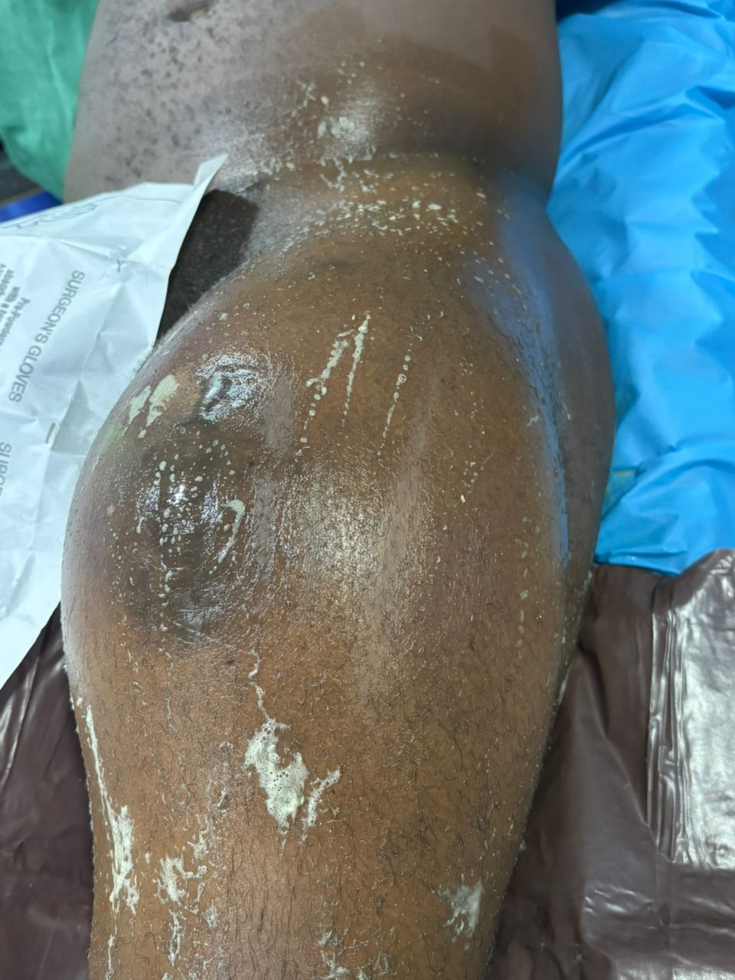
Figure 1. Preoperative image of the left thigh showing significant swelling and skin sheen suggestive of underlying fluid collection. The overlying skin is taut and shiny, raising suspicion for a deep soft tissue mass or pseudotumor formation related to chronic prosthetic wear.

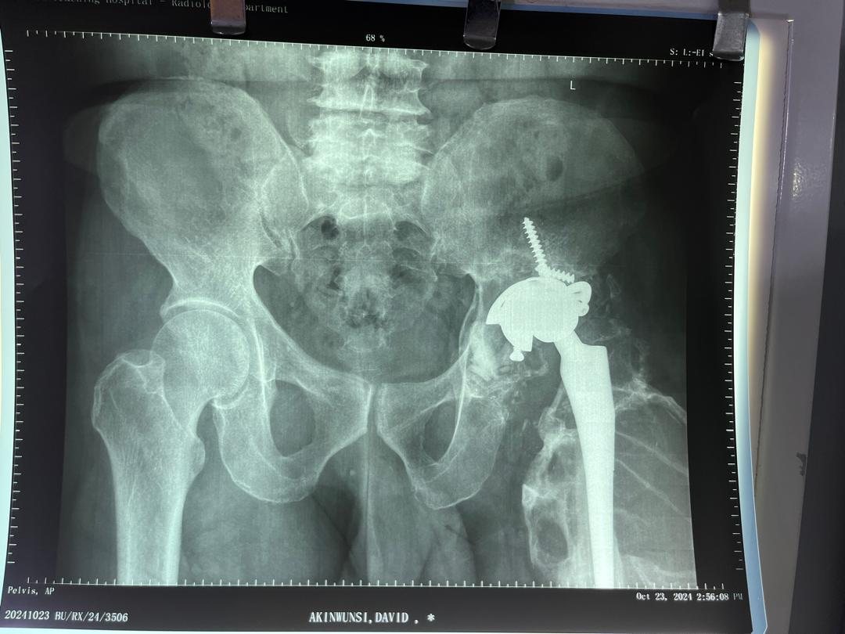
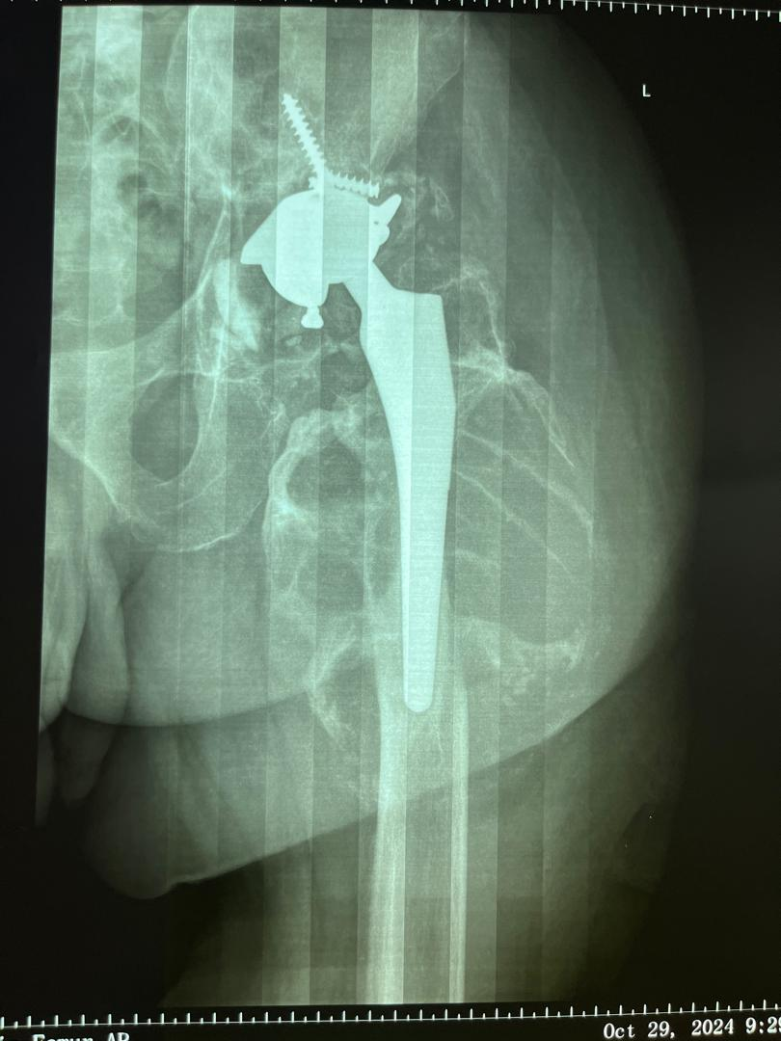

A
B

Figure 2. Posterioranterior (A) and Anterior posterior (B) radiographs of the Left hip prosthesis 20 year after index surgery showed a well fixed THA in adequate alignment without evidence of eccentric

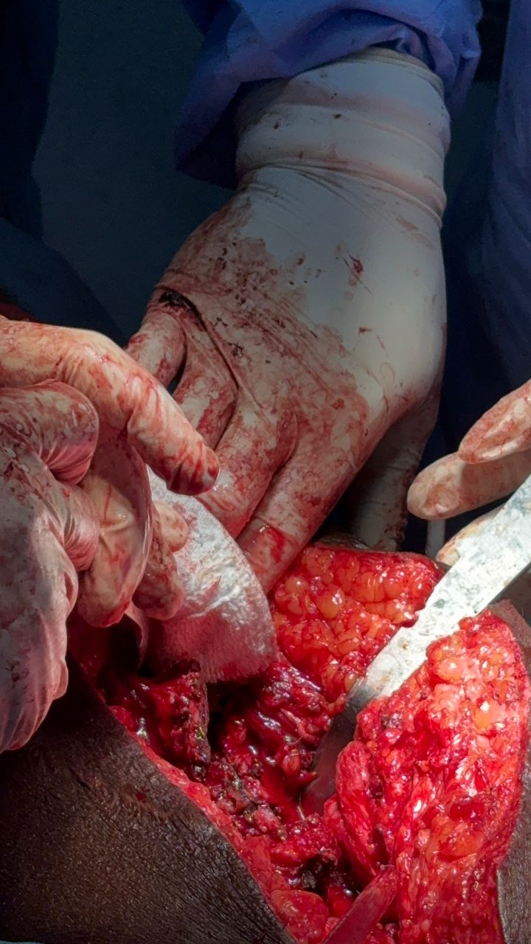

Discussion

Figure 3: Intraoperative image showing excision of a large pseudotumor with necrotic debris and inflamed tissue 20 years post-total hip arthroplasty. Granulation, fatty lobules, and devitalized tissue are visible within the surgical field.
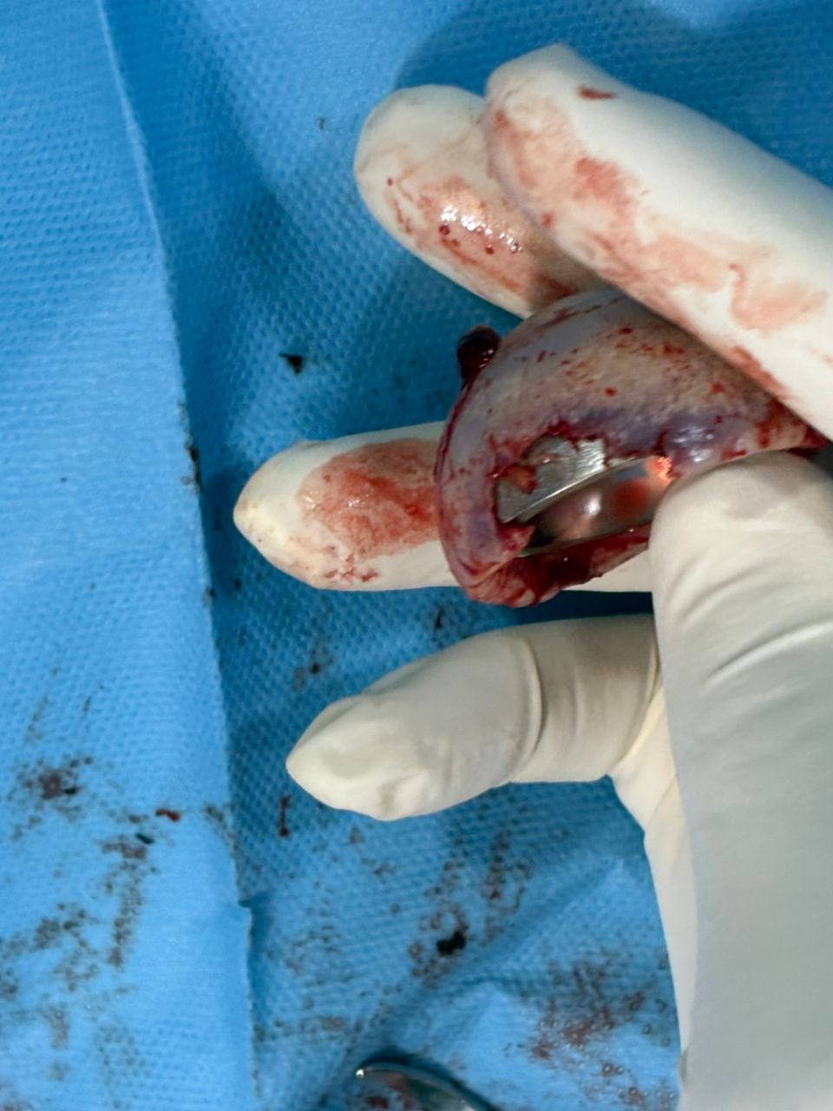

References

Figure 4: Intraoperative photograph demonstrating severe metallosis and pseudotumor formation during revision surgery for a total hip replacement performed 20 years prior. The image shows extensive wear of the polyethylene liner with direct metal-on-metal contact between the femoral head and acetabular cup, leading to generation of metallic debris and soft tissue discoloration. The dark staining and damaged prosthetic components are consistent with catastrophic wear, despite this being a non-metal-on-metal (non-MoM) total hip replacement

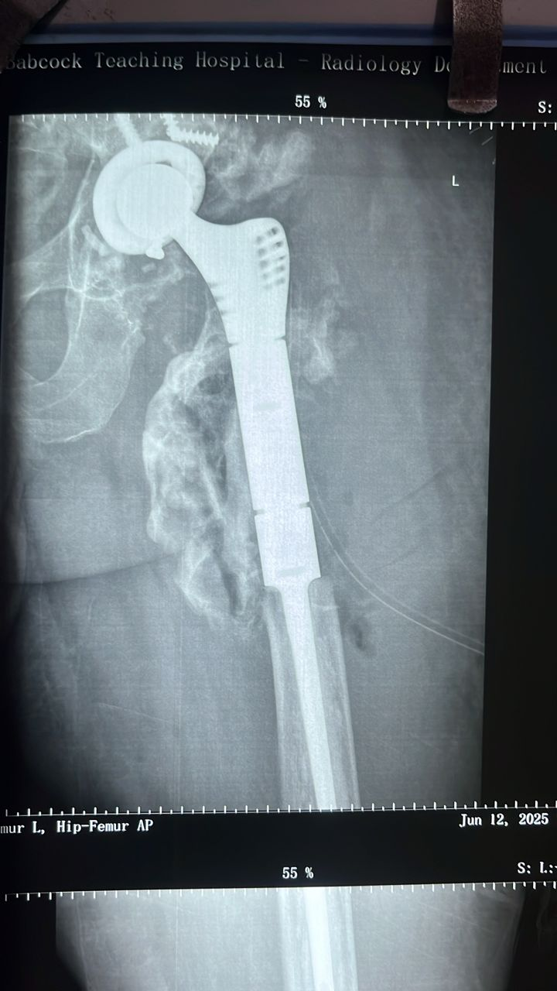
Figure 5: Postoperative anteroposterior radiograph of the left hip and femur demonstrating a revision total hip arthroplasty with distal femoral replacement. The image shows a modular femoral stem securely implanted, with cement mantle extending distally.
Discussion
Pseudotumor formation is a rare but serious complication following total hip arthroplasty, most commonly associated with metal-on-metal implants.¹⁵ However, this case illustrates that pseudotumors can also occur in patients with non-metal-on-metal constructs, such as metal-on-polyethylene articulations, particularly in the setting of catastrophic bearing surface failure. In this patient, polyethylene liner wear led to direct contact between the cobalt-chromium femoral head and the titanium acetabular shell, resulting in metallosis, chronic inflammation, and pseudotumor formation. The pathogenesis of pseudotumors in total hip replacements is multifactorial and remains incompletely understood. In metal on metal prostheses, the prevailing mechanism involves excessive release of cobalt and chromium ions which trigger a delayed type hypersensitivity response.^{16,17} This leads to the recruitment of lymphocytes and plasma cells, resulting in chronic inflammation, soft tissue necrosis, and granulomatous pseudotumor formation. Histopathological studies have consistently demonstrated features such as perivascular lymphocytic infiltration, fibrin deposition, and tissue necrosis in association with these lesions, commonly termed aseptic lymphocyte dominated vasculitis associated lesions or ALVAL.¹⁸
In contrast, pseudotumor formation in non-metal on metal implants has been attributed to alternative mechanisms including extensive polyethylene wear,⁷ corrosion at modular junctions,¹⁹ and mechanical impingement.²⁰ In our case, complete wear through of the polyethylene liner resulted in direct articulation between the cobalt chromium femoral head and the titanium acetabular shell, generating substantial metal debris and metallosis. This secondary metal on metal articulation likely contributed to the elevated serum metal ion levels and tissue reaction observed intraoperatively. Such a pattern of secondary metallosis in metal on polyethylene constructs has been increasingly recognized in the literature and represents a significant cause of adverse local tissue reactions in long term implant survivors.^{21,22}
The clinical presentation of pseudotumors can vary widely. Many patients remain asymptomatic while others may develop pain, stiffness, swelling, or even neurological deficits due to mass effect.²⁰ In the present case, the patient developed progressive pain and an enlarging soft tissue mass over a six month period, prompting further investigation. Imaging revealed classic features of catastrophic polyethylene wear including eccentric femoral head positioning, osteolysis, and a heterogeneous soft tissue mass with areas of calcification. Advanced imaging with computed tomography and magnetic resonance imaging allowed better delineation of the lesion and supported the diagnosis of a chronic inflammatory pseudotumor. Notably, the fluid aspirated from the lesion was sterile, and histological analysis confirmed a lymphoplasmacytic inflammatory pattern consistent with ALVAL, in the absence of malignancy.
Although metal on metal implants have been withdrawn from routine clinical use, the recognition of pseudotumor formation in alternative bearing surfaces remains important. Several long term follow up studies have reported pseudotumor formation in metal on polyethylene or ceramic on polyethylene constructs, especially in the setting of severe liner wear or trunnionosis. A study reported a pseudotumor incidence of 1.6% in metal on polyethylene hips undergoing revision surgery.²³ Another study described similar findings in cases where the polyethylene liner was completely worn through, leading to secondary metal contact and soft tissue damage (Runner et al., 2016).²⁴ Our case mirrors these findings, with near total liner loss and subsequent metal on metal articulation generating inflammatory debris and contributing to the pseudotumor formation.
Management of wear induced pseudotumors remains challenging due to the lack of standardized treatment protocols. In our case, a staged revision approach was adopted. The first stage involved complete excision of the pseudotumor, debridement of necrotic tissue, and placement of an antibiotic laden cement spacer. This allowed for control of the local inflammatory process and exclusion of occult infection. The second stage involved definitive reconstruction with a proximal femoral replacement due to extensive bone loss. This approach aligns with contemporary revision strategies, especially in cases with severe metallosis and compromised bone stock. Functional outcomes following pseudotumor excision and revision arthroplasty are generally favorable when managed promptly. Our patient demonstrated progressive functional recovery, with resolution of symptoms and no recurrence of the lesion during early follow up. However, long term surveillance remains essential to monitor for implant stability, recurrence of inflammation, and systemic complications from residual metal debris.
Conclusion
This case emphasizes the importance of recognizing catastrophic polyethylene wear as a potential cause of pseudotumor formation even in non-metal on metal total hip arthroplasty. Clinicians should maintain a high index of suspicion in patients presenting with late onset hip pain and swelling, regardless of implant type. Early imaging, serum metal ion analysis, and prompt surgical intervention are key to minimizing morbidity and preserving function in these rare but serious complications.

Disclaimer (Artificial intelligence)

Option 1:

Author(s) hereby declare that NO generative AI technologies such as Large Language Models (ChatGPT, COPILOT, etc.) and text-to-image generators have been used during the writing or editing of this manuscript.

REFERENCES
- Grote, C., Cowan, P., Anderson, D., & Templeton, K. (2018). Pseudotumor from Metal-on-Metal Total Hip Arthroplasty Causing Unilateral Leg Edema: Case Presentation and Literature Review. BioResearch Open Access, 7, 33 - 38. https://doi.org/10.1089/biores.2017.0035.
- Stimolo D, Muratori F, et al. Pseudotumor following total hip arthroplasty: experience of a tertiary referral center and proposal of the new PCS classification system. Archives of Orthopaedic and Trauma Surgery. 2025;145:168
- Langton DJ, Jameson SS, Joyce TJ, Hallab NJ, Natu S, Nargol AV. Early failure of metal-on-metal bearings in hip resurfacing and large-diameter total hip replacement: A consequence of excess wear. J Bone Joint Surg Br. 2010 Jan;92(1):38-46. doi: 10.1302/0301-620X.92B1.22770. PMID: 20044676.
- Davis DL, Morrison JJ (2016) Hip arthroplasty pseudotumors: pathogenesis, imaging, and clinical decision making. J Clin Imaging Sci. https:// doi. org/ 10. 4103/ 2156- 7514. 181493
- Miller RA, Ro JY, Schwartz MR (2017) Adverse tissue reactions after total hip arthroplasty. Ann Diagn Pathol 27:83–87. https:// doi. org/ 10. 1016/j. anndi agpath. 2016. 07. 006
- Lakhotia D, et al. Pseudotumor is abnormal periprosthetic soft tissue reaction developed in relation to both Metal-on-Polyethylene THA due to polyethylene debris and MoM THA due to metal debris. Annals of Bone and Joint Surgery
- Ishida, T., Tateiwa, T., Takahashi, Y., Masaoka, T., Shishido, T., & Yamamoto, K. (2023). Do polyethylene wear particles affect the development of pseudotumor in total hip arthroplasty? A minimum 15-year follow-up. Journal of Orthopaedic Surgery and Research, 18. https://doi.org/10.1186/s13018-023-03634-7.
- Tallroth K, Eskola A, Santavirta S, Konttinen Y, Lindholm T (1989) Aggressive granulomatous lesions after hip arthroplasty. J Bone Joint Surg Br. https:// doi. org/ 10. 1302/ 0301- 620X. 71B4. 27682 99
- Persson A, Eisler T, Boden H, Krupic F, Skoldenberg O, Muren O (2018) Revision for symptomatic pseudotumor after primary metal-on-polyethylene total hip arthroplasty with a standard femoral stem. J Bone Joint Surgery - American 100:942–949. https:// doi. org/ 10. 2106/ JBJS. 17. 00616
- van der Weegen W, Sijbesma T, Hoekstra HJ, Brakel K, Pilot P, Nelissen RGHH (2014) Treatment of pseudotumors after metalon- metal hip resurfacing based on magnetic resonance imaging, metal ion levels and symptoms. J Arthroplasty 29:416–421. https:// doi. org/ 10. 1016/j. arth. 2013. 06. 021
- Bisschop R, Boomsma MF, Van Raay JJAM, Tiebosch ATMG, Maas M, Gerritsma CLE (2013) High prevalence of pseudotumors in patients with a birmingham hip resurfacing prosthesis. J Bone Joint Surg 95:1554–1560. https:// doi. org/ 10. 2106/ JBJS.L. 00716
- Nawabi DH, Gold S, Lyman S, Fields K, Padgett DE, Potter HG (2014) MRI predicts ALVAL and tissue damage in metal-on-metal hip arthroplasty. Clin Orthop Relat Res. https:// doi. org/ 10. 1007/ s11999- 013- 2788-y
- Boomsma MF, Edens MA, Van Lingen CP, Warringa N, Ettema HB, Verheyen CCPM et al (2015) Development and first validation of a simplified CT-based classification system of soft tissue changes in large-head metal-on-metal total hip replacement: intraand interrater reliability and association with revision rates in a uniform cohort of 664 arthroplasties. Skeletal Radiol 44:1141– 1149. https:// doi. org/ 10. 1007/ s00256- 015- 2146-0
- Malviya A, Ramaskandhan J, Holland JP, Lingard EA (2010) Metal-on-metal total hip arthroplasty. J Bone Joint Surg 92:1675– 1683. https:// doi. org/ 10. 2106/ JBJS.I. 01426
- Kleeman, L., Goltz, D., Seyler, T., Mammarappallil, J., Attarian, D., Wellman, S., & Bolognesi, M. (2018). Association Between Pseudotumor Formation and Patient Factors in Metal-on-Metal Total Hip Arthroplasty Population.. The Journal of arthroplasty, 33 7S, S259-S264 . https://doi.org/10.1016/j.arth.2018.03.039.
- Campbell, J., & Estey, M. (2012). Metal release from hip prostheses: cobalt and chromium toxicity and the role of the clinical laboratory. Clinical Chemistry and Laboratory Medicine (CCLM), 51, 213 - 220. https://doi.org/10.1515/cclm-2012-0492.
- Wu, D., Bhalekar, R., Marsh, J., Langton, D., & Stewart, A. (2022). Periarticular metal hypersensitivity complications of hip bearings containing cobalt–chromium. EFORT Open Reviews, 7, 758 - 771. https://doi.org/10.1530/EOR-22-0036.
- Lehtovirta L, Reito A, Parkkinen J, Hothi H, Henckel J, Hart A, Eskelinen A. Analysis of bearing wear, whole blood and synovial fluid metal ion concentrations and histopathological findings in patients with failed ASR hip resurfacings. BMC Musculoskelet Disord. 2017 Dec 11;18(1):523. doi: 10.1186/s12891-017-1894-5. PMID: 29228956
- Desai, B., Sumarriva, G., & Chimento, G. (2020). Pseudotumor recurrence in a post-revision total hip arthroplasty with stem neck modularity: A case report.. World journal of orthopedics, 11 2, 116-122 . https://doi.org/10.5312/wjo.v11.i2.116.
- Davis DL, Morrison JJ. Hip Arthroplasty Pseudotumors: Pathogenesis, Imaging, and Clinical Decision Making. J Clin Imaging Sci. 2016 Apr 29;6:17. doi: 10.4103/2156-7514.181493.
- Ude CC, Esdaille CJ, Ogueri KS, Ho-Man K, Laurencin SJ, Nair LS, Laurencin CT. The Mechanism of Metallosis After Total Hip Arthroplasty. Regen Eng Transl Med. 2021 Sep;7(3):247-261. doi: 10.1007/s40883-021-00222-1. Epub 2021 Jul 29. PMID: 35530571
- Singh N, Awasthi A, Pisulkar G, Taywade S, Samal N. Adverse Metal Reaction in a Case of Metal-on-Polyethylene Hip Arthroplasty. Cureus. 2024 May 21;16(5):e60810. doi: 10.7759/cureus.60810.
- Matharu GS, Eskelinen A, Judge A, Pandit HG, Murray DW. Revision surgery of metal-on-metal hip arthroplasties for adverse reactions to metal debris. Acta Orthop. 2018 Jun;89(3):278-288. doi: 10.1080/17453674.2018.1440455. Epub 2018 Mar 1.
- Runner RP, Ahearn BM, Guild GN 3rd. Unusual presentation of failed metal-on-metal total hip arthroplasty with features of neoplastic process. Arthroplast Today. 2016 Dec 3;3(2):71-76. doi: 10.1016/j.artd.2016.10.004.

