Original Research Article
Environmental Impacts of Slaughterhouse Waste Management in Daloa and Man, Côte d’Ivoire

.
ABSTRACT

Aims: This study examines waste production and management in slaughterhouses in the Côte d'Ivoirean cities of Daloa and Man, as well as its impact on the surrounding waterways in Man.
Study design: The study is experimental in nature and employed a Research and Development (R&D) research design.
Place and Duration of Study: Daloa and Man, cities located in the central-western and western regions of Côte d'Ivoire, respectively, Central laboratory of the University of Man, between September and December 2024.
Methodology: Data were collected by surveying slaughterhouse managers in both cities of Daloa and Man and analyzing the physical and chemical characteristics of water samples taken from the Koh River near the Man slaughterhouse using a multi-parameter meter and ISO methods.
Results: The animals slaughtered are sheep, cattle and goats, with cattle predominating. Nevertheless, between 2020 and 2023, the Daloa slaughterhouse recorded the highest number of animals slaughtered each year: 3,440–9,884 sheep, 9,253–10,374 cattle, and 2,912–4,810 goats. The waste produced at these two slaughterhouses consists of blood, horns, hooves, bones, dung (the contents of the animals' rumen) and wastewater from cleaning. These liquids are mixed during the slaughtering process and then discharged. In Man, this mixture is discharged into the Koh River. In Daloa, however, liquid waste is discharged into the natural environment behind the slaughterhouse. Solid waste, such as dung, is usually mixed with wastewater for disposal at both sites. Other solid waste, such as horns, hooves and bones, is left on site and exposed to scavenging animals, including rats, cats and stray dogs. The discharge point for effluent from the Man slaughterhouse into the Koh River is significantly more contaminated with nutrients and organic matter than the sections upstream and downstream, with average chemical oxygen demand and biochemical oxygen demand concentrations of 3,137.5 mg/L and 1,873.7 mg/L respectively. Average concentrations are 40.1 mg/L for total phosphorus, 30.6 mg/L for orthophosphate, 497.9 mg/L for total nitrogen, 81.9 mg/L for nitrate and 341.6 mg/L for ammonium.
Conclusion: The current method of managing slaughterhouse waste in these two cities is seriously damaging their appearance and degrading the water quality of the Koh River in Man. This is also affecting their image as tourist destinations.

Keywords: Côte d'Ivoire, Daloa and Man, Environment, Slaughterhouses, Waste management

1. INTRODUCTION

The management of animal slaughter by-products (cattle, sheep, goats, etc.) is one of the main daily problems of meat production in various urban areas around the world. Indeed, the process of slaughtering animals generates by-products, including inedible parts (organs, intestines, ligaments, tendons, blood vessels, feathers and bones), which can represent up to 45% of the slaughtered animal, as well as blood (Jayathilakan et al., 2012; Alibekov et al., 2024). In addition, slaughterhouses produce large amounts of wastewater containing large amounts of organic matter and suspended and colloidal matter (fats, proteins and cellulose), which must be managed to protect the environment and human health (Ogbuewu et al., 2012; Franke-Whittle and Insam, 2013; Alibekov et al., 2024).
It is estimated that the animal slaughtering sector alone discharges the same organic load as a population of 300,000 people (Cointreau, 2009). Such a discharge into the natural environment can lead to environmental impacts such as the destabilization of ecosystems, as well as microbiological and toxicological risks. It has the potential to destabilize the nitrogen cycle of the ecosystem and lead to eutrophication with a predominance of nitrites, as well as the release of toxins by cyanobacteria (Ward et al., 2018; Teo et al., 2023). In addition, all microorganisms (bacteria, viruses and parasites) found in the effluent, such as Staphylococcus spp, Escherichia coli, Salmonella typhi and Giardia lamblia, are harmful to human health. In addition, livestock waste can lead to air quality degradation due to ammonia and methane emissions, soil quality degradation due to excess nutrients, and soil acidification (Sampat et al., 2018; Elemile et al., 2019; Cai et al., 2021).
In developed countries, animal by-products are a source of income for slaughterhouses. The animal by-products industry processes all raw materials not directly intended for human consumption and some raw materials intended for human consumption (Cointreau, 2009; Pontoppidan and Miseljic, 2016; Limeneh et al., 2022). In Europe, for example, the authorized use and disposal methods are regulated by Regulation (EC) No 1774/2002 of the European Parliament and of the Council of 3 October 2002 laying down health rules concerning animal by-products not intended for human consumption (European Commission, 2005; Karlis et al., 2024). On the other hand, in developing countries, particularly in sub-Saharan Africa, there are regulations governing the slaughter of animals, but they only regulate the conditions under which meat is slaughtered, transported and marketed. However, these decrees are only adopted for application in large agglomerations, such as primary cities (i.e. political and economic capitals) [Roesel and Grace, 2016].
In Côte d'Ivoire, Decree no. 67-117 of 21 March 1967, which regulates the slaughter of animals for slaughter and the marketing of meat in the Abidjan region, is a perfect example of the prioritization of capital cities in development policy, which could leave the country's secondary towns out in the cold. The challenges facing local authorities are numerous and immense, and revolve around improving the living conditions of the population. This includes housing, but also urban sanitation, which means better collection and disposal of all types of waste, improved sanitation, elimination of anarchic facilities, etc. (PUIUR, 2008; IMF, 2009).
Like the country's secondary cities, which are experiencing urban growth against a backdrop of inadequate sanitation and hygiene services, the cities of Daloa and Man, despite being regional capitals, are not immune to this situation. Indeed, Daloa is the capital of the Haut Sassandra region in the centre-west of the country, and Man is the capital of the Tonkpi region in the west. These places have long been, and continue to be, the pride of the country, thanks to the many tourist sites they host (Aphing-Kouassi, 2001). In the case of Daloa, these include the craft centre, the elephant rock of Brizoua, the game park with its famous antelopes, the artificial lake of the city, the sacred monkeys of Gbétitapéa and the rock of Wandaguhé. All these sites make the town one of the most visited in the country (Koukougnon, 2020). The same is true of the town of Man, which boasts numerous tourist attractions such as the sacred Gbèpleu monkey forest, the museum and royal palace, liana bridges, spectacular waterfalls, Mount Tonkoui, one of the highest peaks in the country at 1,189 metres, and the Dent de Man, a 900-metre natural structure that represents the town's tourist identity (Aphing-Kouassi, 2001). Places like these deserve an appropriate framework to protect the environment and people's health, but also to preserve the attractiveness of the towns.
In these localities, most of the scientific work carried out describes, in particular, the vulnerability to natural hazards (Konan & Alla, 2020) and the quality of household well and borehole water (Adjiri et al., 2018; Ahoussi et al., 2018; Eblin et al., 2020; Kouamé et al., 2021; Kouakou et al., 2022). To date, very few studies have addressed the area of sanitation and waste management in these localities, let alone the environment of animal slaughterhouses in these cities. For this reason, the present study investigated the management of solid and liquid wastes generated in animal slaughterhouses in the two cities of the country and assessed any potential impacts.
The objectives were (i) to describe the slaughterhouses in the cities of Daloa and Man, (ii) to estimate their production and deduce the amount of animal by-products generated, (iii) to describe the typology of waste generated in these slaughterhouses, (iv) to examine the waste management methods used and (v) to assess the impact of the slaughterhouses' operations on the quality of the nearby lake's water, particularly in Man.

2. material and methods

2.1 Study area
This study was conducted in the animal slaughterhouses of the towns of Daloa and Man, located in the central west (latitudes 6°53’ North and 6°27’ West) and west (latitudes 7° 24′ North and 7° 33′ West) of Côte d'Ivoire, respectively (Figure 1). Each of these towns has an animal slaughterhouse for sheep, cattle, and goats. The choice of these cities is explained by their attractiveness and tourist potential (Sogo, 1995). The cities of Daloa and Man have an area of 1,080 km² and 471 km², respectively, and a population of 421,800 and 241,969, respectively, according to RGPH (2021).
The Man Municipal Slaughterhouse was built before the country's independence, in 1945. It is located on the banks of the Koh River, in the Camp Séa area of the city. The Daloa municipal slaughterhouse was built in 1974 and is located in the slaughterhouse district (Sogo, 1995). While the Man municipal has been renovated in 2019, the Daloa slaughterhouse was not. The animals slaughtered there on a daily basis include sheep, cattle, and goats.
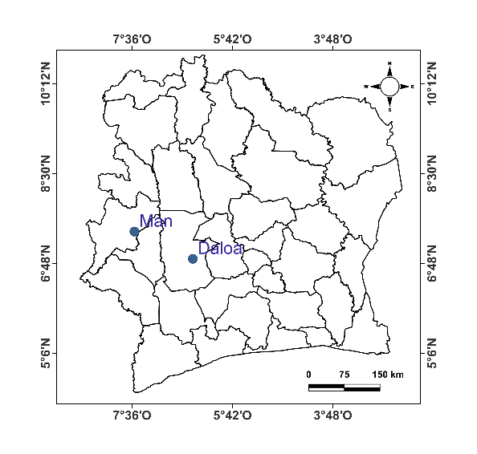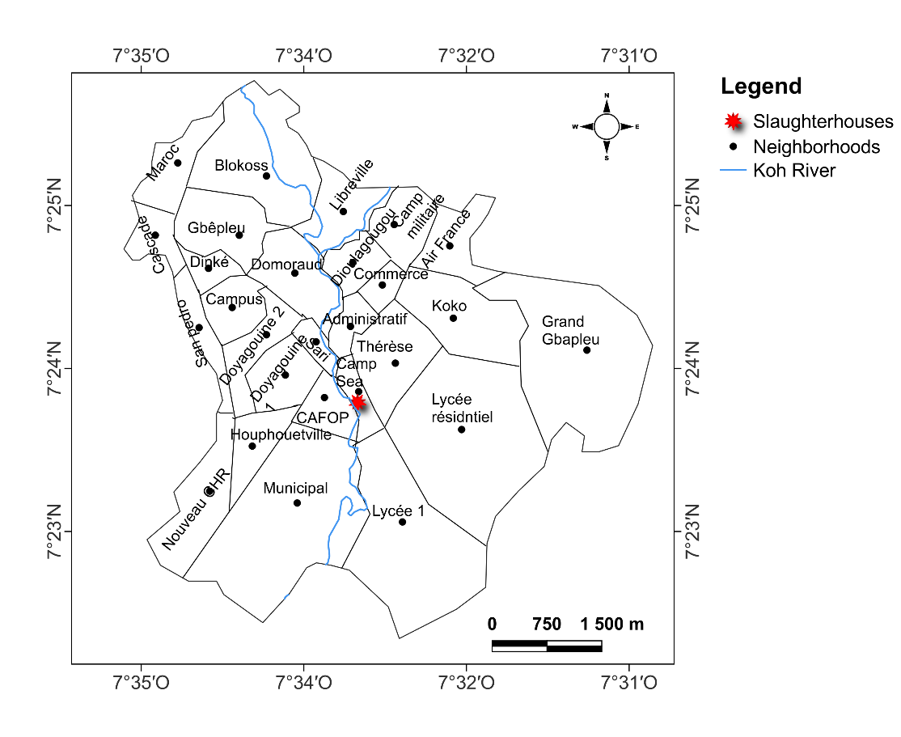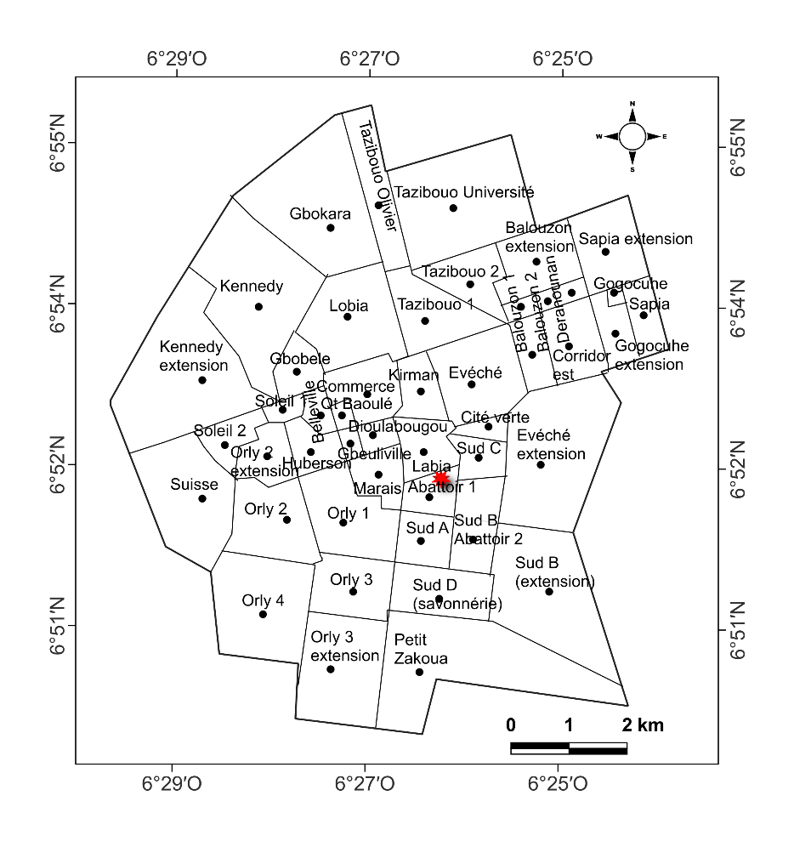
Fig. 1. Location of study area

2.2 Data collection
Data collection, which took place between September and December 2024, consisted of two joint activities: field observation and the survey itself, which was carried out in the regional offices of the Côte d'Ivoire Ministry of Animal and Fisheries Resources in Daloa and Man, followed by a further survey of slaughterhouse managers in each of these locations.
Furthermore, given the proximity of the slaughterhouse to the river running (Koh River) through the city of Man (see Figure 1), water samples were collected from various locations to evaluate the slaughterhouse's impact on the water's physical and chemical quality.

2.2.1 Field observation
Visits to slaughterhouses in Daloa and Man provided an overview of the health status of slaughterhouses in these two cities. The aim was also to understand the type of waste generated on site and how it was managed. Photographs were taken during the site visits to illustrate the observations made.

2.2.2 Survey
Two types of interviews were conducted and the information gathered was recorded on forms provided for this purpose. The first was an interview with staff from the regional offices of the Ministry of Animal Resources and Fisheries in Daloa and Man. These interviews, conducted in the two locations, provided information on the operation of the abattoirs, statistics on the number of animals slaughtered, the type of waste and how it was disposed of, etc. The second set of interviews with the direct managers of the slaughterhouses in the two towns confirmed or refuted the information provided by the Ministry's services on the type of waste and how it was disposed of.

2.2.3 Analysis of water quality near the Man slaughterhouse
Five sampling stations were established along the koh River, from upstream to downstream, in the section bordering the Man City slaughterhouse, to assess the impact of the slaughterhouse on surface water quality in the surrounding area. Two stations were positioned upstream, one in the middle (where the slaughterhouse effluent is discharged) and two downstream (see Figure 2). At each station, three water samples were taken across the entire width of the river (between 15 and 20 metres): one from each bank, and one from the middle.
Two 1-litre polyethylene bottles were used at each sampling point for the analysis of the various water samples collected. The first bottle was used to test the samples for physical parameters (pH, dissolved oxygen, salinity, electrical conductivity and total dissolved solids), while the second bottle was used to test the samples for chemical parameters (chemical oxygen demand (COD), biological oxygen demand (BOD₅), total nitrogen (TN), ammonium (NH₄⁺), nitrate (NO₃⁻), orthophosphate (PO₄³⁻) and total phosphorus (TP)). Regarding the analysis of the chemical parameters, the COD, BOD₅, TKN, PO₄³⁻ and TP, NH₄⁺ and NO₃⁻ were determined in accordance with the following ISO standards: ISO 6060/2 (1989), ISO 5815/1 (2003), ISO 5663 (1984), ISO 6878 (2004), ISO 7150-1 (1984) and ISO 7890-3 (1988), respectively. The samples were carefully stored and transported to the central analysis laboratory at the University of Man, located about ten kilometers from the slaughterhouse (the sample collection area), where these parameters were analyzed in the laboratory.
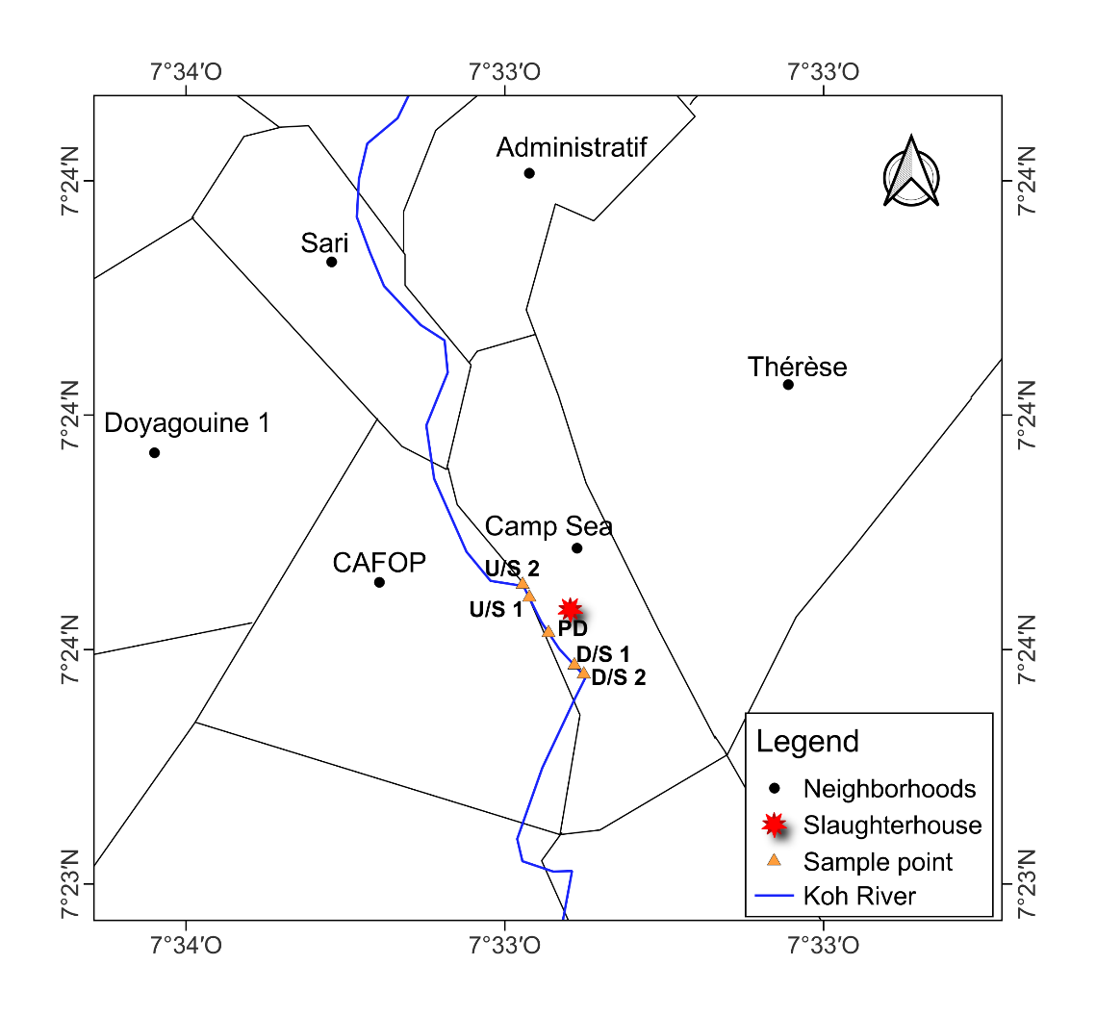
Fig. 2. Location of the sampling stations along the section of the Koh River bordering the slaughterhouse in the city of Man, U/S1 and U/S2 = upstream points, D/S1 and D/S2 = downstream points, and PD = Point of Discharge

2.3 Data analysis
The data collected from the Directorates of Animal Resources and Fisheries mainly concerned statistics on the number of animals slaughtered (sheep, cattle and goats) and their carcasses for the years 2020, 2021, 2022 and 2023. The data from the two towns were grouped by type of animal and by year and then presented in the form of histograms (descriptive statistics). Information on the typology and management of slaughterhouse waste was presented in narrative form, supported by photographic illustrations taken during the site visits.
The quantity of methanizable waste from slaughterhouses (e.g. rumen and intestinal contents, blood and faeces collected from animal pens) was estimated based on the work of Farinet (2017). According to the author, this amount corresponds to 280 kg of waste per tonne of carcass, of which 15% is dry matter. Therefore, this estimate was used in this study to quantify the amount of methanizable waste.
The water quality of the corresponding Koh River was statistically compared based on the three measurements taken at each station using R software, with a significance threshold set at 5%. As the data followed a normal distribution, ANOVA and t-tests were employed for the comparison. The results from the three stations were averaged to obtain a representative water quality value for each station. Changes in river water quality from upstream to downstream, including at the point where the slaughterhouse effluent is discharged, are presented in a box plot showing the maximum, minimum and average values.

3. results

3.1 Description of the slaughterhouses in the cities of Daloa and Man
The municipal slaughterhouse in Daloa covers an area of 1.92 hectares. The slaughter area measures 75 meters by 25 meters. The site has all the necessary facilities, including a holding pen enclosed by a 1.3-metre-high wall, an unfenced livestock pen and several pressurized water stations and washing areas.
In comparison, the municipal slaughterhouse in Man is less spacious, covering an area of approximately 1.5 hectares. This site has a slaughter area that is 50 meters long and approximately 40 meters wide. The animal waiting pen is enclosed by a low wall approximately 1.5 meters high. The livestock pen consists of several enclosures between the slaughter area and the holding pen. There are also several washing facilities and a water tower which is used to draw pressurized water from a well that was dug on the site for this purpose.
Figure 3 provides an overview of the two slaughterhouses in Man and Daloa. Figures A1, A2 and A3 show the livestock pens, holding pens and washbasins observed in these two cities, respectively.

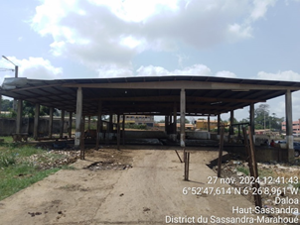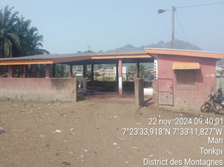
(a)
(b)
Fig. 3. Views of the slaughterhouses in the cities of Daloa (a) and Man (b).

3.2 Production of slaughterhouses and animal by-products generated
3.2.1. Slaughter of sheep and generation of by-products

Figure 4 illustrates the number of sheep slaughtered, the number of carcasses produced and the quantity of methane-producing waste generated in the slaughterhouses of Daloa and Man between 2020 and 2023. Overall, the slaughterhouse in Daloa processes more sheep, produces more carcasses and generates more methane-producing waste.
Figure 4a shows that the number of sheep slaughtered varies between 3,440 and 9,884 per year. By contrast, the number of sheep slaughtered in the Man slaughterhouse fluctuates between 1,136 and 1,356 per year. The mass of sheep carcasses (Fig. 4b) fluctuates between 75,000 and 370,000 kg per year in the Daloa slaughterhouse. In the Man slaughterhouse, this figure ranges from 3,674 to 5,413 kg per year. The amount of methane-producing waste from sheep slaughter increased from 21,000 kg to 103,600 kg and from 1,029 kg to 1,599 kg per year in the Daloa and Man slaughterhouses, respectively.

Fig. 4. Number of sheep slaughtered and carcasses, as well as quantities of methane-producing waste from slaughter in the Daloa and Man slaughterhouses

3.2.2. Slaughter of cattle and generation of by-products

Figures 5a, 5b and 5c show the number of cattle slaughtered and carcasses, as well as the quantities of methane-producing by-products from these slaughters in the Daloa and Man slaughterhouses during the period 2020-2023. It should be noted that the number of cattle slaughtered each year remains higher at the Daloa slaughterhouse. Between 9,253 and 10,374 cattle were slaughtered there each year, compared to between 5,982 and 6,179 in the Man slaughterhouse (see Figure 5a).
The carcasses recorded over the period varied from 1,561,684 to 1,987,356 kg per year in the Daloa slaughterhouse and from 551,694 to 663,398 kg per year in the Man slaughterhouse (see Figure 5b). Figure 5c shows the production of methane-producing waste by-products resulting from cattle slaughter, ranging from 437,272 to 556,460 kg in the Daloa slaughterhouse, and from 154,474 to 185,752 kg in the Man slaughterhouse.

Fig. 5. Number of cattle slaughtered and carcasses, as well as quantities of methane-producing by-products from slaughter in the Daloa and Man slaughterhouses

3.2.3. Slaughter of goats and generation of by-products

From 2020 to 2023, the slaughterhouse in Daloa slaughtered more goats than the one in Man, with quantities ranging from 2,912 to 4,810 per year compared to 917 and 952 respectively (Figure 6a).
The quantity of carcasses produced at the Daloa slaughterhouse has also remained higher each year during this period. This varies between 46,900 and 131,000 kg per year. In contrast, the annual production of carcasses in the Man slaughterhouse ranges from 6,857 to 8,627 kg (see Figure 6b). Production of methane-producing by-products from goat slaughter ranges from 13,132 to 36,680 kg at the Daloa slaughterhouse and from 1,920 to 2,362 kg at the Man slaughterhouse (Figure 6c).

Fig. 6. Number of goats slaughtered and carcasses, as well as quantities of methane-producing by-products from slaughter in the Daloa and Man slaughterhouses

3.3 Types of waste generated in the slaughterhouses and methods of management
The waste produced by the slaughterhouses in Man and Daloa consists of blood, horns, hooves, bones, the contents of the animals' stomachs (rumen contents) and wastewater from cleaning.
Most of this waste, particularly liquids such as blood and wastewater, is mixed together during the slaughtering process at both study sites. However, in Man, liquid waste is discharged into the Koh River (see Figure 7). By contrast, the Daloa slaughterhouse discharges liquid waste into the natural environment behind the site (see Figure 8).

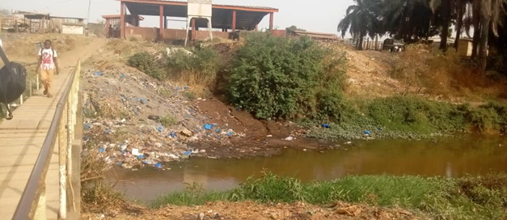
C
A
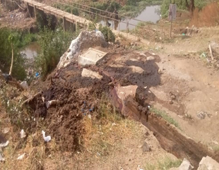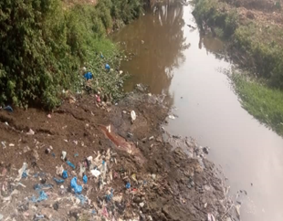
B
Fig. 7: Discharge of wastewater from the Man slaughterhouse. A = overview of the slaughterhouse, B = wastewater pipe to the Koh River, C = wastewater inlet into the river.

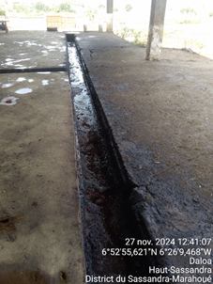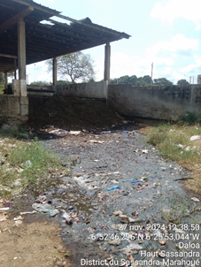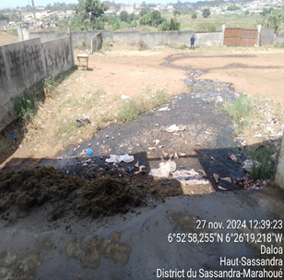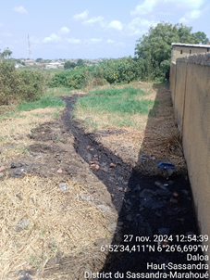
C
D
A
B
Fig. 8: Path of wastewater from the Daloa slaughterhouse during discharge. A = wastewater pipe within the slaughterhouse; B and C = runoff on the slaughterhouse site; C = runoff outside the slaughterhouse site.

Solid waste, such as rumen contents (the contents of the animals' stomachs), is usually disposed of with wastewater at both study sites (see Figures 7B, 7C, 8C and 8D).
The rest of the solid waste, such as horns, hooves and bones, is left on site (see Figure 9), exposed to the elements and scavenging animals (e.g. rats, cats and stray dogs).

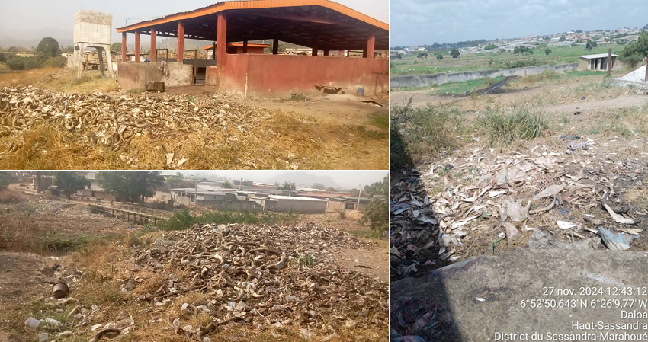
A
C
B
Fig. 9 : Overview of solid waste such as horns, hooves and bones at animal slaughter sites in the cities of Man (A and B) and Daloa (C).

3.4 Water quality of the Koh River near the city's slaughterhouse.
3.4.1. Physical quality of the water in the Koh River
Figure 10 illustrates the changes in the physical properties of the water in the Koh River, including pH, electrical conductivity, salinity, dissolved oxygen content, temperature and turbidity, as it flows from upstream to downstream and passes through the discharge point of the Man City slaughterhouse effluent. Two trends can be observed for these different parameters. While pH and dissolved oxygen content decrease from the upstream measurement points to the discharge point and then increase downstream, the other parameters — namely electrical conductivity, salinity, temperature and turbidity — increase from the upstream measurement points to the discharge point before decreasing downstream. In both cases, the values measured at the slaughterhouse discharge point differ significantly from those recorded upstream and downstream (t-test <0.05). However, there are similarities between the results obtained upstream and downstream (t-test > 0.05).
Regarding pH, the average values measured at the different stations were 7.3 at the upstream station farthest from the discharge point (U/S2), 7.1 at the upstream station closest to the discharge point (U/S1), 6.9 at the slaughterhouse discharge point (PD), 7.2 at the downstream station closest to the discharge point (D/S1) and 7.4 at the downstream station farthest from the discharge point (D/S2). The respective averages for dissolved oxygen content were 0.69 mg/L (U/S2), 0.66 mg/L (U/S1), 0.22 mg/L (PD), 0.34 mg/L (D/S1) and 0.68 mg/L (D/S2).
The highest average values obtained for electrical conductivity, salinity, temperature and turbidity are 150.0 μS/cm, 0.07 PSU, 27.2 °C and 143.8 NTU, respectively, at the slaughterhouse discharge point. Upstream, the average values vary between 91.5 and 101.3 μS/cm, 0.04 and 0.05 PSU, 26.9 and 27.0 °C and 42.1 and 51.6 NTU. Downstream, the values range between 114 and 115 μS/cm, 0.05 PSU, 26.7 and 26.9 °C and 47.2 and 55.4 NTU.
Fig. 10: Physical characteristics of the water in the Koh River, upstream and downstream from the discharge point of the Man City slaughterhouse, U/S = upstream, PD = Point of Discharge, D/S = downstream, Box-plots bearing the same letter indicate no significant difference (p > 0.05).

3.4.2. Chemical quality of the water in the Koh River
Analysis of Figure 11, focusing on the variation in chemical oxygen demand (COD) and biochemical oxygen demand (BOD), and of Figure 12, focusing on total nitrogen, ammonium (NH₄⁺), nitrate (NO₃⁻), orthophosphate (PO₄³⁻) and total phosphorus, shows that the concentrations of these parameters are significantly higher at the slaughterhouse discharge point (t-test p < 0.05).
The average COD rises from 307.3 mg/L at U/S2 to 325.2 mg/L at U/S1 upstream, then from 3,137.5 mg/L at the slaughterhouse discharge point (PD) to 2,072.5 mg/L at the nearest downstream station (D/S1), finally reaching 1,643.4 mg/L at the furthest station (D/S2). Meanwhile, BOD rose from 236.3 mg/L to 253.4 mg/L at the upstream stations, reaching 1,873.7 mg/L at the discharge point before decreasing to 898.9 mg/L at station D/S1 and 718.2 mg/L at station D/S2 (see Figure 11).
Fig. 11: Concentrations of chemical (COD) and bio-chemical (BOD5) oxygen demand in the water in the Koh River, upstream and downstream from the Man City slaughterhouse discharge point. U/S = upstream, PD = point of discharge, D/S = downstream, Box-plots bearing the same letter indicate no significant difference (p > 0.05).

With regard to nutrients, particularly total nitrogen, ammonium (NH₄⁺), nitrate (NO₃⁻), orthophosphate (PO₄³⁻) and total phosphorus, concentrations increase from U/S1 to U/S2, and then to PD (see Figure 12). Concentrations then decrease at D/S1 and D/S2. Average concentrations are recorded at the following stations:
- total nitrogen: 170.8 mg/L (U/S2), 218.5 mg/L (U/S1), 497.9 mg/L (PD), 381.5 mg/L (D/S1) and 300.8 mg/L (D/S2).
- NH₄⁺: 115.8 mg/L (U/S2), 117.5 mg/L (U/S1), 341.6 mg/L (PD), 231.2 mg/L (D/S1) and 176.7 mg/L (D/S2).
- NO₃⁻: 31.4 mg/L (U/S2), 37.0 mg/L (U/S1), 81.9 mg/L (PD), 64.4 mg/L (D/S1) and 55.6 mg/L (D/S2).
- PO₄³⁻: 11.9 mg/L (U/S2), 13.6 mg/L (U/S1), 30.6 mg/L (PD), 26.9 mg/L (D/S1) and 24.6 mg/L (D/S2).
- total phosphorus : 14.3 mg/L (U/S2), 19.8 mg/L (U/S1), 40.1 mg/L (PD), 33.0 mg/L (D/S1) and 28.7 mg/L (D/S2).
Fig. 12: Concentrations of nitrogen compounds (total nitrogen, ammonium [NH₄⁺], nitrate [NO₃⁻]) and phosphorus compounds (total phosphorus, orthophosphate [PO₄³⁻]) in the water in the Koh River, upstream and downstream from the Man City slaughterhouse discharge point. U/S = upstream; PD = point of discharge; D/S = downstream, Box-plots bearing the same letter indicate no significant difference (p > 0.05).
4. discussion

This research focuses on the management of solid and liquid waste produced in the slaughterhouses of Daloa and Man, and its associated environmental impact, particularly on the quality of bodies of water receiving effluent from these slaughterhouses. Between 1,136 and 9,884 sheep, 5,982 and 10,374 cattle and 917 and 4,810 goats are slaughtered in these two cities every year. Daloa has the highest population density and therefore the highest number of animals slaughtered. According to the 2021 General Population and Housing Census in Côte d'Ivoire (RGPH, 2021), Daloa has 421,879 inhabitants, compared to 241,969 in Man. In order to meet the population's daily animal protein requirements, a greater number of animals are slaughtered in Daloa than in Man. This would also explain why there are more cattle, sheep and goat carcasses in the Daloa slaughterhouse than in the Man slaughterhouse. In the slaughterhouses of the two cities, a greater number of cattle are slaughtered per day than sheep and goats. Beef is more popular than sheep and goat meat in Côte d'Ivoire because of its taste, accounting for 4.9 kg per person per year of overall consumption, compared to 1.2 kg of sheep and goat meat per person per year (AWE, 2021). This trend has also been observed in Benin (Montcho et al., 2025), Cameroon, the Republic of the Congo and Chad (FAO, 2013). However, the number of sheep, cattle and goats slaughtered in the Daloa and Man slaughterhouses is lower than at the Tamale slaughterhouse in Ghana, where an average of 20,000 cattle, 18,250 sheep and 18,250 goats are slaughtered each year. Tamale is a much more populous location than the areas covered by this study (Mohammed et al., 2018).
The waste produced by the slaughterhouses in Man and Daloa consists of blood, horns, hooves, bones, the contents of the animals' stomachs (rumen contents), and wastewater from cleaning. This waste is produced during various activities, such as bleeding, cutting and cleaning the premises. Similar observations have been made in other African slaughterhouses, notably in Cameroon (Awono et al., 2025) and Benin, Niger and Burkina Faso (Montcho et al., 2025). As in the Daloa slaughterhouse, this waste is not managed adequately in the Man slaughterhouse. Blood and wastewater from the Man slaughterhouse are discharged untreated into the natural environment in Daloa and into the Koh River in Man, thereby polluting these areas (FAO, 2013). Solid waste, such as dung (the rumen contents), is often mixed with wastewater when disposed of at the two study sites. Horns, hooves and bones are left behind. This results in an accumulation of waste from these slaughterhouses, generating odor nuisances, microbial proliferation and deterioration in the well-being of populations living near these slaughterhouses (Odekanle et al., 2020; Bhunia et al., 2022). However, this waste is a significant source of recoverable resources. The amount of methane-producing waste from sheep slaughter varies from 21,000 to 103,600 kg per year in the Daloa slaughterhouse, and from 1,029 to 1,599 kg per year in the Man slaughterhouse. For cattle, methane-producing waste from slaughter ranges from 437,272 to 556,460 kg in Daloa and from 154,474 to 185,752 kg in Man. The production of methanizable by-products from goat slaughter ranges from 13,132 to 36,680 kg at the Daloa slaughterhouse and from 1,920 to 2,362 kg at the Man slaughterhouse. Ideally, these waste resources would be exploited by developing technologies to mechanize the treatment and recovery of this type of organic matter. Methanization, also known as anaerobic digestion, is a promising process for breaking down organic matter. In the absence of oxygen, specific bacteria break down the matter to produce a mixture of methane and carbon dioxide called biogas. This biogas can be used to produce heat, electricity, or fuel for vehicles, and the resulting digestate can be recovered and used as fertilizer (Chennaoui et al., 2002; Ouahabi et al., 2016; Farinet, 2017; Afilal et al., 2020; Al-Gheethi et al., 2023).
Regarding the physical and chemical quality of the Koh River, which receives waste from the Man slaughterhouse, the results show lower levels of dissolved oxygen and pH at the point where the slaughterhouse's liquid waste is discharged, compared to stations located both upstream and downstream. The low levels of dissolved oxygen indicate high levels of organic pollution, which is likely due to the presence of blood in the water. The decomposition of blood leads to significant oxygen consumption by aerobic microorganisms that purify the water (Hlordzi et al. 2020). This decomposition also promotes the production of acids, which could explain the decrease in pH at the point where liquid waste is discharged into the river. Nevertheless, all recorded pH values in the river comply with Côte d'Ivoire's wastewater discharge standards (Ministry of Environment, Water and Forests, 2008) and the WHO's (WHO, 2006). Electrical conductivity and salinity increase from the upstream point to the discharge point, before decreasing downstream. It should be noted that conductivity reflects the overall degree of mineralization and provides information on salinity levels. Thus, the high conductivity and salinity values at the discharge point can be explained by the high concentration of organic compounds, nitrogen and phosphates present at this location. The concentrations of biochemical oxygen demand (BOD), chemical oxygen demand (COD), total nitrogen, ammonium (NH₄⁺), nitrate (NO₃⁻), orthophosphate (PO₄³⁻) and total phosphorus at the slaughterhouse discharge point are 1,873.7 mg/L, 3,187.3 mg/L, 497.9 mg/L, 341.6 mg/L, 81.9 mg/L, 30.6 mg/L and 33.0 mg/L respectively. These concentrations are much higher than those obtained upstream and downstream of the discharge point and reflect the heavy pressure exerted by the slaughterhouse on the Koh River. However, the concentrations of BOD, COD, total nitrogen, NH₄⁺, NO₃⁻, PO₄³⁻ and total phosphorus remain above Côte d'Ivoire's wastewater discharge standards (Ministry of Environment, Water and Forests, 2008) and the WHO's standards (WHO, 2006) from upstream to downstream. This indicate that the river is subject to pollution from other sources, including dwellings along its banks. The situation on the Koh River could undoubtedly be responsible for the destruction of the lake's biodiversity and the damage to the city of Man's tourist image and the aesthetic quality of the environment, since the river runs right through the city.
In urban areas of many sub-Saharan African countries, populations use rainwater collectors and bodies of water as receptacles for domestic effluents, such as sewage and grey water (Coulibaly et al., 2018; Ama-Cauphys et al., 2022). This undoubtedly leads to high concentrations of nitrogen, phosphorus and organic matter upstream and downstream of the Koh River, which runs through the city. However, further studies need to be carried out in collaboration with the municipality and other decision-makers in order to identify the connection or discharge points for effluents from households and small and medium-sized enterprises, thus preserving the environment. The study would also consider the discharge point of the slaughterhouse effluent, as well as the upstream and downstream areas. A larger number of stations and samples would be taken into account, and seasonal variations would be considered, in order to refine the results of the present study further. However, the present study, conducted between September and December, was carried out during the dry season in the study area. Therefore, the results of this study accurately reflect the pollution generated by the slaughterhouse in the water body, particularly since dilution phenomena are limited or non-existent during the dry season (Makhoukh et al., 2011). The concentrations of biochemical oxygen demand (BOD), chemical oxygen demand (COD), ammonium (NH₄⁺), nitrates (NO₃⁻) and phosphates (PO₄³⁻) obtained in this study are similar to those reported by Mbog et al. (2023) in the waters of the Ako'o River in Cameroon, which is affected by discharges from the Etoudi slaughterhouse.

5. Conclusion

This study analyzed the management of solid and liquid waste produced in the slaughterhouses of Daloa and Man, assessing the associated environmental impacts. Between 1,136 and 9,884 sheep, between 5,982 and 10,374 cattle and between 917 and 4,810 goats are slaughtered in these two cities each year. The highest number of animals slaughtered is recorded in Daloa.
These slaughterhouses generate several categories of waste, including blood, horns, hooves, bones, rumen contents and wastewater from cleaning. This waste is not properly managed. In fact, blood and wastewater from the Man slaughterhouse are discharged untreated into the natural environment in Daloa and into the Koh River in Man. At the two study sites, rumen contents are most often mixed with wastewater when they are disposed of. Horns, hooves and bones are left on site, exposed to the elements and to scavenging animals such as rats, cats and stray dogs. The Daloa and Man slaughterhouses produce large volumes of waste that produces methane (154,474–556,460 kg per year for cattle; 1,029–103,600 kg per year for sheep; and 1,920–36,680 kg per year for goats), which requires particular attention.
Regarding the physicochemical quality of the Koh River, which receives waste from the Man slaughterhouse, lower levels of dissolved oxygen and pH are observed at the point where the slaughterhouse discharges liquid waste compared to stations located upstream and downstream. Electrical conductivity, salinity, temperature and turbidity all increase from the upstream point to the discharge point, before decreasing downstream. Concentrations of BOD, COD, total nitrogen, ammonium, nitrates, total phosphorus and phosphates at the slaughterhouse discharge point are 1,873.7 mg/L, 3,187.3 mg/L, 497.9 mg/L, 341.6 mg/L, 81.9 mg/L, 30.6 mg/L and 33.0 mg/L respectively. Concentrations of BOD, COD, total nitrogen, ammonium, nitrates and total phosphorus remain above the wastewater discharge standards of Côte d'Ivoire and the WHO from upstream to downstream.
This study is groundbreaking, being the first of its kind in this area. However, further studies that take into account seasonal variation and include a larger number of samples, both upstream and downstream, as well as at the point where effluent is discharged from the slaughterhouse in the city of Man, would be worthwhile. Nevertheless, decision-makers must take measures to preserve quality of life and local aquatic biodiversity in the vicinity of the slaughterhouse.

DISCLAIMER (ARTIFICIAL INTELLIGENCE)

The authors declare that the use of Artificial Intelligence (AI) software such as ChatGPT, Gemini, CoPilot, and others was not practiced during the writing and editing of the study

ETHICAL ConsIDERATION

All authors declare that the managers of the slaughterhouses in the cities of Daloa and Man have approved the use of the collected database.
The original ﬁle was anonymous.

Definitions, Acronyms, Abbreviations
ANOVA: Analysis of Variance
AWE: Agentur wirtschaft und Entwicklung
D/S1 and D/S2: Downstream Station 1 & 2
FAO: Food and Agriculture Organization
IMF: International Monetary Fund
ISO: International Organization for Standardization
PD: Point of Discharge
PUIUR : Projet d'Urgence d'Infrastructures Urbaines
RGPH : Recensement Général de la Population et de l’Habitation
U/S1 and U/S2: Upstream Station 1 & 2
WHO: World Health Organization

References

Adjiri O. A., Aka N., Soro T. D., Affessi A. C., Konaté D. & Soro N. (2018). Characterization of alternative water resources in the city of Daloa: health impacts and implications for regional development. Techniques Sciences Méthodes, 113, (12), 89-114.
Afilal M. E., Deh I. & Elfarh L. (2020). Evaluation des effluents d’abattoir et proposition de solution valorisante pour le Maroc. EWASH & TI Journal, 4, 1, 300-306. http://revues.imist.ma/?journal=ewash-ti/
Ahoussi, K. E., Keumean, K. N., Kouassi, A. M., & Koffi, Y. B. (2018). Study of the hydrogeochemical and microbiological characteristics of drinking water in the peri-urban area of the city of Man: Case of the village of Kpangouin (Côte d’Ivoire). International Journal of Biological and Chemical Sciences, 11, 3018-3033. https://doi.org/10.4314/ijbcs.v11i6.37
Al-Gheethi, A., Ma, N. L., Rupani, P. F., Sultana, N., Yaakob, M. A., Mohamed, R. M. S. R., & Soon, C. F. (2023). Biowastes of slaughterhouses and wet markets: an overview of waste management for disease prevention. Environmental Science and Pollution Research, 30, 28, 71780-71793. https://doi.org/10.1007/s11356-021-16629-w
Alibekov, R. S., Alibekova, Z. I., Bakhtybekova, A. R., Taip, F. S., Urazbayeva, K. A. & Kobzhasarova, Z. I. (2024) Review of slaughter waste and meat by-product recycling opportunities. Front. Sustain. Food Syst., 8, 1410640. https://doi.org/10.3389/fsufs.2024.1410640
Ama-Cauphys A. B., Messou A., Mangoua-Allali A. L. C., Aka J. P. & Coulibaly L. (2022). Fonctionnement des collecteurs d’eau pluviale de cinq quartiers de la ville de Yamoussoukro, Côte d’Ivoire : identification des dysfonctionnements et dynamique des nutriments. Afrique SCIENCE, 21, 4, 105-119.
Aphing-Kouassi, N. G. (2001). Coastal tourism in southwestern Ivory Coast. Geography. University of Cocody - Abidjan, 2001. French. NNT: tel-00282992, 363 p.
AWE (Agentur wirtschaft und Entwicklung) (2021). Country Analysis. https://wirtschaft-entwicklung.de/fileadmin/user_upload/Downloads/Studie_Milch-_und_Fleischwirtschaft/Analyse_Pays_CIV. Accessed August 15, 2025.
Awono, M. M. L., Fopa, L. G. B., Atangana, N. M. L. F. (2025). Management of waste from the slaughter of animals at the slaughterhouse located in the Biyem district in the city of Ayos central region, Cameroon. Journal of Environmental Education Research and Sustainable Development, 3, 1, 1-16.
Bhunia, S., Bhowmik, A. & Mukherjee, J. (2022). Waste management of rural slaughterhouses in developing countries. In Advanced Organic Waste Management, 425–449.
Cai, Y., Tang, R., Tian, L. & Chang, S. Environmental impacts of livestock excreta under increasing livestock production and management considerations: Implications for developing countries, Current Opinion in Environmental Science & Health, 24, 100300, https://doi.org/10.1016/j.coesh.2021.100300.
Chennaoui M., Assobhei O. & Mountadar M. (2002). Biostabilisation des eaux usées d’abattoir de la ville d’El Jadida (Maroc). Reviews in Biology and Biotechnology, 2, 44-48.
Cointreau, S. (2009). Global Study of Livestock Markets, Slaughterhouses and Related Waste Management Systems. Final report, World Bank, 305 p.
Coulibaly M., Tuo P. & Ake-Awomon D. F. (2018). Ordures ménagères, eaux usées et santé de la population dans la ville de Daloa (Centre-ouest de la Côte d’Ivoire). Revue Espace Territoires Sociétés et Santé, 1, 1, 46- 65.
Eblin G. S., Konan, S. K., Adélaïde, M.-J A., Ohou-Yao, J., Mangoua, M. O., Brou, D. & Kouamé, L. K. (2020). Mineralization of Natural Spring Water in the City of Daloa (West-Central Côte d’Ivoire). Journal of Geoscience and Environment Protection, 8, 200-210. https://doi.org/10.4236/gep.2020.812012
Elemile, O. O., Raphael, D. O., Omole, D. O., Oloruntoba E. O., Ajayi E. O. & Ohwavborua N. A. (2019). Assessment of the impact of slaughterhouse effluent on the quality of groundwater in a residential area of Omu-Aran, Nigeria. Environ Sci Eur 31, 16 (2019). https://doi.org/10.1186/s12302-019-0201-5
European Commission (2005). Reference Document on Best Available Techniques in the Slaughterhouses and Animal By-Products Industries. European IPPC Bureau at the Institute for Prospective Technological Studies. Seville, Spain, 433 p.
FAO (2013). Study on slaughterhouses for meat animals in Central Africa (Cameroon – Congo – Gabon – Chad). Summary document, FAO, 65 p.
Farinet J.-L. (2017). Agro-energy recovery of slaughterhouse waste through methanization. In: Restoring the productivity of tropical and Mediterranean soils: a contribution to agroecology. Roose, Eric (ed.). Marseille: IRD, 315-317.
Franke-Whittle, I. H. & Insam, H. (2013). Treatment alternatives of slaughterhouse wastes and their effect on the inactivation of different pathogens: a review. Crit Rev Microbiol, 39, 2, 139-51. https://doi.org/10.3109/1040841X.2012.694410.
Hlordzi, V., Kuebutornye, F. K. A., Afriyie, G., Abarike, E. D., Lu, Y., Chi, S. & Anokyewaa, M. A. (2020). The use of Bacillus species in maintenance of water quality in aquaculture: A review. Aquaculture Reports, 18, p. 100503. https://doi.org/10.1016/j.aqrep.2020.100503
IMF (2009). Côte d'Ivoire: Poverty Reduction Strategy Progress Report 2009, Report No. 09/156, International Monetary Fund, Washington, D.C., 223 p.
ISO. International Standardization Organization (ISO) (1984) 5663: Water Quality-Determination of Kjedahl Nitrogen-Method after Mineralization with Selenium, 1st ed.; ISO: Geneva, Switzerland.
ISO. International Standardization Organization (ISO) (1984) 7150-1: Water quality - Determination of ammonium- Part 1 Manual spectrometric method. 1st ed.; ISO: Geneva, Switzerland.
ISO. International Standardization Organization (ISO) (1988) 7890-3: Water quality - Determination of nitrate - Part 3: Spectrometric method using sulfosalicylic acid, 1st ed.; ISO: Geneva, Switzerland.
ISO. International Standardization Organization (ISO) (1989) 6060/2: Water Quality-Determination of Chemical Oxygen Demand-Potassium Dichromate Method, 2nd ed.; ISO: Geneva, Switzerland.
ISO. International Standardization Organization (ISO) (2003) 5815/1: Water Quality—Determination of Biochemical Oxygen Demand after n Days (BODn)—Part 1: Dilution and Seeding Method with Allylthiourea Addition, 1st ed.; ISO: Geneva, Switzerland.
ISO. International Standardization Organization (ISO) (2004) 6878: Water Quality-Determination of Phosphorus—Ammonium Molybdate Spectrometric Method, 2nd ed.; ISO: Geneva, Switzerland.
Jayathilakan , K. , Sultana , K. , Radhakrishna , K. & Bawa , A. S. (2012). Utilization of byproducts and waste materials from meat, poultry and fish processing industries: a review. J Food Sci Technol., 49, 278–293. https://doi.org/10.1007/s13197-011-0290-7
Karlis , P. , Presicce , F. , Giner Santonja , G. , Brinkmann , T. & Roudier , S. (2024). Best Available Techniques (BAT) Reference Document for the Slaughterhouses, Animal By-products and/or Edible Co-products Industries, Publications Office of the European Union, Luxembourg, 2024, 510 p. https://doi.org/10.2760/18199
Conan, K.E. & Alla, D.A. (2020). Evolution and exposure of a mountain town to natural hazards: Man (Ivory Coast). Geo-Eco-Trop., 2020, 44, 4: 531-540.
Kouakou , LPM-S. , Kouyate , A. , Sanou , A. , Koffi , A. E. , Tigori , M. A. , Meite , N. , Bohoussou , K. J.-P. & Dark, B. (2022). Evaluation of the Physico-chemical Quality of Drinking Water in the City of Daloa (Mid-West of Côte d'Ivoire) -Effects on Human Health. Journal of Health and Environmental Research, 8(3):186-196. https://doi.org/10.11648/j.jher.20220803.13
Kouame, Y. F., Kedi, A. B. B., Kouassi, S. S., Konan, N. J. A., Assohoun, E. S., Yapo, O. B. & Gnagne, T. (2021). Physico-chemical characteristics of domestic borehole waters in the town of Daloa (central-western Ivory Coast). Int. J. Biol. Chem. Sci. 15(2): 835-8 https://dx.doi.org/10.4314/ijbcs.v15i2.33
Koukougnon, W. G. (2020). Resilience of DALOA Hotel Establishments to Freshwater Desert Uncertainty (Centre-Ouest De La Cote D’ivoire). Moroccan Geographical Space and Society Review, 33-34, 289-309.
Limeneh , D. Y. , Tesfaye , T. , Ayele , M. , Husien , N. M. , Ferede , E. , Haile , A. , Mengie , W. , Abuhay , A. , Gelebo , G. G. , Gibril , M. & Kong F. (2022). A Comprehensive Review on Utilization of Slaughterhouse By-Product: Current Status and Prospect. Sustainability, 14, 6469. http://doi.org/10.3390/su14116469
Makhoukh M., Sbaa M., Berrahou A. & Vanclooster M. (2011). Contribution a l’étude physicochimique des eaux superficielles de l’oued Moulouya (Maroc oriental). Larhyss J., 9, 149-169.
Mbog M. S., Bot B. V., Reounodji A. & Bitondo D. (2023). Assessment of Wastewater Management at the Etoudi Slaughterhouse in the Municipality of Yaoundé – Cameroon. International Journal of Environmental Protection and Policy, 11, 31-36. https://doi.org/10.11648/j.ijepp.20231102.12
Ministry of Environment, Water and Forestry (2008). Order No. 01164/MINEEF/CIAPOL/SDIIC of 04 Nov. 2008, bearing Regulation of Rejects and Discharges from Facilities Classified for Environmental Protection. Ministry of Environment, Water and Forestry/Centre Ivoirien Antipollution, 20 p.
Mohammed A., Abdulai A., Birteeb P.T. & Hussein, S. M. A. (2018). Major causes of organ and carcass condemnations of cattle and their associated financial loss at the tamale abattoir, Ghana. UDS International Journal of Development, 5, 1, 53-67. https://doi.org/10.47740/233.UDSIJD6i
Montcho , M. , Seidou , A. A. , Nouri , B. , Dao A. N. C. , Montcho M. & Bougouma‐Yameogo V. (2025). Assessment and modeling of sustainable slaughterhouse waste management in West African cities: the case of the main cities of Benin, Niger and Burkina Faso. Valuation of Residual Biomass, 1-16. https://doi.org/10.1007/s12649-025-02922-z
Odekanle , E.L. , Odejobi , O.J. , Dahunsi , S.O. & Acredolu, F.A. (2020). Potential for cleaner energy recovery and electricity generation from abattoir wastes in Nigeria. Energy Rep., 6, 1262–1267. https://doi.org/10.1016/j.egyr.2020.05.005
Ogbuewu, I. P., Odoemenam, V. U., Omede, A. A., Durunna, C. S., Emenalom, O. O., Uchegbu, M. C., Okoli, I. C. & Iloeje, M. U. (2012). Livestock waste and its impact on the environment. Scientific Journal of Review, 1(2), 17–32.
Ouahabi Y. R., Maamir N. & Bensadok K. (2016). Etude du potentiel biométhane des déchets d’abattoirs. Revue des Energies Renouvelables, 19,1, 111-118. https://doi.org/10.54966/jreen.v19i1.552
WHO (2006). WHO Guidelines for the Safe Use of Wastewater, Excreta and Greywater, Volume II, Wastewater Use in Agriculture, 222 p.
Pontoppidan , O. & Miseljic , M. (2016). Slaughterhouses and Producers of Animal By-Products in the Nordic Countries; Report from the Nordic Council of Ministers; ThemeNorth 2016:551; Nordic Council of Ministers: Copenhagen, Denmark, 2016; 77 p.
PUIUR (2008). Environmental and Social Management Framework (EMS), Final Report, Ministry of Economic Infrastructure, Côte d’Ivoire, 89 p.
RGPH (General Census of Population and Housing) (2021). Abidjan, Ivory Coast, 2021, 37 p.
Roesel , K. & Grace , D. (2016). Food sanitary and informal markets: products of animal origin in sub-Saharan Africa. Nairobi, Kenya: International Livestock Research Institute, 217p.
Sampat , A. M. , Ruiz-Market , G. & Zavala , V. M. (2018). Economic and Environmental Analysis for Advancing Sustainable Management of Livestock Waste: A Wisconsin Case Study. ACS Sustain. Chem. Eng., 6, 5, 6018–6031. https://doi.org/10.1021/acssuschemeng.7b04657 .
Meat A. (1995). Contribution to hygienic mastery of traditional slaughterhouses in Côte d’Ivoire. Doctoral Thesis, Faculty of Medicine, Pharmacy and Dentostomatology, University Cheick Anta DIOP, (Dakar, Senegal), 184 p.
Teo , C. J. , Karkou , E. , Vlad , O. , Vyrkou , A. , Savvakis , N. , Arampatzis , G. & Angelis-Dimakis , A. (2023). Life cycle environmental impact assessment of slaughterhouse wastewater treatment, Chemical Engineering Research and Design, 200, 550-565, https://doi.org/10.1016/j.cherd.2023.11.016. Ward, M. H., Jones, R. R., Brender, J. D., De Kok, T. M., Weyer, P. J., Nolan, B. T., Villanueva, C. M. & Van Breda, S. G. (2018). Drinking Water Nitrate and Human Health: An Updated Review. Int J Environ Res Public Health. 2018 Jul 23;15(7):1557. https://doi.org/10.3390/ijerph15071557.
APPENDIX

Figure A1 | Views of the livestock pens in the slaughterhouse areas of the cities of Daloa (a) and Man (b)
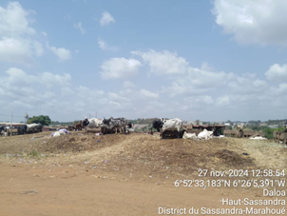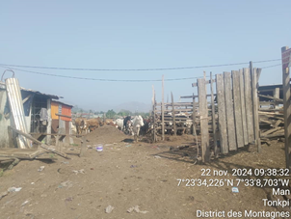
(a)
(b)
Figure A2 | Views of the holding pens in the Daloa (a) and Man (b) slaughterhouse areas
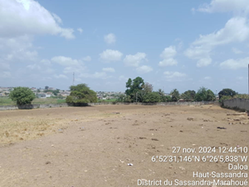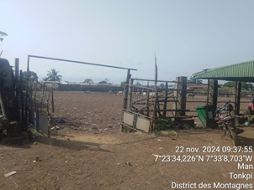
(a)
(b)
Figure A3 | Views of washbasins inside the Daloa (a) and Man (b) slaughterhouses
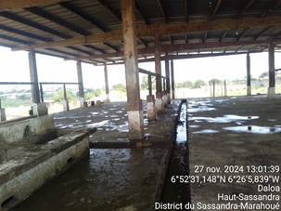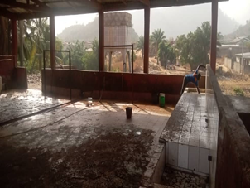
(b)
(a)

