Sustainable Phytoremediation of Nickel-Contaminated Wastewater using Eichhornia crassipes (Mart.) Solms
Original Research Article
Abstract
Nickel (Ni) toxicity is a major environmental concern, posing serious risks to aquatic ecosystems, plant growth, and human health. This study highlights how water hyacinth (Eichhornia crassipes) can be used as a simple, low-cost, and sustainable method to remove Ni from industrial wastewater. Importantly, it also validates that the dimethylglyoxime (DMG) colorimetric test is a reliable and easy-to-use tool for monitoring Ni uptake in real-time. When exposed to wastewater with varying Ni concentrations, the plants achieved over 90% removal in the highest concentration treatment within just 8 days. The results from the DMG assay closely matched those from atomic absorption spectroscopy (AAS), validating its effectiveness for practical field use. These findings demonstrate that integrating E. crassipes into wastewater treatment systems could greatly improve water quality in areas with limited resources—provided that the invasive biomass is managed responsibly. This approach offers a promising, accessible solution for communities dealing with heavy metal contamination.
Key Words:- Nickel toxicity, phytoremediation, Eichhornia crassipes, DMG, waste water treatment.
1. Introduction
Heavy metal contamination of water is a global concern because metals like nickel (Ni), lead (Pb), copper (Cu), and cadmium (Cd) are highly toxic, persistent, and bioaccumulative in the environment. Even low levels of these metals can pose serious risks to aquatic life, soil health, and human well-being, leading to diseases such as cancer, neurological disorders, and kidney damage (Jaishankar, Tseten, Anbalagan, Mathew, & Beeregowda, 2014). Heavy metals enter surface and groundwater systems primarily through industrial activities such as mining, refining, electroplating, and agriculture, where improper waste disposal and runoff carry these pollutants into ecosystems (Tchounwou, Yedjou, Patlolla, & Sutton, 2012). Once introduced, these metals do not degrade easily and tend to accumulate in sediments, plants, and aquatic organisms, leading to long-term environmental contamination, disruption of food chains, and biodiversity loss (Ali, Khan, & Ilahi, 2020).
The hazards of heavy metal pollution extend beyond aquatic ecosystems, affecting agricultural productivity and the health of communities reliant on contaminated water sources (Ahmad, Bano, & Khan, 2018). Conventional methods for treating metal-contaminated wastewater, such as chemical precipitation, ion exchange or membrane filtration, are often expensive, resource-intensive, and inaccessible to rural or underdeveloped regions (Lu, Tian, & Yang, 2010). In response to these challenges, phytoremediation—the use of plants to remove, stabilize, or transform pollutants—has emerged as an environmentally friendly, cost-effective, and sustainable alternative (Ali, Khan, & Sajad, 2013).
Among aquatic plants, water hyacinth (Eichhornia crassipes) has been widely recognized as a potential bio-remediator due to its rapid growth rate, extensive root network, and high biomass production, allowing it to accumulate and detoxify heavy metals from contaminated water bodies (Rezania, Taib, Din, & Dahalan, 2015; Sood, Uniyal, & Prasanna, 2012). Its ability to uptake metals like Cu, Pb, and Ni has been confirmed in several studies, making it a viable tool for treating industrial effluents and improving water quality (Rezania, Taib, Din, Dahalan, & Kamyab, 2016; Santos, Sanchez, & Gouveia, 2014). Additionally, its widespread availability and adaptability to diverse aquatic environments enhance its practical applicability, especially in areas lacking advanced wastewater treatment infrastructure (Adewumi & Ogbiye, 2009).
The mechanism of nickel uptake by Eichhornia crassipes primarily involves rhizofiltration, where the plant's extensive and fibrous root system acts as a natural filter to absorb and accumulate heavy metals from the surrounding water (Jadia & Fulekar, 2009). The process of nickel absorption can be described in two phases: a rapid initial phase of adsorption and a slower, more prolonged phase of bioaccumulation. The initial rapid phase is a passive process where Ni²⁺ ions are quickly bound to the negatively charged functional groups (e.g., carboxyl, hydroxyl) on the root cell walls (Hasan et al., 2022). This binding is a physicochemical process driven by ion exchange and surface adsorption. Following this, the slower phase involves the active transport of nickel into the root cells via specific membrane proteins, leading to intracellular accumulation (Yilwa et al., 2023). Most of the absorbed nickel is sequestered and stored within the roots, with only a small fraction translocating to the shoots and leaves (Sangeeta et al., 2011). This high retention in the roots is a key characteristic of rhizofiltration and explains the plant's high bioconcentration factor (BCF) for nickel. Overall, the combination of a large root surface area and a high capacity for both surface adsorption and intracellular accumulation makes E. crassipes an efficient phytoremediation agent for nickel-polluted waters.
Although several studies have reported the potential of Eichhornia crassipes for removing heavy metals like copper, lead, and nickel from wastewater (Rezania et al., 2015; Santos et al., 2014), there is a valuable opportunity to build on these findings by expanding the research toward practical, field-applicable methods that can translate laboratory successes into real-world solutions.
However, the invasive nature of E. crassipes presents a management challenge, as unchecked growth can block waterways, reduce oxygen levels, and outcompete native species (Ahmad, Bano, & Khan, 2018). Thus, while water hyacinth represents a promising solution to heavy metal contamination, its use must be coupled with responsible harvesting and disposal strategies to prevent secondary pollution and ecological imbalance.
2. Methods
2.1 Site and sample collection: Wastewater was collected from a pond near a petroleum-contaminated area in Assam, India.. Sampling was done in the morning to minimize diurnal variation (Deka et al., 2010). About 20 L of water were collected in clean polyethylene containers, which were pre-rinsed with the same wastewater to avoid dilution. Samples were kept cool and shaded until the experiment. Healthy water hyacinth plants were harvested from a nearby uncontaminated pond. Plants of similar size and maturity were selected, gently uprooted, rinsed of debris, and transported in pond water to the laboratory (Mengistu et al. 2023).
2.2 Experimental design: The experiment used four treatment groups, each with a 10-L polycarbonate jar, Sample EC 1 Control (0% effluent: 10 L deionized water), EC 2 20% effluent (2 L wastewater + 8 L deionized water), EC 3 50% effluent (5 L wastewater + 5 L deionized water), and EC 4 100% effluent (10 L untreated wastewater) (Hussain et al. 2010). In each jar, three healthy hyacinth plants were placed with their roots submerged in the water. Jars were lined with plastic to prevent leakage. The jars were kept in a growth room at 30–35 °C with a natural light cycle, and all jars experienced similar light and temperature conditions. Over the 8-day period, no fertilizer or additional nutrients were added.
2.3 Sampling and measurements: Water samples (~10 mL) were taken from each jar on Days 0, 2, 4, 6, and 8. The Ni concentration in water was measured by flame atomic absorption spectroscopy (AAS) following standard protocols (Welz & Sperling, 2007). AAS calibration standards for Ni were prepared to bracket the expected concentration range (Skoog et al., 2014).
At each time point (Day 2, 4, 6, 8), a small root section (~1 cm) was cut from each jar’s hyacinth plants for Ni analysis. Roots were rinsed with deionized water and blotted dry. For the qualitative Ni test, root segments were digested in a few drops of concentrated HNO₃ to release bound Ni (Santos et al., 2014). After dilution, an ammonia buffer was added along with dimethylglyoxime (DMG) reagent, which forms a pink precipitate in the presence of Ni²⁺ (Santos et al., 2014). The color intensity of the Ni–DMG complex was noted for each treatment as a qualitative indicator of Ni uptake. The pink Ni–DMG precipitate was collected on filter paper and dried. For quantification, the precipitate from each treatment was weighed on Days 0–8 to track Ni accumulation in roots (Rao, 2010; Santra, 2005). Throughout the experiment, plant health was monitored (leaf color, wilting) and water quality (pH, turbidity) was observed to assess any stress effects. Data are reported as mean ± standard deviation. Statistical analyses confirmed that Ni concentrations changed significantly over time and treatment (p < 0.05).
3. Results
3.1 Nickel Estimation in Water Sample
Table 1: Concentration of Nickel (Ni) (mg/l) in the water on Experiment days

Day | Concentration of Nickel (Ni) (mg/l)
Day | EC 1 (0% Effluent) | EC 2 (20% Effluent) | EC 3 (50% Effluent) | EC 4 (100% Effluent)
0 | 0.00 ± 0.00 | 2.20 ± 0.03 | 4.80 ± 0.04 | 8.90 ± 0.07
2nd | 0.00 ± 0.00 | 1.65 ± 0.02 | 3.60 ± 0.04 | 6.68 ± 0.05
4th | 0.00 ± 0.00 | 0.91 ± 0.02 | 2.16 ± 0.02 | 3.56 ± 0.04
6th | 0.00 ± 0.00 | 0.48 ± 0.01 | 1.30 ± 0.03 | 1.78 ± 0.03
8th | 0.00 ± 0.00 | 0.22 ± 0.01 | 0.72 ± 0.02 | 0.71 ± 0.02

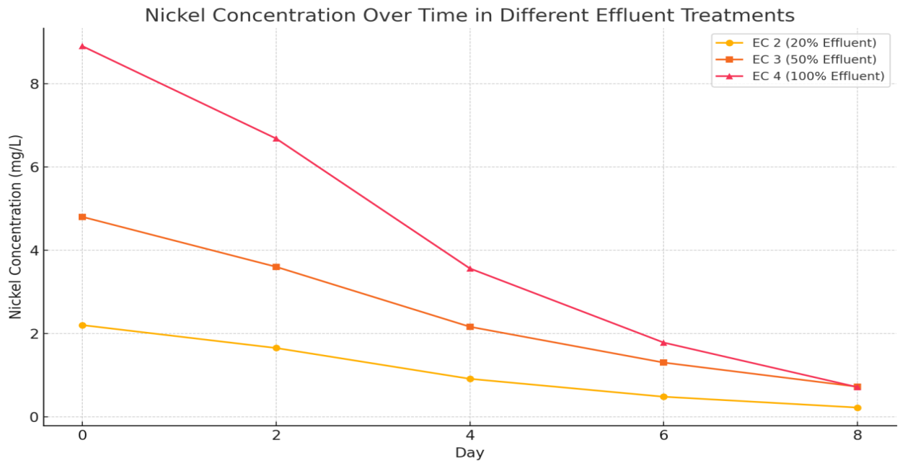 Fig 1:- Comparative representation of Ni concentration in the Water samples
The phytoremediation experiment using Eichhornia crassipes (Mart.) was conducted over eight days to assess its effectiveness in removing nickel (Ni) from wastewater at varying effluent concentrations. Four treatment groups were set up: EC 1 (0% effluent, control), EC 2 (20% effluent), EC 3 (50% effluent), and EC 4 (100% effluent). Atomic Absorption Spectroscopy (AAS) was used to determine the nickel concentration in each treatment at 0, 2, 4, 6, and 8 days.
In EC 1 (0% effluent), nickel was not detected throughout the experiment, confirming that the deionized water used as a control was free of nickel contamination.
In EC 2 (20% effluent), the initial nickel concentration was 2.20 ± 0.03 mg/L. By day 2, it had decreased to 1.65 ± 0.02 mg/L (a 25.0% reduction). On day 4, the level dropped further to 0.91 ± 0.02 mg/L (58.6% total reduction), followed by 0.48 ± 0.01 mg/L on day 6 (78.2%), and finally 0.22 ± 0.01 mg/L on day 8, showing a total reduction of 90.0% from the initial value.
In EC 3 (50% effluent), the starting nickel concentration was 4.80 ± 0.04 mg/L. This reduced to 3.60 ± 0.06 mg/L on day 2 (25.0% reduction), 2.16 ± 0.02 mg/L on day 4 (55.0%), 1.30 ± 0.03 mg/L on day 6 (72.9%), and ultimately 0.72 ± 0.02 mg/L on day 8, achieving a 85.0% reduction overall.
In EC 4 (100% effluent), the highest initial nickel concentration was recorded at 8.90 ± 0.07 mg/L. The concentration decreased to 6.68 ± 0.05 mg/L on day 2 (24.9%), 3.56 ± 0.04 mg/L on day 4 (60.0%), and 1.78 ± 0.03 mg/L on day 6 (80.0%). By day 8, it dropped to 0.71 ± 0.02 mg/L, reflecting a 92.0% total reduction.
The results clearly indicate a consistent and significant decrease in nickel concentration across all effluent levels treated with Eichhornia crassipes. The plant showed high efficiency in nickel uptake, with the highest removal percentage (92.0%) observed in the EC 4 group (100% effluent). This suggests that Eichhornia crassipes (Mart.) is highly effective for the phytoremediation of nickel, even in highly contaminated wastewater.
3.2 Qualitative Assessment of Nickel in roots of Eichhornia crassipes):
The DMG assay on root digests produced the characteristic pink Ni–DMG complex in all effluent treatments, with intensity reflecting the initial Ni concentration. Roots from the control (0%) showed no pink coloration (no Ni). The 20% effluent roots yielded a faint pink color (indicative of low Ni uptake), the 50% treatment a moderate pink, and the 100% effluent an intense pink (Table 2). This visual scale confirms that Ni was bioaccumulated in roots and that higher effluent led to more Ni accumulation.
Table 2: Qualitative dimethylglyoxime (DMG) test results on E. crassipes root extracts. The pink Ni–DMG color intensity increases with initial wastewater Ni concentration, indicating corresponding Ni uptake.
Sample | DMG Test Result | Interpretation
Sample EC 1 | No color change | No detectable Ni accumulation
Sample EC 2 | Faint pink color | Low Ni uptake in roots
Sample EC 3 | Moderate pink color | Medium Ni accumulation
Sample EC 4 | Intense pink color | High Ni accumulation in root tissues
3.3 Quantitative Assessment of Nickel in roots of Eichhornia crassipes (Mart.)
Table 3. Mass of Ni–DMG precipitate) collected from E. crassipes root extracts at different days. Higher Ni–DMG mass indicates greater Ni accumulation in roots. The 0% control (no effluent) had no precipitate
Day | Nickel-DMG Precipitate Weights (mg) from Water Hyacinth Roots
Day | Sample 2 (20% Effluent) | Sample 3 (50% Effluent) | Sample 4 (100% Effluent)
0 | 0.0 ± 0.00 | 0.0 ± 0.00 | 0.0 ± 0.00
2nd | 1.4 ± 0.04 | 3.6 ± 0.09 | 6.2 ± 0.12
4th | 2.1 ± 0.05 | 5.0 ± 0.10 | 8.4 ± 0.15
6th | 2.8 ± 0.06 | 6.1 ± 0.12 | 9.9 ± 0.18
8th | 3.3 ± 0.07 | 7.4 ± 0.15 | 11.1 ± 0.20

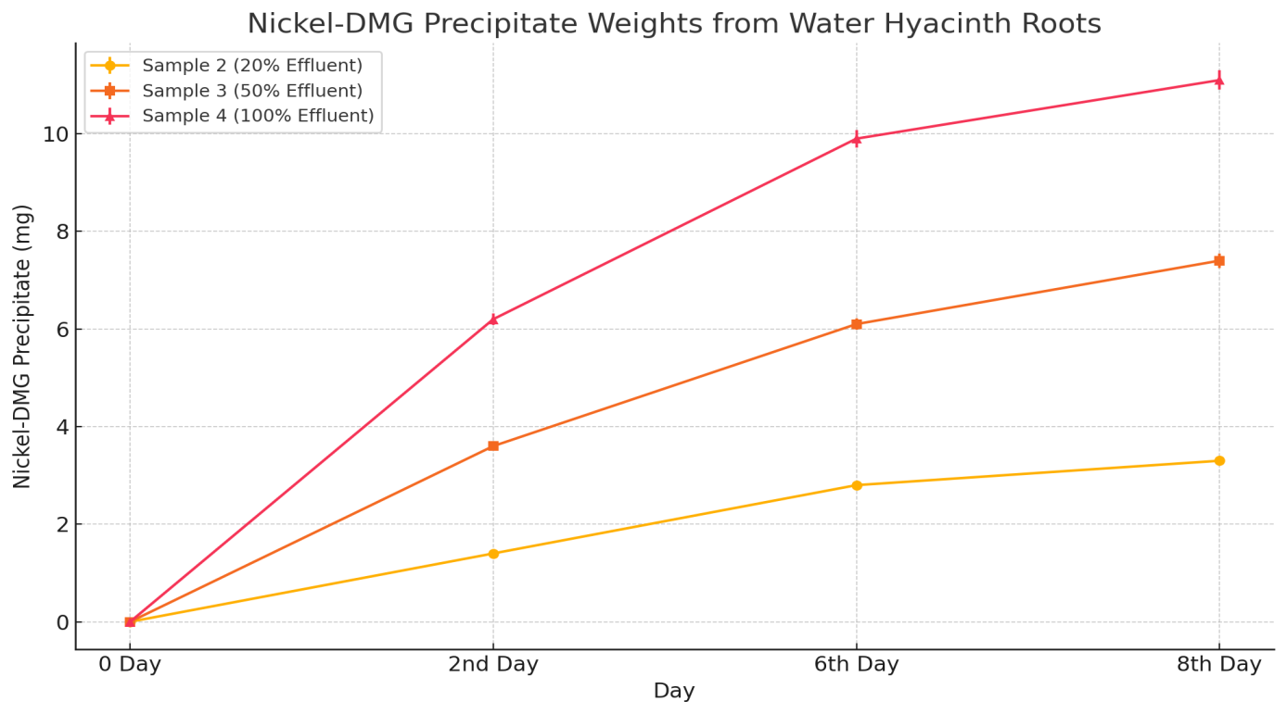
Fig 2:- Comparative representation of Ni concentration in the Water hyacinth roots

In this study measured the mass of the dried Ni–DMG precipitate from roots at each time point (Table 3). No Ni–DMG precipitate was found at Day 0 (no initial uptake). By Day 2, precipitate weights were 6.2 ± 0.12 mg in the 100% treatment, 3.6 ± 0.09 mg (50%), and 1.4 ± 0.04 mg (20%). These weights steadily increased through Day 8: in the 100% group the Ni–DMG mass grew to 11.1 ± 0.20 mg; in the 50% group to 7.4 ± 0.15 mg; and in the 20% group to 3.3 ± 0.07 mg. The control (0%) produced no precipitate. The increasing precipitate masses confirm that roots progressively accumulated more Ni over time, and that absolute Ni uptake was greatest at higher effluent levels.
4. Discussion
The results of this study confirm that Eichhornia crassipes can effectively reduce nickel concentrations from wastewater, achieving more than 85% removal within eight days, even at high initial concentrations. The highest removal efficiency (92%) observed in the 100% effluent treatment suggests that the plant’s uptake capacity is strongly influenced by concentration gradients, consistent with the findings of Sinha and Biswas (2011), who reported faster metal absorption at higher pollutant levels. The progressive decline in nickel over time aligns with earlier observations that E. crassipes rapidly adapts to contaminated environments and sustain metal uptake without significant physiological stress at moderate concentrations (Malik, 2007; Nazir et al., 2020). Similar phytoremediation potential of heavy metals like cadmium by Eichhornia crassipeswas also reported by Abdullahi et al. (2023).
Nazir et al. (2020), observed continued metal uptake by E. crassipes over prolonged periods, particularly in wastewater with high contaminant loads. This was evident in the present study, wherein it was observed that the phytoremediation efficiency did not plateau even by the 8th day, suggesting that extended exposure may yield near-complete removal. The consistent decline in nickel concentrations also indicates the plant’s ability to tolerate and function under high metal stress, which stands as an important trait for successful phytoremediation capabilities. (Rezania et al., 2016).
The results obtained from DMG colorimetric assay closely mirrored the atomic absorption spectroscopy (AAS) data, validating this simple test as a practical monitoring tool. The correlation between DMG precipitate intensity and AAS-measured nickel depletion, demonstrates that inexpensive and rapid field assays can complement traditional techniques in wastewater managementwhich aligns as per Welz & Sperling, 2007.
The qualitative observations of pink coloration in root digests corresponded with the increasing precipitate mass over time, supporting the hypothesis that nickel accumulates primarily in root tissues rather than being translocated extensively to shoots. This is consistent with previous reports on root sequestration mechanisms involving cell wall binding and chelation by organic molecules (Cobbett & Goldsbrough, 2002; Odjegba & Fasidi, 2007).
The results obtained in this study further contribute to address challenges identified in earlier research, such as the need for scalable, low-cost remediation methods and strategies for managing the invasive nature of E. crassipes (Ahmad, Bano, & Khan, 2018; Lu, Tian, & Yang, 2010). By integrating phytoremediation with accessible monitoring techniques, this study offers a practical approach for resource-constrained communities seeking to mitigate nickel toxicity while safeguarding environmental health.Additionally, this approach supports the global sustainable development goals by advancing nature-based, community-driven solutions that balance ecological restoration with socio-economic benefits (Ali, Khan, & Sajad, 2013).
The versatility and resilience of E. crassipes as a phytoremediation agent while providing evidence for cost-effective monitoring solutions that can empower local communities is well depicted in this study. By bridging laboratory findings with field applicability, it offers practical interventions that can significantly enhance heavy metal remediation efforts in regions with limited access to advanced treatment technologies. These findings also open avenues for future research focused on optimizing exposure times, evaluating long-term plant health, and exploring synergistic remediation strategies such as microbial-assisted processes, as recommended by Ali, Khan, and Ilahi (2020) and Vymazal (2010).
4.1 Environmental implications:
These findings support the concept of using water hyacinth in a controlled way for wastewater treatment. As a fast-growing perennial, E. crassipes can be deployed in constructed wetlands or pond systems to treat industrial effluents (Vymazal, 2010). Its use is particularly attractive in regions lacking advanced treatment plants, as it requires minimal energy and maintenance (Ali et al., 2013). The work also addresses UN Sustainable Development Goals (SDGs 6 and 12) by providing a low-cost method for cleaner water and responsible waste management. However, caution is warranted: water hyacinth is invasive and can disrupt local ecosystems if it escapes (Ahmad et al., 2018). Any phytoremediation system must include measures for containment and periodic harvesting. Harvested biomass itself contains concentrated metals, so it should be disposed of or processed safely (e.g., metal recovery, composting, or biofuel production) to prevent secondary pollution (Lu et al., 2010; Ahmad et al., 2018). In terms of methodology, the combination of AAS and DMG tests proved robust. AAS provided precise Ni concentrations (Welz & Sperling, 2007), while the DMG color test served as a quick visual assay (Santos et al., 2014). Such dual-approach can be useful in field monitoring: if instrumentation is unavailable, the DMG test can still indicate whether treatment is progressing. Overall, the results reinforce that E. crassipes is an efficient Ni bioaccumulator, and further research could integrate this plant with other remediation strategies (e.g. microbial augmentation or adsorption media) to improve performance (Ali et al., 2020; Vymazal, 2010).

5. Conclusion
This study confirms that water hyacinth (Eichhornia crassipes) effectively cleans nickel-contaminated water under controlled conditions. Significant Ni removal (>85%) was achieved within one week, even at high initial concentrations (8.90 mg/L Ni reduced to ~0.7 mg/L). The Ni removed from the water was evidently sequestered by the plants, as shown by the Ni–DMG precipitate in roots. These results demonstrate that E. crassipes can serve as a sustainable, low-cost alternative to conventional wastewater treatment for heavy metals. Its use could be particularly beneficial in decentralized or rural settings (Vymazal, 2010; Ali et al., 2013). For real-world application, the invasive nature of hyacinth must be managed, and harvested biomass handled safely. Overall, the integration of E. crassipes based phytoremediation aligns with broader environmental goals of clean water and resource recycling. Future work should pilot this approach at larger scales and in actual effluent channels to validate efficacy. Incorporating such nature-based solutions can contribute to cleaner ecosystems and reduced health risks from industrial pollutants.
Disclaimer (Artificial intelligence)
Author(s) hereby declare that NO generative AI technologies such as Large Language Models (ChatGPT, COPILOT, etc.) and text-to-image generators have been used during the writing or editing of this manuscript.

References
Abdullahi, F. A., Akpai, A. S., Sunday, A. D., & Ocholi, Y.(2024) Contaminants Correlation and Curtailment Prospect of Water hyacinth, Water lettuce and Vetiver Grass in Wastewater Treatment.
Abdullahi, F. A., Akpai, A. S., Sunday, A. D., & Ocholi, Y. (2023). Contaminants correlation and curtailment prospect of water hyacinth, water lettuce and vetiver grass in wastewater treatment. International Journal of Emerging Multidisciplinaries: Biomedical and Clinical Research, 1(2), 1–13. https://doi.org/10.54938/ijemdbmcr.2023.01.2.258
Adewumi, I. K., Ogbiye, A. S., Longe, E., & Omole, D. O. (2009). Using water hyacinth (Eichhornia crassipes) to treat wastewater of a residential institution. Toxicological and Environmental Chemistry, 91(5), 891–903.
Ahmad, A., Bano, M., & Khan, N. (2018). Phytoremediation of heavy metals: Recent techniques and mechanisms. Environmental Science and Pollution Research, 25(3), 3015–3029.
Ahmad, M. M., Alam, M. T., & Naaz, S. (2025). Water Hyacinth is A Potential Aquatic Plant Used in Water Treatment: A Short Review. Sch Acad J Biosci, 7, 898-907.
Ali, H., Khan, E., & Ilahi, I. (2020). Environmental chemistry and ecotoxicology of hazardous heavy metals: Environmental persistence, toxicity, and bioaccumulation. Journal of Chemistry, 2020, 1–14.
Ali, H., Khan, E., & Sajad, M. A. (2013). Phytoremediation of heavy metals—Concepts and applications. Chemosphere, 91(7), 869–881.
Al-Kinani, H. A., & Mana, H. A. (2025). Ecological and chemical study of Eichhornia Crassipes plant growing in water of Shatt Al-Ksar in Thi Qar-southern Iraq. University of Thi-Qar Journal of agricultural research, 14(1), 721-730.
Cobbett, C., & Goldsbrough, P. (2002). Phytochelatins and metallothioneins: Roles in heavy metal detoxification and homeostasis. Annual Review of Plant Biology, 53, 159–182.
Deka, S., Sharma, H. P., & Sarma, H. P. (2010). Use of aquatic plants for removal of heavy metals from wastewater. Environmental Monitoring and Assessment, 170(1–4), 621–629.
Dharmaji, D., Rahman, M., & Saidah, S. (2025). Effectiveness of water hyacinth (Eichhornia Crassipes (Mart.) Solms.) Dan Kiambang (Salvinia molesta Ds Mitchell) in phytoremediation of manganese (Mn) heavy metal levels in dug well water in Sungai Ulin housing estate, North Banjarbaru District, South. Fish Scientiae, 15(1), 78-86.
Hasan, A. J., Hassan, M. A., & Al-Ameri, I. B. (2022). Phytoremediation of nickel from wastewater by using water hyacinth (Eichhornia crassipes). Journal of Engineering Science and Technology, 17(5), 3508-3521.
Hussain, A., Mahmood, Q., & Malik, R. N. (2010). Phytoremediation technologies for remediating industrial wastewater. Environmental Science and Technology, 44(1), 206–212.
Hussain, F., Javed, I., & Ahmad, R. (2010). Phytoremediation of heavy metals by water hyacinth (Eichhornia crassipes). Journal of Environmental Research and Development, 5(2), 363–370.
Jadia, C. D., & Fulekar, M. H. (2009). Phytoremediation of heavy metals: Recent techniques. African Journal of Biotechnology, 8(6), 921-931.
Jaishankar, M., Tseten, T., Anbalagan, N., Mathew, B. B., & Beeregowda, K. N. (2014). Toxicity, mechanism and health effects of some heavy metals. Interdisciplinary Toxicology, 7(2), 60–72.
Jyoti D, Sinha R, Faggio C. Advances in biological methods for the sequestration of heavy metals from water bodies: A review. Environ Toxicol Pharmacol. 2022 Aug;94:103927. doi: 10.1016/j.etap.2022.103927. Epub 2022 Jul 6. PMID: 35809826.
Lu, L., Tian, S., & Yang, X. (2010). Heavy metal pollution and phytoremediation. Plant and Soil, 327(1–2), 45–52.
Lu, L., Tian, S., Liao, H., Zhang, J., Yang, X., & Labavitch, J. M. (2004). Uptake and translocation of heavy metals in hyperaccumulator plants. Plant Physiology, 134(2), 839–848.
Malik, A. (2007). Environmental challenge vis a vis opportunity: The case of water hyacinth. Environment International, 33(1), 122–138.
Maurya, N. K., Shivakumar, M., Lakshmipathi, M. T., Kumar, V., & Annappaswamya, T. S. (2025) Phytoremediation of Metal Contamination: Evaluating Pistia stratiotes and Eichhornia crassipes for Lead and Cadmium Removal. ^{(As per MOH New)}
Mengistu, T., Alemayehu, E., & Tilahun, S. (2023). Assessment of water hyacinth’s potential in phytoremediation of industrial wastewater. Scientific Reports, 13(1), 1123.
Moreno-Rubio, J. L., García-Sánchez, I. M., & García-Morales, V. (2022). Water quality restoration using phytoremediation systems: A review. Water, 14(4), 612.
Moreno-Rubio, N., Ortega-Villamizar, D., Marimon-Bolívar, W., Bustillo-Lecompte, C., & Tejeda-Benítez, L. P. (2023). Potential of Lemna minor and Eichhornia crassipes for the phytoremediation of water contaminated with Nickel (II). Environmental Monitoring and Assessment, 195(1), 119.^{(As per MoH new & Sus )}
Nazir, R., Khan, M., Masab, M., & Ullah, M. (2020). Ecotoxicology of heavy metals and their uptake by plants: A review. Environmental Science and Pollution Research, 27(2), 2058–2070.
Odjegba, V. J., & Fasidi, I. O. (2007). Accumulation of trace elements by Pistia stratiotes: Implications for phytoremediation. Ecotoxicology, 16(2), 199–209.
Rao, M. N. (2010). Environmental pollution control engineering. New Age International.
Rezania, S., Taib, S. M., Din, M. F. M., & Dahalan, F. A. (2015). The role of water hyacinth in phytoremediation of heavy metals. Environmental Monitoring and Assessment, 187(6), 1–10.
Rezania, S., Taib, S. M., Din, M. F. M., Dahalan, F. A., & Kamyab, H. (2016). Comprehensive review on phytotechnology: Heavy metals removal by diverse aquatic plants species from wastewater. Journal of Hazardous Materials, 318, 587–599.
Santra, S. C. (2005). Environmental science. New Central Book Agency.
Sangeeta, H., Nandan, M., Ritu, S., S. V., & Anima, M. (2011). Eichhornia crassipes (Mart.) Solms. Application of Macrophyte in Heavy Metals Removal. Microbiology Journal, 1(1), 1-8.

Santos, A., Sanchez, A., & Gouveia, C. (2014). Application of aquatic plants for the treatment of wastewater containing heavy metals. Ecological Engineering, 69, 303–308.
Sinha, S., & Biswas, R. (2011). Bioremediation of heavy metals using water hyacinth. Environmental Research Journal, 5(2), 71–82.
Sinha, S., & Pandey, K. (2003). Evaluation of hyperaccumulator potential of aquatic macrophyte. Environmental Monitoring and Assessment, 80(1), 17–31.
Skoog, D. A., West, D. M., Holler, F. J., & Crouch, S. R. (2014). Fundamentals of analytical chemistry (9th ed.). Cengage Learning.
Sood, A., Uniyal, P. L., & Prasanna, R. (2012). Phytoremediation potential of aquatic macrophyte, water hyacinth (Eichhornia crassipes). Journal of Environmental Biology, 33(4), 545–551.
Tchounwou, P. B., Yedjou, C. G., Patlolla, A. K., & Sutton, D. J. (2012). Heavy metal toxicity and the environment. Experientia Supplementum, 101, 133–164.
Tusti, A. G., Rahman, R., & Hossain, M. D. (2025). Effectiveness of Using Water Hyacinth and Submerged Aerator to Accelerate the Ammonia-Nitrate Conversion in Trimohoni Area. In Sustainable Water Management and Environmental Resilience (pp. 269-279). Cham: Springer Nature Switzerland.
Vymazal, J. (2010). Constructed wetlands for wastewater treatment. Water, 2(3), 530–549.
Welz, B., & Sperling, M. (2007). Atomic absorption spectrometry (3rd ed.). Wiley-VCH.
Yilwa, V. M., Tochukwu, N. C., Chika, E. M., Ojodale, A. P., & Barde, D. T. (2023). Phytoremediation Indices of Water Hyacinth (Eichhornia crassipes) Growing in Panteka Stream, Kaduna, Nigeria. Asian Journal of Biology, 19(3), 21-31. https://doi.org/10.9734/ajob/2023/v19i3369

