Original Research Article
Impact of Sleep Quality on Performance and Well-Being Among Healthcare Personnel

.
ABSTRACT

Sleep quality is a determining factor in the physical, emotional, and cognitive performance of healthcare personnel, whose performance has direct implications for the healthcare provided to the population of Teziutlan, Puebla. This study hypothesizes that poor sleep quality directly affects the work and school performance of healthcare personnel, compromising their daily functioning, concentration, and well-being. Therefore, this research aimed to evaluate sleep quality in healthcare personnel in the region, with the aim of identifying and analyzing the quality of sleep among healthcare workers and students and how it relates to their performance, mood, and the use of substances that affect it. The study was carried out in June 2025, in which, through the application of structured forms with 18 questions and using as a sample 68 participants of active health personnel and in training from different hospitals, clinics, health centers, and institutions in the region, it was revealed that 36.8% of the participants sleep only 6 hours during their workdays, and only 11.8% achieve an optimal rest of 8 hours, which means that when waking up, 55.9% of the staff feel "tired but functional," and only 4.4% feel "very rested and energized," reflecting a general perception of fatigue and accumulated stress. These findings support the need to recognize and implement strategies that prioritize sleep as an integral part of the professional care and training of healthcare personnel.

Keywords: sleep quality, health personnel, burnout, stress, rest.

1. INTRODUCTION

Sleep is an essential biological function for human physical, cognitive, and emotional balance. Its adequate quality and duration are related to academic and occupational performance, as well as general health. For healthcare personnel, sleep quality is especially important, as their work requires high levels of concentration, quick decision-making, emotional stability, and constant attention.
Various studies have indicated that sleep deprivation or disruption of sleep cycles can lead to significant consequences such as decreased performance, errors in the workplace, emotional disorders, and less safe patient care. These effects not only compromise the well-being of healthcare personnel but also the quality of care provided to the population.
Sleep quality is a fundamental determinant for appropriate functional, cognitive, and emotional performance among healthcare personnel at all levels (both work and school), which directly impacts the quality of care provided to the population of the Teziutlan region, Puebla.
Studies have shown that healthcare professionals are particularly vulnerable to sleep disturbances, which can affect their performance, concentration, mood, and even their clinical decision-making.
However, in the Teziutlan region, there is limited information to assess sleep quality in this group, which limits the implementation of preventive strategies. In this regard, this research contributes by creating and implementing forms that identify disturbed sleep patterns, drowsiness, mood, and other factors. These forms provide useful evidence for implementing preventive measures or self-care programs.
Therefore, this research seeks to answer the question: What is the sleep quality of healthcare workers and students, and how does it relate to their performance, mood, and the substances that affect it?

2. Theoretical Framework

Patel et al. (2021) describe sleep as an active process that presents changes in electroencephalographic activity and is divided into two phases: rapid eye movement (REM) sleep and non-REM sleep. REM sleep is characterized by fast, desynchronized brain waves, similar to those of wakefulness, while non-REM sleep presents slow waves, relaxed muscles, and is subdivided into four stages. Furthermore, they highlight the importance of the circadian system, which is primarily synchronized with the light-dark cycle, a result of the Earth's rotation. However, this system can become endogenously desynchronized, which can lead to insomnia, fatigue, and poor performance in our daily activities. In this sense, sleeping well is much more important than we sometimes think, since sleep not only helps us rest but also directly influences how we feel physically and mentally. Throughout life, the way we sleep changes: babies sleep for many hours, adults for fewer, and older adults tend to have lighter, more fragmented sleep. Our bodies go through different phases of sleep, some deeper and others more active, which affect the heart, breathing, hormones, and even the body's defenses. Therefore, when we sleep little or poorly, all of this becomes disrupted.
Likewise, it has been observed that women tend to have better quality of sleep at certain stages of their lives, although they are also more prone to insomnia, especially due to hormonal changes. Today's modern lifestyle, with excessive screen use and irregular schedules, is seriously affecting sleep. Many people have difficulty falling asleep or staying asleep at night, reinforcing the idea that taking care of our sleep habits is a key way to protect our health and feel better on a daily basis (Gonzales, 2018; Ghalichi et al., 2013).
Based on this, Silva et al. (2022) mention that sleep is an essential biological process that allows for the restoration of the body, and its quality is directly related to physical and mental health and job performance. A study conducted with 42 hospital professionals, specifically nursing staff, used the Pittsburgh Sleep Quality Index (PSQI) and identified that they face multiple factors that affect their sleep quality, such as night shifts, work overload, and irregular schedules. These factors disrupt circadian cycles and impair sleep quality, which can lead to fatigue, work errors, physical and mental illness, and even accidents.
Additionally, the study by Castillo et al. (2022) analyzes how work shifts affect sleep quality in nursing staff at two tertiary hospitals in the Canary Islands. Using the same instrument (PSQI), they surveyed 275 professionals, finding that 65.8% reported poor sleep quality, with rotating shifts (morning-afternoon-evening) being the most detrimental. In contrast, the anti-stress shift (12-hour day/night shift) showed better results. Although no significant differences were observed regarding age, sex, or professional category, significant relationships were detected with variables such as shift satisfaction, desire to change shifts, history of sleep disorders, and medication use. Therefore, it is concluded that shift work negatively impacts staff health, and organizational and educational interventions are recommended to mitigate these effects.
Along the same lines, Díaz et al. (2020) explored the relationship between sleep habits and psychological health in healthcare professionals, with a sample of 511 workers from public hospitals in the Community of Madrid. To do so, they used the GHQ-28 (General Health Questionnaire) and the CHAS (Sleep Habits Questionnaire), in addition to collecting sociodemographic data. The results showed a significant deterioration in sleep quality and the presence of daytime sleepiness, factors related to higher levels of psychological distress, especially in the areas of anxiety/insomnia and somatic symptoms. Differences were also reported according to professional category: nursing staff showed worse sleep quality and a higher prevalence of psychological symptoms than physicians, possibly due to the greater emotional burden and frequency of night shifts they undertake.
On the other hand, the analysis conducted by Ríos et al. (2022) sought to determine the relationship between sleep quality and job satisfaction in 53 medical residents. It was found that the majority slept an average of 5.4 hours, which indicates poor sleep quality based on the number of hours slept. Most notably, better sleep quality was significantly associated with higher job satisfaction (OR=5.57, p<0.05), reinforcing the need to balance work hours with rest hours.

Evidence demonstrates that adolescents who have experienced partial sleep deprivation are less likely to sustain attention, working memory, executive function, mood and subjective alertness. Some sleep deprivation associated deficits persist even after recovery sleep (Lo et al., 2016). With hospital workers, screening positive for sleep or mood disorders was significantly related to increased incidence of adverse safety outcomes, including medical errors and occupational exposures. These studies indicate that when students and healthcare workers are not getting enough or have disordered sleep, cognitive performance, emotional well-being and safety is compromised (Benca et al., 2018).

3. Methodology

3.1 Study Desing
This research was conducted using a quantitative, descriptive, and cross-sectional approach, with the objective of exploring sleep quality in healthcare personnel and its potential influence on job performance. Data were collected at a single point in time, with no interventions on the variables.
3.2 Sample description
The study population consisted of a total of 68 healthcare personnel, including physicians, interns, medical students, nurses, and administrative staff from various healthcare institutions in the Teziutlan region, Puebla (hospitals, clinics, health centers, and universities). The sample was non-probability convenience sample, comprised of individuals who voluntarily agreed to participate in the web-based form completed through the Google Forms application.
3.3 Instruments
A questionnaire entitled "Sleep Quality: Work and/or School Performance in Healthcare Professionals and Trainees," developed by the researchers, was used as a data collection instrument. The questionnaire consisted of 18 questions, divided into 14 multiple-choice questions and 4 open-ended questions, aimed at exploring aspects related to sleep duration and perception, factors affecting rest, use of medications or supplements, symptoms of daytime sleepiness, and their impact on concentration, mood, and performance.
3.4 Data Collection Procedure
Data collection was conducted using a mixed strategy, combining in-person and online administration of the questionnaire. The in-person method consisted of directly administering the printed instrument to healthcare personnel at their respective workplaces. The online method was conducted through a digital version of the questionnaire distributed via Google Forms,
which allowed for the inclusion of professionals located in municipalities far from the area where the fieldwork was conducted.
Before administering the questionnaire, participants were informed about the study objectives, ensuring the confidentiality of the information and the anonymity of their responses. Informed consent was requested from each participant. Since the questionnaire did not generate standardized scores, a descriptive analysis of the responses was performed, identifying frequencies, proportions, and general patterns related to sleep quality and its potential impact on the workplace.

3.5 Limitations
This study presents certain limitations that should be considered when interpreting the findings. The use of a non-probability convenience sample and the relatively small sample size (68 participants) limit the generalizability of the results to all healthcare personnel in other regions. Additionally, data were collected through a self-report questionnaire, which may introduce recall and response biases.

4. Results

Below are the results obtained during the fieldwork, collected through an online form. The sample consisted of 68 healthcare workers, distributed across various job categories. The largest proportion were nursing staff (39.7%), followed by medical staff (23.5%), and a smaller proportion were nursing interns (2.9%) and nursing assistants (2.9%). A large proportion of these workers came from public healthcare institutions, mainly concentrated in the Teziutlan General Hospital (32.4%) and the Zone 23 General Hospital (25%).
Regarding the average hours of sleep during workdays, the results reflect a trend toward insufficient rest, as most staff, representing 37% of the participants, slept 6 hours. Twenty-six percent reported sleeping 7 hours, and only 13% managed to get the recommended 8 hours. These findings reveal that a significant percentage of staff do not achieve optimal rest, which could impact their physical and mental well-being, as well as their job performance.
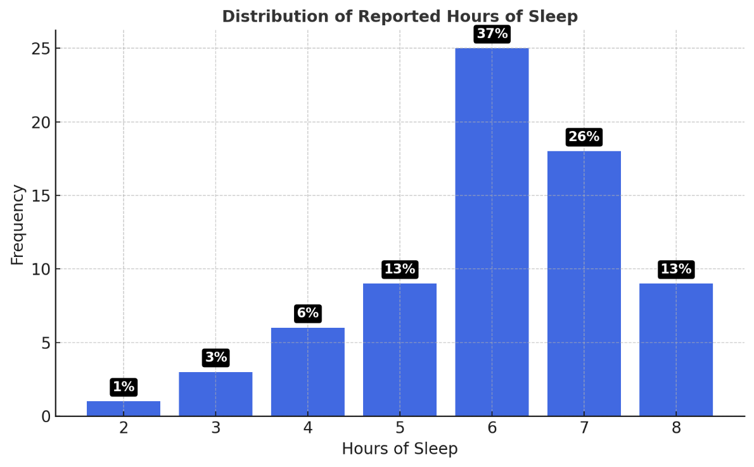

Fig. 1. How many hours of sleep do you get on average during your workdays?
Table 1. Place of work or center of assignment.
 | Frequency | Percentage | Cumulative percentage
Coahuixco Health Center | 6d | 8.8 | 8.8
BUAP Northeastern Regional Complex | 8 | 11.8 | 20.6
Zone General Hospital No. 23 | 10 | 14.7 | 35.3
Other work center | 10 | 14.7 | 50.0
IMSS Family Medical Unit No. 22 | 12 | 17.6 | 67.6
Teziutlan General Hospital | 22 | 32.4 | 100.0
Total | 68 | 100.0

Table 2. Job position
 | Frequency | Percentage | Valid percentage | Cumulative percentage
Physician | 4 | 5.9 | 5.9 | 5.9
Nurse | 27 | 39.7 | 39.7 | 45.6
Medical Student | 8 | 11.8 | 11.8 | 57.4
Medical Intern | 3 | 4.4 | 4.4 | 61.8
Nursing Intern | 2 | 2.9 | 2.9 | 64.7
Nursing Assistant | 2 | 2.9 | 2.9 | 67.6
Administrative Staff | 16 | 23.5 | 23.5 | 91.2
Other Healthcare Professionals | 6 | 8.8 | 8.8 | 100
Total | 68 | 100 | 100

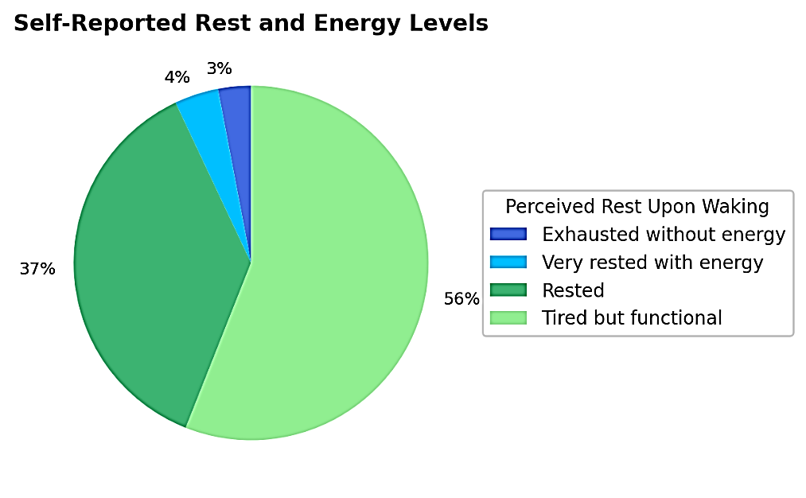

Fig. 2. The pie chart presents Self-reported Rest and Energy Levels

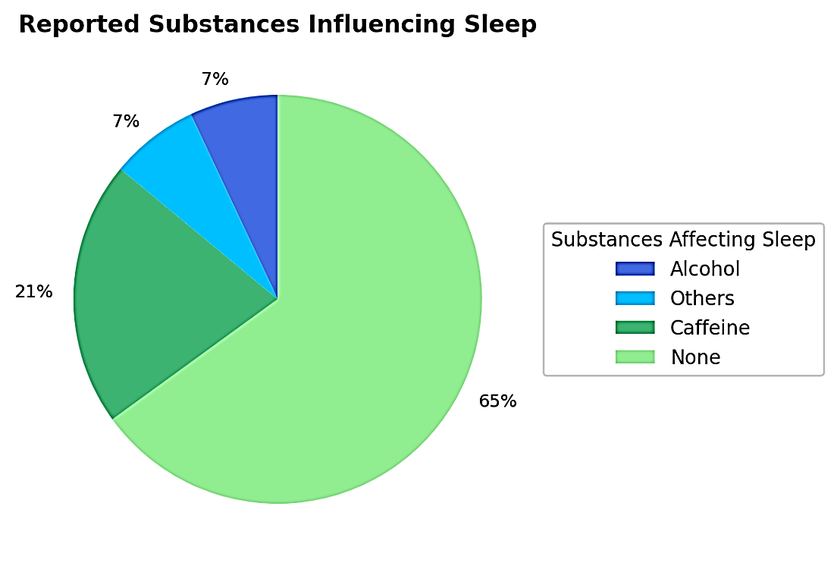

Fig. 3. The pie chat presents the Reported Substance Influencing Sleep
4. Discussion

The results obtained in this study in the Teziutlan region of Puebla confirm that sleep quality among healthcare personnel—including both professionals and students in training—is low and directly affects their daily functioning. 36.8% of respondents sleep only 6 hours during their workdays, while only 13% manage to get the recommended 8 hours. This finding is also reflected in the 56% who report feeling "tired but functional" upon waking, suggesting a widespread pattern of insufficient rest and accumulated fatigue.
These figures find support and parallels in the study conducted by Díaz et al. (2020) in public hospitals in Madrid, where a high prevalence of daytime sleepiness (37.6%) and poor sleep quality (44.8%) was observed, primarily among nursing staff. Both studies identify that sleepiness and fatigue negatively affect concentration and the ability to maintain good performance, especially in high-demand settings such as the healthcare sector.
Furthermore, in the present study, 60% of respondents reported experiencing frequent or regular daytime sleepiness, and more than 40% had difficulty concentrating during their workday. These figures reflect a functional impact consistent with the regression analyses conducted by Díaz-Ramiro et al., which concluded that sleep quality and sleepiness are the main predictors of symptoms such as anxiety, social dysfunction, and somatic symptoms.
This study confirms that sleep quality among healthcare personnel in the Teziutlan region is insufficient. This is consistent with the findings of previous research such as Silva et al. (2022) and Castillo et al. (2022), which already warned about the impact of some factors affecting healthcare personnel's sleep quality, such as night shifts, work overload, and irregular schedules.
In the article by Ríos et al. (2022), comparing their research with the present work, we find different concordant results, such as the reduction in sleep hours among healthcare personnel and trainees, with a very similar average sleep time. Another common finding was the speed at which they fall asleep. This is likely due to the physical exhaustion that comes with working in the healthcare field.
Although the sample in this study includes a more diverse sample from the healthcare field and not just medical residents, as in the case of Samilegios et al. (2022), we can identify that sleep problems continue to persist in both Peru and Mexico.
Taken together, both research papers point to poor sleep quality as a problem for the overall well-being of healthcare personnel.
Furthermore, the qualitative responses to the questionnaire revealed that, faced with insufficient quality of rest, some workers or students resort to the use of natural supplements such as magnesium, magnesium glycinate, chamomile tea, or passionflower tea to help them sleep. On the other hand, the use of medications such as cytolopram, Simi PZ valerian, melatonin, and alptazolam was also identified, which demonstrates the presence of symptoms that the workers themselves consider bothersome or limiting enough to require pharmacological intervention. We also observed that the same healthcare workers mentioned that if they slept poorly, they performed poorly the next day, their work at school or at work took longer, and they suffered from poor concentration. Once again, poor quality of sleep is a problem.
Together, these findings reinforce the evidence that healthcare personnel, both in training and in practice, operate under conditions of sleep-wake imbalance that compromise not only their individual well-being but also the safety and quality of the services provided.

4. conclusion

This research observed a frequently ignored reality: the physical and mental exhaustion of healthcare personnel and students in training related to poor sleep quality. A good night's sleep is not a luxury or a secondary recommendation, but a basic and fundamental need for proper bodily function, emotional stability, and daily performance. Throughout the research, it was evident that a large portion of healthcare personnel in the Teziutlan region sleep less than necessary and wake up with a constant feeling of fatigue. We want everyone to understand that sleep should not be viewed as a simple biological act, but as a restorative process that maintains the balance of those who, day after day, face the challenge of caring for others.
In this sense, we propose that healthcare and educational institutions take a more active role in promoting sleep health. Sleep hygiene should be encouraged as an essential part of internal policies, ensuring more established schedules, effective rest breaks, and environments that promote both physical and emotional rest. Furthermore, vocational training must educate students and professionals about the importance of integrating self-care into their daily practice.

Disclaimer (Artificial intelligence)

The authors declare that generative AI technology was used during the editing of the manuscript for grammatical revision and translation into English from Spanish. GPT5/OpenAI model.

References

Ángeles, M., Rojas, A., Quezada, R., Arellano, E., Ruiz, D., Velázquez, O., & Sánchez, M. (2023). Circadian sleep disorders. Journal of the Faculty of Medicine, 66(2), 40–48. https://doi.org/10.22201/fm.24484865e.2023.66.2.06
Díaz, R., Rubio, V., & López, M., & Aparicio, G. (2020). Sleep habits as predictors of psychological health in healthcare professionals. Annals of Psychology, 36(2), 242–246. https://doi.org/10.6018/analesps.350301
Ghalichi, L., Pournik, O., Ghaffari, M., & Vingard, E. (2013). Sleep quality among health care workers. Archives of Iranian medicine, 16(2), 100–103. https://pubmed.ncbi.nlm.nih.gov/23360632/
Gonzales, R. (2018). Calidad del sueño en residentes de Medicina Familiar de la UMF 20 IMSS DF [Sleep quality in healthcare personnel at the UMF 20] [Bachelor's thesis, National Autonomous University of Mexico]. http://132.248.9.195/ptd2013/agosto/0698646/0698646.pdf
Lo, J. C., Ong, J. L., Leong, R. L., Gooley, J. J., & Chee, M. W. (2016). Cognitive performance, sleepiness, and mood in partially sleep deprived adolescents: The need for sleep study. Sleep, 39(3), 687–698. https://doi.org/10.5665/sleep.5552
Patel, A.K., Reddy, V., Shumway, K.R., et al. (2024) Physiology, Sleep Stages. [Updated 2024 Jan 26]. In: StatPearls [Internet]. Treasure Island (FL): StatPearls Publishing. https://www.ncbi.nlm.nih.gov/books/NBK526132/
Samaniego Ríos, M., Distefano Martínez, J., & Ayala-Servín, N. (2022). Sleep quality and job satisfaction in medical residents. Medicina Clínica y Social, 6(1), 26–32. https://doi.org/10.52379/mcs.v6i1.235
Silva, A. F., De Cássia de Marchi Barcellos Dalri, R., Eckeli, A. L., De Sousa Uva, A. N. P., De Oliveira Cruz Mendes, A. M., & Robazzi, M. L. D. C. C. (2022). Sleep quality, personal, occupational, and lifestyle variables of hospital nurses. Revista Latino-Americana de Enfermagem, 30, e3538. https://doi.org/10.1590/1518-8345.5756.3538
Taffinder, N. (1998). Effect of sleep deprivation on surgeons’ dexterity on laparoscopy simulator. The Lancet, 352(9135), 1191. https://doi.org/10.1016/S0140-6736(98)00034-8

Weaver, M. D., Vetter, C., Rajaratnam, S. M. W., O'Brien, C. S., Qadri, S., Benca, R. M., Rogers, A. E., Leary, E. B., Walsh, J. K., Czeisler, C. A., & Barger, L. K. (2018). Sleep disorders, depression and anxiety are associated with adverse safety outcomes in healthcare workers: A prospective cohort study. Journal of sleep research, 27(6), e12722. https://doi.org/10.1111/jsr.12722

