Research Article
"Exploration of Priestia flexa for the Biosynthesis of Polyhydroxybutyrate (PHB) and Comprehensive Evaluation of Its Biodegradation Potential under Different Environmental Conditions"

ABSTRACT
Biodegradable alternatives are required due to the increasing environmental impact of synthetic polymers. Although production costs and yields limit its industrial use, polyhydroxybutyrate (PHB), a microbial polyester with thermoplastic and biocompatible qualities, is a viable possibility. In this study, resilient PHB-producing bacteria were isolated from industrial soils, the biodegradation capability of PHB was assessed, and cultural conditions were optimized for improved PHB synthesis. Soil samples from the industrial region of Goraguntepalya, Bangalore, were processed via serial dilution, yielding four isolates. PHB 2 showed the largest intracellular concentration among the two PHB-positive strains found by Sudan Black B staining. 16S rRNA sequencing, morphological analysis, and biochemistry all confirmed that PHB 2 was Priestia flexa (GenBank accession: OR462711.1). 1.13 g of PHB per 300 mL of broth was the greatest amount of PHB that could be produced using the following conditions: 48 hours of incubation, pH 7.0, 35 °C, 0.5% NaCl, 1% sucrose, and 1% peptone. The typical absorption peak at 250 nm in UV-visible spectroscopy verified PHB. Biodegradation assays demonstrated weight loss of 0.08% after 5 days in rhizosphere soil, confirming PHB’s microbial degradability. These results highlight P. flexa as a promising bioplastic producer with potential for sustainable applications. Using agro-industrial wastes as carbon substrates, enhancing yields through metabolic engineering, and carrying out extended biodegradation experiments in various environments are some future objectives. When combined, these tactics have the potential to hasten PHB's shift to environmentally benign, scalable plastic replacements.
Keywords: Biodegradable plastic, Biopolymer optimization, environmental sustainability, microbial biopolymer, Microbial degradation, Priestia flexa, Plastic pollution,

Graphical Abstract
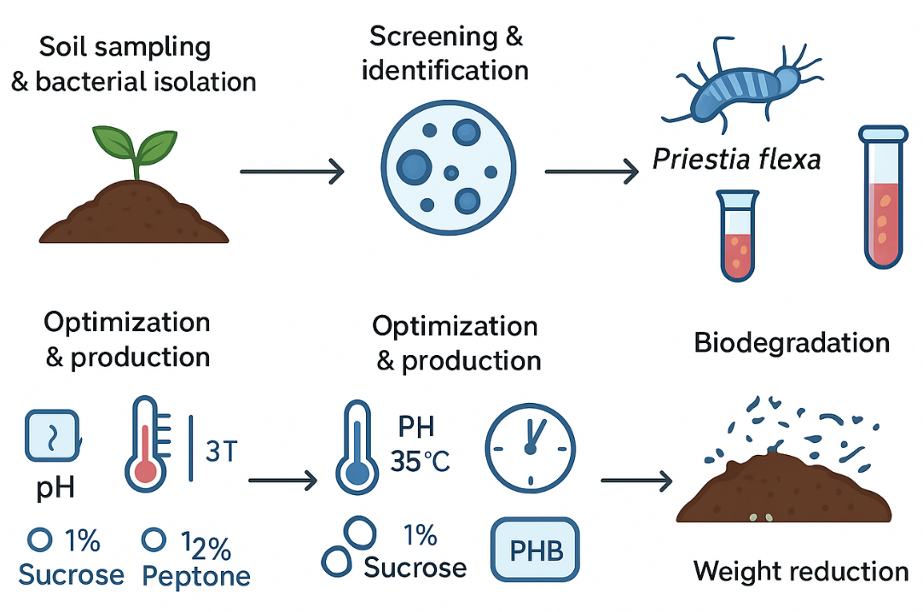

1. INTRODUCTION
Plastics have revolutionized our lives with their versatile and economical properties. However, their rapid use from fossil fuels has led to environmental issues, particularly in the packaging industry. Common commodity plastics, like PET, degrade slowly, with an expected lifespan of 100 years. In 2021, global plastic production reached 390.7 million metric tons (Saikumar et al., 2023).
Plastics' 10-50kDa molecular weight makes them resistant to chemicals and biodegradation. Research is ongoing to develop sustainable, environmentally friendly plastics from renewable sources like agriculture, microbial, and biomass. Alternative biopolymers like polyhydroxyalkanoate and polyhydroxybutyrate have the potential to replace linear plastic use and disposal practices, promoting a fully circular life cycle (Jansen, 2016).
PHB materials are stiff, brittle, and low thermal stable, similar to petroleum polymers. They are the most extensively studied biopolymer from PHAs' family. The high production cost is due to expensive raw materials. Strategies to reduce costs include using alternative carbon sources like natural products, industrial wastes, and agro-industrial residues through fermentation processes (McAdam et al., 2020).
Poly (3-hydroxybutyrate) (PHB) is a highly crystalline polymer with a linear chain structure, containing both amorphous and crystalline phases. It is produced as a carbon reserve in various bacterial strains and is produced industrially through bacterial fermentation. PHB has advantages over synthetic polymers, such as superior barrier permeability, better barrier properties, and biodegradability. It is produced in the cells of microorganisms as a product of microbial secondary metabolism, usually in conditions of nutrient stress or carbon excess with limited nutrients. PHBs are produced by various species of bacteria, such as Bacillus spp., Alcaligenes spp., Pseudomonas spp., and Azotobacter spp. PHBs are a type of polyester produced naturally by microorganisms as an intracellular energy storage compound. It is a biodegradable and biocompatible material with properties similar to conventional petrochemical-based plastics but with the added benefit of being environmentally friendly (Alshammari 2021; Fatima et al., 2021).
High-level production economics hinder bioprocess technology for polymers like PHB, which have biodegradability and renewable resource potential. PHB has mechanical characteristics comparable to thermoplastics, resistance to water and UV rays, and high gas barrier qualities. It can be created by bacteria and algae or recombinant DNA technology under different conditions (Kalia et al., 2021). PHB, a non-toxic, biodegradable, and biocompatible material, has potential applications in various industries such as pharmaceuticals, nano delivery, food safety, and biomedical applications. Its biodegradability is crucial in single-use items like packaging and utensils, making it a desirable material to replace fossil fuel-based petrochemical polymers. PHB is used in biocompatible implants, tissue engineering scaffolds, smart packaging, and 3D printing inks (Rofeal et al., 2022; Abd El-malek et al., 2020).
The global demand for PHB production is increasing, with projections from the Nova Institute showing a rise from 34,000 metric tons in 2013 to 7.4 thousand metric tons in 2018. However, the main obstacle is production costs, which have been reduced by researching efficient bacterial strains and optimizing fermentation and recovery procedures (Aeshelmann et al., 2015).
Bacillus species, found in diverse habitats worldwide, have demonstrated a yield of up to 90% PHA from total dry cells produced by liquid fermentation. This versatile genus is a potential candidate for PHA production due to its high yields and minimal fermentation factors. Bacillus cell sizes range from 0.6 to 1.2 μm in width and 0.9-8 μm in length, depending on species, culture medium, and growth conditions. Agricultural soil has higher PHB-producing isolates (Mohapatra et al., 2017; Adebajo et al., 2024).
Plastic materials steadily break down to generate tiny particles due to environmental factors such as weathering, solar radiation, mechanical forces, and microorganism isms. This leads to the formation of micro plastics (MPs) (ranging from 5 mm to 0.1 µm) and nanoplastics (NPs) (ranging from 0.1 µm to 100 nm). These emerging pollutants are a nuisance to the environment and humans. MPs and NPs are now distributed in freshwater sources, oceans, drinking water, soil, atmosphere, food, as well as in the human body. Due to their small sizes, both are easily mistaken for food and are devoured by or attached to aquatic organisms (rotifers, fish, shrimp, algae, zooplankton, etc.) causing them to potentially travel into humans through the food chain (Dhali et al., 2024).
Plastic degradation involves various treatments of physical, chemical and biological factors. Physical factors involve heat and radiations, chemical factors include acids and alkalis and biological factors are using microbes like bacteria, fungi and actinomycetes. Based on the nature of the causative agents, degradation of polymer is classified as thermal degradation, photo-oxidative degradation, mechano-chemical degradation, catalytic degradation, ozone induced degradation, and biodegradation. The conventional techniques employed to degrade plastic in the environment are inadequate as it releases harmful by-products. The most abundant plastic waste materials discarded in landfills are the plastic bags (69.13%) which are made up of low density polyethylene (LDPE). LDPE is amorphous in nature (10-30 methyl (CH₃) groups per 1000 C atoms) and composed of butene, hexene, and octene. The branching system in LDPE chains makes more accessible and susceptible to attack due to the presence of more tertiary carbon atoms at the branch sites. In LDPE material, the physical arrangement of the polymer chains and the vinylidene content have shown to be directly related with the polymer oxidization which makes it more biodegradable (Saritha et al., 2021).
This project was chosen to address the urgent global challenge of plastic pollution by focusing on biodegradable polymer production through microbial processes. The significance lies in its potential to develop sustainable, low-cost, and environmentally safe alternatives to conventional plastics, contributing to cleaner ecosystems and advancing green biotechnological solutions.
2. MATERIALS AND METHOD
2.1. Study area and collection of soil samples
Soil sample was collected from Industrial area of Goraguntepalya, Yeshwanthpur, (Lat. 13.023451°N; Long. 77.537714°E), Bangalore, Karnataka, India. The rhizosphere soil sample at a depth of 6 to 15cm was collected. The soil sample was collected with the help of knife and spade. A clean tool is used to avoid the contamination, and samples were placed in a sterile plastic bags labelled them with site information, date and depth. The sample was stored at 20ºC for further analysis (Prajapati et al., 2012).
2.2. Isolation of bacteria by serial dilution method.
Isolation of bacteria for PHB screening was carried out using serial dilution and spread plate techniques. One gram of collected soil sample was suspended in 9 mL of sterile distilled water and serially diluted up to 10⁻⁹. From 10⁻⁶, 10⁻⁷ and 10⁻⁸ dilution, 0.1 mL aliquots from each dilution were aseptically plated onto sterile nutrient agar plates. The plates were incubated at 37°C for 24 h. Distinct colonies were selected based on morphological characteristics and pure culture was isolated by continues streaking. The pure isolates were preserved on nutrient agar slants at 4°C for further screening and analysis (Patel et al., 2021).
2.3 Primary screening for selection of PHB producing bacteria.
Detection for PHB production was employed by using lipophilic stain called Sudan Black. Stain was prepared by dissolution of 0.3g powdered stain in 100 ml of 70% ethanol. For microscopic studies, smears of colonies were heat-fixed on clean, grease-free glass slides, followed by staining with 0.3% solution of the Sudan Black B. After leaving the slides undisturbed for 15 minutes, immersion in xylene and counterstaining with safranin (5% w/v in sterile distilled water) was performed. Cells appearing blue-black under microscope were accredited as PHB positive strains. PHB positive strain was preserved on two vials, viz., working and stock vials containing agar slants with 2% glycerol for preservation (Burdon et al., 1942).
2.4. Identification of PHB producing bacteria.
24.1. Morphological characterization of PHB producing bacteria.
Morphological characteristics of the isolated bacterial colonies were observed after incubation on nutrient agar plates. Each distinct colony was assessed based on visible features such as shape, size, elevation, margin, surface texture, opacity. Observations were recorded after 24 h of incubation at 37° C. For microscopic examination, bacterial smears were prepared on clean glass slides, heat-fixed, and stained using Gram staining. The stained slides were observed under oil immersion (100X objective) to determine the Gram reaction, cell shape and cell arrangement (Gurubasajar et al., 2024).
2.4.2. Biochemical characterization of PHB producing bacteria.
The purified bacterial isolates were subjected to various biochemical tests to identify their genus based on morphological and metabolic characteristics. The performed biochemical test includes Gram staining, Indole test, Methyl red test (MR), Voges-Proskauer test (VP), Citrate utilization test, Catalase test, Oxidase test, Urease test, Hydrogen sulfide production test, KOH Solubility test, Carbohydrate utilization test and endospore staining. These tests were carried out by following standard protocols described in Bergey’s Manual of Determinative Bacteriology (Holt et al., 1994).
2.4.3. Molecular characterization of PHB Producing bacteria.
DNA Extraction
DNA was extracted from each bacterial isolate by the standard phenol/chloroform method of Cheng and Jiang (2006). The quality of DNA was checked by electrophoresis in 0.8% agarose gel and quantified using Nano-Drop ND-1000 spectrometer (Eppendorf, Germany).
PCR Amplification
The PCR of 16S rRNA gene from isolated DNA was amplified using a universal oligonucleotide primer pair 27F (5′-AGAGTTTGATCCTGGCTCAG-3′) and 1492R (5′-TACGGTTACCTTGTTACGACTT-3′) (Lane, 1991) in a thermal cycler (Thermo Fisher, United States). The reaction mixture, conditions, and protocol for the polymerase chain reaction amplification were done following the method of Chagnaud et al., (2001). The PCR amplification was performed in a mixture containing a final volume of 50 μL of GoTaq Green Master Mix (2×) (M7122, Promega, United States), 10 μM of F primer, 10 μM of R primer, and nuclease-free water (NEB). The PCR reaction program was set under the following PCR conditions: 94°C for 10 min; 94°C for 1 min, 65°C for 1 min, and 72°C for 30 s for 35 cycles; and 72°C for 7 min. The PCR products were detected by electrophoresis using 1% agarose, and the bands were stained with 7 μl/100 ml of ethidium bromide and visualized using Gel Doc EZ Imager (Bio-Rad, United States). A standard 100-base pair DNA ladder was used for the verification of amplicon size. The amplified PCR products were purified using the PEG (polyethylene glycol)-NaCl (sodium chloride) (20% w/v of PEG, 2.5 M NaCl) precipitation method of Schmitz and Riesner (2006).
16S rRNA Gene Sequencing
The PCR products were set up in 5 μl volume for a single primer amplification with the same universal primers 27F and 1492R (Lane, 1991) for separate reactions of each primer. The PCR reaction was set as follows: denaturation (96°C, 10 s), annealing (50°C, 5 s), and elongation (60°C, 2 min) with a stop reaction at 4°C. The amplicons were then precipitated with 1 μl sodium acetate (3 M, pH 5.2) and 24 μl of absolute alcohol, mixed briefly in vortex, and incubated at room temperature for 15 min, centrifuged at 12,000 rpm for 20 min, further washed with 70% ethanol, air-dried, and suspended in 10 μl formamide. Sequencing of the amplicons was performed by the Sanger sequencing method of Heather and Chain (2016) which was carried out in an automated DNA Analyzer (ABI 3730XL Capillary Sequencers, Applied Biosystems, Foster City, CA, United States).
Data Analysis
The quality of sequences was analyzed by Sequence Scanner v.1.0 (Applied Biosystems, Foster City, CA, United States) followed by DNA sequence assembly using ChromasPro 2.1.81. The contigs were subjected to BLAST (Basic Local Alignment Search Tool) (Benson et al., 2014) for nucleotide similarity search. The sequences were then aligned by pairwise alignment using ClustalW and the phylogenetic tree was constructed by the neighbor joining method using MEGA7.0 software (Kumar et al., 2016). The genera and species were identified based on the lowest E-value in BLAST.

  - Optimization of cultural parameters
2.5.1. Optimization of Incubation Period
25 ml production media was distributed in each test tube and sterilized by autoclave at 121°C for 15-20 minutes. Then 0.25 mL inoculum of positive PHB producers were inoculated into sterile production media and incubated at 37°C for different incubation periods of 24, 48 and 72 h. On Completion of desired incubation period, PHB yield was estimated according to Hahn et al., (1994).
2.5.2. Optimization of pH
Microorganisms have a minimum, an optimum and a maximum pH for growth. To standardize the optimum pH to produce PHB, 0.25 mL of PHB positive bacterial inoculum was inoculated in production media whose pH varied from 5 to 8 and incubated at 37°C. After completion of the optimum incubation period PHB yield was estimated as per Hahn et al., (1994).
2.5.3 Optimization of Temperature
Microorganisms have different range of temperatures suitable for their growth. To standardize the optimum temperature to produce PHB, 0.25mL of PHB positive bacterial inoculum was inoculated in production media with optimum pH and incubated at different temperatures ranging from 25°C to 40°C with 5°C variation, later yield of PHB obtained in each variation was examined (Adnan et al., 2023).
2.5.4. Optimization of Salinity
Growth rate and productivity rate can be higher when bacteria are exposed to change in salinity, hence study on effect of salinity towards the efficient PHB producer was carried out. Growth media with salt concentration ranging from 1% to 4% was inoculated with the isolate and incubated under optimum conditions, later PHB yield was estimated in each salt medium to evaluate the effect of peptone concentration on PHB accumulation (Adnan et al., 2023).
2.5.5. Optimization of glucose concentration
To determine the most suitable concentration of carbon source for enhanced PHB production, 0.25 mL of the PHB-positive bacterial inoculum was inoculated into the production medium supplemented with sucrose at varying concentrations: 0.25%, 0.50%, 0.75%, and 1.0% (w/v). The cultures were incubated under the previously determined optimum incubation period and conditions. After incubation, PHB was extracted and quantified according to the method of Hahn et al., (1994) to assess the influence of sucrose concentration on PHB accumulation.
2.5.6. Optimization of peptone source concentration
To determine the most suitable concentration of nitrogen source for enhanced PHB production, 0.25 mL of the PHB-positive bacterial inoculum was inoculated into the production medium supplemented with peptone at varying concentrations: 0.25%, 0.50%, 0.75%, and 1.0% (w/v). The cultures were incubated under the previously determined optimum incubation period and conditions. After incubation, the PHB was extracted and quantified using the method of Hahn et al., (1994) to evaluate the effect of peptone concentration on PHB accumulation.
2.6. Mass production of bacterial culture for PHB synthesis
Mass production of the selected PHB producing bacterial isolate was carried out using the optimized culture parameters obtained from preliminary experiments. A loopful of the isolate was first inoculated into a small volume of sterile nutrient broth to prepare an actively growing pre-inoculum. After suitable incubation, 3 mL of pre-inoculum was transferred aseptically into 300 mL production medium. The production medium was prepared with appropriate concentrations of carbon and nitrogen sources, and its pH was adjusted as per the optimized values. Inoculated flasks were incubated for optimal bacterial growth and PHB synthesis. After incubation period PHB was extracted.
2.7 Extraction of PHB
The bacterial culture was centrifuged at 5000 rpm for 15 minutes, supernatant was discarded carefully, and the pellet was treated with 10 ml of 6% Sodium hypochlorite. The mixture was then incubated at 50°C for 1 hour and centrifuged at 5000 rpm for 10 minutes. Sodium hypochlorite solution (supernatant) was discarded, and the pellet was washed with 2ml of distilled water followed by acetone and ethanol. The pellet was dissolved with 10-15ml of hot chloroform and filtered using a pre-weighed Whatman filter paper in a pre-weighed evaporating dish. The evaporating dish was placed on water bath for the evaporation, Weight of the evaporating dish after evaporation was noted and the amount of PHB yield was calculated by using the below formula (Biradar et al., 2015, Ratnaningrum et al., 2020).
Yield of PHB (g) = Weight of evaporating dish with PHB – Wight of empty evaporating dish

2.8. Characterization of PHB by UV visible spectrophotometer
The extracted PHB was dissolved in hot chloroform, evaporated, and dissolved in concentrated sulfuric acid (H₂SO₄) to convert it into crotonic acid. The sample was scanned in a UV-Visible spectrophotometer, and a sharp absorption peak near 235-240 nm confirmed PHB's presence through crotonic acid detection. A blank containing concentrated sulfuric acid was used as a reference (Law and Slepecky (2015).
2.7. PHB degradability test evaluation
Evaluation of PHB degradation was carried out using native microorganisms present in rhizosphere soil. Extracted PHB was mixed with 5 grams of freshly collected rhizosphere soil in a pre-weighed sterile beaker. The setup was maintained under laboratory conditions to allow natural microbial activity. After 5-day incubation period, the initial and final weights were compared to assessing the extent of degradation. Percentage degradation was calculated using the formula,
Percentage degradation = $\frac{w_{0}-w_{t}}{w_{0}}×100$
Where: W₀= Initial dry weight of PHB
W_{t}= Dry weight of PHB after 5 days

3. RESULTS
3.1. Collection of soil samples
Soil samples were collected from rhizosphere region of plants grown in an industrially contaminated area. Samples were taken at a depth of 5–10 cm using sterile tools. Collected soils were stored in sterile polythene bags at 4°C until processing. This source was chosen to increase the chances of isolating efficient PHB producing bacteria.
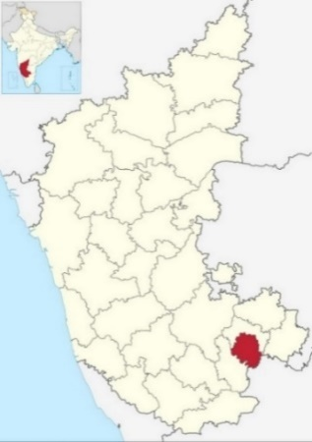

Fig. 1. Geographical area of soil sample collection
3.2. Isolation of bacteria by serial dilution method.
Soil samples collected from the industrial area of Goraguntepalya, Yeshwanthpur, Bangalore, were serially diluted up to 10⁻⁸and plated on nutrient agar medium. After incubation at 37°C for 24 h, distinct bacterial colonies were observed on plates from 10⁻⁶ to 10⁻⁸ dilutions. Based on differences in colony morphology such as size, shape, color, and surface texture, four distinct colonies were selected. These isolates were re-streaked on fresh nutrient agar plates to obtain pure cultures and were designated as PHB 1, PHB 2, PHB 3, and PHB 4.
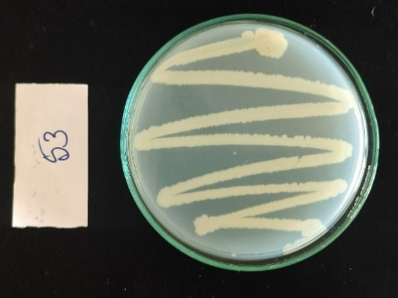
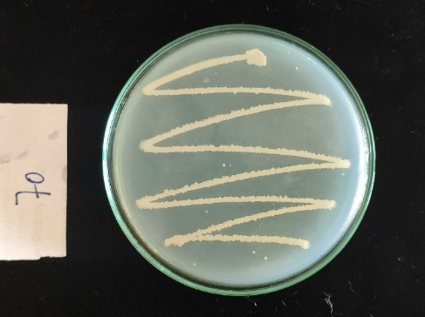
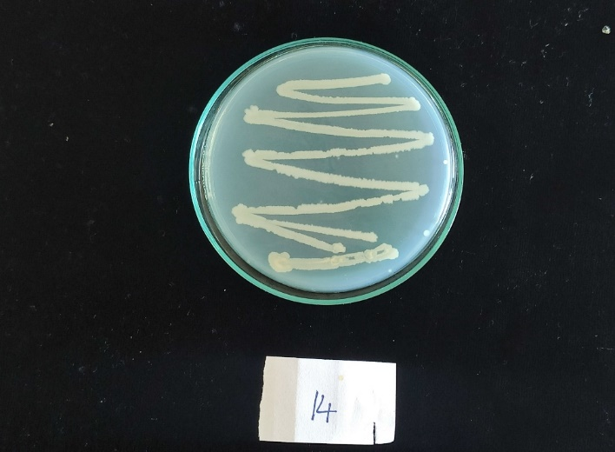
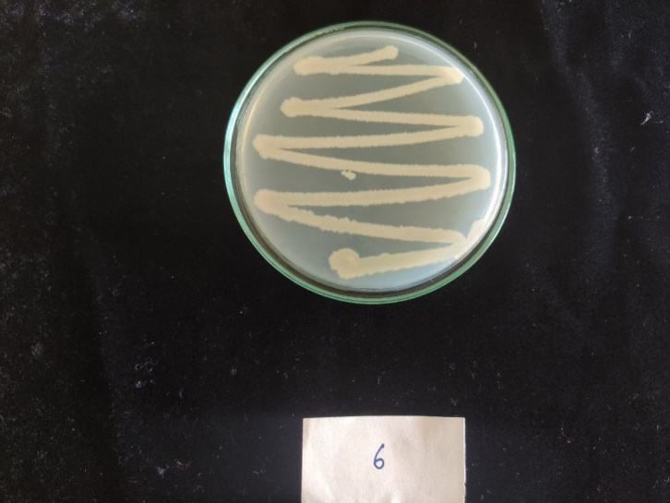
b
a
c
d

Fig. 2. Pure cultures of isolated colonies: (a) PHB 1 (b) PHB 2, (c) PHB 3 and (d) PHB 4
3.3. Primary screening by Sudan Black B stain
All purified bacterial isolates were subjected to preliminary screening for PHB accumulation using Sudan Black B staining. This lipid-soluble dye selectively stains PHB granules present within the cytoplasm of bacterial cells. Out of the total 4 isolates (PHB 1, PHB 2, PHB 3 and PHB 4), 2 isolates, (PHB 2 and PHB 4) showed positive results, indicated by the presence of dark blue to black intracellular granules under the microscope. These stained granules confirmed the intracellular accumulation of PHB. The remaining isolates did not exhibit any granule formation and were considered PHB-negative. Among PHB 2 and PHB 4, PHB 2 shows more PHB granules than PHB 4. The PHB 2 isolates were considered as potential PHB producer and selected for further morphological, biochemical and molecular characterization.

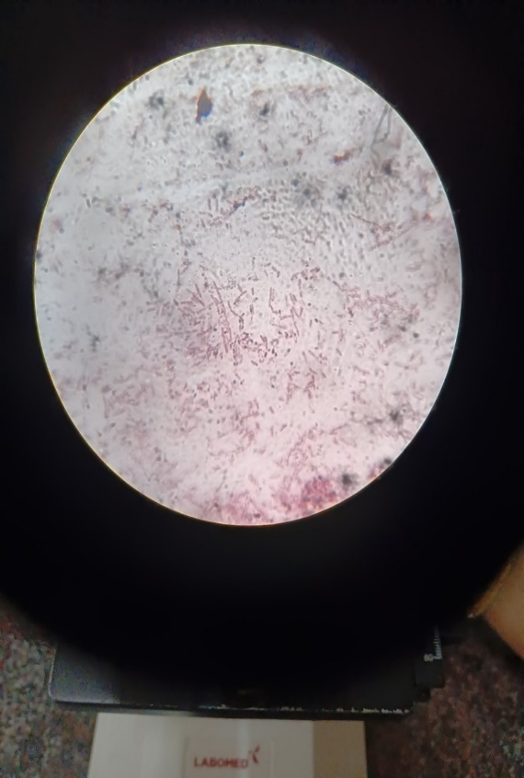
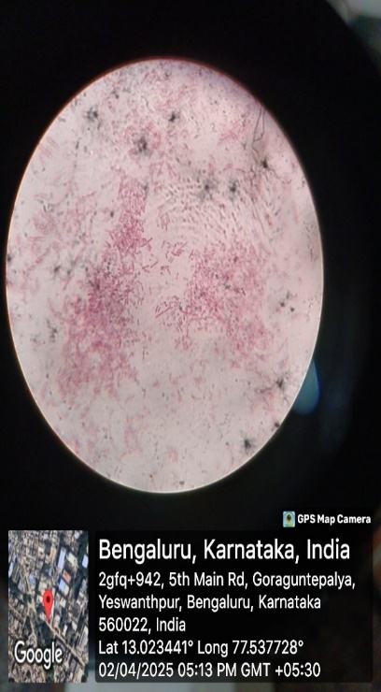
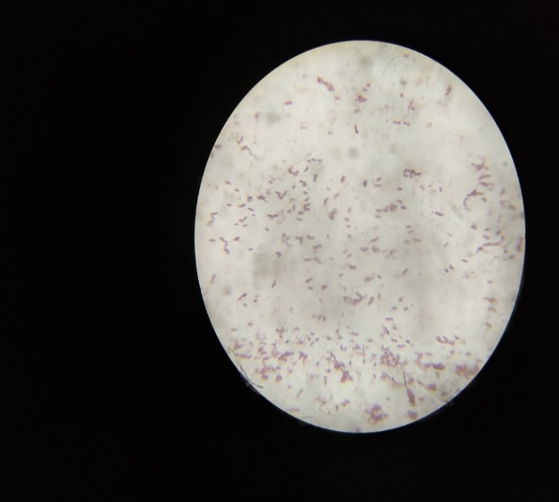
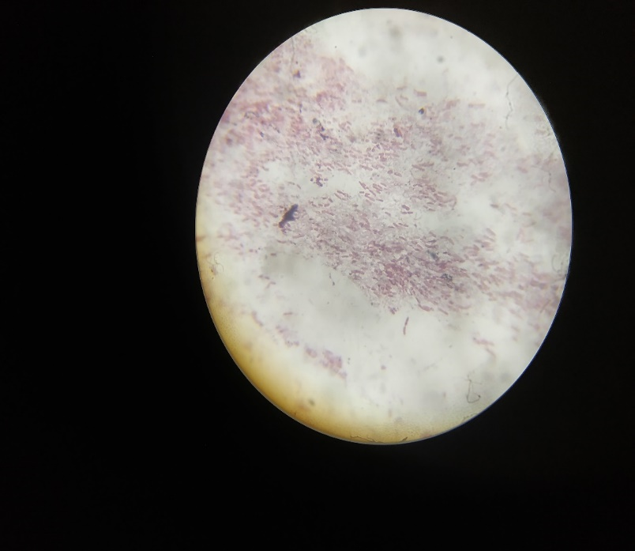

Fig. 3. Sudan black staining of isolated colonies for PHB granules (a) PHB 1 (negative), (b) PHB 2 (positive), (c) PHB 3 (negative) and (d) PHB 4 (positive).
3.4. Identification of PHB producing bacteria
3.3.1. Morphological characterization
PHB 2 isolate was examined for its morphological characteristics. On nutrient agar, the colony appeared circular, with a slightly convex elevation, and a waxy, milk white surface. The colony exhibited low transparency and was non-pigmented. Microscopic examination after Gram staining showed that the organism was Gram-positive rods and arranged in chain forms (Table 1).
Table 1. Morphological characterization of PHB 2 isolate.
Feature | Observation
Colony shape | Circular
Elevation | Slightly convex
Surface texture | Waxy
Color | Milk white
Transparency | Low
Pigmentation | Absent
Gram’s staining | Positive
Cell shape | Rods
Arrangement | Chain

3.3.2. Biochemical characterization
The PHB 2 bacterial isolate was subjected to a series of biochemical tests to support its identification. The PHB 2 isolate shows positive for catalase, oxidase, VP, and citrate, and tested negative for indole, methyl red, urease, and H₂S. The KOH solubility test was also negative, indicating the isolation is Gram positive. Carbohydrate utilization tests revealed the organism could ferment glucose, sucrose, and lactose, producing acid, as indicated by a color change in the medium. Mannitol was not fermented by the isolate.
Table 2. Result of biochemical tests
Biochemical test | Result | Interpretation
Indole | Negative | No tryptophanase activity
Methyl Red | Negative | No stable acid production
Voges Proskauer | Positive | Acetonin production positive
Citrate Utilization | Positive | Utilizes citrate as carbon source
Catalase | Positive | Bubble formation indicates catalase enzyme
Oxidase | Positive | Purple color confirms oxidase
Urease | Negative | No urea hydrolysis
H₂S production | Negative | No black precipitate formation
KOH Solubility | Negative | Indicates Gram positive nature
Endospore staining | Positive | Green color spores
Carbohydrate Utilization
Glucose | Positive | Acid production
Sucrose | Positive | Acid production
Mannitol | Positive | No fermentation
Lactose | Negative | Acid production

3.3.3. Molecular characterization
The species molecular level identification of isolated bacteria was confirmed by accomplishing 16S rRNA gene sequencing. The nucleotide sequence was deposited to GenBank, NCBI and assigned with unique identifier i.e., OR462711.1. The gene sequence alignment utilizing pair-wise alignment showed the greatest (100%) similarity with Priestia flexa isolate KUMBSHGNBT-01. The PCR amplicon size was 901 base pairs. The neighbor joining method and a bootstrap value of 100 was used to analyze the isolate's phylogeny.
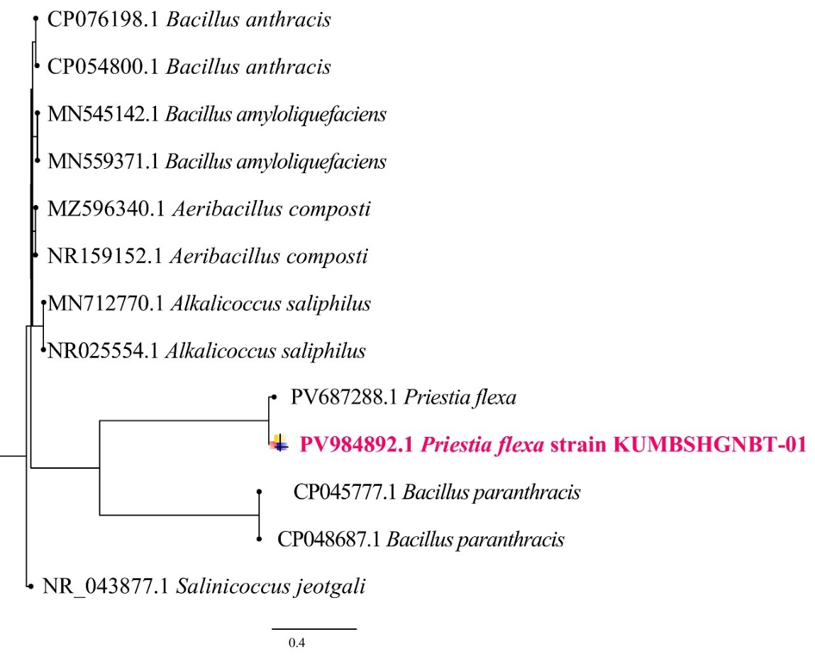

Fig. 4. Phylogenetic tree of Priestia flexa KUMBSHGNBT-01 isolate with reference strains using neighbour-joining method with bootstrap value of 100.Priestia flexa
3.4. Optimization of cultural parameters for enhanced PHB production
3.4.1 Optimization of Incubation Period
The effect of incubation period on PHB production by the selected isolate (PHB 2) was evaluated at 24, 48, and 72 h. PHB yield increased progressively from 24 to 48 h, reaching its maximum at 48 h, which corresponds to the early stationary phase of bacterial growth. Beyond this period, at 72 h, PHB production declined, likely due to nutrient depletion and possible utilization of stored PHB as an energy source. These results indicate that 48 h of incubation provides the optimal balance between active bacterial growth and PHB accumulation.

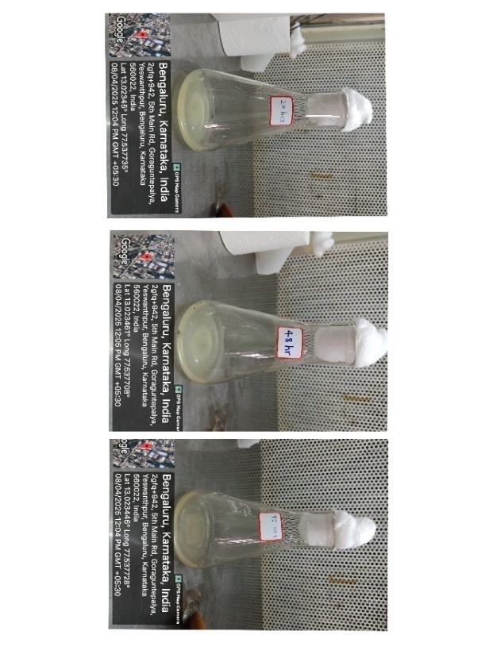

Fig. 5. Effect of incubation period on PHB production.
3.4.2. Optimization of Temperature
The influence of temperature on PHB production was tested by growing the selected isolate (PHB 2) at different temperatures ranging from 25°C to 40°C. PHB production was observed to be lower at 25°C and 30°C, but it gradually increased as the temperature approached 35°C, where the maximum yield was recorded. At 40°C, PHB production declined, possibly due to heat stress affecting bacterial metabolism. These findings suggest that 35°C is the most suitable temperature for the selected isolate to achieve maximum PHB production.
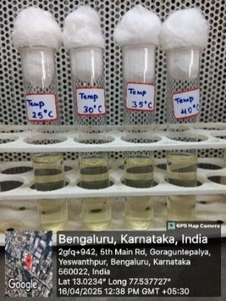

Fig. 6. Effect of temperature on PHB production.
3.4.3. Optimization of pH
The effect of pH on PHB production was evaluated by cultivating the selected isolate (PHB2) in media with pH values ranging from 5.0 to 8.0. PHB production was lower at more acidic (pH 5) and slightly alkaline (pH 8) conditions. The yield improved steadily as the pH approached neutrality, with maximum PHB production observed at pH 7.0. Beyond this range, the production decreased, likely due to suboptimal enzyme activity and reduced bacterial growth.
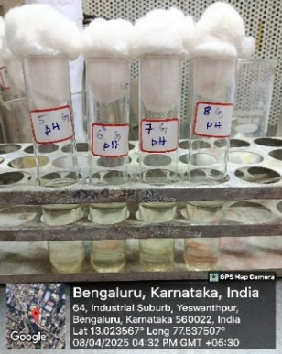
a

Fig. 7. Effect of pH on PHB production
3.4.3. Optimization of NaCl Concentration
Sodium chloride was added to the production medium in varying concentrations to study its influence. Maximum PHB production occurred at 0.50% NaCl, suggesting a moderate salt tolerance of the isolate under optimal growth conditions.
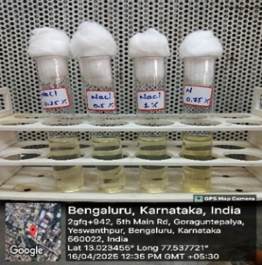

Fig. 8. Effect of NaCl concentration on PHB production.
3.4.5. Optimization of glucose concentration
The effect of sucrose concentration on PHB synthesis was studied at 0.25%, 0.50%, 0.75%, and 1.0%. The highest PHB accumulation was observed at 1% sucrose, indicating sufficient carbon availability promoted biosynthesis.
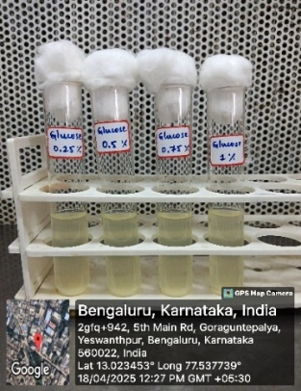

Fig. 9. Effect of glucose concentration on PHB production.
3.4.6. Optimization of peptone concentration
Peptone was used as the nitrogen source, and its concentrations were varied from 0.25% to 1.0%. The highest PHB production was achieved at 1% peptone, suggesting that higher nitrogen levels supported better biomass formation, indirectly enhancing PHB accumulation.
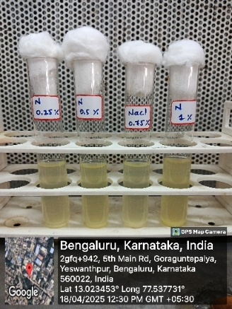
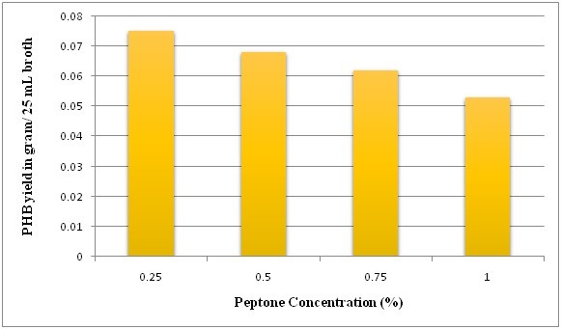

Fig. 10. Effect of peptone concentration on PHB production.
Table 3. Results of different optimized parameters for enhanced PHB production
Optimization parameter |  | PHB yield in gram/ 25 mL broth
Incubation period (h) | 24 | 0.052
Incubation period (h) | 48 | 0.062
Incubation period (h) | 72 | 0.056
pH | 5 | 0.034
pH | 6 | 0.063
pH | 7 | 0.073
pH | 8 | 0.067
Temperature (°C) | 25 | 0.053
Temperature (°C) | 30 | 0.063
Temperature (°C) | 35 | 0.071
Temperature (°C) | 40 | 0.058
NaCl (%) | 0.25 | 0.054
NaCl (%) | 0.50 | 0.063
NaCl (%) | 0.75 | 0.053
NaCl (%) | 1.0 | 0.043
Carbon (%) | 0.25 | 0.052
Carbon (%) | 0.50 | 0.063
Carbon (%) | 0.75 | 0.070
Carbon (%) | 1.0 | 0.077
Nitrogen (%) | 0.25 | 0.075
Nitrogen (%) | 0.50 | 0.068
Nitrogen (%) | 0.75 | 0.062
Nitrogen (%) | 1.0 | 0.053

3.5. Production and Extraction of Polyhydroxybutyrate
The optimized conditions obtained from culture parameter studies were used for large-scale production of PHB. The PHB positive isolate was cultivated in a production medium supplemented with 1% sucrose and 1% peptone, at pH 7.0 and a temperature of 35°C. The culture was incubated for 48 h to promote biomass accumulation and PHB synthesis.
Following incubation, the bacterial biomass was harvested by centrifugation. PHB was extracted from the pellet using the sodium hypochlorite digestion method followed by washing with acetone and ethanol to remove cell debris and impurities. The resulting crude extract was dissolved in chloroform and evaporated to obtain the purified PHB.
The extracted PHB appeared as a white, powdery residue after evaporation. The total yield of PHB obtained from 300 mL of production broth was 1.13 grams, indicating a high accumulation potential by the isolate under optimized conditions. The purified PHB was then stored for further characterization and degradation studies.
3.6. Characterization of Extracted PHB
The extracted PHB was subjected to UV–Visible spectrophotometric analysis to confirm the presence of polyhydroxybutyrate. The polymer was dissolved in chloroform, and absorbance was measured in the range of 200–400 nm using a UV–Visible spectrophotometer.
The spectrum exhibited a sharp absorption peak at 250 nm, which is characteristic of PHB. This λ-max confirms the presence of conjugated C=O (carbonyl) groups typically found in PHB molecules. The absorbance data, in agreement with published literature, verified that the extracted material was polyhydroxybutyrate.

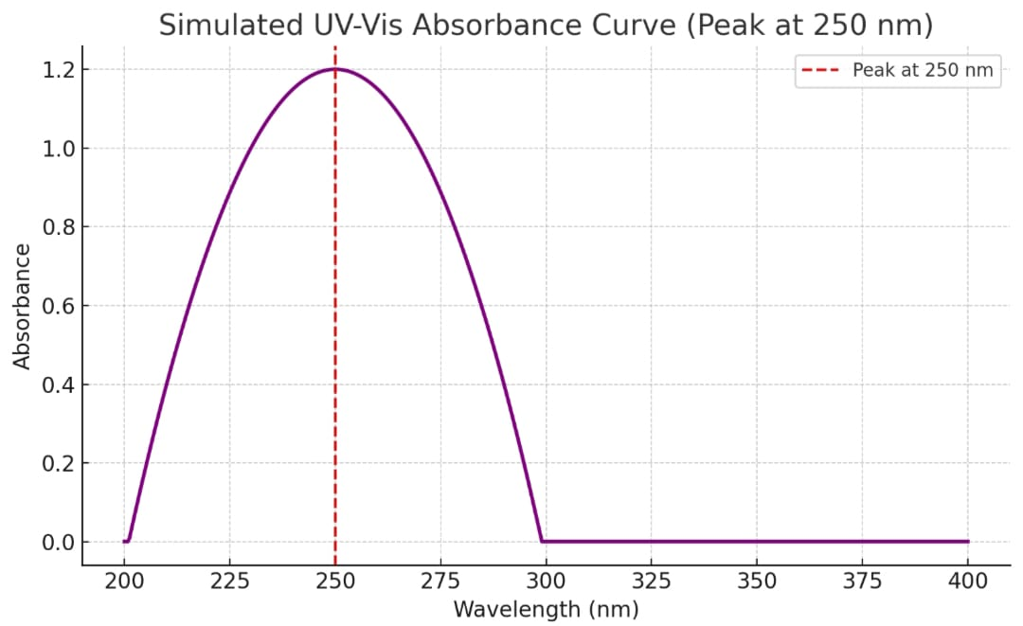

Fig. 11. UV–Visible absorption spectrum of extracted PHB.
3.7. Evaluation of PHB degradation by rhizosphere soil microorganisms
The observed reduction in PHB weight after 5 days of incubation with rhizosphere soil microorganisms indicates active biodegradation of the polymer. Rhizosphere soil is known to be rich in diverse microbial populations, including bacteria and fungi capable of degrading natural polymers. The microbial enzymes likely broke down the PHB into simpler molecules, resulting in a measurable decrease in mass.
This result demonstrates that the PHB produced by the isolate is biodegradable under natural conditions. It validates the eco-friendly nature of PHB.
Empty weight of bacteria = 56.056g
Weight of soil = 5 g
Weight of PHB = 0.2 g
Final weight of the beaker = 61.256 g
Weight of beaker after 5 days of incubation = 56.043 g
Percentage degradation = $\frac{w_{0}-w_{t}}{w_{0}}×100$
% of degradation of PHB was =0.08 %
- DISCUSSUION
Soil samples were collected from rhizosphere region and industrial contaminated soils to ensure a diverse microbial pool. The logic behind choosing such locations is supported by studies like Olukayode et al., (2022), who reported that microorganisms in stressed environments exhibit high metabolic adaptability and are potential PHB accumulators. In this study, initial screening with Sudan Black B staining confirmed the presence of PHB granules in one bacterial isolate. This method is a widely used preliminary screening tool as shown by Gurubasappa et al., (2021), due to its ability to bind intracellular lipid inclusions visible as dark-stained granules. The isolate's colony morphology was milky white, waxy, circular, and slightly convex typical of PHB-positive strains, especially within the genus Priestia.
Biochemical tests including IMViC, oxidase, urease, H₂S production, KOH solubility, and carbohydrate utilization were conducted. These confirmed the isolate belong to the Priestia genus, which is known for PHB producing potential. Identification was further validated through 16S rRNA sequencing, a gold standard for microbial taxonomy (Woese et al., 1990). Similar strains like Bacillus flexus (Adnan et al., 2023) and Bacillus subtilis (Patel et al., 2020) have previously shown high PHB yields under optimized culture conditions.
PHB production peaked at 48 h of incubation, corresponding to the early stationary phase. This is consistent with Lee et al., (2005), who noted that PHB biosynthesis intensifies when cell growth slows and nutrient limitations trigger carbon storage mechanisms. The ideal pH was found to be between 6.0 and 7.0, and optimal temperature was 35°C, aligning with findings by Gomaa (2014) and Patel et al., (2021), who reported that most Bacillus species perform well at neutral pH and mesophilic temperatures. Interestingly, a salt concentration of 0.5% NaCl was found to be optimal. This low-salt condition appears to slightly stress the bacterial cells, encouraging them to accumulate PHB, which serves as a protective reserve material.
Sucrose was the best carbon source at 1% concentration, and peptone was the preferred nitrogen source, also at 1%. These results agree with Gouda et al., (2001), who highlighted the role of simple sugars in promoting rapid bacterial growth and PHB synthesis. Peptone, being a complex organic nitrogen source, likely supported both growth and enzymatic activity needed for PHB biosynthesis.
Using the optimized parameters, a significant PHB yield of 1.13 grams per 300 mL of broth was achieved. Adnan et al., (2023) reported a yield of 3.9 g/L using Bacillus flexus and Kumar et al., (2016) obtained 4.3 g/L CDW from a similar strain.
The UV–Visible spectrophotometric analysis confirmed PHB with an absorbance peak at 250 nm. These finding matches those of Hahn et al., (1994) and Shrivastav et al., (2010), who identified PHB’s λ-max in the range of 230–250 nm.
One of the most critical advantages of PHB is its biodegradability. In this study, the extracted PHB was mixed with rhizosphere soil and monitored over 5 days. A visible reduction in weight confirmed microbial degradation. Rhizosphere soils are rich in microbial communities capable of producing depolymerase enzymes, which are essential for breaking down PHB (Kumar et al., 2016). Studies like those by Mohd Adnan et al., (2023) observed similar results using soil and compost, indicating the real potential for PHB to degrade safely after disposal.
5. CONCLUSION
This study demonstrates that certain soil bacteria from both natural and stressed environments can effectively produce eco-friendly PHB, especially when growth conditions such as pH, temperature, and nutrient levels are carefully optimized. The simple, resource-efficient methods used yielded encouraging results, highlighting the bacteria’s adaptability and potential for industrial PHB production. The findings suggest PHB’s biodegradability in soil offers a sustainable alternative to conventional plastics, addressing major environmental concerns. Future research could enhance affordability and impact by utilizing low-cost carbon sources like kitchen or agricultural waste and adopting advanced extraction and analytical techniques, further supporting bacteria-based biodegradable plastics as a practical solution to plastic pollution.

Disclaimer (Artificial intelligence)
Option 1:
Author(s) hereby declare that NO generative AI technologies such as Large Language Models (ChatGPT, COPILOT, etc.) and text-to-image generators have been used during the writing or editing of this manuscript.
Option 2:
Author(s) hereby declare that generative AI technologies such as Large Language Models, etc. have been used during the writing or editing of manuscripts. This explanation will include the name, version, model, and source of the generative AI technology and as well as all input prompts provided to the generative AI technology
Details of the AI usage are given below:
1. No we have not used any AI tools for writing manuscript

6. REFERENCES
- Abd El-malek, F., Ghanem, K., & Hafez, E. (2020). Biodegradable polyhydroxybutyrate bioplastic production by bacterial fermentation. Journal of Scientific Research, 12(2), 321–332.
- Adebajo, S. O., Olufemi, O. O., & Ogunbanwo, S. T. (2024). Polyhydroxyalkanoates production from Bacillus species: Recent advances and future prospects. Biotechnology Reports, 42, e00956. https://doi.org/10.1016/j.btre.2023.e00956.
- Adnan, M., Siddiqui, A. J., Ashraf, S. A., Snoussi, M., Badraoui, R., Ibrahim, A. M. M., Alreshidi, M., Sachidanandan, M., & Patel, M. (2023). Characterization and process optimization for enhanced production of polyhydroxybutyrate (PHB) based biodegradable polymer from Bacillus flexus isolated from municipal solid waste landfill site. Polymers, 15(3), 510. https://doi.org/10.3390/polym15030510.
- Aeschelmann, F., & Carus, M. (2015). Bio-based building blocks and polymers in the world: Capacities, production, and applications—Status quo and trends towards 2020. Industrial Biotechnology, 11(3), 154–159. https://doi.org/10.1089/ind.2015.28999.fae.
- Alshammari, M. K. (2021). Biodegradable polymers: Synthesis, properties, and applications. Polymer Bulletin, 78(9), 5217–5232. https://doi.org/10.1007/s00289-020-03388-2.
- Benson, D. A., Clark, K., Karsch-Mizrachi, I., Lipman, D. J., Ostell, J., & Sayers, E. W. (2014). GenBank. Nucleic Acids Research, 43(D1), D30–D35. https://doi.org/10.1093/nar/gku1216.
- Biradar, G. G., Shivasharana, C. T., & Kaliwal, B. B. (2015). Isolation and characterization of polyhydroxybutyrate (PHB) producing Bacillus species from agricultural soil. International Journal of Recent Scientific Research, 6(4), 3336–3341.
- Burdon, K. L., Stokes, J. L., & Kimbrough, R. C. (1942). Studies on the staining of bacterial poly-beta-hydroxybutyrate. Journal of Bacteriology, 43(1), 1–17.
- Chagnaud, P., Röske, I., Faurie, G., & Hirsch, P. (2001). Polymerase chain reaction amplification of 16S rDNA for identification of bacteria in activated sludge. Applied and Environmental Microbiology, 67(3), 1166–1174. https://doi.org/10.1128/AEM.67.3.1166-1174.2001.
- Cheng, H. R., & Jiang, N. (2006). Extremely rapid extraction of DNA from bacteria and yeasts. Biotechnology Letters, 28(1), 55–59. https://doi.org/10.1007/s10529-005-4688-z.
- Dhali, S. L., Parida, D., Kumar, B., & Bala, K. (2024). Recent trends in microbial and enzymatic plastic degradation: A solution for plastic pollution predicaments. Biotechnology for Sustainable Materials, 1(1), 11.
- Fatima, A., Pathak, V., & Verma, P. (2021). Polyhydroxybutyrate: A green alternative for sustainable development. Journal of Polymers and the Environment, 29(4), 1107–1118. https://doi.org/10.1007/s10924-020-01932-6.
- Gomaa, E. Z. (2014). Production of Polyhydroxybutyrate (PHB) by Bacillus subtilis and Escherichia coli isolated from soil of Egypt. World Applied Sciences Journal, 32(1), 01–08. https://doi.org/10.5829/idosi.wasj.2014.32.01.84223.
- Gouda, M. K., Swellam, A. E., & Omar, S. H. (2001). Production of PHB by a Bacillus isolate and evaluation of its biodegradability. Polymers Degradation and Stability, 73(3), 413–418. https://doi.org/10.1016/S0141-3910 (01)00131-6.
- Gurubasajar, N., Veeranna, S. H., & Basaiah, T. (2023). Assessment of Polyhydroxybutyrate (PHB) in Bacillus tequilensis KUMBNGBT-64a isolated from Trash Yard Soil. Current Applied Science and Technology, e0264649-e0264649.
- Gurubasappa, K. C., Naik, M. K., & Shivakumar, S. (2021). Sudan Black B staining as a screening method for PHB-producing bacteria. International Journal of Current Microbiology and Applied Sciences, 10(5), 456–463. https://doi.org/10.20546/ijcmas.2021.1005.050.
- Hahn, S. K., Chang, Y. K., Kim, B. S., & Chang, H. N. (1994). Optimization of microbial poly (3-hydroxybutyrate) recovery using dispersions of sodium hypochlorite solution and chloroform. Biotechnology and Bioengineering, 44(2), 256–261. https://doi.org/10.1002/bit.260440210.
- Heather, J. M., & Chain, B. (2016). The sequence of sequencers: The history of sequencing DNA. Genomics, 107(1), 1–8. https://doi.org/10.1016/j.ygeno.2015.11.003.
- Holt, J. G., Krieg, N. R., Sneath, P. H. A., Staley, J. T., & Williams, S. T. (1994). Bergey’s manual of determinative bacteriology (9th ed.). Williams & Wilkins.
- Jansen, K. (2016). Sustainable plastics: Trends and challenges. Journal of Cleaner Production, 137, 1469–1476. https://doi.org/10.1016/j.jclepro.2016.07.123.
- Kalia, V. C., Kumar, P., Shobha, R., & Lal, S. (2021). Biodegradable plastics from microbes: Recent trends and future prospects. Critical Reviews in Microbiology, 47(2), 242–258. https://doi.org/10.1080/1040841X.2020.1804526.
- Kumar, S., Singh, M., & Singh, A. (2016). Production of biodegradable plastic (poly-β-hydroxybutyrate) from Bacillus species isolated from soil. International Journal of ChemTech Research, 9(3), 285–292.
- Kumar, S., Stecher, G., & Tamura, K. (2016). MEGA7: Molecular evolutionary genetics analysis version 7.0 for bigger datasets. Molecular Biology and Evolution, 33(7), 1870–1874. https://doi.org/10.1093/molbev/msw054.
- Lane, D. J. (1991). 16S/23S rRNA sequencing. In E. Stackebrandt & M. Goodfellow (Eds.), Nucleic acid techniques in bacterial systematics (pp. 115–175). Wiley.
- Law, J. H., & Slepecky, R. A. (2015). Assay of poly-β-hydroxybutyric acid. Journal of Bacteriology, 82(1), 33–36.
- Lee, S. Y., Wong, H. H., Choi, J., Lee, S. H., Lee, S. C., & Han, C. S. (2005). Production of polyhydroxyalkanoates by Escherichia coli mutants and recombinant strains. Applied and Environmental Microbiology, 71(1), 444–454. https://doi.org/10.1128/AEM.71.1.444-454.2005.
- McAdam, B., Brennan Fournet, M., McDonald, P., & Mojicevic, M. (2020). Production of polyhydroxybutyrate by bacteria: A review of recent developments. International Journal of Biological Macromolecules, 144, 24–31. https://doi.org/10.1016/j.ijbiomac.2019.12.113.
- Mohapatra, S., Maity, S., Dash, H. R., Das, S., Pattnaik, S., & Rath, C. C. (2017). Bacillus sp. as potential PHB producers: A review. Journal of Polymers and the Environment, 25(3), 585–600. https://doi.org/10.1007/s10924-016-0835-2.
- Olukayode, A. O., Adeosun, O. M., & Abiodun, A. O. (2022). Polyhydroxybutyrate production by bacteria from stressed environments: A case study. Environmental Research, 207, 112–121. https://doi.org/10.1016/j.envres.2021.112121.
- Patel, M., Singh, S., & Gupta, R. (2021). Isolation and characterization of PHB-producing Bacillus subtilis from soil. International Journal of Scientific Research, 10(4), 52–56.
- Prajapati, S., Patel, A., & Trivedi, U. (2012). Screening and characterization of PHB-producing bacteria from contaminated soil. Journal of Environmental Biology, 33(5), 933–938.
- Ratnaningrum, D., Widiastuti, H., & Rahayu, S. (2020). Optimization of PHB extraction methods from Bacillus megaterium. IOP Conference Series: Earth and Environmental Science, 456, 012018. https://doi.org/10.1088/1755-1315/456/1/012018.
- Rofeal, M., El-Gendi, H., & Awad, M. (2022). Biodegradable PHB bioplastics and their applications in biomedical and food industries. Polymer-Plastics Technology and Materials, 61(10), 1135–1151. https://doi.org/10.1080/25740881.2022.2051239.
- Saikumar, G., Thomas, J., & Mathew, J. (2023). Global trends in plastic production and consumption: Environmental implications. Environmental Science and Pollution Research, 30(2), 2456–2469. https://doi.org/10.1007/s11356-022-22345-9.
- Saritha, B., Sindgi, S. A., & Remadevi, O. K. (2021). Plastic degrading microbes: a review. Microbiology Research Journal International, 31(6), 22-28.
- Schmitz, A., & Riesner, D. (2006). Purification of nucleic acids by selective precipitation with polyethylene glycol 6000. Analytical Biochemistry, 354(2), 311–313. https://doi.org/10.1016/j.ab.2006.04.011.
- Shrivastav, A., Mishra, S. K., & Mishra, S. (2010). Polyhydroxyalkanoate (PHA): Biosynthesis and its applications. Indian Journal of Biotechnology, 9(3), 233–246.
- Woese, C. R., Kandler, O., & Wheelis, M. L. (1990). Towards a natural system of organisms: Proposal for the domains Archaea, Bacteria, and Eucarya. Proceedings of the National Academy of Sciences of the United States of America, 87(12), 4576–4579. https://doi.org/10.1073/pnas.87.12.4576.

