Review Article

THE COMPREHENSIVE GUIDE TO THE CARE AND PRODUCTION OF (SERINUS CANARIA) BIRDS

ABSTRACT

Background: Canary birds (Serinus canaria) are considered ornamental domestic birds, were found out in the Canary islands and the Azores islands and the Madeira island. It is distinguished by its melodic songs in addition to its beautiful soft feathers and bright colors and playful personalities. It is one of the birds that are easy to keep and raise at home, due to its low price, easy of care and ownership also that its cage space requirements are small. It is suitable for living in home because adapts easily to family members.
Objectives: This guide aims to provide knowledge and assistance to hobbyists regarding the most important requirements for caring canary birds and supply useful information regarding nutrition, reproduction and the most important problems encountered by breeders who benefit from caring for birds in their spare time for trade and profit for the purpose of economic benefit, as they constitute a source of income, specifically of all ages and genders interested in this field, such as retirees and the housewives and the university and school students and families who raise them for commercial purposes.
Conclusions: We have tried to provide the most important basic guidelines in a simplified way for everything a novice breeders might need to care for their birds, based on our own experiences, and on the answers we found in some scientific books and references. We believe that this comprehensive guide will attract the interest of hobbyists at the local, regional, and even global, given that ornamental birds are often imported to all countries of the world. And loving the birds and trying to gather information about it and the experience and the power of the observation and performing duties on the time are the keys to success in caring of the canary birds.

Keywords: Canary birds; Care; Production; Nutrition; Reproductive problems; Health.

1. INTRODUCTION
The hobby of owning and caring for canary birds has become very popular in recent years. Canaries are considered ornamental small domestic birds (Rubbenstroth et al., 2013). The average tall of the canary is about 12 to 15 cm long, with a wingspan from 20 to 23 cm and a weight from 15 to 20 g and their average lifespan is between 8 to 10 years. Canary birds belongs to the Fringillidae family, and its scientific name is (Serinus canaria). Canaries were found out in the Canary islands, the Azores islands and Madeira island (Pollock, 2012; McLeod, 2021). Wild canary also live freely in many parts of the world, such as Africa and southern Europe (Illera, 2024). Canary bird is distinguished by its melodic songs, especially the males, in addition to its beautiful soft feathers and bright colors that attract attention and playful personalities (Amborg & Claire, 2022). And its cheerful nature and low maintenance care requirements make them a popular choice for bird lovers (Small, 2015). It is one of the birds that are easy to keep and raise at home, due to its low price, easy of care and ownership also that its cage space requirements are small (Harper & Turner, 2000). It is suitable for living in home because adapts easily to family members. In addition, the bird often gets used to the presence of other domestic animals beside it in the house, such as dogs and cats. These birds are also loved by children, and in return, the child feels happy next to the canary birds. The domestication of canary birds began in the 15th century, after Spanish sailors discovered wild canary in the Canary islands (Svanberg, 2024). Where they were widely admired for their melodious songs and distinctive colors. Initially, Spanish monopolized the canary trade for a period of time, selling only singing males, which helped maintain high demand (McLeod, 2021). However, Italian monks began breeding and raising canary, which led to their spread to the rest of Europe, especially in Germany, France, and England. They have been domesticated and raised by humans since the 17th century. In developed countries, private associations and clubs have been established to care for ornamental birds, benefiting hobbyists through the exchange of opinions and experiences and expertise and holding exhibitions and competitions between various clubs. Dutch, Portuguese, Germans, and Italians have greatly benefited from the canary birds trade (Elkhouri-Vidarte et al., 2023; (Justryaningsih et al., 2025). Taiwan and Singapore are also important exporters of the birds, while Japan prohibits the export of its birds for the sake of their conservation (Nawaya, 1986).

2. THE IMPORTANCE AND AIMS OF STUDY
The importance of this guide coms from the fact that it is the first of its kind, given the scarcity of information on the success of home canary birds care. And, published articles about canary birds care are almost nonexistent, as most of the information related to it can only be obtained from scientific books offered on electronic shopping sites at high prices. Meanwhile, we note that the widespread dissemination of articles and research interested in other types of birds, and for free. Therefore, this study is the first of its kind that contributes to enriching the digital scientific library and to be somewhat comprehensive and rich and a useful reference that interested parties can refer to when needed. Many hobbyists are interested in their colors and sounds, while few are interested in the subject of propagation. This is probably due to the lack of information available, in addition to the secrecy imposed by those in the know on their work, who consider it a professional secret. When browsing any book on canary bird breeding, we will find that the author always advises hobbyists to contact specialized associations and the most experienced breeders to gather the necessary information. We would like to emphasize here as well that such associations and clubs are important, both at the hobbyist level and at the national economy level. Those interested in the field of ornamental bird breeding have boosted the economies of their countries, especially in Italy, the Netherlands, and Germany. This guide aims to provide knowledge and assistance to hobbyists regarding the most important requirements for caring canary birds and supply useful information regarding nutrition and reproduction and the most important problems encountered by breeders and hobbyists of all ages and genders interested in this field, from the elderly such as retirees and the housewives and the university and school students, who benefit from caring for birds in their spare time for entertainment and enjoyment of the beauty of canary in terms of appearance and voice, and some for trade and profit for the purpose of economic benefit, as they constitute a source of income, specifically for families who raise them for commercial purposes. In this guide, we will present some of the necessary conditions that should be followed for the success of the canary birds production project at home.

3. SOME OF THE CHARACTERISTICS THAT BE REQUIRED FROM BIRDS BREEDERS
Deciding to adopt a pet is not an easy decision, it is important to gain some basic understanding of some of their needs before bringing home. Therefore, we have created a beginners guide to canary birds care, so you will be an expert by the time you are done reading. Birds breeder should be have the love for its birds, seriousness in caring for them, accept both success and disappointment, curiosity to learn new things about them, and willingness to monitor, observe, and analyze. Long time is required as birds need to be fed daily and the water changed at least once and cage cleaned. Also, birds need to be around people as they are social by nature. However, birds can be a major obstacle to a breeders how long absence from home, because birds care require sedentary breeder at the place. However, it is essential to ensure that someone is available to care for the bird during the breeder absence, especially if the absence lasts for more than two days and the bird is kept in a small cage (Nawaya, 1986).

4. ECONOMIC COST OF CARING A CANARY BIRDS
Before starting a canary breeding project, the breeder should be know the prices of the birds and cages supplies and equipment and feed materials prices in the local markets. Birds prices vary from country to another, It is known that the older birds have the higher price compared to young birds, and the price of the male is generally higher than that of the female. Generally, It is preferable when purchase the birds choose the young ages, with the availability of the feed materials for throughout the year and the stability of their prices. Compared to other animal projects, breeding canary birds does not cost a lot of money to purchase them and the necessary equipment and the feed and the medications. However, caution should be exercised when purchasing birds, good birds are not always sold at normal prices. Because breeders are refused to get ride from their good birds, especially if they are rare. For example, the red canary breed is more expensive than other popular breeds, while breeders can tolerates unwanted birds (Nawaya, 1986; McLeod, 2021).

5. CAGES AND EQUIPMENT OF CANARY BIRDS CARE
When purchasing the cages, it should be choose suitable size of the cages to allow the birds to fly short distances inside the cage because it needs space to stretch its wings and explore its surroundings. Therefore, the larger the cage is the better. Most cages standard size are 75 cm long and from 30 to 35 cm high and from 25 to 35 cm deep as shown in (Fig. 1) (Nawaya, 1986; Ritchie et al., 1994). It is preferable to be rectangular in shape, as this is more suitable than a circular cage, as it provides better flight space. For the cage wires should not be exceed the distance among each wire and other than 1.2 cm to prevent the birds from escaping and not too narrow for it head to get stuck in (Pollock, 2012; McLeod, 2021). It is preferable to purchase the cage before purchasing the bird, and the cage should be made of rust-resistant metal and not to paint it with toxic paints such as those containing lead, modern paints can be used safely (Nawaya, 1986).
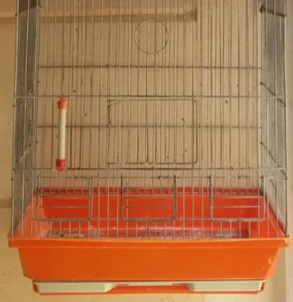
Fig. 1. Standard cage size

It is important to choose the perches that made of the plastic material, oval in shape rather than round, and it is preferable for them to be thick to maintain the health of the birds feet as shown in (Fig. 2) (Ritchie et al., 1994; DEFRA, 2021). When distribute the perches inside the cage it should not be too close to each other to allow the birds to move freely, and should not be placed underneath each other, because the bird does not like vertical fly and is bothered by them. All The perches should not be close to the walls and ceiling and the floor of the cage, to prevent the head and the wings and the tail from hit the cage wires. Also, should be distribute them far away above the food or drink, in order do not lets birds droppings fall on them causing diseases as shown in (Fig. 3) (Nawaya, 1986; McLeod, 2021).

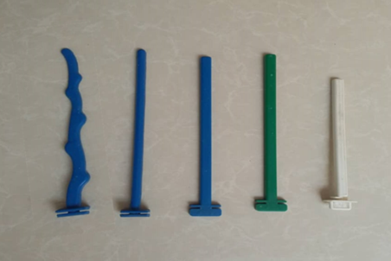
Fig. 2. The perches

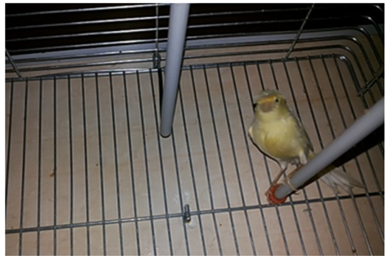
Fig. 3. Distribute the perches inside the cage

Each bird in the cage should be have its own feeder and drinker, with additional cups for providing nutritional supplements. The feeders and drinkers should be hung on the cage bars away from the cage floor, and it is preferable for the feeders and drinkers to be made of the plastic material as shown in (Fig. 4) (Nawaya, 1986; Ritchie et al., 1994; DEFRA, 2021).

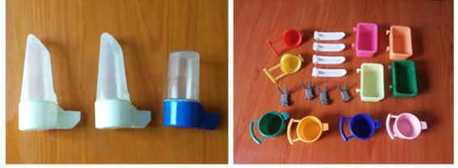
Fig. 4. Feeders and drinkers

It is known that canaries are active birds and loves the entertainment and play and move constantly, so the cage should be provided with a swing and should be hang in the middle of the cage in a size that suits the size of the bird, and arranging the perches in a way that prevents the bird from colliding with the swing while flying within the cage as shown in (Fig. 5). It is also necessary to allocate a bathing bowl for each bird, especially during the summer season, to maintain the cleanliness on the one hand and to provide the cooler to the bird in the hot season on the other hand as shown in (Fig. 6) (Nawaya, 1986; Ritchie et al., 1994; McLeod, 2021).

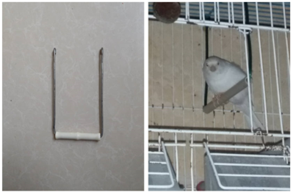
Fig. 5. The swing

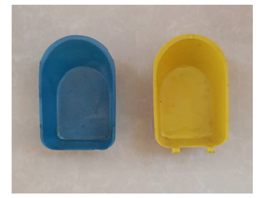
Fig. 6. Bird bathing bowl

It is suitable to start a canary care project with a little number, such as 5 or 6 pairs by placing each pair in a separate cage. Also, Some birds shows ownership within their dwelling and this is caused hostile relationship between some birds (Ritchie et al., 1994; McLeod, 2021). In this case, it is preferable to choose the single care system and allocate a separate cage for each bird separately as shown in (Fig. 7). Also, we can choose the collective care system by putting the birds in groups together in a large cage, with do not cause this system harms to them as shown in (Fig. 8), with availability of spare cages may be need to isolate some birds when they become sick (Nawaya, 1986).

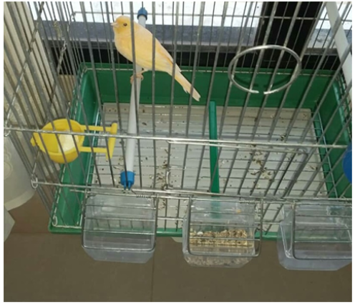
Fig. 7. Single care system

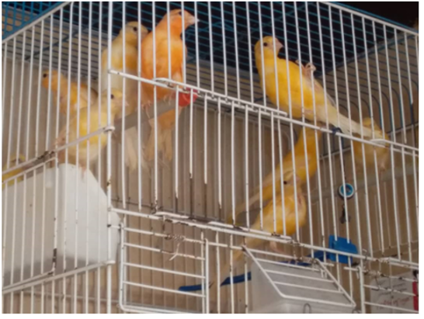
Fig. 8. Collective care system

Cages can be divided into two sections by using the wire barrier can be placed to divide the cage to two section as shown in (Fig. 9). This cage can be used for 6 to 8 young chicks, or 3 pairs for breeding purpose. And outside of the breeding season this wire barrier can be removed (Nawaya, 1986).

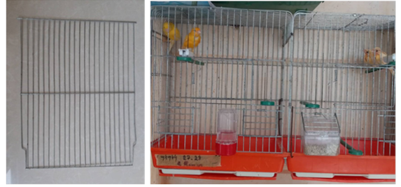
Fig. 9. The wire barrier to divide the cage to two section

6. ENVIRONMENTAL CONDITIONS REQUIREMENT OF THE CANARY BIRDS
Choosing the right location for hang the birds cages important to providing the canary birds all the necessary environmental conditions, including lighting and temperature and humidity and ventilation (McLeod, 2021). Therefore, utilizing empty spaces in the home garden, on the roof, or on enclosed balconies with windows is the ideal place for them. The cage should be hung on the wall in an easily accessible location for providing the birds feed and water and for cleaning it periodically, and should be able to be moved from one place to another according to the seasons. And stay away from windows as much as possible, because the windows makes the birds feel stressed and unsafe. Providing good ventilation and keep them from the winds and the moisture and the direct sunlight. And very important point that the cages are should be close to where people are, because canary birds do not like the isolation as shown in (Fig. 10) (Nawaya, 1986; Ritchie et al., 1994; DEFRA, 2021).

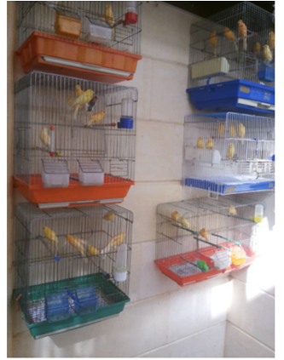
Fig. 10. Choosing the right location for hang the birds cages

Canary needs to exposure a natural light cycle daily (12 hours of light/12 hours of darkness), so it is important to exposing them to the sunlight from sunrise until 10:00 a.m., or close to sunset. Because, other times cause them harm, just like humans as shown in (Fig. 11) (Nawaya, 1986; DEFRA, 2021; McLeod, 2021).

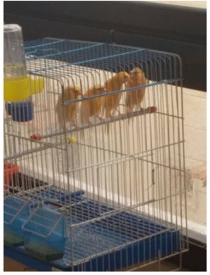
Fig. 11. Canary exposure to natural light daily

It is preferable to give the birds artificial lighting by adding lighting devices that gradually turn off the lamp for two hours immediately after sunset, which allows the birds to rest before taking their last meal. This allows the birds to prepare for sleep and take their places on the perches, canaries needs to sleep about 10 to 12 hours day as shown in (Fig. 12) (Nawaya, 1986; DEFRA, 2021).

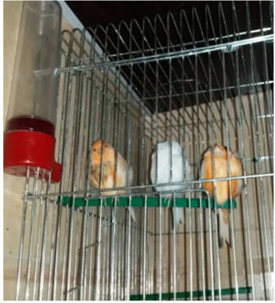
Fig. 12. Canary take their places on the perches for sleep

Generally, canary prefer to live in temperatures ranging from 18 to 24 °C, for that should be provided in the room electrical heating device with a thermostat during the winter season (Pollock, 2012; McLeod, 2021). The birds should be kept away from direct heat sources which directly close to the cage, because this can cause respiratory and digestive diseases, in addition to spread spots without feathers on the skin (Doneley, 2010). With avoiding use the diesel and the wood stoves, in places where canaries are live. As known birds release gases such as ammonia and carbon dioxide that are harmful and dangerous, due to and cause them difficulty breathing, and endanger their lives when gas concentrations increase in closed spaces, which leads to their death by suffocation, because birds have very sensitive respiratory systems (Nawaya, 1986; DEFRA, 2021; Jilenkerian et al., 2023). Because, birds sensitive to cold, they should be kept in a covered cage with a thick cloth to make it easier to keep warm especially in winter season. During the summer season the cage should be put in a place where direct sunlight does not reach on it. In the morning, the bird can be exposed to sunlight by covering part of the cage, thus allowing the bird to choose the sunlight or the shade as shown in (Fig. 13) (Nawaya, 1986; McLeod, 2021).

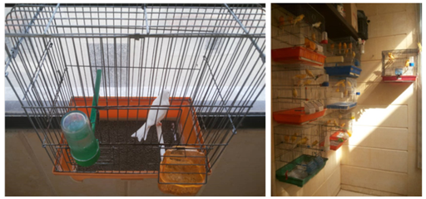
Fig. 13. Putting the cage in a place does not exposure birds to the direct sunlight

There are a many things in the home that are considered toxic to the birds, therefore, birds should be kept away from them, such as smoke and fumes and cooking odors and sprays and air fresheners, because all of these are considered highly toxic to the sensitive respiratory system of birds (Nawaya, 1986; McLeod, 2021). When the breeder away from home, should be potting the cages near the windows to allow the birds to see the people. Also, Other factors that could cause stress should be also be avoided, such as the cats and the dogs or sudden loud noises that could startle the birds (Nawaya, 1986).

7. CHOOSING AND BUYING CANARY BIRDS
It is preferable to purchase canary birds from a trusted breeders stores, and to be these stores located in the same area where the birds will live. Often the new breeder needs to inquire about the behavior and temperament of the birds that purchased. It is preferable for the new breeder when choosing and purchasing birds to be accompaniment with knowledgeable breeder in these matters, especially at the first time (McLeod, 2021). Because, the seller deny the fraud as soon as he has sold once he receives the price. There are many kinds of fraud that the new breeder falls into by the birds sellers, such as sell a female canary as a male. Generally, sellers tries to get rid of the unwanted birds, perhaps at a high price. In addition, breeders do not give away their good birds for a low price, so do not expect to pay a cheap price if you want an excellent bird. However, this does not mean that all sellers behave this way. Some are honest and care about their reputation. In any case, the excellent bird is worth the high price, because the patience and the effort that the breeder exerts on his birds and the disappointments that he was exposed to, are not equal to the price of the good bird, no matter how high it is. When purchasing birds, should be choose the strong and active birds and clean, and the feathers should be soft and tidy and without spots or pecking or split ends. The eyes should be healthy and bright, also the eyes and nose should be without of secretions. The sternum should not be protrude, breathing should be normal, and without gurgling sounds or signs of respiratory distress and no coughing or sneezing (DEFRA, 2021). The cloaca should be clean and without of fecal or signs of diarrhea. The bird legs should be healthy, and the bird way of standing on the perch to be stable, and changing its place jumping frequently from perch to perch. Usually, the birds refuse to sing in front of the new visitors in the store, however the breeder prefer listening to the canary bird voice before buy it. As for the color of the feathers or the canary birds, they range from orange to dark red, and the most famous of which are yellow canary, orange canary, and white canary as shown in (Fig. 14,15,16) (Doneley, 2010). Also another canary birds have a hat of feathers on its head called crested canary as shown in (Fig. 17) (Nawaya, 1986; McLeod, 2021).

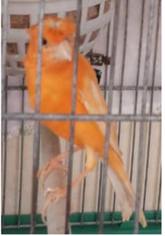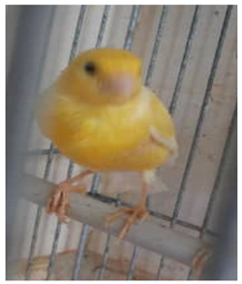
Fig. 14. Yellow Serinus canaria Fig. 15. Orang Serinus canaria

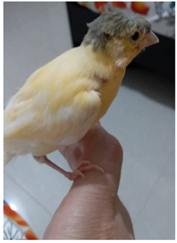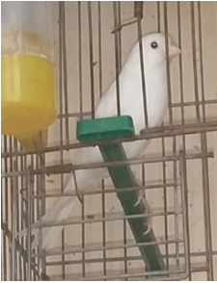
Fig. 16. White Serinus canaria Fig. 17. Crested Serinus canaria

8. DOMESTICATION AND ACCLIMATION THE CANARY BIRD
After isolated the canary bird from its family, and brought to a new and strange place, it will see a new creatures and hear a new sounds that it does not understand, will become afraid in front of these creatures that are different in size and shape they have no feathers or beak from it. So during this period, in the first days of the domestication process of the new canary bird, the breeder should be direct all his focus on achieving familiarity between himself and the new bird, and on the other hand with the new place and the bird. Then start walking slowly beside the bird and talk to quietly and in a low voice to avoid frightening, with imitating bird sounds such as whistling and singing it makes more reassured. This is because the bird fears the sudden appearance of a human. But in contrast, the canary fears absolute silence. Also play canary birds sound clips through the music player to attract their attention and make them feel safe. After several days, the bird is still not completely confident in you, but it becomes tolerant of your presence. This is period the domestication phase begins, as the bird begins to get used to the new situation, its movements become more confident, and jumps from perch to perch (Nawaya, 1986). It is important not to let others see him too much at first days of the domestication phase, try to get him used to you only, and do not think that your bird forgotten his family and friends as soon as he enters your house. After week or two the bird start singing, do not forget that only the male sings, while the female voice does not perform long songs but it is truly beautiful and pleasant chirping. In the second week, let the bird see one of your birds standing on your hand as shown in (Fig. 18) the bird will begin to adapt to his cage. Then try to inter your hand into the cage and talk to him while offering him some of his favorite food with the other hand, in this period the bird should be get used to the family members (McLeod, 2021).

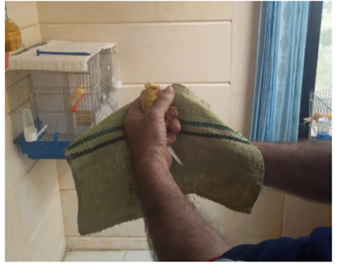
Fig. 18. Acclimation the canary bird to its cage

Now try to input your hand into the cage to catch the bird out of it, at first, it will not respond to you and will move away from your hand, but with patience and long suffering and good treatment, you will be able to do so. This process should not be continue for more than a quarter of an hour, two or three times a day as shown in (Fig. 19) (Nawaya, 1986; Pollock, 2012).

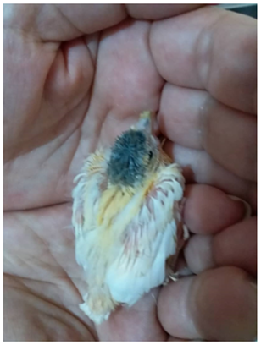
Fig. 19. Acclimation the canary bird with the breeder

During this stage, you should be remove mirrors and toys and everything that could distract the bird from you, and get it used to eating food from your hand as shown in (Fig. 20). Do not hit it, as it will never understand this language, and this will harm the relationship between you and it at the expense of the trust you have built. If the bird run away from the cage and refuse to go inside, wait until it calm down, then try to catch it, or offer it a stick to stand on, or bring the cage after adding some fruits in it, If it refuse to inter, leave it where it is and leave the cage door open. It will return to it on its own. If it does not return, wait until dark and catch it and put it in the cage by yourself (Nawaya, 1986; Ritchie et al., 1994).

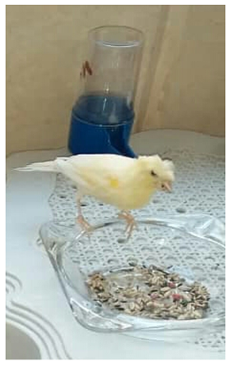
Fig. 20. Canary bird use to eating outside his cage

Veterinary supervision is necessary before introducing any new bird to an existing collection of birds, to ensure its safety. If there are other birds in the house, the new bird should be placed in a quiet place away from other birds, until it gets used to the new place, and until its safety is ensured. If it is to be introduced into a large shared cage, it should be kept for at least one day in its cage and in the sight of the birds inside the cage, until it gets used to them and they get used to it. Birds often become agitated when they see a new bird invading their home, especially if new bird have brightly colored, fighting begins and injuries occur before they have a chance to get used to each other (Ritchie et al., 1994; DEFRA, 2021). It is preferable to isolate the birds upon arrival, until it is confirmed that they are free of disease. They should be monitored for the first signs of any disease. If any abnormal symptoms appear in the birds, an avian expert should be consulted and their advice should be followed. If the matter is neglected, it may lead to its death and the spread of infection to healthy birds. A sick bird is easily distinguished by its appearance of drowsiness most of the day and its refusal to eat. Therefore, it should be isolated immediately and taken out for treatment (DEFRA, 2021). The acclimatization process is also very important for these birds that have been transferred to the new environment, the most of domestic birds are imported, especially from warm regions. Some species of birds even require being kept indoors continuously throughout the year, the normal room temperature is suitable for most of these species, and in order for them to get used to the new climate, they require what we call the acclimatization process (McLeod, 2021). These birds need to artificial conditions of heat and humidity and lighting, and they can tolerate cold to some extent, so providing more hours of lighting artificially lengthening the day so that the birds are able to feed for a longer period, and thus obtain an increase in energy. As a result of changes in weather conditions, birds may suffer from diarrhea, which can be avoided by proper feeding and heating, and it is preferable to add the complete group of vitamins to the drinking water (Nawaya, 1986; DEFRA, 2021).

9. CARES OF THE CAGES AND EQUIPMENT OF THE CANARY BIRDS
Breeders are required to check the feeders daily, as birds remove the seed husks and eat the pulp, this makes the feeder look full of seeds, even though it actually contains only the husks. Do not let the appearance of the husks deceive you and lead to the bird starvation. Blow on the feeder with your mouth until the husks have blown away (McLeod, 2021). Add another quantity of seeds to last the next day, at a rate of 1/4 teaspoon per day. Blowing on the seeds should be avoided when the breeder is suffering from contagious diseases. If you or a family member suffers from bird allergies, we advise you to be careful. It is emphasize the importance of clean water and should be changed twice daily, if possible, and at least once, especially during the hot summer months, if possible (Nawaya, 1986). The fresh water is essential for canary birds, it is also recommended to use bottled mineral water, as this is preferable, as tap water contains disinfectant chemicals that a bird body, which is lightweight may not tolerate. Alternatively, use boiled and cooled water. Keep the drinkers clean, as it is also used for water based medication. Vitamins should also be added to the drinking water once a week, as the amount found in natural foods is sometimes insufficient, and you will find that these utensils quickly become dirty if not washed daily (Ritchie et al., 1994; McLeod, 2021). The cage should be cleaned regularly to prevent disease, it is preferable to place a bedding of sand on the floor of the cage to prevent the decomposition and accumulation of the feces and the droppings over time, and should be replaced daily or when it becomes dirty to eliminating the source of disease (Ritchie et al., 1994; DEFRA, 2021). Recently, materials these kind of bedding have been replaced by adding natural zeolite to absorb and decrease the humidity, cause high levels of the humidity is the number one enemy of birds as shown in (Fig. 21) (Jilenkerian et al., 2021,2022,2024).

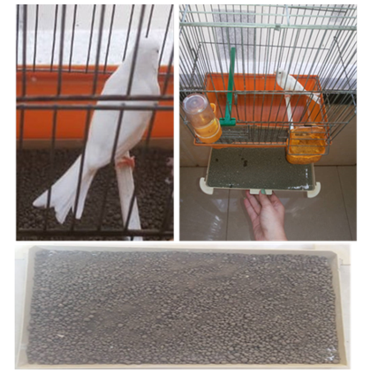
Fig. 21. Adding the zeolite on the floor of the canary bird cage

10. CARE OF THE CANARY BIRDS
It is important to provide the canary birds with a daily bath during the summer, because it loves water, adding the water in a small bowl made for this purpose, so that it can quickly dive into it and play around it happily, the suitable time to take h bath is in the morning or before noon in order to allow the birds to dry completely before nightfall, so that they can sleep completely dry (Ritchie et al., 1994; McLeod, 2021). Also, during the spring and autumn, it is possible to spray the canary with water spray instead of placing a bath as shown in (Fig. 22). Also, birds should be dried with a special towel to absorption the water from the body and the feathers, especially, for young birds as shown in (Fig. 23) (Nawaya, 1986).
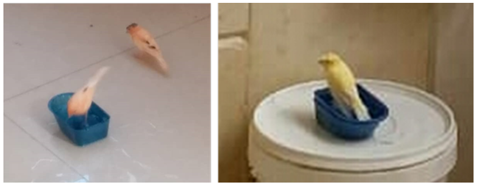
Fig. 22. Canary bird taking the bath

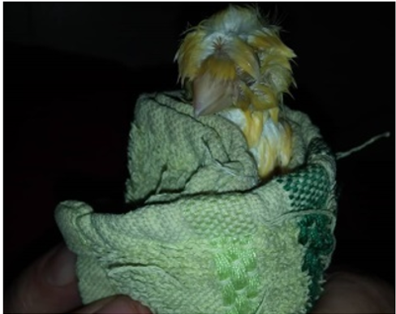
Fig. 23. Dried the canary bird after the bath

Canary birds use their claws to stand on the perches, so the claws of the front toes should not be meet the claw of the back toe on the perch to avoid breaking the claws. The long claw may get caught on the wires of the cage, which lead to a broken the leg or dislocation, and this causes pain to the bird. Therefore, the breeder should be trim its birds claws when necessary, by using new nail clippers, that fit the size of the bird claw, should be careful and trimming only the front part of the claw and avoid approaching the pinkish area of the finger where there is a blood vessel. Also file the tip of the claw after the procedure to soften it as shown in (Fig. 24) (Ritchie et al., 1994). Because the excessive trimming causes a bleeding wound. Bleeding can be stopped by applying pressure with a piece of cloth or cotton or using wound powder. The loss of a few drops of blood from a small bird, is considered a large amount relative to its small size (Nawaya, 1986).

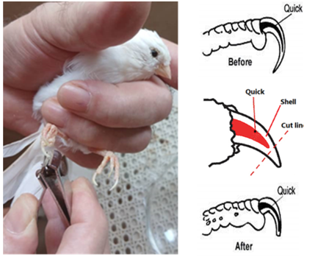
Fig. 24. The procedure of the canary bird trimming claws

Canary spend long hours grooming their feathers, by using their beak to distribute the oil secreted from the preen gland located near the base of the tail over their entire body, to help them not get wet when bathing and to maintain their health (Gilles, 2024). Also, the bird trims its beak itself, by rubbing it on the perch if it is bothered by its length, if its beak becomes too long and the bird does not trim it, the breeder should be trim the beak by using nail clippers, so that the tip of the beak is removed without causing bleeding (Ritchie et al., 1994). If bleeding occurs, follow the same procedures mentioned in the claw trimming section, and repeat the trimming process whenever the beak becomes too long. The body exercise is essential for birds, as it is for humans. Lack of exercise can lead to lethargy and obesity and flabbiness. Therefore, it is important to provides birds the movement, that is as close as possible to what it does when it is free in nature. This can include setting specific hours during the day when the bird gets used to leaving its cage after the door is opened, this gives the bird the opportunity to fly, this exercise should be part of the birds daily care routine as shown in (Fig. 25) (Nawaya, 1986; Ritchie et al., 1994).

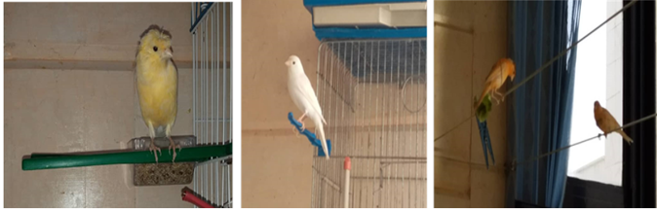
Fig. 25. Canary birds flying out of the cage for exercise

Before allowing the bird to leave the cage, it should be ensure a number of things, such as covering the mirrors and the windows and the doors so that it does not collide with them, and closing the windows and doors tightly so that they do not open suddenly while it is flying, and turning off the exhaust fans and the heater in the room (Ritchie et al., 1994). It should also be avoided in the kitchen or where stoves are located. It is important not to put the birds near the heater in the winter season so that it does not suffer from feather loss or respiratory diseases, with removal the poisonous plants. birds should be handled gently and not pressed too hard while catching them, to avoid breaking their bones, so prevent the children to catch the birds. Also, do not allow other animals, such as dogs and cats to come close the birds, can be allowed to play with the bird if they are familiar with it. Provide food, add vitamins to the drinking water, and allow the bird to take a bathroom if the weather is warm (McLeod, 2021). The cage door should be left open so the bird can return to it whenever it wishes, especially before sunset, to allow enough time for its final meal. In addition to the fun the birds gain from this exercise, the breeder can closely monitor their health, making it easier to detect any health problems. Birds need to play, hear sounds, and see things, this is what we call mental exercise. Always remember that you are responsible for your bird happiness. You should be make it happy. Observe it whenever you can and monitor its behavior, as birds can become depressed if neglected and left alone for long periods. Signs of this include lack of interest in toys, singing, and talking, increased predation through feather pecking, nervousness with loud screams, restlessness, and moving from perch to perch, these may all be symptoms of illness (Nawaya, 1986; Ritchie et al., 1994).

11. CANARY BIRDS NUTRITION
Breeders are required to feed their canary birds a balanced and complete diet, that contains all the necessary components to maintain their fitness and health. Seed mixture is the primary food source for canary, but they also require to fresh fruits and vegetables, and vitamin supplements to maintain their vital functions. There are many seed mixtures feeds available in specialized bird stores for feeding, if the number of birds small, breeder can rely on these special canary bird seed mix as shown in (Fig. 26) (Nawaya, 1986; Ritchie et al., 1994; Pollock, 2012).

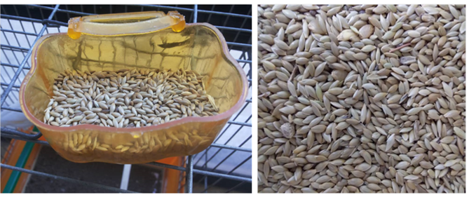
Fig. 26. Canary birds special seed mix

If the breeder have a flock of birds, it is best to buy seeds in bulk, and always try to get the best seeds. This saves money, but only if the seeds are fresh, sweet tasting, clean and free of dust and foreign materials that may harm the birds. These seeds can saved in the refrigerator for more than a week, they should be washed and cleaned and presented to the birds after preparing a balanced mixture of these seeds as follows: a quantity of rapeseed, a similar quantity of hemp seeds, half the amount of canary seed, and a few millet seeds as shown in (Fig. 27,28,29,30) (DEFRA, 2021). In winter or when the weather is cold, the amount of hemp increases, is also added a small amount of flax seeds as shown in (Fig. 31), but in the summer, flax seeds should be less to reduce the risk of obesity. Flax seeds are also useful during molting (removing feathers) as they contain a high percentage of oil which is beneficial for canary at this stage (Nawaya, 1986).

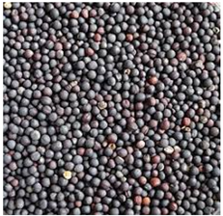
Fig. 27. Rapeseed

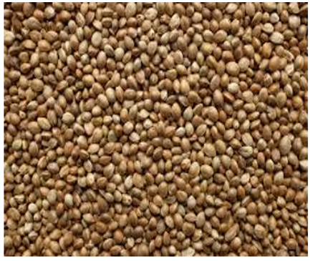
Fig. 28. Hemp seeds

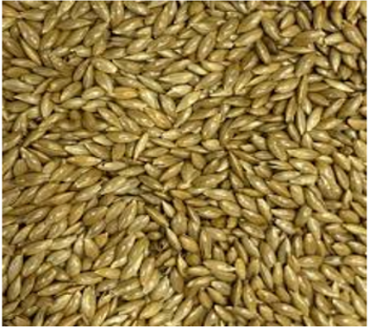
Fig. 29. Canary seed

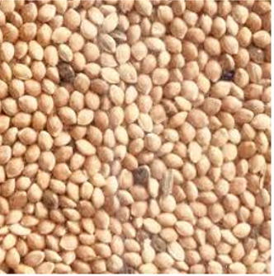
Fig. 30. Millet seeds

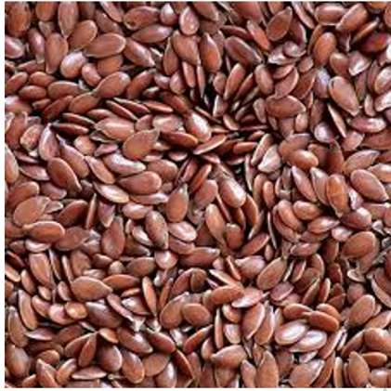
Fig. 31. Flax seeds

It is also necessary to provide green plants for both adult and young birds. Canary can eat a large number of vegetables and fresh fruits such as inner cabbage leaves, radish leaves, cucumbers apples, pears, oranges, figs but the most favorite is corn cobs and grated carrots and mashed dates as shown in (Fig. 32,33,34) (Pollock, 2012; McLeod, 2021). It is beneficial not to increase the amount of green food too much especially during the winter and early spring, as it can cause digestive upsets for the bird, it should also be given to newly purchased birds only in small quantities and then can increasing gradually. And remaining food should be removed as soon as it wilts (Ritchie et al., 1994). Also, before offering green food, should be ensure that it is not sprayed with a chemical pesticide and it should be washed and dried before giving it to the canary and should not be offered wet or damp. Birds also need coarse sand to help the gizzard to grind and crush food, sand is commonly sold commercially, so it should be provided in the form of coarse sand at all times in the cage. Birds body also obtains the minerals it needs from food, such as seeds, vegetables, fruits, and chicken eggs, so the eggshells are an important source of calcium, so boiled eggs are best served with their shells (Nawaya, 1986).

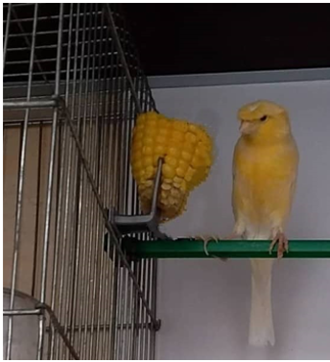
Fig. 32. Corn cobs

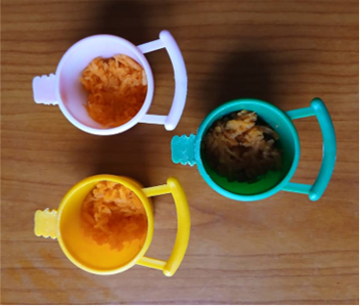
Fig. 33. Grated carrots

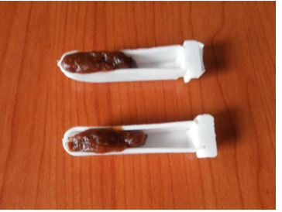
Fig. 34. Mashed dates

12. FEEDING DURING THE BREEDING SEASON
Canary need limited amounts of soft food throughout the year, especially during the breeding season, in order to produce strong chicks. The parents should be strong, so seeds and soft foods rich in protein should be provided with an increased amount of calcium. The amount should be increased in order for the eggs to be normal and to prevent cases of egg binding (Nawaya, 1986). It is possible to obtain a balanced mixture such as bread soaked in milk, boiled eggs used as a source of protein, especially during the breeding season or for canary chicks, biscuits or crushed cake with grated carrots. This food is necessary in the breeding season, provided that small quantities of it can be consumed within a short time as they spoil quickly, it can be given two or three times a day while caring for the young chicks(Ritchie et al., 1994).

13. CANARY BIRDS BREEDING
The breeding process of canary birds requires achieving conditions that are as close as possible to the conditions prevailing in their original habitat. In general, the canary breeding season begins between the period of the month March to then month May, some canary varieties start the breeding season before other varieties. There are several factors that determine the success of the breeding process including: the type of canary, compatibility between the selected pair, the region in which the breeder lives, the warmth of the weather, and the light factor (Nawaya, 1986; Ritchie et al., 1994; McLeod, 2021).

14. CHOOSING THE CANARY BIRDS COUPLES
Choosing the first stock the first male and female for breeding is very important, and it is very easy for beginners to make mistakes at this stage when chose the breeding couples (Ritchie et al., 1994). And should be rely on trusted experts and veteran hobbyists when purchasing the initial stock. So, advice from experienced breeders will be very important for new hobbyists to minimize mistakes. New breeders have to buy birds in the first or second year at the most, after which he should be obtain new parents from the birds he has, with keeping a special record for each bird. In general, canary reach sexual maturity at approximately three months of age. It is difficult to distinguish between the male and female in terms of external appearance, as it is not possible to distinguish between the male and female in most cases, especially outside the breeding season, as they are similar in appearance as shown in (Fig. 35). However, this is very easy during the breeding season. In general, the male tends to be dominant and quarrelsome when singing, while the female is calmer, softer and gentler, rarely tends to be dominant, and her chirping is nothing more than a call. Generally, the female is slightly smaller than the male, and her colors are less vibrant. These characteristics also apply to young males before they reach puberty, as they resemble the females. The male is usually more active and aggressive. Sometimes the breeder discovers from the unfertilized eggs that the mating parents have chosen two females for the purpose of reproduction. Both the male and female should be ready for reproduction, If this condition is not met, mating will not occur, and if it does occur, it will produce no more than one or two chicks at most. This means that the selected pairs should be in excellent health, with the male singing at its peak, and the female should be active and carry nest building materials in her beak. It is rare to achieve good results when using males that are not in good condition with active females that are ready to breed (Nawaya, 1986).

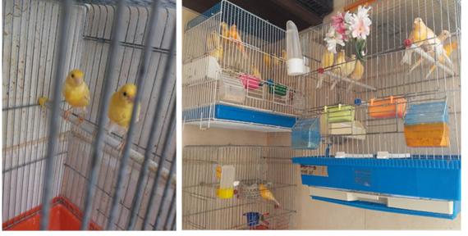
Fig. 35. Difficulty of the distinguish between the male and the female of canary birds
Although the canary is an independent species, mating with several other species is often successful including: Red hooded Siskin (parent of the red canary), Goldfinch, Green Sparrow, Linnet, and Bullfinch. Some breeders crossbreed a male goldfinch with a female canary (McLeod, 2021). The resulting hybrid, sells for high prices due to its beautiful voice and strength. However, this hybrid is sterile and does not reproduce. Furthermore, the hybrid does not always produce good results, so the pairs should be replaced (Nawaya, 1986).

15. COUPLE MEETING
In the first stage, the male and female birds are to be taken are separated so that neither of them sees the other. In the second stage, the two cages are placed a little close to each other so that each can see the other, and the breeder feels that they are calling to each other while the male performs beautiful singing sessions. In the third stage, after a week, one of them can be introduced into the other cage, in the cage prepared for breeding, which is usually the male cage as shown in (Fig. 36).When one of the pair is first introduced into the others cage, some fighting often occurs between them. The male may sing well, but as a rule, his singing is reduced except during sexual intercourse with the female. If a serious fight occurs between them, they should be separated immediately, either with a wire barrier if the cage is double, or each should be placed in a separate cage and allowed to see each other. Within a week and when they are placed together again, the meeting will take place, and within a few days the first egg will be laid (Nawaya, 1986; Ritchie et al., 1994).
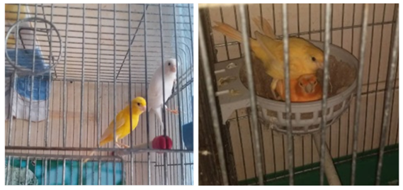
Fig. 36. Couple meeting of the canary birds

16. NEST PREPARATION AND NEST BUILDING MATERIALS
Plastic nests are used to breed canary, and it is preferable that they be lined on the inside to keep the nest clean as shown in (Fig. 37). As for the materials for building the nest, it can use the felt or the hemp fibers or any other similar material as shown in (Fig. 38). It should not be too long so that it does not twist and become tangled, thus confusing the birds. This is to create a lining inside and complete the construction of the nest. If the females are not given such this materials, they may pluck out their own feathers and the male feathers. The nest is placed in one of the back corners of the cage as shown in (Fig. 39).The pair should be kept alone in the cage, when the incubation begins and the breeder should be decreased observing them from a suitable distance. Because some birds abandon the nest after any disturbance. Therefore, children and pets should be kept away from the birds during breeding (Nawaya, 1986).

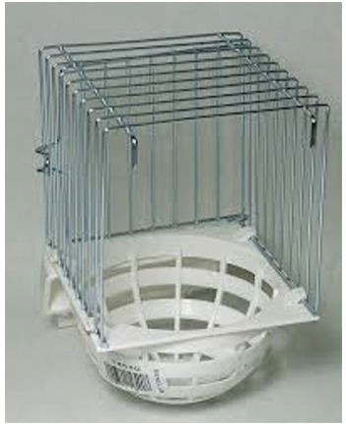
Fig. 37. The plastic nests

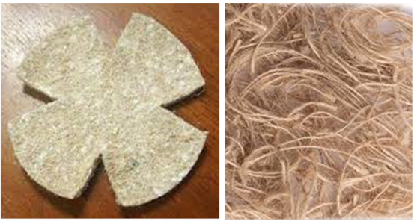
Fig. 38. Nest building materials

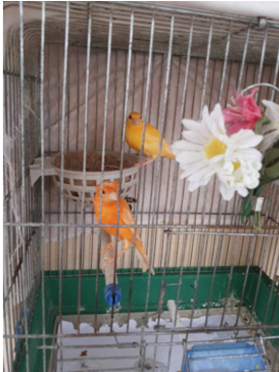
Fig. 39. The suitable location of the nest in the canary birds cage

17. THE INCUBATION OF THE CANARY BIRDS EGGS
After the male and female mate for mating and after the nest is built and prepared, the female lays their first egg as shown in (Fig. 40). This usually occurs the day after the nest is built, but can sometimes be as long as a week later. The average time between egg laying is one day, sometimes two. The female canary usually lays three to five eggs in each clutch, and rarely does a clutch exceed this number (Ritchie et al., 1994). The eggs are pale blue or blue-green with purple and red markings at the wide end of the egg as shown in (Fig. 41) (Nawaya, 1986).

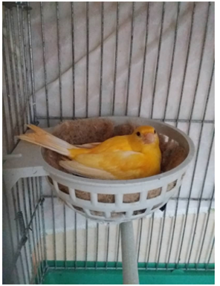
Fig. 40. The incubation of the canary birds eggs by the female

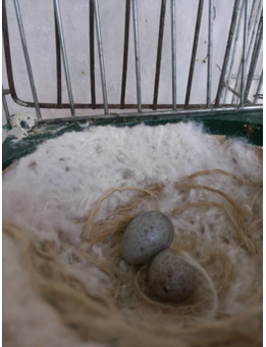
Fig. 41. Canary birds eggs

If the female is allowed to incubate the eggs, she will begin immediately and in a brood of five eggs, there will be a three or four day age gap between the chicks. This should be avoided, as the younger chicks will be vulnerable to starvation, suffocation, and eventual death from their older and larger siblings. To avoid this, each egg laid by the female is removed and placed in an egg carton, and an artificial egg is placed in its place in the nest. Artificial eggs can be obtained from specialized stores. The egg carton should be divided, lined with cotton or fine sawdust, and numbered according to the cages from which the eggs were removed. When the female has finished laying, the eggs should be returned to their place after removing the artificial egg that replaced it in the nest. The date should be recorded in a special breeding records. Care should be taken when removing and returning the eggs, as they have very thin shells. Incubation of eggs lasts about fourteen days or one day less. The eggs should be hatch together on the same day, with the interval between eggs not exceeding a few hours as shown in (Fig. 42) (Nawaya, 1986; Pollock, 2012).

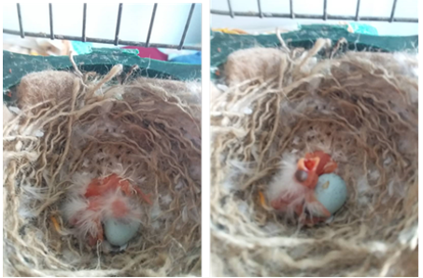
Fig. 42. Canary birds eggs hatched in the same day

Three or four days before hatching the eggs, the parents should be encouraged to take a bath, which they were deprived during the incubation period. If they refuse to take a bath, spray the eggs with a fine mist of warm water, this will prevent them from drying out. During this period, the male will care for the female and feed her until hatching time arrives. This may be one day shorter or one day longer, depending on the incubation conditions as shown in (Fig. 43) (Nawaya, 1986).

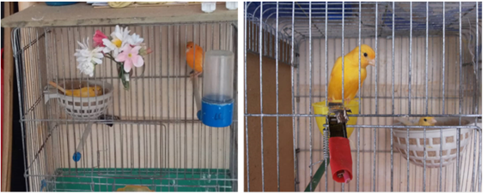
Fig. 43. Canary birds male care the female and feed her until eggs hatching time

18. CARE OF CANARY CHICKS
One day before the eggs hatch and in the evening, the parents should be given soft food so that they are ready to feed their chicks when they hatch. Because the parents cooperate in caring for their chicks from hatching until weaning, and during this period they require careful care to ensure their healthy growth and avoid diseases or neglect by the parents as shown in (Fig. 44) (Nawaya, 1986; Ritchie et al., 1994).

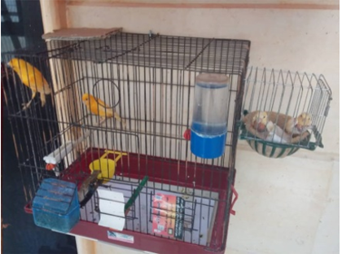
Fig. 44. The parents caring for their chicks

Chicks are entirely dependent on their mother for warmth and nourishment during the first five days after hatching well as shown in (Fig. 45), so the female and her chicks should not be disturbed until she has fed them. Many mothers, especially new ones less than a year old, become dissatisfied with their nests and tamper with them, or abandon their chicks, neglecting to feed or care for them, leaving them to die. In any case, a quick check of the nest is necessary to ensure that all is. It is noted that the male often feeds the female, who in turn feeds the chicks (Nawaya, 1986).

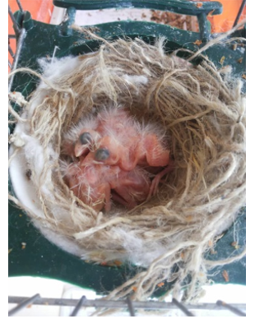
Fig. 45. Canary chicks five days old

From the fifth day to the fourteenth day, the female feeds the chicks a mixture of partially digested seeds with mashed boiled eggs or chick mixes sold in bird shops as shown in (Fig. 46) (Nawaya, 1986).

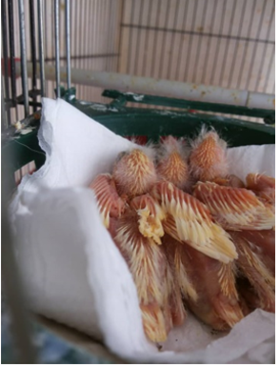
Fig. 46. Canary chicks fifth to fourteenth day old

During the period of chicks growth from the fourteenth day until the twenty one day, the chicks begin to open their eyes and try to stand. The feathers gradually grow and cover the body of the chick. Here, it is possible to begin offering small amounts of soft food beside their parents, such as mashed vegetables or grated apple as shown in (Fig. 47). Increased humidity in the nest is often caused by chicks suffering from diarrhea (Ritchie et al., 1994). This diarrhea is often caused by contaminated water or soft or green food consumed by the parents. It is not caused by the chicks sweating, as the skin of canary, like that of other birds, does not contain sweat glands. High humidity in the nest makes the chicks wet, sticky, and generally uncomfortable. In this case, the breeder intervenes by drying and cleaning the chicks with cotton wool, then placing them in another nest, the mother can also be separated from the chicks by placing bars over their heads to prevent the mother from sticking to them. Air should be left between the bars and the chicks. So, the nests should be replenished and their contents replaced every two days, and the bars should be moved to allow the chicks to grow. The cages also should be cleaned carefully, as feeders and drinkers should be boiled for sterilization (Nawaya, 1986).

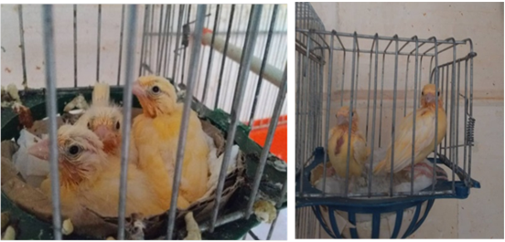
Fig. 47. Canary chicks fourteenth to twenty one day old

When chicks weaned on the twenty one day, they are ready to leave the nest and going out and wandering around the cage. When they leave the nest, the chicks look like small, soft creatures covered with feathers that are still in the growth stage as shown in (Fig. 48). During this stage, they are given soaked or ground seeds to gradually accustom them to self-feeding (Nawaya, 1986).

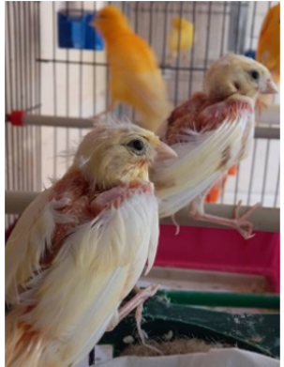
Fig. 48. Canary chicks twenty one day old

They can be separated from their parents after about three to thirty five days if they are feeding on their own. The immature characteristics of the breed gradually begin to appear, when their feathers are fully developed, they are fully independent and can be separated from their parents as shown in (Fig. 49). During this stage, separation of the chicks is necessary, as females often want to have a second eggs incubation before the chicks leave the nest. They can also be helped by placing a second nest in the cage. The male may express a desire to mate again, which often happens. If a second mating would interfere with the mothers care of the chicks, the male should be isolated in this period, and then returned to the cage after chicks separation (Nawaya, 1986).

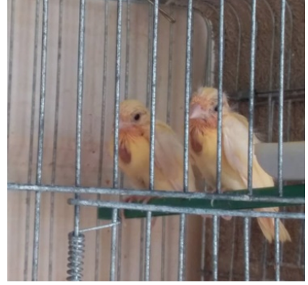
Fig. 49. Separating canary chicks from their parents

Canary chicks grow rapidly, breeders should be gradually increase their food intake, particularly soft food, to maintain this rapid growth rate and appetite. We always recommend consulting experienced breeders if you have any questions or problems. The chicks naval and droppings should also be checked daily, any change in the color of the droppings or bloating of the abdomen could indicate a health problem. During this period, it is important to maintain a moderate temperature and avoid the air currents (Nawaya, 1986; Ritchie et al., 1994).

19. CANARY BIRDS SEXING
It is difficult to determine the sex of canary chicks at an early age, it is possible to determine the sex of a bird after it has fully fledged. Generally, it is possible to predict the sex by observing the chicks behavior. As a general rule, males are bolder and more energetic than females, and males often appear to be trying to sing (McLeod, 2021). Young females are generally more subdued in their behavior and certainly less aggressive, although they will nudge each other mischievously at any opportunity. The anatomical difference between the sexes is not apparent until the bird has fully matured, and then it can only be determined by examination (Nawaya, 1986).

20. REPRODUCTIVE PROBLEMS OF THE CANARY BIRDS
There are some reproductive problems that affect the success of the breeding process of canary birds

20. 1. FAILURE OF CANARY BIRDS EGGS FERTILIZATION
The most common causes of this condition are that the partners are too young or too old, or that they are of the same sex, the female alone without the male can lay eggs, and even if two females are placed together by mistake. But, the eggs will not be fertilized. Breeding birds need a suitable place to build a nest, with the correct temperature and lighting, and a place away from noise and disturbance. Also, some birds do not like other birds of the same species of the opposite sex. Improper nutrition affects the reproductive organs and feathers and skin. In addition, diseases can also affect the completion of the pollination process (Nawaya, 1986).

20. 2. Laying Fertilized Eggs That Do Not Hatch
The most important causes are improper parental nutrition or exposure of the eggs to cold and sometimes viral or bacterial infections that affect the fertilized eggs. Also, humidity may also be the cause, especially if the incubating birds are allowed to bathe (Nawaya, 1986).

20. 3. EGG BINDING
Egg binding is happened especially where they are unable to pass an egg due to laying large or abnormally sized eggs due to excessive or early mating or female stress or weak reproductive muscles and malnutrition or calcium deficiency. The symptoms appear to be redness and swelling in the lower abdomen at the cloaca, the presence of an egg like substance the remainder of the oviduct. Because, the birds reproductive tract, turns inside out and protrudes through the cloaca, and withe wet feathers around the area as shown in (Fig. 50). Immediate veterinary attention is crucial when notice following symptoms: feather loss with general weakness and tremors and difficulty breathing and cessation of singing, abdominal distension, diarrhea, loss of appetite, or weight loss. And should be make the following treatments warming and hydration with massage and supply calcium supplements and in severe cases breaking the egg and removing it (Nawaya, 1986).

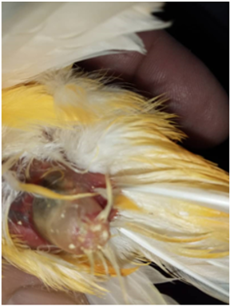
Fig. 50. Egg binding in canary female

20. 4. CRACKED EGGS DURING THE INCUBATION PERIOD
This happens when the egg shell may be thin due to malnutrition, or one of the parents may be handling the egg harshly especially when the female is in the first time (Nawaya, 1986).

20. 5. EATING INCUBATE EGGS
If the male is an egg eater, prefers to isolate the male from the nest while laying and incubating them, and this reason for this phenomenon is still unknown (Nawaya, 1986).

20. 6. CHICKS DIE INSIDE THE EGG DURING THE INCUBATION PERIOD
The exact causes are unknown, but nutrition and disease and humidity are all important factors (Nawaya, 1986; Jilenkerian et al., 2021).

20. 7. PLUCKING CHICKS FEATHERS
Some females pluck their chicks feathers in preparation for the next nest. In this case, the mother is removed from the cage and the father is left to care for the chicks (Nawaya, 1986; Doneley, 2010; DEFRA, 2021).

20. 8. DIRTY CHICKS FEET
This occurs due to a dirty nest. Therefore, it is recommended to keep the nest clean and replace it regularly to remove chick droppings, which can stick to the chicks toes. Also, wash the chicks toes with soap and water and dry them immediately (Nawaya, 1986; DEFRA, 2021).

20. 9. REFRAINING FROM FEEDING CHICKS
If the parents refuse to feed their chicks, the breeder should be hand feed them. This can be done by preparing carrot cakes with honey or human baby food (Cerelac) or soaking some seeds before feeding. And keep the chicks warm, as this is essential during this period due to the chicks incomplete body temperature regulation (Nawaya, 1986).

20. 10. INEXPERIENCED CANARY BIRDS MOTHERS
Some mothers, especially young ones, tend to care for their chicks for extended periods of time and remaining closely attached to them, these caused to increasing their temperature and causing discomfort, which can exhaust their chicks (Nawaya, 1986).

21. CANARY BIRDS HEALTH
The most important thing provide canary birds is good nutrition with proper healthcare. Canary often suffer from infectious diseases, including external parasitic diseases such as skin parasites and internal parasites that affect the respiratory and digestive systems (Doneley, 2010; DEFRA, 2021). As for non-communicable diseases, birds suffer from many health problems such as increased water consumption, decreased appetite, vomiting, diarrhea, constipation, rhinorrhea , shortness of breath, feather loss, beak problems, eye swelling and discharge, seizures and convulsions, sunstroke, and poisoning by petroleum products, acids, alkalis, toxic plants, harmful gases, and smoke inhalation (McLeod, 2021). Birds also suffer from accidents such as wounds, bleeding, amputations, bone fractures, and burns. One of the most important accidents that affect chicks is rickets and problems with the toes and claws. Rickets is the inability of the bird to use one or both of its legs, partially or completely, as a result of an accident or illness. Sometimes the cause is a nutritional imbalance resulting from a deficiency of some vitamins such as D and B12 and calcium deficiency. In addition, use of an inappropriate perch. This causes problems for the bird in perching and flying and moving and eating and drinking, and the bird feels pain in the affected leg due to abdominal pressure on the nerve of the affected leg as shown in (Fig. 51) (Nawaya, 1986).

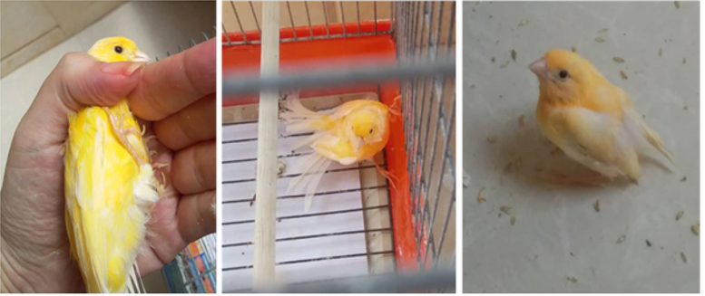
Fig. 51. Canary bird caused with rickets

Also, canary birds caused with skin parasitic diseases and causes symptoms such as brown tumors on the skin of the nose, and white growths with gray around the eyes and beak, causing localized feather loss and skin deformities and inflammation and localized swelling, the cause of these symptoms is a type of mite that infects the face of birds as shown in (Fig. 52) (Doneley, 2010). When abnormal symptoms appear, such as changes in behavior, feathers, appetite or droppings or collide the birds with objects during flight, which causes rupture of blood vessels under the skin, all of these may indicate a disease. Therefore, should be consult a veterinarian who specializes in birds and ensuring that the feathers are clean and preventing parasites or foot infections (Nawaya, 1986).

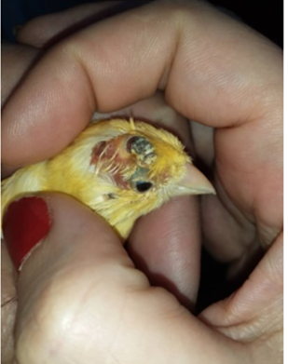
Fig. 52. Canary bird caused with skin diseases

22. CANARY BIRDS FEATHER MOLTING
This biological process occurs in birds when shedding their old feather to allow for new growth of feather. Birds also pass through the end of the breeding season during the period extending from September to October, which occurs annually, during this time, the birds body is under additional stress as it experiences physical and emotional pressure. Some birds also undergo another molt in the spring before entering the breeding season. And this triggered by hormonal and environmental and physiological factors to adapt to seasonal changes. The main environmental cause of this phenomenon is the difference in day length according to the seasons. Also the sudden change in the quality of feed and exposure to shocks or what is called stress. As for temperatures, some birds can withstand low temperatures, while others cannot. And as knew birds body temperature does not regulate immediately after hatching, but rather after a period of time, as the chicks absorb heat from their parents (DEFRA, 2021). Birds usually stop singing during the molting period, the breeder may not notice this due to the gradual process of the molting phenomenon, but he will be surprised when the bird stops singing without noticing any areas of bare feathers on its body. If he looks at it closely and examines it carefully, he will find that it is in the molting stage. When a feather is plucked or naturally falls out, a new feather grows in its place within a short time. The flight feathers do not fall out all at once during the molting, thus maintaining the bird's ability to fly. Decreasing stress and tension is especially important when birds are going through the molt period (Nawaya, 1986; Pollock, 2012).

23. CARE AND BREEDING RECORDS
Bird breeders have to kept for parents and their chicks special records to be identified. Record keeping is essential for anyone who wants to achieve good results, as it allows them to identify the different characteristics of their stock. In addition, numbered and dated metal or plastic rings can be placed on the legs of the birds of any age written with the breeders name or other special symbols on them (Nawaya, 1986; DEFRA, 2021).

24. CONCLUSION
The project of producing canary at home requires prior planning and knowledge the important basic conditions of the cares. We have tried to provide the most important basic guidelines in a simplified way for everything a novice breeders might need to care for their birds, based on our own experiences, and on the answers we found in some scientific books and references. We believe that this comprehensive guide will attract the interest of hobbyists at the local, regional, and even global, given that ornamental birds are often imported to all countries of the world. And loving the birds and trying to gather information about it and the experience and the power of the observation and performing duties on the time are the keys to success in caring of the canary birds. Therefore, the project of raising ornamental birds is one of the very profitable home projects, in addition to being an entertaining hobby for some.

DISCLAIMER (ARTIFICIAL INTELLIGENCE)
Author(s) hereby declare that NO generative AI technologies such as Large Language Models (ChatGPT, COPILOT, etc) and text-to-image generators have been used during writing or editing of this manuscript.

Competing interests
Authors have declared that no competing interests exist.

REFERENCE
- (DEFRA). Department for environment food and rural affairs. (2021). Biosecurity and preventing welfare impacts in poultry and captive birds Advice for all captive bird and poultry keepers (including game birds, waterfowl, and pet birds). https://www.gov.wales/sites/default/files/publications/2021-11/biosecurity-and-preventing-disease-captive-birds.pdf

- Doneley, B. (2010). Avian Medicine and Surgery in Practice: Companion and Aviary Birds. Manson publishing. https://www.academia.edu/11320333/Avian_Medicine_and_Surgery_in_Practice

- Gilles, M. (2024). The role of preen oil and body odour in birds. Bielefeld: Universität Bielefeld. Thesis for: PhD Advisor: Barbara A. Caspers, Innes. Cuthill. https://doi.org/10.4119/unibi/2993613

- Jilenkerian, B.K., Nisafi, A., Kara Ali, A., AI-Eissa, B. (2021). The effect of adding Syrian natural zeolite to broiler litter on the humidity of the litter and in the indoor air of the barn during the winter season. Biological Sciences Series for Lattakia Tishreen University Journal for Research and Scientific Studies, 43(5), 159-169. https://journal.latakia-univ.edu.sy/index.php/bioscnc/article/view/11062

- Jilenkerian, B.K., Nisafi, A., Kara Ali, A., AI-Eissa, B. (2022). First study of the impact of the Syrian natural zeolite on air biological contamination concentrations in broiler farms during spring and autumn. Asian Journal of Advances in Research, 17(4): 84-92
- https://www.jasianresearch.com/index.php/AJOAIR/article/view/329.

- Jilenkerian, B.K., Nisafi, A., Kara Ali, A., AI-Eissa, B. (2023). The effect of adding Syrian zeolite to the broiler litter on the concentrations of ammonia (NH₃) gas in the indoor air of the barn during the winter season. Syrian Journal of Agricultural Research (SJAR), 10(2), 119-128. https://agri-research-journal.net/SjarEn/?p=6480

- Jilenkerian, B.K., Nisafi, A., Kara Ali, A., AI-Eissa, B. (2024). Decrease air biological contamination by improving the litter characteristics in broiler barns during winter. Advances in Ecological Science (AECS), April, Volume (1), Issue (2), 1-7. https://doi.org/10.61706/aecs15005

- McLeod, L. 2021. Canary: Bird Species Profile Temperament, Diet, and Care Tips. https://www.thesprucepets.com/pet-canaries-1236727

- -Nawaya, D. (1986). Ornamental Birds, Cages and Birdhouses. Book, First Edition. Nicosia. Cyprus.

- Pollock, C. 2012. LafeberVet. The resource for exotic animal veterinary professionals. https://lafeber.com/vet/basic-information-sheet-for-the-canary

- Ritchie, B. W., Harrison, G. J., & Harrison, L. R. (1994). Avian Medicine: Principles and Application. Veterinary Medicine https://www.academia.edu/8784159/Avian_Medicine_Principles_and_Application

- Rubbenstroth, D., Rinder, M., Stein, M., Höper, D., Kaspers, B., Brosinski, K., ... & Staeheli, P. (2013). Avian bornaviruses are widely distributed in canary birds (Serinus canaria f. domestica). Veterinary microbiology, 165(3-4), 287-295.

- Svanberg, I. (2024). The domestication and cultural significance of the canary. In The Canary (pp. 47-81). Academic Press.

- Elkhouri-Vidarte, N., Díaz, M., Martín-Torrijos, L., Gamero, M. B., & Rubio, A. C. (2023). The Bird Trade in Spanish Social Media: Popularity and Potential Negative Consequences. Ardeola, 71(1), 3-18.

- Justryaningsih, L. L., Mardiastuti, A., & Kusrini, M. D. (2025, June). Trade of live non-native birds in Indonesia through e-commerce. In IOP Conference Series: Earth and Environmental Science (Vol. 1506, No. 1, p. 012023). IOP Publishing.

- Illera, J. C. (2024). Macaronesian birds and the natural environment of the canary. The Canary, 3-22.

- Harper, E. J., & Turner, C. L. (2000). Nutrition and energetics of the canary (Serinus canarius). Comparative Biochemistry and Physiology Part B: Biochemistry and Molecular Biology, 126(3), 271-281.

- Amborg, J., & Claire, E. (2022). The canary in love. Clio. Women, Gender, History, (55), 95-116.

- Small, E. (2015). 48. Canary Grass–a special crop for birds and biodiversity. Biodiversity, 16(2-3), 177-188.

