Exploring the role of a principal to influence the school culture, teacher performance, and community: A Case study of Bhutanese School

Abstract
The role of an individual is vital in a group or organization as their actions influence group’s direction and culture. This study employed a mixed method approach with surveys and open ended questions to explore the role of a principal in influencing the school culture, teacher performance, and community. The study was conducted in one of the schools in Bhutan. The findings revealed a major gap between the principal’s self-rating and the ratings of the ten teacher participants. It was found that the creation of supportive school climate, maintaining of strong community relationships and uplifting of teachers’ performance are negatively impacted due to disparity between the leader and the subordinates. Though, qualitative feedback highlighted the principal’s strengths in collaboration, it was identified areas for improvement in decision-making and empowering staff. Thus, this study concludes that a leader’s effectiveness is not only based on their actions but also on their ability to bridge the gap between their self-perception and their staff’s reality.
Keywords: Leadership, school culture, community relationship, teacher performance

Introduction
The role of the principal is not only an administrative function rather it is one of instructional leaderships. According to Moh (2024), the success of an educational institution is directly tied to the principal’s leadership style for improving the quality of education and enhancing teacher performance by providing a clear vision for the school’s future. The principals as individual acts as a bridge between the school, the community and the Ministry. They have an imperative role to educate its children with school plans. Leadership style has not been effectively examined in educational institution in developing countries (Hamdi et al., 2021). Similarly, no much research paper in Bhutan explores the role of a principal as an individual to influence the school culture, teacher performance, and community.

The individual selected for this study is a school principal, who has a major impact in the society. The principal’s leadership style and practices help in shaping, transforming, or disrupting various aspects of the institution and society. Thus, this study aims to explore the role of the school principal in one of the schools in Bhutan. Since it is the case study, the researcher has selected one principal and ten teachers to focus an in-depth exploration on role of the principal. The selected principal has been serving as a leader for more than 1.6 decades in different parts of the country. He owns Master Degree in Leadership and Management. This study examines how his leadership practices influences the school’s culture, achievement and his relationships with its local community in development of the institution. It explores in-depth understanding of his leadership traits that have profound influence on social groups and institutions within the school and community. It also explores areas for improvement in strengthening his leadership skills as an individual.

Objectives
- To examine the effectiveness of principal’s leadership styles and practices in creating a positive and supportive school environment
- To investigate how principal’s leadership influences the school’s climate and culture to foster a sense of belonging among staff and students.
- To determine the impact of principal support on teachers’ pedagogical practices, their professional growth and achievement of students.
- To explore the impact of principal’s relationships with the local community in development of the institution

Research Questions
- How do the principal’s leadership styles and practices influence the creation of a positive and supportive school environment?
- In what ways does the principal’s leadership affect the school’s climate and culture to foster a sense of belonging among staff and students?
- What is the relationship between a principal’s support for teachers and its impact on student engagement and achievement?
- How does the principal’s relationship with the local community contribute to the development of the institution?
LITERATURE REVIEW
A leader is a person who influences other people by demonstrating integrity, clear communication, accountability, vision and self-awareness. Leaders (Sabir, 2017) adopt diverse styles and strategies as they are shaped by external influences and personal challenges. Effective leaders go beyond giving orders instead they inspire and empower their teams, trusting them to work efficiently and independently. Principal, as a leader in the school plays a vital role in daily management of the institution ensuring an effective learning atmosphere. Moh (2024) ascertain that visionary principals enhance teacher performance and improve the quality of education by providing a clear vision for the school.
The Role of the Principal
The role of a school principal goes beyond the daily management of the institution rather it emphasizes in shaping a school into an effective learning space. An instructional leader is characterized as being relationally smart, professional, and accountable. The success of an educational institution is often directly tied to the principal’s leadership style (Hamdi et al., 2021). The mutual relationship of the instructional leadership by the principal towards teacher would help the teacher to perform well in the classroom where students academically achieve better (Lim, Bishen & Gurcharan, 2020). Thus, principal’s instructional leadership is essential for the teacher performance in the classroom to achieve the school goals which has effect to students learning. Instructional leadership (Tshering, 2022) emphasizes improving teaching and learning by providing guidance and support to teachers that ultimately impact the student achievement.
Leadership styles
There are different kinds of leadership style in an educational setting that impacts the school culture and performance. Transformational leadership (Lawrence, 2024; Hamdi et al., 2021) encourages a team by creating a shared vision with a collaborative environment and lead to improve academic results. On the other hand, transactional leadership is a structured approach that uses rewards and punishments to achieve short-term goals and it may hinder long-term creativity (Lawrence, 2024; Hamdi et al., 2021). According to Lawrence (2024), a laissez-faire leadership leads to a fragmented organizational culture and inconsistent performance style as it provides autonomy without much guidance.
A servant leader (Lawrence, 2024) promotes a sense of community and prioritizes the well-being and growth of their team. As per him, instructional leadership emphasizes improving the quality of teaching and learning by providing support and guidance to teachers. Finally, the visionary leaders (Moh, 2024) are agents of change who create an ideal future for the organization to improve the quality of education.
Leadership, Teacher Performance and School Climate
Leadership is the process of influencing a group to achieve a common goal. An effective leadership is a two-way interactive process where leaders and followers mutually influence each other (Hamdi et al., 2021). In a school context, this leadership is essential for enhancing teacher performance to improve the quality of education. Phuntsho (2022) found a positive relationship between principals’ instructional leadership and teacher performance. The study’s findings showed that teacher performance is strongly correlated with a principal’s actions, such as delegating responsibilities to teachers for improvement.

Leadership and Community Relationships
The transition to a democratic governance model in Bhutan has required school leaders to practice shared leadership and act as a bridge between the school, the community and the Ministry of Education (Tashi, 2022). This model expects the community to take responsibility for educating their children by being involved in school plans and programs. His finding shows that school community partnerships in the Bhutanese context manifest as good governance, community vitality, and collaboration. The effectiveness of these partnerships can be affected by cultural sensitivity, empowerment, and accountability. Thus, these findings highlight the need for improved policies and programs to better prepare school principals and community members for implementing and enhancing partnerships through shared leadership.

METHODS AND TOOLS
This study employed a mix of both quantitative and qualitative methodologies. The online Likert scale survey questions were employed as a quantitative method. This approach collected numerical data that were statistically analyzed to find patterns and trends. The survey questionnaires were prepared in google forms and shared with the teachers of that selected school. Non-Probability Sampling Technique was used and the participants were selected as per the convenience of the researcher. The proper approval from the selected school leader was sought prior to the actual data collection.
On the other hand, qualitative method was employed where the open-ended questions to collect feedback or comments from the participants. This approach gathered descriptive, non-numerical data that provided deeper insights into opinions and experiences. The data collected from the teacher participants were then studied by transferring key information to Microsoft Excel and Microsoft Word, aligned with the themes and research questions.
Population and Sample
The sample of the study included 10 teachers (05 males and 05 females) who responded to the questionnaires via online survey as shown in the figure 1. A principal from the participants’ school also participated in online survey. The participants were asked to rate each statement in terms of their opinion or observation of the principal over the past year. The questions for the principal were prepared differently from the participants covering same themes of the participants. The qualitative questionnaire consisted of five themes totaling 27 items for the participants and 19 items with four themes for the principal were used.
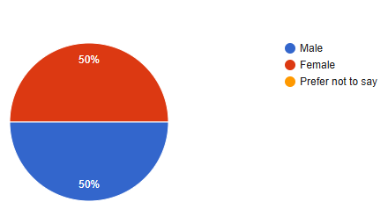

Fig. 1: Pie Chart shows the demographic information of the participants

The participants of the study were from varying teaching experiences. 60% of the participants have teaching experiences of 11 years and above and 20% each with the teaching experience of 0-5 years and 6-10 years. Figure 2 depicts the participants’ teaching experiences of the school.
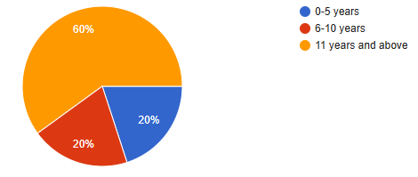

Fig. 2: Pie Chart depicts the respondents’ teaching experiences of the school

RESULTS AND DISCUSSION
This section provides a presentation and analysis of the data collected to address the research questions of this study. The figures and tables represent the key findings that show a clear overview of the results. This is followed by a comprehensive discussion that interprets these findings and evaluates their significance within the context of the study’s objectives and questions.

Analysis of Leadership Style and Practices Data
This analysis interprets the survey data on leadership style and practices. The findings are categorized into quantitative data from the Likert scale questions and qualitative data from the open-ended questions. The tables below portray responses of the principal’s self-rating and the teacher participants’ rating regarding principal’s leadership style and practices.
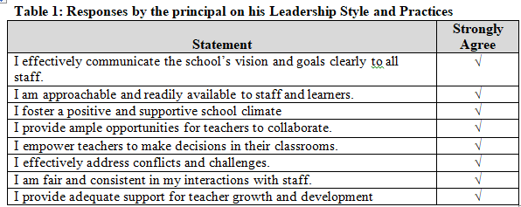
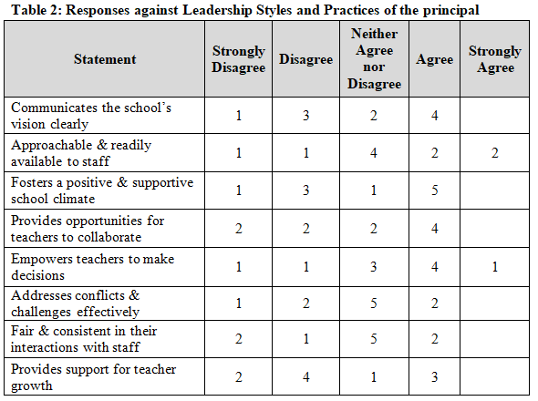
Based on the Likert scale data provided in table 1 and 2, the Principal’s self-rating and the teachers’ rating of his leadership style are in strong contrast. The Principal consistently rated himself with either Agree or Strongly Agree across all eight statements regarding his leadership style and practices. This indicates a belief that he is highly effective at everything from communicating the school’s vision to empowering teachers and providing support for growth as shown in the above table 1. The principal’s self-ratings align with the characteristics of a transformational or visionary leader (Lawrence, 2024; Hamdi et al., 2021; Moh, 2024).
According to Sabir (2017) and Thapa & Phuntsho (2021), effective leadership is a two-way, interactive process where leaders and followers mutually influence each other. The data suggests this two-way influence is not fully realized as the Principal’s positive self-view is not consistently reflected in his staff’s perceptions. This indicates a potential lack of the “self-awareness” (Sabir, 2017) essential for a leader to precisely understand his impact on others. The teachers’ ratings are mixed and do not show a strong consensus. For example, on the statement “Communicates the school’s vision clearly,” four teachers agreed while four were neutral, disagreed, or strongly disagreed. This pattern of mixed responses is seen throughout the teacher data. While five teachers strongly agreed that the principal fosters a positive school climate, more than four teachers disagreed on the items like being approachable, fair, and providing support for teacher growth. On the other hand, the qualitative data from the teachers further highlights this disparity. Some comments were positive on their principal’s leadership.
He is approachable, he provides positive feedbacks after the lesson observations and he guides and fixes accountability after coaching. (Participants 01, 03 06and 08)
The two teacher participants stated that there was “No positive impact” on their work under their leader. Other participants have not provided any descriptive feedback on their principal’s leadership. The Principal, however, believes his actions have a positive impact on teacher practices and student achievement as indicated in his self-ratings.
In essence, the data reveals a clear gap between the Principal’s self-perception and the teachers’ views. The Principal sees his leadership as generally effective with self-rating as either Agree or Strongly Agree on every statement. In contrast, the teachers’ responses are mixed with a divided reality with no clear consensus on his effectiveness.
Analysis on School Climate and Culture
This section assessed the School’s Climate and Culture. There were five items and each item was rated on a scale of 1 to 5, where 1 = Strongly Disagree, 2=Disagree, 3=Neither Agree Nor Disagree, 4=Agree and 5 = Strongly Agree.
Fig. 3: Participants rating on their leader in creating school culture
…………School climate and culture ………..

As seen in the fig 1, it shows that a majority of participants (4 participants) feel safe at school. However, there are strong concerns regarding the principal’s role in fostering a positive culture. This statement has the highest negative response with 50% of participants rating Disagree. This finding reveals a major concern regarding the principal’s ability to foster a positive and supportive school culture. On the other hand, a large number of responses (5 participants each in inclusive and sense of belonging statements) are in the Neutral category that represents a lack of strong positive sentiment.
Fig. 4: Principal’s self-rating on his leadership in creating school culture
…………School climate and culture ………..

However, as indicated in the above figure 2, the principal’s self-rating presents that he creates inclusive and supportive school culture with the rating of either agree on strongly agree on four different statements. But there is a big difference between how the principal and the staff see the school’s culture. 50% of participants rated on disagreeing that the principal fosters a supportive school culture which conflicts with the principal’s own self-rating of either Agree or Strongly Agree category. This difference in perception between the leader and the participants suggests that disconnect within them is a barrier to improve the school’s climate and culture. Phuntsho (2022) found that a principal’s actions such as delegating responsibilities strongly correlate with teacher performance. Therefore, the perceptual gap between these two data could suggest that the principal’s actions are not being received as intended and hamper teacher performance and overall school improvement. Thus, a principal’s effectiveness is not just on their actions, but on their ability to understand and bridge this perceptual divide with their staff.
Teacher Practices and Student Outcomes
The figure 3 and 4 depicts the principal’s perception of his influence on teacher practices and student outcomes are in contrast to the views of his staff. This difference reveals how an individual’s influence on groups and institutions is not always what they intend it to be.

Fig. 5: Participants’ responses on Teacher Practices and Student Outcomes

Fig. 6: Principal’s self-rating on Teacher Practices and Student Outcomes

The Principal’s self-rating as indicated in figure 4 shows a belief that he has a generally positive influence. He marked Strongly Agree for all the statements indicating that he believes his individual leadership effectively shapes the pedagogical practices and academic results of the school.
On the other hand, the teachers’ responses (Fig. 3) represent a mixed picture. On the statement about the principal’s positive impact on teacher practices, only two teachers agreed, while a majority (four) rated either disagreed or strongly disagreed. This shows a direct contradiction to the principal’s view. Regarding the influence on staff and student achievement, the results are similarly split, with only three teachers agreeing, while four disagreed or were neutral. The most positive result from the teachers was on student engagement with five agreeing that students are motivated in their learning. However, four teachers disagreed and that shows a lack of consensus.
This difference highlights how the principal as an individual plays a role in influencing a group and the institution. The Principal’s influence is not a one-way action rather it is mediated through the perceptions and experiences of the group. His self-assessed effectiveness is not translating into a unified and positive experience for the staff. This could lead to a lack of trust and cohesion which eventually hinder the school’s ability to operate effectively as a unified institution.
Leader’s relationship with communities
This analysis of the data reveals an inconsistency between the Principal’s perception and the teachers’ views on community partnerships. The Principal’s self-rating on community relationships presents a mixed but generally positive view. He strongly agrees that he collaborates with community organizations and religious groups as shown in table 3. He also agrees that he partners with local businesses. However, he is neutral on whether his initiatives have influenced families and communities showing lack of self-awareness regarding his perception.
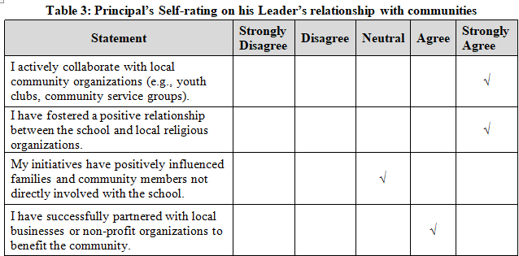
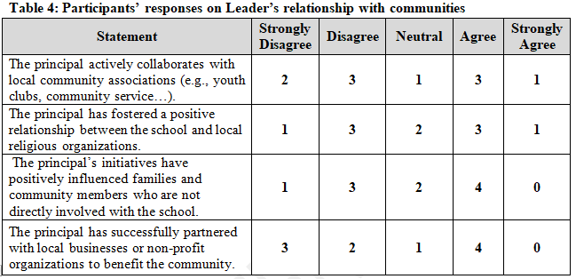
On the contrary, the teachers’ ratings are divided and mostly less positive as reflected in above table 4. The responses on collaboration, religious relationships and partnerships with businesses are spread across the scale with a significant number of teachers disagreeing (3 participants each) or remaining neutral. This indicates a lack of collective awareness among the staff regarding the Principal’s community initiatives. This perception gap is evident in the qualitative data from the earlier survey section, where some teachers reported “no positive impact” on their work.
It is essential to triangulate the data with the Principal’s self-perception, the teachers’ perception and the literature. Tashi (2022) highlights the importance of shared leadership where school leaders must act as a bridge between the school and the community. The Principal’s belief in his effective collaboration is not fully shared by his staff proposing that this shared leadership model may not be implemented effectively.
The findings reveal that the Principal, as an individual leader has a major impact on groups and the institution, but this influence is complex and not always what he expects. His belief in his strong community ties may be a personal truth, but the lack of shared knowledge and perception among his staff indicates that his actions are not fully translating into a cohesive and institution wide effort. This could lead to weakening of institutional bond, making school’s internal workings not aligned with its external partnerships. It may also hinder shared leadership as the Principal operates under a different reality than his staff. It may create an environment where all individuals act independently and fail to cooperate for the betterment of the organization.
Feedback and Continuous Improvement
As shown in the table 5 below, the feedback from participants reveals the principal’s strengths, areas for improvement and key suggestions for professional growth. The data reveals that a principal with strong interpersonal skills, who is seen as collaborative, kind, and approachable. While recognized for their positive initiative, punctuality and a focus on school development, the principal is also faced with a clear call for growth in leadership. The feedback consistently points to a need to improve his decision-making, being assertive in taking risks, and empower their staff. Several participants (04 participants) shared that their leader’s greatest strengths are understandable, kind, collaborative, good initiative, punctual and approachable. The sentences below summarize four participant’s feedback.
Our principal exhibits positive collaboration with staff, shows an understanding and kind, takes initiative, he is punctual, and are both approachable and skilled in developmental activities. (Participants 01, 03 06and 08)
Additionally, a critical area for development is strengthening community relationships. The participants suggest the principal to adopt a stricter approach to minimize classroom disruptions and to actively work on improving staff morale and welfare as a professional growth.
The principal needs to improve community relationships, provide more professional development (PD) programs, and need to make better decisions. The principal should also accept suggestions from colleagues and empower staff. (Participants 02, 04, 05, 07, 09)
Overall, the findings suggest that the principal has a solid foundation of positive interpersonal skills but must evolve his leadership style to be more authoritative, decisive and focused on both internal and external relationships.
Conclusion
The findings revealed that the principal possesses strong interpersonal skills that includes being collaborative, kind and approachable. However, there is a substantial inconsistency between the principal’s self-perception and the teachers’ perceptions. This divide negatively influences the school’s climate, teacher performance and community relationships of the selected school. The study concludes that the principal’s efficiency is impeded by the perceptual gap and a need for improvement in strengthening decision-making, taking risks and empowering staff. The principal may translate his positive actions into a unified, effective and cohesive school environment if the perceptual gap is being addressed.
LIMITATIONS AND RECOMMENDATIONS
This study was carried out to examine how principal as individual impacts the groups and institutions in one of the school. However, it is important to consider several limitations that may affect the breadth and applicability of the conclusions drawn in interpreting the findings. These constraints demand a deeper understanding of the results within the specific context of this study.
The small sample size of the study that includes only one principal and ten teachers from a single school is a major limitation. This small and localized sample through a Non-Probability Sampling Technique would be bias and makes it difficult to generalize the findings to a broader population of schools or leaders. The study’s narrow focus on a single institution also prevents it from accounting for variations that might exist in schools with different locations, sizes, or institutional cultures.
Additionally, the reliance on subjective, self-reported data from Likert scale surveys is a limitation. The data collected from the quantitative method is not based on objective performance metrics or direct observations. The qualitative data gathered from open-ended questions is also limited to a few specific examples, which may not provide enough depth to fully understand the complexities behind the quantitative ratings.
Thus, future research should expand the sample size to include more principals and teachers from multiple schools across different regions of Bhutan to make the findings more generalizable. Future studies should also strengthen the qualitative component with more in-depth interviews, focus groups, or direct observations to provide richer context for the quantitative data. Additionally, to get a more complete understanding of community partnerships, researchers should include community members in the surveys or interviews to triangulate the data with the perceptions of the principal and teachers. Finally, research should aim to explore the root causes of the perceptual gap between principals and staff by examining communication styles and professional development opportunities.
Disclaimer (Artificial intelligence)

Option 1:

Author(s) hereby declare that NO generative AI technologies such as Large Language Models (ChatGPT, COPILOT, etc.) and text-to-image generators have been used during the writing or editing of this manuscript.

Option 2:

Author(s) hereby declare that generative AI technologies such as Large Language Models, etc. have been used during the writing or editing of manuscripts. This explanation will include the name, version, model, and source of the generative AI technology and as well as all input prompts provided to the generative AI technology

Details of the AI usage are given below:
1.
2.
3.

Reference
Almas Sabir. A Leader: One, Who Knows the Way, Goes the Way and Shows the Way. European Business & Management.
Lawrence, E. (2024, December). The Role of Leadership Styles in Shaping Educational Organizational Culture and Performance. ResearchGate. https://www.researchgate.net/publication/386459227
LIM, Siew Hui; Bischen Singh, Gurcharan Singh(2020). The Influence of Instructional Leadership on Learning Organisation At High Performing Primary Schools in Malaysia. Asian Journal of University Education
Moh, M. (2024). The Visionary Leadership of the School Principal for Improving the Quality of Education. Journal of Ecohumanism, 3(8), 3297–3304. https://doi.org/10.62754/joe.v3i8.4971
Murphy, C., & D'Auria, J. (2021). The influential school leader: Inspiring teachers, students, and families through social and organizational psychology. Routledge.
Nellitawati, N., & Ermita, E. (2021). The role of the principal as a leader, innovator and motivator in vocational high schools. Journal of Educational and Learning Studies, 4(2), 218–221. https://doi.org/10.32698/01622
Phuntsho, D. (2022). Influence of principal's instructional leadership on teacher performance in secondary schools of Thimphu district, Bhutan. Bhutan Journal of Research & Development, 11(2), 98-112.
Sabir, A. (2017). A Leader: One, Who Knows the Way, Goes the Way and Shows the Way. European Business & Management, 3(5), 82–85. https://doi.org/10.11648/j.ebm.20170305.12
Suharjo, S., & Purnomo, S. (2024). School Principal Leadership Style and Organizational Performance in Improving the Quality of Education. International Journal of Multidisciplinary Research and Analysis, 7(3), 1257–1265. https://doi.org/10.47191/ijmra/v7-i03-48
Tashi, S. (2022). School-Community Partnerships: Bhutanese Principals’ Impact on Community Involvement in Schools [Master's thesis, Queensland University of Technology]. QUT ePrints.
Tshering, N. (2022). Influence of principal’s instructional leadership on teacher performance in secondary schools of Thimphu district, Bhutan. Bhutan Journal of Research & Development, 98. https://doi.org/10.17102/bjrd.rub.11.2.034
Thapa, T. R., & Phuntsho, J. (2021). School Principal Leadership Style and Organization Citizenship Behavior.
Hamdi, S. S., Jameel, A. S., Massoudi, A. H., & Ahmad, A. R. (2021). Leadership styles and organizational citizenship behaviour in secondary schools. In 3rd International Conference on Administrative & Financial Sciences. https://doi.org/10.24086/afs2020/paper.231

