Case Report

Bardet-Biedl syndrome in a 10-year-old child: clinical observation and literature review

ABSTRACT

Aims: To report a pediatric case of Bardet-Biedl syndrome (BBS) and discuss its clinical, diagnostic, and therapeutic aspects in light of current literature.
Study Design : Case report and literature review.
Place and Duration of Study : Department of Pediatrics, Hôpital Militaire d’Instruction Mohammed V, Rabat, Morocco, 2024.
Methodology : We describe a 10-year-old boy, born from a first-degree consanguineous marriage, who presented with growth retardation, obesity, facial dysmorphism, polydactyly, brachydactyly, micropenis, learning difficulties, and decreased visual acuity. Clinical, radiological, ophthalmological, renal, and genetic investigations were performed.
Results: The child exhibited multiple features suggestive of Bardet-Biedl syndrome: polydactyly of hands and feet, obesity, retinal dystrophy with extinguished electroretinogram, renal anomalies (horseshoe kidney with asymmetric function), and learning difficulties. Genetic testing was initiated but results were pending at the time of reporting. Symptomatic and multidisciplinary management was initiated [37].
Conclusion: Bardet-Biedl syndrome is a rare multisystem ciliopathy. Early recognition, even in the absence of genetic confirmation, is essential for timely multidisciplinary management. Visual and renal complications largely determine long-term prognosis.

Keywords: Bardet-Biedl syndrome, ciliopathy, polydactyly, obesity, renal anomalies, retinal dystrophy, case report

1. INTRODUCTION

Bardet-Biedl syndrome (BBS; OMIM 209900) is a rare autosomal recessive ciliopathy characterized by retinal dystrophy, obesity, post-axial polydactyly, hypogonadism, renal anomalies, and variable intellectual disability [1–3]. Its prevalence is estimated at 1 in 140,000 in Europe and North America but is higher in consanguineous populations [4,5]. Clinical variability has been observed even within the same family [6,7], and longitudinal studies in defined populations confirm significant phenotypic heterogeneity [8,9].
More than 20 genes (BBS1–BBS21) have been identified to date [10–13]. These encode proteins involved in the structure and function of the primary cilium [14,15]. Their dysfunction explains the pleiotropic manifestations, including ocular, renal, endocrine, and skeletal anomalies [16–18]. Population studies have shown that BBS1 and BBS10 mutations are the most common [19,20]. Genotype–phenotype correlations are increasingly recognized, with some variants linked to more severe renal or visual outcomes [21–23].
Several studies emphasize the renal involvement in BBS, which represents the main determinant of prognosis [24,25]. Research has also highlighted the oligogenic inheritance and interaction between different BBS genes [26,27]. Targeted sequencing and exome approaches allow for improved genetic diagnosis [28,29]. The BBSome complex and related trafficking proteins play a central role in ciliary membrane biogenesis [30–33]. Finally, recent reviews underline the importance of early recognition, multidisciplinary care, and ongoing genetic discoveries in this complex disorder [34–36].

2. CASE PRESENTATION

A 10-year-old boy, born from first-degree consanguineous parents, was referred for evaluation of growth retardation, obesity, and decreased visual acuity. His height was 123 cm (−3 SD), weight 34 kg (BMI 22.47, >97th percentile). Clinical examination revealed dysmorphic features, post-axial polydactyly of both hands and feet, brachydactyly, micropenis, learning difficulties, and poor school performance. Progressive night blindness was reported over two years.
Radiographs confirmed polydactyly and brachydactyly. Ophthalmological evaluation revealed retinal dystrophy with extinguished electroretinogram [10]. Abdominal ultrasound showed hepatomegaly and a horseshoe kidney with asymmetric function. Renal scintigraphy demonstrated asymmetry in function (right kidney 63%). Genetic analysis was initiated but pending at the time of report.
Written informed consent was obtained from the parents.

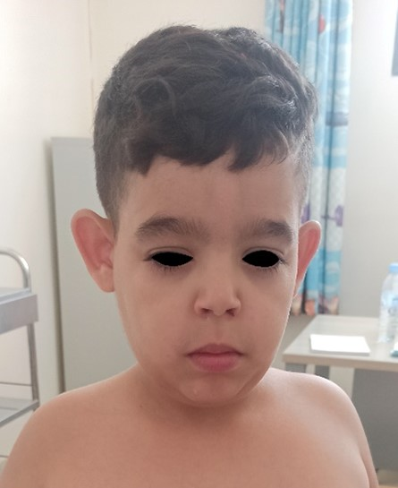
Figure 1. Dysmorphic face.

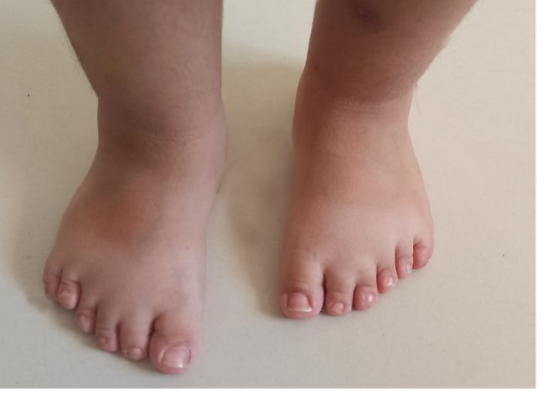
Figure 2. Polydactyly of foot.

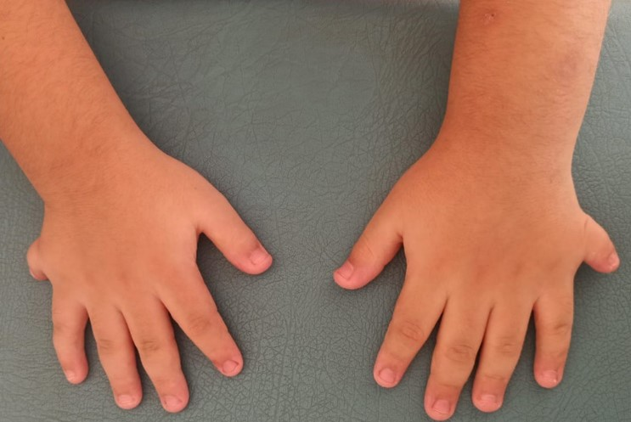
Figure 3. Polydactyly of hand.


Figure 4. Micro-penis.

3. discussion

The clinical features in our patient fulfill the major diagnostic criteria of BBS: obesity, retinal dystrophy, post-axial polydactyly, learning difficulties, renal anomalies, and hypogonadism [2,4,5]. Although molecular confirmation was pending, the constellation of signs was highly suggestive [6,7,12]. Phenotypic variability has been described across families and populations [13–15], and triallelic inheritance further complicates genetic counseling [7,26].
Retinal dystrophy is the most consistent manifestation and usually progresses to blindness [8,34]. Our patient’s electroretinography confirmed rod-cone dystrophy. Renal anomalies, reported in up to 90% of cases, are the leading cause of morbidity and mortality [9,18,24,29]. Our case with a horseshoe kidney illustrates this variability. Skeletal anomalies such as brachydactyly and polydactyly are common, with radiographic documentation supporting the diagnosis [11].
Genetic studies have identified more than 20 causative genes [19,20,27]. BBS1 and BBS10 are the most frequently mutated, but novel variants continue to be reported [18,23]. Exome sequencing has expanded the mutational spectrum [19,28]. Molecular insights confirm the central role of the BBSome and its interaction with intraflagellar transport proteins [30–33], which regulate ciliary membrane dynamics and signaling.
Management remains symptomatic and multidisciplinary. Recommendations include regular ophthalmological follow-up, renal surveillance, weight management, endocrine assessment, and educational support [10,24,25]. Cognitive and psychological interventions improve school outcomes [12,16]. Research into gene therapy, cell-based interventions, and pharmacological modulation of ciliary function is ongoing but remains experimental [17,30].
Our case aligns with previous series in consanguineous populations [27,29] and emphasizes the importance of early diagnosis for prognosis and family counseling [14,15,35,36]. The addition of recent case reports [40,41] illustrates the continued relevance of detailed clinical observation, particularly in regions where molecular testing may be delayed.

4. Conclusion

BBS is a rare multisystem ciliopathy. Clinical diagnosis remains crucial where molecular testing is delayed or unavailable. Early recognition allows multidisciplinary management to reduce morbidity and improve prognosis.

Ethical Approval:
As per international standards or university standards written ethical approval has been collected and preserved by the author(s).

Consent
As per international standards, parental written consent has been collected and preserved by the author(s).

Definitions, Acronyms, Abbreviations
BBS: Bardet-Biedl Syndrome
BMI: Body Mass Index
ERG: Electroretinogram
PNDS: Protocole National de Diagnostic et de Soins
SD: Standard Deviation

Disclaimer (Artificial intelligence)

Author(s) hereby declare that NO generative AI technologies such as Large Language Models (ChatGPT, COPILOT, etc.) and text-to-image generators have been used during the writing or editing of this manuscript.

References

- Khaled H, Echebbi S, Miladi N. Le syndrome de Bardet-Biedl: à propos de deux cas. Rev Neurol (Paris). 2012;168:A20–A21.
- Putoux A. Bardet-Biedl syndrome and related disorders. In: Bacchetta J, Boyer O, editors. Pediatric Nephrology. Paris: Elsevier Masson; 2020. p. 235–238.
- Dollfus H, et al. Le point sur le syndrome de Bardet-Biedl. J Fr Ophtalmol. 2005;28(1):106–112.
- Campo RV, Aaberg TM. Ocular and systemic manifestations of the Bardet-Biedl syndrome. Am J Ophthalmol. 1982;94(6):750–756.
- Spaggiari E, et al. Evolution of ocular clinical and electrophysiological findings in pediatric Bardet-Biedl syndrome. J Fr Ophtalmol. 1999;23(2):61–67.
- Cox GF, et al. Retinal function in carriers of Bardet-Biedl syndrome. Ophthalmology. 2003;121(6):804–810.
- Katsanis N, et al. Triallelic inheritance in Bardet-Biedl syndrome, a Mendelian recessive disorder. Science. 2001;293(5538):2256–2259.
- Green JS, et al. The cardinal manifestations of Bardet-Biedl syndrome. N Engl J Med. 1989;321(15):1002–1009.
- Rudling O, et al. Skeletal abnormalities of hands and feet in Laurence-Moon-Bardet-Biedl (LMBB) syndrome: a radiographic study. Clin Genet. 1996;25(7):655–660.
- Beales PL, et al. Genetic and mutational analyses of a large multiethnic Bardet-Biedl cohort reveal a minor involvement of BBS6. Am J Hum Genet. 2001;68(3):606–616.
- Riise R, et al. Intrafamilial variation of the phenotype in Bardet-Biedl syndrome. Br J Ophthalmol. 1997;81:378–385.
- Moore SJ, et al. Clinical and genetic epidemiology of Bardet-Biedl syndrome in Newfoundland: a 22-year prospective, population-based, cohort study. Am J Med Genet A. 2005;132(4):352–360.
- Deveault C, et al. BBS genotype–phenotype assessment of a multiethnic patient cohort. Hum Mutat. 2011;32(6):710–729.
- Beales PL, et al. New criteria for improved diagnosis of Bardet-Biedl syndrome: results of a population survey. J Med Genet. 1999;36:437–446.
- Hjortshøj TD, et al. Bardet-Biedl syndrome in Denmark: report of 13 novel sequence variations in six genes. Hum Mutat. 2010;31(4):429–436.
- Slavotinek AM, Biesecker LG. Phenotypic overlap of McKusick–Kaufman syndrome with Bardet–Biedl syndrome: a literature review. Am J Med Genet. 2000;95(3):208–215.
- Zaghloul NA, Katsanis N. Mechanistic insights into Bardet-Biedl syndrome, a model ciliopathy. J Clin Invest. 2009;119(3):428–437.
- Schaefer E, et al. Clinical and molecular study of 33 patients with Bardet-Biedl syndrome. Pediatr Nephrol. 2011;26:499–509.
- Marion V, et al. Exome sequencing identifies mutations in IFT27 causing Bardet-Biedl syndrome. Am J Hum Genet. 2012;90:246–257.
- Forsythe E, Beales PL. Bardet-Biedl syndrome. Eur J Hum Genet. 2013;21(1):8–13.
- Tobin JL, et al. Inhibition of a PCP pathway reduces renal cystogenesis in juvenile cystic kidney disease. Hum Mol Genet. 2008;17:1291–1301.
- Chiang AP, et al. Homozygosity mapping with SNP arrays identifies novel Bardet-Biedl syndrome loci. PLoS Genet. 2004;3(3):e19.
- Estrada-Cuzcano A, et al. BBS1 mutations are the most frequent cause of Bardet-Biedl syndrome in a Dutch cohort. Eur J Hum Genet. 2012;20:135–141.
- Imhoff O, et al. Bardet-Biedl syndrome: new aspects of renal involvement in a large cohort of French patients. Nephrol Dial Transplant. 2011;26(4):1322–1329.
- Marion V, et al. Bardet-Biedl syndrome: an update. Curr Opin Pediatr. 2011;23(6):439–444.
- Badano JL, et al. Dissection of epistasis in oligogenic Bardet-Biedl syndrome. Nature. 2006;439(7074):326–330.
- M’Hamdi O, et al. Clinical and genetic characterization of Bardet-Biedl syndrome in Tunisian families: revisiting the burden of BBS genes in North Africa. Clin Genet. 2014;85(6):568–579.
- Forsythe E, Sparks K, Hoskins BE, et al. Genetic diagnosis of Bardet-Biedl syndrome: an assessment of a targeted testing strategy. J Med Genet. 2015;52(8):514–522.
- Khan SA, et al. Renal abnormalities in Bardet-Biedl syndrome. Clin Kidney J. 2013;6(6):558–563.
- Fath MA, et al. The BBSome and intraflagellar transport. Methods Cell Biol. 2015;127:479–495.
- Seo S, et al. A novel protein LZTFL1 regulates ciliary trafficking of the BBSome and Smoothened. PLoS Genet. 2011;7(11):e1002358.
- Nachury MV, et al. A core complex of BBS proteins cooperates with the GTPase Rab8 to promote ciliary membrane biogenesis. Cell. 2007;129(6):1201–1213.
- Loktev AV, et al. A BBSome subunit links ciliogenesis, microtubule stability, and acetylated tubulin. J Cell Biol. 2008;180(6):883–893.
- Mockel A, et al. Retinal dystrophy in Bardet-Biedl syndrome and related syndromic ciliopathies. Prog Retin Eye Res. 2011;30(4):258–274.
- Baker K, Beales PL. Making sense of cilia in disease: the human ciliopathies. Am J Med Genet C Semin Med Genet. 2009;151C(4):281–295.
- Estrada-Cuzcano A, et al. Mutation spectrum of Bardet-Biedl syndrome genes in patients from different populations. Hum Mutat. 2012;33:42–52.
- Novas R, Cardenas-Rodriguez M, Irigoín F, Badano JL. Bardet-Biedl syndrome: is it only cilia dysfunction? FEBS Lett. 2015;589(22):3479–3491.
- Forsyth RL, Gunay-Aygun M. Bardet-Biedl syndrome overview. In: Adam MP, Mirzaa GM, Pagon RA, Wallace SE, Bean LJH, Mirzaa GM, et al., editors. GeneReviews® [Internet]. Seattle (WA): University of Washington, Seattle; 1993–2023. Updated 2023. Available from: https://www.ncbi.nlm.nih.gov/books/NBK1363/
- Srinivas R, Rao N, Balachandra G. Bardet-Biedl-Moon Syndrome: A rare case with multi-organ manifestations presenting as renal failure. J Adv Med Med Res. 2025;37(6):296–300.
- Mohapatra AP, Patra P, Mohapatra I. Beyond the extra digit: A rare case of Bardet-Biedl syndrome in a 12-year-old with polydactyly, obesity and vision loss. Asian J Pediatr Res. 2025;15(5):10–17.

